58二手车：

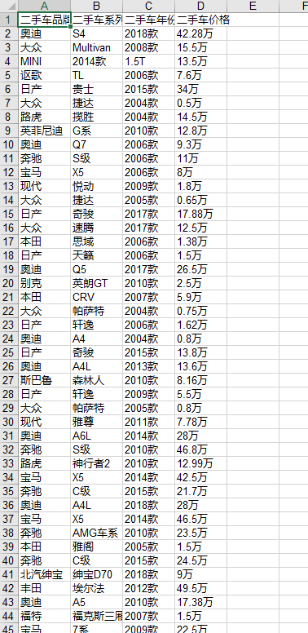

风雨骤：

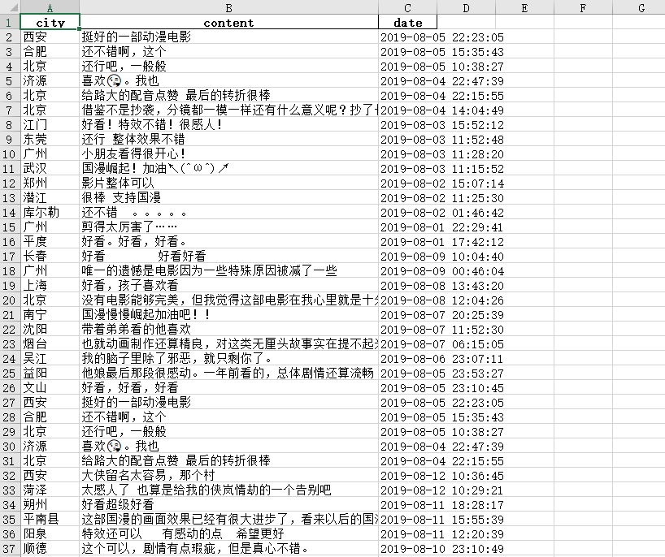

决策树：

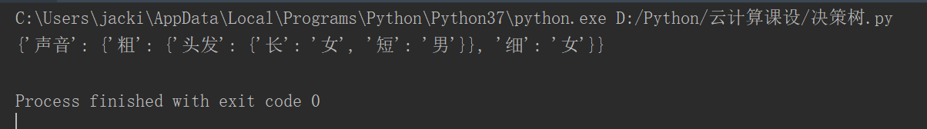

聚类算法：第一次聚类

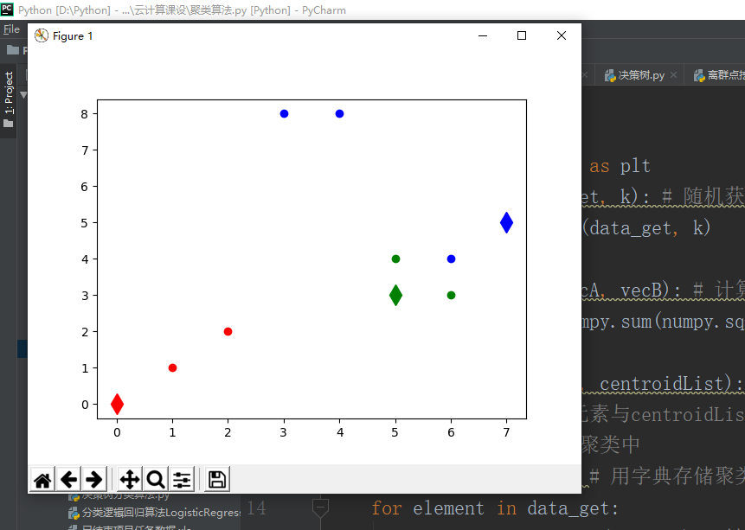

第二次聚类：

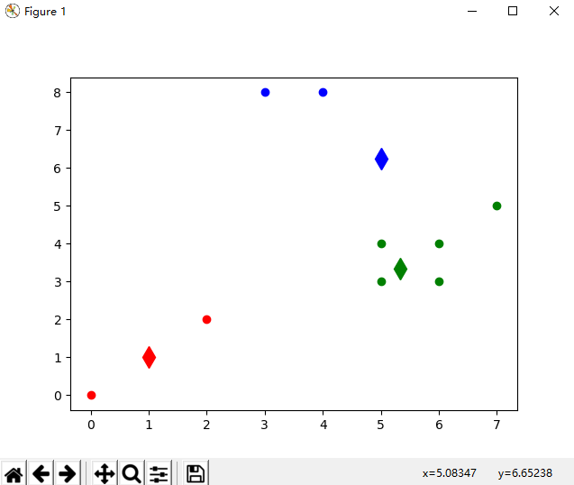

第三次聚类：

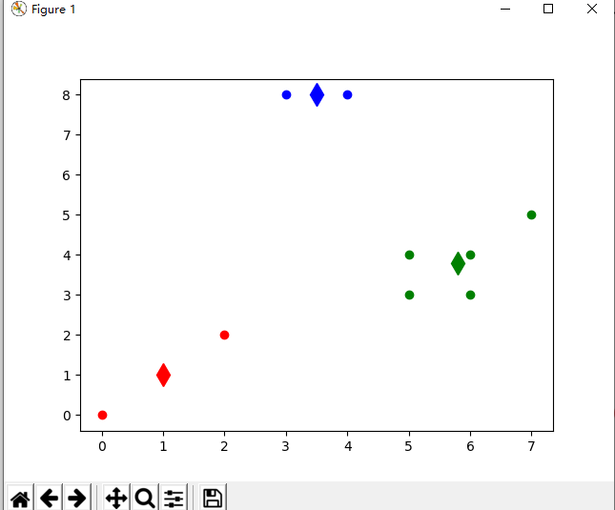

总结果：

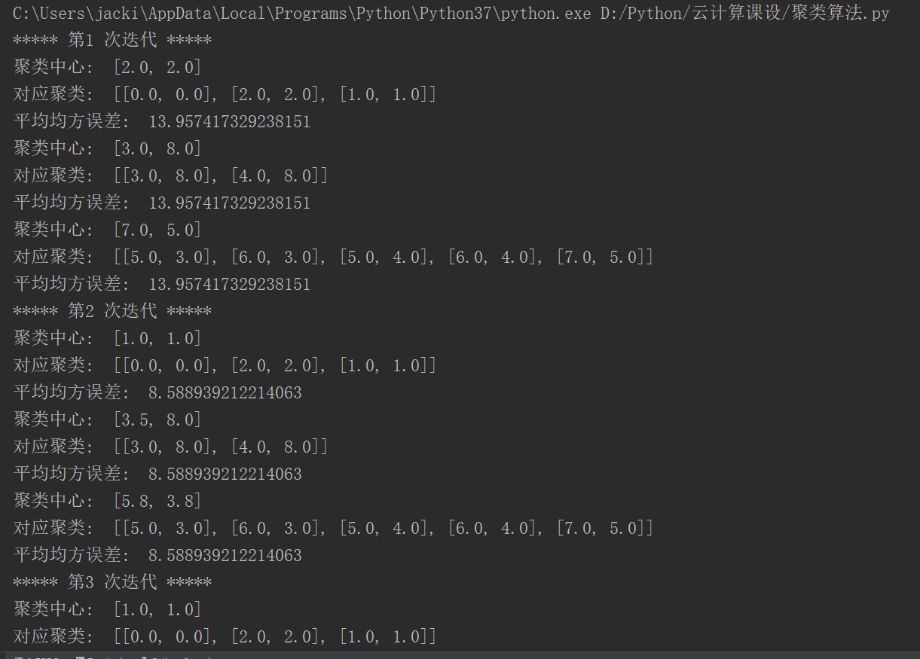

关联规则：

import os,itertools  
import numpy as np  
import pandas as pd  
class Apriori(object):  
 def __init__(self, itemSets, minSupport=0.5, minConf=0.7, sort = False):  
 self.itemSets = itemSets  
 self.minSupport = minSupport  
 self.minConf = minConf  
 self.sort = sort  
 self.__Initialize()  
 def __Initialize(self):  
 self.__item()  
 self.__creat_matrix()  
 self.update(minSupport=self.minSupport, minConf=self.minConf)  
 def __item(self):  
 *''' 获取项目元素列表 '''* self.item = []  
 for itemSet in self.itemSets:  
 for item in itemSet:  
 if item not in self.item:  
 self.item.append(item)  
 self.item.sort()  
 def __creat_matrix(self):  
 *''' 将项集转为 pandas.DataFrame 数据类型 '''* self.data = pd.DataFrame(columns=self.item)  
 for i in range(len(self.itemSets)):  
 self.data.loc[i, self.itemSets[i]] = 1  
 def __candidate_itemsets_l1(self):  
 *''' 创建单项频繁项集及 L1'''* self.L1 = self.data.loc[:, self.data.sum(axis=0) / len(self.itemSets) >= self.minSupport]  
 self.L1_support_selects = dict(self.L1.sum(axis=0) / len(self.itemSets)) # 只作为分母，不进行拆分  
 def __candidate_itemsets_lk(self):  
 *''' 根据 L1 创建多项频繁项集 Lk ，非频繁项集的任何超集都不是频繁项集 '''* last_support_selects = self.L1_support_selects.copy() # 初始化  
 while last_support_selects:  
 new_support_selects = {}  
 for last_support_select in last_support_selects.keys():  
 for L1_support_name in set(self.L1.columns) - set(last_support_select.split(',')):  
 columns = sorted([L1_support_name] + last_support_select.split(',')) # 新的列名：合并后排序  
 count = (self.L1.loc[:, columns].sum(axis=1) == len(columns)).sum()  
 if count / len(self.itemSets) >= self.minSupport:  
 new_support_selects[','.join(columns)] = count / len(self.itemSets)  
 self.support_selects.update(new_support_selects)  
 last_support_selects = new_support_selects.copy() # 作为新的 Lk，进行下一轮更新  
 def __support_selects(self):  
 *''' 支持度选择 '''* self.__candidate_itemsets_l1()  
 self.__candidate_itemsets_lk()  
 self.item_Conf = self.L1_support_selects.copy()  
 self.item_Conf.update(self.support_selects)  
 def __confidence_selects(self):  
 *''' 生成关联规则，其中 support_selects 已经按照长度大小排列 '''* for groups, Supp_groups in self.support_selects.items():  
 groups_list = groups.split(',')  
 for recommend_len in range(1, len(groups_list)):  
 for recommend in itertools.combinations(groups_list, recommend_len):  
 items = ','.join(sorted(set(groups_list) - set(recommend)))  
 Conf = Supp_groups / self.item_Conf[items]  
 if Conf >= self.minConf:  
 self.confidence_select.setdefault(items, {})  
 self.confidence_select[items].setdefault(','.join(recommend),{'Support': Supp_groups,  
'Confidence': Conf})  
 def show(self,**kwargs):  
 *''' 可视化输出 '''* if kwargs.get('data'):  
 select = kwargs['data']  
 else:  
 select = self.confidence_select  
 items = []  
 value = []  
 for ks, vs in select.items():  
 items.extend(list(zip([ks] * vs.__len__(), vs.keys())))  
 for v in vs.values():  
 value.append([v['Support'], v['Confidence']])  
 index = pd.MultiIndex.from_tuples(items, names=['Items', 'Recommend'])  
 self.rules = pd.DataFrame(value, index=index, columns=['Support', 'Confidence'])  
 if self.sort or kwargs.get('sort'):  
 result = self.rules.sort_values(by=['Support', 'Confidence'], ascending=False)  
 else:  
 result = self.rules.copy()  
 return result  
 def update(self, **kwargs):  
 *''' 用于更新数据 '''* if kwargs.get('minSupport'):  
 self.minSupport = kwargs['minSupport']  
 self.support_selects = {} # 用于储存满足支持度的频繁项集  
 self.__support_selects()  
 if kwargs.get('minConf'):  
 self.minConf = kwargs['minConf']  
 self.confidence_select = {} # 用于储存满足自信度的关联规则  
 self.__confidence_selects()  
 print(self.show())  
 if kwargs.get('file_name'):  
 file_name = kwargs['file_name']  
 self.show().to_excel(f'/../table/{file_name}.xlsx')  
 self.apriori_rules = self.rules.copy()  
 def __get_Recommend_list(self,itemSet):  
 *''' 输入数据，获取关联规则列表 '''* self.recommend_selects = {}  
 itemSet = set(itemSet) & set(self.apriori_rules.index.levels[0])  
 if itemSet:  
 for start_str in itemSet:  
 for end_str in self.apriori_rules.loc[start_str].index:  
 start_list = start_str.split(',')  
 end_list = end_str.split(',')  
 self.__creat_Recommend_list(start_list, end_list, itemSet)  
 def __creat_Recommend_list(self,start_list,end_list,itemSet):  
 *''' 迭代创建关联规则列表 '''* if set(end_list).issubset(itemSet):  
 start_str = ','.join(sorted(start_list+end_list))  
 if start_str in self.apriori_rules.index.levels[0]:  
 for end_str in self.apriori_rules.loc[start_str].index:  
 start_list = start_str.split(',')  
 end_list = end_str.split(',')  
 self.__creat_Recommend_list(sorted(start_list),end_list,itemSet)  
 elif not set(end_list) & itemSet:  
 start_str = ','.join(start_list)  
 end_str = ','.join(end_list)  
 self.recommend_selects.setdefault(start_str, {})  
 self.recommend_selects[start_str].setdefault(end_str, {'Support': self.apriori_rules.loc[(start_str,  
end_str), 'Support'], 'Confidence': self.apriori_rules.loc[(start_str, end_str), 'Confidence']})  
 def get_Recommend(self,itemSet,**kwargs):  
 *''' 获取加权关联规则 '''* self.recommend = {}  
 self.__get_Recommend_list(itemSet)  
 self.show(data = self.recommend_selects)  
 items = self.rules.index.levels[0]  
 for item_str in items:  
 for recommends_str in self.rules.loc[item_str].index:  
 recommends_list = recommends_str.split(',')  
 for recommend_str in recommends_list:  
 self.recommend.setdefault(recommend_str,0)  
 self.recommend[recommend_str] += self.rules.loc[(item_str,recommends_str),'Support'] * self.rules.loc[(item_str,recommends_str),'Confidence'] * self.rules.loc[item_str,'Support'].mean()/(self.rules.loc[item_str,'Support'].sum()*len(recommends_list))  
 result = pd.Series(self.recommend,name='Weight').sort_values(ascending=False)  
 result.index.name = 'Recommend'  
 result = result/result.sum()  
 result = 1/(1+np.exp(-result))  
 print(result)  
 if kwargs.get('file_name'):  
 file_name = kwargs['file_name']  
 excel_writer = pd.ExcelWriter(f'{os.getcwd()}/../table/{file_name}.xlsx')  
 result.to_excel(excel_writer,'推荐项目及权重')  
 self.rules.to_excel(excel_writer, '关联规则树状表')  
 self.show().to_excel(excel_writer, '总关联规则树状表')  
 self.show(sort = True).to_excel(excel_writer, '总关联规则排序表')  
 excel_writer.save()  
 return result  
def str2itemsets(strings, split=','):  
 *''' 将字符串列表转化为对应的集合 '''* itemsets = []  
 for string in strings:  
 itemsets.append(sorted(string.split(split)))  
 return itemsets  
if __name__ == '__main__':  
 # 1.导入数据  
 data = pd.read_excel(r'apriori算法实现.xlsx', index=False)  
 # 2.关联规则中不考虑多次购买同一件物品，删除重复数据  
 data = data.drop_duplicates()  
 # 3.初始化列表  
 itemSets = []  
 # 3.按销售单分组，只有 1 件商品的没有意义，需要进行过滤  
 groups = data.groupby(by='销售单明细')  
 for group in groups:  
 if len(group[1]) >= 2:  
 itemSets.append(group[1]['商品编码'].tolist())  
 # 4.训练 Apriori  
 ap = Apriori(itemSets, minSupport=0.03, minConf=0.5)  
 ap.get_Recommend('2BYP206,2BYW001-,2BYW013,2BYX029'.split(','))

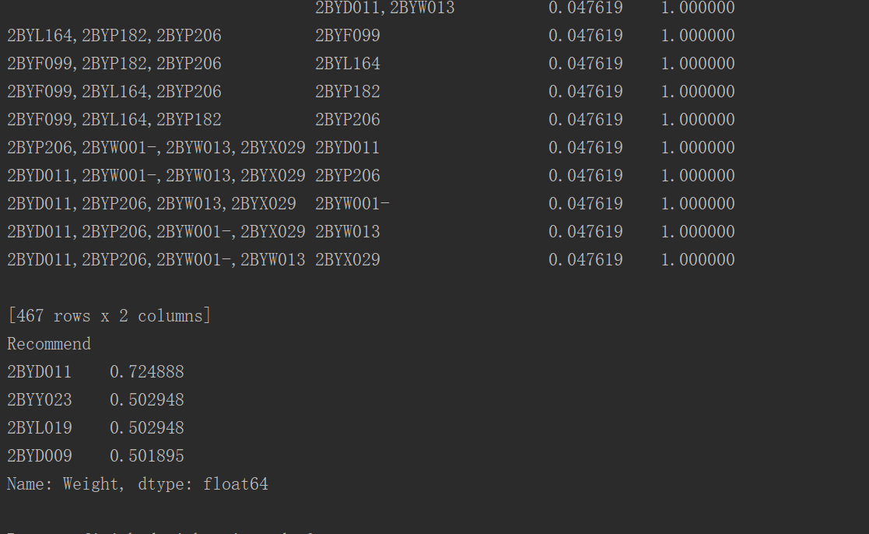

离群点挖掘：

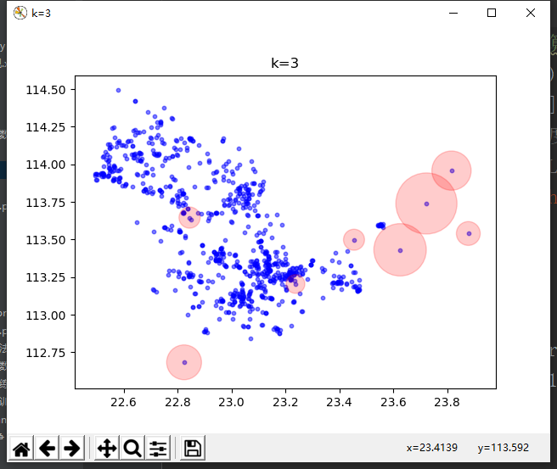

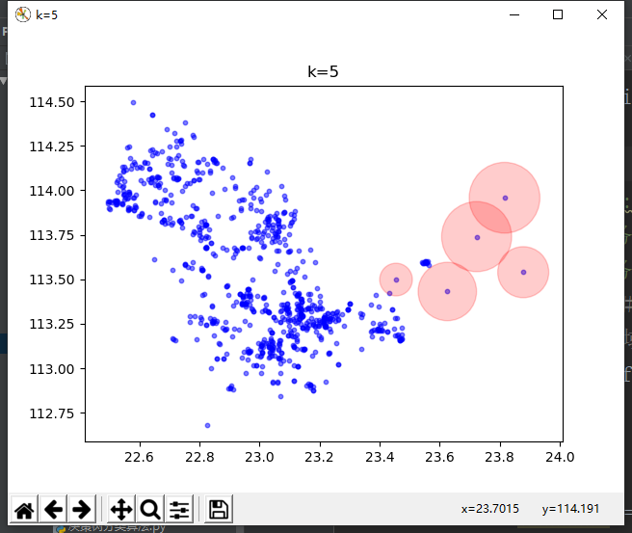

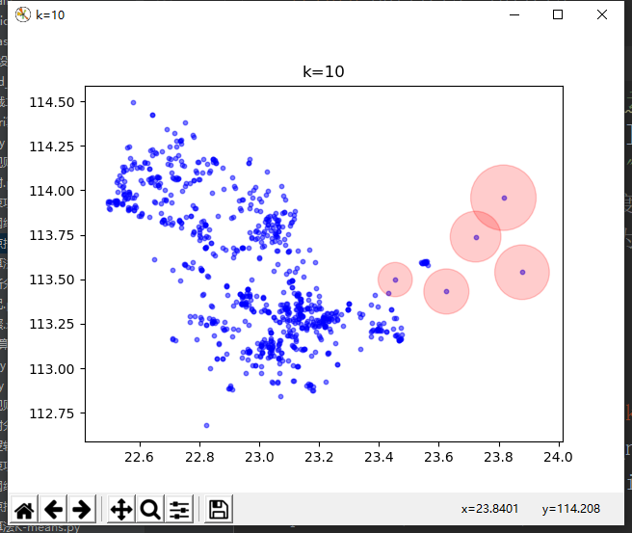

神经网络：

