Unit 8. Workshop 1. IT industry. Historical timeline
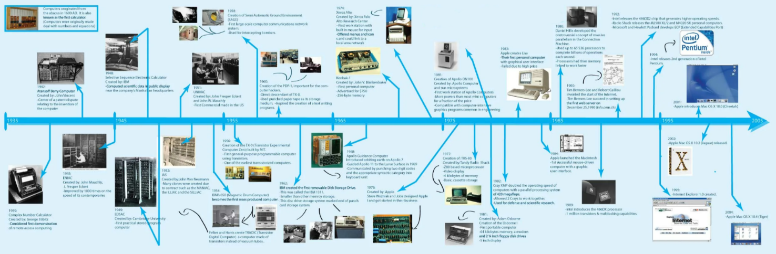
Stage 1. In pairs or small groups answer the warming-up questions.
- What do your smartphone and the first computer have in common?
- How do you think people managed communication, calculation, statistics, graphics and learning without computers? What pros and cons did they have?
- What’s the oldest computer you’ve ever heard of?
Stage 2. Deal with the lecture about computer history and be ready for the quiz.
https://e.sfu-kras.ru/mod/lesson/view.php?id=1701143&pageid=504186
Quiz task 1. Give Russian equivalents to the words below and pronounce correctly.
- vacuum tubes | - printouts | - abacus | - paper tapes | - output
- input | - analog | - to develop | - sophisticated | - digital
- silicon | - the slide rule | - to emit | - multiplying | - division

Quiz task 2. Name historical issues and explain their role.
1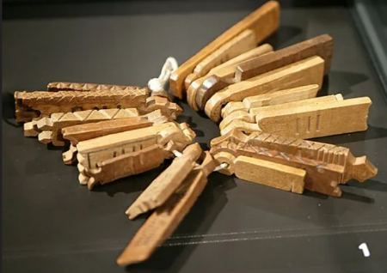 | 2  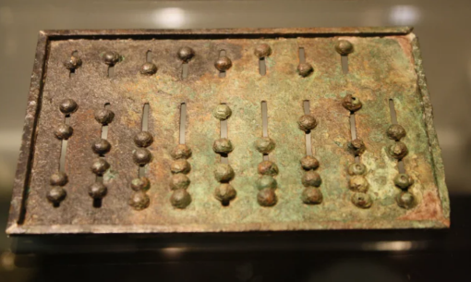 | 3  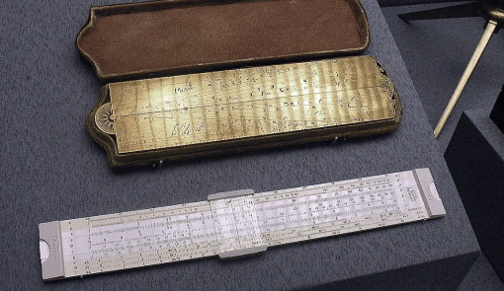
4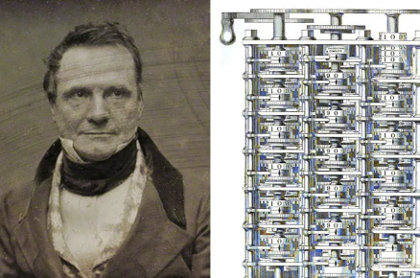 | 5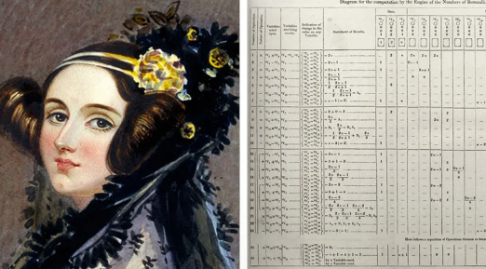 | 6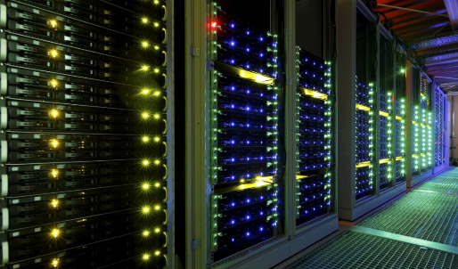

Quiz task 2. Restore historical order in the sentences below. Read and give a translation.

- The slide rule is considered the first analog computing device that works on the logarithms principle.
- Around 1964 to 1971 the third-generation computers were characterized by the invention of Integrated Circuits (ICs) based on silicon chips made from quartz.
- Tallies have been used for numerous purposes. They were the first tool of calculation.
- Howard Aiken of Harvard University designed the first fully automatic calculating machine in collaboration with IBM. It was the first programmable digital computer.
- The Osborne 1 is the first portable computer, released on April 3, 1981 AD, by Osborne Computer Corporation.
- In 1837, Charles Babbage, known as the Father of Computer, proposed Analytical Engine, the first general mechanical computer.
- Defining the fifth generation of computers is tricky because the field is still in its process.
- The first generation of computers occurred from 1940 to 1956 and was extremely large in size. These early machines required vacuum tubes that worked as switches, amplifiers, and magnetic drums for memory. T
- Abacus, appeared about 5,000 years ago in Asia and still in use today, is one of the first mechanical calculating devices.
- The second one was the generation of Transistorized Computers. Transistors replaced vacuum tubes so machines became more reliable, smaller in size, faster in speed, and cheaper. Magnetic drums were replaced by magnetic disks and magnetic tape for secondary storage.
- Lady Augusta Byron, Countess of Lovelace, was an English mathematician mainly known as as the first computer programmer and the Mother of digital computer.
- The fourth-generation computers were developed from 1971 to 1990 and acknowledged Scale Integration which could hold big number of components on one silicon chip.

Chapter 2. Read key thesis of OS development.

1. An operating system (OS) serves as the fundamental software interface between users, applications, and computer hardware. It acts as a vital intermediary, managing resources and providing essential services to ensure the efficient and secure operation of a computer system. The primary aim of an operating system is to manage computer resources, security, and file systems, offering a platform for application software and other system software to perform their tasks.

2.Operating systems consist of several key components that work together to provide a cohesive and efficient computing environment they are:

- Process Management: This component manages multiple processes running simultaneously on the system. It handles the creation, scheduling, and termination of processes, as well as the allocation of CPU time and other resources.
- Memory Management: The OS manages the main memory, which is a volatile storage device. It handles the allocation and deallocation of memory to processes, ensuring efficient use of available memory resources.
- File Management: This component provides a file system for organizing and storing data. It manages file creation, deletion, and access, as well as maintaining directory structures.
- I/O Device Management: The OS manages input/output devices, providing an abstract layer that hides the peculiarities of specific hardware devices from users and applications.
- Network Management: This component handles network-related tasks, optimizing computer networks and ensuring quality of service for network applications and services.
- Security Management: The OS implements security measures to protect system resources, files, and processes from unauthorized access or malicious activities.

3.The architecture of operating systems has evolved significantly over time, reflecting advancements in hardware capabilities and changing user needs. This evolution can be broadly categorized into four generations:

4. First Generation (1940s-1950s): These early systems lacked a distinct operating system. Computers were operated manually, requiring extensive knowledge of the machine’s hardware. They used serial processing, completing one task before starting the next. The concept of resident monitors emerged as a precursor to modern operating systems with several key functions: clearing memory from the last used program (except for itself), loading programs, searching for program data, maintaining standard input-output routines in memory

Batch processing systems represented a significant advancement in early computing. General Motors Research Laboratories (GMRL) announced the first batch processing systems in the early 1950s. These systems performed one job at a time, with data sent in batches or groups. The key characteristics of batch processing systems include: job grouping, offline preparation, non-interactive operation, efficient resource utilization.

5. Second Generation (1950s-1960s): This era saw the introduction of batch processing systems. Similar tasks were grouped into batches and processed sequentially without user interaction. Job Control Language (JCL) was introduced to manage these batches.

Multiprogramming represented a major advancement in operating system design, allowing multiple programs to be active simultaneously. This concept addressed the inefficiencies of earlier systems where only one program could be loaded and run at a time. Key features of multiprogramming systems included: single CPU utilization, context switching between processes, reduced CPU idle time, high resource utilization, improved performance. Multiprogramming created the illusion that users could run multiple applications on a single CPU, even though the CPU was still running one process at a time.

Time-sharing systems emerged as a logical extension of multiprogramming, allowing multiple users to interact concurrently with a single computer. Time-sharing systems operate by giving each task or user a small slice of processing time, creating the illusion of simultaneous execution through rapid switching between tasks. Key characteristics of time-sharing systems included: support for multiple concurrent users, reduced response times for all users, more effective resource utilization, cost-effectiveness for businesses

The IBM System/360, launched on April 7, 1964, revolutionized the computer industry by unifying a family of computers under a single architecture. This system introduced the concept of a platform business model, which is still embraced today by IBM and technology companies across various industries. Key features of the IBM System/360 included: software compatibility across the entire product line, scalability, allowing companies to start small and expand without rewriting software,
unified architecture for both commercial and scientific computing, introduction of the 8-bit byte, still in use today, central memory capacity of 8,000 to 524,000 characters, with additional storage of up to 8 million characters.

6. Third Generation (1960s-1970s): Multiprogramming allowed multiple jobs to reside in main memory simultaneously, improving CPU utilization. This led to the development of advanced memory management concepts such as memory partitioning, paging, and segmentation.

UNIX, one of the most influential operating systems in computing history, was born out of necessity at Bell Labs in 1969. Ken Thompson and Dennis Ritchie created UNIX for a PDP-7 computer. Initially, UNIX was a single-tasking operating system with basic functionalities, including an assembler, file system, and text processing capabilities. The C language, which appeared in Version 2 of UNIX, became integral to its success. UNIX introduced several innovative concepts: hierarchical file system, concept of device files, abstracting hardware through the file system, pipes, allowing the output of one program to serve as input for another.

Minicomputer OS. The 1970s also saw the rise of minicomputers, which required specialized operating systems. Digital Equipment Corporation (DEC) played a crucial role in this space with its PDP series. The PDP-11, introduced in the early 1970s, became an industry benchmark until the early 1980s, with approximately 200,000 units sold. Its popularity stemmed from its ease of programming, flexible I/O structure, and support for multiple operating systems tailored for various applications.

CP/M and Early Microcomputer OS, developed by Gary Kildall in 1974, became a pivotal operating system. Initially created for Intel 8080/85-based systems, CP/M was designed as a disk operating system to organize files on magnetic storage media and load and run programs stored on disk. Key features of CP/M included: single-tasking operation on 8-bit processors, support for 64 kilobytes of memory, compatibility with various hardware platforms. However, CP/M’s dominance was challenged with the advent of MS-DOS and the rise of the IBM PC compatible platform in the early 1980s.

7. Fourth Generation (1980s-Present) introduced time-sharing operating systems with features like graphical user interfaces, multitasking capabilities, and network connectivity. Modern operating systems in this generation offer advanced security mechanisms, compatibility with a wide range of hardware devices, and the ability to automatically recognize and configure hardware.

Personal Computer OS. In 1980, IBM began developing a desktop computer for the mass market, which would become known as the IBM PC. Initially, IBM approached Digital Research (DRI), the company behind CP/M, to license their operating system. However, negotiations between IBM and DRI reached an impasse over financial terms.

Apple Computer introduced the Macintosh in 1984, featuring a revolutionary graphical user interface (GUI) implementation on its operating system. This new OS introduced the use of a mouse as a pointing device and command input device for users to interact with the system. The Apple operating system was closed, attracting few software developers initially. However, it set a new standard for user-friendly interfaces in personal computing.

In 1985, Apple removed Steve Jobs from management, leading him to found NeXT Computer. Although NeXT hardware was phased out by 1993, its operating system, NeXTSTEP, would have a lasting legacy. NeXTSTEP was based on the Mach kernel developed at Carnegie Mellon University and BSD, featuring an object-oriented programming framework.

Microsoft Windows 1.0 was introduced in 1985. This operating system was the first to offer a graphical user interface for IBM-compatible PCs. Windows 1.0 allowed DOS users to visually navigate a virtual desktop, opening graphical windows displaying the contents of electronic folders and files with the click of a mouse button. Windows 1.0 was essentially a GUI offered as an extension of Microsoft’s existing disk operating system, MS-DOS. It was based in part on licensed concepts that Apple Inc. had used for its Macintosh System Software. Despite its limitations, Windows 1.0 laid the foundation for future versions that would dominate the PC market.

Linux, created by Linus Torvalds in 1991, has transformed the world of computing and technology in surprising and revolutionary ways. Torvalds’ idea was to create a free and open-source operating system, inspired by the Unix system. Initially released under a non-free software license, Torvalds relicensed the project under the GNU General Public License in February 1992. Linux’s flexibility and customizability made it an attractive option for various devices, including smartphones (Android), embedded systems, and even control systems in cars .

Android, initially created by Andy Rubin and his team in 2003, was acquired by Google in 2005. It adopted an open-source approach, allowing various manufacturers to use and modify the OS. This strategy led to a proliferation of Android-powered devices from different companies, giving consumers a wide array of choices.

iOS, originally known as iPhone OS, was developed by Apple Inc. for its revolutionary iPhone, introduced in 2007. The iPhone, with its multitouch display and intuitive user interface, set a new standard for smartphones and kickstarted the mobile revolution.

10. The journey through the history of operating systems has a profound influence on how we interact with computers. This evolution reflects not only technological progress but also changes in user needs. Looking ahead, the future of operating systems is likely to be shaped by emerging technologies and changing user demands.

https://blog.hellomybd.com/history-of-operating-systems/

1.Gap Stage. Fill in with key missing elements, so that sentences would organize OS timeline summary.
- ___________ serves as the fundamental software interface between users, files applications, and computer hardware. What word is extra?
- It consists of number key components that work together to provide a cohesive and efficient computing environment.
- The OS evolution can be broadly categorized into number generations.
- The First Generation is remarkable by the development of the concept of __________and ____________ represented a significant advancement in early computing.
- Second Generation era saw the introduction of_____, ____ and _______, launched on April 7, 1964.
- Third Generation led to the development of advanced memory management concepts such as_________, __________, and __________.
- This time _______, one of the most influential operating systems in computing history, was born.
- Fourth Generation introduced time-sharing operating systems with features like ____, ________, and _____.
- Apple Computer introduced the Macintosh in 1984, featuring a_____________.
- Windows 1.0 allowed DOS users to_____________.
- Linux’s flexibility and customizability ________.
- Android, acquired by Google in 2005 adopted an open-source approach, allowing various manufacturers to use and modify the OS. This strategy led_____________.
- _____________, introduced in 2007 with its multitouch display and intuitive user interface, set a new standard for smartphones and kickstarted the mobile revolution

2.Browser Stage. Match years, key words and browser logos to make a timeline.

1990 | 1993 | 1994 | 1995 | 1998 | 2008 | 2012

World wide web  Tim Berners – Lee | Netscape  Mosaic Upgraded | Chrome  Google | Opera  Telenor\ Norway
Mosaic  NCSA | Internet Explorer  Microsoft | Mozilla Firefox  Ex. Phoenix\US | Yandex  I. Segalovich\ A. Volozh

1 | 3 | 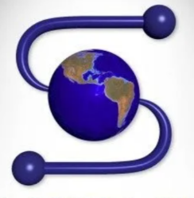5 | 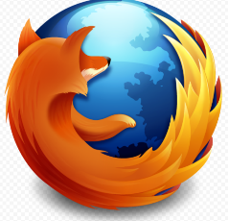7
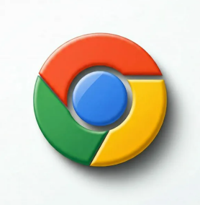2 |   4. no icon, interface only | 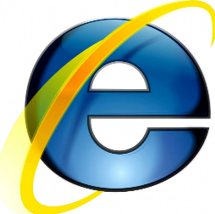6 | 8

3.Speaking Stage. The Fifth OS generation. How do you see it? Describe in 4-6 sentences.

