Explanatory note

1. Roguelike game “9Rogue”
2. **Description**:

It is a classic roguelike game. The game features:

* Random level generation
* Random NPC generation
* Implements permadeath
* RPG system

Additional information:

* The game uses MdxConsole (by Dmitriy Nesteruk: <https://www.codeproject.com/Articles/34498/The-Console-Reinvented>)
* For the correct work the user might have to download other libraries (DirectX, NET Framework 3.5, Utility Assembley)

1. <https://github.com/Egor4ik-3000/rglgameproject>
2. Egor Pomazkov: design, level generation logic, UI  
   Arsen Makhmudov: design, interaction logic  
   Dmitriy Nikitin: design, items and characters generation
3. **Classes Description**

|  |  |
| --- | --- |
| Class | Description |
| Program.cs | Welcome window, runs the level generation, runs Processing.cs |
| Level.cs | Level generator, spawning NPCs, player character |
| Room.cs | Room generator |
| LevelObject.cs | Base class for all classes of objects, that are displayed as a part of game world |
| Player.cs  Guard.cs  Skeleton.cs  SkeletonWarrior.cs | Player character and hostile creatures |
| ItemContainer.cs | Item container displayed on the level |
| Door.cs  Floor.cs  Wall.cs | Surroundings(static objects used at the level generation) |
| Armor.cs  Weapon.cs  Poison.cs | Items that are stored at player’s inventory(or item container) |
| Inventory.cs | Player’s inventory |

1. Interface

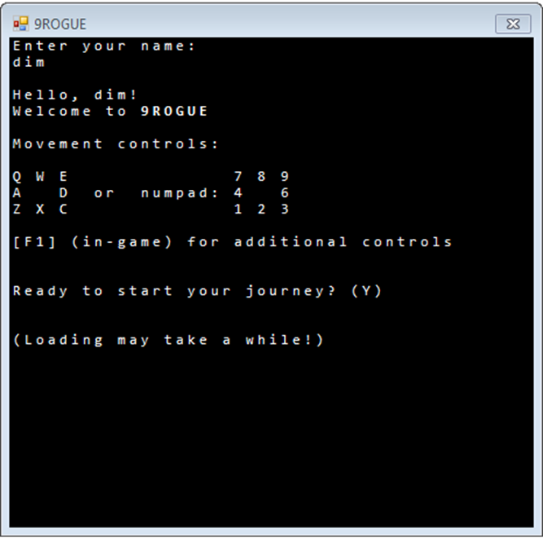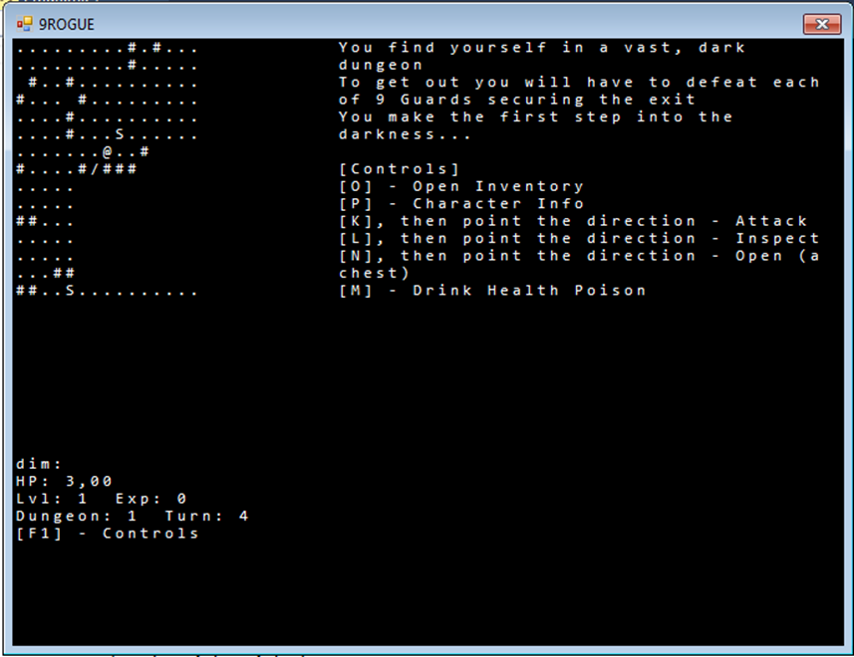

*Player Stats*

*Level*

*In-game Messages*

*Welcome window Game process*