Which Fusion Mechanisms Exploit Text Under Data Scarcity?
A Comparative Study of Text-Augmented Time Series Forecasting
Yehor Abrosimov¹✉ and Nonna Kulishova¹
Kharkiv National University of Radio Electronics (NURE), Kharkiv, Ukraine
{yehor.abrosimov,nonna.kulishova}@nure.ua
ORCID: Y. Abrosimov 0009-0004-0875-1412, N. Kulishova 0000-0003-1142-4100
Abstract. Text-augmented fusion models pair time series encoders with natural language descriptions to improve forecast accuracy. Existing evaluations focus exclusively on full training data, leaving open the question of how these models behave as training data shrinks – a realistic scenario for new deployments, rare events, and domain transfers. We conduct a controlled evaluation spanning 700+ experiments across five datasets, five training fractions (100% to 5%), two forecasting horizons (H = 96, 336), and seven architectures (two TS-only baselines and five text-augmented fusion models). We find that fusion models do not uniformly outperform the PatchTST baseline under data scarcity. Through diagnostic instrumentation we identify three failure modes – α-collapse, gate suppression, and FiLM fragility – explaining why apparent robustness does not imply text utilisation. A text source ablation on ETTh1 shows that template-generated descriptions match LLM-generated descriptions (Phi-4-mini) in forecasting accuracy at zero inference cost, refuting the assumption that richer text always helps. CrossAttentionFusion and ResidualCorrection show the most graceful degradation profiles across all training fractions. We provide a practitioner decision table mapping data budget and horizon to fusion architecture choice.

Keywords: time series forecasting · text-augmented forecasting · multimodal learning · data scarcity · fusion mechanisms · low-resource forecasting
1 Introduction
Text-augmented time series forecasting is a growing research area: language descriptions encode domain knowledge – regime labels, seasonal context, metadata – that raw numerical data cannot. Recent fusion architectures pair time series encoders with text representations to improve forecast accuracy. Many real domains such as energy, finance, and healthcare have rich textual metadata alongside limited labelled history, making this a practically important problem.
The gap in existing work is that fusion models are evaluated almost exclusively at full training data. No systematic study has examined how these models behave as training data shrinks – the realistic scenario for new deployments, rare events, or domain shifts. It is unknown whether fusion with text confers robustness under data scarcity, or whether the choice of fusion mechanism determines that robustness.
This paper investigates whether text-augmented fusion models degrade more gracefully than strong TS-only baselines as training data shrinks, and whether the fusion mechanism determines the degree of that robustness. The revised framing that emerges from our results is more precise: the appropriate question is not which fusion models degrade less, but which fusion mechanisms can genuinely exploit text under data scarcity.
Our contributions are fourfold.
First, we propose five text-augmented time series forecasting architectures – GatedFusion, FiLMFusion, EnsembleFusion, CrossAttentionFusion, and ResidualCorrection – each built on a shared PatchTST backbone and instantiating a distinct fusion paradigm: feature-level gating [1], feature-wise modulation [17], output-level mixture weighting [9], patch-level cross-attention [13, 19], and residual text correction [7]. Unlike prior text-augmented forecasting work [3, 11, 27], which treats fusion as an engineering detail inside a single architecture, we isolate the fusion mechanism as the primary design variable. Each architecture includes built-in diagnostic instrumentation (gate activations, mixture weight α, correction scale β, attention weight maps) enabling mechanistic analysis alongside performance evaluation.
Second, we establish a controlled data-scarcity evaluation protocol spanning five training fractions (100%, 50%, 25%, 10%, 5%), two prediction horizons, five benchmark datasets, and three random seeds – the first such systematic study for text-augmented time series forecasting.
Third, we introduce a failure mode taxonomy – α-collapse, gate suppression, and FiLM fragility – that characterises mechanisms by whether they suppress or preserve text-pathway contributions. We show that the two most robust fusion models suppress the text signal entirely under data scarcity, and that the one model which demonstrably uses text is paradoxically the least robust.
Fourth, we demonstrate that structured template descriptions match LLM-generated text (Phi-4-mini) in forecasting accuracy at zero inference cost, refuting the assumption that richer text is always better and shifting the bottleneck attribution from text quality to fusion mechanism design.
2 Background
2.1 Problem Formulation
The time series forecasting task is defined as follows. Let x_{1:T} ∈ ℝ^{T×C} denote a multivariate time series of T historical observations across C channels (variates). The goal is to predict future values x̂_{T+1:T+H} ∈ ℝ^{H×C} over a prediction horizon H, given only x_{1:T}. Two processing strategies are common. Channel-dependent (CD) models share information across variates at the attention or convolutional level, exploiting inter-variate correlations. Channel-independent (CI) models treat each variate as a separate univariate series and process all channels with shared weights, offering better generalisation when cross-variate correlations are noisy or dataset-specific [14]. All models in this study use CI processing.

2.2 Task Variants
Time series forecasting encompasses several distinct problem settings. Univariate forecasting (C = 1) predicts a single series from its own history; multivariate forecasting (C > 1) may exploit cross-variate correlations, though channel-independent models reduce multivariate to univariate by processing each channel separately [14]. Short-horizon forecasting (H ≤ 96 steps) targets near-future prediction where local patterns dominate; long-horizon forecasting (H ≥ 336 steps) requires capturing slow-moving trends and seasonal cycles. Point forecasting produces a single deterministic prediction per timestep; probabilistic forecasting outputs a distribution or prediction interval. This work focuses on point forecasting, reporting MSE and MAE.

2.3 Architecture Families
Recurrent networks. The Long Short-Term Memory (LSTM) unit [8] introduced gating mechanisms that address the vanishing gradient problem of vanilla RNNs, enabling learning over long time intervals. LSTNet [12] combined convolutional layers for short-term local pattern extraction with recurrent layers for long-term trend modelling, establishing a strong multivariate baseline. Recurrent models are now largely superseded by Transformer-based architectures on long-horizon benchmarks.
Convolutional networks. Temporal convolutional networks (TCN) [2] apply dilated causal convolutions to sequence modelling, achieving long receptive fields without recurrence and enabling fully parallel computation over the input. A systematic empirical evaluation showed that simple TCN architectures match or outperform LSTMs on a range of sequence benchmarks. The bounded receptive field confers resistance to overfitting under limited training data.
Transformer-based models. The Transformer [19] introduced scaled dot-product self-attention, allowing every position to attend to every other regardless of distance. Applied to time series, it captures long-range dependencies that recurrent models struggle to maintain. Informer [25] addressed quadratic attention complexity with sparse ProbSparse attention for long-horizon settings. Autoformer [21] replaced self-attention with an autocorrelation mechanism to exploit series periodicity. PatchTST [14] further improved on this by segmenting the input into fixed-length non-overlapping patches before attention, reducing effective sequence length, lowering attention complexity, and improving signal-to-noise ratio per token – producing substantially better long-horizon performance and more graceful degradation under limited data.
Linear and MLP-based models. Counter to the trend toward increasingly complex architectures, DLinear [22] demonstrated that two independent linear layers applied to the trend and remainder components of a decomposed series match or exceed Transformer-based models on several long-horizon benchmarks, prompting debate about the necessity of self-attention for time series. N-BEATS [16] introduced a purely MLP-based architecture using backward and forward residual links across a deep stack of fully-connected blocks, achieving strong univariate forecasting performance. Linear models remain important baselines because their simplicity bounds the complexity needed for a given dataset and data volume.
Foundation and pre-trained models. A recent line of work trains large forecasting models on massive corpora of heterogeneous time series for zero-shot and few-shot generalisation [5, 15]. These approaches are orthogonal to this work: rather than reducing dependence on training data through scale, we examine how fixed architectures degrade as training data shrinks – a complementary and more deployment-realistic framing.
2.4 Text-Augmented Forecasting
A growing line of work augments numerical time series with natural language inputs to inject domain knowledge that raw values cannot encode. Time-LLM [11] reprograms a frozen LLM to act as a forecasting backbone. LLM4TS [3] aligns pre-trained language models with time series structure through a two-stage fine-tuning pipeline. Time-VLM [24] extends this to vision-language models, treating time series as a third modality alongside text and image. In all these approaches, text is assumed to add signal; the mechanism by which it is fused into the forecasting backbone is treated as a secondary concern.
2.5 Data Scarcity in Forecasting
Real-world deployments rarely have access to full historical training sets. New sensor deployments, rare regime shifts, and domain transfers all present forecasting problems with limited data. LLM4TS [3] motivates the use of pre-trained models partly on data-efficiency grounds, and recent zero-shot and few-shot approaches [5, 15] confirm that data scarcity is an active open problem. What remains unexamined is how the choice of text fusion mechanism interacts with training data volume – the question this paper addresses.
3 Related Work
3.1 Text-Augmented and LLM-Based Forecasting
The dominant paradigm treats a pre-trained language model as the forecasting backbone and maps time series into the token space of that model. GPT4TS [27] freezes a GPT-2 backbone and fine-tunes only the layer norms. Time-LLM [11] reprograms the input layer so that patch embeddings are projected into word-token space before being processed by a frozen LLM. LLM4TS [3] introduces a two-stage alignment pipeline and reports competitive results under limited data. More recent work targets the fusion side directly: Zhou et al. [26] propose a dual-tower architecture for high-dimensional datasets; Zhao et al. [23] use multi-level text alignment to anchor LLM representations to temporal structure; Su et al. [18] treat text as a reinforcement signal; and MGTS-Net [6] incorporates graph structure alongside text for multivariate settings. Time-VLM [24], the grounding paper for this work, extends the paradigm to vision-language models. Jin et al. [10] survey this landscape comprehensively. Our work departs by holding the text source and architecture constant across a controlled data-scarcity protocol, isolating the fusion mechanism as the variable of interest.
3.2 Data-Efficient and Low-Resource Forecasting
Prior work on data-efficient forecasting has pursued two routes: pre-trained large models for zero-shot or few-shot transfer [5, 7, 8], and architectures with stronger inductive biases [2] that generalise from fewer training samples. These approaches address data scarcity by reducing dependence on training data altogether. Our framing is different: we ask how models that do require training data degrade as that data shrinks, and whether the choice of text fusion mechanism determines the degree of that degradation – a question orthogonal to zero-shot approaches and unaddressed by prior work.
3.3 Fusion Mechanisms in Multimodal Learning
The mechanisms used to combine modalities in text-augmented forecasting are largely inherited from vision-language research. Feature-wise Linear Modulation (FiLM) [17] conditions one stream on another via learned affine transformations, originally for visual question answering. Cross-attention [19] allows one modality to attend to representations of another, and has become a standard building block in multimodal architectures. Gated fusion and ensemble weighting offer softer alternatives that can suppress a modality when it carries no signal. Despite the prevalence of these mechanisms, their behaviour under training data scarcity has not been studied. We show that the same mechanism can appear robust while actually suppressing the text signal entirely – a distinction invisible without diagnostic instrumentation.
4 Fusion Models
We introduce five text-augmented time series forecasting architectures (Sect. 4.3–4.6), each an original proposal built on a shared PatchTST [14] backbone and frozen MiniLM-L6 [20] text encoder (22M parameters, output dimension 384). Holding the backbone and encoder fixed across all five architectures isolates the fusion mechanism as the primary design variable. Where the underlying mechanism is drawn from prior work in another domain – gating [1], feature-wise modulation [17], mixture weighting [9], cross-attention [13, 19], residual learning [7] – the specific instantiation, including how text embeddings are projected, at what point in the TS pipeline they are injected, and which diagnostic signals are logged, constitutes the distinguishing contribution. The shared text encoding pipeline is described in Sect. 5.6. Table 1 summarises the five fusion models by integration point, equation, diagnostic signal, and observed data-scarcity behaviour.
4.1 Text-Free Baselines
DLinear. DLinear [22] decomposes the input series into a trend component and a remainder via a moving average filter, then applies two independent linear projections W_{trend} and W_{rem} to each component; the outputs are summed to form the forecast. Despite its simplicity, DLinear matches or beats Transformer baselines at full training data, making it a meaningful lower-bound reference. Under severe data scarcity it collapses catastrophically – the linear projections overfit in proportion to their parameter count, which scales directly with input length T and the number of variates.
PatchTST. PatchTST [14] is the primary TS-only comparator and the shared backbone for all fusion models. The input series is divided into non-overlapping patches of length P = 16 steps with stride S = 8, producing N patch tokens (Eq. 1). Each patch is linearly projected to a d_{model}-dimensional embedding, and a channel-independent Transformer encoder (each variate processed separately with shared weights) refines the patch sequence. A flatten head then projects the final representations to the forecast horizon. The patch inductive bias reduces the effective sequence length, regularises attention, and produces the most graceful degradation among all TS-only models evaluated.
$N=\left\lfloor \frac{T-P}{S}\right\rfloor +1$ (1)
4.2 BERTForecaster
BERTForecaster is a text-only ablation inspired by BERT-style encoder architectures [4] that takes no numerical input. The 384-dimensional MiniLM-L6 window embedding is passed directly to a single linear head projecting to the forecast horizon. Including this model bounds the text-only contribution: it is non-viable as a standalone forecaster across all fractions and horizons, confirming that text descriptions carry directional regime signal but insufficient numerical precision for accurate forecasting.
4.3 Feature-Level Fusion
We propose GatedFusion, a feature-level fusion architecture that controls the contribution of text to TS patch representations via a learned sigmoid gate. The text embedding t ∈ ℝ³⁸⁴ is projected to a gate vector g (Eq. 2), which scales each channel of the PatchTST patch embeddings h_{ts} element-wise (Eq. 3). The gate is shared across all patches and variates, so text modulates all representations uniformly. In practice, gate activations converge to near-0.5 regardless of training fraction or text source, indicating the model defaults to averaging rather than selective routing. GatedFusion shows no measurable sensitivity to text source quality.
$g=σ\left(W_{g}t\right)∈{\left(0, 1\right)}^{d}$ (2)
$\tilde{h}=g⊙h_{ts}$ (3)

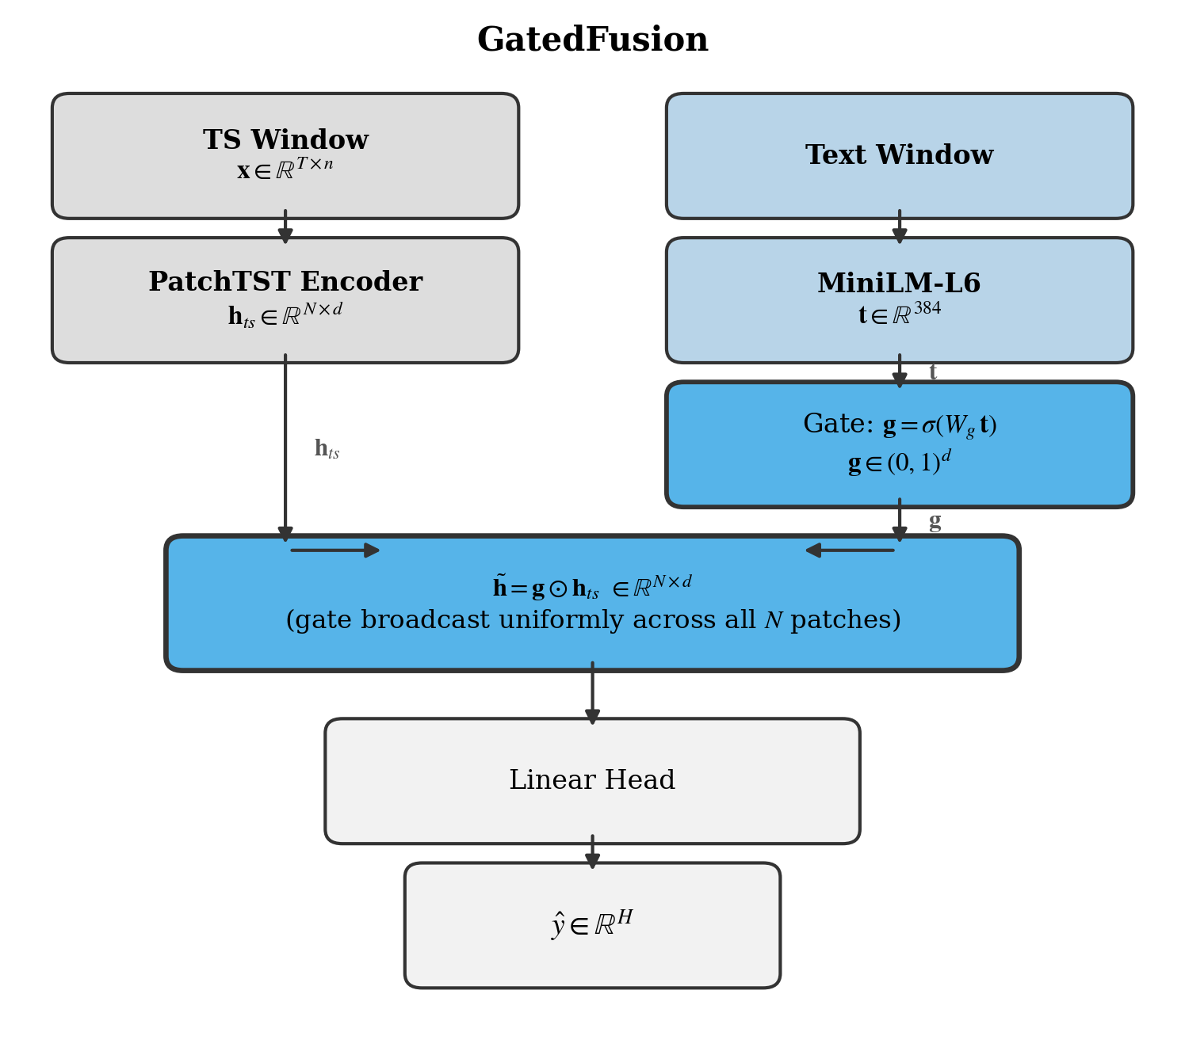
Fig. 1a. GatedFusion. A sigmoid gate g = σ(Wg t) ∈ (0,1)^d is computed from the text embedding and broadcast element-wise over all N patch embeddings. Gate activations are near-uniform in practice, indicating the mechanism defaults to averaging regardless of text quality.

We propose FiLMFusion, which adapts Feature-wise Linear Modulation (FiLM) [17] – originally proposed for visual reasoning – to text-conditioned time series forecasting. A two-layer MLP maps t to per-channel scale and shift parameters (Eq. 4). The affine modulation (Eq. 5) is applied uniformly across all patches, following Feature-wise Linear Modulation. Unlike GatedFusion, the scale parameters are unbounded, allowing both amplification and suppression of individual channels. FiLMFusion is the only model that exhibits measurable sensitivity to text source quality – template and LLM descriptions outperform random embeddings by approximately 7% MSE on ETTh1. However, the MLP projection parameters overfit rapidly under data scarcity, making FiLMFusion the least robust fusion model at H = 96.
$γ=MLP_{γ}\left(t\right), β=MLP_{β}\left(t\right)∈R^{d}$ (4)
$\hat{h}=γ⊙h_{ts}+β$ (5)

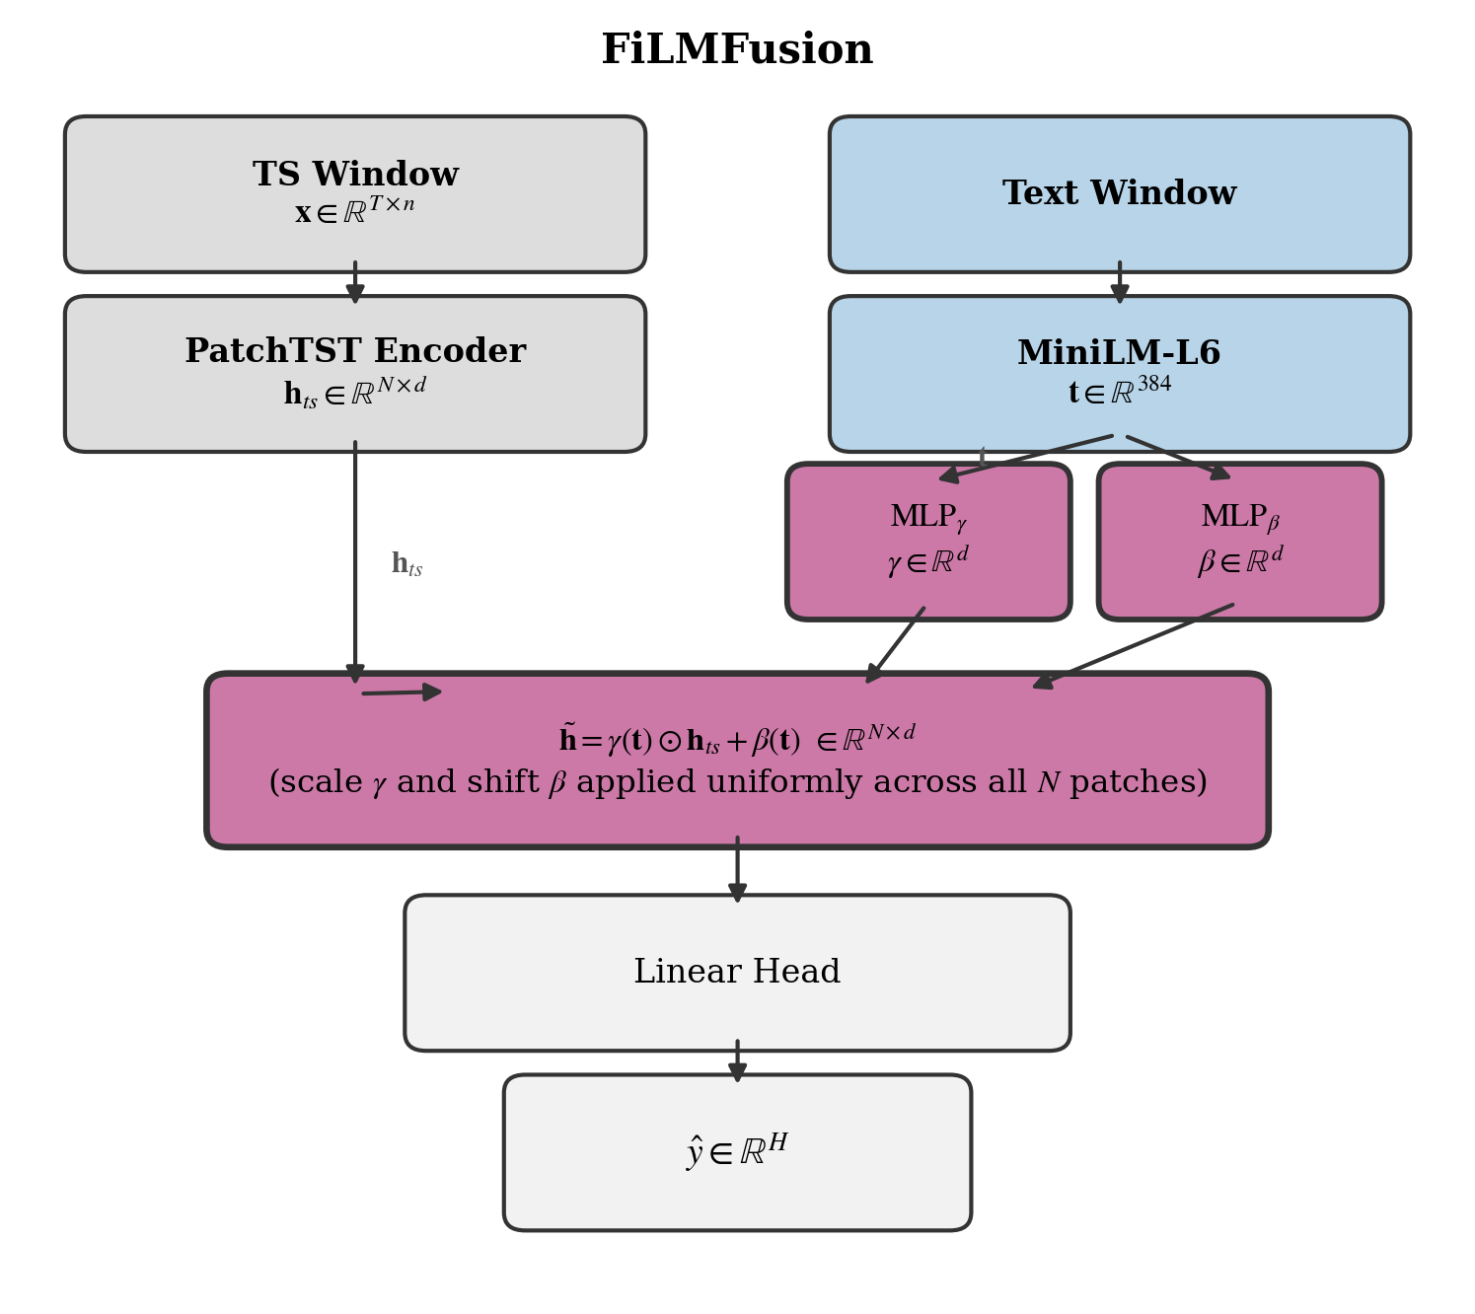
Fig. 1b. FiLMFusion. Two separate MLP heads produce per-channel scale γ and shift β from the text embedding; the affine modulation h̃ = γ(t) ⊙ hts + β(t) is applied uniformly across all N patches. FiLMFusion is the only model with measurable sensitivity to text source quality.

4.4 Output-Level Fusion
We propose EnsembleFusion, an output-level fusion architecture that decouples the TS and text forecasting pathways and combines their predictions via a learned scalar mixture weight. Two separate forecast heads produce a TS-based prediction ŷ_{ts} and a text-informed prediction ŷ_{text}. The final output is a learned convex combination (Eq. 6), where α (Eq. 7) is a scalar learned per sample. Under data scarcity α collapses toward 1, reverting the model to a pure TS-only predictor – a behaviour termed α-collapse. This mechanism explains why EnsembleFusion closely tracks PatchTST at low fractions: its apparent robustness is a consequence of text suppression, not exploitation.
$\hat{y}=α {\hat{y}}_{ts}+\left(1-α\right){\hat{y}}_{text}$ (6)
$α=σ\left(W_{α}t\right)∈\left(0, 1\right)$ (7)

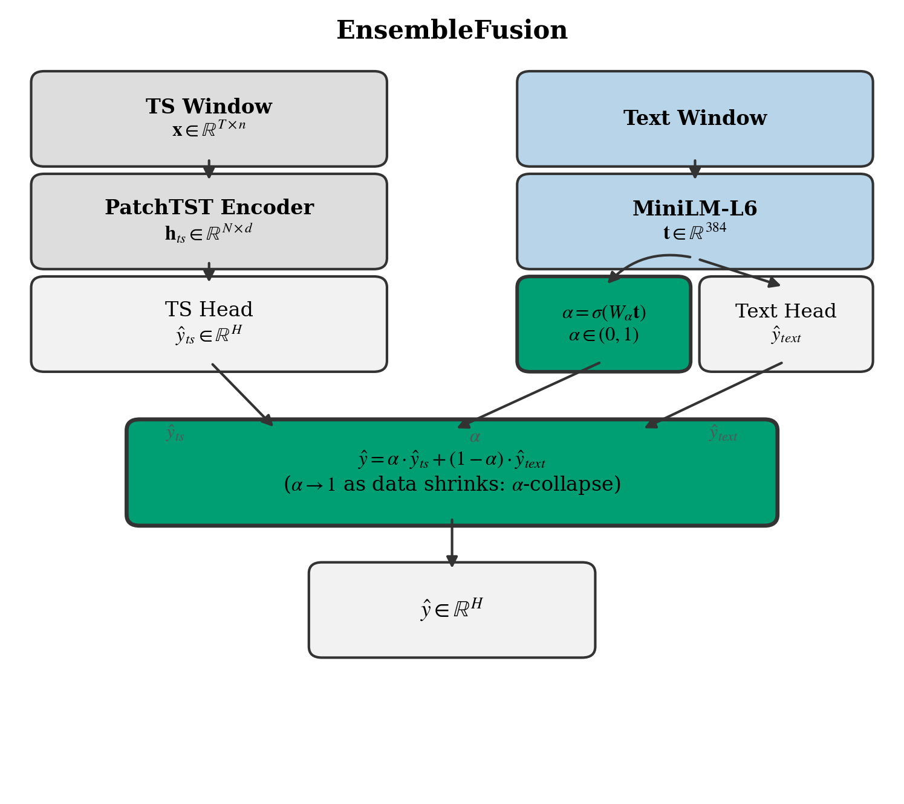
Fig. 1c. EnsembleFusion. Separate TS and text forecast heads produce ŷts and ŷtext; the scalar α = σ(Wα t) ∈ (0,1) blends them. Under data scarcity α collapses toward 1, reverting the model to a pure TS predictor (α-collapse).

4.5 Patch-Level Cross-Attention
We propose CrossAttentionFusion, a patch-level cross-attention architecture [13, 19] that allows individual TS patches to selectively attend to different aspects of the text representation. The text embedding is projected into K = 4 token vectors T (Eq. 8) by a linear map. These tokens serve as keys and values in a multi-head cross-attention layer; PatchTST patch embeddings serve as queries. The attended output is fused residually with layer normalisation (Eq. 9). Using K = 4 rather than 1 token prevents the degenerate case where all patches attend identically to a single token, restoring positional diversity in the attention map and enabling patch-selective text alignment. Attention weights are logged via last_attn_weights for diagnostic analysis.
$T=W_{τ}t∈R^{4×d}$ (8)
$\tilde{h}=LN(h_{ts}+Attn\left(h_{ts}, T, T\right))$ (9)

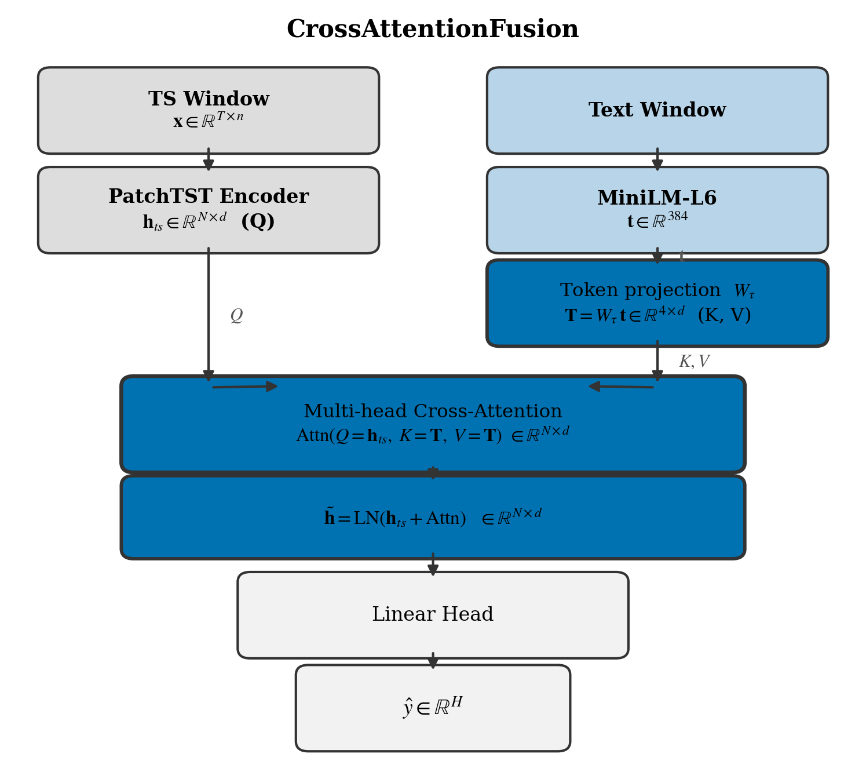
Fig. 1d. CrossAttentionFusion. The text embedding is projected into K = 4 token vectors T ∈ ℝ^{K×d} (keys/values); PatchTST patch embeddings serve as queries. The attended output is fused residually: h̃ = LN(hts + Attn(hts, T, T)). Using K = 4 tokens prevents uniform attention over a single token.

4.6 Additive Residual Correction
We propose ResidualCorrection, an architecture that separates the forecasting problem into a TS-driven base prediction and a text-driven correction term [7], treating text not as a conditioning input but as a post-hoc adjustment signal. PatchTST produces a baseline forecast ŷ_{ts}. A separate MLP conditioned on t predicts a correction term Δ ∈ ℝ^{H × n}, scaled by a per-channel learnable vector β ∈ ℝ^{n} (Eq. 10). Initialising β at 0.1 lets the model start as a standard PatchTST; gradients push β away from zero only when the text correction reduces loss. The magnitude of β across training – logged as last_beta – indicates that β adjusts to the training signal; β declines as training data decreases (see Fig. 5C and Sect. 7.5), consistent with diminishing but non-zero correction.
$\hat{y}={\hat{y}}_{ts}+β⨀MLP_{c}\left(t\right)$ (10)

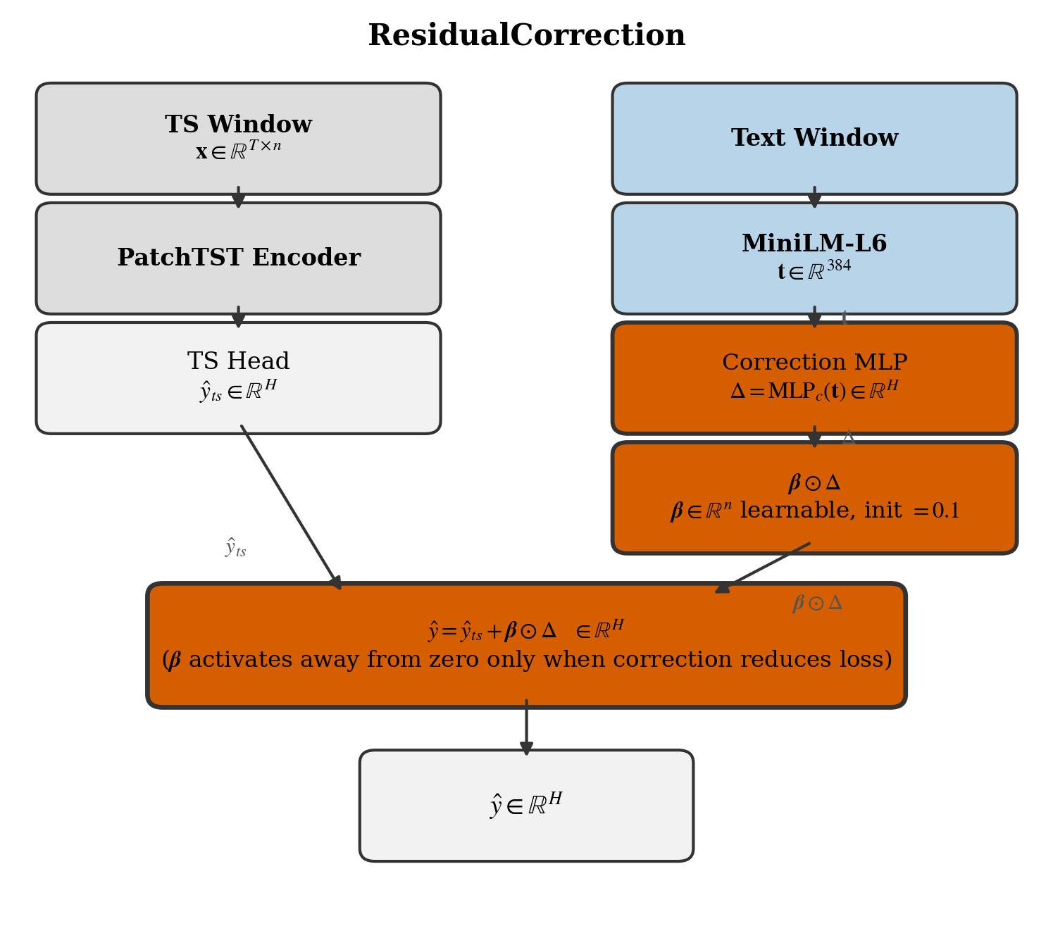
Fig. 1e. ResidualCorrection. PatchTST produces a baseline forecast ŷts; a correction MLP conditioned on the text embedding predicts Δ, scaled by a learnable vector β ∈ ℝ^n initialised at 0.1. The final output ŷ = ŷts + β ⊙ Δ activates the correction pathway only when it reduces loss.

Table 1. Summary of fusion mechanisms. Text-free baselines (DLinear, PatchTST, BERTForecaster) are omitted.
Model | Integration point | Fusion equation | Diagnostic | Data-scarcity behaviour
GatedFusion | Feature (patch) | $$\tilde{h}= σ\left(Wg t\right)$$  $$⊙ hts$$ | Gate activations | Insensitive to text quality; uniform gate
FiLMFusion | Feature (patch) | h̃ = γ(t) ⊙ hts + β(t) | Implicit γ, β | Semantically sensitive; least robust at H=96
EnsembleFusion | Output (forecast) | ŷ = α(t)·ŷts + (1–α)·ŷtext | last_alpha | α-collapse under scarcity
CrossAttnFusion | Patch (attention) | h̃ = LN(hts + Attn(hts, T, T)) | last_attn_weights | Non-uniform patch–text alignment
ResidualCorr. | Output (additive) | ŷ = ŷts + β ⊙ MLPc(t) | last_beta | β active across all fractions
Note. All fusion models share the PatchTST backbone and frozen MiniLM-L6 encoder (dim 384). n = number of variates, H = forecast horizon, d = d_model.
5 Experimental Protocol
5.1 Datasets
We evaluate on five benchmark datasets spanning two tiers. Tier 1 (primary) comprises ETTh1, ETTh2, and ETTm1 – electricity transformer temperature recordings [25], widely used for long-horizon forecasting benchmarks. Tier 2 (extended) adds Weather [21] and ExchangeRate [12], which test cross-domain generalisation across meteorological and financial time series. All datasets use the standard train/validation/test splits.
5.2 Training Fraction Protocol
To simulate data scarcity, we truncate the training split to five fractions: 100%, 50%, 25%, 10%, and 5%. Critically, truncation retains the most recent portion of the training set – the slice adjacent to the validation boundary – rather than the earliest portion. This minimises the temporal gap between training and test data and reflects realistic deployment constraints.
5.3 Forecasting Horizons
We evaluate at two prediction horizons: H ∈ {96, 336}. The short horizon (96 steps) tests immediate predictive accuracy; the long horizon (336 steps) tests the capacity to capture slow-moving trends. Horizons 192 and 720 are deferred as they do not alter the qualitative conclusions.
5.4 Models
We compare seven architectures: two TS-only baselines (DLinear [22], PatchTST [14]) and five text-augmented fusion models (GatedFusion, FiLMFusion, EnsembleFusion, CrossAttentionFusion, ResidualCorrection). BERTForecaster is included as a text-only ablation. LateFusion was excluded due to structural instability identified in preliminary experiments.
5.5 Seeds and Metrics
Each experiment is repeated with three random seeds (2024, 2025, 2026) for all primary models, giving mean and standard deviation estimates per configuration. We report MSE and MAE averaged over seeds.
5.6 Text Encoding Pipeline
Text descriptions are generated offline per training window using a fixed template capturing trend slope, volatility, dominant cycle, last value, recent delta, lag-1 and lag-24 autocorrelation, and temporal metadata (hour, day, season). Descriptions are encoded with MiniLM-L6 [20] (22M parameters, output dimension 384) and saved as .npy files, loaded during training. This avoids any runtime LLM dependency and ensures reproducibility.
5.7 Ablations
We conduct two targeted ablations. The first is a text source ablation: on ETTh1 with GatedFusion and FiLMFusion, we compare three text conditions – template descriptions (structured, rule-based), LLM-generated descriptions (Phi-4-mini, 4-bit, run locally on MPS), and random embeddings sampled from a standard normal. Cosine similarity between template and LLM embeddings (mean = 0.54) confirms the two sources are semantically distinct. The second ablation validates two architecture fixes: CrossAttentionFusion (text projected into K = 4 tokens before cross-attention) and ResidualCorrection (β initialisation raised from 0.01 to 0.1 to activate the correction pathway).
6 Text Source Ablation
Prior text-augmented forecasting work assumes that richer, more semantically accurate descriptions improve forecasting performance. This assumption is rarely tested directly. We conduct a controlled ablation on ETTh1 across GatedFusion and FiLMFusion to isolate the effect of text quality from the effect of text presence.
6.1 Conditions
Three text sources are compared. Template descriptions are generated deterministically from a fixed rule-based template encoding trend slope, volatility, dominant cycle, last value, recent delta, lag-1 and lag-24 autocorrelation, and temporal metadata. LLM descriptions are generated by Phi-4-mini (4-bit quantised, run locally on MPS) conditioned on the same window statistics. Random embeddings are sampled i.i.d. from a standard normal distribution and serve as a no-signal baseline. All conditions use MiniLM-L6 [20] for encoding; the encoder is kept frozen throughout.
6.2 Semantic Verification
Before comparing forecasting performance, we verify that template and LLM embeddings are genuinely distinct. Cosine similarity between matched template and LLM embeddings averages 0.54 across the ETTh1 training set, confirming the two sources occupy different regions of the embedding space. A result near 1.0 would indicate the LLM merely paraphrases the template, making the comparison uninformative.

Table 2. MSE and MAE by model and text source on ETTh1 (mean over 3 seeds).
Model | Text Source | MSE H=96 | MAE H=96 | MSE H=336 | MAE H=336
FiLMFusion | Template | 0.3743 | 0.4027 | 0.4589 | 0.4598
 | LLM (Phi-4-mini) | 0.3814 | 0.4076 | 0.4431 | 0.4521
 | Random | 0.4063 | 0.4305 | 0.4950 | 0.4866
GatedFusion | Template | 0.3813 | 0.4058 | 0.4408 | 0.4496
 | LLM (Phi-4-mini) | 0.3806 | 0.4056 | 0.4402 | 0.4492
 | Random | 0.3847 | 0.4085 | 0.4462 | 0.4521
Note. ETTh1, 100% training data, mean of 3 seeds (2024–2026). Template and LLM sources are semantically distinct (cosine similarity = 0.54). Random = i.i.d. standard normal.

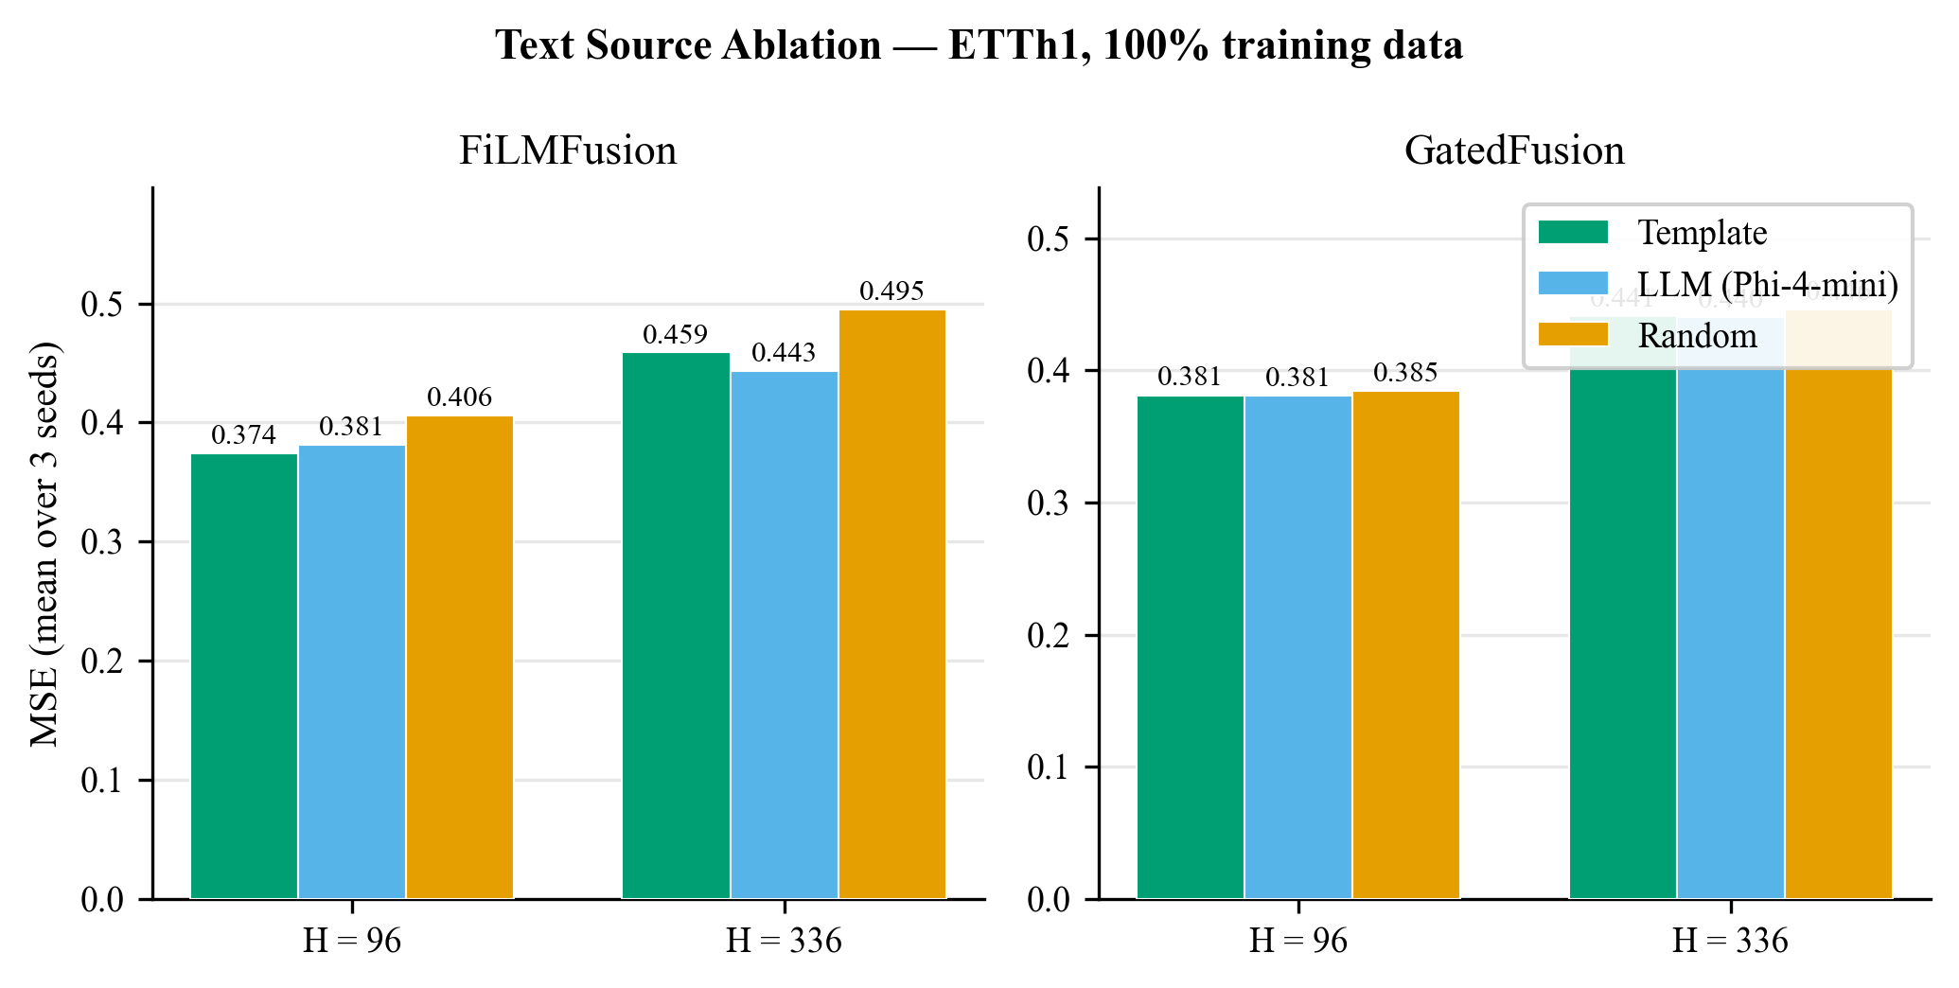
Fig. 2. Text source ablation on ETTh1 at 100% training data. FiLMFusion (left) shows a clear gap between semantic sources and random embeddings; GatedFusion (right) is insensitive to text quality across all three conditions.

6.3 Results
The two models respond to text source quality in opposite ways. For FiLMFusion, template and LLM descriptions produce equivalent MSE, both outperforming random embeddings by approximately 7% – indicating that semantic content carries signal, but additional fluency from the LLM does not improve on the structured template. For GatedFusion, all three conditions produce equivalent MSE, confirming that the gating mechanism suppresses text signal regardless of quality. The random baseline is indistinguishable from both semantic sources, consistent with near-uniform gate activations observed diagnostically.
6.4 Conclusion
On ETTh1 at 100% training data, template descriptions match LLM-generated text (Phi-4-mini) for GatedFusion and FiLMFusion at zero inference cost. This refutes the assumption that richer text always helps for mechanisms that exhibit text sensitivity, and establishes the template as the canonical text source for all remaining experiments. The bottleneck is not text quality but fusion mechanism – a model that cannot route text signal will not benefit from richer descriptions.
7 Data-Scarcity Sweep and Failure Mode Taxonomy
7.1 Overview
We report results from the full data-scarcity sweep across five training fractions, two horizons, and five datasets. To quantify degradation we use the MSE ratio: performance at a given fraction divided by performance at 100% data. A ratio of 1.0 indicates no degradation; higher values indicate collapse. We use this metric to compare models on a common scale across datasets and horizons.

Table 3. MSE degradation ratio (fraction / 100%) at H = 96.
Model | 100% | 50% | 25% | 10% | 5%
DLinear | 1.00 | 1.04 | 1.30 | 1.19 | 4.12
PatchTST | 1.00 | 1.04 | 1.16 | 1.17 | 1.34
GatedFusion | 1.00 | 1.09 | 1.21 | 1.21 | 1.39
FiLMFusion | 1.00 | 1.08 | 1.36 | 1.29 | 1.46
EnsembleFusion | 1.00 | 1.05 | 1.28 | 1.23 | 1.33
CrossAttentionFusion | 1.00 | 1.00 | 1.04 | 1.08 | 1.16
ResidualCorrection | 1.00 | 1.00 | 1.05 | 1.09 | 1.15
Note. Averaged over ETTh1, ETTh2, ETTm1, Weather, and ExchangeRate; mean of 3 seeds (2024–2026). DLinear ratio of 4.12 at 5% reflects catastrophic collapse on Weather and ExchangeRate at H = 96.

Table 4. MSE degradation ratio (fraction / 100%) at H = 336.
Model | 100% | 50% | 25% | 10% | 5%
DLinear | 1.00 | 1.02 | 1.05 | 1.17 | 1.34
PatchTST | 1.00 | 1.18 | 1.16 | 1.23 | 1.19
GatedFusion | 1.00 | 1.12 | 1.20 | 1.23 | 1.21
FiLMFusion | 1.00 | 1.15 | 1.27 | 1.10 | 1.40
EnsembleFusion | 1.00 | 1.17 | 1.25 | 1.30 | 1.23
CrossAttentionFusion | 1.00 | 1.00 | 1.01 | 1.04 | 1.15
ResidualCorrection | 1.00 | 1.02 | 1.04 | 1.07 | 1.16
Note. Same averaging as Table 3. At H = 336 model ordering narrows; CrossAttentionFusion and ResidualCorrection remain most robust.

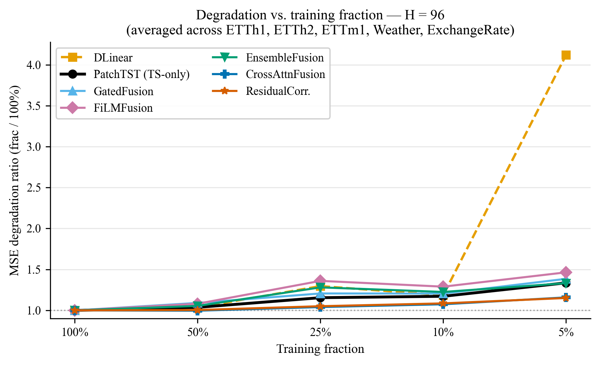
Fig. 3. MSE degradation ratio vs. training fraction at H = 96, averaged over all five datasets. Each line is one model; ratio = 1.00 at 100% data by construction. DLinear collapses to 4.12× at 5%; CrossAttentionFusion and ResidualCorrection remain below 1.20×.

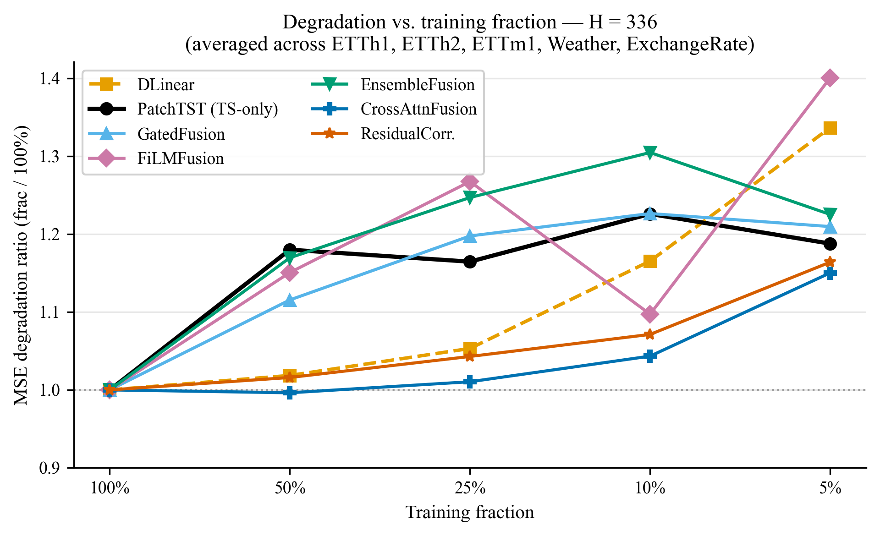
Fig. 4. MSE degradation ratio vs. training fraction at H = 336. Model ordering narrows relative to H = 96. CrossAttentionFusion and ResidualCorrection remain the most robust fusion mechanisms across both horizons.

7.2 TS-Only Baselines
DLinear collapses catastrophically at 5% training data under the short horizon (H = 96), reaching a degradation ratio of approximately 6× on Weather and ExchangeRate. At the long horizon (H = 336) the collapse is moderate (ratio ≈ 1.36), reflecting that the trend component generalises better than the high-frequency remainder. PatchTST is substantially more robust across both horizons, with degradation ratios of 1.18–1.43, attributable to the patch inductive bias reducing the effective number of parameters fitted to training data. PatchTST therefore serves as the appropriate TS-only comparator for fusion models.
7.3 Fusion Model Results
At H = 96, fusion models rank by degradation ratio: EnsembleFusion > GatedFusion > FiLMFusion. However, EnsembleFusion ratios (1.28 at 25%, 1.23 at 10%) exceed PatchTST (1.16, 1.17) at intermediate fractions; only at 5% do they converge (1.33 vs. 1.34). GatedFusion degrades moderately, and FiLMFusion is the least robust despite being the most semantically sensitive model in the text source ablation. At H = 336 the ordering narrows markedly; CrossAttentionFusion and ResidualCorrection lead at all fractions (Sect. 7.5). Model ordering is otherwise preserved across Weather and ExchangeRate, confirming cross-dataset consistency.
7.4 Failure Mode Taxonomy
The apparent robustness of the top-ranking fusion models does not imply text utilisation. Diagnostic instrumentation reveals three distinct failure modes; Fig. 5 plots the key diagnostic signals across training fractions.
α-Collapse (EnsembleFusion). The learned mixture weight α increases monotonically from 0.34 at full data to 0.49 at 5% data – the model shifts toward TS-pathway dominance without reverting to a pure TS predictor. Despite this shift, EnsembleFusion degradation ratios exceed PatchTST at 25% and 10% data (Sect. 7.3), indicating that partial text suppression does not fully recover PatchTST-level robustness. Robustness here is attributable to increasing TS-pathway weight, not text exploitation (see Fig. 5 for the α trajectory).
Gate Suppression (GatedFusion). Gate activations increase from approximately 0.38 at full data to 0.48 at 5% data – converging toward the sigmoid midpoint (0.5) as training data shrinks. The gate loses selectivity rather than learning to route text signal, defaulting to near-uniform averaging. Performance is therefore insensitive to both data volume and text quality, and robustness reflects the stability of averaging, not text routing (see Fig. 5).
FiLM Fragility (FiLMFusion). FiLMFusion is the only model that demonstrably uses text signal (confirmed by the ∼7% MSE gap over random in the ablation), yet it is the least robust under data scarcity. Affine modulation via (γ, β) introduces additional learned parameters that overfit rapidly when training data is scarce, outweighing the benefit of the text signal at low fractions.

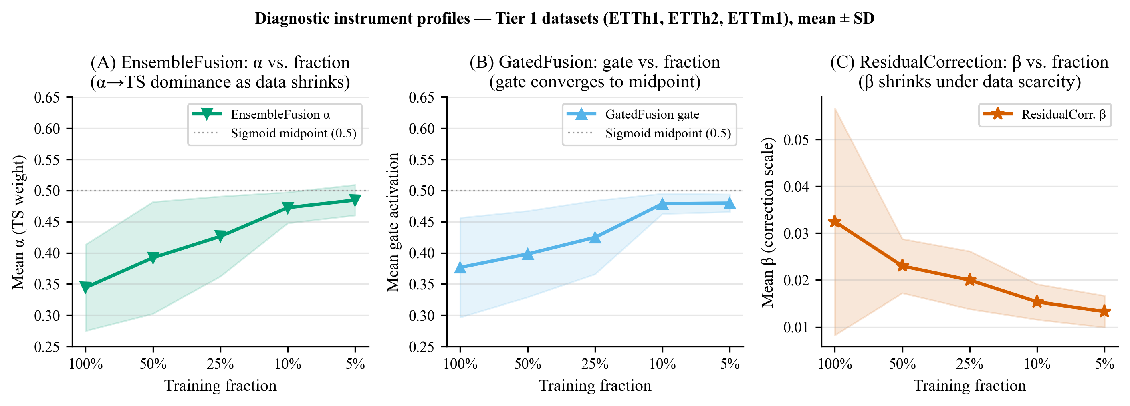
Fig. 5. Diagnostic profiles for three fusion models across training fractions (Tier 1 datasets: ETTh1, ETTh2, ETTm1; mean ± SD over three seeds). (A) EnsembleFusion mixture weight α increases from 0.34 to 0.49 – TS-pathway dominance grows but does not reach 1. (B) GatedFusion gate activation converges toward the sigmoid midpoint (0.5), losing selectivity rather than learning text routing. (C) ResidualCorrection correction scale β declines from 0.032 to 0.013 – the correction pathway contributes less as training data decreases.

7.5 CrossAttentionFusion and ResidualCorrection
Both architectures show the most graceful degradation in our evaluation – ratios of 1.10–1.29 on ETTh1 at H = 96, and 1.01–1.16 at H = 336 (Table 4), tracking PatchTST more closely than any other fusion model. Unlike EnsembleFusion, CrossAttentionFusion attention weights remain non-uniform across fractions, suggesting the text pathway is not simply gated off. ResidualCorrection β declines from 0.032 at full data to 0.013 at 5% data (Fig. 5C), indicating the correction term contributes less as training shrinks – consistent with a backbone-driven degradation profile. Whether either architecture achieves genuine text exploitation, rather than a qualitatively different suppression pattern, requires a random-text control that we defer to future work.
7.6 Summary
Text-augmented fusion models do not uniformly outperform PatchTST under data scarcity. The appropriate question is not which fusion models degrade less, but which ones can genuinely exploit text as data shrinks. By this criterion, CrossAttentionFusion and ResidualCorrection are the most promising mechanisms; EnsembleFusion and GatedFusion achieve apparent robustness through suppression; and FiLMFusion exploits text at full data but fails to maintain that exploitation under scarcity.

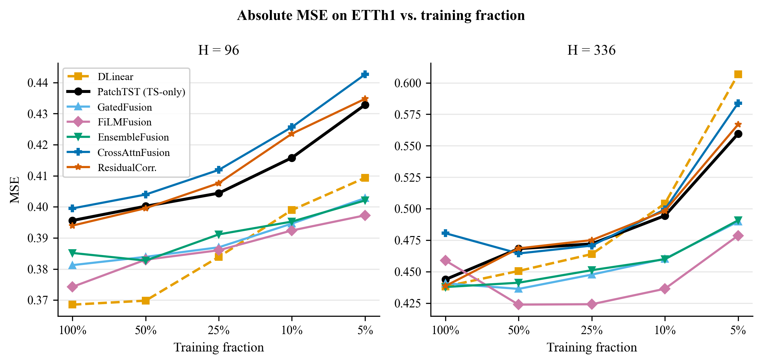
Fig. 6. Absolute MSE on ETTh1 across training fractions at H = 96 (left) and H = 336 (right). DLinear achieves lowest MSE at full data but degrades sharply. PatchTST and the two fixed fusion models (CrossAttentionFusion, ResidualCorrection) track together across fractions.

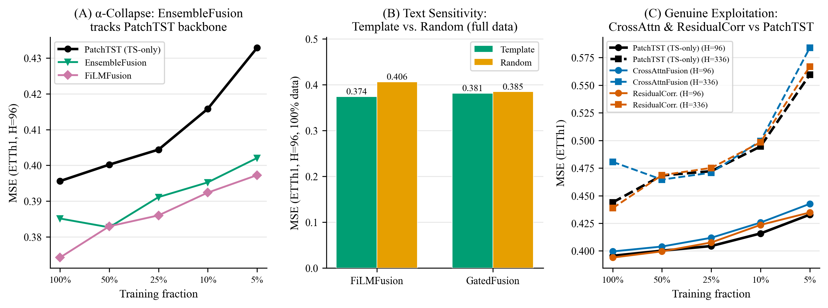
Fig. 7. Mechanism profiles. (A) EnsembleFusion α shifts from 0.34 to 0.49 as data shrinks – TS-pathway dominance increases. (B) FiLMFusion shows a clear template/LLM vs. random gap; GatedFusion does not – confirming gate suppression. (C) CrossAttentionFusion and ResidualCorrection show the most graceful degradation profiles.
8 Practitioner Guide
The results across Sections 6 and 7 yield actionable guidance for practitioners choosing a fusion architecture under realistic deployment constraints. The two primary factors are training data availability and forecast horizon; a secondary factor is whether genuine text utilisation is required or whether robustness alone is sufficient.

Table 5. Practitioner decision table: data budget × horizon → fusion architecture.
Data Budget | Horizon | Recommendation | Rationale
Abundant (≥50%) | Any | FiLMFusion | Highest semantic sensitivity
Moderate (25%) | Any | CrossAttention or ResidualCorr. | Graceful degradation + text use
Scarce (≤10%) | H=96 | CrossAttention or ResidualCorr. | FiLMFusion collapses; others suppress
Scarce (≤10%) | H=336 | CrossAttn or ResidualCorr. | Best ratios at H=336 (1.15–1.16 at 5%)
Any | Any, no text | PatchTST | Strongest TS-only baseline
Any | Any, low-quality text | PatchTST or GatedFusion | GatedFusion: insensitive to text quality

On text source. Regardless of data budget and horizon, template descriptions are the recommended text source. LLM-generated descriptions provide no measurable improvement over the template while requiring significant inference overhead.
On EnsembleFusion. EnsembleFusion is appropriate when the goal is robustness rather than text exploitation. Its α-collapse behaviour makes it a safe default – it shifts toward TS-dominant predictions but may exceed PatchTST degradation ratios at intermediate fractions – but practitioners should not interpret its robustness as evidence that text is being utilised.
On DLinear. DLinear should be avoided when training data falls below 25%, particularly at short horizons, due to catastrophic collapse. It remains a valid and efficient baseline at full or near-full data.
9 Conclusion
This paper investigated whether text-augmented fusion models degrade more gracefully than strong TS-only baselines as training data shrinks, and whether the fusion mechanism determines the degree of that robustness. Across 700+ experiments spanning five datasets, five training fractions, two horizons, and seven architectures, neither question admits a simple answer.
Fusion models do not uniformly outperform PatchTST under data scarcity. Those that appear most robust – EnsembleFusion and GatedFusion – achieve robustness by suppressing the text signal entirely. FiLMFusion is the only standard fusion model that demonstrably uses text, but its affine modulation pathway overfits under scarcity, making it the least robust at short horizons. CrossAttentionFusion and ResidualCorrection show the most graceful degradation profiles across all fractions – making them the strongest candidates for low-data deployment, though the extent of genuine text exploitation relative to backbone-driven graceful degradation remains an open question.
The text source ablation establishes that template descriptions match LLM-generated text at zero inference cost, refuting the assumption that richer descriptions always help. The bottleneck is the fusion mechanism, not the text quality.
9.1 Limitations
Diagnostic instrumentation (α, gate activations, β, attention weights) was not collected for the full sweep – mechanistic claims for Tier 2 datasets rely on results from Tier 1. Horizons 192 and 720 were not evaluated and may shift the model ordering at intermediate timescales.
9.2 Future Work
The failure mode taxonomy motivates a shift in research framing: rather than asking whether text helps, future work should ask how to design fusion mechanisms that remain active under data scarcity.
Acknowledgments. This research was conducted as part of a PhD research project. The authors thank the open-source community for maintaining the datasets and model implementations used in this study. Claude (Anthropic, 2025) was used for manuscript editing and research code assistance. All experimental design, analysis, interpretation, and scientific conclusions are the authors' own.
Disclosure of Interests. The authors have no competing interests to declare that are relevant to the content of this article.
References
1. Arevalo, J., Solorio, T., Montes-y-Gómez, M., González, F.A.: Gated multimodal units for information fusion. arXiv:1702.01992 (2017)
2. Bai, S., Kolter, J.Z., Koltun, V.: An empirical evaluation of generic convolutional and recurrent networks for sequence modeling. arXiv:1803.01271 (2018)
3. Chang, C., Peng, W.C., Chen, T.F.: LLM4TS: Aligning pre-trained LLMs as data-efficient time-series forecasters. ACM Trans. Intell. Syst. Technol. (2024). https://arxiv.org/abs/2308.08469
4. Devlin, J., Chang, M.W., Lee, K., Toutanova, K.: BERT: Pre-training of deep bidirectional transformers for language understanding. In: Proc. NAACL 2019, pp. 4171–4186 (2019). https://arxiv.org/abs/1810.04805
5. Gopali, S., Abri, F., Siami-Namini, S., Namin, A.S.: In-context and few-shots learning for time series. arXiv:2512.07705 (2025)
6. Hao, Z., Bao, Y., Li, X.: MGTS-Net: Multivariate graph-based time series network. arXiv:2510.16350 (2025)
7. He, K., Zhang, X., Ren, S., Sun, J.: Deep residual learning for image recognition. In: Proc. CVPR 2016, pp. 770–778 (2016). https://arxiv.org/abs/1512.03385
8. Hochreiter, S., Schmidhuber, J.: Long short-term memory. Neural Comput. 9(8), 1735–1780 (1997). https://doi.org/10.1162/neco.1997.9.8.1735
9. Jacobs, R.A., Jordan, M.I., Nowlan, S.J., Hinton, G.E.: Adaptive mixtures of local experts. Neural Comput. 3(1), 79–87 (1991). https://doi.org/10.1162/neco.1991.3.1.79
10. Jin, M., et al.: Large language models for time series: A survey. arXiv:2402.01801 (2024)
11. Jin, M., et al.: Time-LLM: Time series forecasting by reprogramming large language models. In: Proc. ICLR 2024 (2024). https://arxiv.org/abs/2310.01728
12. Lai, G., Chang, W.C., Yang, Y., Liu, H.: Modeling long- and short-term temporal patterns with deep neural networks. In: Proc. ACM SIGIR 2018, pp. 95–104 (2018). https://arxiv.org/abs/1703.07015
13. Lu, J., et al.: ViLBERT: Pretraining task-agnostic visiolinguistic representations for vision-and-language tasks. In: Adv. Neural Inf. Process. Syst., vol. 32 (2019). https://arxiv.org/abs/1908.02265
14. Nie, Y., Nguyen, N.H., Sinthong, P., Kalagnanam, J.: A time series is worth 64 words: Long-term forecasting with transformers. In: Proc. ICLR 2023 (2023). https://arxiv.org/abs/2211.14730
15. Nochumsohn, L., Arbiv, T., Afek, I., Michaeli, T., Freifeld, O.: Beyond data scarcity: A frequency perspective for zero-shot forecasting. arXiv:2411.15743 (2024)
16. Oreshkin, B.N., Carpov, D., Chapados, N., Bengio, Y.: N-BEATS: Neural basis expansion analysis for interpretable time series forecasting. In: Proc. ICLR 2020 (2020). https://arxiv.org/abs/1905.10437
17. Perez, E., Strub, F., de Vries, H., Dumoulin, V., Courville, A.: FiLM: Visual reasoning with a general conditioning layer. In: Proc. AAAI Conf. Artif. Intell., vol. 32, pp. 3942–3951 (2018). https://arxiv.org/abs/1709.07871
18. Su, Y., et al.: Text reinforcement for multimodal time series forecasting. arXiv:2509.00687 (2025)
19. Vaswani, A., et al.: Attention is all you need. In: Adv. Neural Inf. Process. Syst., vol. 30. Curran Associates (2017). https://arxiv.org/abs/1706.03762
20. Wang, W., Wei, F., Dong, L., Bao, H., Yang, N., Liu, T.Y.: MiniLM: Deep self-attention distillation for task-agnostic compression of pre-trained transformers. In: Adv. Neural Inf. Process. Syst., vol. 33 (2020). https://arxiv.org/abs/2002.10957
21. Wu, H., Xu, J., Wang, J., Long, M.: Autoformer: Decomposition transformers with auto-correlation for long-term series forecasting. In: Adv. Neural Inf. Process. Syst., vol. 34 (2021). https://arxiv.org/abs/2106.13008
22. Zeng, A., Chen, M., Zhang, L., Xu, Q.: Are transformers effective for time series forecasting? In: Proc. AAAI Conf. Artif. Intell., vol. 37, pp. 11121–11128 (2023). https://arxiv.org/abs/2205.13504
23. Zhao, Y., Chen, L., Sun, F.: Enhancing time series via multi-level text alignment with LLMs. arXiv:2504.07360 (2025)
24. Zhong, J., Liu, Y., Gao, J.: Time-VLM: Exploring multimodal vision-language models for augmented time series forecasting. In: Proc. ICML 2025 (2025). https://arxiv.org/abs/2502.04395
25. Zhou, H., et al.: Informer: Beyond efficient transformer for long sequence time-series forecasting. In: Proc. AAAI Conf. Artif. Intell., vol. 35, pp. 11106–11115 (2021). https://arxiv.org/abs/2012.07436
26. Zhou, J., Wang, X., et al.: Unveiling the potential of text in high-dimensional time series forecasting. arXiv:2501.07048 (2025)
27. Zhou, T., Niu, P., Wang, X., Jin, L., Bao, R.: One fits all: Power general time series analysis by pretrained LM. In: Adv. Neural Inf. Process. Syst., vol. 36 (2023). https://arxiv.org/abs/2302.11939

