UI / Widget Issues and Questions

Calendar Widget
1. Designer properties only work in Full Calendar mode. Compact Calendar mode seems to ignore these settings.
2. It is unclear how to enable the heatmap feature.
3. It is not clear how to pass an array of dates using a single variable. Currently only start and end dates can be passed.
Screenshots:
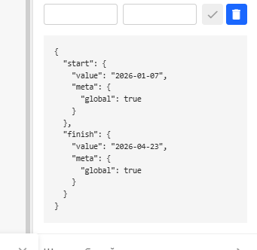
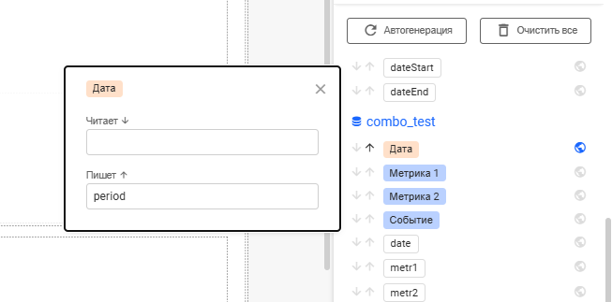
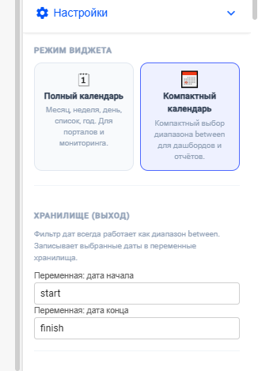

Dynamic Container Widget
1. When Stack mode is selected and a Container widget is added to slot 'test1', the widget is added to the default slot instead of the selected slot.
2. When CSS styles are applied to slots, the property appears in the editor under the Slots group but is not applied in the actual widget.
3. The expected behavior of slot styling and configuration is unclear.
Screenshots:
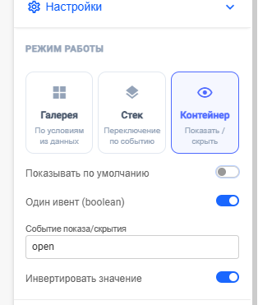
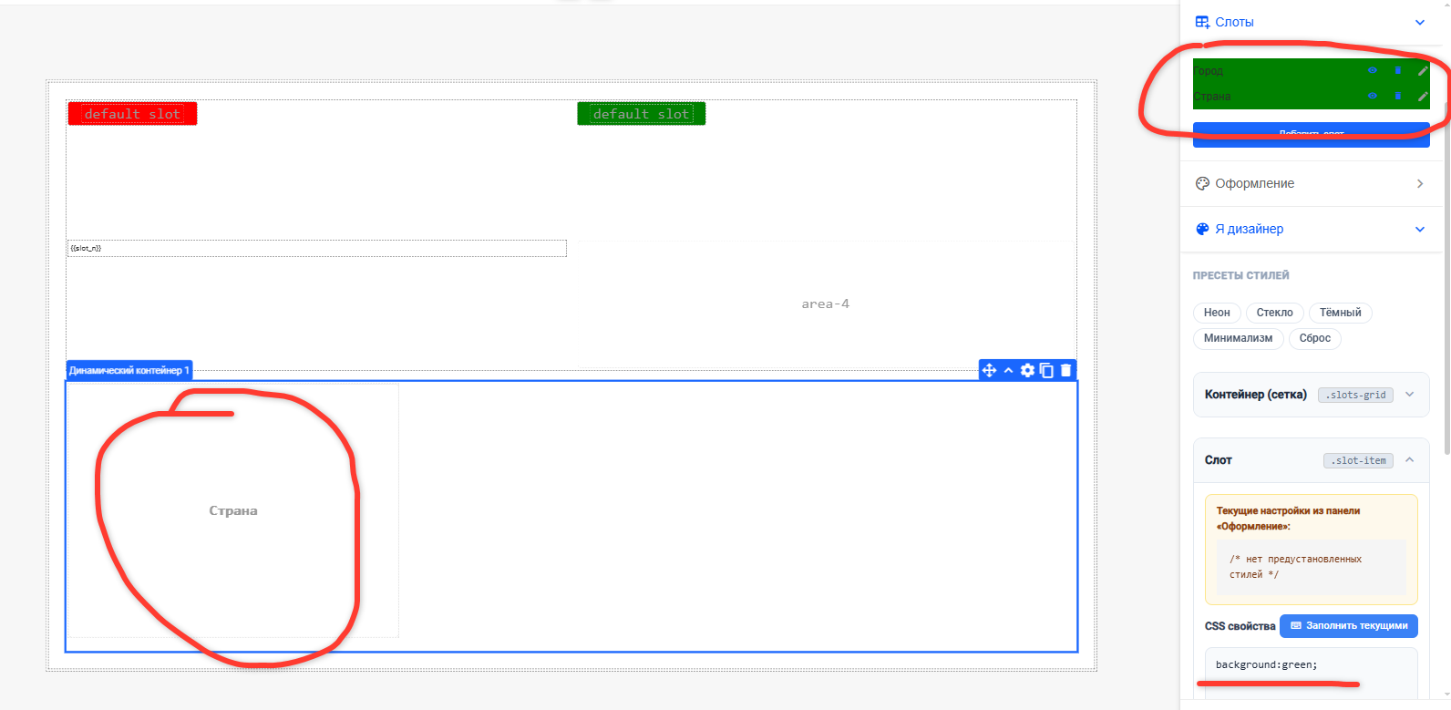
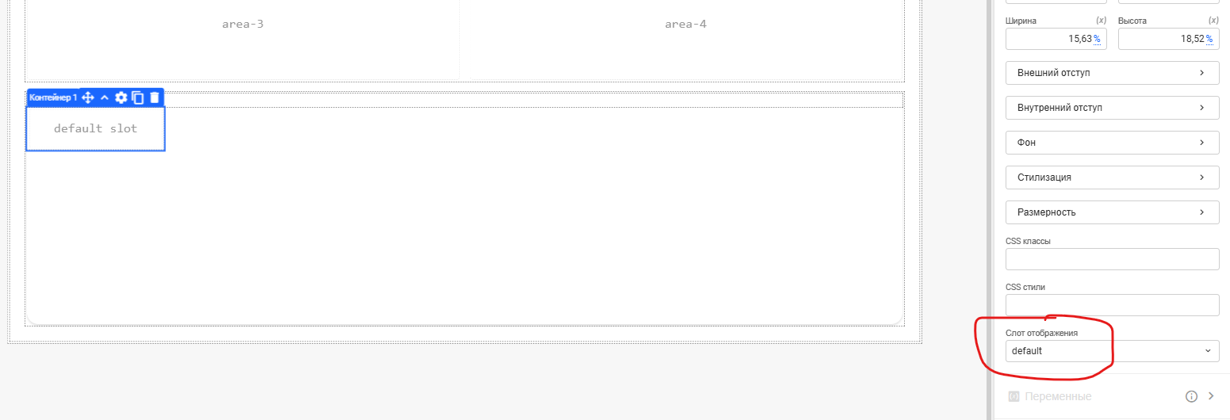
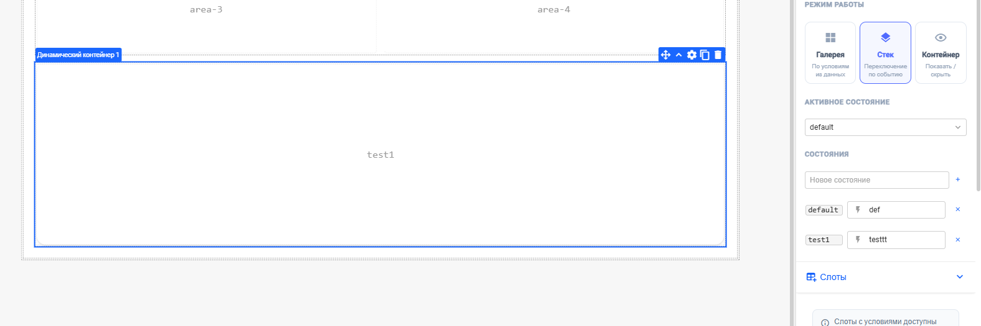

Button Widget
1. In 'I am a designer' mode there are some confusing behaviors. When selecting the 'Underline' style preset, the selected option is not visually highlighted.
2. After selecting the preset, the CSS property opacity:0.75 appears, which does not correspond to an underline style.
3. If custom CSS values are added manually, it is unclear how to apply them. An 'Apply' button may be needed.
4. The widget contains built‑in properties that are not clearly visible, which may make it harder for new users to understand.
5. The 'Snapshot' button name may be confusing and could be renamed to 'Share'.
6. It is unclear how some controls in the interface are supposed to work.
7. In most places text wrapping exists, but in the 'Button Style' block wrapping is missing, which causes horizontal scrolling.
Screenshots:
