Инструкция

1. Создать БД PostgreSQL с именем "library" (настройки оставить по умолчанию)

2. Запустить приложение "LibraryTest.jar

3. Postman запросы:

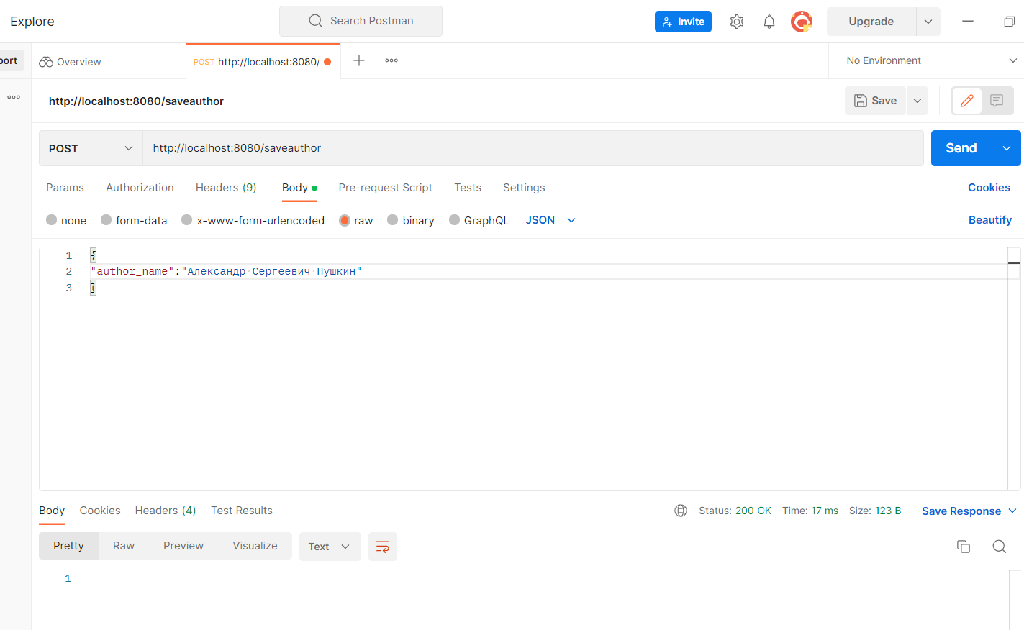

*Настройки postman (ПРИМЕР)*

SELECT

GET <http://localhost:8080/selauthor>

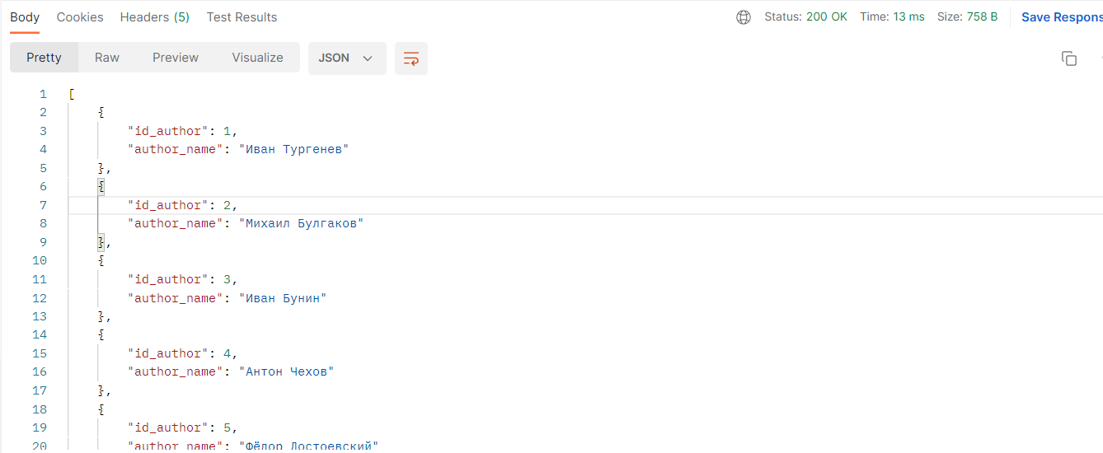

GET <http://localhost:8080/selauthorbooks>

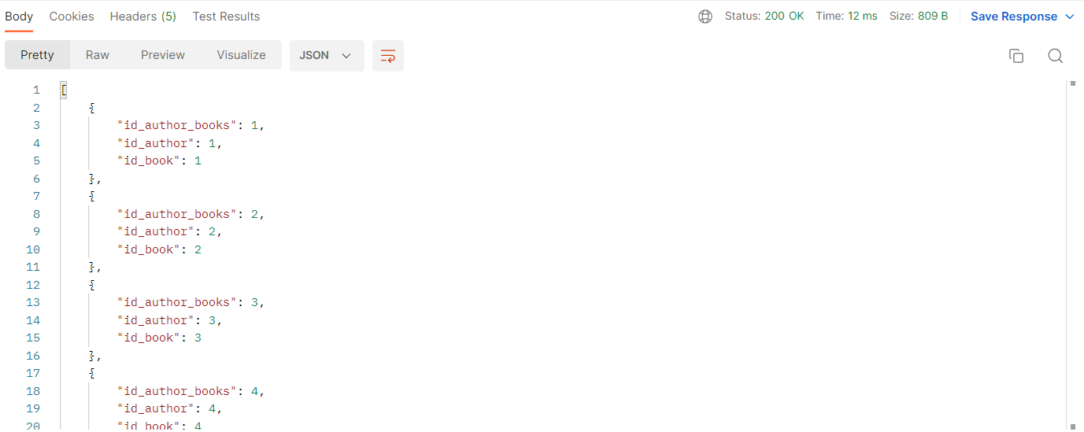

GET <http://localhost:8080/selbook>

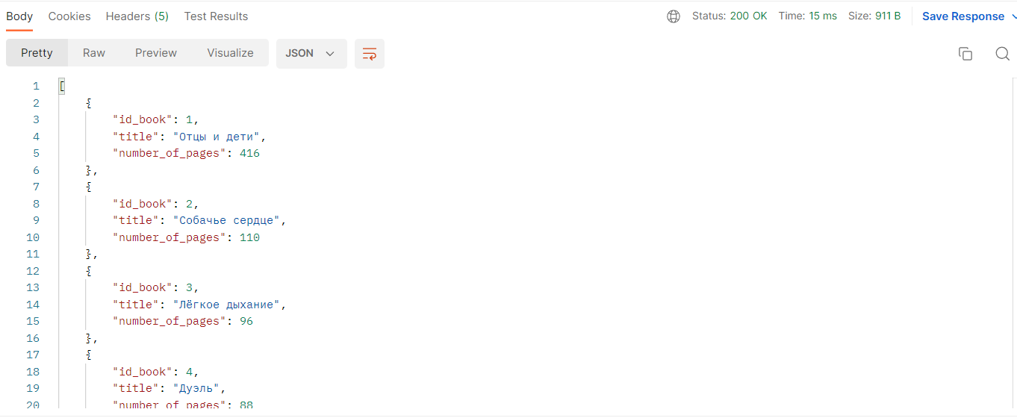

GET <http://localhost:8080/sellibrarycard>

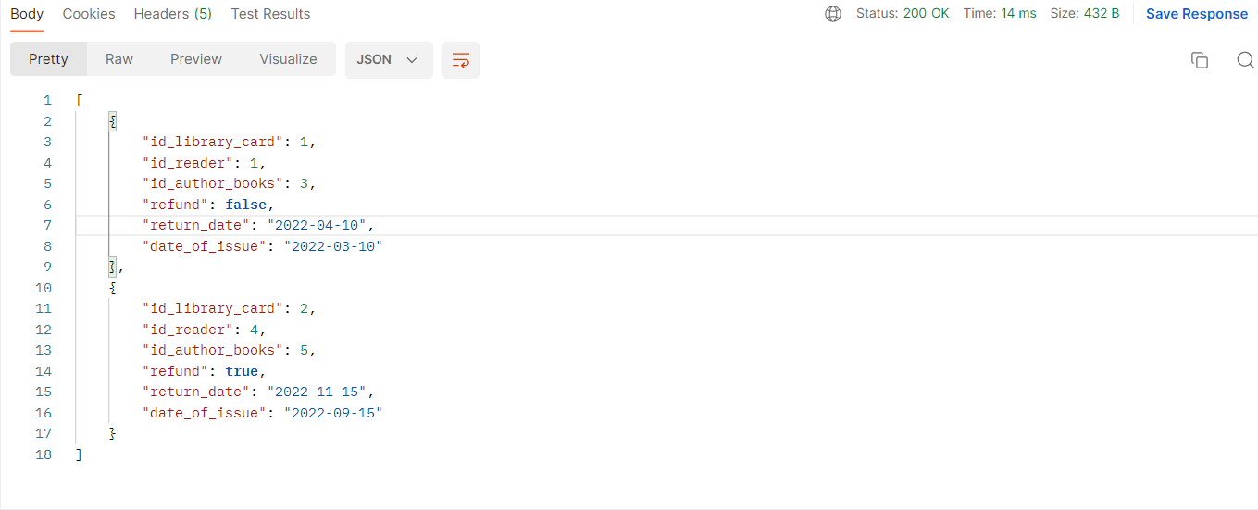

GET <http://localhost:8080/selreader>

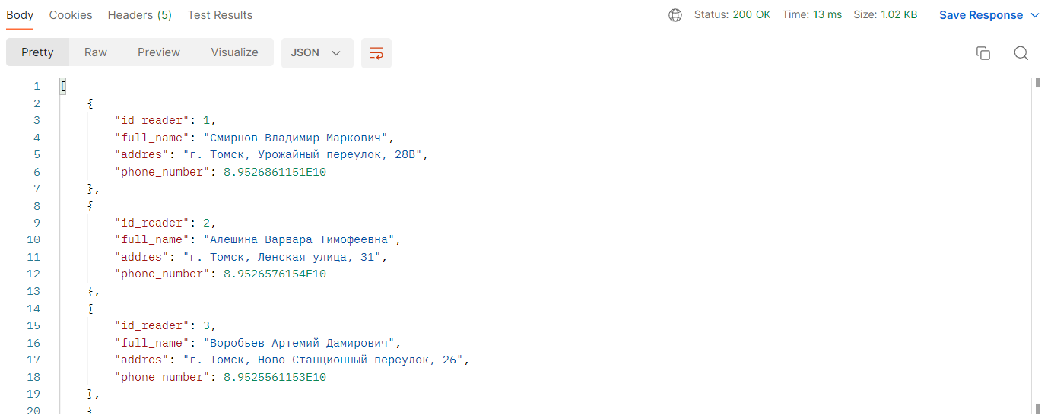

INSERT

POST <http://localhost:8080/saveauthor>

{

"author_name":"Имя Автора"

}

POST <http://localhost:8080/savebook>

{

"title":"Название книги",

"number_of_pages":666

}

POST <http://localhost:8080/saveauthorbooks>

{

"id_author": 1,

"id_book": 1

}

POST <http://localhost:8080/savereader>

{

"full_name": "Имя читателя",

"addres": "Адрес",

"phone_number": 89526865711

}

POST <http://localhost:8080/savelibrarycard>

{

"id_reader": 4,

"id_author_books": 5,

"refund": **true**,

"return_date": "2022-11-15",

"date_of_issue": "2022-11-15"

}

UPDATE

POST <http://localhost:8080/updateauthor>

{

"id_author": 15,

"author_name": "Новое имя автора"

}

POST <http://localhost:8080/updateauthorbooks>

{

"id_author_books": 12,

"id_author": 15,

"id_book": 8

}

POST <http://localhost:8080/updatebook>

{

"id_book": 14,

"title": "Новое название книги",

"number_of_pages": 777

}

POST <http://localhost:8080/updatereader>

{

"id_reader": 7,

"full_name": "Новое имя читателя",

"addres": "Новый адрес",

"phone_number": 89526865711

}

POST <http://localhost:8080/updatelibrarycard>

{

"id_library_card": 8,

"id_reader": 1,

"id_author_books": 1,

"refund": **false**,

"return_date": "2022-11-15",

"date_of_issue": "2022-11-12"

}

POST <http://localhost:8080/delauthor>

{

"id_author": 15

}

POST <http://localhost:8080/delauthorbooks>

{

"id_author_books": 12

}

POST <http://localhost:8080/dellibrarycard>

{

"id_library_card": 8

}

POST <http://localhost:8080/delreader>

{

"id_reader": 7

}