**Схема установки**

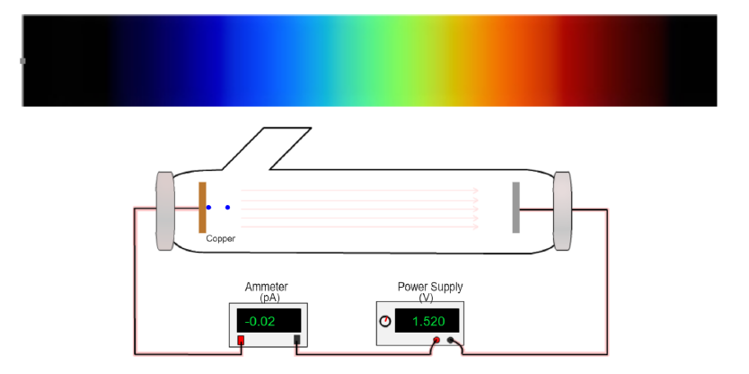

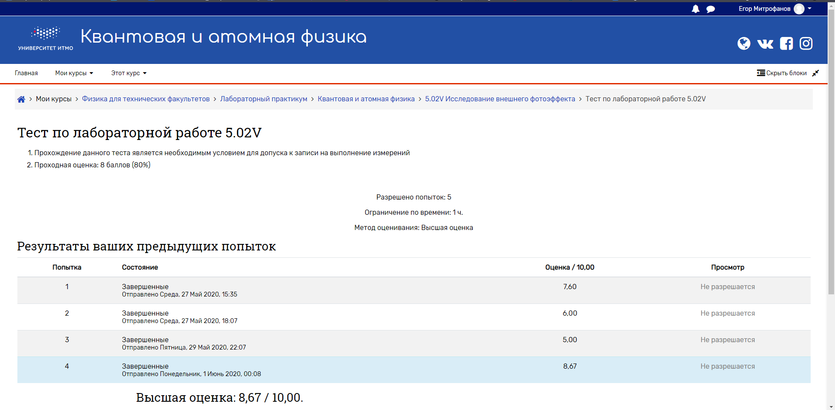**Результат тестирования**

**Полученные таблицы измерений**

1. Цинк (λкр = 289 нм)

|  |  |  |  |  |  |  |  |
| --- | --- | --- | --- | --- | --- | --- | --- |
| Trial | Metal | Voltage (V) | Current (pA) | | Frequency (Hz) | | Wavelength (nm) |
| 1 | Zinc | 0,068 | 0,01 | 1,05E+15 | | 285 | |
| 2 | Zinc | 0,141 | 0 | 1,07E+15 | | 280 | |
| 3 | Zinc | 0,209 | -0,02 | 1,09E+15 | | 276 | |
| 4 | Zinc | 0,289 | -0,01 | 1,11E+15 | | 271 | |
| 5 | Zinc | 0,371 | 0 | 1,12E+15 | | 267 | |
| 6 | Zinc | 0,448 | 0 | 1,15E+15 | | 262 | |
| 7 | Zinc | 0,521 | 0,02 | 1,16E+15 | | 258 | |
| 8 | Zinc | 0,618 | 0 | 1,19E+15 | | 253 | |
| 9 | Zinc | 0,721 | -0,02 | 1,20E+15 | | 249 | |
| 10 | Zinc | 0,789 | 0,02 | 1,22E+15 | | 245 | |
| 11 | Zinc | 0,89 | 0,02 | 1,25E+15 | | 240 | |
| 12 | Zinc | 0,971 | -0,02 | 1,27E+15 | | 236 | |
| 13 | Zinc | 1,09 | 0 | 1,30E+15 | | 231 | |
| 14 | Zinc | 1,18 | 0,02 | 1,32E+15 | | 227 | |
| 15 | Zinc | 1,3 | 0 | 1,35E+15 | | 222 | |
| 16 | Zinc | 1,408 | -0,02 | 1,38E+15 | | 218 | |
| 17 | Zinc | 1,558 | 0,01 | 1,41E+15 | | 213 | |
| 18 | Zinc | 1,652 | 0,02 | 1,44E+15 | | 209 | |
| 19 | Zinc | 1,811 | -0,02 | 1,47E+15 | | 204 | |
| 20 | Zinc | 1,932 | -0,01 | 1,50E+15 | | 200 | |

1. Магний (λкр = 337 нм)

|  |  |  |  |  |  |  |
| --- | --- | --- | --- | --- | --- | --- |
| Trial | Metal | Voltage (V) | Current (pA) | Frequency (Hz) | | Wavelength (nm) |
| 1 | Magnesium | 0,088 | -0,01 | 9,09E+14 | 330 | |
| 2 | Magnesium | 0,168 | 0 | 9,29E+14 | 323 | |
| 3 | Magnesium | 0,262 | -0,01 | 9,49E+14 | 316 | |
| 4 | Magnesium | 0,371 | 0 | 9,68E+14 | 310 | |
| 5 | Magnesium | 0,429 | -0,02 | 9,90E+14 | 303 | |
| 6 | Magnesium | 0,531 | 0,01 | 1,01E+15 | 296 | |
| 7 | Magnesium | 0,628 | -0,01 | 1,04E+15 | 289 | |
| 8 | Magnesium | 0,74 | 0,01 | 1,06E+15 | 282 | |
| 9 | Magnesium | 0,839 | 0,01 | 1,09E+15 | 275 | |
| 10 | Magnesium | 0,961 | -0,02 | 1,12E+15 | 269 | |
| 11 | Magnesium | 1,072 | -0,02 | 1,15E+15 | 262 | |
| 12 | Magnesium | 1,21 | -0,01 | 1,18E+15 | 255 | |
| 13 | Magnesium | 1,338 | -0,01 | 1,21E+15 | 248 | |
| 14 | Magnesium | 1,492 | 0 | 1,24E+15 | 241 | |
| 15 | Magnesium | 1,64 | 0,01 | 1,28E+15 | 234 | |
| 16 | Magnesium | 1,798 | -0,02 | 1,32E+15 | 227 | |
| 17 | Magnesium | 1,948 | 0,02 | 1,36E+15 | 221 | |
| 18 | Magnesium | 2,13 | 0 | 1,40E+15 | 214 | |
| 19 | Magnesium | 2,331 | 0,01 | 1,45E+15 | 207 | |
| 20 | Magnesium | 2,539 | -0,01 | 1,50E+15 | 200 | |

1. Кобальт (λкр = 248 нм)

|  |  |  |  |  |  |
| --- | --- | --- | --- | --- | --- |
| Trial | Metal | Voltage (V) | Current (pA) | Frequency (Hz) | Wavelength (nm) |
| 1 | Cobalt | 0,068 | -0,01 | 1,22E+15 | 246 |
| 2 | Cobalt | 0,13 | -0,01 | 1,23E+15 | 243 |
| 3 | Cobalt | 0,172 | 0,02 | 1,24E+15 | 241 |
| 4 | Cobalt | 0,239 | 0 | 1,26E+15 | 238 |
| 5 | Cobalt | 0,269 | -0,02 | 1,27E+15 | 236 |
| 6 | Cobalt | 0,322 | -0,01 | 1,28E+15 | 234 |
| 7 | Cobalt | 0,389 | 0 | 1,30E+15 | 231 |
| 8 | Cobalt | 0,439 | 0,02 | 1,31E+15 | 229 |
| 9 | Cobalt | 0,498 | 0 | 1,33E+15 | 226 |
| 10 | Cobalt | 0,552 | 0 | 1,34E+15 | 224 |
| 11 | Cobalt | 0,598 | -0,02 | 1,35E+15 | 222 |
| 12 | Cobalt | 0,678 | 0 | 1,37E+15 | 219 |
| 13 | Cobalt | 0,732 | 0 | 1,38E+15 | 217 |
| 14 | Cobalt | 0,808 | 0 | 1,40E+15 | 214 |
| 15 | Cobalt | 0,868 | 0 | 1,42E+15 | 212 |
| 16 | Cobalt | 0,919 | 0,02 | 1,43E+15 | 210 |
| 17 | Cobalt | 1,01 | 0,01 | 1,45E+15 | 207 |
| 18 | Cobalt | 1,071 | -0,02 | 1,46E+15 | 205 |
| 19 | Cobalt | 1,162 | -0,01 | 1,49E+15 | 202 |
| 20 | Cobalt | 1,218 | 0,01 | 1,50E+15 | 200 |

**График зависимости запирающего напряжения от частоты**

**U, в**

**ν, Гц**

*y = ax + β, x = 0, y = β*