Вариант - 51

$С=A*B$

**1. Составление таблицы истинности**

|  |  |  |  |  |  |  |  |  |  |
| --- | --- | --- | --- | --- | --- | --- | --- | --- | --- |
| $$a_{1}$$ | $$a_{2}$$ | $$a_{3}$$ | $$b_{1}$$ | $$b_{2}$$ | $$c_{1}$$ | $$c_{2}$$ | $$c_{3}$$ | $$c_{4}$$ | $$c_{5}$$ |
| 0 | 0 | 0 | 0 | 0 | d | d | d | d | d |
| 0 | 0 | 0 | 0 | 1 | 0 | 0 | 0 | 0 | 0 |
| 0 | 0 | 0 | 1 | 0 | 0 | 0 | 0 | 0 | 0 |
| 0 | 0 | 0 | 1 | 1 | 0 | 0 | 0 | 0 | 0 |
| 0 | 0 | 1 | 0 | 0 | d | d | d | d | d |
| 0 | 0 | 1 | 0 | 1 | 0 | 0 | 0 | 0 | 1 |
| 0 | 0 | 1 | 1 | 0 | 0 | 0 | 0 | 1 | 0 |
| 0 | 0 | 1 | 1 | 1 | 0 | 0 | 0 | 1 | 1 |
| 0 | 1 | 0 | 0 | 0 | d | d | d | d | d |
| 0 | 1 | 0 | 0 | 1 | 0 | 0 | 0 | 1 | 0 |
| 0 | 1 | 0 | 1 | 0 | 0 | 0 | 1 | 0 | 0 |
| 0 | 1 | 0 | 1 | 1 | 0 | 0 | 1 | 1 | 0 |
| 0 | 1 | 1 | 0 | 0 | d | d | d | d | d |
| 0 | 1 | 1 | 0 | 1 | 0 | 0 | 0 | 1 | 1 |
| 0 | 1 | 1 | 1 | 0 | 0 | 0 | 1 | 1 | 0 |
| 0 | 1 | 1 | 1 | 1 | 0 | 1 | 0 | 0 | 1 |
| 1 | 0 | 0 | 0 | 0 | d | d | d | d | d |
| 1 | 0 | 0 | 0 | 1 | 0 | 0 | 1 | 0 | 0 |
| 1 | 0 | 0 | 1 | 0 | 0 | 1 | 0 | 0 | 0 |
| 1 | 0 | 0 | 1 | 1 | 0 | 1 | 1 | 0 | 0 |
| 1 | 0 | 1 | 0 | 0 | d | d | d | d | d |
| 1 | 0 | 1 | 0 | 1 | 0 | 0 | 1 | 0 | 1 |
| 1 | 0 | 1 | 1 | 0 | 0 | 1 | 0 | 1 | 0 |
| 1 | 0 | 1 | 1 | 1 | 0 | 1 | 1 | 1 | 1 |
| 1 | 1 | 0 | 0 | 0 | d | d | d | d | d |
| 1 | 1 | 0 | 0 | 1 | 0 | 0 | 1 | 1 | 0 |
| 1 | 1 | 0 | 1 | 0 | 0 | 1 | 1 | 0 | 0 |
| 1 | 1 | 0 | 1 | 1 | 1 | 0 | 0 | 1 | 0 |
| 1 | 1 | 1 | 0 | 0 | d | d | d | d | d |
| 1 | 1 | 1 | 0 | 1 | 0 | 0 | 1 | 1 | 1 |
| 1 | 1 | 1 | 1 | 0 | 0 | 1 | 1 | 1 | 0 |
| 1 | 1 | 1 | 1 | 1 | 1 | 0 | 1 | 0 | 1 |

**2. Минимизация булевых функций системы**

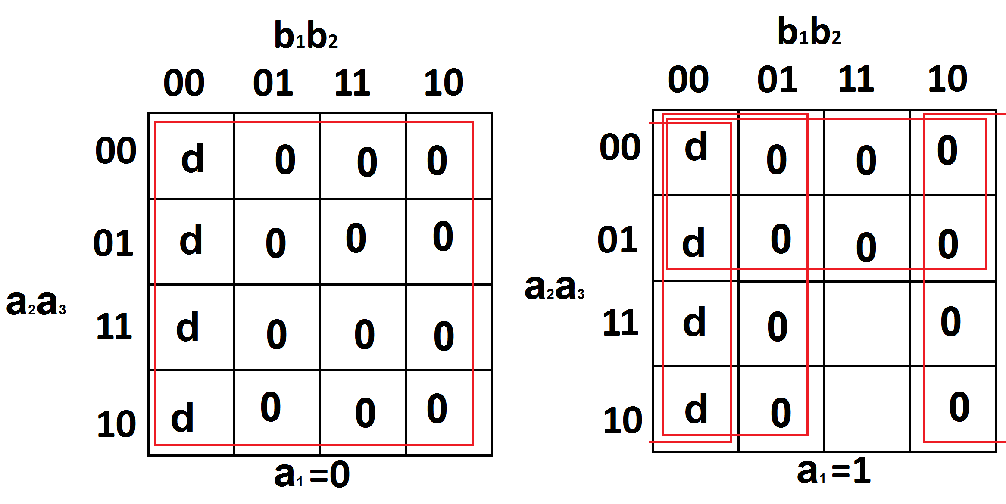**2.1. для МКНФ**

$С_{1}=\left\{\begin{aligned}0xxxx \\ x0xxx \\ xxx0x \\ xxxx0\end{aligned}\right\}$

$S^{A}=4$ $S^{B}=4$

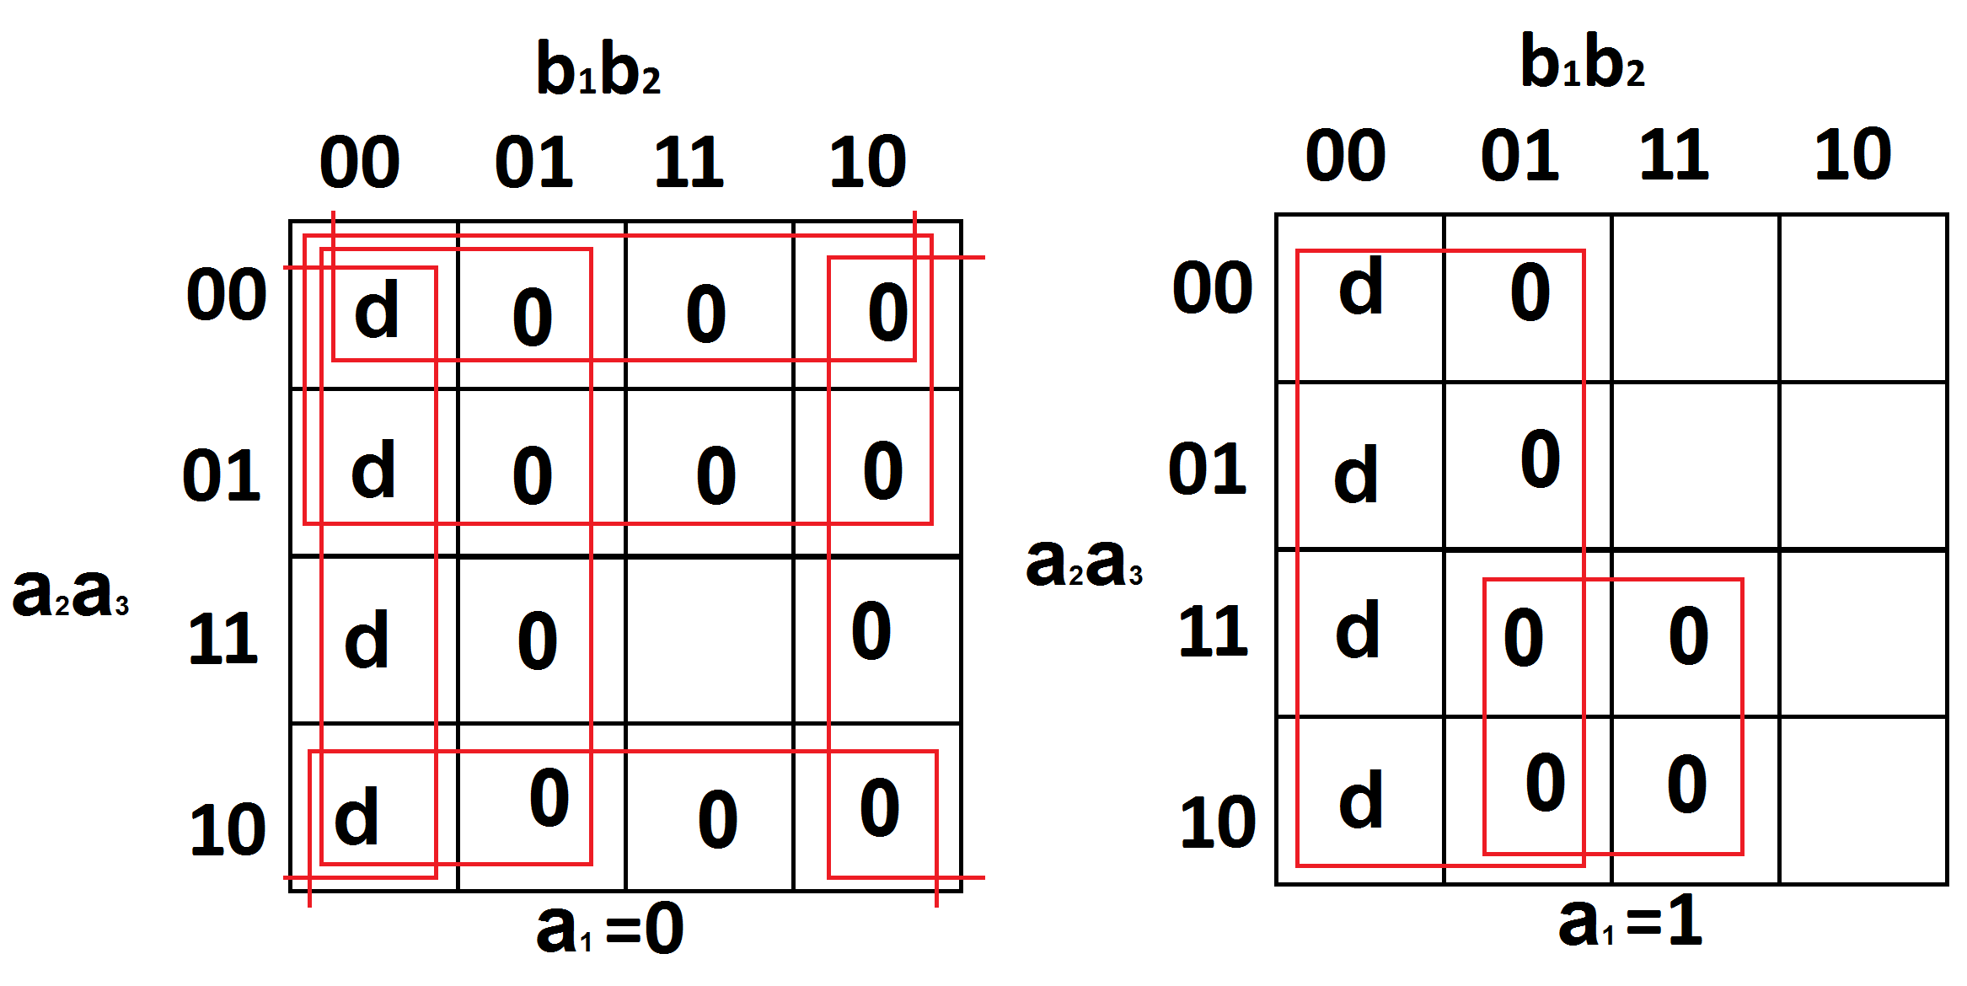 $C_{1}=x_{1}x_{2}x_{4}x_{5}$

$C_{2}=\left\{\begin{aligned}xxx0x \\ 11xx1 \\ 00xxx \\ 0x0xx \\ 0xxx0\end{aligned}\right\}$

$S^{A}=10$ $S^{B}=15$

$C_{2}=x_{4}({\overline{x}}_{1}v{\overline{x}}_{2}v{\overline{x}}_{5})(x_{1}vx_{2})(x_{1}vx_{3})(x_{1}vx_{5})$

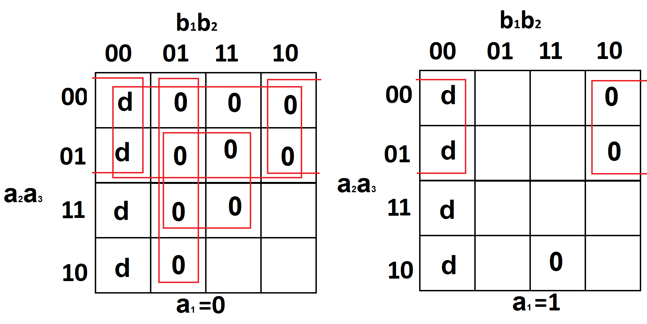

$C_{3}=\left\{\begin{aligned}11011 \\ x0xx0 \\ 00xxx \\ 0xx01 \\ 0x1x1\end{aligned}\right\}$

$S^{A}=15$ $S^{B}=20$

$C_{3}=({\overline{x}}_{1}v{\overline{x}}_{2}vx_{3}v{\overline{x}}_{4}v{\overline{x}}_{5})(x_{2}vx_{5})(x_{1}vx_{2})(x_{1}vx_{4}v{\overline{x}}_{5})(x_{1}v{\overline{x}}_{3}v{\overline{x}}_{5})$

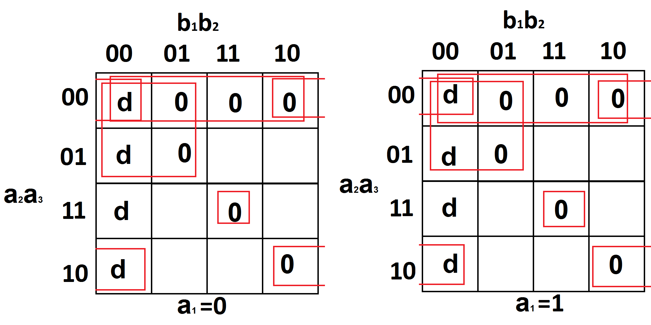

$C_{4}=\left\{\begin{aligned}xx0x0 \\ x1111 \\ x00xx \\ x0x0x\end{aligned}\right\}$

$S^{A}=10$ $S^{B}=14$

$C_{4}=(x_{3}vx_{5})({\overline{x}}_{2}v{\overline{x}}_{3}v{\overline{x}}_{4}v{\overline{x}}_{5})(x_{2}vx_{3})(x_{2}vx_{4})$

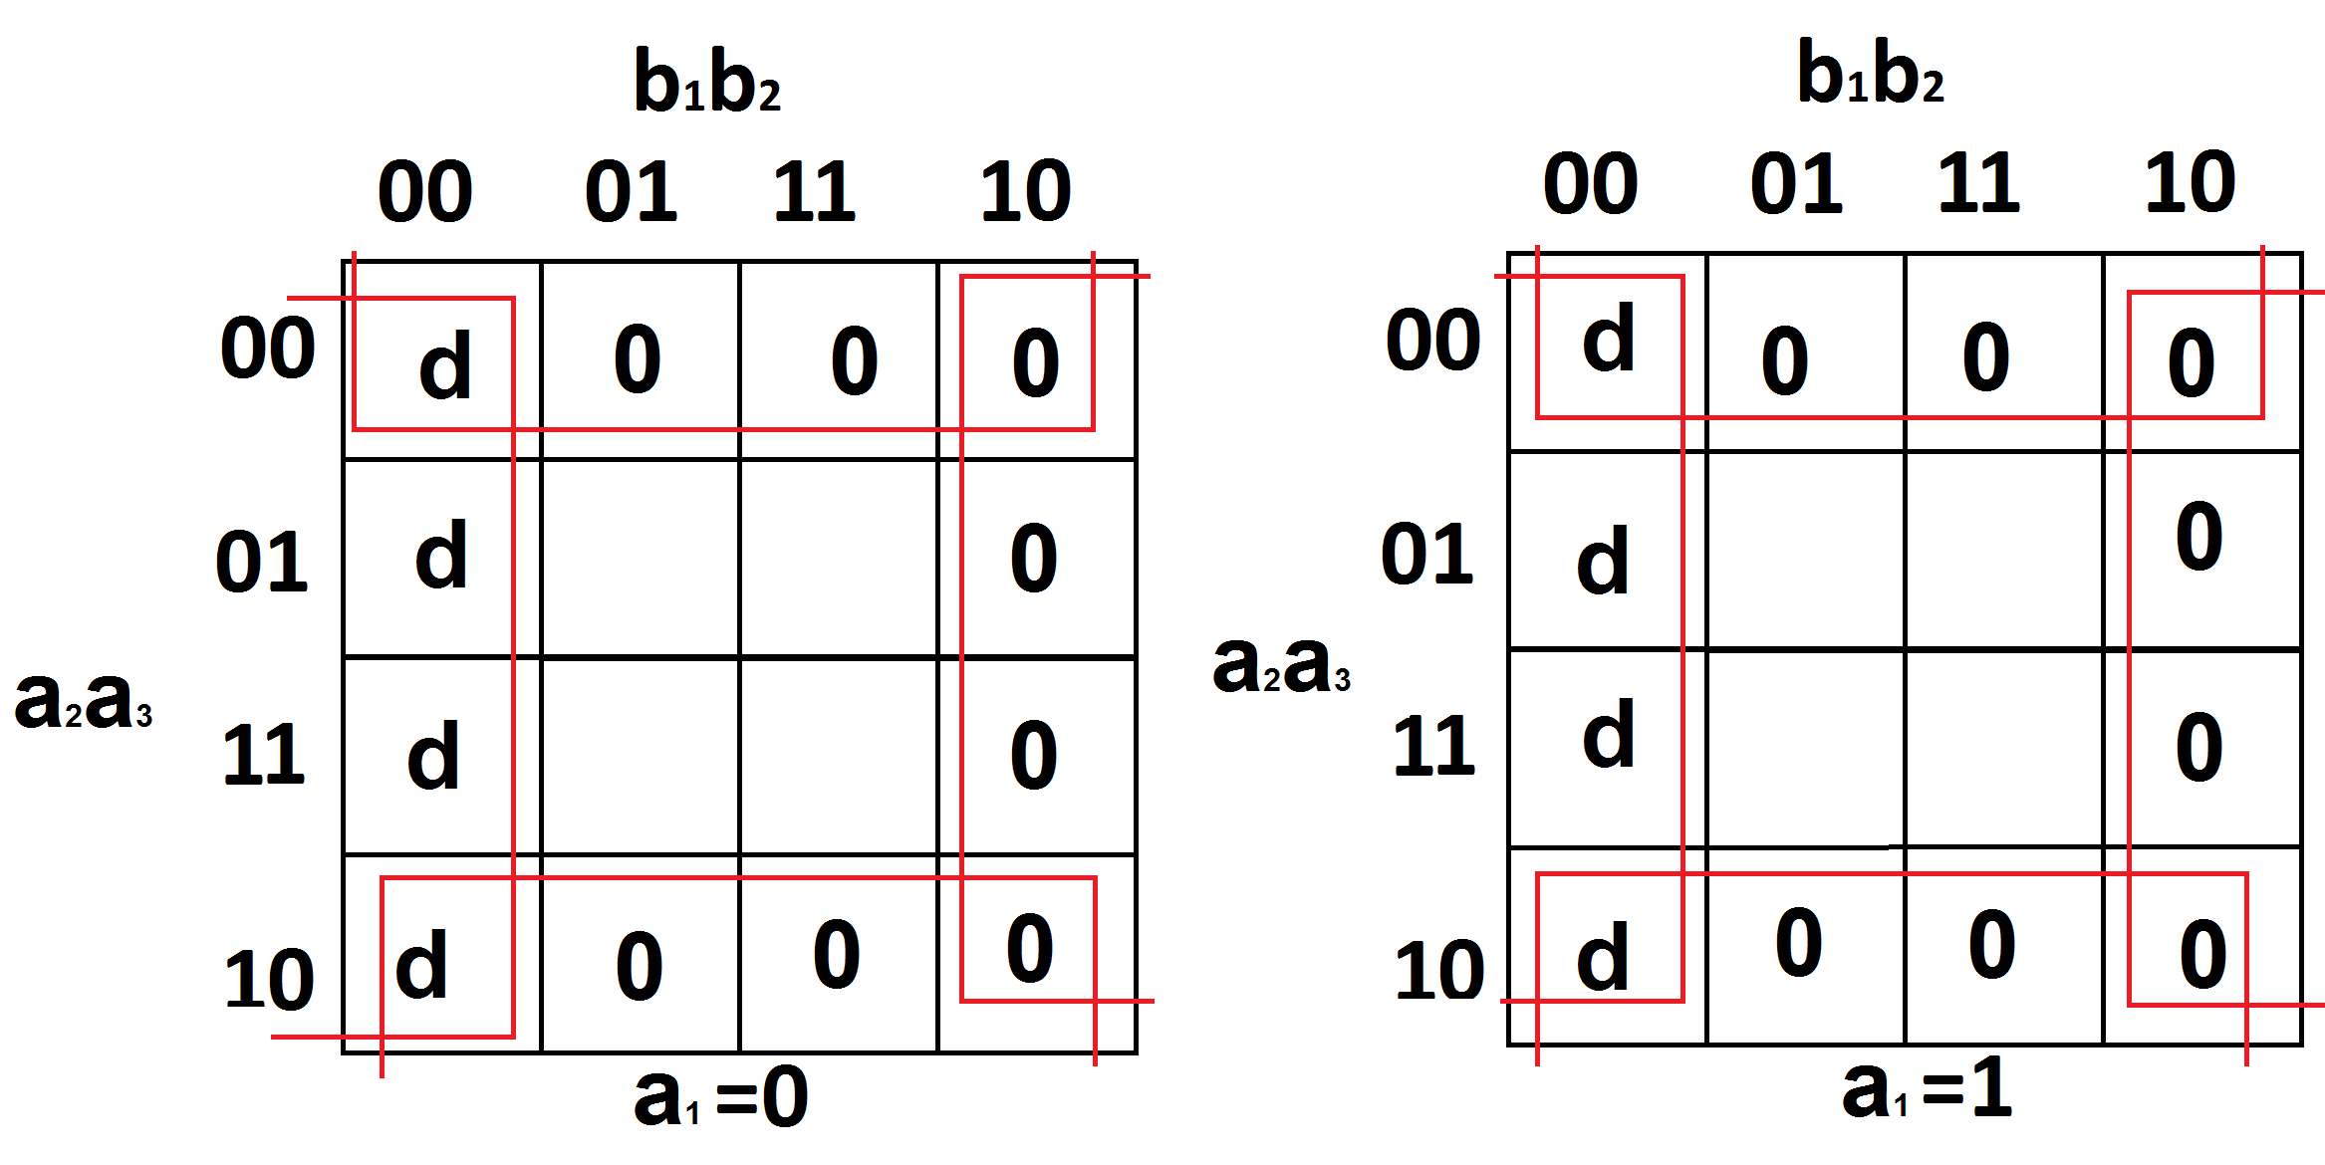

$C_{5}\left\{\begin{aligned}xx0xx \\ xxxx0\end{aligned}\right\}$

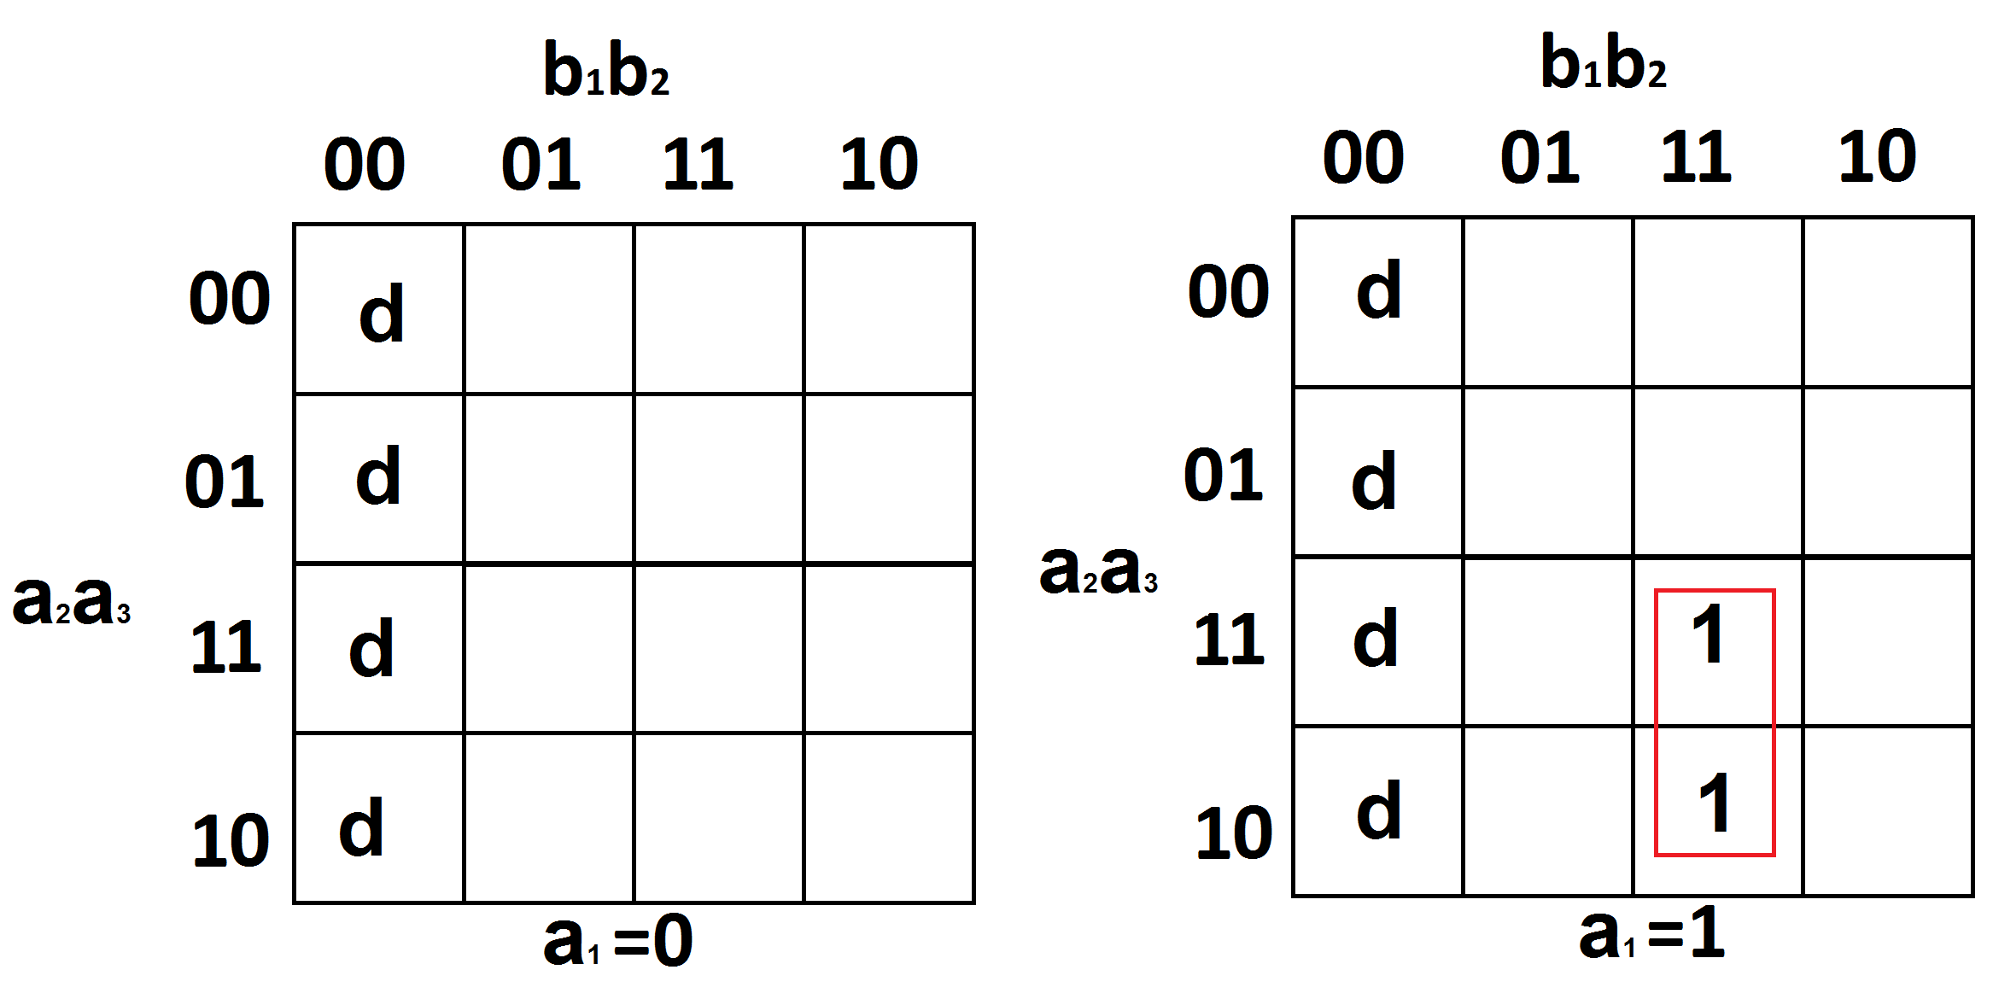 $C_{5}=x_{3}x_{5}$

$С_{1}=\left\{11x11\right\}$

$S^{A}=4$ $S^{B}=4$

$C_{1}=x_{1}x_{2}x_{4}x_{5}$

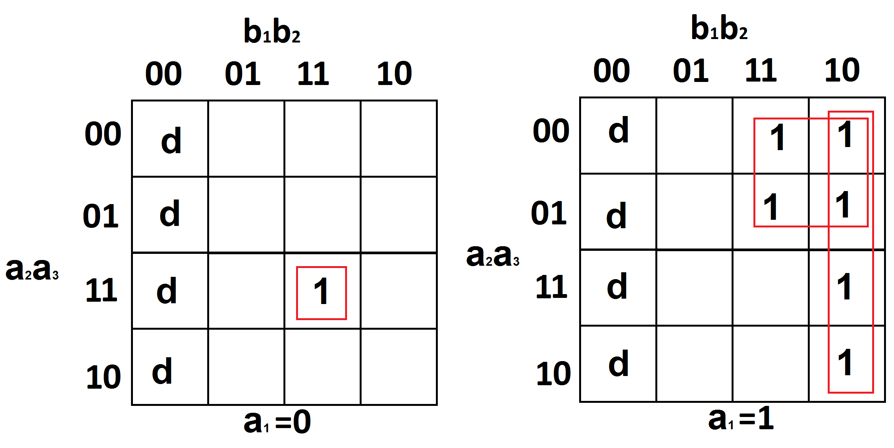

$C_{2}=\left\{\begin{aligned}01111 \\ 10x1x \\ 1xx10\end{aligned}\right\}$

$S^{A}=12$ $S^{B}=15$

$C_{2}={\overline{x}}_{1}x_{2}x_{3}x_{4}x_{5}vx_{1}{\overline{x}}_{2}x_{4}vx_{1}x_{4}{\overline{x}}_{5}$

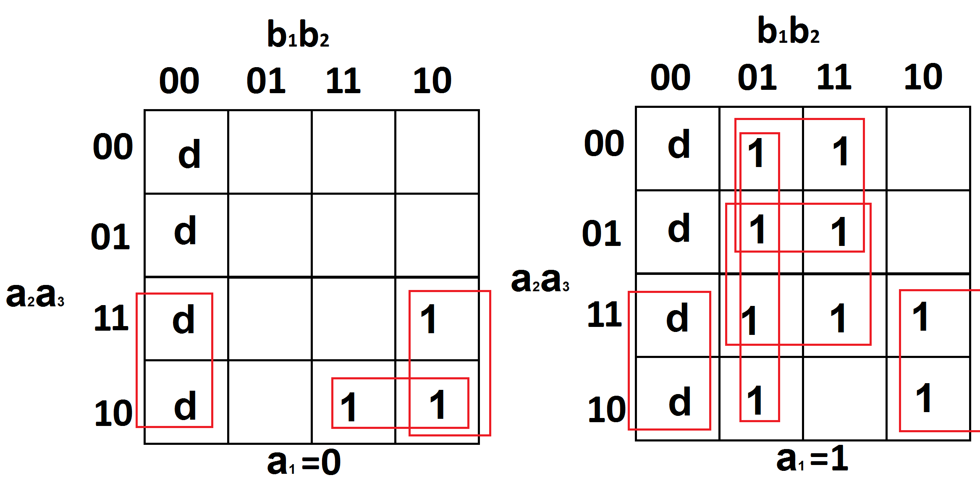

$C_{3}=\left\{\begin{aligned}x1xx0 \\ 0101x \\ 1xx01 \\ 10xx1 \\ 1x1x1\end{aligned}\right\}$

$S^{A}=15$ $S^{B}=20$

$C_{3}=x_{2}{\overline{x}}_{5}v{\overline{x}}_{1}x_{2}{\overline{x}}_{3}x_{4}vx_{1}{\overline{x}}_{4}x_{5}vx_{1}{\overline{x}}_{2}x_{5}vx_{1}x_{3}x_{5}$

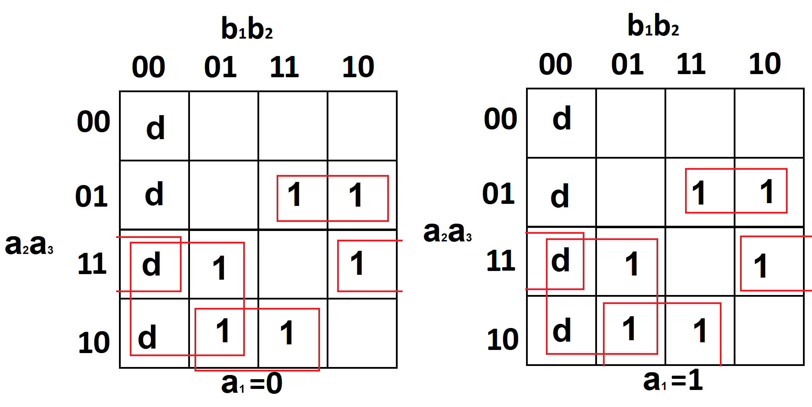

$C_{4}=\left\{\begin{aligned}x011x \\ x11x0 \\ x1x0x \\ x10x1\end{aligned}\right\}$

$S^{A}=11$ $S^{B}=15$

$C_{4}={\overline{x}}_{2}x_{3}x_{4}vx_{2}x_{3}{\overline{x}}_{5}vx_{2}{\overline{x}}_{4}vx_{2}{\overline{x}}_{3}x_{5}$

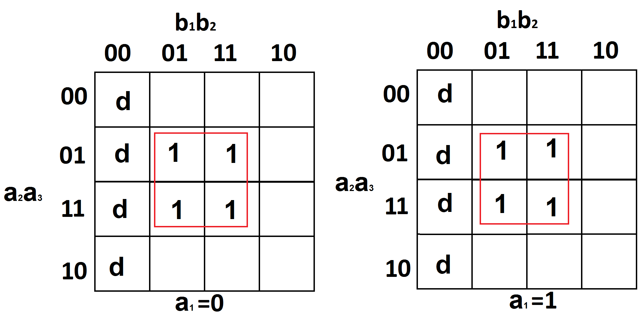

$C_{5}=\left\{xx1x1\right\}$

$S^{A}=2$ $S^{B}=2$

$C_{5}=x_{3}x_{5}$

**3. Преобразование минимальных форм булевых функций системы**

**3.1. для МКНФ**

$\left\{\begin{aligned}С_{1}=x_{1}x_{2}x_{4}x_{5} \\ C_{2}=x_{4}({\overline{x}}_{1}v{\overline{x}}_{2}v{\overline{x}}_{5})(x_{1}vx_{2})(x_{1}vx_{3})(x_{1}vx_{5}) \\ C_{3}=({\overline{x}}_{1}v{\overline{x}}_{2}vx_{3}v{\overline{x}}_{4}v{\overline{x}}_{5})(x_{2}vx_{5})(x_{1}vx_{2})(x_{1}vx_{4}v{\overline{x}}_{5})(x_{1}v{\overline{x}}_{3}v{\overline{x}}_{5}) \\ C_{4}=(x_{3}vx_{5})({\overline{x}}_{2}v{\overline{x}}_{3}v{\overline{x}}_{4}v{\overline{x}}_{5})(x_{2}vx_{3})(x_{2}vx_{4}) \\ C_{5}=x_{3}x_{5}\end{aligned}\right.$

$\left\{\begin{aligned}С_{1}=x_{1}x_{2}x_{4}x_{5} \\ C_{2}=x_{4}({\overline{x}}_{1}v{\overline{x}}_{2}v{\overline{x}}_{5})(x_{1}vx_{2}x_{3}x_{5}) \\ C_{3}=({\overline{x}}_{1}v{\overline{x}}_{2}vx_{3}v{\overline{x}}_{4}v{\overline{x}}_{5})(x_{2}vx_{1}x_{5})(x_{1}v{\overline{x}}_{5}v{\overline{x}}_{3}x_{4}) \\ C_{4}=(x_{3}vx_{5})({\overline{x}}_{2}v{\overline{x}}_{3}v{\overline{x}}_{4}v{\overline{x}}_{5})(x_{2}vx_{3}x_{4}) \\ C_{5}=x_{3}x_{5}\end{aligned}\right.$

$\left\{\begin{aligned}С_{1}=x_{1}x_{2}x_{4}x_{5} \\ C_{2}=x_{4}({\overline{x}}_{1}v{\overline{x}}_{2}v{\overline{x}}_{5})(x_{1}vx_{2}x_{3}x_{5}) \\ C_{3}=({\overline{x}}_{1}v{\overline{x}}_{2}vx_{3}v{\overline{x}}_{4}v{\overline{x}}_{5})(x_{2}vx_{1}x_{5})(x_{1}v{\overline{x}}_{5}v{\overline{x}}_{3}x_{4}) \\ C_{4}=(x_{3}vx_{5})({\overline{x}}_{2}v\overline{φ}v{\overline{x}}_{5})(x_{2}vφ) \\ C_{5}=x_{3}x_{5} \\ φ=x_{3}x_{4}\end{aligned}\right.$ $\begin{aligned}S^{Q}=4 \\ S^{Q}=11 \\ S^{Q}=16 \\ S^{Q}=10 \\ S^{Q}=2 \\ S^{Q}=2\end{aligned}$ $S^{Q}=45$

**3.2. для МДНФ**

$\left\{\begin{aligned}C_{1}=x_{1}x_{2}x_{4}x_{5} \\ C_{2}={\overline{x}}_{1}x_{2}x_{3}x_{4}x_{5}vx_{1}{\overline{x}}_{2}x_{4}vx_{1}x_{4}{\overline{x}}_{5} \\ C_{3}=x_{2}{\overline{x}}_{5}v{\overline{x}}_{1}x_{2}{\overline{x}}_{3}x_{4}vx_{1}{\overline{x}}_{4}x_{5}vx_{1}{\overline{x}}_{2}x_{5}vx_{1}x_{3}x_{5} \\ C_{4}={\overline{x}}_{2}x_{3}x_{4}vx_{2}x_{3}{\overline{x}}_{5}vx_{2}{\overline{x}}_{4}vx_{2}{\overline{x}}_{3}x_{5} \\ C_{5}=x_{3}x_{5}\end{aligned}\right.$ $\left\{\begin{aligned}C_{1}=x_{1}x_{2}x_{4}x_{5} \\ C_{2}={\overline{x}}_{1}x_{2}x_{3}x_{4}x_{5}vx_{1}x_{4}({\overline{x}}_{2}v{\overline{x}}_{5}) \\ C_{3}=x_{2}{\overline{x}}_{5}v{\overline{x}}_{1}x_{2}{\overline{x}}_{3}x_{4}vx_{1}x_{5}({\overline{x}}_{2}vx_{3}v{\overline{x}}_{4}) \\ C_{4}={\overline{x}}_{2}x_{3}x_{4}vx_{2}(x_{3}{\overline{x}}_{5}v{\overline{x}}_{4}v{\overline{x}}_{3}x_{5}) \\ C_{5}=x_{3}x_{5}\end{aligned}\right.$

$\left\{\begin{aligned}C_{1}=x_{1}x_{2}x_{4}x_{5} \\ C_{2}={\overline{x}}_{1}x_{2}x_{3}x_{4}x_{5}vx_{1}x_{4}({\overline{x}}_{2}v{\overline{x}}_{5}) \\ C_{3}=x_{2}{\overline{x}}_{5}v{\overline{x}}_{1}\overline{φ}vx_{1}x_{5}φ \\ C_{4}={\overline{x}}_{2}x_{3}x_{4}vx_{2}(x_{3}{\overline{x}}_{5}v{\overline{x}}_{4}v{\overline{x}}_{3}x_{5}) \\ C_{5}=x_{3}x_{5} \\ φ={\overline{x}}_{2}vx_{3}v{\overline{x}}_{4}\end{aligned}\right.$ $\begin{aligned}S^{Q}=4 \\ S^{Q}=12 \\ S^{Q}=10 \\ S^{Q}=14 \\ S^{Q}=2 \\ S^{Q}=3\end{aligned}$ $S^{Q}=45$

**4. Синтез многовыходной комбинационной схемы**

**4.1. Без ограничений**

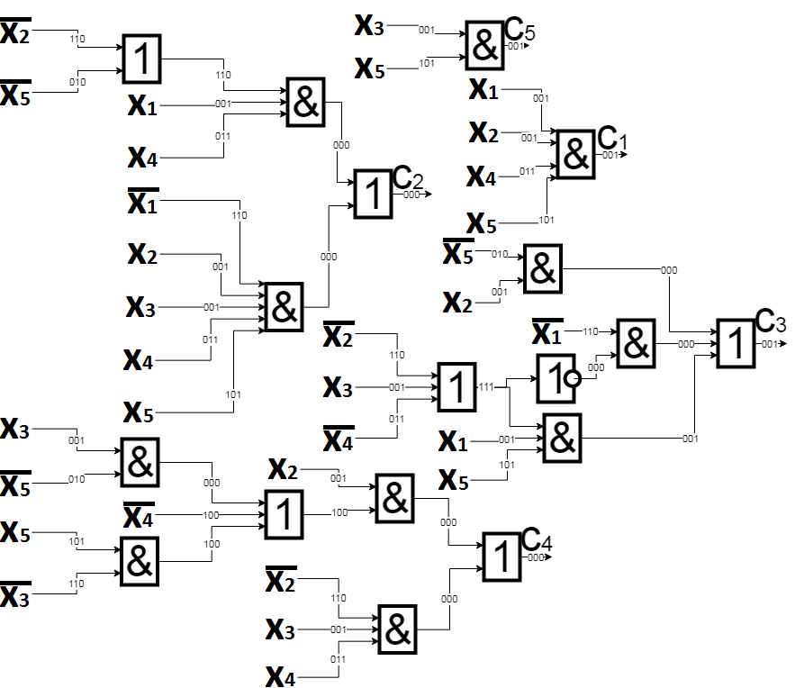

$S^{Q}=45$

$T=4τ$

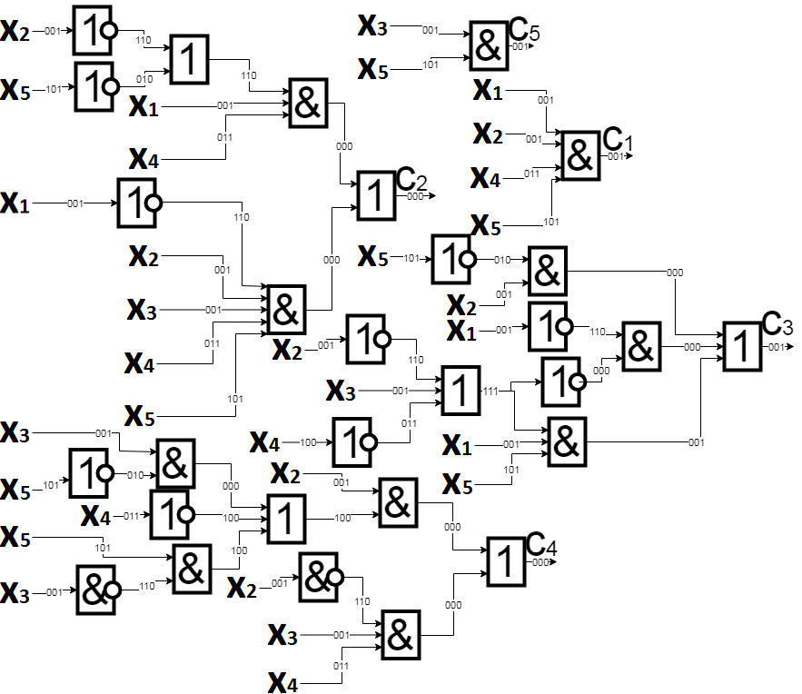**4.2. Однофазный**

$S^{Q}=56$

$T=5τ$

**4.3. Ограничение на выходы 2**

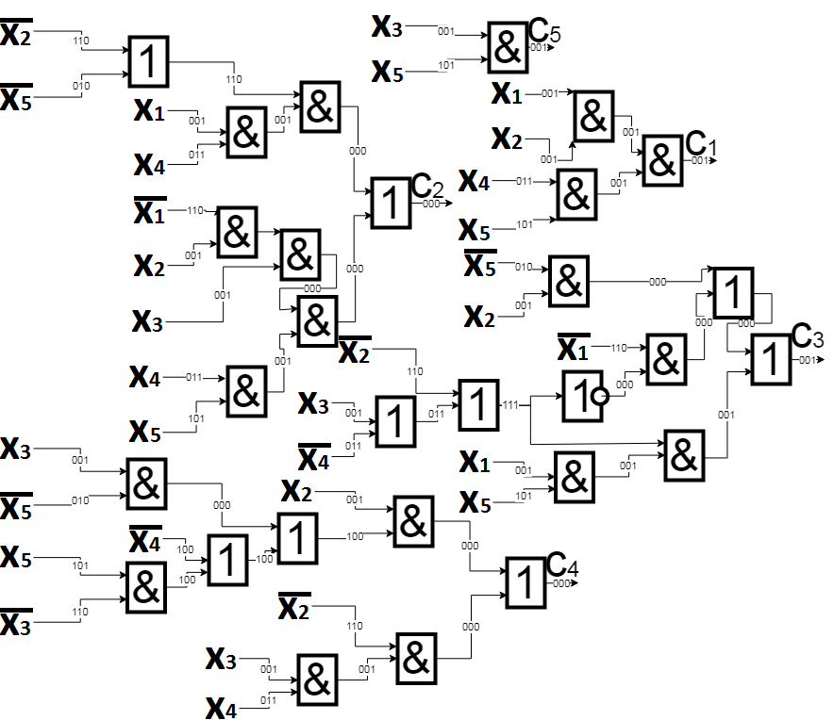

$S^{Q}=56$

$T=6τ$

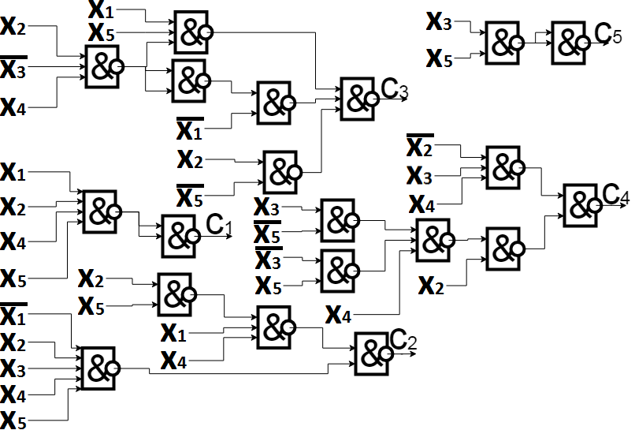**4.4. Базис И-НЕ**

$\left\{\begin{aligned}C_{1}=\overline{\overline{x_{1}x_{2}x_{4}x_{5}}} \\ C_{2}=\overline{\overline{{\overline{x}}_{1}x_{2}x_{3}x_{4}x_{5}} \overline{x_{1}x_{4}(\overline{x_{2}x_{5}})}} \\ C_{3}=\overline{\overline{x_{2}{\overline{x}}_{5}} \overline{{\overline{x}}_{1}\overline{φ}} \overline{x_{1}x_{5}φ}} \\ C_{4}=\overline{\overline{{\overline{x}}_{2}x_{3}x_{4}} \overline{x_{2}(\overline{\overline{x_{3}{\overline{x}}_{5}} x_{4} \overline{{\overline{x}}_{3}x_{5}}})}} \\ C_{5}=\overline{\overline{x_{3}x_{5}}} \\ φ=\overline{x_{2} {\overline{x}}_{3} x_{4}}\end{aligned}\right.$

$S^{Q}=51$

$T=4τ$

**5. Анализ многовыходной комбинационной схемы**

Анализ проведён на булевых базисах на наборах (00001), (00010) и (11111)