- 14
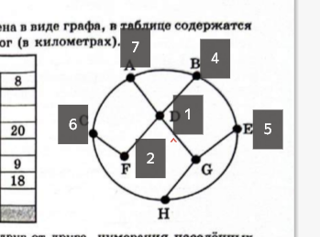
- ('w', 'x', 'z', 'y')
from itertools import *

def f(x,y,z,w):
return (x <= (not ((y <= z) and (z == (not w)))))

for a1,a2,a3,a4,a5 in product([0,1], repeat=5):
table = [(0,a1,a2,0), (a3,1,1,a4), (a5,1,0,0)]

if len(set(table)) == len(table):
for p in permutations('xyzw'):
if [f(**dict(zip(p,r))) for r in table] == [0,0,0]:
print(p)

- 465
- 16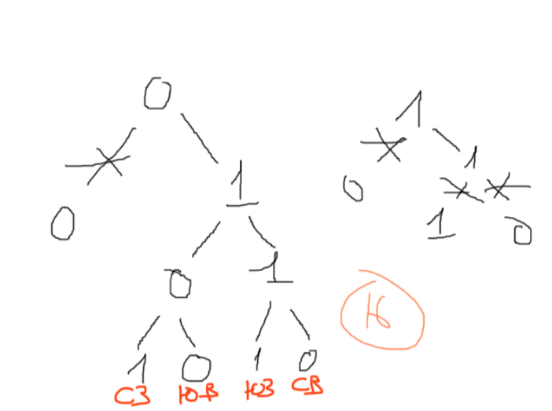
- 411
def f(n):
new_n = bin(n)[2:]
if n % 3 == 0:
new_n += new_n[-3:]
else:
new_n += bin((3*(n % 3 + 1)))[2:]
return int(new_n, 2)

m = 0
for n in range(1, 1000):
r = f(n)
if r <= 416:
m = max(m, r)

print(m)

- 591
from turtle import *

tracer(0)
screensize(5000,5000)

m = 5

down()
for i in range(4):
fd(9*m)
lt(180)
backward(10*m)
rt(90)

up()
backward(7*m)
lt(90)
fd(3*m)
rt(90)

down()
for i in range(2):
fd(17*m)
lt(90)
fd(20*m)
lt(90)

up()
for x in range(-50,50):
for y in range(-50,50):
goto(x*m, y*m)
dot(2,'red')

done()
update()

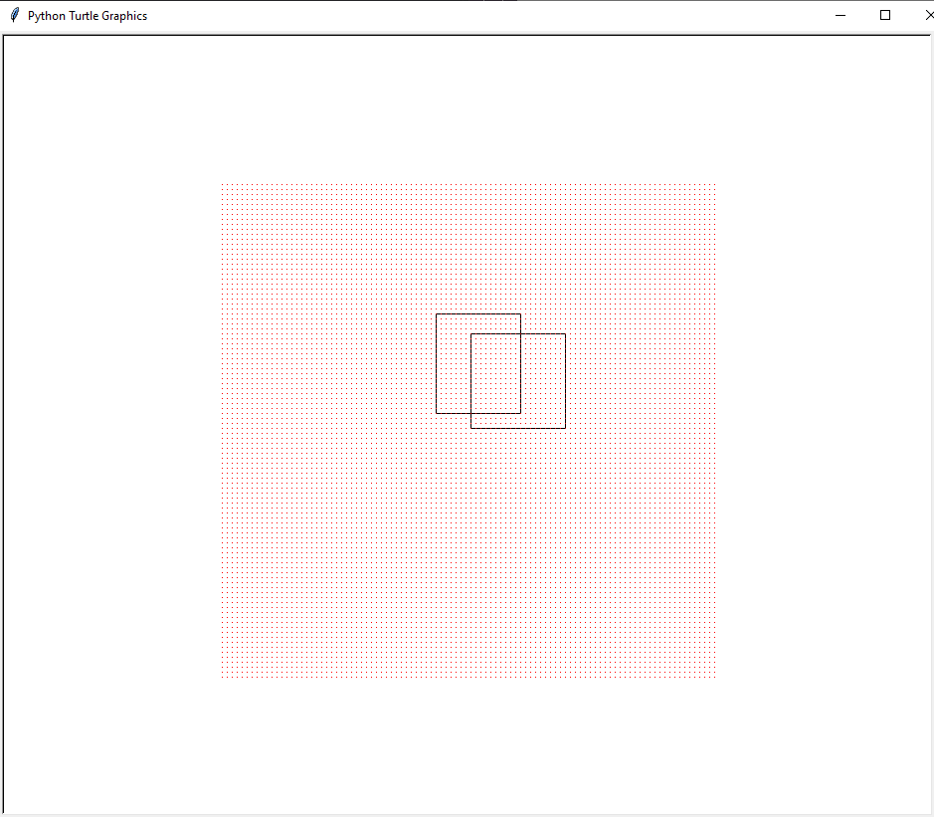
- 20325
- 4518
from itertools import *

for e,i in enumerate(product('АЕЛРСТ', repeat = 5)):
if (e+1) % 2 == 0:
i = ''.join(i)
if i[0] != 'А' and i[0] != 'С' and i[0] != 'Т' and 'ЛЛ' not in i and i.count('Л') == 2:
print(e+1, i)
- 11597
text = open('text.txt', mode = 'r')

for e, i in enumerate(text):
stroka = i.split()
odni_chisla = list(map(int, [b for b in stroka if stroka.count(b) == 1]))
tri_chisla = list(map(int, [b for b in stroka if stroka.count(b) == 3]))

if len(odni_chisla) == 4 and len(tri_chisla) == 3 and sum(odni_chisla) > sum(tri_chisla):
print(e+1)

- 35
- 23
- 519
- 77180177254
from ipaddress import *

net= ip_network('77.180.176.14/255.255.254.0', 0)

print(net[-2])
- 3432
a = 3*2187**1801 + 729**2000 - 4*243**2100 + 81**2200 - 2*27**2400-13122

def to_27(number):
chisla = '0123456789abcdefghijklmnopqrstuvwxyz'

result = ''
while number > 0:
result = chisla[number % 27] + result
number //= 27

return result
ts_a = to_27(a)
cnt = 0
chisla = '9abcdefghijklmnopqrstuvwxyz'
for d in ts_a:
if d in chisla: cnt += 1
print(cnt)
- 2809
def search_dels(n):
dels = set()
for i in range(2, int(n**0.5)+1):
if n % i == 0:
dels.add(i)
dels.add(n//i)

return dels

a = list(range(3,60))
b = search_dels(177)

def check_y(y):
dels_y = search_dels(y)
if len(dels_y) == 0:
return False
for x in range(1,10_000):
if not ((x in dels_y) <= ((x in a) and not (x in b))):
return False
return True

for y in range(10_000, 0, -1):
if check_y(y):
print(y)
break

- 6.0
import sys
sys.setrecursionlimit(10_000_000)

def f(n):
if n == 1: return 2
if n >= 2: return 3*f(n-1)-n

print((f(2025)-f(2023)-1)/3**2022)
- 8 99191
text = open('text.txt', mode='r', encoding='UTF-8')

all_nums = [int(i) for i in text]
dvuh_nums = [i for i in all_nums if abs(i/100) < 1 and abs(i) >= 10]
minimum = min(dvuh_nums)
maximum = max(dvuh_nums)

uk = 0

cnt = 0
m = 0
for b in range(0, len(all_nums)-2):
ch = (all_nums[b], all_nums[b+1], all_nums[b+2])
dvuh_nums = [i for i in ch if abs(i/100) < 1 and abs(i) >= 10]

if len(dvuh_nums) >= 2 and sum(ch) > minimum+maximum:
m = max(m, sum(ch))
cnt += 1

print(cnt, m)

- 3006 891
def f(s, m):
if s <= 60:
return m % 2 == 0
if m == 0:
return 0

mov = [f(s-3, m-1), f(s-5, m-1), f(s//4, m-1)]

return all(mov) if m % 2 == 0 else any(mov)

print('19:', min([s for s in range(61, 1000) if f(s, 2)]))
print('20:', *[s for s in range(61, 1000)
if not f(s, 1) and not f(s, 2) and f(s, 3)][:2])
print('21:', min([s for s in range(61, 1000) if not f(s, 2) and f(s, 4)]))
- 244
- 247 248
- 252
- 5
- 89
def f(a, b):
if a > b:
return 0
if a == b:
return 1
s = str(a)
if int(s[-1]) > int(s[-2]):
return f(a+1, b) + f(int(s[:-2] + s[-1] + s[-2]), b)
else:
return f(a+1, b)

print(f(101, 154))

def check_n(n):
p = 0
while True:
p += 1
power = 3**p
if power > n:
return None
r = n - power
if r % 2 == 1 and r % 103 == 0:
return p

c = 0
for n in range(200000, 1000000):
if '1' in str(n):
continue
r = check_n(n)
if r is not None:
print(n, r)
c += 1
if c == 5:
break

200004 4
200034 6
200036 9
200050 7
200056 10
27.
83354 110525 8580 9126

