Національний технічний університет України

«Київський політехнічний інститут імені Ігоря Сікорського»

Науково-навчальний  інститут телекомунікаційних систем

Кредитний модуль

 «Основи програмування Java»

Лабораторна робота №8

Об'єкти, які реалізують інтерфейси Set, Map

Виконав студент групи ТЗ-22

Єгоров Олексій Андрійович

Перевірив: Руренко Олександр

Григорович

11 грудня 2024 р.

Київ 2023

**Виконання роботи:**

Створено клас **main.java**  
package lab8;

import java.util.ArrayList;

import java.util.Iterator;

import java.util.List;

public class main {

public static void main(String[] args) {

Comment comment1 = new Comment("Great", 10, 1);

Comment comment2 = new Comment("Bad", 5, 2);

Comment comment3 = new Comment("Don't know", 2, 10);

Video video1 = new Video("Video 1", "https://video1.com", 100, 50, 5);

video1.addComment(comment1);

video1.addComment(comment2);

Video video2 = new Video("Video 2", "https://video2.com", 200, 30, 15);

video2.addComment(comment3);

VideoBlog blog = new VideoBlog("BloggerName");

blog.addVideo(video1);

blog.addVideo(video2);

System.out.println("Total views: " + getTotalViews(blog));

System.out.println("Is there a comment more liked than the video? " + isCommentMoreLikedThanVideo(blog));

List<Video> mostDislikedVideos = getMostDislikedVideos(blog);

if (mostDislikedVideos.isEmpty()) {

System.out.println("No videos with dislikes.");

} else {

System.out.println("Most disliked video(s):");

for (Video video : mostDislikedVideos) {

System.out.println(video.getTitle());

}

}

Video foundVideo = findVideoByUrl(blog, "https://video1.com");

System.out.println("Found video: " + (foundVideo != null ? foundVideo.getTitle() : "Not found"));

}

public static int getTotalViews(VideoBlog blog) {

int totalViews = 0;

for (Video video : blog.getVideos()) {

totalViews += video.getViews();

}

return totalViews;

}

public static boolean isCommentMoreLikedThanVideo(VideoBlog blog) {

for (Video video : blog.getVideos()) {

for (Comment comment : video.getComments()) {

if (comment.getLikes() > video.getLikes()) {

return true;

}

}

}

return false;

}

public static List<Video> getMostDislikedVideos(VideoBlog blog) {

List<Video> result = new ArrayList<>();

int maxDislikes = 0;

Iterator<Video> iterator = blog.getVideos().iterator();

while (iterator.hasNext()) {

Video video = iterator.next();

if (video.getDislikes() > maxDislikes) {

maxDislikes = video.getDislikes();

result.clear();

result.add(video);

} else if (video.getDislikes() == maxDislikes) {

result.add(video);

}

}

return result;

}

public static Video findVideoByUrl(VideoBlog blog, String url) {

return blog.getVideoByUrl(url);

}

}

Створено клас **Video.java**

package lab8;

import java.util.HashSet;

import java.util.Set;

public class Video {

private String title;

private String url;

private int views;

private int likes;

private int dislikes;

private Set<Comment> comments;

public Video(String title, String url, int views, int likes, int dislikes) {

this.title = title;

this.url = url;

this.views = views;

this.likes = likes;

this.dislikes = dislikes;

this.comments = new HashSet<>();

}

public void addComment(Comment comment) {

comments.add(comment);

}

public int getViews() {

return views;

}

public int getLikes() {

return likes;

}

public int getDislikes() {

return dislikes;

}

public Set<Comment> getComments() {

return comments;

}

public String getTitle() {

return title;

}

public String getUrl() {

return url;

}

@Override

public boolean equals(Object o) {

if (this == o) return true;

if (o == null || getClass() != o.getClass()) return false;

Video video = (Video) o;

return url.equals(video.url);

}

@Override

public int hashCode() {

return url.hashCode();

}

}

Створено клас **VideoBlog.java**

package lab8;

import java.util.HashMap;

import java.util.HashSet;

import java.util.Map;

import java.util.Set;

public class VideoBlog {

private String bloggerName;

private Set<Video> videos;

private Map<String, Video> videoMap;

public VideoBlog(String bloggerName) {

this.bloggerName = bloggerName;

this.videos = new HashSet<>();

this.videoMap = new HashMap<>();

}

public void addVideo(Video video) {

videos.add(video);

videoMap.put(video.getUrl(), video);

}

public Set<Video> getVideos() {

return videos;

}

public Video getVideoByUrl(String url) {

return videoMap.get(url);

}

}

Створено клас **Comment.java**

package lab8;

public class Comment {

private String text;

private int likes;

private int dislikes;

public Comment(String text, int likes, int dislikes) {

this.text = text;

this.likes = likes;

this.dislikes = dislikes;

}

public int getLikes() {

return likes;

}

public int getDislikes() {

return dislikes;

}

public String getText() {

return text;

}

@Override

public boolean equals(Object o) {

if (this == o) return true;

if (o == null || getClass() != o.getClass()) return false;

Comment comment = (Comment) o;

return text.equals(comment.text);

}

@Override

public int hashCode() {

return text.hashCode();

}

}

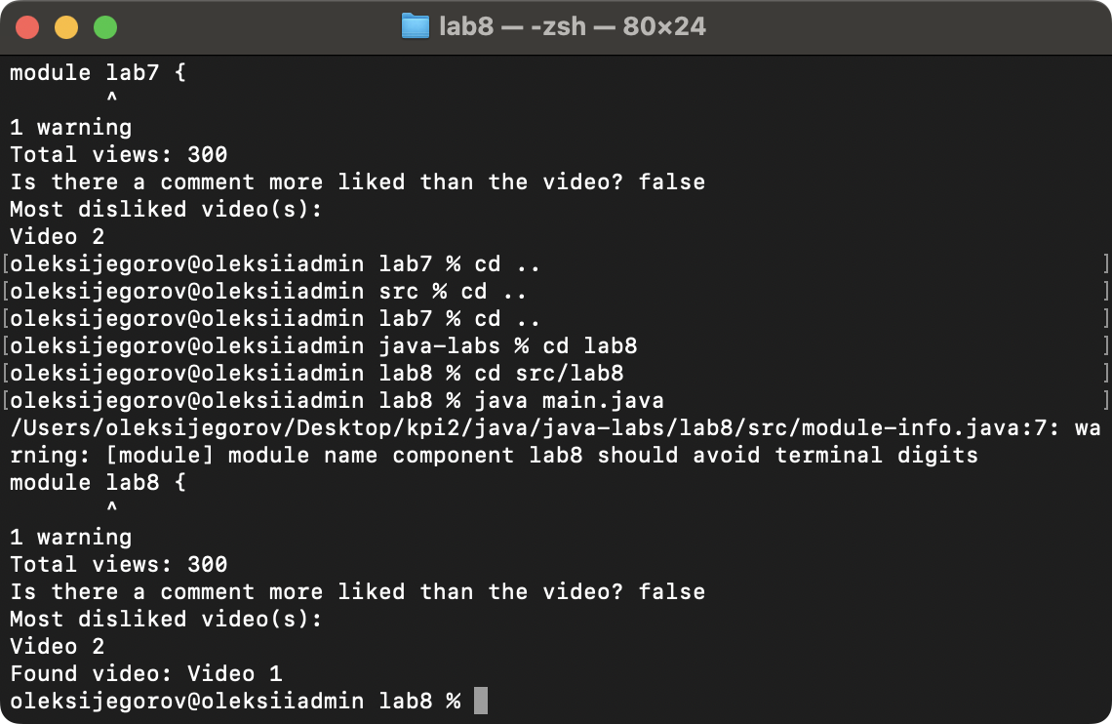

Контрольні запитання: