[QID] QJEEMM001

[QL] Easy

[Q] 

(a) 

(b) 

(c) 

(d) 

[QANS] d

[QTYPE] MCQ4

[QSOL] 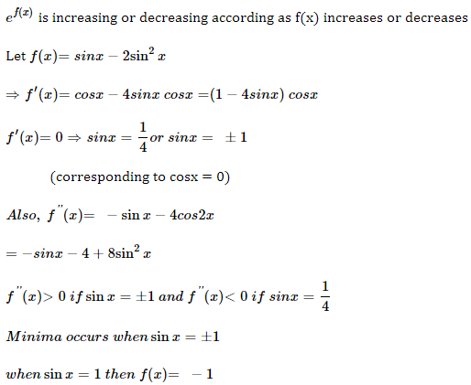

[QVSOL] <https://youtu.be/WO5UUCwnK6I?si=gUVqUtmoSs448hAJ>

[QID] QJEEMM002

[QL] Medium

[Q]   
(a) 

(b)   
(c) 

(d) 

[QANS] c

[QTYPE] MCQ4

[QSOL] 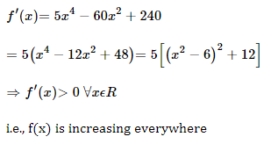

[QVSOL] <https://youtu.be/WO5UUCwnK6I?si=gUVqUtmoSs448hAJ>

[QID] QJEEMM003

[QL] Hard

[Q]   
(a) 

(b) 

(c) 

(d) 

[QANS] a

[QTYPE] MCQ4

[QSOL] 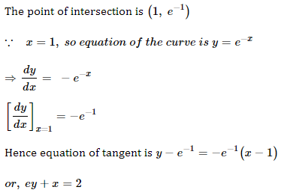

[QVSOL] <https://youtu.be/WO5UUCwnK6I?si=gUVqUtmoSs448hAJ>

[QID] QJEEMM004

[QL] Easy

[Q] 

(a) 

(b) 

(c) 

(d) 

[QANS] a

[QTYPE] MCQ4

[QSOL] 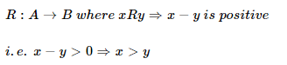

[QVSOL] <https://youtu.be/WO5UUCwnK6I?si=gUVqUtmoSs448hAJ>

[QID] QJEEMM005

[QL] Medium

[Q] 

(a) 

(b) 

(c) 

(d) 

[QANS] a

[QTYPE] MCQ4

[QSOL] 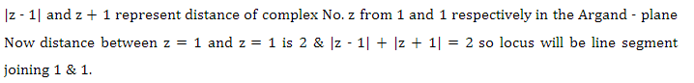

[QVSOL] <https://youtu.be/WO5UUCwnK6I?si=gUVqUtmoSs448hAJ>

[QID] QJEEMM006

[QL] Hard

[Q] 

(a) 

(b) 

(c) 

(d) 

[QANS] b

[QTYPE] MCQ4

[QSOL] 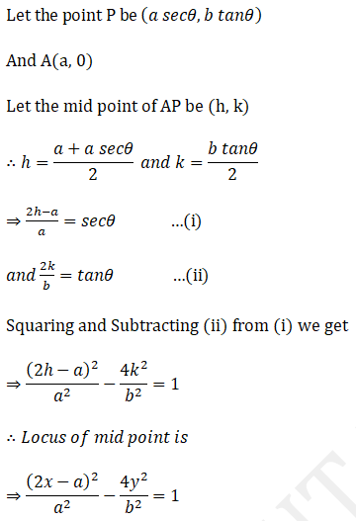  
  
[QVSOL] <https://youtu.be/WO5UUCwnK6I?si=gUVqUtmoSs448hAJ>

[QID] QJEEMM007

[QL] Easy

[Q] 

(a) 

(b) 

(c) 

(d) 

[QANS] b

[QTYPE] MCQ5

[QSOL] 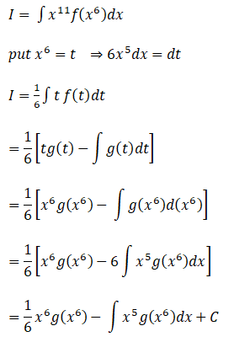

[QVSOL] <https://youtu.be/WO5UUCwnK6I?si=gUVqUtmoSs448hAJ>

[QID] QJEEMM008

[QL] Medium

[Q] 

(a) 

(b) 

(c) 

(d) 

(e) 

[QANS] c

[QTYPE] MCQ5

[QSOL] 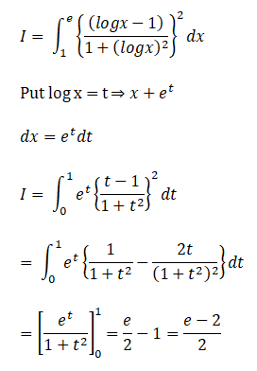

[QVSOL] <https://youtu.be/WO5UUCwnK6I?si=gUVqUtmoSs448hAJ>

[QID] QJEEMM009

[QL] Hard

[Q] 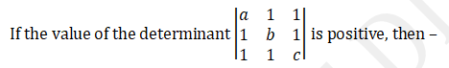

(a) 

(b) 

(c) 

(d) 

(e) 

[QANS] b

[QTYPE] MCQ5

[QSOL] 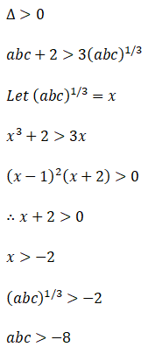

[QVSOL] <https://youtu.be/WO5UUCwnK6I?si=gUVqUtmoSs448hAJ>

[QID] QJEEMM010

[QL] Easy

[Q] 

(a) 

(b) 

(c) 

(d) 

(e) 

[QANS] a

[QTYPE] MCQ5

[QSOL] 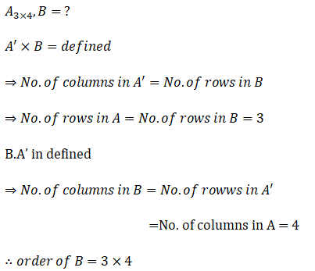

[QVSOL] <https://youtu.be/WO5UUCwnK6I?si=gUVqUtmoSs448hAJ>