[LN]Zero potential method introduction Lecture 1.

[LVL] https://youtu.be/Q3_fo0znNiw?si=ewD6T1_jbuVOyGsi

[EN]Zero Potential exercise set 1.

[EQ] 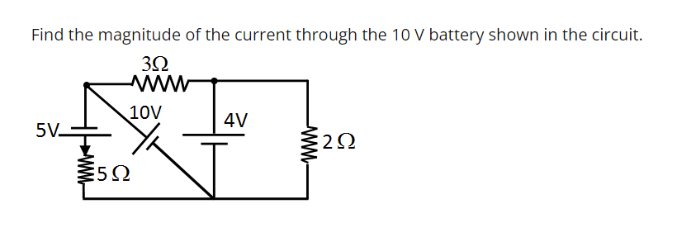

[EANS]5,A

[ESOL] <https://youtu.be/WO5UUCwnK6I?si=gUVqUtmoSs448hAJ>

[EQSID]1

[EQ] 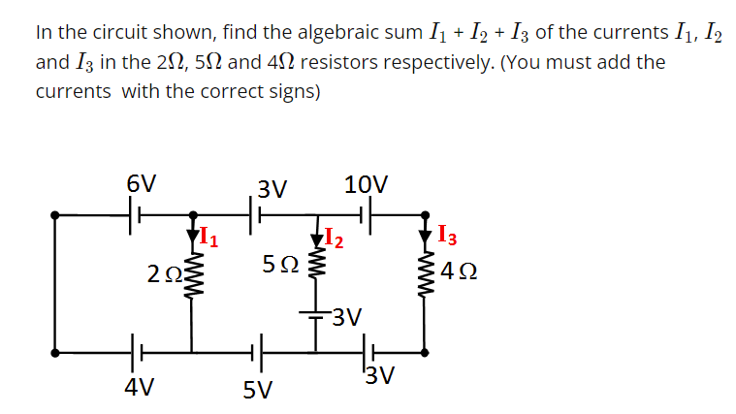

[EANS]-2.85,A

[ESOL] https://youtu.be/8_ewX1WbXSc?si=452DvtXSRLQ0ERu6

[EQSID]2

[EQ] 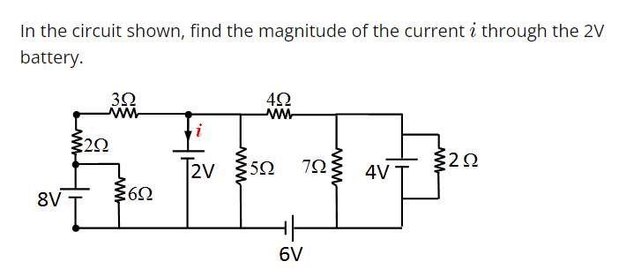

[EANS]2.8,A

[ESOL] https://youtu.be/WO5UUCwnK6I?si=gUVqUtmoSs448hAJ

[EQSID]3

[EQ] 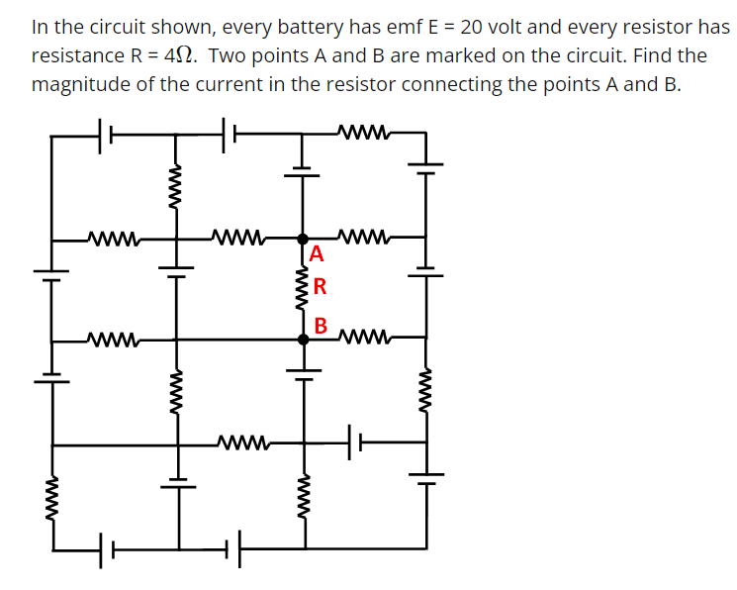

[EANS]30,A

[ESOL] https://youtu.be/8_ewX1WbXSc?si=452DvtXSRLQ0ERu6

[EQSID]4

[EQ] 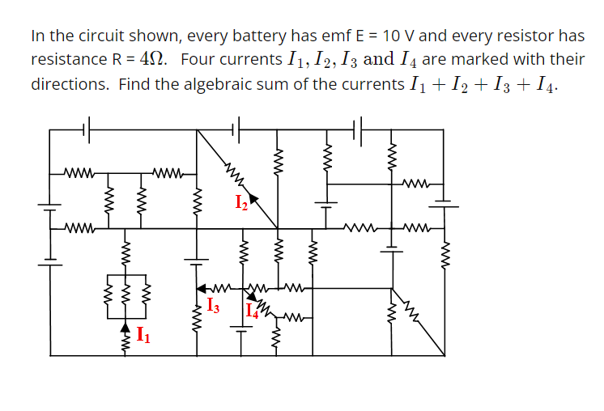

[EANS]6.309,A

[ESOL] https://youtu.be/8_ewX1WbXSc?si=452DvtXSRLQ0ERu6

[EQSID]5

[LN]Finding Unknown Potential.

[LVL] https://youtu.be/Q3_fo0znNiw?si=ewD6T1_jbuVOyGsi

[EN]Zero Potential exercise set 2.

[EQ] 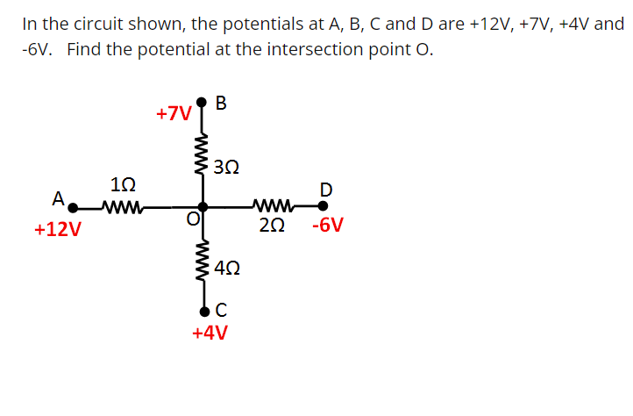

[EANS]39,A

[ESOL] https://youtu.be/8_ewX1WbXSc?si=452DvtXSRLQ0ERu6

[EQSID]1

[EQ] 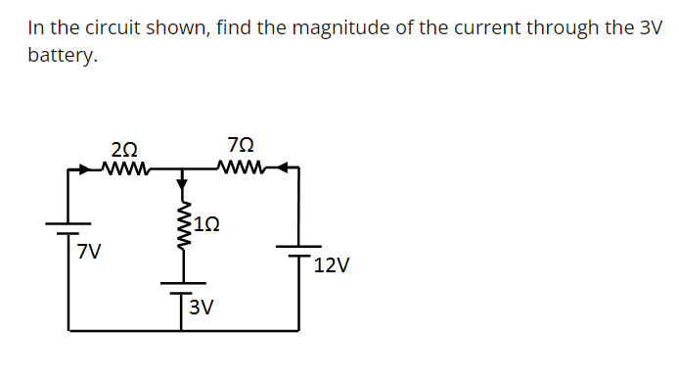

[EANS]6.309,A

[ESOL] https://youtu.be/8_ewX1WbXSc?si=452DvtXSRLQ0ERu6

[EQSID]2

[EQ] 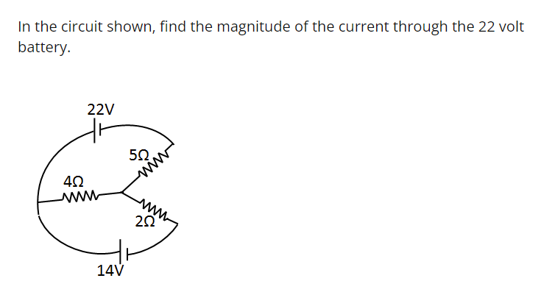

[EANS]9,A

[ESOL] https://youtu.be/8_ewX1WbXSc?si=452DvtXSRLQ0ERu6

[EQSID]3

[EQ] 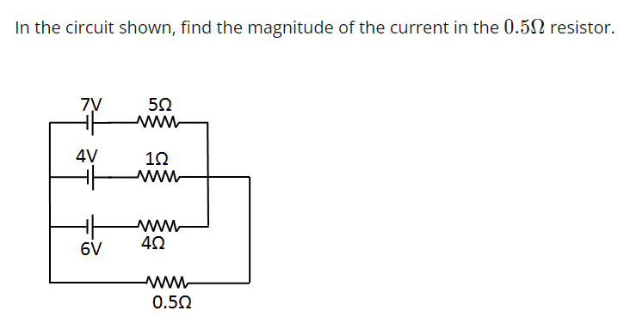

[EANS]6309,A

[ESOL] https://youtu.be/8_ewX1WbXSc?si=452DvtXSRLQ0ERu6

[EQSID]4

[LN]Flip Tip for Zero Potential Method Lecture 3.

[LVL] https://youtu.be/Q3_fo0znNiw?si=ewD6T1_jbuVOyGsi

[EN]Zero Potential exercise set 3.

[EQ] 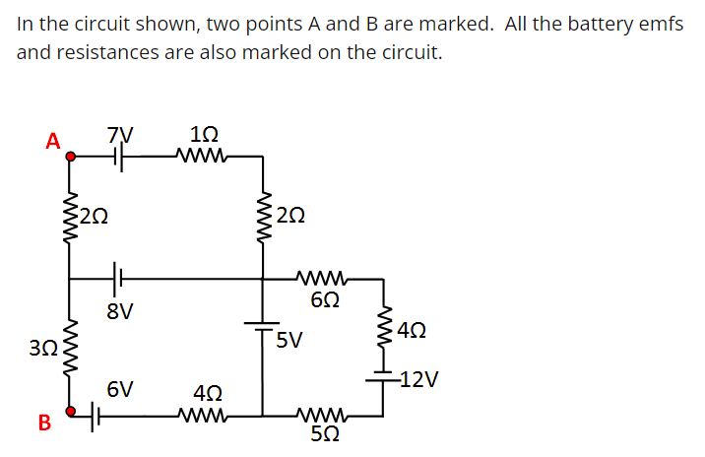

[EANS]6,A

[ESOL] https://youtu.be/8_ewX1WbXSc?si=452DvtXSRLQ0ERu6

[EQSID]1

[EQ]

[EANS]6.309,A

[ESOL] https://youtu.be/8_ewX1WbXSc?si=452DvtXSRLQ0ERu6

[EQSID]2

[EQ] 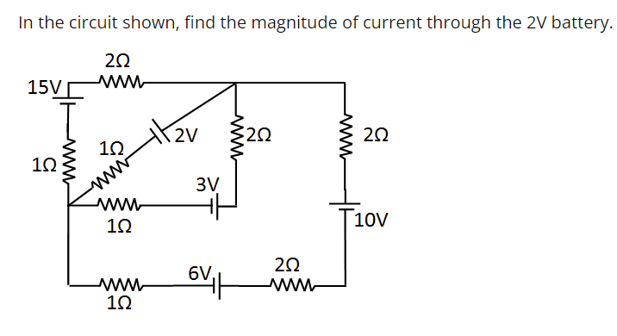

[EANS]9,A

[ESOL] https://youtu.be/8_ewX1WbXSc?si=452DvtXSRLQ0ERu6

[EQSID]3

[EQ] 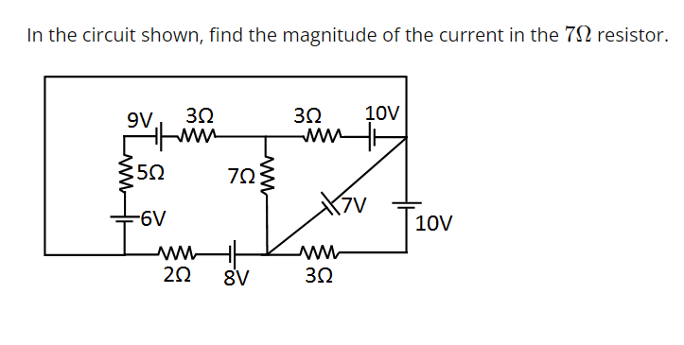

[EANS]0,A

[ESOL] https://youtu.be/8_ewX1WbXSc?si=452DvtXSRLQ0ERu6

[EQSID]4

[LN]Earthing Circuits Lecture 4.

[LVL] https://youtu.be/Q3_fo0znNiw?si=ewD6T1_jbuVOyGsi

[EN]Zero Potential exercise set 4.

[EQ] 

[EANS]5,A

[ESOL] <https://youtu.be/WO5UUCwnK6I?si=gUVqUtmoSs448hAJ>

[EQSID]1

[EQ] 

[EANS]-2.85,A

[ESOL] https://youtu.be/8_ewX1WbXSc?si=452DvtXSRLQ0ERu6

[EQSID]2

[EQ] 

[EANS]2.8,A

[ESOL] https://youtu.be/WO5UUCwnK6I?si=gUVqUtmoSs448hAJ

[EQSID]3

[EQ] 

[EANS]30,A

[ESOL] https://youtu.be/8_ewX1WbXSc?si=452DvtXSRLQ0ERu6

[EQSID]4

[EQ] 

[EANS]6.309,A

[ESOL] https://youtu.be/8_ewX1WbXSc?si=452DvtXSRLQ0ERu6

[EQSID]5

[LN]Zero Potential Method for Capacitors Lecture 5.

[LVL] https://youtu.be/Q3_fo0znNiw?si=ewD6T1_jbuVOyGsi

[EN]Zero Potential exercise set 5.

[EQ] 

[EANS]39,A

[ESOL] https://youtu.be/8_ewX1WbXSc?si=452DvtXSRLQ0ERu6

[EQSID]1

[EQ] 

[EANS]6.309,A

[ESOL] https://youtu.be/8_ewX1WbXSc?si=452DvtXSRLQ0ERu6

[EQSID]2

[EQ] 

[EANS]9,A

[ESOL] https://youtu.be/8_ewX1WbXSc?si=452DvtXSRLQ0ERu6

[EQSID]3