# Installing R

R is a free software environment for statistical computing and graphics. It compiles and runs on a wide variety of UNIX platforms, Windows and MacOS.

A download link and more information about R can be found at <https://www.r-project.org>

1. Click on the download link.
2. Choose a mirror near you.
3. Choose the download link for you operating system. If your computer is Windows 64bit, ensure you select the 64bit install if available.

The top of the download page will look something like the following:

### Download and Install R

Precompiled binary distributions of the base system and contributed packages, **Windows and Mac**users most likely want one of these versions of R:

* [Download R for Linux](http://cran.ms.unimelb.edu.au/bin/linux/)
* [Download R for (Mac) OS X](http://cran.ms.unimelb.edu.au/bin/macosx/)
* [Download R for Windows](http://cran.ms.unimelb.edu.au/bin/windows/)

R is part of many Linux distributions, you should check with your Linux package management system in addition to the link above.

If you have any problem downloading the software you will need to remove yourself from the Orica network. You can do this by;

1. Download it at home
2. Use your Mobile Internet connection

Note 1: DO NOT connect to the Orica network using Network Connect. It is the Orica network that causes the download problems.

Note 2: It is not a breach of Orica IT policy to install this software.

Note 3: As long as you follow these instructions to the given links, you will not be downloading any viruses or any other nasty software. R is used by thousands of universities, scientists and students, and it is therefore in everybody’s interest to ensure using R on any computer does not cause nasty infections.

* Install R using the default options.

R automatically installs a range of ‘Packages’ with associated data sets. There are many other packages that provide different tools and analysis methods that can be downloaded. We will be using a few of these, and they can be downloaded within the R environment. You will need to be on a non-Orica connection to install these.

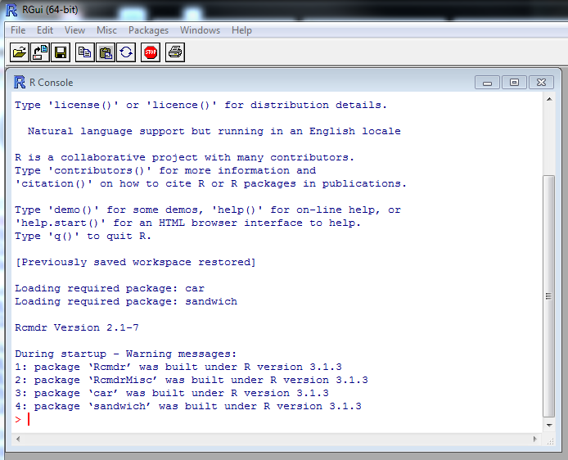Run R. You will see a very boring screen that looks like this.

Figure 1

The first thing you need to do is install some packages.

* Click on Package>Install Packages.
* Select a mirror that is close and click OK
* Scroll down to ‘Rcmdr’ and click OK. The package will install.
* Run (or load) the package by typing into the R window:

*library(Rcmdr)*

Now download and install the following packages:

* MASS
* fitdistrplus
* psych
* ggplot2