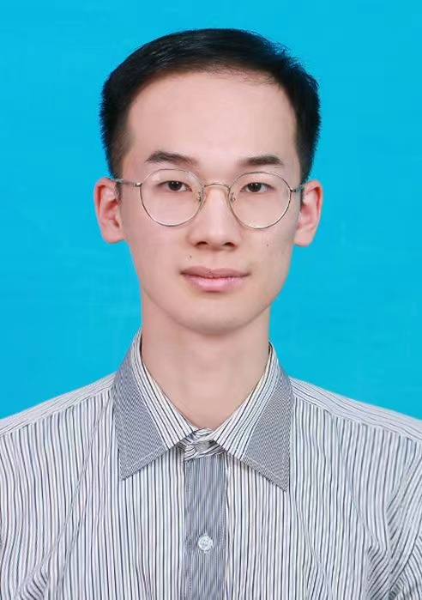

Resume:

Chen. Yihe, Shanghai
上海市浦东新区张江镇华夏中路393号
Phone: (86)China 18800208672

Professional Objective
To obtain teaching or researching position in the area of electrochemistry in an upper tier university/institution, or related applied jobs.

Education
2020-present
Shanghai Advanced Research Institution, CAS
ShanghaiTech University
Doctor’s of electrocatalysis
Individualized doctor's program in electrocatalysis.
Key courses: inorganic chemistry, electrochemistry principle, solid chemistry, etc.
Skill：Research&development of catalytic for new energy battery.
Minister of the graduate student union, Secretary of the branch of the Communist Youth League, Piano solo&Music technical director in several compaigns,
The total GPA3.58, Professional GPA3.63.

2016-2020
Zhengzhou University
Bachelor's of Chemical Engineering
Key courses: chemical principle, physical chemistry, organic chemistry, etc.
Associate director of Musician Union, President; Student Union Officer;
Vice director of marketing department of school entrepreneurship office;
Led the team to independently complete university level scientific research projects (photocatalysis series projects) and chemical design competition projects;
Participated in mathematical modeling national competition, American competition and other competitions, and won provincial or above awards;
The main founder of Zhengzhou University Feiyang Symphony Orchestra.

Special Skills
Electrocatalysis Pianist
Chemical simulation Methodological Design
Mathematical Modeling Data analysis skills

Work Experience

Sep 2020-present
Scientific Researchers
ShanghaiTech University & Shanghai Advanced Research Institution, CAS
Cultured the ability of electrocatalytic design and methodological innovation.
Worked on the project of electrocatalysis.

Sep 2020-present
Part-time teacher
Working independently as a chemistry teacher in high school for graduate students.
Piano teacher in music education institutions.
Developed a unique way of piano educating.
Further improved the ability of communication in educational occupations.
Formed my own teaching style.

References available upon request

