Site Visit Report

The team visited the north yard on 12 October 2026 to check the new storage area and the loading bays.


Figure 1: the north yard from the gate.

Status:  approved by the site manager.

Inspector | 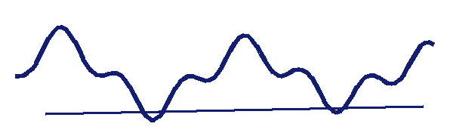
Company stamp | 

تمت زيارة الموقع والتأكد من جاهزية منطقة التخزين الجديدة.

Next steps
The loading bays will be painted before the end of the month.

Signed:

مع خالص الشكر لفريق العمل.

