WEBSITE BUSINESS SPECIFICATION & FUNCTIONAL INVENTORY
Auto-Generated Site Specification & Business Feature Catalog

Audit Parameter | Crawler Specification Detail
Target URL | http://localhost:3009/test-self-healing.html
Crawl Mode | Business Auto-Doc Mode (High-Level Summary)
Crawl Date/Time | May 31, 2026 at 4:38 PM
AI Explorer Model | qwen2.5-coder:7b (Ollama)
Browser Executed | CHROME (Headless)
1. Site Sitemap & Route Inventory
Below is the list of unique page routes mapped by the AI crawler, along with their detected heading hierarchies.
No. | Page Title | Visited URL Pathname | Heading Hierarchy Detected
1. | Self-Healing Test Sandbox | /test-self-healing.html | H1: "Self-Healing Test Sandbox"
2. Business Feature Catalog (Functional Inventory)
A comprehensive catalog of major UI elements, components, and sections discovered on each page, written in plain business English describing their functional use and business value.
Page Name | Feature/Component | Functional Description | Business / User Value
/test-self-healing.html | User Email Input Field | Allows users to enter their email address for authentication purposes. | Enables seamless user registration and login, enhancing customer convenience.
/test-self-healing.html | General Text Input Field | Provides a text input field for users to enter various types of information. | Supports flexible data collection, aiding in user surveys and feedback.
/test-self-healing.html | Username Input in Modal | Enables users to enter their username within a modal dialog for secure login. | Enhances security by isolating sensitive input, protecting user data.
/test-self-healing.html | Obstructed Button | A button that may be partially obstructed or have other elements covering it. | Needs to be investigated for usability issues, ensuring all buttons are accessible.
/test-self-healing.html | Login Submit Button | Allows users to submit their login credentials for authentication. | Enables quick and secure access to the platform, improving user experience.
/test-self-healing.html | Interactive Target Button | A button that may be covered or obstructed by other elements on the page. | Needs to be investigated for usability issues, ensuring all buttons are accessible.
/test-self-healing.html | Close Modal Button | Enables users to close a modal dialog or form window. | Improves user experience by providing an easy way to exit forms or dialogs.
3. User Journey & Visual Walkthrough
Below is the detailed visual walkthrough representing the exact sequence of navigations and actions triggered during exploration, along with functional intents and screenshot proofs.
Step 1: Navigate to http://localhost:3009/test-self-healing.html
Functional Intent: "Initial page load"
Flow Transition: `Start` ⟶ `/test-self-healing.html` [Browser: CHROME]
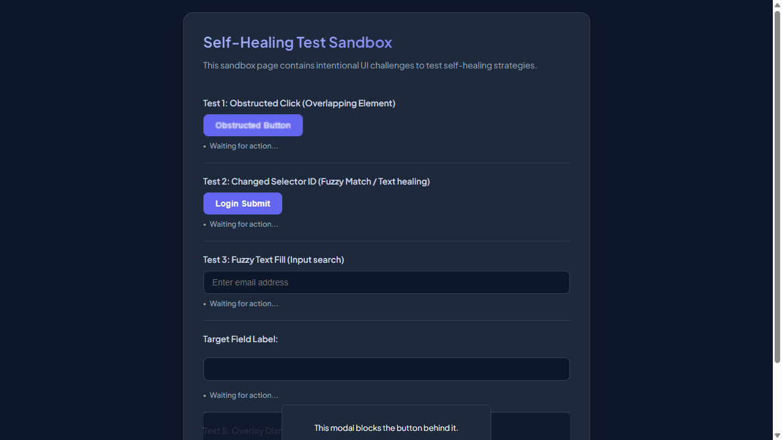

━━━━━━━━━━━━━━━━━━━━━━━━━━━━━━━━━━━━━━━━━━━━━
Step 2: [R1] click → #healed-login-submit
Functional Intent: "Initiate user login process to test system recovery"
Flow Transition: `/test-self-healing.html` ⟶ `/test-self-healing.html` [Browser: CHROME]
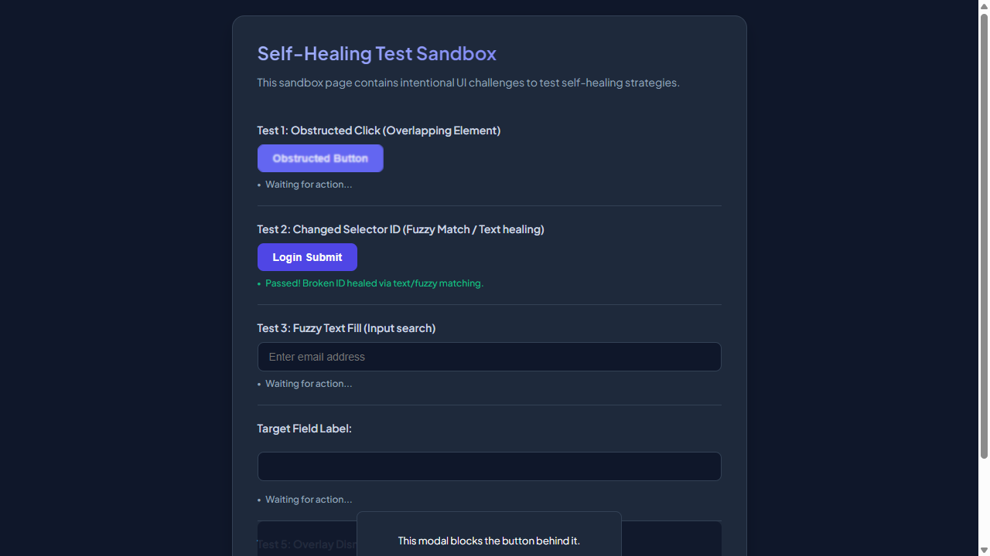

━━━━━━━━━━━━━━━━━━━━━━━━━━━━━━━━━━━━━━━━━━━━━
Step 3: [R1] screenshot
Functional Intent: "Capture login form after successful submission to verify state"
Flow Transition: `/test-self-healing.html` ⟶ `/test-self-healing.html` [Browser: CHROME]

━━━━━━━━━━━━━━━━━━━━━━━━━━━━━━━━━━━━━━━━━━━━━
Step 4: [R1] scroll → body
Functional Intent: "Scroll down to test infinite scroll functionality"
Flow Transition: `/test-self-healing.html` ⟶ `/test-self-healing.html` [Browser: CHROME]

━━━━━━━━━━━━━━━━━━━━━━━━━━━━━━━━━━━━━━━━━━━━━
Step 5: [R1] click → .modal-close-button
Functional Intent: "Close modal to ensure it can be reopened and closed repeatedly"
Flow Transition: `/test-self-healing.html` ⟶ `/test-self-healing.html` [Browser: CHROME]
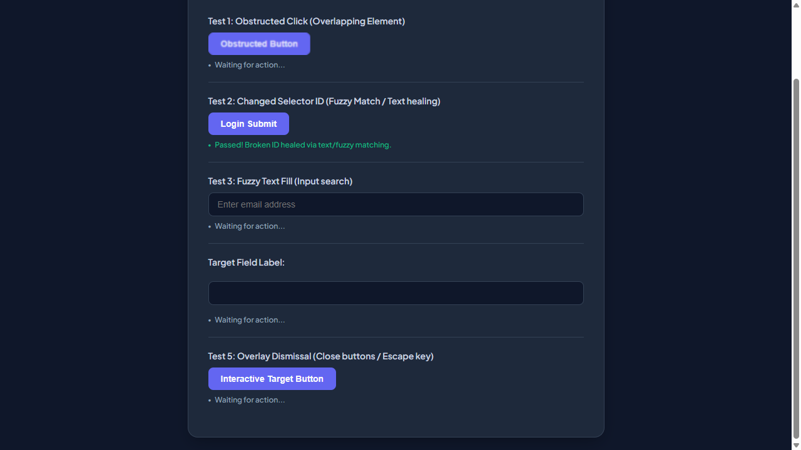

━━━━━━━━━━━━━━━━━━━━━━━━━━━━━━━━━━━━━━━━━━━━━
Step 6: [R2] click → #user-email-address
Functional Intent: "Enter user's email address for login process"
Flow Transition: `/test-self-healing.html` ⟶ `/test-self-healing.html` [Browser: CHROME]
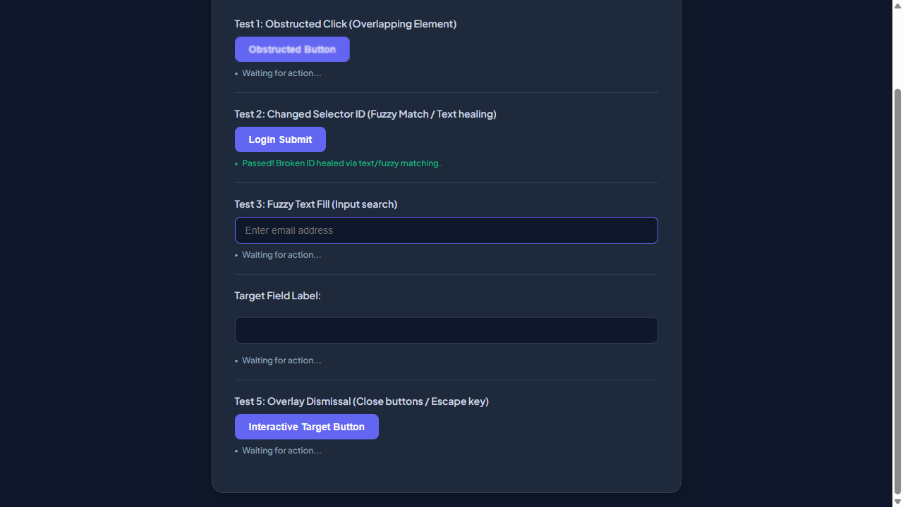

━━━━━━━━━━━━━━━━━━━━━━━━━━━━━━━━━━━━━━━━━━━━━
Step 7: [R2] fill → input[type="text"]
Functional Intent: "Enter user's password for login process"
Flow Transition: `/test-self-healing.html` ⟶ `/test-self-healing.html` [Browser: CHROME]
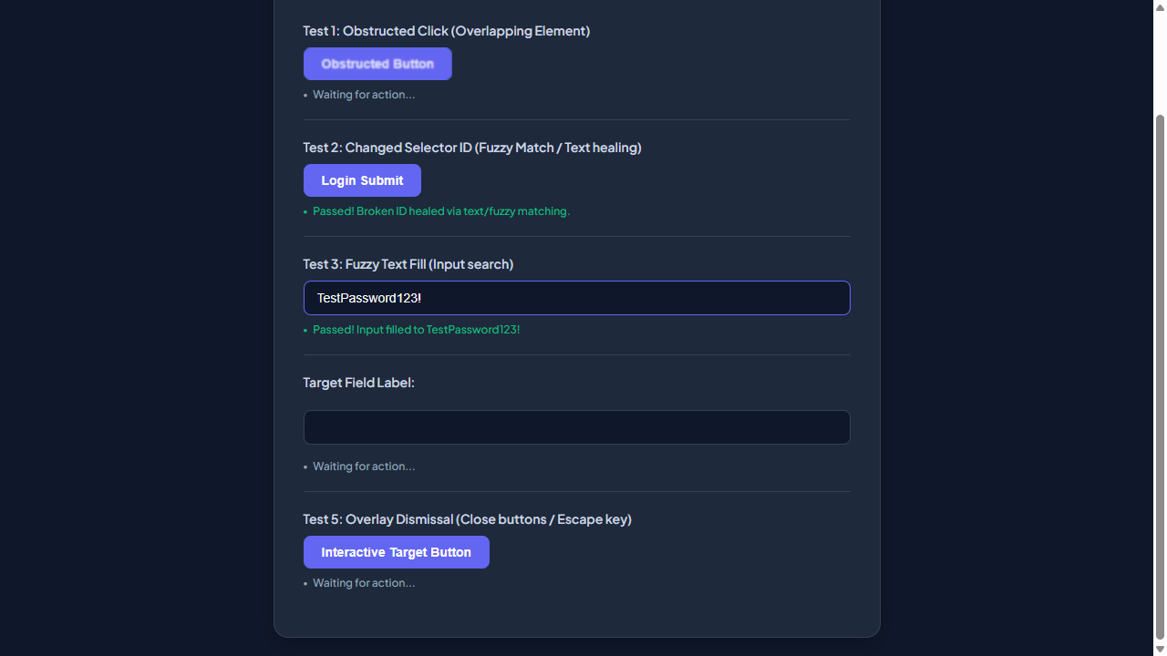

━━━━━━━━━━━━━━━━━━━━━━━━━━━━━━━━━━━━━━━━━━━━━
Step 8: [R2] click → #healed-login-submit
Functional Intent: "Submit the login form to authenticate user"
Flow Transition: `/test-self-healing.html` ⟶ `/test-self-healing.html` [Browser: CHROME]




