WEBSITE FUNCTIONAL SPECIFICATION & LOCATOR REGISTRY
Auto-Generated Site Specification & Page Object Model Draft

Audit Parameter | Crawler Specification Detail
Target URL | http://localhost:3009/test-self-healing.html
Crawl Mode | Site Documentation Mode (Auto-Doc)
Crawl Date/Time | 28/05/2026, 19:57:04
AI Explorer Model | qwen2.5-coder:7b
Browser Executed | CHROME (Headless)
1. Site Sitemap & Route Inventory
Below is the list of unique URLs and page titles mapped by the AI crawler, along with their detected heading hierarchies.
No. | Page Title | Visited URL Pathname | Heading Hierarchy Detected
1 | Self-Healing Test Sandbox | /test-self-healing.html | H1: "Self-Healing Test Sandbox"
2. Component Locator Catalog (Page Object Model Draft)
The table below contains pre-identified stable CSS selectors for visible fields, inputs, and buttons discovered on each page path. Use these locators to construct automated test scripts.
Page Title / Path | Element Name / Value | Action | Stable Selector | Description / Purpose
/test-self-healing.html | Enter email address | fill | #user-email-address | Input field with placeholder "Enter email address"
/test-self-healing.html | Interactive Element | fill | input[type="text"] | text component on page
/test-self-healing.html | Enter username in modal | fill | #covered-input | Input field with placeholder "Enter username in modal"
/test-self-healing.html | Obstructed Button | click | #obstructed-btn | button component on page
/test-self-healing.html | Login Submit | click | #healed-login-submit | button component on page
/test-self-healing.html | Interactive Target Button | click | #covered-btn | button component on page
/test-self-healing.html | Close Modal | click | button.modal-close-button | button component on page
3. User Journey & Visual Walkthrough
Below is the detailed traversal log representing the exact sequence of clicks, navigation states, and text entry actions triggered by the AI agent during the exploration.
Step 1: Navigate to http://localhost:3009/test-self-healing.html
Flow Transition: `Start` ⟶ `/test-self-healing.html` [Browser: CHROME]
AI Rationale: Initial page load
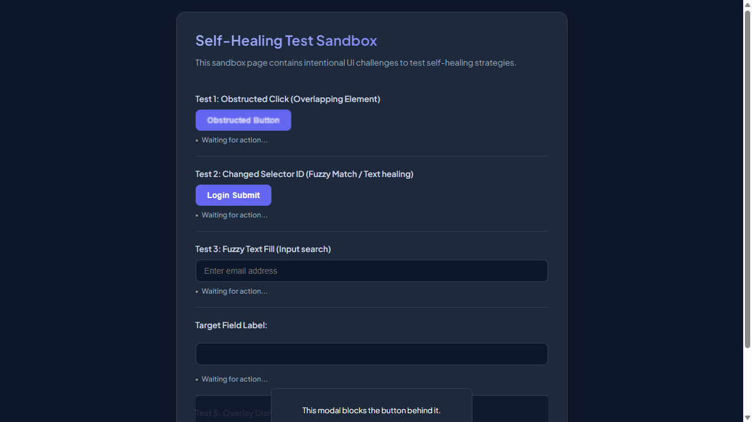
━━━━━━━━━━━━━━━━━━━━━━━━━━━━━━━━━━━━━━━━━━━━━
Step 2: [R1] screenshot
Flow Transition: `/test-self-healing.html` ⟶ `/test-self-healing.html` [Browser: CHROME]
AI Rationale: Capture initial state
━━━━━━━━━━━━━━━━━━━━━━━━━━━━━━━━━━━━━━━━━━━━━
Step 3: [R1] click → #covered-btn
Flow Transition: `/test-self-healing.html` ⟶ `/test-self-healing.html` [Browser: CHROME]
AI Rationale: Identify interactive target button
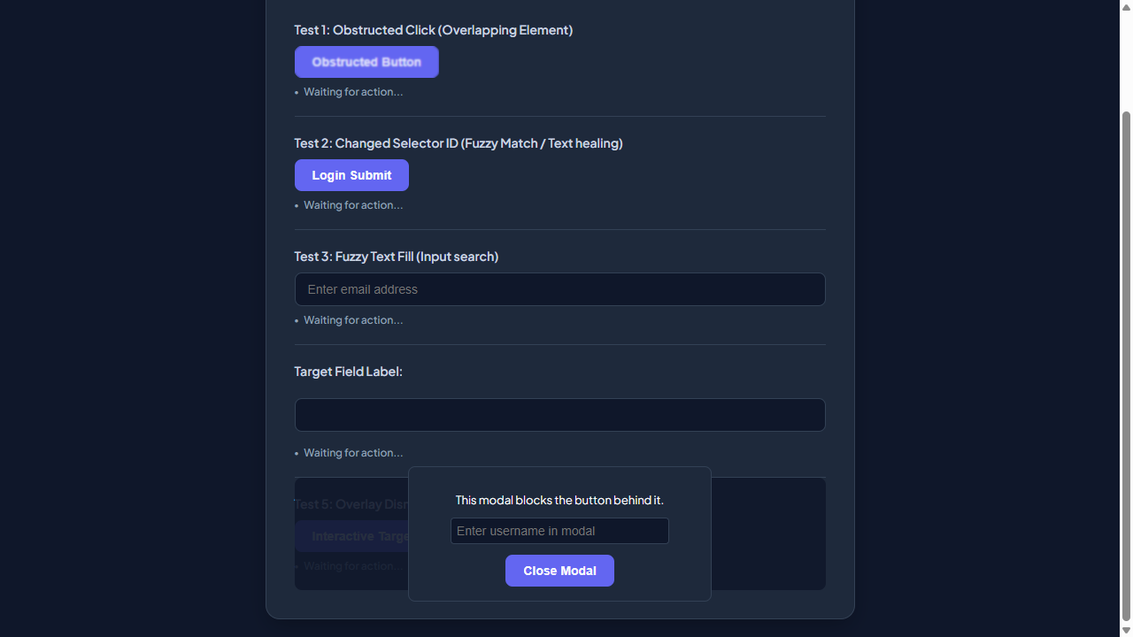
━━━━━━━━━━━━━━━━━━━━━━━━━━━━━━━━━━━━━━━━━━━━━
Step 4: [R1] fill → #user-email-address
Flow Transition: `/test-self-healing.html` ⟶ `/test-self-healing.html` [Browser: CHROME]
AI Rationale: Fill email input
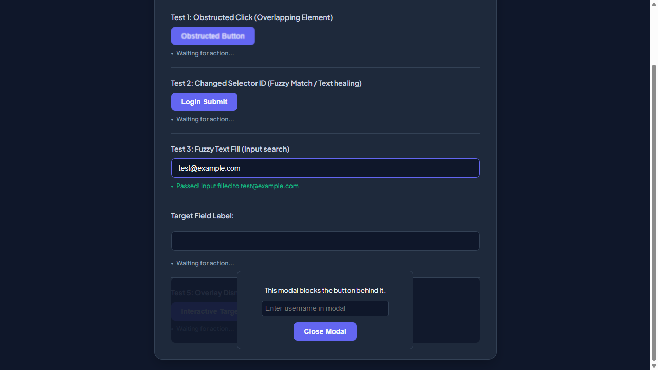
━━━━━━━━━━━━━━━━━━━━━━━━━━━━━━━━━━━━━━━━━━━━━
Step 5: [R1] click → #healed-login-submit
Flow Transition: `/test-self-healing.html` ⟶ `/test-self-healing.html` [Browser: CHROME]
AI Rationale: Submit the login form
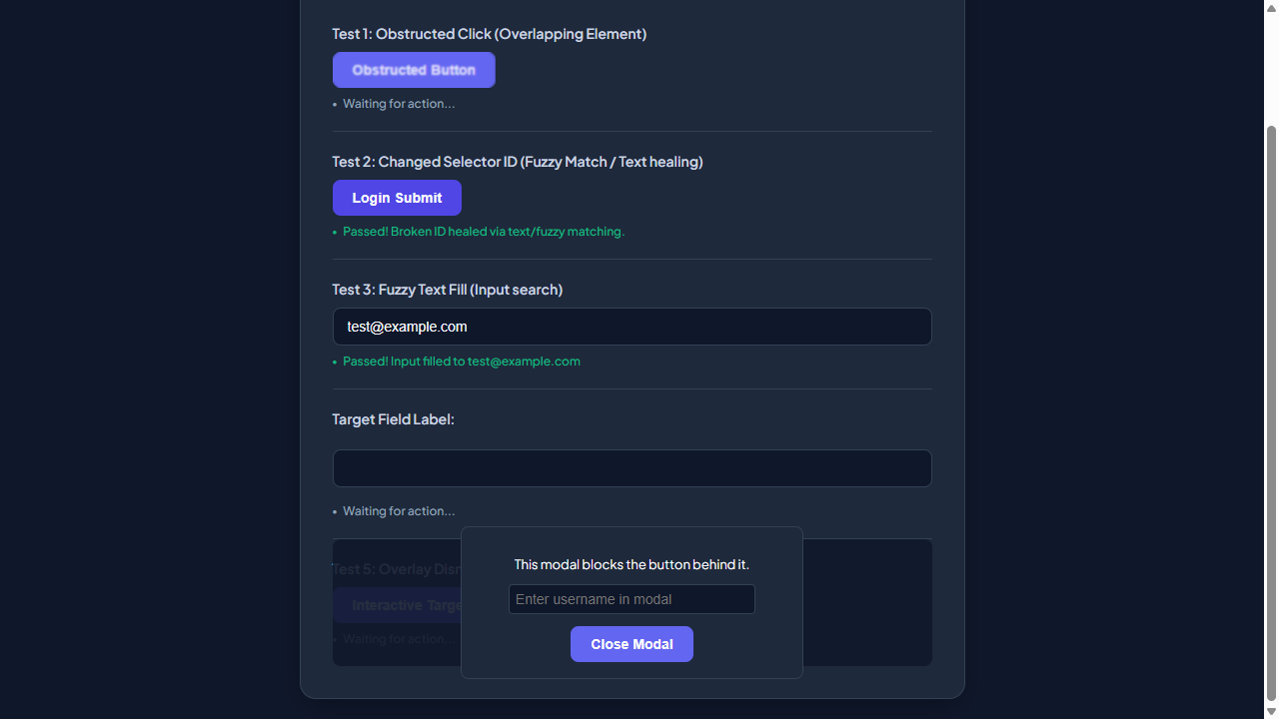
━━━━━━━━━━━━━━━━━━━━━━━━━━━━━━━━━━━━━━━━━━━━━
Step 6: [R1] wait
Flow Transition: `/test-self-healing.html` ⟶ `/test-self-healing.html` [Browser: CHROME]
AI Rationale: Wait for page to respond
━━━━━━━━━━━━━━━━━━━━━━━━━━━━━━━━━━━━━━━━━━━━━
Step 7: [R2] screenshot
Flow Transition: `/test-self-healing.html` ⟶ `/test-self-healing.html` [Browser: CHROME]
AI Rationale: Capture initial state
━━━━━━━━━━━━━━━━━━━━━━━━━━━━━━━━━━━━━━━━━━━━━

