WEBSITE FUNCTIONAL SPECIFICATION & LOCATOR REGISTRY
Auto-Generated Site Specification & Page Object Model Draft

Audit Parameter | Crawler Specification Detail
Target URL | https://ecommerce-playground.lambdatest.io/
Crawl Mode | Site Documentation Mode (Auto-Doc)
Crawl Date/Time | 28/05/2026, 20:07:29
AI Explorer Model | qwen2.5-coder:7b
Browser Executed | CHROME (Headless)
1. Site Sitemap & Route Inventory
Below is the list of unique URLs and page titles mapped by the AI crawler, along with their detected heading hierarchies.
No. | Page Title | Visited URL Pathname | Heading Hierarchy Detected
1 | Your Store | / | H3: "Mobiles"  H3: "Laptops"  H3: "Accessories"  H3: "Smart Wearable"  H3: "Tablets"  H3: "Computers"  H3: "Sound System"  H3: "Top Trending Categories"  H3: "Top Products"  H2: "Latest Range of Earphones"  H3: "Top Collection"  H3: "Under @99"  H3: "From The Blog"
2 | Search - | /index.php | H3: "Mobiles"  H3: "Laptops"  H3: "Accessories"  H3: "Smart Wearable"  H3: "Tablets"  H3: "Computers"  H3: "Sound System"  H1: "Search -"  H3: "Filter"
2. Component Locator Catalog (Page Object Model Draft)
The table below contains pre-identified stable CSS selectors for visible fields, inputs, and buttons discovered on each page path. Use these locators to construct automated test scripts.
Page Title / Path | Element Name / Value | Action | Stable Selector | Description / Purpose
/ | search | fill | [name="search"] | Input field with placeholder "Search For Products"
/ | Edit cart | click | button.icon-right | button component on page
/ | Interactive Element | click | button.icon-left | button component on page
/ | All Categories | click | button.btn | button component on page
/ | Search | click | button.type-text | button component on page
/ | 0 0 item(s) - $0.00 | click | button.cart | button component on page
/index.php | mz_fp[min] | fill | [name="mz_fp[min]"] | Input field with placeholder "Minimum Price"
/index.php | mz_fp[max] | fill | [name="mz_fp[max]"] | Input field with placeholder "Maximum Price"
/index.php | mz_fm | fill | #mz-fm-1-8 | checkbox component on page
/index.php | mz_fm | fill | #mz-fm-1-9 | checkbox component on page
/index.php | mz_fm | fill | #mz-fm-1-7 | checkbox component on page
/index.php | mz_fm | fill | #mz-fm-1-5 | checkbox component on page
/index.php | mz_fm | fill | #mz-fm-1-11 | checkbox component on page
/index.php | mz_fm | fill | #mz-fm-1-6 | checkbox component on page
/index.php | mz_fm | fill | #mz-fm-1-10 | checkbox component on page
/index.php | mz_fq | fill | [name="mz_fq"] | Input field with placeholder "Search"
/index.php | Edit cart | click | button.icon-right | button component on page
/index.php | Interactive Element | click | button.icon-left | button component on page
/index.php | All Categories | click | button.btn | button component on page
/index.php | Search | click | button.type-text | button component on page
/index.php | 0 0 item(s) - $0.00 | click | button.cart | button component on page
3. User Journey & Visual Walkthrough
Below is the detailed traversal log representing the exact sequence of clicks, navigation states, and text entry actions triggered by the AI agent during the exploration.
Step 1: Navigate to https://ecommerce-playground.lambdatest.io/
Flow Transition: `Start` ⟶ `/` [Browser: CHROME]
AI Rationale: Initial page load
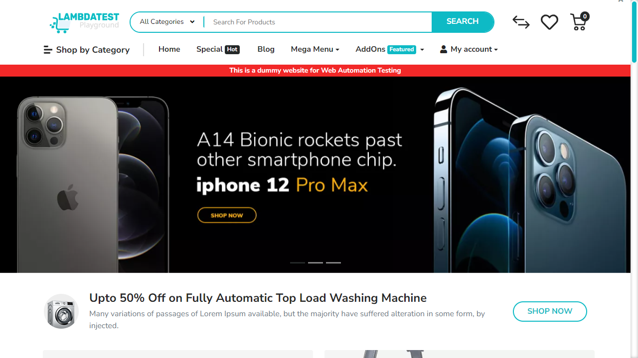
━━━━━━━━━━━━━━━━━━━━━━━━━━━━━━━━━━━━━━━━━━━━━
Step 2: [R1] screenshot
Flow Transition: `/` ⟶ `/` [Browser: CHROME]
AI Rationale: Capture initial state
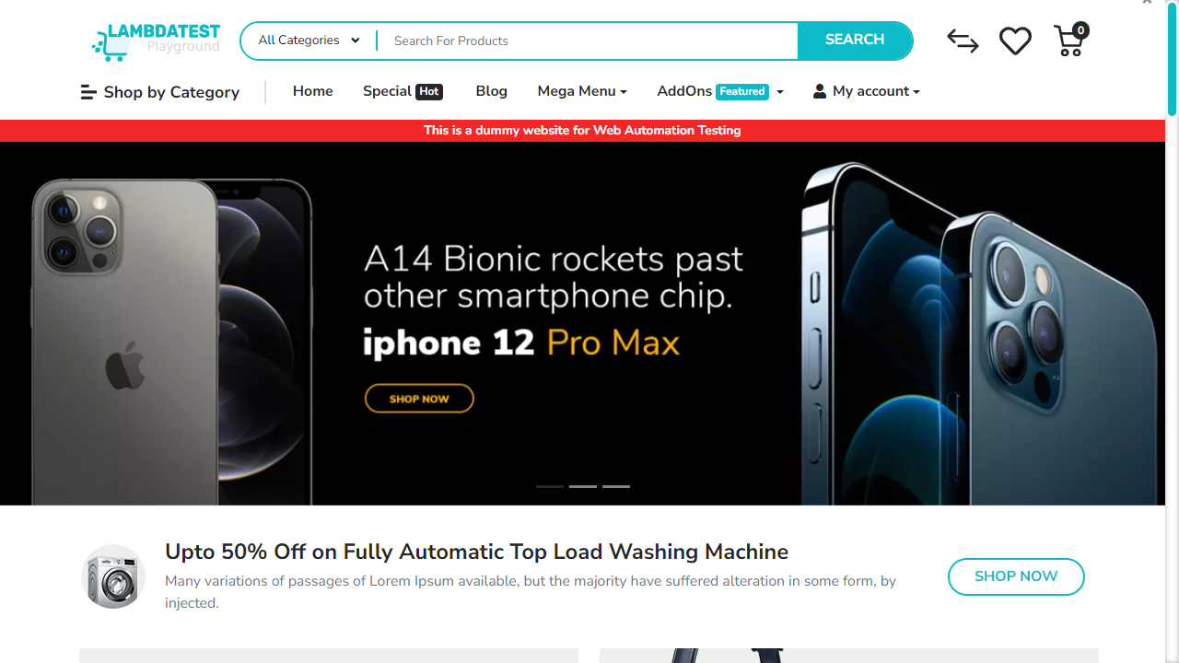
━━━━━━━━━━━━━━━━━━━━━━━━━━━━━━━━━━━━━━━━━━━━━
Step 3: [R1] click → button.btn
Flow Transition: `/` ⟶ `/` [Browser: CHROME]
AI Rationale: Navigate to All Categories page
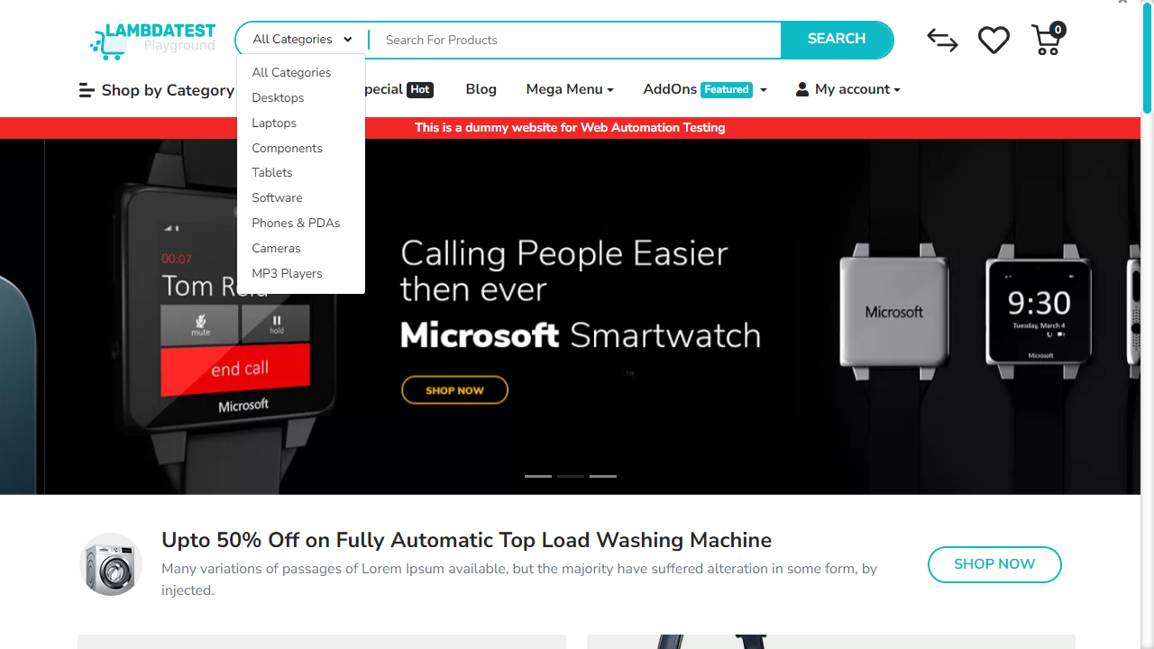
━━━━━━━━━━━━━━━━━━━━━━━━━━━━━━━━━━━━━━━━━━━━━
Step 4: [R2] click → button.btn
Flow Transition: `/` ⟶ `/` [Browser: CHROME]
AI Rationale: Click on 'All Categories' button to explore more sections
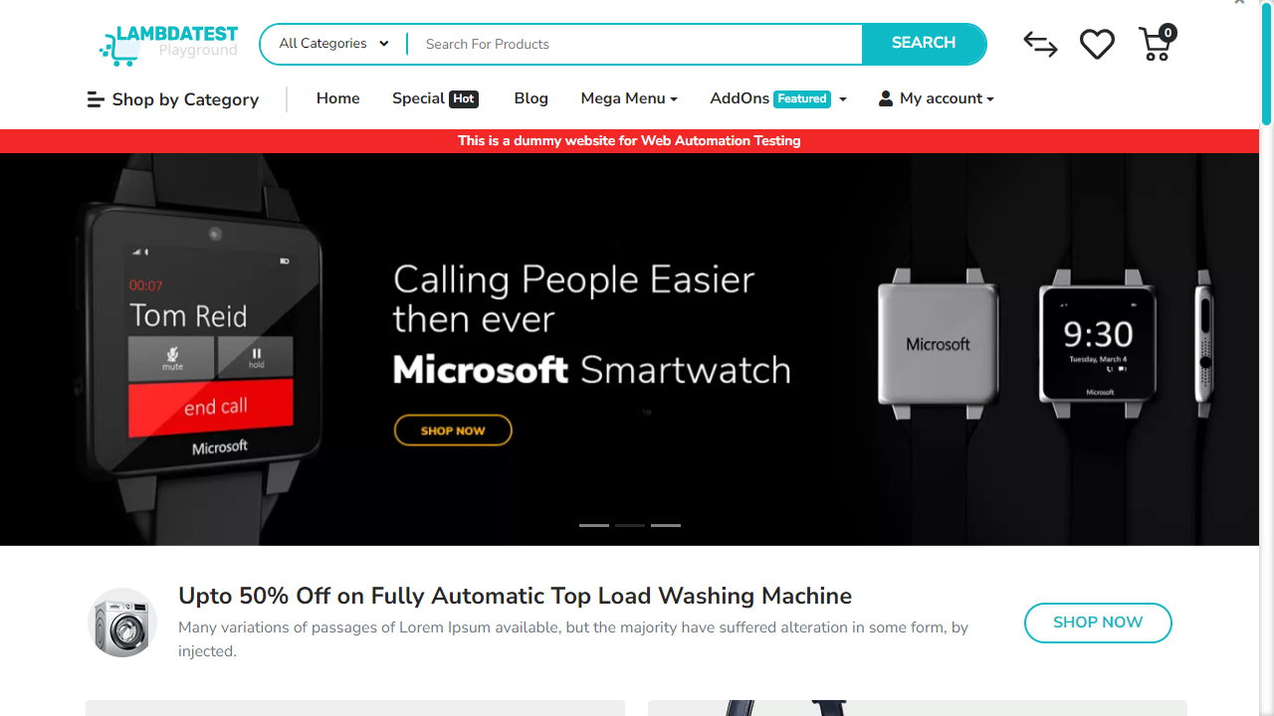
━━━━━━━━━━━━━━━━━━━━━━━━━━━━━━━━━━━━━━━━━━━━━
Step 5: [R2] click → a.icon-left
Flow Transition: `/` ⟶ `/index.php` [Browser: CHROME]
AI Rationale: Navigate to 'Phone, Tablets & Ipod' section
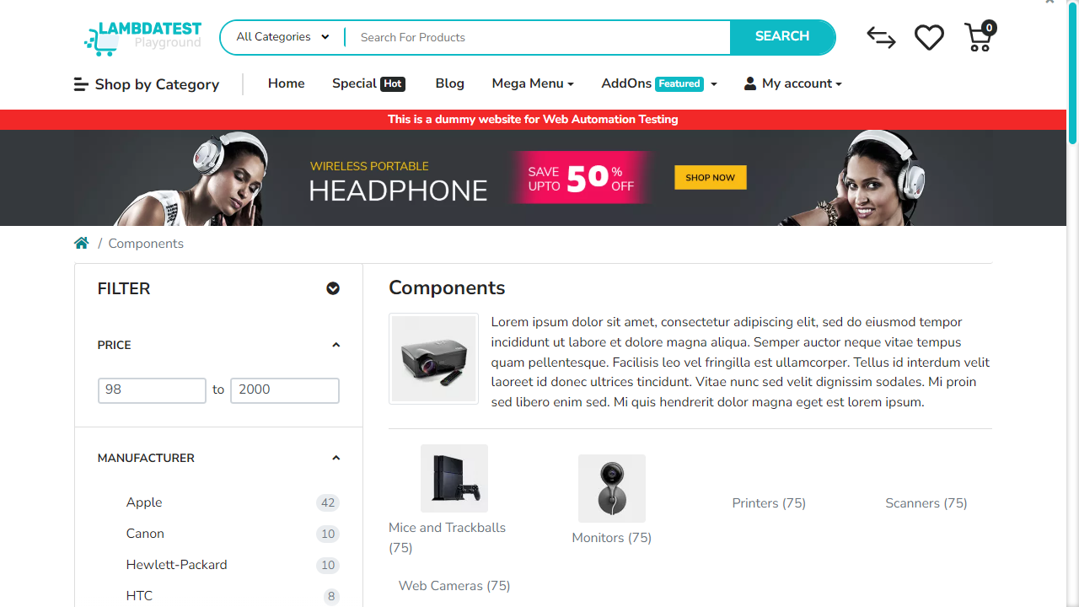
━━━━━━━━━━━━━━━━━━━━━━━━━━━━━━━━━━━━━━━━━━━━━
Step 6: [R2] screenshot
Flow Transition: `/index.php` ⟶ `/index.php` [Browser: CHROME]
AI Rationale: Capture the product list for 'Phone, Tablets & Ipod'
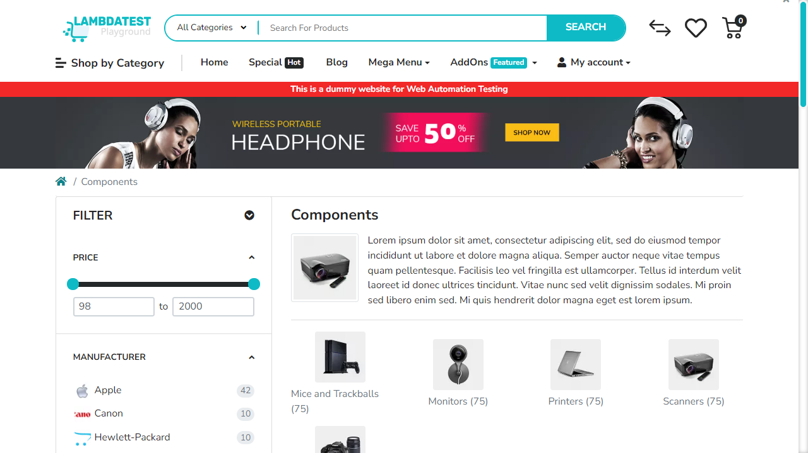
━━━━━━━━━━━━━━━━━━━━━━━━━━━━━━━━━━━━━━━━━━━━━
Step 7: [R2] click → a[name='search']
Flow Transition: `/index.php` ⟶ `/index.php` [Browser: CHROME]
AI Rationale: Focus on search input to type a query
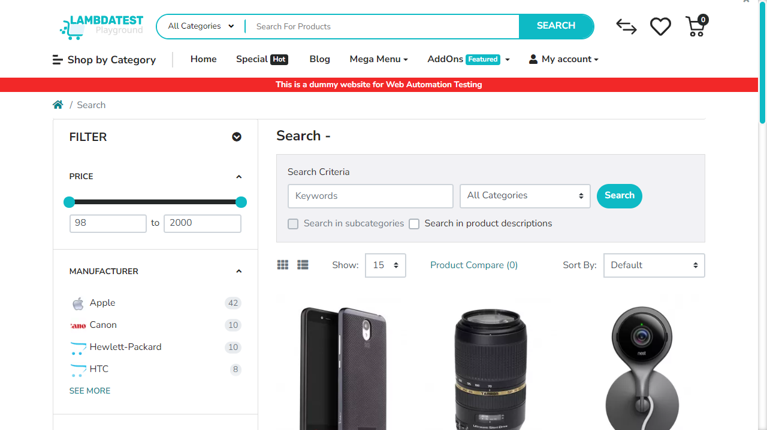
━━━━━━━━━━━━━━━━━━━━━━━━━━━━━━━━━━━━━━━━━━━━━
Step 8: [R2] fill → input[name='search']
Flow Transition: `/index.php` ⟶ `/index.php` [Browser: CHROME]
AI Rationale: Type 'iPhone 14' in the search box
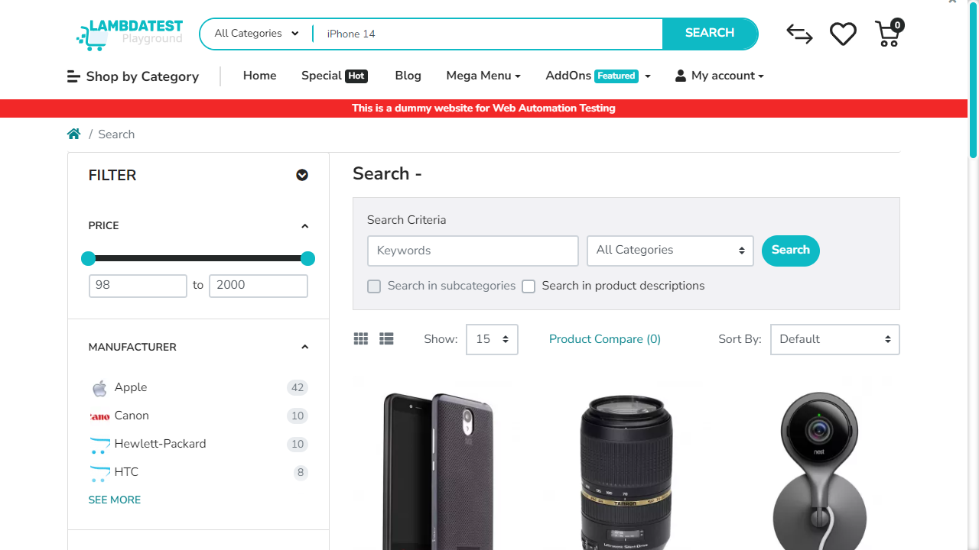
━━━━━━━━━━━━━━━━━━━━━━━━━━━━━━━━━━━━━━━━━━━━━
Step 9: [R3] click → button.btn
Flow Transition: `/index.php` ⟶ `/index.php` [Browser: CHROME]
AI Rationale: Navigate to 'All Categories' page



