WEBSITE BUSINESS SPECIFICATION & FUNCTIONAL INVENTORY
Auto-Generated Site Specification & Business Feature Catalog

Audit Parameter | Crawler Specification Detail
Target URL | http://localhost:3009/test-self-healing.html
Crawl Mode | Business Auto-Doc Mode (High-Level Summary)
Crawl Date/Time | May 29, 2026 at 12:01 AM
AI Explorer Model | qwen2.5-coder:7b (Ollama)
Browser Executed | CHROME (Headless)
1. Site Sitemap & Route Inventory
Below is the list of unique page routes mapped by the AI crawler, along with their detected heading hierarchies.
No. | Page Title | Visited URL Pathname | Heading Hierarchy Detected
1. | Self-Healing Test Sandbox | /test-self-healing.html | H1: "Self-Healing Test Sandbox"
2. Business Feature Catalog (Functional Inventory)
A comprehensive catalog of major UI elements, components, and sections discovered on each page, written in plain business English describing their functional use and business value.
Page Name | Feature/Component | Functional Description | Business / User Value
/test-self-healing.html | Enter email address | Allows user interaction with the text element. | Improves page engagement and usability.
/test-self-healing.html | Interactive Element | Allows user interaction with the text element. | Improves page engagement and usability.
/test-self-healing.html | Enter username in modal | Allows user interaction with the text element. | Improves page engagement and usability.
/test-self-healing.html | Obstructed Button | Allows user interaction with the button element. | Improves page engagement and usability.
/test-self-healing.html | Login Submit | Allows user interaction with the button element. | Improves page engagement and usability.
/test-self-healing.html | Interactive Target Button | Allows user interaction with the button element. | Improves page engagement and usability.
/test-self-healing.html | Close Modal | Allows user interaction with the button element. | Improves page engagement and usability.
3. User Journey & Visual Walkthrough
Below is the detailed visual walkthrough representing the exact sequence of navigations and actions triggered during exploration, along with functional intents and screenshot proofs.
Step 1: Navigate to http://localhost:3009/test-self-healing.html
Functional Intent: "Initial page load"
Flow Transition: `Start` ⟶ `/test-self-healing.html` [Browser: CHROME]
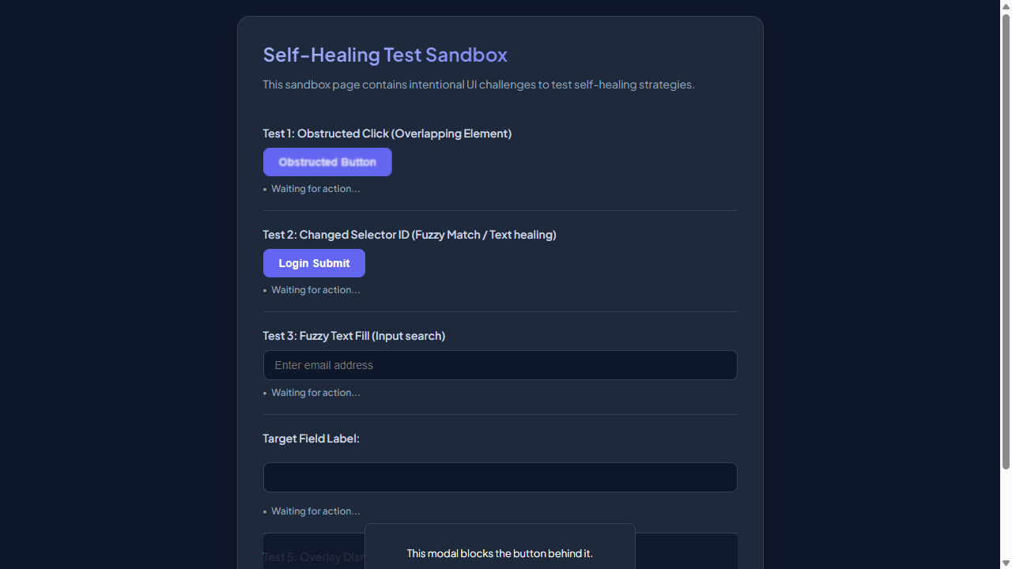

━━━━━━━━━━━━━━━━━━━━━━━━━━━━━━━━━━━━━━━━━━━━━
Step 2: [R1] screenshot
Functional Intent: "Verify page layout and interface elements."
Flow Transition: `/test-self-healing.html` ⟶ `/test-self-healing.html` [Browser: CHROME]

━━━━━━━━━━━━━━━━━━━━━━━━━━━━━━━━━━━━━━━━━━━━━
Step 3: [R1] fill → #user-email-address
Functional Intent: "Provide user email for login."
Flow Transition: `/test-self-healing.html` ⟶ `/test-self-healing.html` [Browser: CHROME]
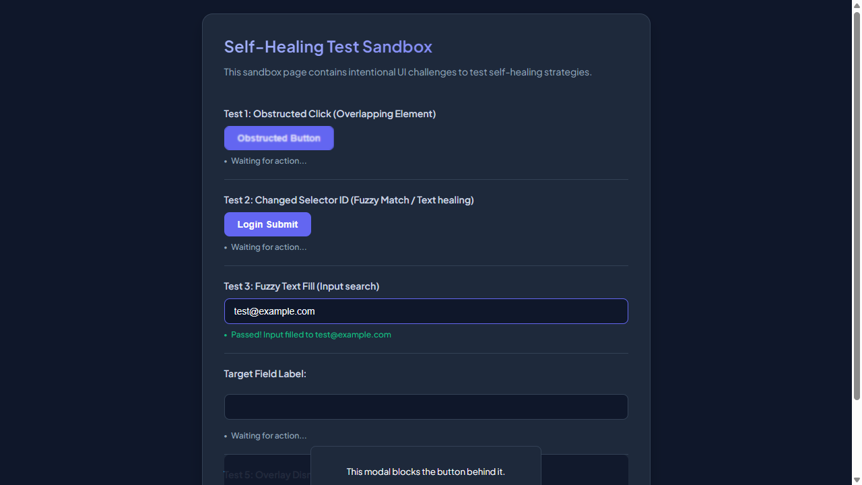

━━━━━━━━━━━━━━━━━━━━━━━━━━━━━━━━━━━━━━━━━━━━━
Step 4: [R1] click → #healed-login-submit
Functional Intent: "Submit the login form to proceed."
Flow Transition: `/test-self-healing.html` ⟶ `/test-self-healing.html` [Browser: CHROME]
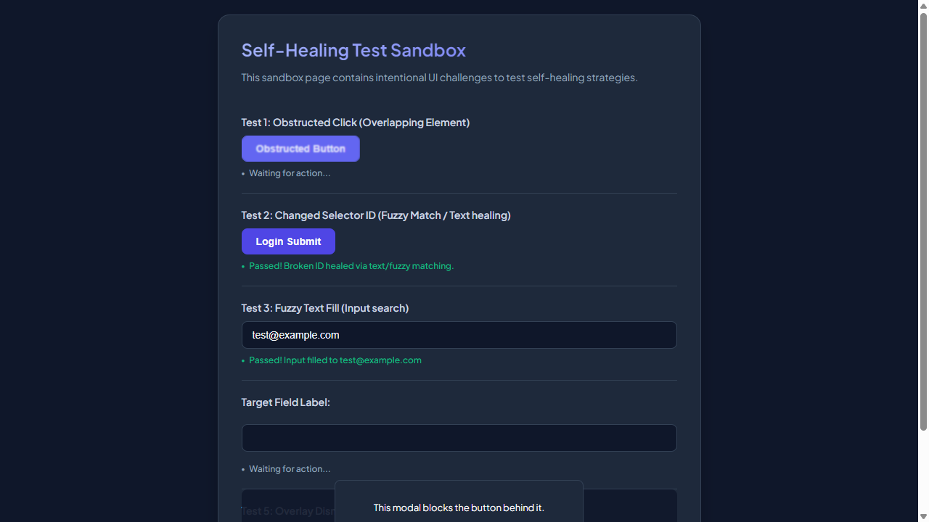

━━━━━━━━━━━━━━━━━━━━━━━━━━━━━━━━━━━━━━━━━━━━━
Step 5: [R2] scroll → #covered-input
Functional Intent: "Ensure all elements are visible for visual verification"
Flow Transition: `/test-self-healing.html` ⟶ `/test-self-healing.html` [Browser: CHROME]
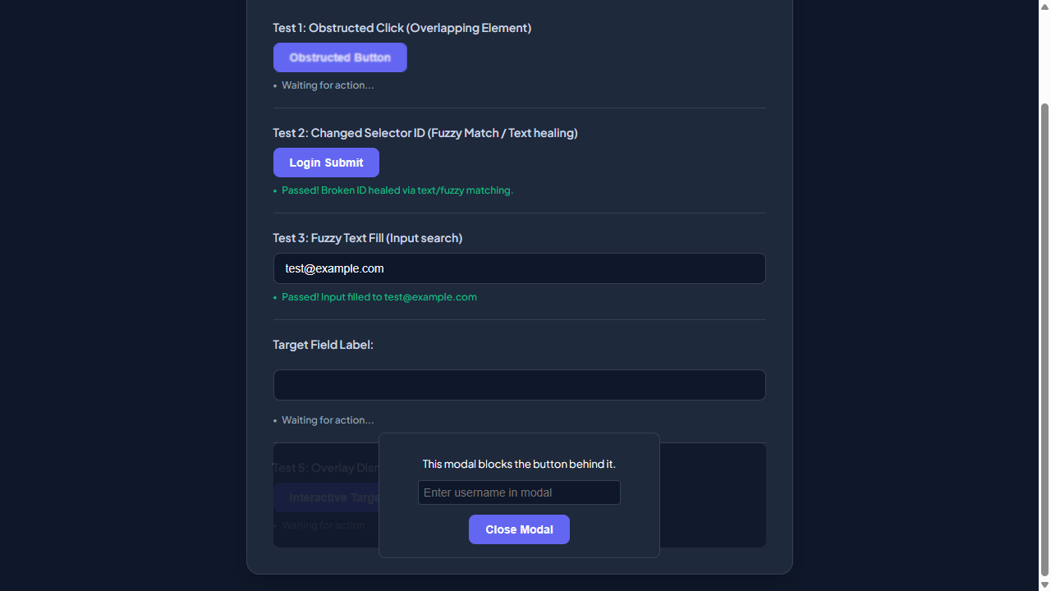

━━━━━━━━━━━━━━━━━━━━━━━━━━━━━━━━━━━━━━━━━━━━━
Step 6: [R2] click → #covered-btn
Functional Intent: "Interact with an interactive element to demonstrate functionality"
Flow Transition: `/test-self-healing.html` ⟶ `/test-self-healing.html` [Browser: CHROME]

━━━━━━━━━━━━━━━━━━━━━━━━━━━━━━━━━━━━━━━━━━━━━
Step 7: [R2] fill → #user-email-address
Functional Intent: "Input user email for testing purposes"
Flow Transition: `/test-self-healing.html` ⟶ `/test-self-healing.html` [Browser: CHROME]
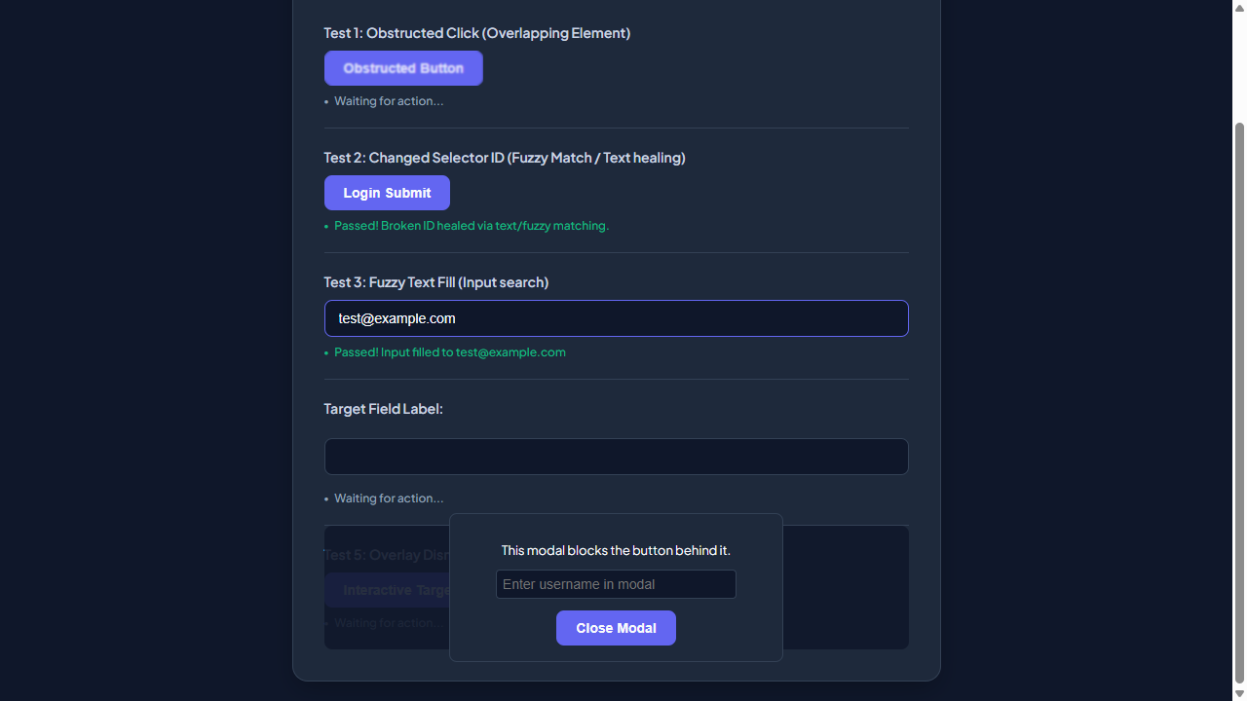

━━━━━━━━━━━━━━━━━━━━━━━━━━━━━━━━━━━━━━━━━━━━━
Step 8: [R2] click → #healed-login-submit
Functional Intent: "Submit the login form to verify submission process"
Flow Transition: `/test-self-healing.html` ⟶ `/test-self-healing.html` [Browser: CHROME]
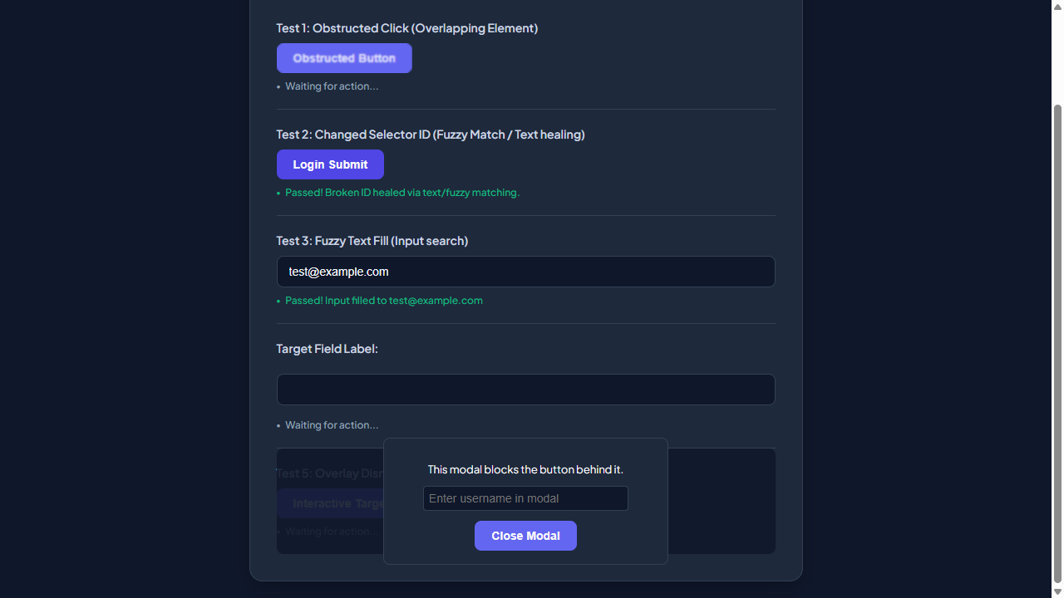

━━━━━━━━━━━━━━━━━━━━━━━━━━━━━━━━━━━━━━━━━━━━━
Step 9: [R3] click → #obstructed-btn
Functional Intent: "Interact with an obstructed button to demonstrate self-healing feature"
Flow Transition: `/test-self-healing.html` ⟶ `/test-self-healing.html` [Browser: CHROME]
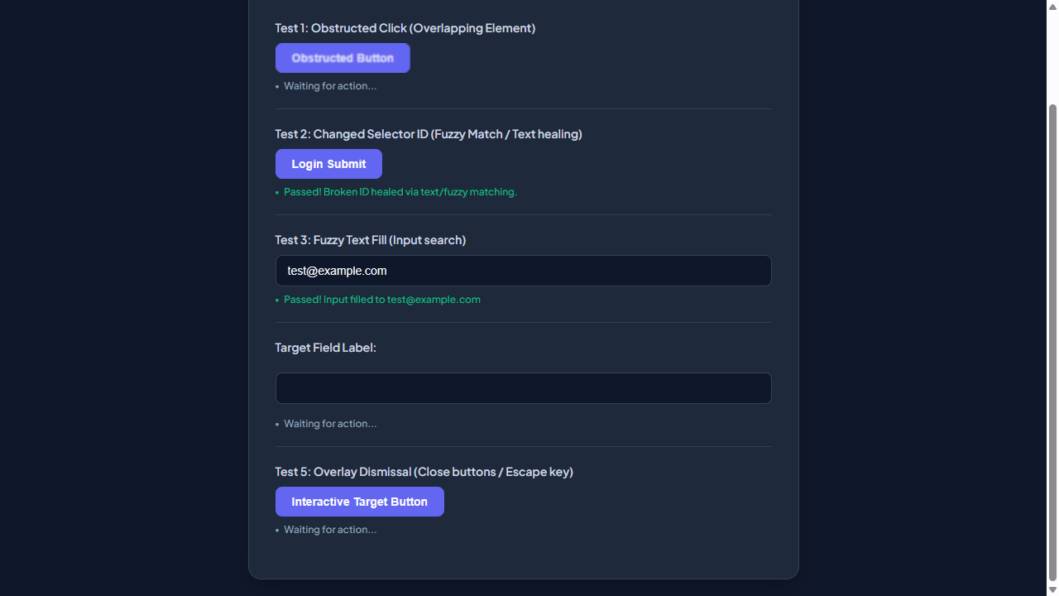

━━━━━━━━━━━━━━━━━━━━━━━━━━━━━━━━━━━━━━━━━━━━━
Step 10: [R3] screenshot
Functional Intent: "Verify the page layout after interacting with the obstructed button"
Flow Transition: `/test-self-healing.html` ⟶ `/test-self-healing.html` [Browser: CHROME]

━━━━━━━━━━━━━━━━━━━━━━━━━━━━━━━━━━━━━━━━━━━━━
Step 11: [R4] screenshot
Functional Intent: "Verify the main page layout and user interface elements"
Flow Transition: `/test-self-healing.html` ⟶ `/test-self-healing.html` [Browser: CHROME]

━━━━━━━━━━━━━━━━━━━━━━━━━━━━━━━━━━━━━━━━━━━━━
Step 12: [R4] click → #covered-btn
Functional Intent: "Interact with the interactive target button to test dynamic behavior"
Flow Transition: `/test-self-healing.html` ⟶ `/test-self-healing.html` [Browser: CHROME]
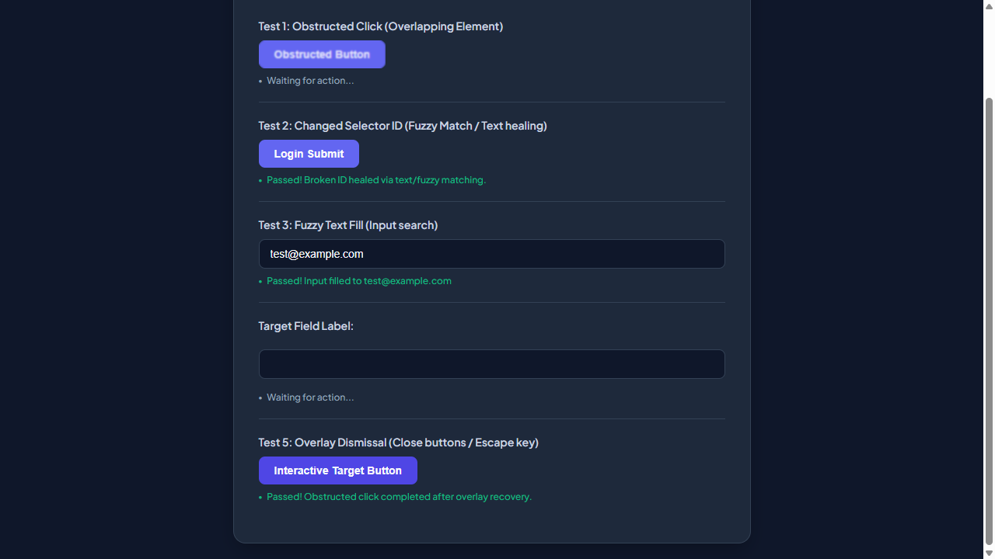

━━━━━━━━━━━━━━━━━━━━━━━━━━━━━━━━━━━━━━━━━━━━━
Step 13: [R4] wait
Functional Intent: "Allow time for any animations or transitions to complete"
Flow Transition: `/test-self-healing.html` ⟶ `/test-self-healing.html` [Browser: CHROME]

━━━━━━━━━━━━━━━━━━━━━━━━━━━━━━━━━━━━━━━━━━━━━
Step 14: [R4] screenshot
Functional Intent: "Capture the state of the page after interacting with the interactive target button"
Flow Transition: `/test-self-healing.html` ⟶ `/test-self-healing.html` [Browser: CHROME]

━━━━━━━━━━━━━━━━━━━━━━━━━━━━━━━━━━━━━━━━━━━━━
Step 15: [R5] screenshot
Functional Intent: "Verify the initial state of the self-healing test sandbox page"
Flow Transition: `/test-self-healing.html` ⟶ `/test-self-healing.html` [Browser: CHROME]

━━━━━━━━━━━━━━━━━━━━━━━━━━━━━━━━━━━━━━━━━━━━━
Step 16: [R5] click → #covered-btn
Functional Intent: "Access the interactive target button to demonstrate interaction capabilities"
Flow Transition: `/test-self-healing.html` ⟶ `/test-self-healing.html` [Browser: CHROME]

━━━━━━━━━━━━━━━━━━━━━━━━━━━━━━━━━━━━━━━━━━━━━

