WEBSITE BUSINESS SPECIFICATION & FUNCTIONAL INVENTORY
Auto-Generated Site Specification & Business Feature Catalog

Audit Parameter | Crawler Specification Detail
Target URL | http://localhost:3009/test-self-healing.html
Crawl Mode | Business Auto-Doc Mode (High-Level Summary)
Crawl Date/Time | May 29, 2026 at 12:09 AM
AI Explorer Model | qwen2.5-coder:7b (Ollama)
Browser Executed | CHROME (Headless)
1. Site Sitemap & Route Inventory
Below is the list of unique page routes mapped by the AI crawler, along with their detected heading hierarchies.
No. | Page Title | Visited URL Pathname | Heading Hierarchy Detected
1. | Self-Healing Test Sandbox | /test-self-healing.html | H1: "Self-Healing Test Sandbox"
2. Business Feature Catalog (Functional Inventory)
A comprehensive catalog of major UI elements, components, and sections discovered on each page, written in plain business English describing their functional use and business value.
Page Name | Feature/Component | Functional Description | Business / User Value
/test-self-healing.html | User Email Input Field | Allows users to enter their email address for authentication. | Enables users to securely log in or sign up using their email.
/test-self-healing.html | Generic Text Input Field | A generic text input field for various user inputs. | Facilitates the collection of diverse textual information from users.
/test-self-healing.html | Username Input Field in Modal | Enables users to enter a username within a modal dialog. | Supports user registration or login processes by capturing essential information securely.
/test-self-healing.html | Obstructed Button | A button that appears to be disabled or hidden, preventing interaction. | May be used as a placeholder or in scenarios where action is temporarily not available.
/test-self-healing.html | Login Submit Button | Allows users to submit their login credentials for authentication. | Enables users to access protected content or features after successful verification.
/test-self-healing.html | Interactive Target Button | A button that can be interacted with, often leading to specific actions or destinations. | Provides an interactive element for users to perform actions like clicking, submitting forms, etc.
/test-self-healing.html | Modal Close Button | Allows users to close a modal dialog, returning to the previous screen. | Enhances user experience by providing a straightforward way to navigate back or out of dialogs.
3. User Journey & Visual Walkthrough
Below is the detailed visual walkthrough representing the exact sequence of navigations and actions triggered during exploration, along with functional intents and screenshot proofs.
Step 1: Navigate to http://localhost:3009/test-self-healing.html
Functional Intent: "Initial page load"
Flow Transition: `Start` ⟶ `/test-self-healing.html` [Browser: CHROME]
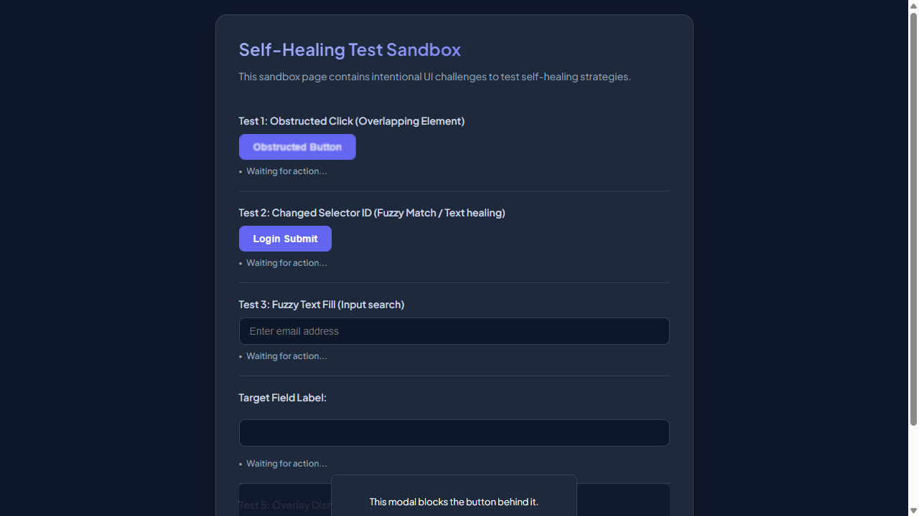

━━━━━━━━━━━━━━━━━━━━━━━━━━━━━━━━━━━━━━━━━━━━━
Step 2: [R1] fill → #user-email-address
Functional Intent: "Provide user email for login process"
Flow Transition: `/test-self-healing.html` ⟶ `/test-self-healing.html` [Browser: CHROME]
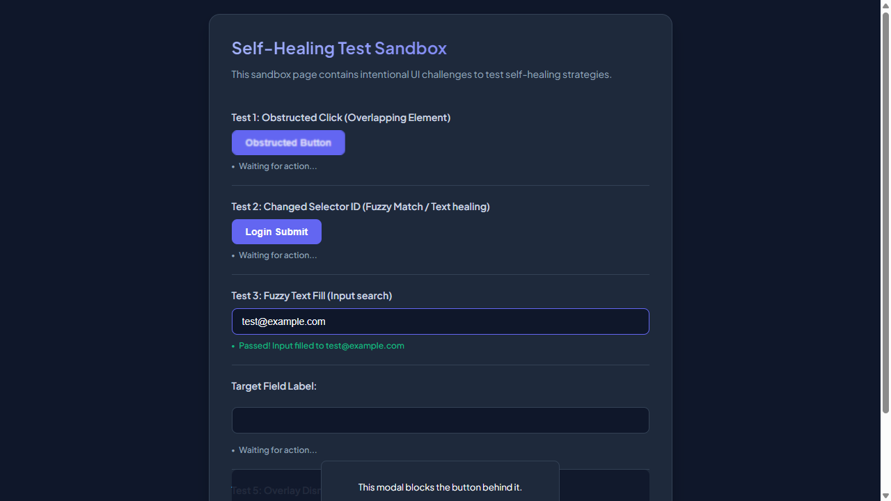

━━━━━━━━━━━━━━━━━━━━━━━━━━━━━━━━━━━━━━━━━━━━━
Step 3: [R1] click → #healed-login-submit
Functional Intent: "Submit login form to proceed"
Flow Transition: `/test-self-healing.html` ⟶ `/test-self-healing.html` [Browser: CHROME]




