WEBSITE BUSINESS SPECIFICATION & FUNCTIONAL INVENTORY
Auto-Generated Site Specification & Business Feature Catalog

Audit Parameter | Crawler Specification Detail
Target URL | https://ecommerce-playground.lambdatest.io/
Crawl Mode | Business Auto-Doc Mode (High-Level Summary)
Crawl Date/Time | May 29, 2026 at 12:12 AM
AI Explorer Model | qwen2.5-coder:7b (Ollama)
Browser Executed | CHROME (Headless)
1. Site Sitemap & Route Inventory
Below is the list of unique page routes mapped by the AI crawler, along with their detected heading hierarchies.
No. | Page Title | Visited URL Pathname | Heading Hierarchy Detected
1. | Your Store | / | H3: "Mobiles"  H3: "Laptops"  H3: "Accessories"  H3: "Smart Wearable"  H3: "Tablets"  H3: "Computers"  H3: "Sound System"  H3: "Top Trending Categories"  H3: "Top Products"  H2: "Latest Range of Earphones"  H3: "Top Collection"  H3: "Under @99"  H3: "From The Blog"
2. | Search - smartphones | /index.php | H3: "Mobiles"  H3: "Laptops"  H3: "Accessories"  H3: "Smart Wearable"  H3: "Tablets"  H3: "Computers"  H3: "Sound System"  H1: "Search - smartphones"  H3: "Filter"
2. Business Feature Catalog (Functional Inventory)
A comprehensive catalog of major UI elements, components, and sections discovered on each page, written in plain business English describing their functional use and business value.
Page Name | Feature/Component | Functional Description | Business / User Value
/ | Search Box | Allows users to enter keywords to search for products. | Improves user experience by enabling quick product discovery, potentially increasing sales.
/ | Edit Cart Button | Opens a modal or page allowing users to modify their shopping cart contents. | Enables customers to make adjustments to their orders easily, reducing cart abandonment rates.
/ | Previous Page Button | Navigates the user to the previous page in their browsing history. | Facilitates easy navigation and provides users with a sense of control over their browsing experience.
/ | All Categories Button | Opens a menu or page listing all available product categories. | Assists customers in finding products by category, enhancing navigation and discoverability.
/ | Search Button | Triggers the search functionality based on the user's input in the search box. | Enables users to initiate product searches efficiently, improving usability and accessibility.
/ | Cart Summary Button | Displays the current cart summary, including item count and total price, and allows access to the cart. | Facilitates quick reference to the shopping cart, enhancing checkout readiness and convenience.
/index.php | mz_fp[min] | Allows user interaction with the number element. | Improves page engagement and usability.
/index.php | mz_fp[max] | Allows user interaction with the number element. | Improves page engagement and usability.
/index.php | mz_fq | Allows user interaction with the text element. | Improves page engagement and usability.
/index.php | mz_fss | Allows user interaction with the checkbox element. | Improves page engagement and usability.
/index.php | mz_fd | Allows user interaction with the radio element. | Improves page engagement and usability.
/index.php | mz_fd | Allows user interaction with the radio element. | Improves page engagement and usability.
/index.php | mz_fd | Allows user interaction with the radio element. | Improves page engagement and usability.
/index.php | mz_fd | Allows user interaction with the radio element. | Improves page engagement and usability.
/index.php | mz_fd | Allows user interaction with the radio element. | Improves page engagement and usability.
/index.php | mz_fr | Allows user interaction with the radio element. | Improves page engagement and usability.
/index.php | Edit cart | Allows user interaction with the button element. | Improves page engagement and usability.
/index.php | Interactive Element | Allows user interaction with the button element. | Improves page engagement and usability.
/index.php | All Categories | Allows user interaction with the button element. | Improves page engagement and usability.
/index.php | Search | Allows user interaction with the button element. | Improves page engagement and usability.
/index.php | 0 0 item(s) - $0.00 | Allows user interaction with the button element. | Improves page engagement and usability.
3. User Journey & Visual Walkthrough
Below is the detailed visual walkthrough representing the exact sequence of navigations and actions triggered during exploration, along with functional intents and screenshot proofs.
Step 1: Navigate to https://ecommerce-playground.lambdatest.io/
Functional Intent: "Initial page load"
Flow Transition: `Start` ⟶ `/` [Browser: CHROME]
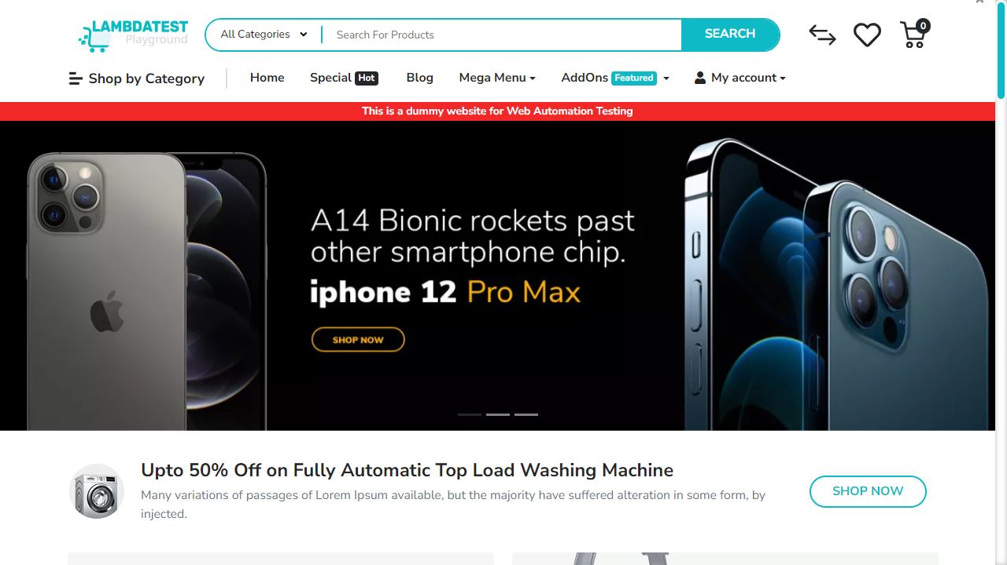

━━━━━━━━━━━━━━━━━━━━━━━━━━━━━━━━━━━━━━━━━━━━━
Step 2: [R1] navigate
Functional Intent: "Load the main page to ensure all features are accessible"
Flow Transition: `/` ⟶ `/` [Browser: CHROME]
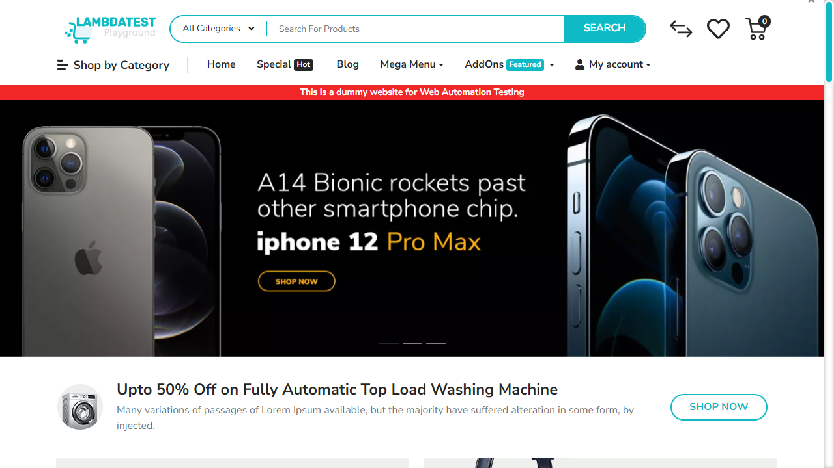

━━━━━━━━━━━━━━━━━━━━━━━━━━━━━━━━━━━━━━━━━━━━━
Step 3: [R1] click → [name='search']
Functional Intent: "Initiate a search to explore product filtering capabilities"
Flow Transition: `/` ⟶ `/` [Browser: CHROME]
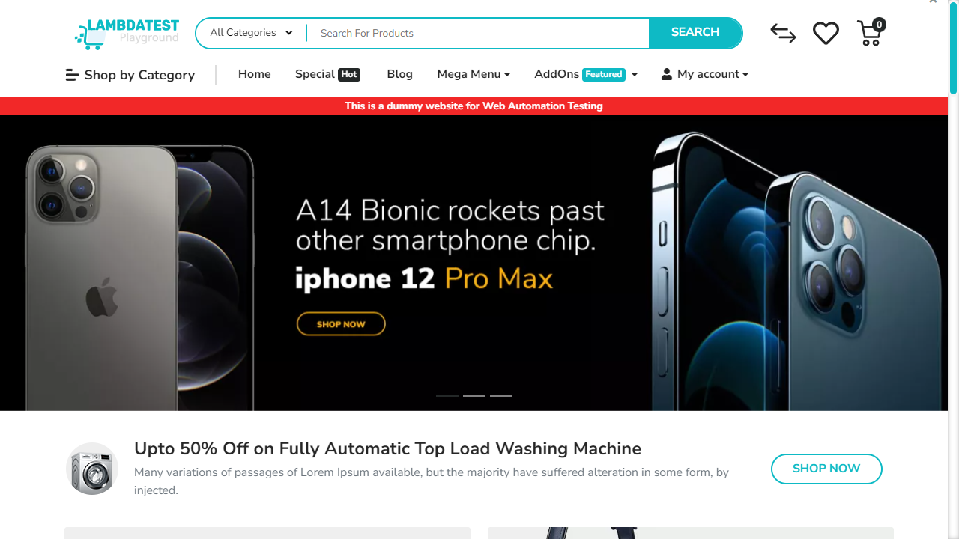

━━━━━━━━━━━━━━━━━━━━━━━━━━━━━━━━━━━━━━━━━━━━━
Step 4: [R1] fill → [name='search']
Functional Intent: "Input search terms for smartphones"
Flow Transition: `/` ⟶ `/` [Browser: CHROME]
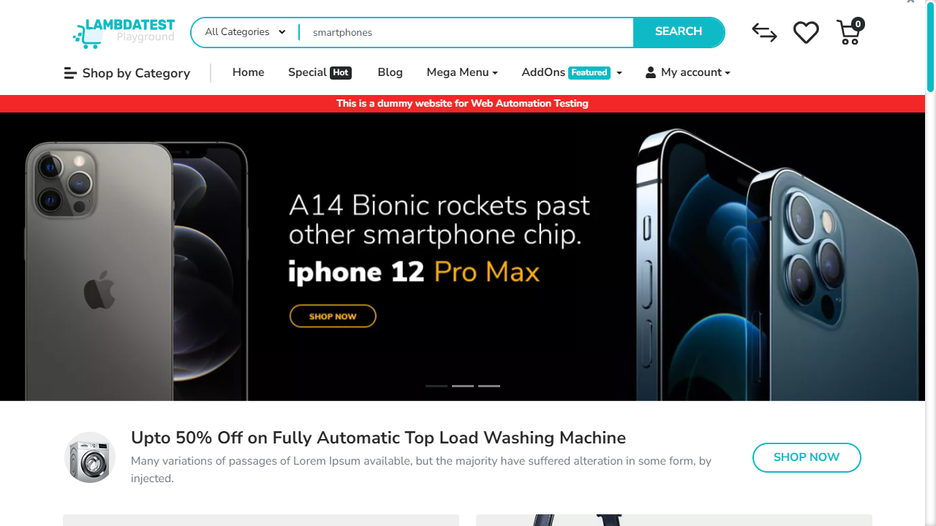

━━━━━━━━━━━━━━━━━━━━━━━━━━━━━━━━━━━━━━━━━━━━━
Step 5: [R1] click → button[type='submit']
Functional Intent: "Submit the search query to display relevant results"
Flow Transition: `/` ⟶ `/index.php` [Browser: CHROME]
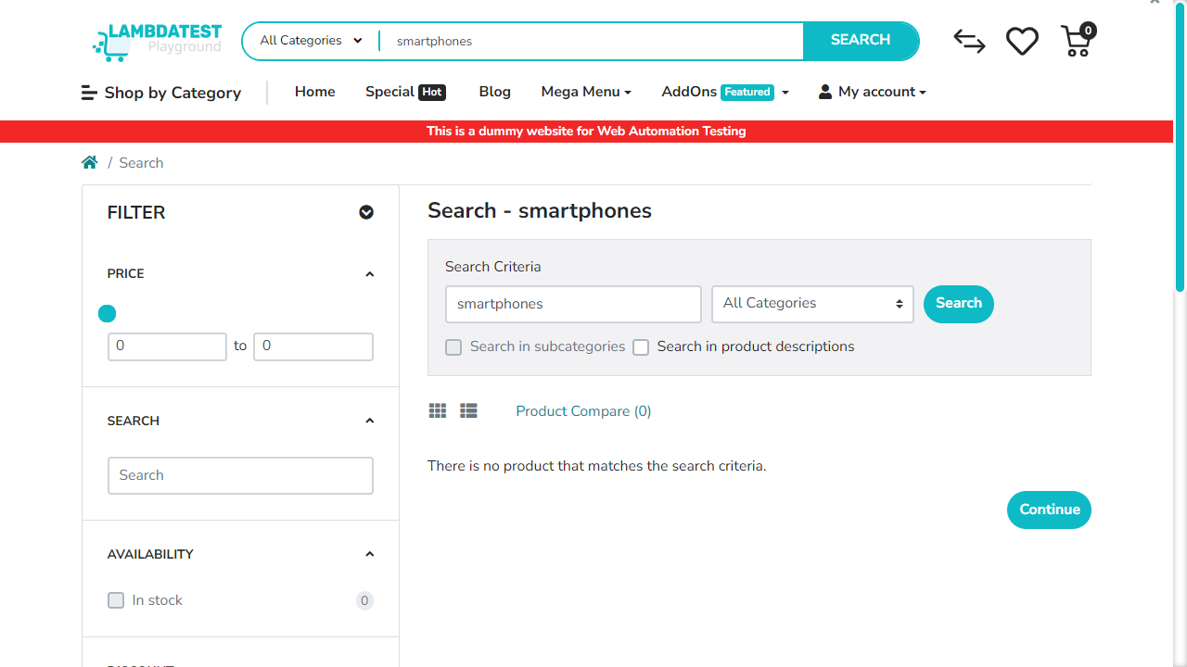

━━━━━━━━━━━━━━━━━━━━━━━━━━━━━━━━━━━━━━━━━━━━━
Step 6: [R1] scroll → .product-card
Functional Intent: "Scroll through product cards to explore multiple options"
Flow Transition: `/index.php` ⟶ `/index.php` [Browser: CHROME]
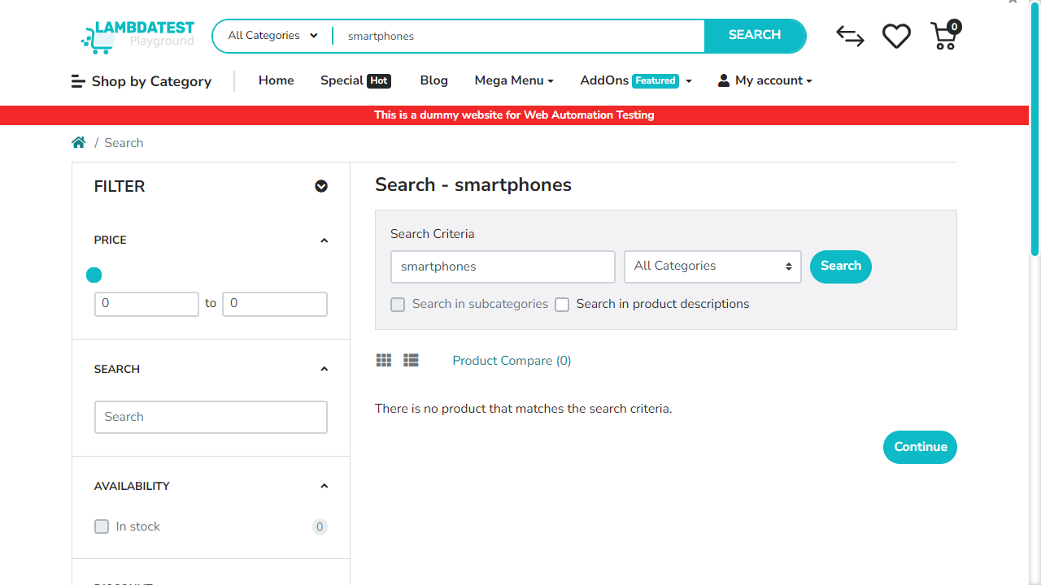

━━━━━━━━━━━━━━━━━━━━━━━━━━━━━━━━━━━━━━━━━━━━━
Step 7: [R2] navigate
Functional Intent: "Return to home page to explore other categories and features"
Flow Transition: `/index.php` ⟶ `/` [Browser: CHROME]
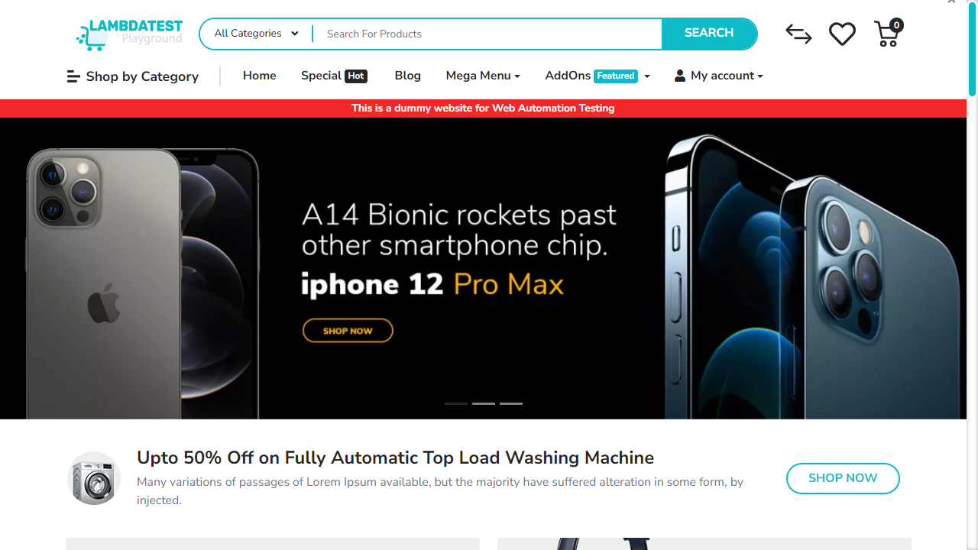

━━━━━━━━━━━━━━━━━━━━━━━━━━━━━━━━━━━━━━━━━━━━━
Step 8: [R3] click → button.btn
Functional Intent: "Access all categories menu to explore products"
Flow Transition: `/` ⟶ `/` [Browser: CHROME]




