WEBSITE BUSINESS SPECIFICATION & FUNCTIONAL INVENTORY
Auto-Generated Site Specification & Business Feature Catalog

Audit Parameter | Crawler Specification Detail
Target URL | http://localhost:3009/test-self-healing.html
Crawl Mode | Business Auto-Doc Mode (High-Level Summary)
Crawl Date/Time | May 29, 2026 at 3:39 AM
AI Explorer Model | qwen2.5-coder:7b (Ollama)
Browser Executed | CHROME (Headless)
1. Site Sitemap & Route Inventory
Below is the list of unique page routes mapped by the AI crawler, along with their detected heading hierarchies.
No. | Page Title | Visited URL Pathname | Heading Hierarchy Detected
1. | Self-Healing Test Sandbox | /test-self-healing.html | H1: "Self-Healing Test Sandbox"
2. Business Feature Catalog (Functional Inventory)
A comprehensive catalog of major UI elements, components, and sections discovered on each page, written in plain business English describing their functional use and business value.
Page Name | Feature/Component | Functional Description | Business / User Value
/test-self-healing.html | User Email Input Field | Allows users to enter their email address for authentication or registration. | Enables easy user identification and streamlines the login process.
/test-self-healing.html | General Text Input Field | A versatile text input field that users can use to enter various types of text information. | Enhances usability by providing a single input method for different data entry requirements.
/test-self-healing.html | Username Input in Modal | Prompts users to enter their username within a modal dialog, typically during user registration or login. | Increases security and privacy by requiring additional authentication steps before accessing sensitive information.
/test-self-healing.html | Obstructed Button | A button that appears to be disabled or hidden, potentially indicating a step in the process that requires further action. | Guides users through a multi-step process and ensures they complete necessary actions before proceeding.
/test-self-healing.html | Login Submit Button | Initiates the login process once the user has entered their credentials, completing the authentication step. | Enables users to access protected content or services securely and efficiently.
/test-self-healing.html | Interactive Target Button | An interactive button that triggers a specific action or feature when clicked, enhancing the user experience. | Increases engagement by providing immediate feedback and enabling users to perform desired actions with ease.
/test-self-healing.html | Close Modal Button | Allows users to close a modal dialog, typically used to exit forms or menus. | Provides a simple and intuitive way for users to navigate away from screens that are no longer relevant.
3. User Journey & Visual Walkthrough
Below is the detailed visual walkthrough representing the exact sequence of navigations and actions triggered during exploration, along with functional intents and screenshot proofs.
Step 1: Navigate to http://localhost:3009/test-self-healing.html
Functional Intent: "Initial page load"
Flow Transition: `Start` ⟶ `/test-self-healing.html` [Browser: CHROME]
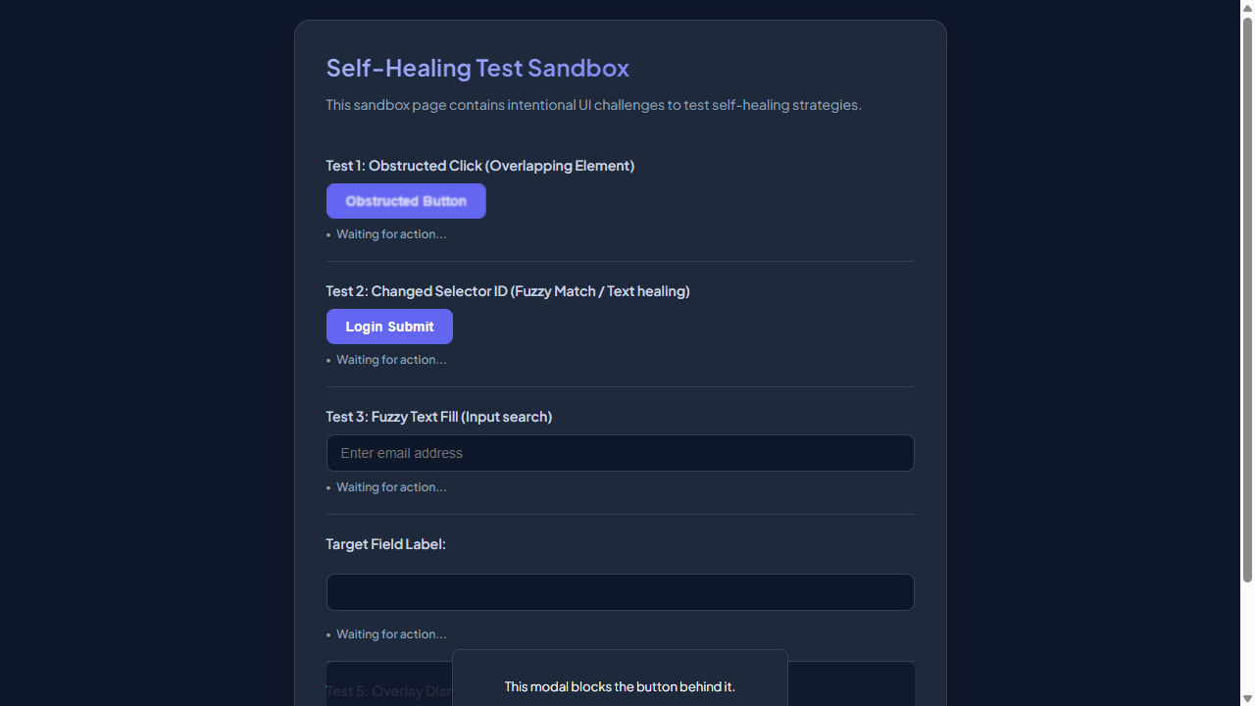

━━━━━━━━━━━━━━━━━━━━━━━━━━━━━━━━━━━━━━━━━━━━━
Step 2: [R1] screenshot
Functional Intent: "Verify initial page layout and elements"
Flow Transition: `/test-self-healing.html` ⟶ `/test-self-healing.html` [Browser: CHROME]

━━━━━━━━━━━━━━━━━━━━━━━━━━━━━━━━━━━━━━━━━━━━━
Step 3: [R1] fill → #user-email-address
Functional Intent: "Input user email for login process"
Flow Transition: `/test-self-healing.html` ⟶ `/test-self-healing.html` [Browser: CHROME]
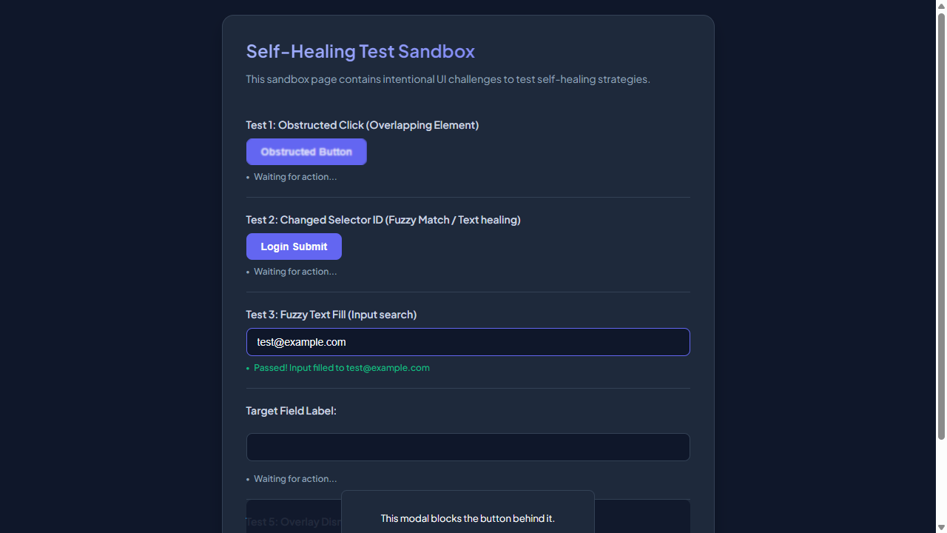

━━━━━━━━━━━━━━━━━━━━━━━━━━━━━━━━━━━━━━━━━━━━━
Step 4: [R1] click → #healed-login-submit
Functional Intent: "Initiate login process to access protected features"
Flow Transition: `/test-self-healing.html` ⟶ `/test-self-healing.html` [Browser: CHROME]




