WEBSITE BUSINESS SPECIFICATION & FUNCTIONAL INVENTORY
Auto-Generated Site Specification & Business Feature Catalog

Audit Parameter | Crawler Specification Detail
Target URL | http://localhost:3009/test-self-healing.html
Crawl Mode | Business Auto-Doc Mode (High-Level Summary)
Crawl Date/Time | May 29, 2026 at 4:08 AM
AI Explorer Model | qwen2.5-coder:7b (Ollama)
Browser Executed | CHROME (Headless)
1. Site Sitemap & Route Inventory
Below is the list of unique page routes mapped by the AI crawler, along with their detected heading hierarchies.
No. | Page Title | Visited URL Pathname | Heading Hierarchy Detected
1. | Self-Healing Test Sandbox | /test-self-healing.html | H1: "Self-Healing Test Sandbox"
2. Business Feature Catalog (Functional Inventory)
A comprehensive catalog of major UI elements, components, and sections discovered on each page, written in plain business English describing their functional use and business value.
Page Name | Feature/Component | Functional Description | Business / User Value
/test-self-healing.html | User Email Input Field | Allows users to enter their email address for login. | Enables customers to access their account using their email, enhancing convenience and user experience.
/test-self-healing.html | Username Input Field | Prompts users to enter a username in the modal. | Facilitates user registration or login by providing an easy way to identify and access accounts.
/test-self-healing.html | Modal Username Input | Collects a username from users in a modal window. | Secures user data and provides a dedicated space for entering sensitive information safely.
/test-self-healing.html | Obstructed Button | A button that is currently obstructed or inaccessible on the page. | Identifies potential issues with navigation or user interaction, affecting usability and user experience.
/test-self-healing.html | Login Submit Button | Enables users to submit their login credentials. | Streamlines the login process, allowing customers to access their accounts efficiently.
/test-self-healing.html | Interactive Target Button | An interactive button within a modal that performs an action when clicked. | Enhances user engagement and interaction by providing actionable elements within modals.
/test-self-healing.html | Modal Close Button | Allows users to close the modal window. | Provides a simple way for users to exit modals, maintaining a clean and organized user interface.
3. User Journey & Visual Walkthrough
Below is the detailed visual walkthrough representing the exact sequence of navigations and actions triggered during exploration, along with functional intents and screenshot proofs.
Step 1: Navigate to http://localhost:3009/test-self-healing.html
Functional Intent: "Initial page load"
Flow Transition: `Start` ⟶ `/test-self-healing.html` [Browser: CHROME]
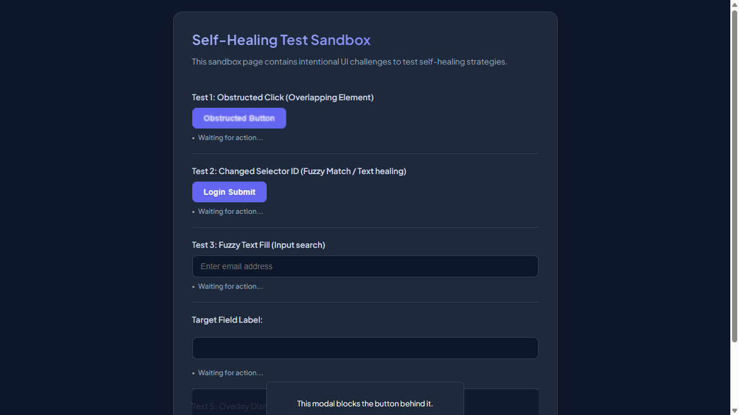

━━━━━━━━━━━━━━━━━━━━━━━━━━━━━━━━━━━━━━━━━━━━━
Step 2: [R1] screenshot
Functional Intent: "Verify the initial state of the self-healing test sandbox"
Flow Transition: `/test-self-healing.html` ⟶ `/test-self-healing.html` [Browser: CHROME]

━━━━━━━━━━━━━━━━━━━━━━━━━━━━━━━━━━━━━━━━━━━━━
Step 3: [R1] click → #covered-btn
Functional Intent: "Interact with the interactive target button to demonstrate self-healing functionality"
Flow Transition: `/test-self-healing.html` ⟶ `/test-self-healing.html` [Browser: CHROME]
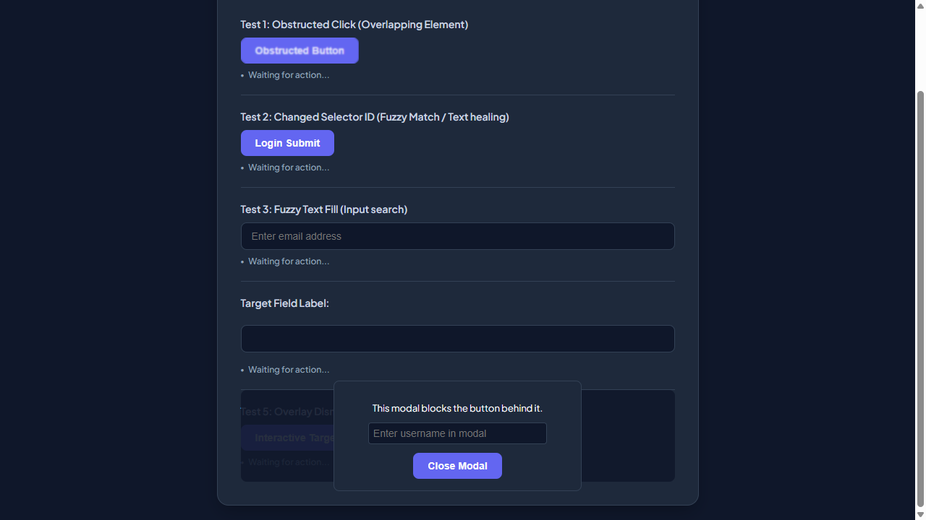

━━━━━━━━━━━━━━━━━━━━━━━━━━━━━━━━━━━━━━━━━━━━━
Step 4: [R1] fill → #user-email-address
Functional Intent: "Enter a user email address for further testing"
Flow Transition: `/test-self-healing.html` ⟶ `/test-self-healing.html` [Browser: CHROME]
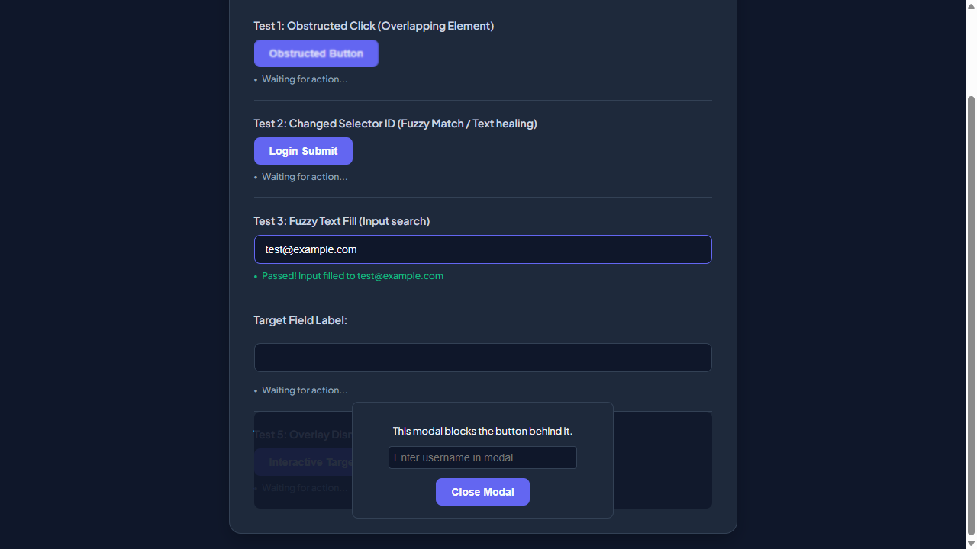

━━━━━━━━━━━━━━━━━━━━━━━━━━━━━━━━━━━━━━━━━━━━━
Step 5: [R1] screenshot
Functional Intent: "Verify the form input after entering an email address"
Flow Transition: `/test-self-healing.html` ⟶ `/test-self-healing.html` [Browser: CHROME]

━━━━━━━━━━━━━━━━━━━━━━━━━━━━━━━━━━━━━━━━━━━━━
Step 6: [R1] click → #healed-login-submit
Functional Intent: "Submit the login form to test self-healing during submission"
Flow Transition: `/test-self-healing.html` ⟶ `/test-self-healing.html` [Browser: CHROME]
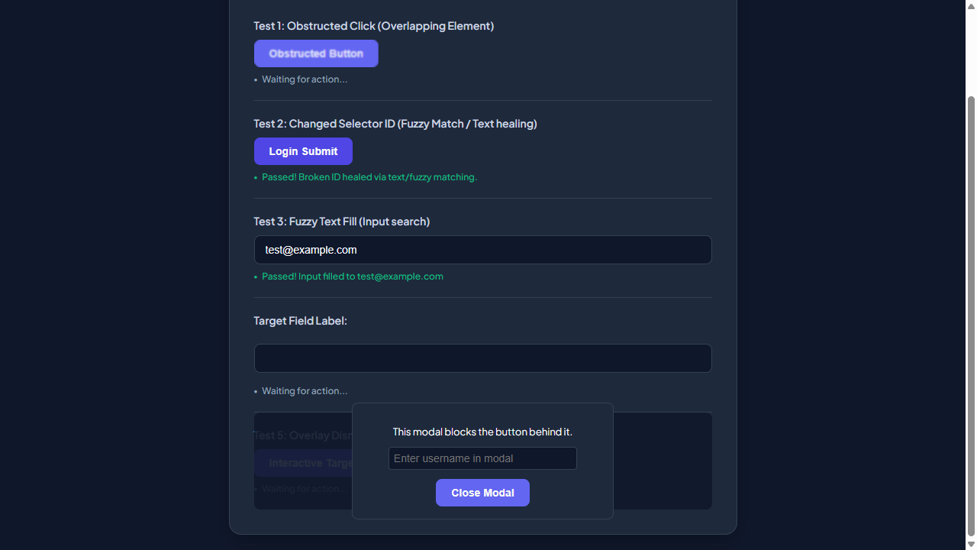

━━━━━━━━━━━━━━━━━━━━━━━━━━━━━━━━━━━━━━━━━━━━━
Step 7: [R2] click → #covered-btn
Functional Intent: "Access interactive target button for further testing."
Flow Transition: `/test-self-healing.html` ⟶ `/test-self-healing.html` [Browser: CHROME]
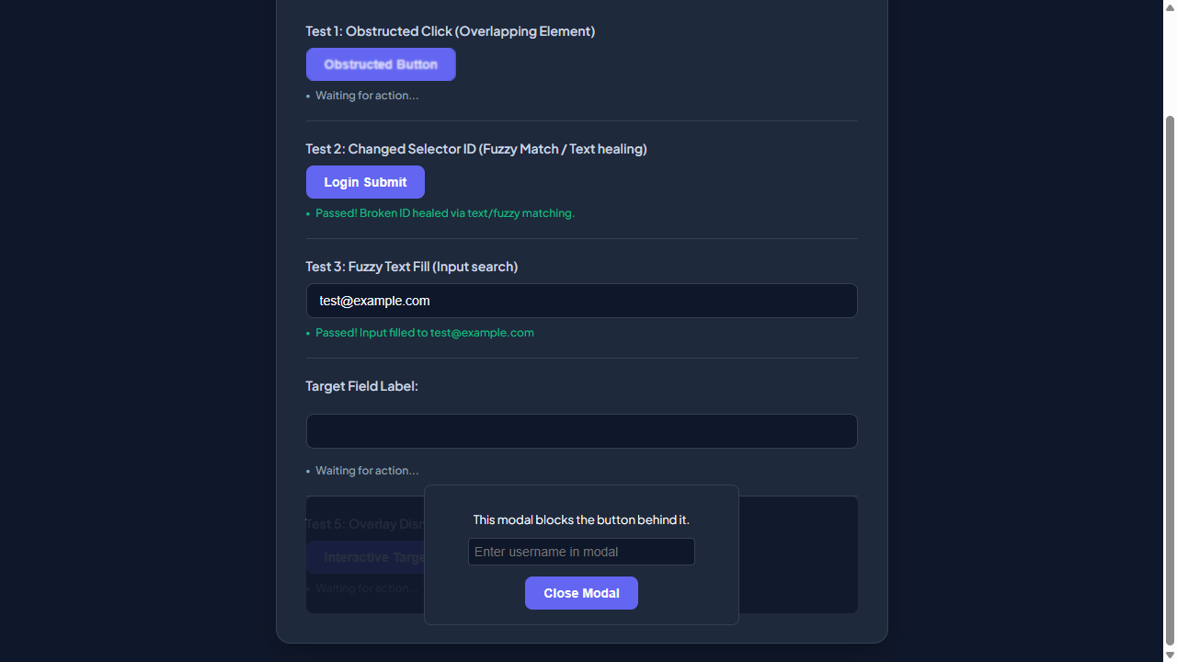

━━━━━━━━━━━━━━━━━━━━━━━━━━━━━━━━━━━━━━━━━━━━━
Step 8: [R2] fill → #user-email-address
Functional Intent: "Enter user email address for login purposes."
Flow Transition: `/test-self-healing.html` ⟶ `/test-self-healing.html` [Browser: CHROME]
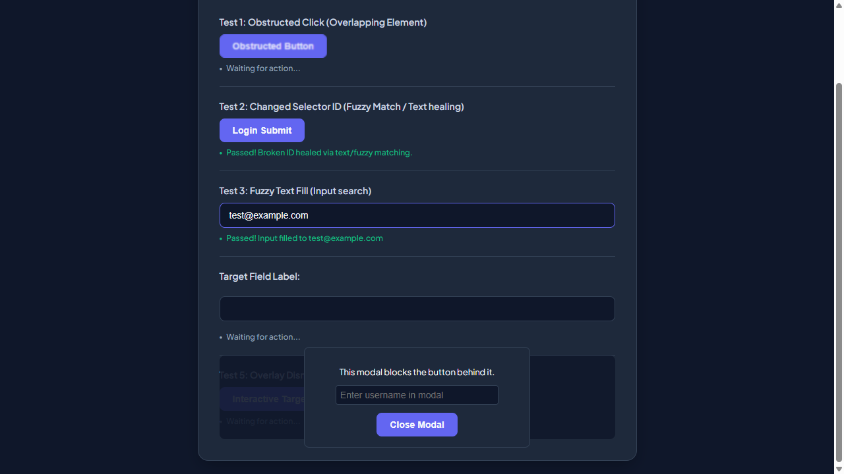

━━━━━━━━━━━━━━━━━━━━━━━━━━━━━━━━━━━━━━━━━━━━━
Step 9: [R2] click → #healed-login-submit
Functional Intent: "Submit the login form to authenticate the user."
Flow Transition: `/test-self-healing.html` ⟶ `/test-self-healing.html` [Browser: CHROME]

━━━━━━━━━━━━━━━━━━━━━━━━━━━━━━━━━━━━━━━━━━━━━
Step 10: [R3] fill → #user-email-address
Functional Intent: "Provide user email for login process"
Flow Transition: `/test-self-healing.html` ⟶ `/test-self-healing.html` [Browser: CHROME]
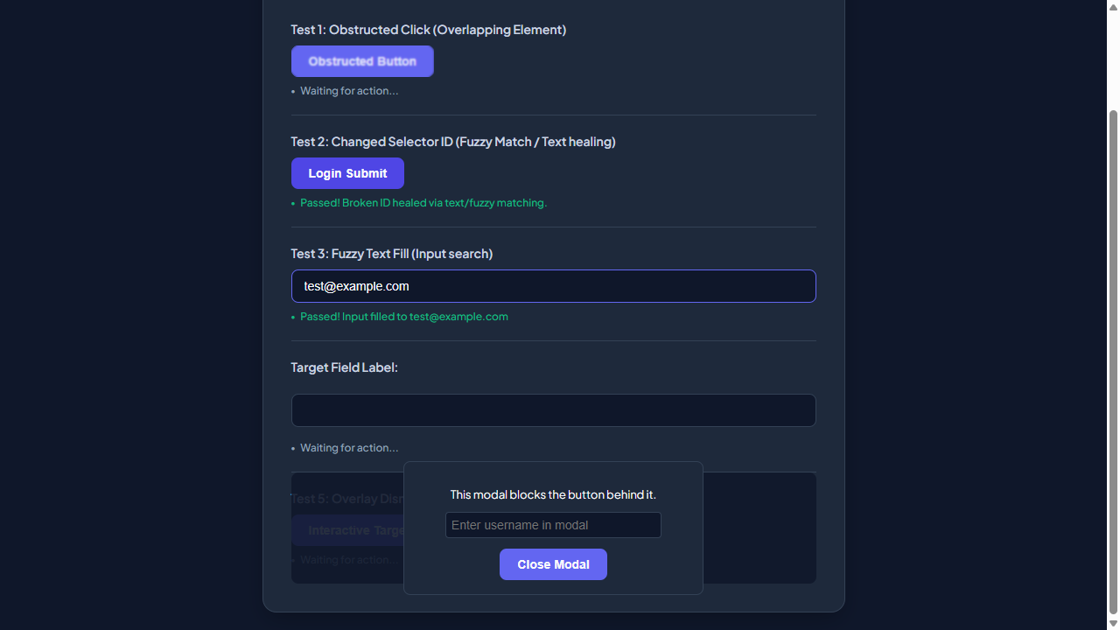

━━━━━━━━━━━━━━━━━━━━━━━━━━━━━━━━━━━━━━━━━━━━━
Step 11: [R3] click → #healed-login-submit
Functional Intent: "Submit login form to proceed with authentication"
Flow Transition: `/test-self-healing.html` ⟶ `/test-self-healing.html` [Browser: CHROME]

━━━━━━━━━━━━━━━━━━━━━━━━━━━━━━━━━━━━━━━━━━━━━
Step 12: [R4] screenshot
Functional Intent: "Verify main page layout and UI elements"
Flow Transition: `/test-self-healing.html` ⟶ `/test-self-healing.html` [Browser: CHROME]

━━━━━━━━━━━━━━━━━━━━━━━━━━━━━━━━━━━━━━━━━━━━━
Step 13: [R4] click → button.modal-close-button
Functional Intent: "Close any modal that might be open to ensure clean state"
Flow Transition: `/test-self-healing.html` ⟶ `/test-self-healing.html` [Browser: CHROME]
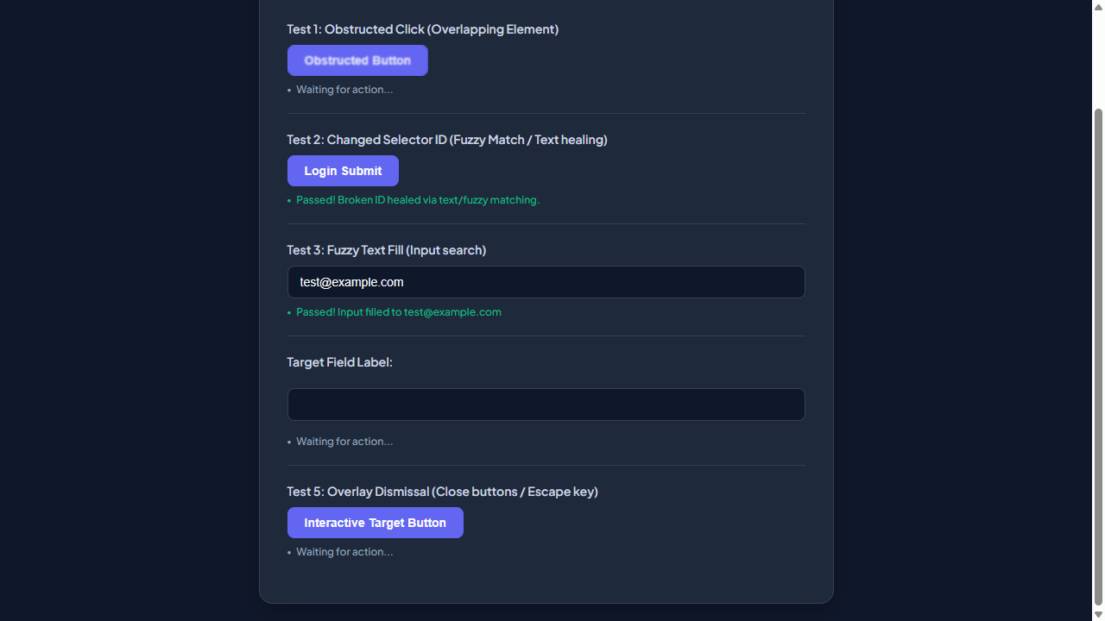

━━━━━━━━━━━━━━━━━━━━━━━━━━━━━━━━━━━━━━━━━━━━━
Step 14: [R5] click → button.modal-close-button
Functional Intent: "Close any existing modal to ensure clean state"
Flow Transition: `/test-self-healing.html` ⟶ `/test-self-healing.html` [Browser: CHROME]

━━━━━━━━━━━━━━━━━━━━━━━━━━━━━━━━━━━━━━━━━━━━━
Step 15: [R5] fill → #user-email-address
Functional Intent: "Enter test user email for login"
Flow Transition: `/test-self-healing.html` ⟶ `/test-self-healing.html` [Browser: CHROME]
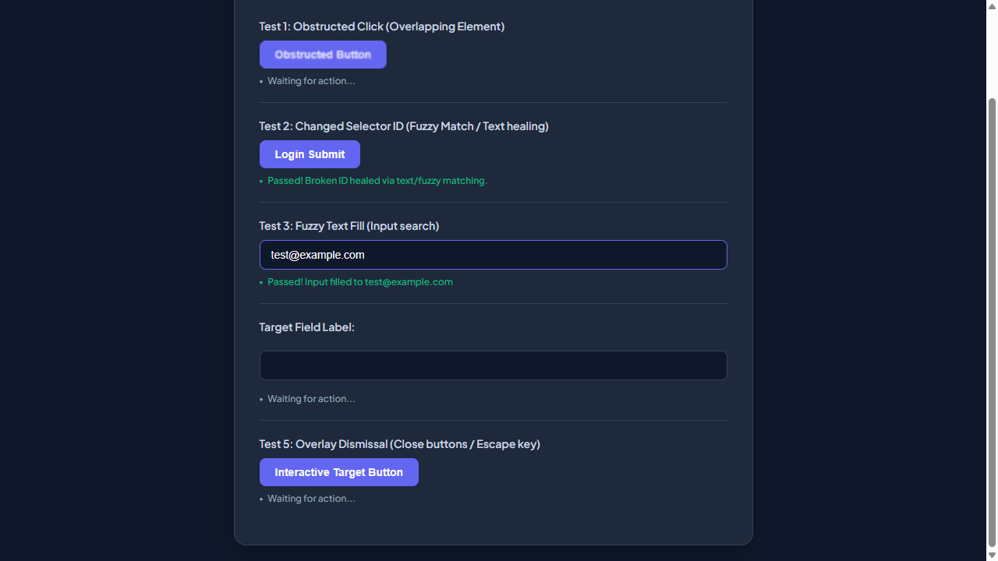

━━━━━━━━━━━━━━━━━━━━━━━━━━━━━━━━━━━━━━━━━━━━━
Step 16: [R5] click → #healed-login-submit
Functional Intent: "Submit the login form with provided credentials"
Flow Transition: `/test-self-healing.html` ⟶ `/test-self-healing.html` [Browser: CHROME]
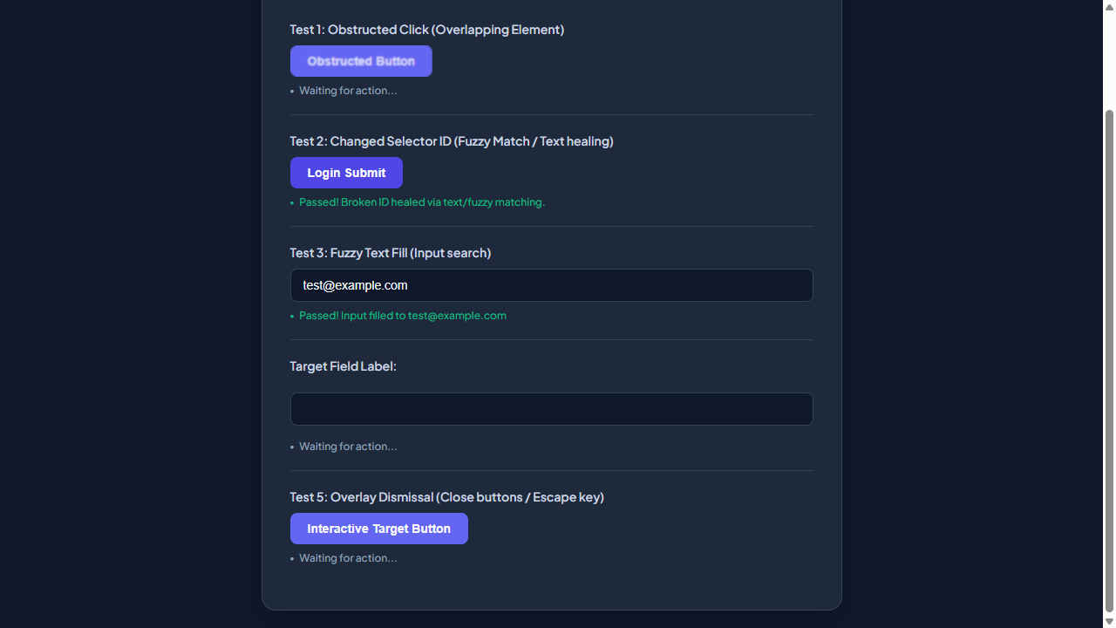

━━━━━━━━━━━━━━━━━━━━━━━━━━━━━━━━━━━━━━━━━━━━━
Step 17: [R5] wait
Functional Intent: "Wait for page to fully load after submission"
Flow Transition: `/test-self-healing.html` ⟶ `/test-self-healing.html` [Browser: CHROME]

━━━━━━━━━━━━━━━━━━━━━━━━━━━━━━━━━━━━━━━━━━━━━
Step 18: [R5] screenshot
Functional Intent: "Capture post-login state of the application"
Flow Transition: `/test-self-healing.html` ⟶ `/test-self-healing.html` [Browser: CHROME]

━━━━━━━━━━━━━━━━━━━━━━━━━━━━━━━━━━━━━━━━━━━━━
Step 19: [R6] screenshot
Functional Intent: "Verify the layout and visibility of self-healing elements"
Flow Transition: `/test-self-healing.html` ⟶ `/test-self-healing.html` [Browser: CHROME]

━━━━━━━━━━━━━━━━━━━━━━━━━━━━━━━━━━━━━━━━━━━━━
Step 20: [R6] click → #covered-btn
Functional Intent: "Initiate interactive session to assess self-healing functionality"
Flow Transition: `/test-self-healing.html` ⟶ `/test-self-healing.html` [Browser: CHROME]




