Process Definition Document (PDD)

*Process Name: <name>*

Table of Contents

**Introduction** **1**

Purpose of the Document 1

Objectives 1

Process Key Contact 1

Minimum Prerequisites for Automation 1

**As-Is Process Description** **2**

Process Overview 2

Applications used in the Process 3

As-Is Process Map 3

**To-Be Process Description** **3**

Detailed Process Map 3

Robot Type 4

Business Exceptions Handling 4

Known Exceptions 4

Unknown Exceptions 4

System Exceptions Handling 4

**Other Observations** **5**

**Additional sources of process documentation** **5**



# Introduction

## Purpose of the Document

The Process Definition Document outlines the business process chosen for automation using UiPath Robotic Process Automation (RPA) technology.

The document describes the sequence of steps performed as part of the business process, the conditions and rules of the process prior to automation and how they are envisioned to work after automating it, partly or entirely. This specifications document serves as a base for developers, providing them with the details required for applying robotic process automation to the selected business process.

## Objectives

The business objectives and benefits expected by the Business Process Owner after automation of the selected business process are:

* Include at least one here
* Up to as many as you want

## Process Key Contact

The specifications document includes concise and complete requirements of the business process and it is built based on the inputs provided by the process Subject Matter Expert (SME)/ Process Owner.

The Process Owner is expected to review it and provide signoff for accuracy and completion of the steps, context, impact and a set of process exceptions. The details are to be included in the table below.

|  |  |  |  |
| --- | --- | --- | --- |
| Role | Name | Contact Details  (email & phone number) | Notes |
| Process Owner | Ehab Momtaz | [ehab.rpa@gmail.com](mailto:ehab.rpa@gmail.com) |  |
| Business Analyst | Ehab Momtaz | [ehab.rpa@gmail.com](mailto:ehab.rpa@gmail.com) |  |

## Minimum Prerequisites for Automation

|  |  |
| --- | --- |
| Met (Y/N) | Prerequisites |
|  | A filled in and completed Process Definition Document |
|  | Closure of any open process questions |
|  | Environment set up |
|  | Test Data to support development and testing |
|  | User access and creation of user accounts (licences, permissions, restriction to create accounts for robots) |

# As-Is Process Description

## Process Overview

General information about the process selected for RPA prior to automation.

|  |  |  |
| --- | --- | --- |
| # | Item | Description |
| 1 | Process Full Name | Amazon Scrapping Products |
| 2 | Process Area | Web automation |
| 3 | Department | Sales |
| 4 | Process Short Description  (operation, activity, outcome) | Scrap products info form Amazon UK , EG, CA and AUE |
| 5 | Role(s) required for performing the process | N/A |
| 6 | Process schedule and frequency | daily |
| 7 | # of items processed /reference period | 10/5 minutes |
| 8 | Process execution time | 50 minutes |
| 9 | Peak period(s) | N/A |
| 10 | Transaction Volume During Peak period | 70 |
| 11 | Total # of FTEs supporting this activity | 2 |
| 12 | Expected increase of volume in the next reference period | 20 |
| 13 | Level of exception rate | low |
| 14 | Input data | Product name along with required Amazon web countries |
| 15 | Output data | Excel file of product info name and price |

*Add more rows to the table to include relevant data for the automation process. No fields should be left empty. Use “n/a” for the items that don't apply to the selected business process.

## Applications used in the Process

The table includes a comprehensive list of all the applications that are used as part of the process to be automated to perform the given steps in the flow.

|  |  |  |  |  |  |
| --- | --- | --- | --- | --- | --- |
| # | Application Name & Version | System Language | Thin/Thick Client | Environment/ Access Method | Comments |
| 1 | Excel |  |  |  |  |
| 2 | Chrome |  |  |  |  |
| 3 | Gmail |  |  |  |  |

*Add more rows to the table to include the complete list of applications.

## As-Is Process Map

**High Level As-Is Process Map:** This chapter depicts the As-Is business process at a High Level to enable developers to have a high-level understanding of the current process.

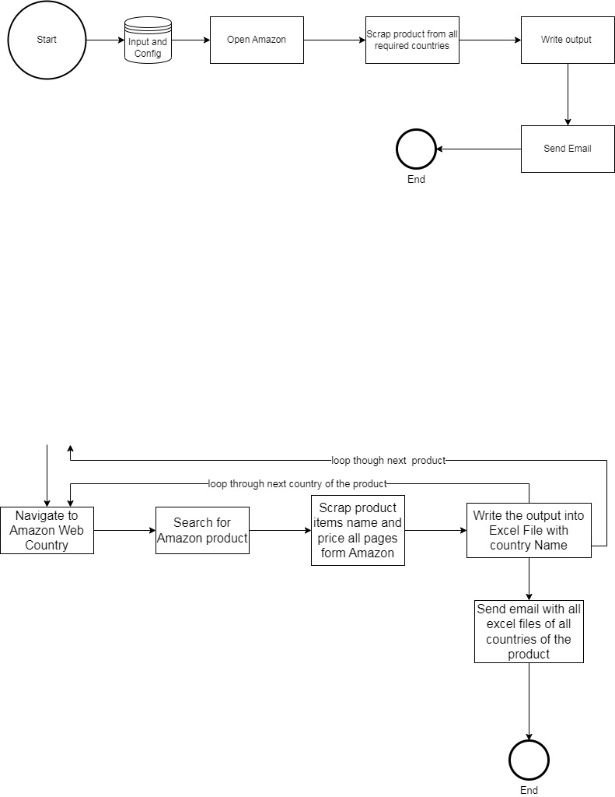

**Detailed Process Map:** This chapter depicts the As-Is business process at a detailed view to enable process owners to document their process

|  |  |  |  |
| --- | --- | --- | --- |
| # | Step Action/Description | Screenshot | Remarks |
| 1 | Read input data and config file |  |  |
| 2 | Open Amazon browser |  |  |
| 3 | Navigate to Amazon website country |  |  |
| 4 | Search for product |  |  |
| 5 | Get all items in all pages item name with its price |  |  |
| 6 | Navigate to other countries of the product if exist and do above mentioned steps |  |  |
| 7 | Continue with next product from input file and do all above mentioned steps |  |  |
| 8 | Write the data into excel file |  |  |
| 9 | Send email with output data for each products attach all excel output countries |  |  |

# 

# To-Be Process Description

## Detailed Process Map

**High Level To-Be Process Map:** This chapter depicts the To-Be automation process at a High Level to enable developers/COE to have a high-level understanding of the to be developed process.

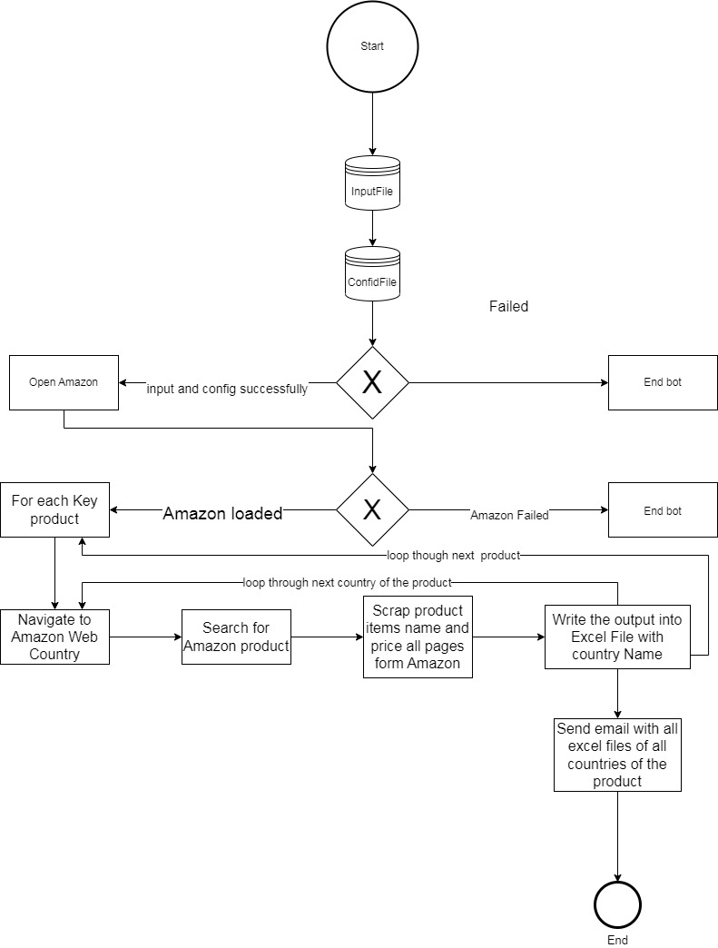

**Detailed Process Map:** This chapter depicts the To-Be automation process at a detailed view to enable developers/COE to see the workflows involved in the RPA solution

|  |  |  |  |  |  |
| --- | --- | --- | --- | --- | --- |
| **Workflow Name** | **Description** | **Pre-conditions** | **Post-actions** | **Arguments** | **Notes** |
| Main | Main Workflow contains all below workflow and nested workflow | **N/A** | **N/A** | None |  |
| ReadConfigAndInput | Read Config File (Amazon URl) and input data file which contains products to be scrapped | N/A | Dictionaries are not empty both config Dicionary and Input Dicionary | out_dictInput out_dicConfig |  |
| OpenAmazonWeb | Open Chrome to the Amazon website | N/A | Amazon web is loaded | out_amazonBrowser out_exceptionAmazonWeb |  |
| mainProcess | iterate through each product in dictionary input (Key) and for each country scrap the product | Amazon Web successfullty Loaded. | All products processed and chrome closed | in_outputDataTable in_dictInput in_amazonBrowser in_exceptionAmazonWeb in_dictConfig |  |
| AmazonScrappingLogicOne | this workflow has the selectors which works and scrapping products and prices on Amazon for UK only | Start Scrapping product in the iteration (key) on Amazon | At least one item scrapped and wrote into the DataTable | in_productName in_outputDataTable |  |
| AmazonScrappingLogicTwo | this workflow has the selectors which works and scrapping products and prices on Amazon for contries: EG, UAE, AU , CA only | Start Scrapping product in the iteration (key) on Amazon | At least one item scrapped and wrote into the DataTable | in_productName in_outputDataTable |  |
| WriteExcelFile | This workflow is starting by creating folder of the product name if not created before then will write the output datatabel into excel sheet. | ProductFolder exist or create it. | Excel wrote successfully | in_productName in_currentCountry in_outputDataTable |  |

## Robot Type

|  |  |  |  |  |
| --- | --- | --- | --- | --- |
| # | Attended | Unattended | Trigger | Comments |
| 1 |  | Unattended |  |  |

## Business Exceptions Handling

The Business Process Owner and Business Analysts are expected to document below all the business exceptions identified in the automation process. These can be classified as:

### Known Exceptions

The table below reflects all the business process exceptions encountered during the process evaluation and documentation. These are known exceptions that occurred before. For each of these exceptions, define a corresponding expected action that the robot should complete if it encounters the exception.

|  |  |  |  |  |
| --- | --- | --- | --- | --- |
| BE # | Exception Name | Step | Parameters | Action to be Taken |
| 1 | No input Data | Read InputFile |  | End bot |
| 2 | No ConfigFile | Read ConfigFile |  | End bot |
|  |  |  |  |  |

### Unknown Exceptions

For all other unanticipated or unknown business (process) exceptions, the robot should:

## System Exceptions Handling

A comprehensive list of all errors, warnings or notifications should be consolidated here with the description and action to be taken, for each, by the robot.

Errors identified in the automation process can be classified as:

|  |  |  |  |  |
| --- | --- | --- | --- | --- |
| SE # | Exception Name | Step | Parameters | Action to be Taken |
| 1 | Amazon not loaded | Open Amazon |  | End bot |
|  |  |  |  |  |
|  |  |  |  |  |

For all the other unanticipated or unknown system exceptions, send an email to **ehab.rpa@gmail.com** and attach a screenshot of the error message.

# Other Observations

Include below any other relevant observations you consider needed to be documented here.

# Additional sources of process documentation