

**Faculty of engineering - Shoubra**

**Benha University**

**Research Project**

in fulfillment of the requirements of

|  |  |
| --- | --- |
| **Department** | **Engineering Mathematics and Physics** |
| **Division** | --------- |
| **Academic Year** | **2019**-**2020 Preparatory** |
| **Course name** | **Computer** |
| **Course code** | **ECE001** |

**Title: -**

**Report on Operating systems**

By:

|  |  |  |  |
| --- | --- | --- | --- |
|  | Name | Edu mail | B.N |
| 1 | إيهاب مسعد صدقي محمود | ehab195263@feng.bu.edu.eg | 247 |

**Approved by:**

|  |  |
| --- | --- |
| Examiners committee | Signature |
| Dr. Ahmed Bayoumi |  |
| Dr. Shady Elmashed |  |
| Dr. Abdelhamid Attaby |  |

**Table of contents**

|  |  |
| --- | --- |
| **Subject / section** | **Page** |
| Application Brief | 2 |
| Screenshots | 3 |

**Application brief**

Operating system is defined as a software that manages the computer hardware. The hardware must provide appropriate to make sure the right operation of the pc system and to forestall user programs from interfering with the right operation of the system.

Operating system has many types, such as:

* Simple Batch System.
* Multiprogramming Batch System.
* Multiprocessor System.
* Desktop System.
* Distributed Operating System.
* Clustered System.
* Real-time Operating System.
* Handheld System.

Operating system performs three functions:-

1. Convenience .
2. Efficiency.
3. Ability to Evolve.

Laptops, tablets and desktop computers all run operating systems that you've probably heard of it.

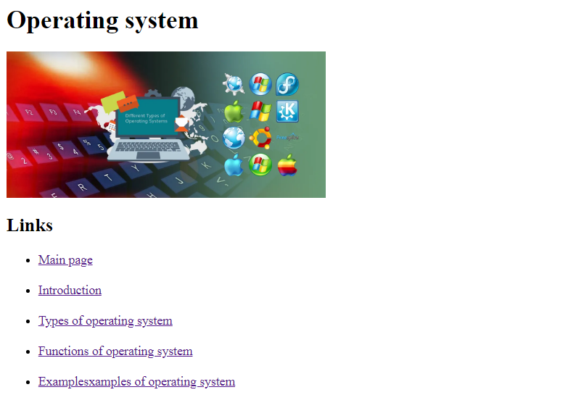**Screen shots**

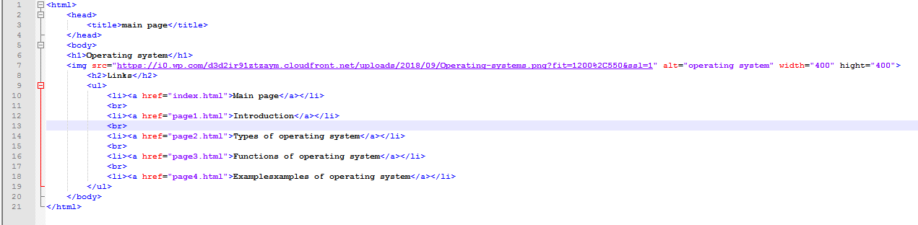

**Screenshot for source code of main page**

**Screenshot of main page**

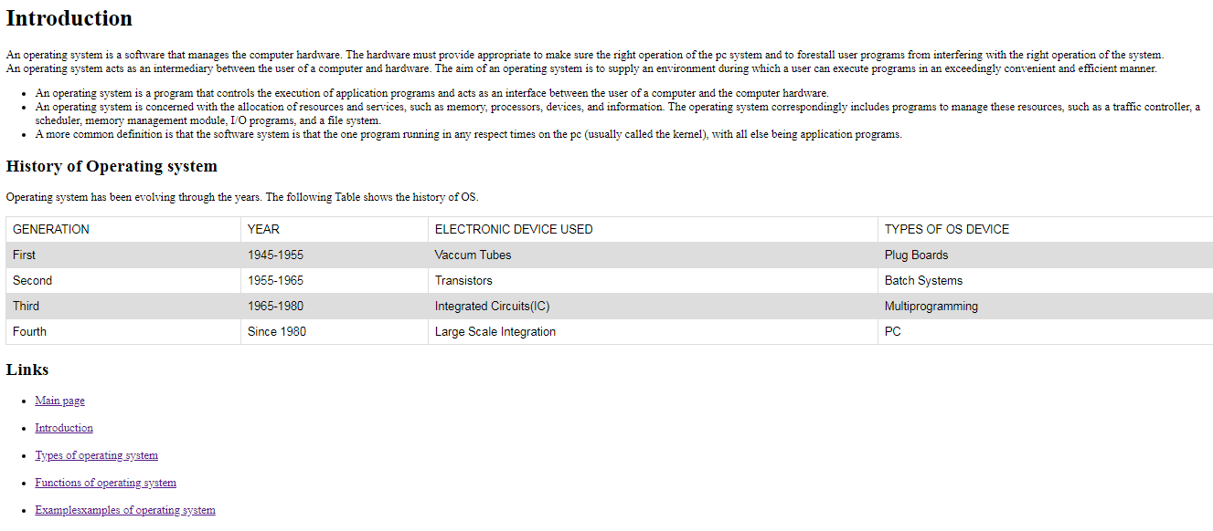

**Screenshot of page 1**

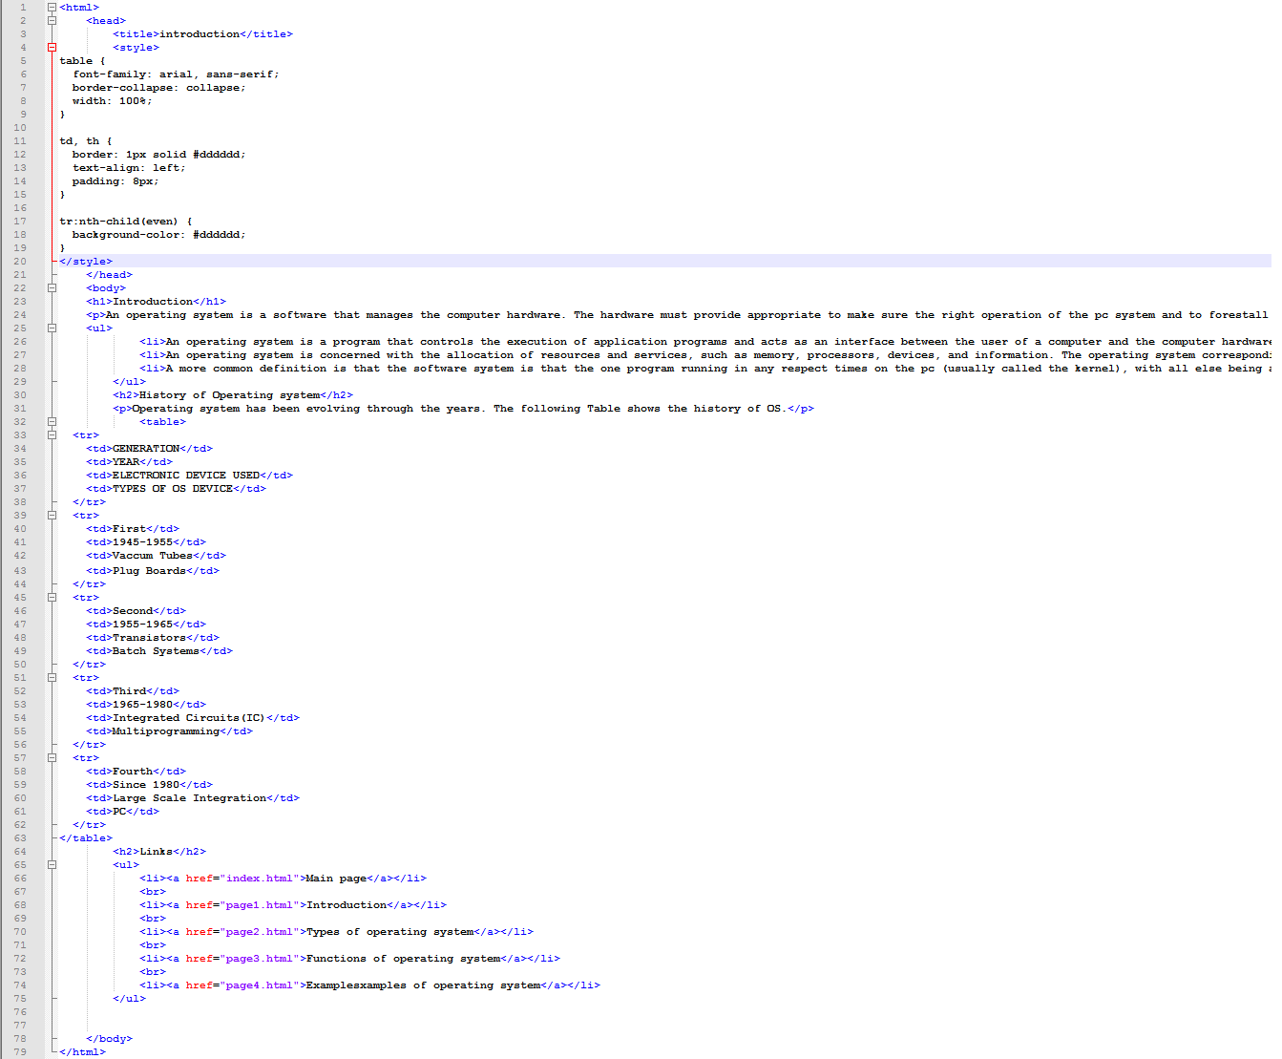

**Screenshot for source code of page 1**

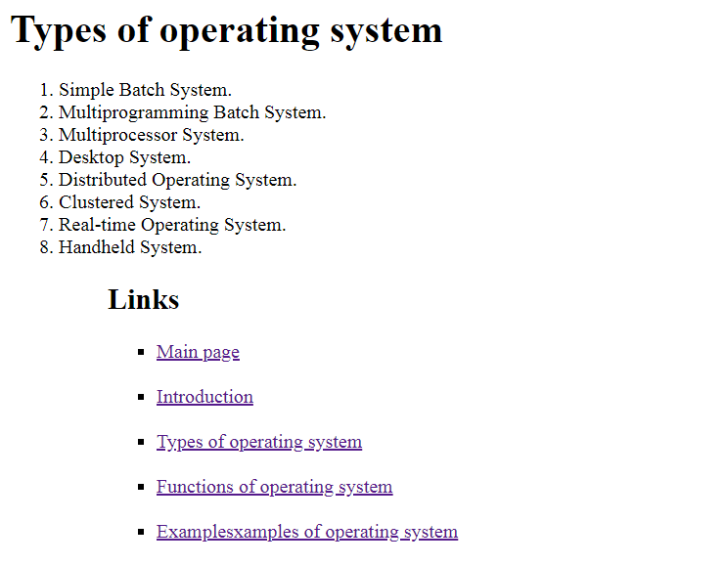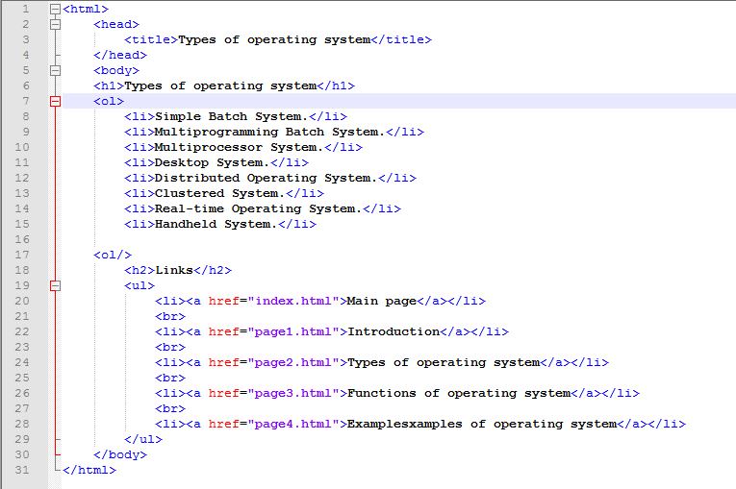

**Screenshot for source code of page 2**

**Screenshot of page 2**

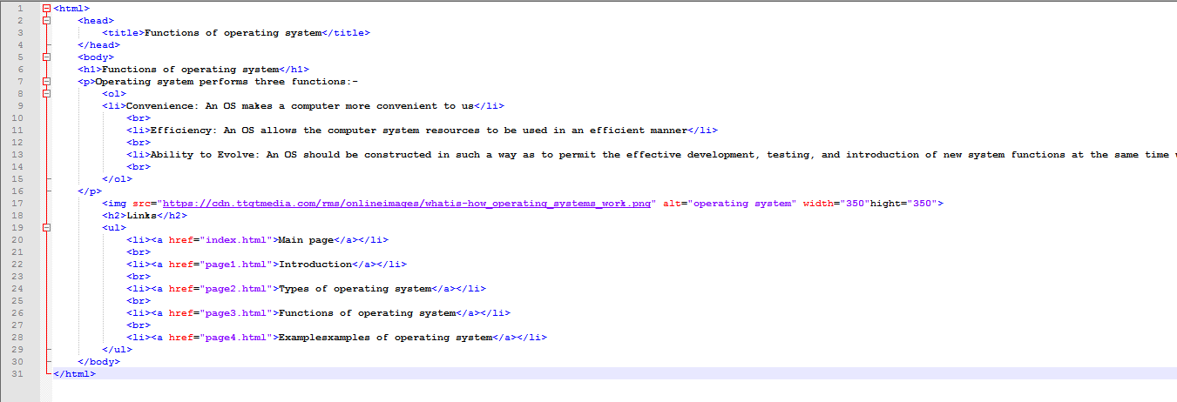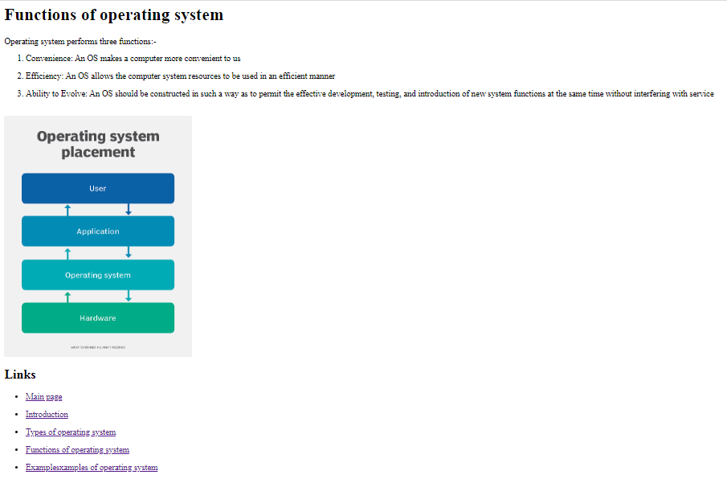

**Screenshot for source code of page 3**

**Screenshot of page 3**

**Screenshot for source code of page3**

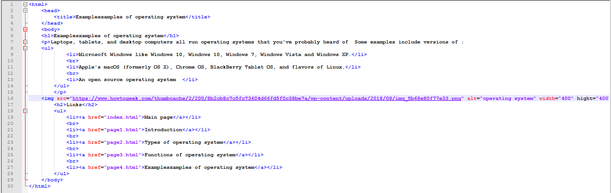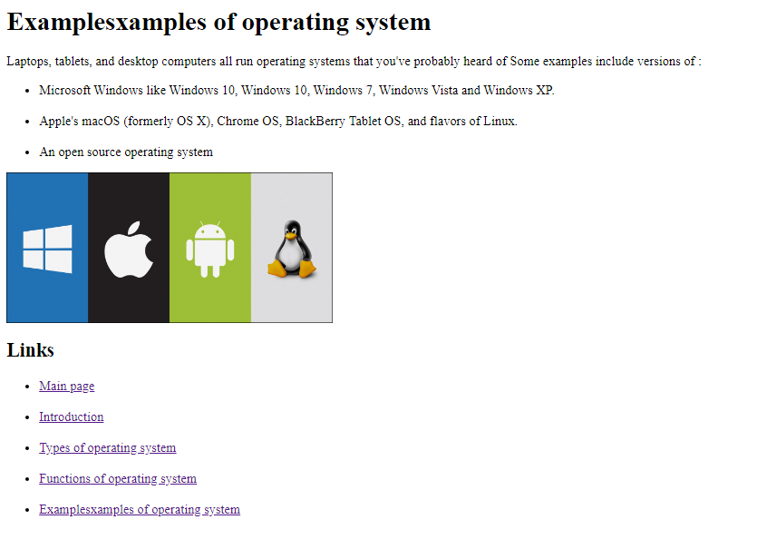

**Screenshot of page 4**

**Screenshot for source code of page 4**