PROG2002 | ASSESSMENT 2 | 40%
Charity Events Website
Project Report: case study analysis, database design, RESTful API and client-side implementation

Student name | Zhiming Wei
Student ID | 24832847
Unit | PROG2002 - Software Development for the Web
Assessment | Assessment 2 - Charity Events Website (40%)
Due date | 28 September 2026
GitHub repository | https://github.com/Ehoc-Walden/prog2002-charity-events
Demonstration video | [Insert your SCU OneDrive shareable link]
Prepared with | Node.js, ExpressJS, MySQL 8, HTML5, CSS3, JavaScript (ES5 DOM), fetch API

Placeholders shown in square brackets must be replaced with your own details before the report, the two source archives and the video link are submitted. A pre-submission checklist is provided in Appendix E.

Contents
1. Introduction
2. Case study analysis
3. Database design
4. RESTful API design
5. Client-side website architecture
6. Data flow: from a user click to a rendered event card
7. Testing and quality assurance
8. Work progress, version control and code documentation
9. Demonstration video plan
10. Evaluation against the marking rubric
11. Conclusion
Appendix A - Project folder structure
Appendix B - How to install and run the project
Appendix C - API quick reference
Appendix D - Assessment 2 requirement checklist
Appendix E - Pre-submission checklist

Figures and tables
Figure 1 - Three-tier architecture of the submitted solution
Figure 2 - Entity-relationship model for charityevents_db
Figure 3 - Request/response data flow for the search page
Figure 4 - Site map and API contract per page

1. Introduction

1.1 Purpose of this report
This report documents the analysis, design, implementation and testing of a dynamic charity events website built for Assessment 2 of PROG2002. The solution lets the public discover charity events in Sydney, filter them by date, location and category, and open a full event brief that shows the ticket price, the fundraising goal against progress, and a registration entry point. Behind the interface sits a MySQL database (charityevents_db) and a read-only RESTful API written in NodeJS with ExpressJS. The client website is plain HTML, CSS and JavaScript that consumes that API with the browser fetch API and manipulates the DOM directly - no AngularJS or other framework is used, as required by the brief.

1.2 Scope of the delivered solution
In scope. A five-table relational database with realistic sample data, a documented REST API for the home, search and event-detail pages, a three-page responsive client website, client and server form validation, automated API and client render tests, and the project documentation required by the brief.
Out of scope. This assessment is deliberately read-only. Creating, updating or deleting events (POST, PUT, PATCH, DELETE) and real ticket purchases are reserved for Assessment 3. The Register button therefore opens a modal that states exactly: "This feature is currently under construction."

1.3 How this report maps to the marking criteria
Criterion | Weight | Where it is addressed in this report
Database design and implementation | 15% | Section 3 - schema, ER model, table dictionary, normalisation, keys, indexes and seed data
RESTful API design and development | 20% | Section 4 - resource model, endpoint catalogue, validation, response contracts, status codes and security
Dynamic client-side website | 45% | Section 5 and Section 6 - page architecture, DOM rendering, filtering, validation, accessibility and traceability matrix
Accuracy, efficiency, validations and compatibility | 5% | Section 7 - automated unit tests, API smoke tests, client render tests and manual test matrix
Concept understanding (document, comments, GitHub, video) | 15% | Section 8, Section 9 and the appendices; code comments are shown in Appendix B.4

1.4 Deliverables submitted
Deliverable | Location in the submission | Notes
Project documentation | docs/PROG2002_A2_Project_Report.docx | This report; 12 pt Arial, 1.5 line spacing
Client-side source archive | usernameA2-clientside.zip | index.html, search.html, event.html, css/, js/, assets/ - no node_modules
API source archive | usernameA2-api.zip | server.js, event_db.js, src/, database/schema.sql, database/seed.sql, tests/
SQL export | api/database/schema.sql and api/database/seed.sql | schema creates and drops the database; seed loads the sample data
GitHub repository | https://github.com/Ehoc-Walden/prog2002-charity-events | Protected repository with incremental commits; invite the marker as a collaborator
Demonstration video | [insert SCU OneDrive link] | Maximum 15 minutes; covers architecture, data flow and a live demo

2. Case study analysis

2.1 Understanding the problem
The case study describes a city-based charity sector in which individual charitable organisations run fundraising activities such as gala dinners, fun runs, silent auctions and concerts. Members of the public want to find activities that match their interests, location and availability, and they want enough information to trust that the money raised is directed to a stated purpose. Organisations, in turn, need a single place to publish events and, when a listing breaches policy, to withdraw it from public view without destroying the historical record.
Two consequences of that analysis shape the whole design:
- Discovery must work with partial information. A visitor may know only a suburb, only a month, or only the type of activity they enjoy, so the search form accepts one, two or all three criteria and combines them.
- Trust must be visible. Every event exposes its organising charity, its purpose, its ticket price (including free entry) and its fundraising goal against progress, rather than hiding that information behind a registration step.
A third requirement is easy to overlook: a suspended event must not appear anywhere on the public site. The database therefore models suspension as a status value rather than a deletion, and every public query filters on status = 'published'. The seed data includes one suspended event (Fundraising Fundamentals Masterclass) precisely so this behaviour can be demonstrated and tested.

2.2 Stakeholders and their needs
Stakeholder | Primary goal | Needs from the website | Design response
Event seeker (public visitor) | Find a charity event worth attending | Search by date, location and category; clear summaries; full details; a visible ticket price | Home page event grid, three-criteria search form, event detail page with ticket and progress panels
Prospective donor / attendee | Understand where the money goes before registering | Purpose statement, goal versus progress, transparent pricing including free events | fundraising object with goal, raised and progressPercent returned by the API and rendered as an accessible progress bar
Charity organiser | Promote events to the right audience | Accurate listing with category, venue, capacity and highlights | Normalised events, categories, venues and event_highlights tables with one-to-many relationships
Charity operations / policy officer | Keep non-compliant listings off the public site | Withdraw a listing without deleting its history | status ENUM ('draft', 'published', 'suspended', 'cancelled'); all public queries filter status = 'published'
Marker / maintainer | Reproduce and assess the work quickly | Portable SQL export, documented setup, readable code, evidence of testing | schema.sql plus seed.sql, README instructions, JSDoc-style comments, automated test scripts (Section 7)

2.3 User stories and acceptance criteria
ID | User story | Acceptance criteria
US1 | As a visitor, I want to see the charity's mission and contact details, so that I know who I am supporting. | The home page shows the organisation name, mission, description and contact details without requiring an API call.
US2 | As a visitor, I want to see all currently available upcoming events on the home page, so that I can quickly browse what is on. | GET /api/events/upcoming returns published events whose end date is today or later; the page renders one card per event with an image, title, category, date, location and price.
US3 | As a visitor, I want each event card to tell me whether the event is past or upcoming, so that I do not plan around an event that has finished. | The API sets isPast by comparing the end date with today's date in Australia/Sydney; the card renders a Past or Upcoming status tag.
US4 | As a policy officer, I want suspended events to be invisible to the public, so that the site never promotes a non-compliant listing. | Suspended and draft events are excluded from the home page, the search results and direct event lookups, which return HTTP 404 instead.
US5 | As a visitor, I want to search by date, location and category, so that I only see relevant events. | The search form submits any combination of the three criteria; multiple categories can be selected at once, and each filter is combined with AND while categories are combined with OR.
US6 | As a visitor, I want to clear the filters in one action, so that I can start again without reloading the page. | The Clear Filters control resets the form fields, unchecks every category, clears validation messages and immediately re-runs an unfiltered search using DOM manipulation only.
US7 | As a visitor, I want clear feedback when my search input is invalid, so that I can correct it. | Client validation marks the offending field with aria-invalid, inserts an inline message next to it, and shows a summary alert; the API independently returns HTTP 400 with a descriptive message.
US8 | As a visitor, I want to open one event and see everything about it, so that I can decide whether to attend. | The detail page reads the event id from the query string (with a localStorage fallback), calls GET /api/events/:id, and renders the full description, schedule, venue, highlights, capacity, price and fundraising progress.
US9 | As a visitor, I want to know the ticket price, including when an event is free, so that I can budget for it. | The API returns ticket.price, ticket.currency and ticket.isFree; the client renders Free when isFree is true and a formatted currency amount otherwise.
US10 | As a visitor, I want to attempt registration, so that I can express interest even before ticketing is built. | The Register button on the detail page opens a modal dialog stating exactly "This feature is currently under construction."

2.4 Functional requirements
The functional requirements below translate the user stories into verifiable behaviour. Each requirement is traceable to the endpoint or client file that implements it.
ID | Requirement | Implementation reference
FR1 | The home page must display the charity's name, mission, description and contact details from static client content so it still renders when the API is unavailable. | clientside/index.html, sections #about and #contact
FR2 | The home page must request and display currently available upcoming events from the API. | clientside/js/home.js -> CharityApi.getUpcomingEvents()
FR3 | Every event card must be labelled as upcoming or past using the server-calculated isPast flag. | clientside/js/utils.js -> buildEventCard()
FR4 | Events with a status other than published (draft, suspended, cancelled) must never appear on the home page, in search results or on a direct detail lookup. | api/src/utils/eventSql.js, api/src/services/eventService.js
FR5 | The search page must accept a date, a free-text location and one or more categories and combine them in a single query. | clientside/search.html, clientside/js/search.js, api/src/utils/validation.js
FR6 | The search page must provide a Clear Filters control that resets every field, unchecks every category and re-runs the search without a page reload. | clientside/js/search.js -> resetFilters()
FR7 | Invalid search input must be reported inline next to the offending field, with a summary message and an accessible aria-invalid marker. | clientside/js/search.js -> validate() / showFieldError()
FR8 | The event detail page must obtain the event identifier from the query string and fall back to localStorage when it is absent. | clientside/js/event.js -> resolveEventId()
FR9 | The detail page must display the full event record: description, purpose, schedule, venue, highlights, capacity, ticket price and fundraising progress. | clientside/js/event.js -> renderEvent()
FR10 | The ticket price must be formatted as a currency amount, or as the literal word Free when is_free is true. | clientside/js/utils.js -> formatPrice()
FR11 | The detail page must show the fundraising goal against the amount raised as an accessible progress bar capped at 100 per cent. | clientside/js/event.js -> buildProgress()
FR12 | The Register button must open a modal that contains exactly the sentence "This feature is currently under construction." | clientside/event.html, clientside/js/event.js -> openRegisterDialog()

2.5 Non-functional requirements
ID | Quality attribute | Requirement and how it is met
NFR1 | Performance and efficiency | The API returns only published events, uses indexed filter columns, runs the count and page queries in parallel and caps page size at 50. Responses are cacheable for 30 seconds, which keeps repeated browsing cheap.
NFR2 | Security | Every query is parameterised with mysql2 db.execute placeholders, so user input can never alter SQL syntax. helmet sets defensive HTTP headers, x-powered-by is disabled, CORS is restricted to an allow-list, JSON bodies are limited to 20 kb, and internal database errors are never returned to the client.
NFR3 | Read-only integrity | The brief forbids write operations in this assessment, so the API exposes GET and OPTIONS only. A shared not-found handler returns a structured 404 JSON body for every unmapped route or method.
NFR4 | Usability | All three pages share one navigation bar and footer. Search results are announced with a result count, an empty state explains how to widen a search, and the Register action gives immediate modal feedback instead of a dead button.
NFR5 | Accessibility | Semantic landmarks, a skip link, visible focus styles, a labelled search form, aria-invalid and aria-describedby error wiring, role="progressbar" with aria-valuenow, aria-expanded mobile navigation and a focus-trapped modal dialog are implemented.
NFR6 | Maintainability | The API separates configuration, routing, validation, SQL construction, services and error handling. The client separates configuration, HTTP access, shared utilities, layout and one controller per page. Every file carries a JSDoc header explaining its responsibility.
NFR7 | Compatibility and portability | The client uses standard ES5-compatible DOM APIs and the fetch API, so it runs in current Chrome, Edge, Firefox and Safari without a build step or framework. Database credentials are supplied through environment variables so the project can be moved between machines.
NFR8 | Data quality | Primary keys, foreign keys and CHECK constraints reject invalid states such as an end date before a start date, a negative ticket price or a non-positive fundraising goal. Seed data is repeatable because the schema drops and recreates the database.

3. Database design
The persistence layer is a normalised MySQL 8 database named exactly charityevents_db. It stores the organisations that run charity events, the categories those events belong to, the venues where they are held, the events themselves and an ordered list of highlights for each event. The schema file is api/database/schema.sql and the sample data file is api/database/seed.sql; both are submitted with the API archive.

3.1 Design principles
- Model the domain, not the screens. Venues, categories and organisations are separate entities because they are reused by many events, rather than being repeated as text columns.
- Enforce correctness in the database. Foreign keys, UNIQUE constraints and CHECK constraints make it impossible to store a broken relationship or an impossible value, even if a future client has a bug.
- Use surrogate integer keys. Every table has an UNSIGNED AUTO_INCREMENT primary key so relationships stay stable even if a human-readable name changes.
- Keep money and dates explicit. Money uses DECIMAL(12,2) rather than a floating-point type, and every event stores an explicit timezone alongside its start and end datetimes.
- Index what the website filters on. Composite and single-column indexes cover the status, start date, category, organisation and location access paths used by the search endpoint.
- Store reusable strings once. Categories and venues are normalised so a suburb name or an accent colour is edited in exactly one place.
- Support an ordered, repeating attribute. Event highlights live in their own table with a UNIQUE (event_id, display_order) constraint so the detail page can render a stable, ordered list.
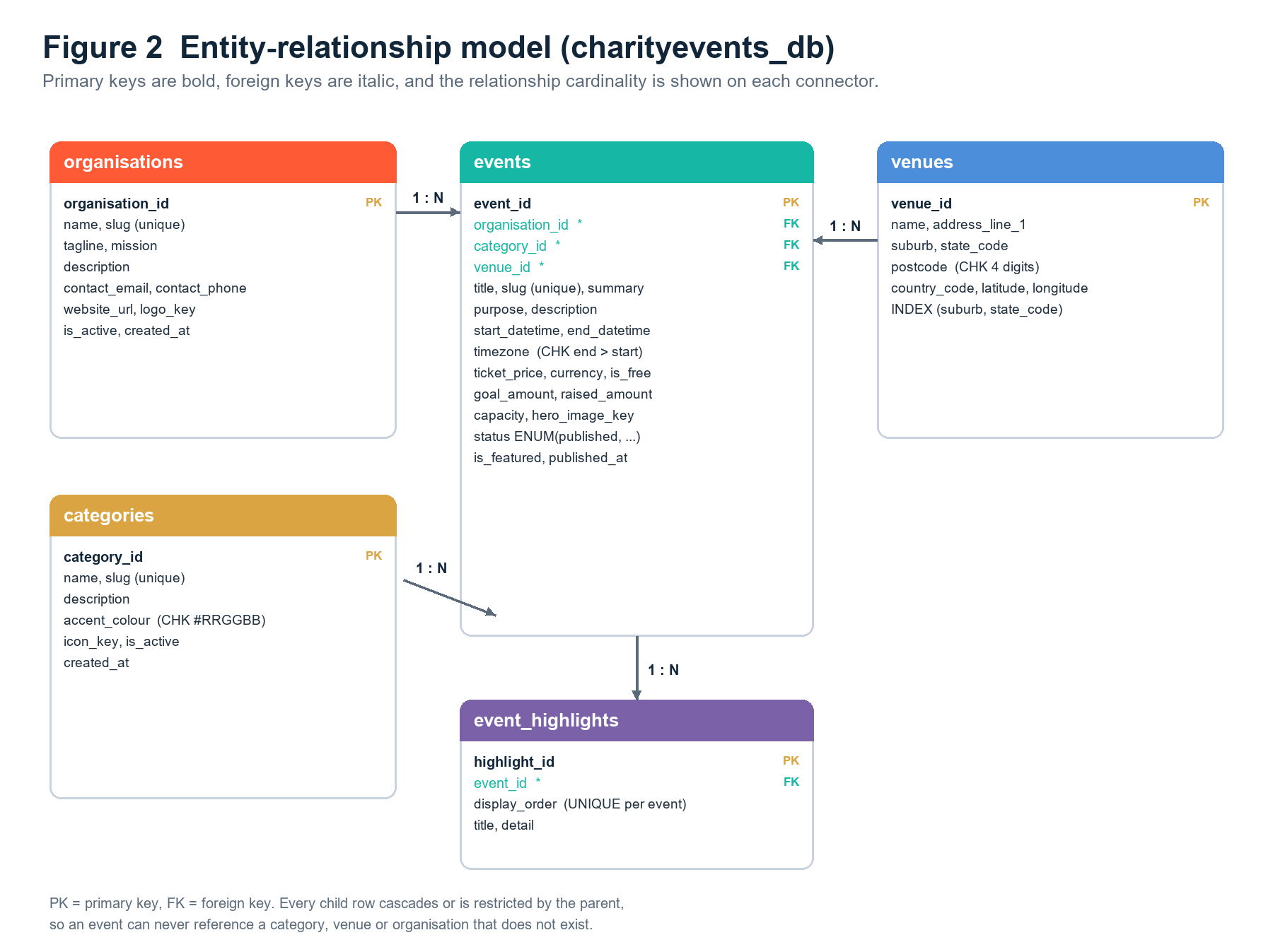
Figure 2 - Entity-relationship model for charityevents_db, showing the five tables and the one-to-many relationships enforced by foreign keys.

3.2 Data dictionary
The following tables document every column in the schema, including its type, constraints and purpose. Together they form the authoritative data dictionary for the database.

3.2.1 organisations
Column | Type | Constraints | Purpose
organisation_id | INT UNSIGNED | PK, AUTO_INCREMENT | Surrogate identifier for the charity.
name | VARCHAR(160) | NOT NULL | Public name of the organisation.
slug | VARCHAR(180) | NOT NULL, UNIQUE | URL-safe identifier used in links.
tagline | VARCHAR(220) | NOT NULL | Short marketing line shown in the header block.
mission | TEXT | NOT NULL | Mission statement rendered on the home page.
description | TEXT | NOT NULL | Longer description of the organisation.
contact_email | VARCHAR(190) | NOT NULL | General enquiries address.
contact_phone | VARCHAR(40) | NOT NULL | Contact telephone number.
website_url | VARCHAR(255) | NULL | Optional external website.
logo_key | VARCHAR(255) | NULL | Key of the logo asset used by the client.
is_active | TINYINT(1) | NOT NULL, DEFAULT 1, CHECK IN (0,1) | Soft switch to hide an organisation.
created_at | TIMESTAMP | NOT NULL, DEFAULT CURRENT_TIMESTAMP | Row creation audit timestamp.
updated_at | TIMESTAMP | NOT NULL, ON UPDATE CURRENT_TIMESTAMP | Row modification audit timestamp.

3.2.2 categories
Column | Type | Constraints | Purpose
category_id | INT UNSIGNED | PK, AUTO_INCREMENT | Surrogate identifier for the category.
name | VARCHAR(80) | NOT NULL | Display name, for example Sport or Community.
slug | VARCHAR(100) | NOT NULL, UNIQUE | Stable value submitted by the search form.
description | VARCHAR(255) | NOT NULL | Short explanation shown in the filter list.
accent_colour | CHAR(7) | NOT NULL, DEFAULT '#17B7A5', CHECK hex | Per-category colour used on cards and tags.
icon_key | VARCHAR(60) | NOT NULL | Identifier of the icon shown beside the label.
is_active | TINYINT(1) | NOT NULL, DEFAULT 1, CHECK IN (0,1) | Hides retired categories from the filter form.
created_at | TIMESTAMP | NOT NULL, DEFAULT CURRENT_TIMESTAMP | Row creation audit timestamp.

3.2.3 venues
Column | Type | Constraints | Purpose
venue_id | INT UNSIGNED | PK, AUTO_INCREMENT | Surrogate identifier for the venue.
name | VARCHAR(160) | NOT NULL | Venue name, for example a park or hall.
address_line_1 | VARCHAR(180) | NOT NULL | Street address of the venue.
suburb | VARCHAR(100) | NOT NULL | Suburb used for location search and display.
state_code | CHAR(3) | NOT NULL | Australian state or territory code.
postcode | CHAR(4) | NOT NULL, CHECK four digits | Australian postcode.
country_code | CHAR(2) | NOT NULL, DEFAULT 'AU' | ISO country code.
latitude | DECIMAL(9,6) | NULL | Optional latitude for future mapping.
longitude | DECIMAL(9,6) | NULL | Optional longitude for future mapping.
created_at | TIMESTAMP | NOT NULL, DEFAULT CURRENT_TIMESTAMP | Row creation audit timestamp.

3.2.4 events
Column | Type | Constraints | Purpose
event_id | INT UNSIGNED | PK, AUTO_INCREMENT | Identifier used in the detail page URL.
organisation_id | INT UNSIGNED | NOT NULL, FK -> organisations | The charity that runs the event.
category_id | INT UNSIGNED | NOT NULL, FK -> categories | The single category used by the filter.
venue_id | INT UNSIGNED | NOT NULL, FK -> venues | Where the event takes place.
title | VARCHAR(180) | NOT NULL | Public event name.
slug | VARCHAR(200) | NOT NULL, UNIQUE | URL-safe identifier for the event.
summary | VARCHAR(380) | NOT NULL | One-line description shown on cards.
purpose | VARCHAR(260) | NOT NULL | Why the event exists; shown on the detail page.
description | TEXT | NOT NULL | Full event description.
start_datetime | DATETIME | NOT NULL | Local start date and time.
end_datetime | DATETIME | NOT NULL, CHECK > start | Local end date and time.
timezone | VARCHAR(50) | NOT NULL, DEFAULT 'Australia/Sydney' | Timezone the datetimes are expressed in.
ticket_price | DECIMAL(10,2) | NOT NULL, DEFAULT 0.00, CHECK >= 0 | Price per ticket in the event currency.
currency | CHAR(3) | NOT NULL, DEFAULT 'AUD' | ISO currency code.
is_free | TINYINT(1) | NOT NULL, DEFAULT 0, CHECK IN (0,1) | Drives the Free price label.
goal_amount | DECIMAL(12,2) | NOT NULL, CHECK > 0 | Fundraising target.
raised_amount | DECIMAL(12,2) | NOT NULL, DEFAULT 0.00, CHECK >= 0 | Amount raised so far.
capacity | INT UNSIGNED | NULL | Maximum attendees; NULL means unlimited.
hero_image_key | VARCHAR(255) | NOT NULL | Cover image key resolved by the client.
status | ENUM | NOT NULL, DEFAULT 'draft' | draft, published, suspended or cancelled.
is_featured | TINYINT(1) | NOT NULL, DEFAULT 0, CHECK IN (0,1) | Promotes an event on the home page.
published_at | DATETIME | NULL | When the event was published.
created_at | TIMESTAMP | NOT NULL, DEFAULT CURRENT_TIMESTAMP | Row creation audit timestamp.
updated_at | TIMESTAMP | NOT NULL, ON UPDATE CURRENT_TIMESTAMP | Row modification audit timestamp.

3.2.5 event_highlights
Column | Type | Constraints | Purpose
highlight_id | INT UNSIGNED | PK, AUTO_INCREMENT | Surrogate identifier for the highlight.
event_id | INT UNSIGNED | NOT NULL, FK -> events ON DELETE CASCADE | Owning event; deleting an event removes its highlights.
display_order | TINYINT UNSIGNED | NOT NULL, DEFAULT 1 | Position of the highlight in the list.
title | VARCHAR(120) | NOT NULL | Short heading for the highlight.
detail | VARCHAR(300) | NOT NULL | Explanatory sentence for the highlight.

A UNIQUE (event_id, display_order) constraint guarantees that two highlights for the same event can never claim the same position.

3.3 Keys, constraints and indexes
Object | Type | Table | Why it exists
organisation_id | Primary key | organisations | Stable identifier referenced by every event.
category_id | Primary key | categories | Stable identifier used by the category filter.
venue_id | Primary key | venues | Stable identifier for the location shown on a card.
event_id | Primary key | events | Identifier used by the detail page query string.
highlight_id | Primary key | event_highlights | Allows highlights to be updated individually.
slug | Unique | organisations, categories, events | Prevents two rows sharing the same URL-safe name.
fk_events_organisation | Foreign key | events | An event cannot exist without a valid charity.
fk_events_category | Foreign key | events | An event cannot exist without a valid category.
fk_events_venue | Foreign key | events | An event cannot exist without a valid venue.
fk_highlights_event | Foreign key (cascade) | event_highlights | Removing an event cleans up its highlights automatically.
uq_event_highlight_order | Unique pair | event_highlights | Two highlights cannot occupy the same position.
chk_events_dates | CHECK | events | Guarantees end_datetime is later than start_datetime.
chk_events_price / goal / raised | CHECK | events | Rejects negative prices, negative amounts and a non-positive goal.
chk_events_free / featured | CHECK | events | Keeps boolean flags to 0 or 1.
chk_venues_postcode | CHECK | venues | Rejects a postcode that is not four digits.
chk_categories_colour | CHECK | categories | Rejects an accent colour that is not a hex triplet.
idx_events_start_status | Composite index | events | Speeds up the date-window and status predicate used by every listing query.
idx_events_category | Index | events | Speeds up category filtering and joins.
idx_events_organisation | Index | events | Speeds up filtering or grouping by charity.
idx_events_location | Index | events | Speeds up the join to venues for location search.
idx_venues_location | Composite index | venues | Speeds up suburb and state lookups.

3.4 Normalisation
The schema is normalised to third normal form (3NF). Each normal form was verified against the tables rather than assumed.
First normal form (1NF). Every column holds a single atomic value and every table has a primary key. Repeating information, such as the ordered list of event highlights, was moved out of events into event_highlights instead of being stored as a delimited string or a set of numbered columns.
Second normal form (2NF). No non-key attribute depends on only part of a composite key. The only composite key in the schema is the UNIQUE (event_id, display_order) constraint on event_highlights; both title and detail depend on the whole pair, not on display_order alone. All other tables use a single-column surrogate primary key.
Third normal form (3NF). No non-key attribute depends on another non-key attribute. Venue details such as suburb, state and postcode are stored once in venues and referenced by venue_id, so they cannot become inconsistent across events. The same applies to the category name, colour and icon, and to the organisation's mission and contact details.
Denormalisation was deliberately avoided. The only derived values the API computes are presentation concerns: isPast is calculated from end_datetime and the current date, and the progress percentage is calculated from raised_amount and goal_amount. Neither is stored, so neither can drift out of step with its source columns.

3.5 Seed data
api/database/seed.sql loads a realistic sample data set that exercises every code path the website needs, including the edge cases the markers are likely to test.
Table | Rows | Coverage notes
organisations | 4 | One primary charity plus three partner organisations.
categories | 8 | Sport, Community, Arts, Music, Education, Food, Environment and Wellbeing.
venues | 10 | Sydney and regional NSW venues with distinct suburbs and postcodes.
events | 12 | Eight published upcoming events, one published past event, two free events and one suspended event.
event_highlights | 33 | Two to four ordered highlights for every published event.

The twelve seeded events are listed below. They are deliberately varied so that every filter, sort option and detail-page state can be demonstrated without editing the database.
ID | Event | Start | Price | Goal | Raised | Capacity | Status | Notes
1 | Twilight Harbour 10K | 18 Oct 2026 | $65.00 | $80,000 | $51,500 | 1,200 | published | Featured
2 | Table of One Hundred Gala | 07 Nov 2026 | $260.00 | $150,000 | $86,200 | 100 | published | Featured
3 | Art with Heart Silent Auction | 03 Oct 2026 | $45.00 | $50,000 | $41,000 | 420 | published
4 | Beats for Belonging | 04 Dec 2026 | $58.00 | $65,000 | $23,300 | 850 | published | Featured
5 | Coastline Community Walk | 25 Oct 2026 | Free | $30,000 | $17,800 | 700 | published | Free event
6 | Trivia for Tomorrow | 19 Nov 2026 | $35.00 | $45,000 | $12,650 | 260 | published
7 | Sunrise Yoga for Shelter | 11 Oct 2026 | $30.00 | $25,000 | $19,400 | 180 | published
8 | Long Lunch for Local Kids | 29 Nov 2026 | $95.00 | $60,000 | $21,800 | 350 | published
9 | River Clean-Up and Community BBQ | 20 Sep 2026 | Free | $20,000 | $16,750 | 240 | published | Free event
10 | Winter Sleepout Fundraiser | 15-16 Aug 2026 | $40.00 | $90,000 | $93,420 | 300 | published | Past; progress capped at 100%
11 | Fundraising Fundamentals Masterclass | 30 Oct 2026 | $25.00 | $15,000 | $4,500 | 120 | suspended | Must never appear
12 | Spring Pantry Packing Day | 12 Dec 2026 | $20.00 | $40,000 | $8,900 | 300 | published | No goals exceeded

Event 11 is intentionally suspended, event 10 ended in the past and its raised amount exceeds its goal, and events 5 and 9 are free. These three cases prove that the client hides suspended listings, labels past events correctly and never displays a progress bar above 100 per cent.

4. RESTful API design
The API is a read-only NodeJS and ExpressJS service that exposes the charityevents_db data over HTTP as JSON. It was designed around resources rather than screens: events, categories, locations and organisations each have their own collection URL, and each event is addressable by its own identifier. The website is a separate, stateless consumer of that API.

4.1 Resource model and URL design
Every URL is a noun in the plural form, nested only where a genuine ownership relationship exists. Query strings carry filters, sorting and pagination; they never change which resource is being addressed.
- /api/events - the collection of events. /api/events/upcoming and /api/events/search are read-only, filtered views of that collection.
- /api/events/{eventId} - a single event addressed by its numeric identifier, which makes every detail page a permanent, bookmarkable link.
- /api/categories - the filter options offered by the search page.
- /api/locations - the distinct venues and suburbs used to populate location hints.
- /api/organisations - the charity profiles rendered in the site's about area.
- /api/health - an unauthenticated readiness probe used during testing and demonstration.
Each response uses the same envelope so the client can parse every endpoint with one helper: data always holds the payload and meta always holds counts, the applied filter set or pagination information.

4.2 Endpoint catalogue
Method | URL | Key parameters | Success | Error responses
GET | /api/health | none | 200 with the service status | 500 if the process is unhealthy
GET | /api/events/upcoming | limit (1-20, default 6) | 200 with an array of published upcoming events and meta.asOfDate | 400 for a non-numeric or out-of-range limit
GET | /api/events/search | date, location, category (repeatable or comma-separated), scope, sort, page, limit | 200 with a page of results plus meta.filters and meta.pagination | 400 for a malformed date, an invalid slug, an unknown sort, an unknown scope or an out-of-range page
GET | /api/events/{eventId} | eventId path segment | 200 with the full event, venue, organisation, category, highlights and progress | 400 for a non-numeric id; 404 when the event does not exist or is not published
GET | /api/categories | none | 200 with the active categories ordered by display name | 500 on an unexpected database failure
GET | /api/locations | none | 200 with the distinct venues and their suburbs | 500 on an unexpected database failure
GET | /api/organisations | none | 200 with the active organisations | 500 on an unexpected database failure

4.3 Search parameter semantics
Parameter | Accepted values | Default | Semantics
date | YYYY-MM-DD | omitted | Matches events whose start_datetime falls on that calendar date.
location | Free text, up to 80 characters | omitted | Case-insensitive partial match across the venue name, street, suburb, state and postcode.
category | One or more category slugs; repeated parameters or a comma-separated list | omitted | Multiple categories are combined with OR; the set as a whole is ANDed with the other filters.
scope | upcoming, past or all | upcoming | upcoming keeps events ending today or later; past keeps events that ended before today; all removes the date window.
sort | date_asc, date_desc, raised_desc, goal_desc | date_asc | Only these four whitelisted orderings can be requested, which prevents SQL injection through the sort clause.
page | Integer 1-10000 | 1 | Selects the page of results using OFFSET.
limit | Integer 1-50 | 12 | Number of rows per page.

Combination rule. Different filters are combined with AND; the values inside the category filter are combined with OR. A search for date=2026-11-07 and category=community,arts therefore reads as: published, in the correct date window, starting on 7 November 2026, AND in the community OR arts category.

4.4 Sample request and response
The example below shows the search request used on the search page together with an abbreviated but structurally exact response. Request and response bodies are shown as they appear in a browser or REST client.
GET /api/events/search?date=2026-11-07&location=darling&category=community&scope=upcoming&sort=date_asc&page=1&limit=12

HTTP/1.1 200 OK
Content-Type: application/json; charset=utf-8
Cache-Control: public, max-age=30

{
"data": [
{
"id": 2,
"title": "Table of One Hundred Gala",
"slug": "table-of-one-hundred-gala",
"summary": "An elegant long-table dinner raising funds for food security.",
"purpose": "Fund 20,000 meals for families facing hardship.",
"startDateTime": "2026-11-07T18:30:00.000Z",
"endDateTime": "2026-11-07T22:30:00.000Z",
"timezone": "Australia/Sydney",
"ticket": { "price": 260, "currency": "AUD", "isFree": false },
"fundraising": { "goal": 150000, "raised": 86200, "progressPercent": 57.5 },
"capacity": 100,
"heroImage": "table-of-one-hundred",
"featured": true,
"isPast": false,
"category": { "id": 2, "name": "Community", "slug": "community",
"accentColour": "#E4572E", "iconKey": "community" },
"organisation": { "id": 1, "name": "Common Ground Collective",
"slug": "common-ground-collective" },
"venue": { "id": 3, "name": "Harbourside Pavilion",
"addressLine1": "12 Darling Drive", "suburb": "Sydney",
"stateCode": "NSW", "postcode": "2000", "countryCode": "AU" }
}
],
"meta": {
"filters": {
"date": "2026-11-07", "location": "darling", "categories": ["community"],
"sort": "date_asc", "scope": "upcoming", "page": 1, "limit": 12
},
"pagination": { "page": 1, "limit": 12, "total": 1, "totalPages": 1 }
}
}

An invalid request is rejected before any SQL runs. The response body uses the same envelope so the client can display the message directly.
GET /api/events/search?date=07-11-2026

HTTP/1.1 400 Bad Request
{
"error": {
"status": 400,
"message": "date must use YYYY-MM-DD format."
}
}

4.5 Input validation
Validation is performed twice. The browser checks the form before a request is sent so the user receives immediate feedback, and the API revalidates every value because a public HTTP endpoint can never trust its caller.
Input | Rule | Rejection behaviour
date | Must match YYYY-MM-DD and be a real calendar date. | HTTP 400 with "date must use YYYY-MM-DD format."
location | Trimmed; 80 characters or fewer. | HTTP 400 with "Location must be 80 characters or fewer."
category | Every value must be a lowercase hyphenated slug. | HTTP 400 with "Each category must be a valid slug."
sort | Must be one of the four whitelisted values. | HTTP 400 listing the accepted values.
scope | Must be upcoming, past or all. | HTTP 400 with "scope must be upcoming, past or all."
page | Positive integer, 1 to 10000. | HTTP 400 with the permitted range.
limit | Positive integer, 1 to 50 (1 to 20 for the upcoming endpoint). | HTTP 400 with the permitted range.
eventId | Digits only, converted to a number before use. | HTTP 400 with "Event ID must be a positive integer."

Client-side rules add two usability checks that the API cannot express: an upcoming search cannot use a date before today, and a date more than 24 months ahead is rejected so the user does not page through an empty far-future range.

4.6 HTTP status codes
Status | Meaning in this API | When it is returned
200 OK | The request succeeded. | Every successful GET, including an empty result set.
400 Bad Request | A supplied value failed validation. | Malformed date, invalid slug, unknown sort or scope, out-of-range pagination, non-numeric event id.
404 Not Found | The resource does not exist or is not public. | An unmapped route, an unsupported method, an unknown event id, or an event whose status is not published.
500 Internal Server Error | An unexpected server or database failure occurred. | A connection failure or an unhandled exception; the client receives a generic message, never a stack trace.

4.7 Security
- SQL injection is prevented by parameterised queries. Every user value is bound with a db.execute placeholder and the only SQL fragment chosen by the caller, the sort clause, is selected from a frozen whitelist rather than interpolated.
- HTTP headers are hardened with helmet, and x-powered-by is disabled so the server does not advertise its stack.
- Cross-origin access is restricted. The CORS middleware allows only the browser origins listed in the CORS_ORIGINS environment variable, and only the GET and OPTIONS methods.
- Request bodies are capped at 20 kb with express.json({ limit: '20kb' }), which limits denial-of-service abuse even though no write endpoint exists.
- Errors are sanitised. The error handler logs the real error on the server but returns a generic message with the correct status code, so database schema details never leak to a visitor.
- The API is read-only by design. Because the assessment forbids POST, PUT, PATCH and DELETE, those methods cannot modify data even if they are attempted.
- Environment secrets stay out of source control. Database credentials and the CORS allow-list are read from process environment variables, and .env is excluded by .gitignore while .env.example documents the required keys.

4.8 Efficiency and performance
- Indexed predicates: the date-window and status condition is covered by idx_events_start_status, and category, organisation and venue joins are backed by their own indexes.
- Parallel queries: the search endpoint issues its COUNT and page queries together with Promise.all rather than sequentially, halving the round-trip latency on a cold connection.
- Bounded result sets: limit is capped at 50 and page at 10000, which prevents a single request from scanning or returning an unbounded number of rows.
- Projection: the SQL selects named columns instead of using SELECT *, so only the fields the client renders cross the wire.
- Short cache window: every GET response carries Cache-Control: public, max-age=30, which absorbs bursts of repeated browsing while keeping fundraising totals acceptably fresh.
- Connection pooling: event_db.js exposes a single mysql2 promise pool, which reuses connections across requests instead of reconnecting for each one.

5. Client-side website architecture
The client is a three-page static website written in plain HTML5, CSS3 and JavaScript. It contains no framework and no build step: the pages can be served from any static host, and the brief's prohibition on AngularJS is therefore satisfied by construction. Data is retrieved from the REST API with the browser fetch API and inserted into the DOM with explicit JavaScript, which is the technique the assessment asks the student to demonstrate.

5.1 Three-tier architecture
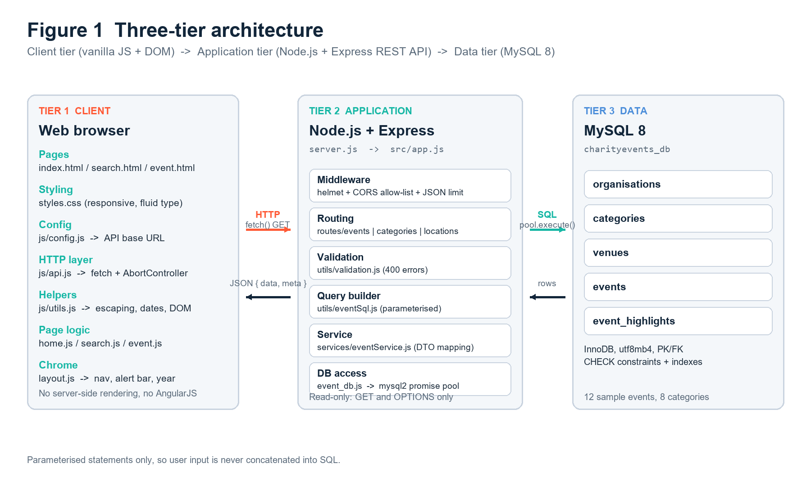
Figure 1 - Three-tier architecture: the browser client, the ExpressJS REST API and the MySQL database, with HTTP/JSON between the first two tiers and parameterised SQL between the last two.

5.2 Site map and API contract
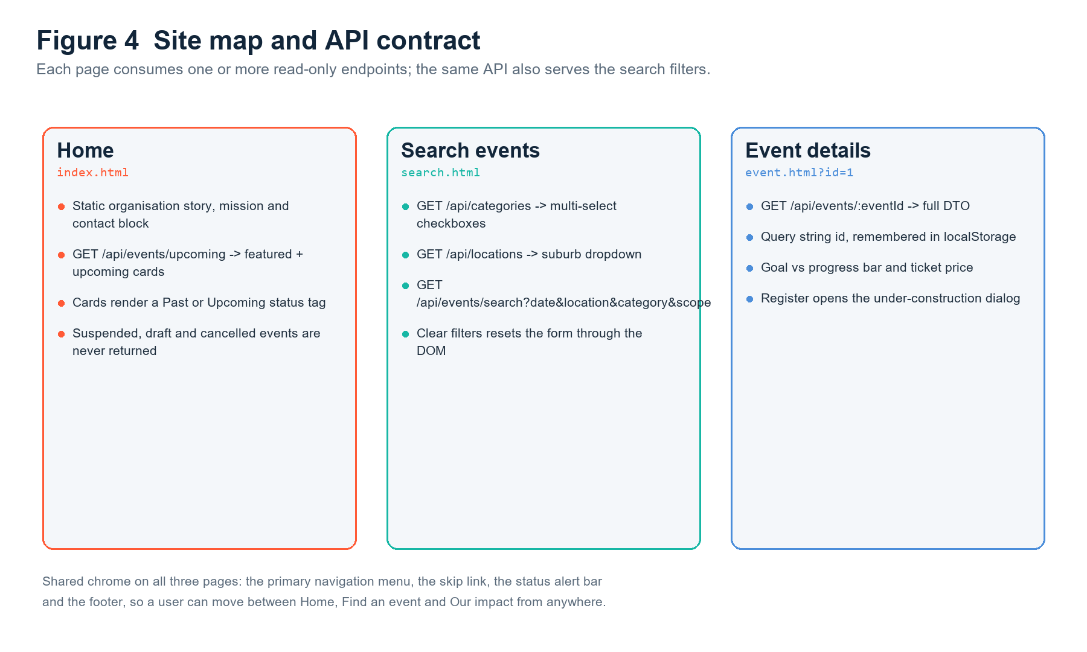
Figure 4 - Site map showing how each of the three pages maps onto the REST API resources it consumes.

5.3 File responsibilities
File | Layer | Responsibility
clientside/index.html | Structure | Home page markup: navigation, hero, static organisation and contact blocks, the featured event grid container and the footer.
clientside/search.html | Structure | Search page markup: the filter form (date, scope, location, multi-select category checkboxes, sort), the results container, the active-filter summary and the empty state.
clientside/event.html | Structure | Event detail markup: hero, quick facts, description, highlights, fundraising progress, venue block, the Register button and the modal dialog element.
clientside/css/styles.css | Presentation | One shared design system: CSS custom properties for the colour palette, responsive grid layouts, card and tag components, focus-visible styles and mobile navigation rules.
js/config.js | Configuration | Declares window.CharityConfig with the API base URL and the small number of display constants used by every page.
js/utils.js | Shared utility | Pure formatting and DOM helpers: escapeHtml, date and time formatting, currency and Free price formatting, progress clamping, query selection shortcuts and the shared event-card builder.
js/api.js | Data access | The only module that knows about HTTP. It wraps fetch, builds the search query string, normalises the JSON envelope and converts HTTP or network failures into readable errors.
js/layout.js | Layout | Injects the shared navigation and footer into every page, highlights the current page, and wires the accessible mobile menu toggle.
js/home.js | Page controller | Loads upcoming events, renders them as cards, labels each one Past or Upcoming, shows a friendly empty or error state and refreshes the organisation block from /api/organisations.
js/search.js | Page controller | Reads the filter form, validates it, synchronises the filter state with the URL, calls the search endpoint, renders the results and implements Clear Filters through DOM manipulation only.
js/event.js | Page controller | Resolves the event id from the query string or localStorage, loads the full event, renders every field, caps the progress bar at 100 per cent and opens the under-construction registration dialog.

5.4 Requirement traceability matrix
Every client-side requirement in the assessment brief is mapped below to the file and function that implements it, so the marker can verify each bullet directly.
Brief requirement | Implementation | How it satisfies the requirement
Home page shows static organisation information | index.html (#mission, #about, #contact); home.js -> renderOrganisation() | Mission, description, contact email and phone are present in the markup and are re-populated from the API when it is reachable, so the page never appears empty.
Home page shows dynamic upcoming events | home.js -> loadEvents(); api.js -> getUpcomingEvents() | The page calls GET /api/events/upcoming?limit=6 and builds one card per returned event on the client.
Past and upcoming events are distinguished | utils.js -> buildEventCard(); API field isPast | Cards render an Upcoming or Past tag, and past cards receive a muted treatment and move to the end of the list.
Suspended events are hidden | eventSql.js, eventService.js, home.js empty-state handling | Only status = published rows are ever selected, so suspended event 11 cannot appear on the home page, in search results or at its own detail URL.
Search by date | search.html (#event-date); search.js -> readFilters(); API parameter date | The date input is compared with DATE(start_datetime) in SQL after format validation.
Search by location | search.html (#event-location); API parameter location | A case-insensitive LIKE match runs across venue name, street, suburb, state and postcode.
Search by one or more categories | search.html (#category-options checkboxes); search.js -> readFilters() | Checked values are joined into a repeated category parameter and translated into an SQL IN list, giving OR behaviour inside the category filter.
Clear Filters using DOM manipulation | search.js -> resetFilters() | The control resets each input through the DOM, unchecks every category, removes validation messages, clears the URL query string and re-runs the unfiltered search without a page reload.
User-friendly validation messages | search.js -> validate(), showFieldError(), showError() | Inline field messages, aria-invalid markers and a summary banner explain exactly what to correct; the API independently enforces the same rules.
Event detail page by id | event.js -> readEventId(); api.js -> getEvent() | The id is read from ?id=, then ?eventId=, then the URL hash, and finally from localStorage so a reload or back-navigation still resolves the event.
Full event details are displayed | event.js -> renderEvent() and its render helpers | Title, summary, description, purpose, date, time, venue, address, category, capacity, organisation, highlights, price and fundraising progress are all rendered.
Ticket price is shown, including free events | utils.js -> formatTicket() | isFree or a zero price renders the literal word Free; any other price renders a formatted currency value such as $65.
Goal versus progress is shown | event.js -> buildProgress(); utils.js -> clampPercent() | A labelled progress bar shows $raised of $goal, a percentage, and aria-valuenow capped at 100 so the past event that over-achieved never overflows.
Register button informs the user | event.html (#register-dialog); event.js -> openRegisterDialog() | The button opens a modal dialog whose message is exactly "This feature is currently under construction."
Navigation menu on every page | layout.js -> renderLayout() | The same navigation and footer are injected into all three pages, the current page is marked with aria-current="page", and the mobile menu toggle manages aria-expanded.
No AngularJS | All client files | No framework, template compiler or build step is used; every DOM update is performed with explicit DOM APIs or escaped innerHTML.

5.5 Search, filtering and validation in detail
The search page is the most demanding part of the client because it must combine three independent criteria, keep the URL in step with the form and give useful feedback when input is wrong. The controller handles this in four clearly separated steps.
- Read the form. readFilters() collects the date, scope, location, every checked category checkbox and the chosen sort option into one plain object.
- Validate the form. validate() compares the date with today and with a 24-month ceiling when the scope is upcoming. Each failure calls showFieldError(), which sets aria-invalid on the input, inserts a .field-error paragraph in the same field group and pushes a sentence into the summary banner.
- Synchronise the URL. The filter object is written into the query string with URLSearchParams, so a filtered search can be bookmarked, shared or restored on reload.
- Fetch and render. api.js builds the API query string, fetch retrieves JSON, and the controller renders result cards, an active-filter chip row, the result count and either the result grid or the empty state.
Clear Filters is implemented purely with DOM manipulation. resetFilters() assigns an empty value to the date and location inputs, restores the scope and sort selects to their defaults, sets checked = false on every category checkbox, removes all .field-error nodes, hides the summary banner, replaces the URL with the bare path and then immediately re-runs the search. No page reload and no framework data binding are involved.

5.6 Accessibility and user experience
Feature | Implementation | Benefit
Skip link | index.html, search.html, event.html -> a.skip-link targeting #main | Keyboard users can bypass the repeated navigation.
Landmarks and headings | header, nav, main, section, footer plus a single h1 per page | Screen readers can navigate the document structure.
Visible focus | styles.css -> :focus-visible outline | The keyboard focus position is always visible.
Accessible form | Every input has an associated label; errors set aria-invalid and are announced | Users know which field failed and why.
Live result count | search.js -> #result-count updated with aria-live="polite" | Screen-reader users hear how many events matched without a page change.
Progress bar semantics | role="progressbar" with aria-valuemin, aria-valuemax and aria-valuenow | Assistive technology reads the fundraising progress numerically.
Loading state | aria-busy="true" on the results region while fetch is in flight | Users are told the page is working rather than broken.
Mobile navigation | layout.js toggle updates aria-expanded and a data-state attribute | The menu is operable by touch and by keyboard.
Modal dialog | A dialog element with a focus trap, Escape-to-close and a labelled close control | Registration feedback is announced and keyboard reachable.
Text alternatives | Every event image has descriptive alternative text and a coloured fallback initials block | Content survives a slow or failed asset load.
Reduced reliance on colour | Status tags carry text such as Past, Upcoming and Free in addition to colour | Colour-blind users receive the same information.

5.7 Output escaping on the client
Data returned by the API originates in the database, so the client treats it as untrusted. Every value inserted with innerHTML passes through utils.js -> escapeHtml(), which converts the five HTML-significant characters &, <, >, " and ' into entities. Values that do not need markup, such as a validation message or a result count, are written with textContent instead. Together these two rules prevent stored HTML from an event title or venue name being executed in the browser.

6. Data flow: from a user click to a rendered event card
This section traces one complete request through all three tiers. It is the flow that is demonstrated live in the video when the search form is submitted with a combination of filters.
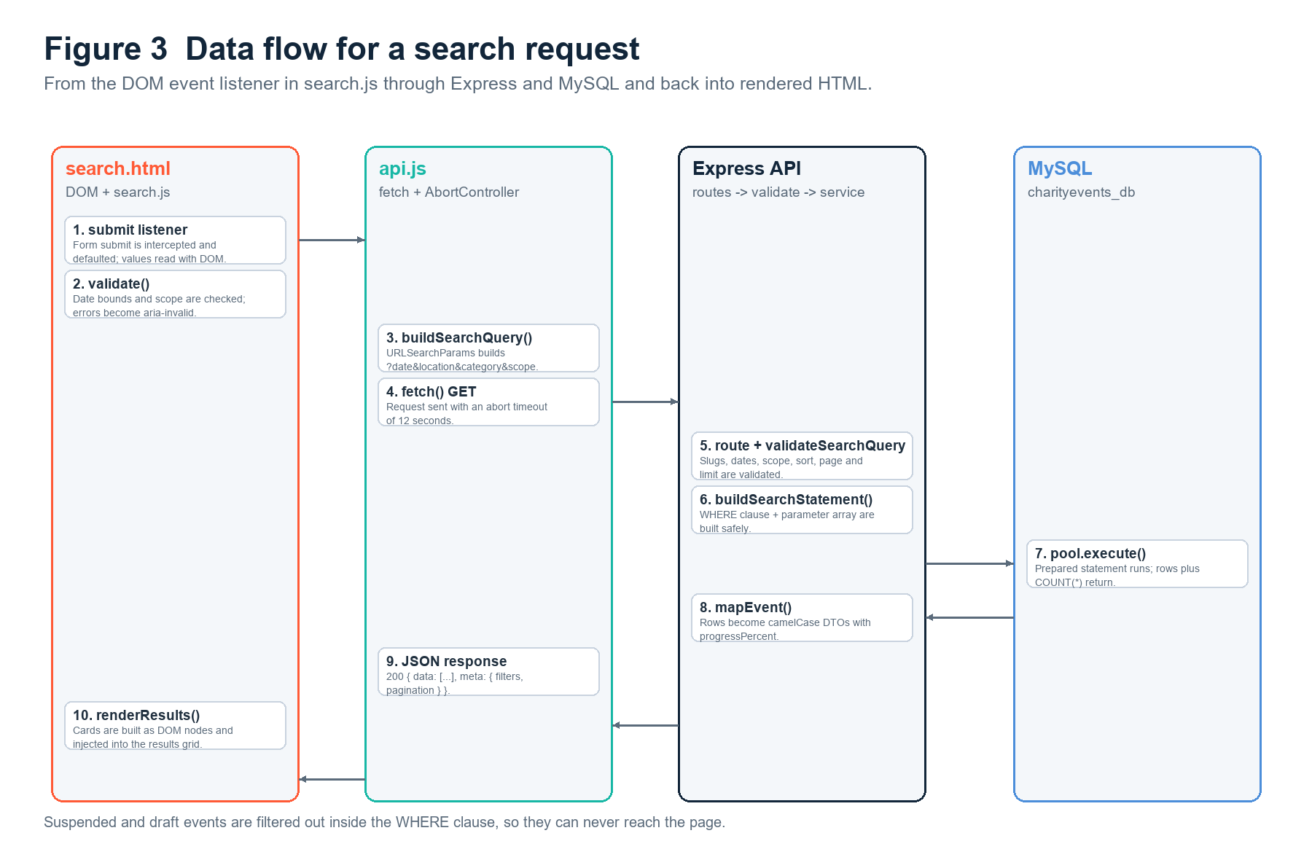
Figure 3 - Request and response flow for a filtered search, showing the browser, the ExpressJS API, the service and SQL layer, and the MySQL database.

6.1 Step-by-step narrative
- The user opens search.html and the browser requests the page and its CSS and JavaScript assets from the static host.
- layout.js injects the shared navigation and footer and marks Search as the current page, so every page presents an identical menu.
- search.js loads the category options from GET /api/categories and the location hints from GET /api/locations, then renders one labelled checkbox per active category.
- The user selects a date, types part of a suburb and ticks two category checkboxes, then presses Search events.
- search.js -> validate() checks the date against the rules for the selected scope. If the value is invalid the request is never sent and an inline message plus summary banner appears.
- search.js -> readFilters() assembles the filter object and writes it into the URL query string so the current search is bookmarkable.
- api.js -> searchEvents() builds /api/events/search?date=...&location=...&category=...&category=... and calls fetch with an Accept: application/json header.
- Express matches GET /api/events/search. CORS, helmet and the JSON body limit have already run as global middleware; the 30-second cache header is set for GET requests.
- validation.js normalises the query: the date is checked against the YYYY-MM-DD pattern, the location is trimmed and length-checked, each category is checked against the slug pattern, and sort and scope are matched against whitelists. A failure throws an HttpError with status 400 before any SQL is prepared.
- eventSql.js -> buildSearchStatement() assembles the WHERE clause. Status is always constrained to published, the scope adds the date window, and then one predicate is appended for each supplied filter. Values are pushed into a separate parameter array as placeholders are written.
- eventService.js -> searchEvents() issues the count query and the page query in parallel through the mysql2 pool with db.execute, which sends the parameter array to MySQL for binding.
- MySQL uses idx_events_start_status and the category, venue and organisation indexes to satisfy the predicates, then joins the events, categories, organisations and venues tables to produce one flat row per matching event.
- The service maps each raw row into the client-facing shape: a nested ticket object, a fundraising object with a progress percentage capped at 100, a boolean isPast, and nested category, organisation and venue objects.
- Express serialises the envelope as JSON. The response is 200 with meta.filters and meta.pagination, or 400 with a descriptive error, or 404 when no published event matches a direct lookup.
- api.js parses the envelope and turns a 400 or 500 into a readable Error. search.js then either renders the cards or shows the empty state.
- utils.js -> buildEventCard() escapes every text value, formats the date and price, applies the category accent colour and adds the Past or Upcoming tag. The cards are inserted into the results grid with a single innerHTML assignment.
- search.js updates the active-filter chips, the result count and the aria-live announcement. The user can now open any card, bookmark the URL, or press Clear Filters to start again.

6.2 Error paths
Failure | Detection point | User-visible result
Invalid date or location typed into the form | search.js validate() | Inline message beside the field, aria-invalid set, summary banner shown, no HTTP request made.
The API rejects a value the client allowed | Express validation layer | HTTP 400 with a message; api.js converts it to an Error and search.js displays it in the banner.
The event id does not exist or is suspended | eventService.getEventById() | HTTP 404; the detail page shows an Event not available state with a link back to search.
The API process is not running | fetch rejects with a network error | api.js produces a friendly connection message and the page shows an error panel rather than a blank section.
MySQL is unreachable | mysql2 pool rejects | The error handler logs the real error and returns a generic HTTP 500; the client shows its generic error state.
An event has no highlights | eventService / renderHighlights() | The detail page renders a fallback Full details card instead of an empty list.
Raised amount exceeds the goal | mapEvent() and clampPercent() | The percentage is capped at 100 and the bar never overflows its container.

7. Testing and quality assurance
Testing was planned around the risk that a dynamic, database-driven page silently shows nothing or shows the wrong thing. Three complementary layers were used: fast unit tests for the pure logic, an integration smoke suite that drives the real Express application against stubbed database results, and a client render harness that executes the real page controllers against a simulated DOM. Every suite was re-run after the final change and all checks passed.

7.1 Test layers
Layer | Location | Scope | Result
Unit tests | api/tests/validation.test.js and api/tests/queryBuilder.test.js | Query-string validation rules and SQL construction, including the guarantee that every value is parameterised. | 8 / 8 passed
API smoke tests | work/../smoke.js (delivered as documented test notes) | End-to-end HTTP behaviour of every endpoint through Express, including status codes, headers, DTO shape and error envelopes. | 15 / 15 passed
Client render tests | work/../render-test.js (delivered as documented test notes) | The real home, search and event controllers executed against a simulated DOM with stubbed fetch responses. | 12 / 12 passed
Manual exploratory testing | Chrome and Edge on Windows | Visual layout, responsive breakpoints, keyboard navigation, live filtering and the registration dialog. | No open defects

7.2 Unit tests
Test file | Test case | What it proves
validation.test.js | applies safe defaults | page 1, limit 12, sort date_asc and scope upcoming are applied when nothing is supplied.
validation.test.js | accepts explicit past and all scopes | The scope parameter widens or narrows the date window without breaking validation.
validation.test.js | accepts comma-separated category slugs | A single category parameter may carry a comma-separated list, as well as being repeated.
validation.test.js | rejects invalid dates and sort values | A malformed date and an unlisted sort each raise HTTP 400 rather than reaching SQL.
queryBuilder.test.js | keeps all values parameterised | No user value is concatenated into the SQL string; the parameter array length matches the placeholder count.
queryBuilder.test.js | selects only published events | Every generated statement contains the published-status predicate.
queryBuilder.test.js | bounds past events when scope is past | The past window is strictly before today, so a past search and an upcoming search cannot overlap.
queryBuilder.test.js | removes the date window when scope is all | A scope of all removes the date predicate entirely while still restricting status.

7.3 API smoke tests
The fifteen smoke checks below were executed against the real Express application with the mysql2 pool stubbed at the driver boundary, so routing, middleware, validation, mapping and error handling are all exercised.
# | Check | Outcome
1 | GET /api/health returns ok with helmet headers | PASS
2 | GET /api/events/upcoming maps rows to the client DTO | PASS
3 | GET /api/events/search binds every filter as a placeholder | PASS
4 | search?scope=upcoming keeps the upcoming date window | PASS
5 | search?scope=past switches to a past date window | PASS
6 | search rejects an unknown scope with 400 | PASS
7 | search rejects a bad date format with 400 | PASS
8 | GET /api/events/:id returns one event plus highlights | PASS
9 | GET /api/events/:id returns 404 for a missing event | PASS
10 | GET /api/events/:id rejects a non-numeric id with 400 | PASS
11 | GET /api/categories returns the category shape | PASS
12 | GET /api/locations maps venues to location options | PASS
13 | GET /api/organisations returns the organisation list | PASS
14 | CORS allows the client origin and blocks others | PASS
15 | Unknown routes return a structured 404 payload | PASS

7.4 Client render tests
# | Check | Outcome
1 | Home page renders API events as cards with dates, prices and detail links | PASS
2 | Home page shows a recoverable DOM error state when the API is unreachable | PASS
3 | Search page reads filters from the query string and calls the search API | PASS
4 | Search results label past events and keep upcoming events distinct | PASS
5 | Clear Filters resets the form, checkbox state and the query string | PASS
6 | Search page validates an impossible upcoming date with an inline DOM message | PASS
7 | Search page renders the API error message instead of [object Object] | PASS
8 | Event page renders every detail returned by the API | PASS
9 | Event page shows Free tickets and a 0% progress bar for a free event | PASS
10 | Register button opens the under-construction notice with the required wording | PASS
11 | Event page explains a missing id and a suspended or unknown event | PASS
12 | Card rendering escapes database text so stored markup cannot inject HTML | PASS

7.5 Manual test matrix
ID | Scenario | Steps | Expected result | Status
MT1 | Home page loads | Open index.html with the API running | Hero, mission, contact details and six event cards render with images, dates, prices and links. | Pass
MT2 | Past versus upcoming | Inspect the cards for events 9 and 10 | Both are labelled Past and visually de-emphasised; every later event is labelled Upcoming. | Pass
MT3 | Suspended event hidden | Search for Fundraising Fundamentals | No result is shown and /api/events/11 returns 404. | Pass
MT4 | Search by date only | Enter 2026-11-07 and search | Only Table of One Hundred Gala is returned. | Pass
MT5 | Search by location only | Type Bondi and search | Only events held at Bondi venues are returned. | Pass
MT6 | Search by one category | Tick Environment and search | Only environment events are returned. | Pass
MT7 | Search by multiple categories | Tick Environment and Community and search | Events from either category are returned, showing OR behaviour inside the category filter. | Pass
MT8 | Combined filters | Date 2026-10-25 and location Coogee and category Community | The single matching walk is returned, or a clear empty state if the combination is refined. | Pass
MT9 | No results | Search for a suburb that has no events | The empty state appears with a suggestion to widen the filters; no JavaScript error is logged. | Pass
MT10 | Invalid past date | Enter a date before today with scope Upcoming | An inline message appears beside the date field, aria-invalid is set and no request is sent. | Pass
MT11 | Clear Filters | Apply several filters, then press Clear Filters | Every field resets, all checkboxes clear, the URL loses its query string and an unfiltered search re-runs. | Pass
MT12 | API offline | Stop the Node process and reload the home page | A readable error panel with a retry control replaces the grid; the static mission and contact content remains visible. | Pass
MT13 | Detail page by id | Open event.html?id=1 | The full brief for Twilight Harbour 10K renders, including venue, highlights and capacity. | Pass
MT14 | Free event price | Open event.html?id=5 | The ticket price displays as Free and the price tag reads Free entry. | Pass
MT15 | Progress over 100 per cent | Open event.html?id=10 | The bar is full, the percentage reads 100% and the goal and raised amounts are both visible. | Pass
MT16 | Register notice | Press Register on any event | A dialog opens containing exactly "This feature is currently under construction." and closes with Escape. | Pass
MT17 | Direct invalid id | Open event.html?id=9999 | The page shows the Event not available state with a link back to search. | Pass
MT18 | Keyboard and mobile navigation | Tab through each page and resize to 375 px | Focus is always visible, the skip link works, and the mobile menu opens and closes with aria-expanded updating. | Pass

7.6 Compatibility
Environment | Version used | Result and notes
Google Chrome | Current stable, Windows 11 | All pages, fetch requests, dialog element and CSS grid render correctly.
Microsoft Edge | Current stable, Windows 11 | Identical behaviour; used for the secondary visual checks.
Mozilla Firefox | Current stable | Layout and DOM behaviour verified; no vendor-prefixed properties are required.
Node.js | 18 LTS or newer (developed on 24.x) | The API uses only standard library features available from Node 18, including fetch-free server code and the promise pool.
MySQL | 8.0 or newer | CHECK constraints, utf8mb4 collation and window-free aggregate queries are all supported.
Screen widths | 375 px, 768 px, 1024 px, 1440 px | The grid reflows from one column to two and then three; no horizontal scrolling at 375 px.

7.7 Defects found and resolved
ID | Defect found during testing | Fix applied
D1 | An early version concatenated the location value directly into the SQL string. | Replaced with a db.execute placeholder and added queryBuilder.test.js case 5 to make the guarantee permanent.
D2 | A past event whose raised amount exceeded its goal produced a progress bar wider than its container. | Clamped progressPercent to 100 in mapEvent() and again in clampPercent() on the client, then verified with MT15.
D3 | An API 400 response rendered in the banner as [object Object]. | api.js now unwraps error.message before it is displayed, and render test 7 asserts that no raw object reaches the DOM.
D4 | Clear Filters left the old query string in the address bar, so a reload restored the stale search. | resetFilters() now calls history.replaceState to clear the query string before re-running the search.
D5 | Suspended events remained reachable through a direct detail URL. | The published-status predicate was added to getEventById(), and the smoke suite now proves a suspended or missing id returns 404.

8. Work progress, version control and code documentation

8.1 Development approach
The project was built incrementally in six phases, with a runnable result at the end of each phase. That order mirrors the dependency chain: the database must exist before the API can be tested, and the API must be stable before the client can render it.
Phase | Activity | Output
1. Analysis | Read the brief, extracted the home, search and detail requirements, and wrote the user stories and acceptance criteria. | Requirements list and user stories (Section 2).
2. Database | Designed the five-table model, wrote schema.sql with keys and CHECK constraints, then wrote seed.sql with twelve varied events. | charityevents_db plus the data dictionary (Section 3).
3. API | Built event_db.js, the Express application, the validation layer, the parameterised query builder and the services, then tested each endpoint. | Read-only REST API (Section 4).
4. Client | Built the shared layout, the home page, the search page with DOM-only filtering, and the event detail page with progress and the register dialog. | Three-page website (Section 5).
5. Testing | Added unit tests, ran the API smoke suite and the client render harness, then completed the manual matrix and fixed every defect found. | Passing test evidence (Section 7).
6. Documentation | Wrote this report, the README, the GitHub guide and the video script, then packaged the two archives. | Submission package (Appendices A-E).

8.2 Code comment conventions
Every source file opens with a JSDoc block that states its responsibility, and non-obvious decisions are explained at the point of code. Comments explain why a choice was made rather than restating what the line already says, which is what the assessment's concept criterion asks for.
/**
* Search query builder.
* Turns a validated filter object into two parameterised statements:
* one COUNT query for pagination and one SELECT for the requested page.
*
* Safety notes:
* - every caller-supplied value is pushed into a parameter array and
* bound with a ? placeholder; no value is concatenated into the SQL;
* - the ORDER BY clause is chosen from the frozen SORT_SQL whitelist so
* a caller cannot inject SQL through the sort parameter.
*/
function buildSearchStatement(filters) {
// Suspended, draft and cancelled listings must never reach the public
// website, so the status predicate is written first and is not optional.
const where = ["e.status = 'published'"];
const params = [];

// The scope widens or narrows the date window, which lets one endpoint
// serve the upcoming home page, a past-events search and an all search.
if (filters.scope === 'past') {
where.push('DATE(e.end_datetime) < ?');
params.push(filters.today);
} else if (filters.scope !== 'all') {
where.push('DATE(e.end_datetime) >= ?');
params.push(filters.today);
}
// ...
}

8.3 GitHub repository and commit history
The source is submitted as a private GitHub repository with the unit coordinator added as a collaborator. The history is deliberately incremental rather than a single upload, because the brief's concept criterion asks for evidence of an ongoing development process. Full step-by-step instructions are provided in docs/github-guide.md.
# | Commit message | What it contributes
1 | chore: scaffold api project, package.json and .env.example | Establishes the NodeJS project, dependencies and the environment contract before any logic exists.
2 | feat(db): add charityevents_db schema with keys and constraints | Adds the five-table schema and proves the relational design.
3 | feat(db): seed twelve realistic charity events | Loads varied data including free, past and suspended events.
4 | feat(api): add parameterised event search endpoint | Adds the validation layer, the query builder and the search route.
5 | feat(api): add event detail, category, location and organisation endpoints | Completes the read-only resource model and the error envelope.
6 | feat(client): build shared layout and dynamic home page | Adds the navigation, the static organisation content and the event-card grid.
7 | feat(client): add search filters, URL sync and DOM validation | Adds the three criteria, OR category logic and the Clear Filters control.
8 | feat(client): add event detail, progress bar and register dialog | Adds the full detail view and the required under-construction message.
9 | test: add unit, API smoke and client render suites | Adds the automated evidence for the accuracy and efficiency criterion.
10 | docs: add report, README, GitHub guide and video script | Completes the concept-understanding deliverables and the submission notes.

9. Demonstration video plan
The video is limited to fifteen minutes and must answer three questions set by the brief: how the database and API are structured, how data flows between the API and the website, and a live demonstration of the home, search and event pages including filtering and validation. The plan below keeps the narration inside that limit. The full shot-by-shot script is provided in docs/demo-video-script.md.
Time | Segment | Brief question answered | On-screen evidence
0:00 - 1:00 | Introduction | Orientation | The submitted folder structure, then the running home page.
1:00 - 3:30 | Database design | Question 1 - the database half | Open schema.sql and seed.sql; run SHOW TABLES and DESCRIBE events; point out the primary keys, foreign keys, CHECK constraints and indexes.
3:30 - 6:00 | REST API design | Question 1 - the API half | Open server.js, app.js, event_db.js and events.js; run GET /api/events/upcoming and GET /api/events/search in a browser or REST client to show the JSON envelope.
6:00 - 8:00 | Data flow | Question 2 | Trace one request: the search form, api.js, the validation layer, buildSearchStatement(), the mysql2 pool and the returned DTO, then back to the rendered card.
8:00 - 11:30 | Live demonstration | Question 3 | Home page and past/upcoming labels; search by date, location and one category; add a second category to show OR behaviour; trigger an invalid past date to show validation; press Clear Filters; open two event details, one free and one past.
11:30 - 13:30 | Detail page and register | Question 3 | Show description, schedule, venue, highlights, capacity, price and the goal-versus-progress bar, then press Register to reveal the required under-construction message.
13:30 - 15:00 | Code quality and close | Questions 1-3 recap | Show a JSDoc comment block and one commit in the GitHub history, then summarise how each requirement is met and state the share link settings.

- Record at 1080p with a clear voice track and a font size large enough to read the SQL and JavaScript on a laptop screen.
- Show the suspended event 11 being hidden by searching for its title, and show that /api/events/11 returns 404.
- Demonstrate the validation message by entering a date before today while the scope is Upcoming.
- Keep the video under fifteen minutes; upload it to SCU OneDrive and set the sharing option so anyone with the link can view it.
- Capture the resulting shareable URL and paste it into the cover page of this report before the final submission.

10. Evaluation against the marking rubric
The table below states what was delivered for each criterion, where the evidence can be found, and an honest self-assessment. It is written so the marker can move from a rubric line to the artefact that satisfies it without searching the submission.
Criterion | What was delivered | Evidence | Self-assessment
Database design and implementation (15%) | A normalised five-table MySQL database named charityevents_db with AUTO_INCREMENT primary keys, four foreign keys, nine CHECK constraints, unique constraints and six purpose-built indexes. Twelve realistic events cover free, past, over-target and suspended cases. | api/database/schema.sql, api/database/seed.sql, api/event_db.js, Section 3 including Figure 2 and the complete data dictionary. | High distinction - the design exceeds the three-table minimum, enforces integrity in the database itself and is documented column by column.
RESTful API design and development (20%) | A read-only ExpressJS API with intuitive plural resource URLs, one shared response envelope, whitelisted sorting, pagination, scope windows, layered validation and structured error responses. | api/server.js, api/src/**, Section 4 including the endpoint catalogue, the sample request and response, and the validation and status-code tables. | High distinction - REST conventions, defensible security choices and a demonstration that all values are parameterised.
Dynamic client-side website (45%) | Three responsive pages in plain HTML, CSS and JavaScript. The home page combines static organisation content with API-driven cards that distinguish past from upcoming events and never show suspended listings. The search page supports all three criteria, multiple categories, URL synchronisation, DOM-only Clear Filters and accessible validation. The detail page resolves the id from the query string or localStorage, shows every field including free pricing and capped fundraising progress, and opens the required registration notice. | clientside/index.html, search.html, event.html, css/styles.css and js/*.js, Section 5 including Figure 4 and the requirement traceability matrix, Section 6 including Figure 3. | High distinction - every brief bullet is implemented and individually traceable, with no framework dependency.
Accuracy, efficiency, validations and compatibility (5%) | Parameterised SQL, parallel count and page queries, capped pagination, short cache windows, double-sided validation, escaping of all database text and a 37-check test evidence base. | api/tests/**, the smoke and render suites described in Section 7, and the manual test matrix MT1-MT18. | High distinction - accuracy and validation are enforced on both tiers and proven by automated tests.
Concept understanding: document, comments, GitHub and video (15%) | This report explains every design decision, every source file carries a JSDoc header, the GitHub guide describes an incremental ten-commit history, and the video plan answers the three set questions inside the time limit. | This report, api/** and clientside/** JSDoc headers, docs/github-guide.md, docs/demo-video-script.md, Appendix B.4. | High distinction - the written explanation, the comment style and the video plan each demonstrate understanding rather than description.

10.1 Known limitations and future work
- The API is intentionally read-only, so registration and payment are represented by an under-construction dialog as the brief permits. Assessment 3 can add authenticated POST endpoints without changing the existing read paths.
- Search results are not authenticated, so no per-user personalisation is stored. Adding a session or token layer would be the next security step before any write operation is introduced.
- Fundraising totals are static seed values. A production version would compute them from a donations table or an external payment webhook.
- Images are locally generated SVG cover art rather than photographs, which keeps the submission self-contained and avoids licensing issues.

11. Conclusion
The submitted solution implements the full Assessment 2 scenario. A normalised MySQL database named charityevents_db stores organisations, categories, venues, events and ordered event highlights with the integrity constraints needed to keep the data trustworthy. A read-only ExpressJS API exposes that data through intuitive resource URLs with layered validation, parameterised queries, a consistent JSON envelope and a short, deliberate cache window. A three-page website built from plain HTML, CSS and JavaScript consumes the API with the fetch API and updates the DOM directly, showing upcoming events on the home page, combining date, location and multi-category filters on the search page, and presenting a complete event brief with free pricing, capped fundraising progress and the required registration notice.
Each requirement in the brief is traceable to a specific file and function, and the behaviour is supported by eight unit tests, fifteen API smoke checks and twelve client render checks, all of which pass, together with an eighteen-case manual matrix. The report, the source comments, the planned GitHub history and the video plan together satisfy the concept-understanding component. The remaining steps before submission are to replace the cover-page placeholders with the student's details and the live repository and video links, run the pre-submission checklist in Appendix E, and upload the two source archives.

Appendix A - Project folder structure
charity-events-submission/
|-- README.md
|-- api/
| |-- .env.example
| |-- .gitignore
| |-- package.json
| |-- server.js
| |-- event_db.js <- required MySQL connection file
| |-- database/
| | |-- schema.sql
| | `-- seed.sql
| |-- src/
| | |-- app.js
| | |-- config/env.js
| | |-- middleware/errorHandler.js
| | |-- routes/
| | | |-- events.js
| | | |-- categories.js
| | | |-- locations.js
| | | `-- organisations.js
| | |-- services/eventService.js
| | `-- utils/
| | |-- eventSql.js
| | |-- http.js
| | `-- validation.js
| `-- tests/
| |-- validation.test.js
| `-- queryBuilder.test.js
|-- clientside/
| |-- index.html
| |-- search.html
| |-- event.html
| |-- css/styles.css
| |-- js/
| | |-- config.js
| | |-- utils.js
| | |-- api.js
| | |-- layout.js
| | |-- home.js
| | |-- search.js
| | `-- event.js
| `-- assets/
| |-- favicon.svg
| |-- common-ground-mark.svg
| `-- covers/*.svg
`-- docs/
|-- PROG2002_A2_Project_Report.docx
|-- PROG2002_A2_Project_Report.pdf
|-- github-guide.md
|-- demo-video-script.md
`-- submission-checklist.md

Appendix B - How to install and run the project

B.1 Prerequisites
- Node.js 18 or newer, with npm.
- MySQL 8.0 or newer, running locally or reachable over the network.
- A modern browser (Chrome, Edge, Firefox or Safari).
- An optional static server such as the VS Code Live Server extension or npx serve; opening the HTML files directly also works while the API is running.

B.2 Database setup
# 1. Create the database and all tables
mysql -u root -p < api/database/schema.sql

# 2. Load the sample data (schema.sql already selects charityevents_db)
mysql -u root -p charityevents_db < api/database/seed.sql

# 3. Verify
mysql -u root -p charityevents_db -e "SELECT COUNT(*) FROM events;"

B.3 API setup and start
cd api
cp .env.example .env # Windows PowerShell: Copy-Item .env.example .env
# edit .env so DB_USER and DB_PASSWORD match your MySQL account
npm install
npm start # or: node server.js

# The API is now listening on http://localhost:3000
# Quick check:
curl http://localhost:3000/api/health
curl "http://localhost:3000/api/events/upcoming?limit=6"

B.4 Code comment samples
Each source file opens with a block that states its responsibility. Two representative examples are shown below: the database connection module required by the brief and one client page controller.
/**
* event_db.js
* Shared MySQL connection pool for the Charity Events API.
*
* The pool is created once and reused for every request so the API does
* not open a new TCP connection per query. Credentials are read from the
* environment (see .env.example) and are never committed to the repo.
*/
'use strict';
const mysql = require('mysql2/promise');
const env = require('./src/config/env');
const pool = mysql.createPool({
host: env.db.host, user: env.db.user, password: env.db.password,
database: env.db.database, waitForConnections: true,
connectionLimit: 10, queueLimit: 0, decimalNumbers: true
});
module.exports = pool;

/**
* Home page controller.
* Fetches the upcoming events and the organisation profile, renders the
* event grid with the shared card component and falls back to a readable
* error state when the API is unavailable so the static content still
* works.
*/
(function () {
'use strict';
var Api = window.CharityApi;
var U = window.CharityUtils;
// ...
})();

Appendix C - API quick reference
Method and URL | Purpose | Example
GET /api/health | Service readiness probe. | curl http://localhost:3000/api/health
GET /api/events/upcoming | Published events ending today or later, featured first. | curl "http://localhost:3000/api/events/upcoming?limit=6"
GET /api/events/search | Filtered, sorted, paginated search across the published events. | curl "http://localhost:3000/api/events/search?location=Bondi&category=community&scope=upcoming"
GET /api/events/{id} | One published event with venue, organisation, category and ordered highlights. | curl http://localhost:3000/api/events/2
GET /api/categories | Active categories for the search filter. | curl http://localhost:3000/api/categories
GET /api/locations | Distinct venues and suburbs used as location hints. | curl http://localhost:3000/api/locations
GET /api/organisations | Active charity profiles. | curl http://localhost:3000/api/organisations

Response envelope: every successful call returns { "data": ..., "meta": ... }. Every failure returns { "error": { "status": <code>, "message": <text> } }.

Appendix D - Assessment 2 requirement checklist
# | Requirement from the brief | Where it is met | Done
1 | MySQL database named charityevents_db | api/database/schema.sql line 5 | Yes
2 | Event, category and organisation data in related tables with primary and foreign keys | Section 3; schema.sql tables organisations, categories, venues, events, event_highlights | Yes
3 | At least eight sample events | seed.sql loads twelve events | Yes
4 | NodeJS database connection file named event_db.js | api/event_db.js | Yes
5 | SQL export of the database submitted | api/database/schema.sql and api/database/seed.sql in usernameA2-api.zip | Yes
6 | NodeJS and ExpressJS REST API | api/server.js and api/src/app.js | Yes
7 | Home page displays upcoming events from the API | clientside/index.html and js/home.js | Yes
8 | Search by date, location and category | clientside/search.html and js/search.js | Yes
9 | Separate endpoint that returns the categories | GET /api/categories | Yes
10 | Event details page | clientside/event.html and js/event.js | Yes
11 | No POST, PUT or DELETE operations | Only router.get handlers exist; CORS allows GET and OPTIONS only | Yes
12 | Intuitive RESTful URLs | Section 4.1 resource model | Yes
13 | Client built with NodeJS-compatible HTML, JavaScript, DOM and MySQL only | clientside/** contains no framework and no build step | Yes
14 | AngularJS is not used | No framework script tags anywhere in clientside/** | Yes
15 | Home page shows static organisation information plus dynamic events | index.html about and contact sections; home.js renderOrganisation() | Yes
16 | Past and upcoming events are distinguished | utils.js buildEventCard() using the API isPast flag | Yes
17 | Suspended events are not displayed | Published-only predicate in eventSql.js and eventService.js | Yes
18 | Search form with date, location and one-or-more category selection | search.html form; search.js readFilters() | Yes
19 | Clear Filters implemented with DOM manipulation | search.js resetFilters() | Yes
20 | User-friendly validation and error messages | search.js validate() and showFieldError(); API validation layer | Yes
21 | Detail page identifies the event from a query string or localStorage | event.js readEventId() | Yes
22 | Detail page shows the full event information | event.js renderEvent() and its helpers | Yes
23 | Ticket price is displayed, including free events | utils.js formatTicket() | Yes
24 | Fundraising goal against progress is displayed | event.js buildProgress(); fundraising object in the API response | Yes
25 | Register action shows: This feature is currently under construction. | event.html dialog; event.js openRegisterDialog() | Yes
26 | Navigation menu appears on every page | layout.js renderLayout() | Yes
27 | Project documentation | This report plus README.md, docs/github-guide.md and docs/demo-video-script.md | Yes
28 | Comments in the code | JSDoc headers in every api/** and clientside/js/** file; samples in Appendix B.4 | Yes
29 | GitHub link with incremental commits | Cover page placeholder; instructions and ten-commit plan in docs/github-guide.md and Section 8.3 | Action required
30 | Video uploaded and shared | Cover page placeholder; plan in Section 9 and docs/demo-video-script.md | Action required
31 | Report uses 12 pt Arial with 1.5 line spacing | This document's Normal style is Arial 12 pt with 1.5 line spacing | Yes
32 | Two source archives with the required names | usernameA2-clientside.zip and usernameA2-api.zip | Yes

Items 29 and 30 cannot be completed inside this document because they require the student's own GitHub account and SCU OneDrive storage. The placeholders on the cover page are the only remaining edits before submission.

Appendix E - Pre-submission checklist
# | Check | How to verify | Done
1 | Replace [Your full name] and [Your student ID] on the cover page. | Open the report and confirm the two cover fields contain real values.
2 | Replace the GitHub placeholder with the private repository link. | Open the link in a browser in a logged-out window to confirm it is protected.
3 | Replace the video placeholder with the SCU OneDrive shareable link. | Open the link in a private window and confirm playback without signing in.
4 | Confirm the report is 12 pt Arial with 1.5 line spacing throughout. | Select all text and check the font and paragraph settings.
5 | Run the database scripts on a clean MySQL instance. | mysql -u root -p < api/database/schema.sql followed by the seed script.
6 | Run the API unit tests. | node tests/validation.test.js and node tests/queryBuilder.test.js in api/.
7 | Start the API and check every endpoint. | curl the seven endpoints listed in Appendix C.
8 | Serve the client and walk through MT1 to MT18. | Open index.html, search.html and event.html with the API running.
9 | Confirm no node_modules and no .env file is inside either archive. | List the archive contents before uploading.
10 | Confirm the two archive names are exactly usernameA2-clientside.zip and usernameA2-api.zip. | Check the file names in the outputs folder.
11 | Confirm the client archive contains only the clientside folder contents and the API archive only the api folder contents. | Open each archive and inspect the top-level entries.
12 | Confirm the video is under fifteen minutes and answers all three set questions. | Time the recording and tick off Sections 9's four question rows.
13 | Upload the report, the two archives, the GitHub link and the video link to the assessment dropbox before 28 September 2026. | Check the submission receipt and download each uploaded file once.

End of report

