Storyboard
S01 - Home: Hero & Live City Thread
TITLE: Common Ground Collective - Charity Events Website | SCREEN ID: S01 | DATE: 5 October 2026

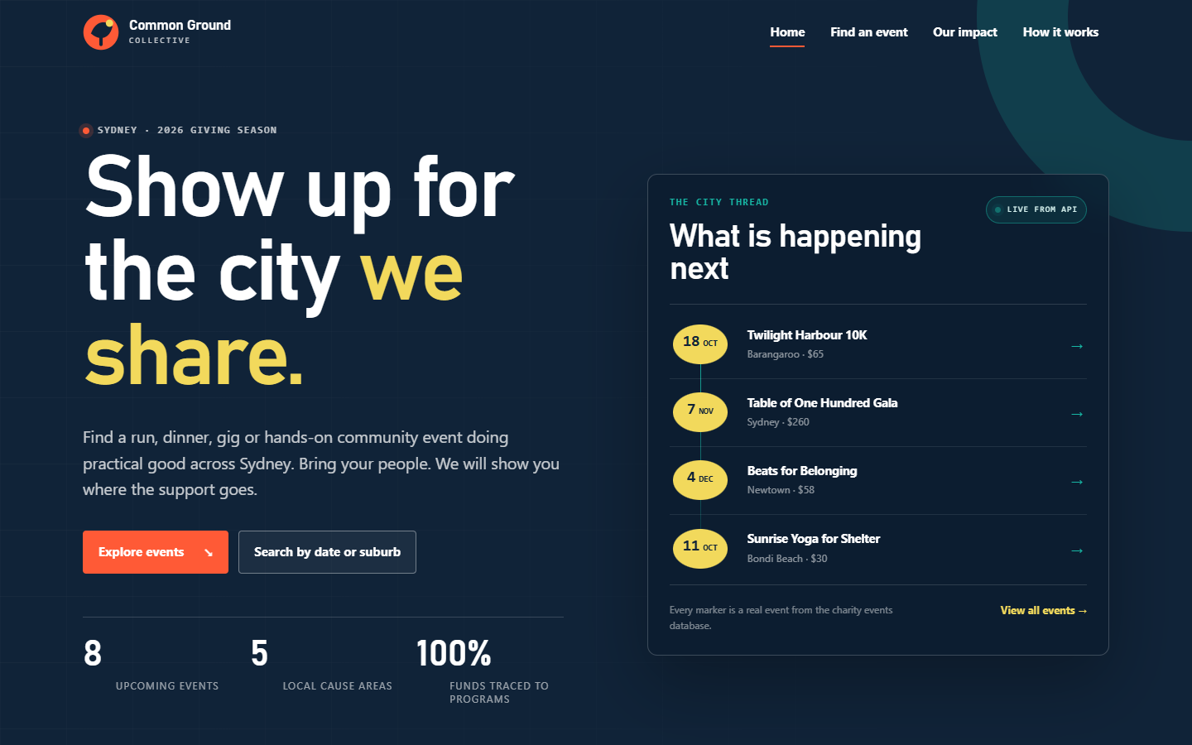
  ELEMENTS | Global header and primary navigation; skip link; hero heading and supporting copy; two CTAs; three proof figures; live city-thread list; footer.
  GRAPHICS | Common Ground mark; dark teal hero; orange and gold accents; grid-line background; live-event pulse; SVG cover thumbnails.
  TEXT | Show up for the city we share. | Find a run, dinner, gig or hands-on community event doing practical good across Sydney. | Explore events | Search by date or suburb | Live from API | 8 upcoming events.
  AUDIO/VIDEO | 0:00-0:45. Voice-over introduces Common Ground Collective, the fragmented-event discovery problem and the one-database / three-page goal. Wide desktop shot; pointer moves from the search CTA to the live event thread.
  NOTES | Establish trust and energy in one view. The count and city thread are fetched from GET /api/events/upcoming, not hard-coded. Keep the reveal animation short so recording stays crisp.

Description: | Opening frame: a first-time visitor lands on the Home page and immediately sees the charity mission plus what is happening next.
Content: | Dynamic upcoming count = 8; live city-thread items include Twilight Harbour 10K, Table of One Hundred Gala, Beats for Belonging and Sunrise Yoga for Shelter.
Interactions: | Hover/focus the navigation and CTAs; click Explore events to scroll to the event grid; click a city-thread item to open its detail page.
Media Creation: | Screen-record Edge at 1440x900 and 100% zoom. Use a subtle cursor highlight and 1.1x zoom on the live thread. No stock video or third-party music.
Navigation: | Explore events -> S02. Find an event -> S03. City-thread item -> S07.

Storyboard
S02 - Home: Upcoming Events & Progress
TITLE: Common Ground Collective - Charity Events Website | SCREEN ID: S02 | DATE: 5 October 2026

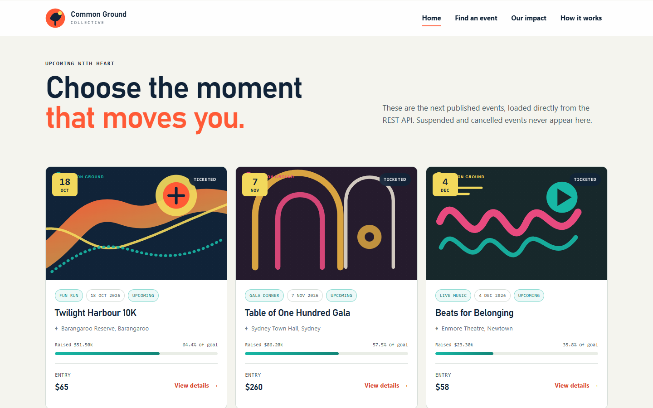
  ELEMENTS | Section heading; event-card grid; category tags; dates; locations; ticket prices; fundraising progress bars; View details links; full-calendar CTA.
  GRAPHICS | Twelve locally generated SVG cover artworks; orange/teal category accents; animated progress bars; card hover elevation.
  TEXT | Choose the moment that moves you. | These are the next published events, loaded directly from the REST API. | Upcoming with heart | View details | Search the full event calendar.
  AUDIO/VIDEO | 0:45-1:30. Narrate that the cards are live API data and that suspended or cancelled events never reach this grid. Slow horizontal pan across the cards, then zoom into one card.
  NOTES | Demonstrate the trust fields: price, date, venue, goal and amount raised. Mention that event 11 is suspended by design and therefore absent.

Description: | The visitor explores current events and compares causes, dates, price and fundraising progress before choosing one.
Content: | Cards shown include Twilight Harbour 10K (64.4%), Table of One Hundred Gala (57.5%) and Beats for Belonging (35.8%); all values come from MySQL seed data through the API.
Interactions: | Hover/focus a card; click a card to open event detail; click Search the full event calendar to move to the Search page.
Media Creation: | Record the populated grid after network idle so skeletons are not shown. Crop to the top three cards for clarity; keep card text readable at 1080p.
Navigation: | Event card -> S07. Search the full event calendar -> S03.

Storyboard
S03 - Search: Filter Design
TITLE: Common Ground Collective - Charity Events Website | SCREEN ID: S03 | DATE: 5 October 2026

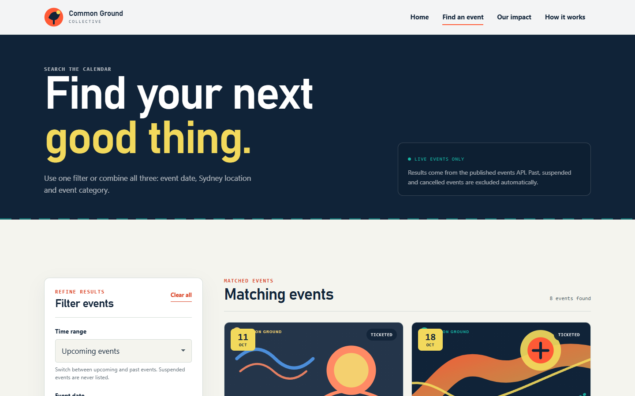
  ELEMENTS | Filter panel; time-range selector; day/month/year selects; location select; multi-select category checkboxes; sort selector; search and clear buttons; results panel.
  GRAPHICS | Route line in the hero; live-events pill; category chips; event cover art; loading skeletons replaced by real results.
  TEXT | Find your next good thing. | Use one filter or combine all three: event date, Sydney location and event category. | Filter events | Show matching events | Clear filters | Live events only.
  AUDIO/VIDEO | 1:30-2:20. Explain that a visitor may know only a suburb, only a month or only a category. Cursor traces the filter flow in order: scope, date, location, category, sort, submit.
  NOTES | The form is plain HTML; JavaScript validates locally and keeps filters in the URL. Category choices are loaded from GET /api/categories and locations from GET /api/locations.

Description: | The visitor moves from browsing to deliberate search using one or several filters.
Content: | Default state: Upcoming events, Anywhere in Sydney, all categories, Date: soonest first. The results panel starts loading from the API immediately.
Interactions: | Select a time range; choose date parts; select a suburb; check one or more categories; change sort order; submit or clear all.
Media Creation: | Capture the default state before submission, then zoom 1.2x on the filter panel. Add a numbered callout for the five filter controls in post-production if helpful.
Navigation: | Submit -> S05. Partial date -> S04. Clear all -> S03 default. Search a no-result date -> S06.

Storyboard
S04 - Search: Client-Side Validation
TITLE: Common Ground Collective - Charity Events Website | SCREEN ID: S04 | DATE: 5 October 2026

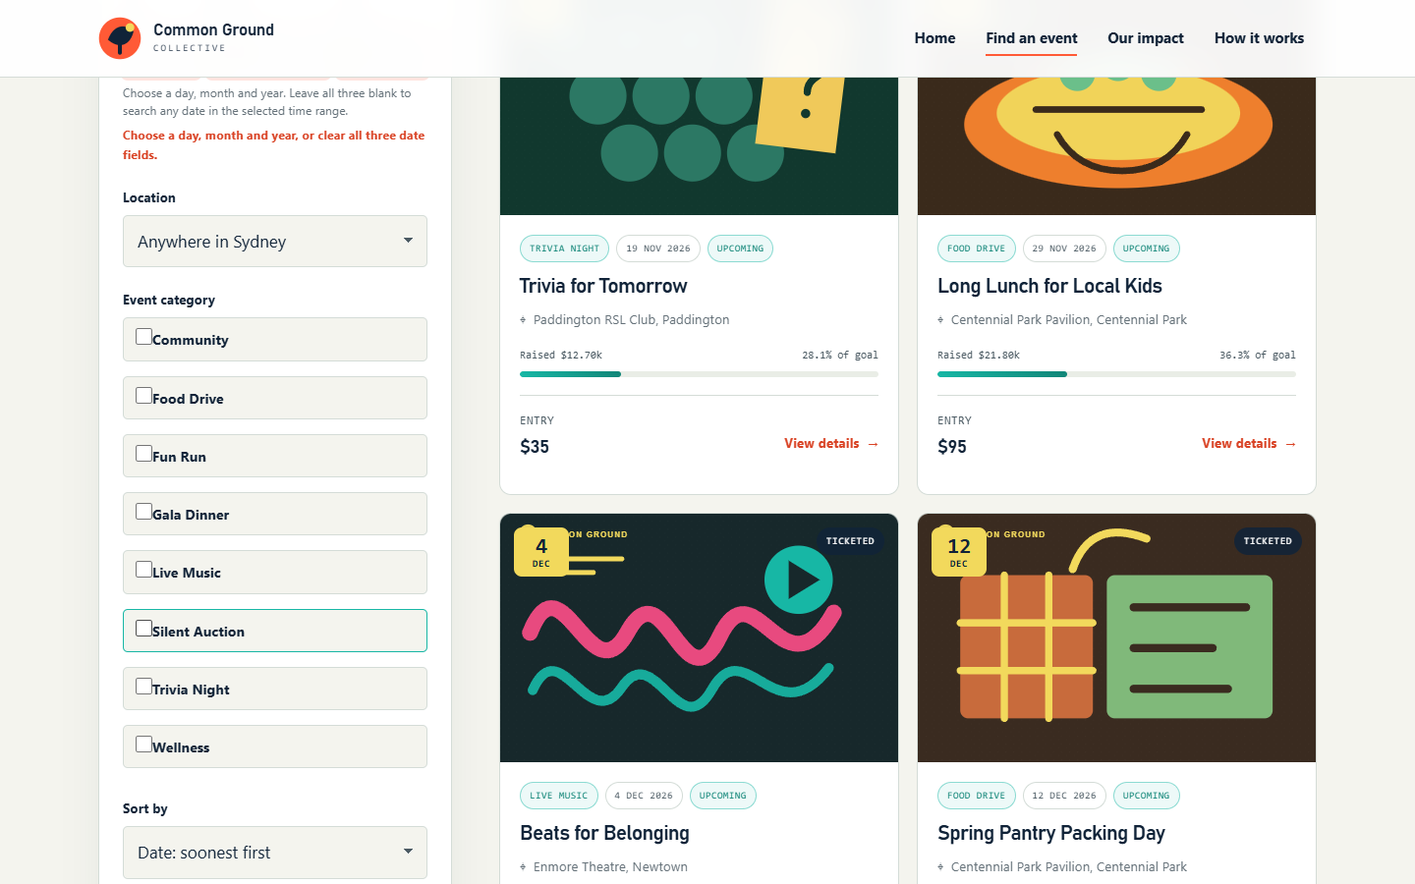
  ELEMENTS | Date field with red focus border; inline field error; result-area status message; otherwise unchanged filter controls and event cards.
  GRAPHICS | Red error outline; inline error text; no network request; accessible aria-invalid state on the date fields.
  TEXT | Choose a day, month and year, or clear all three date fields. | Event date is incomplete. | Check the filters above.
  AUDIO/VIDEO | 2:20-3:00. Explain defence in depth: the browser stops an incomplete request and the server validates the same rules again. Zoom on the error message, then pan to Check the filters above.
  NOTES | WCAG-friendly inline feedback. aria-invalid and aria-describedby are applied; focus remains on the invalid control. Server-side validation still returns 400 for malformed values.

Description: | The visitor selects only part of a date and presses search; the page explains the problem without making a request.
Content: | Day selected without month/year; client validation returns Event date is incomplete. The API search is not called.
Interactions: | Select one or two date parts; press Show matching events; read the inline message; complete the date, clear it or switch to a valid range.
Media Creation: | Record the deliberate error state, then hold for 3 seconds. Highlight the red outline and the message with an unobtrusive rectangle.
Navigation: | Complete or clear date -> S05. Empty valid search -> S06.

Storyboard
S05 - Search: Results & Active Filters
TITLE: Common Ground Collective - Charity Events Website | SCREEN ID: S05 | DATE: 5 October 2026

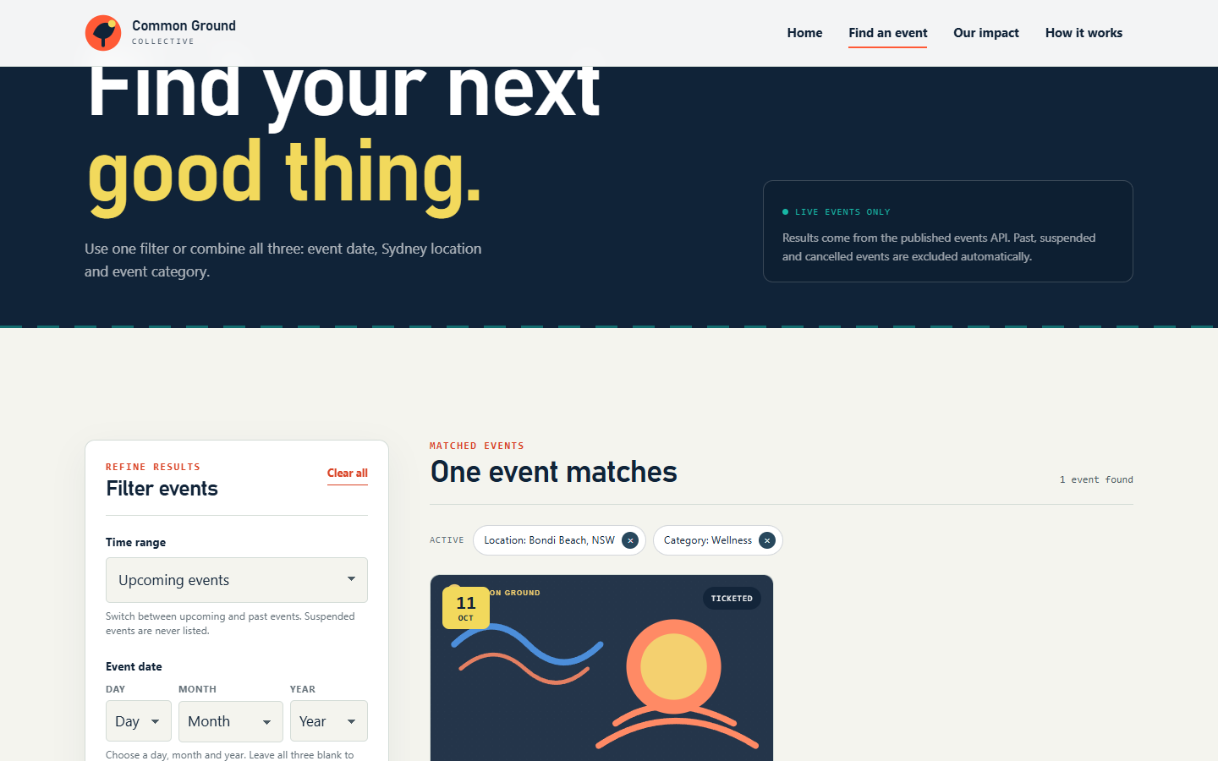
  ELEMENTS | Active-filter chips; removable chips; result count; matching event card; card metadata; clear-all action; URL query string.
  GRAPHICS | Selected category chip; venue chip; colour-coded card cover; fundraising progress bar; card hover state.
  TEXT | Matched events | One event matches | 1 event found | Active filters | Location: Bondi Beach, NSW | Category: Wellness | Sunrise Yoga for Shelter | $30 | View details.
  AUDIO/VIDEO | 3:00-3:50. Explain that multiple categories use OR logic and that every filter is written into the URL so a search can be shared or bookmarked. Pan from the chips to the result card.
  NOTES | Show the Network panel briefly if time permits: the request maps to GET /api/events/search with parameterised query values. Never expose SQL or credentials on screen.

Description: | The visitor combines location and category filters and receives a precise result from the API.
Content: | Bondi Beach + Wellness returns Sunrise Yoga for Shelter, 11 October 2026, $30 entry, 77.6% funded. Result count is driven by API pagination metadata.
Interactions: | Remove an active chip; clear all filters; open the result card; copy or reload the URL to reproduce the search.
Media Creation: | Record after results settle. Zoom to 1.15x on the active chips and result count; keep the network panel hidden in the main take, with a small inset if needed.
Navigation: | Open event card -> S07. Clear filters -> S03. Change to a no-result filter -> S06.

Storyboard
S06 - Search: Empty State & Recovery
TITLE: Common Ground Collective - Charity Events Website | SCREEN ID: S06 | DATE: 5 October 2026

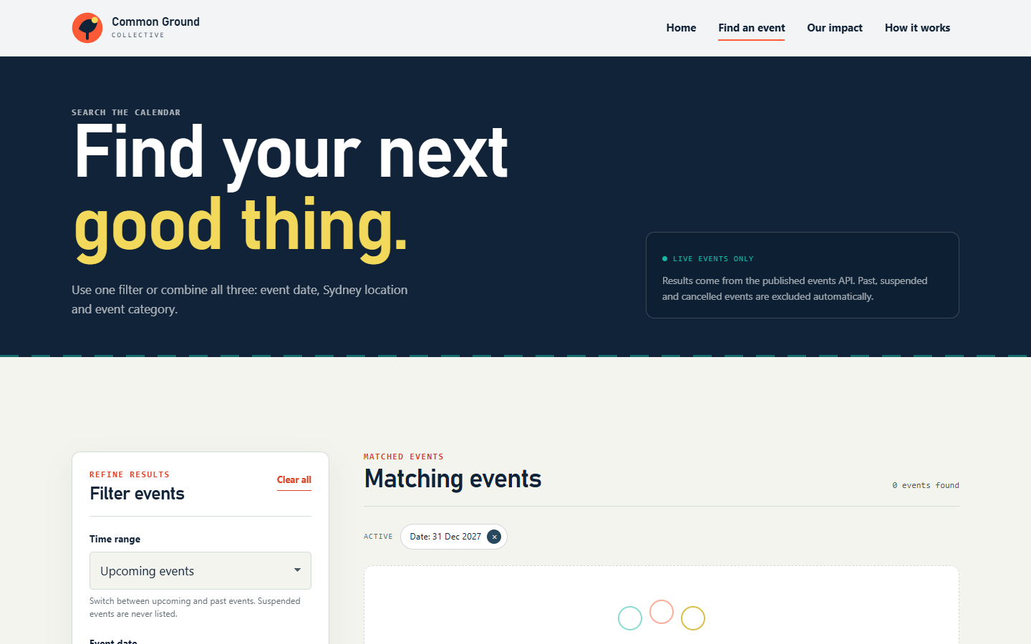
  ELEMENTS | Empty-state illustration; heading; explanatory copy; Clear all filters button; still-visible filter panel and active context.
  GRAPHICS | Three-orbit line illustration; muted background; orange primary button; no broken layout or blank panel.
  TEXT | No events match those filters. | Try a broader date, another suburb or fewer categories. New events are added regularly. | Clear all filters.
  AUDIO/VIDEO | 3:50-4:20. Explain the UX principle: empty results must not be a dead end. The page tells the user what happened and offers one obvious recovery action.
  NOTES | This state is demonstrated with a valid but unmatched future date. It is not an error and does not use an alarming colour.

Description: | The visitor makes a valid search that has no seeded match and is guided back to a useful search.
Content: | Zero matching events; the interface explains why the list is empty and keeps the filter form available for adjustment.
Interactions: | Read the empty message; click Clear all filters; change a date, suburb or category; return to the populated results.
Media Creation: | Capture after the empty-state fade completes. Use a slow push-in or a static frame so the copy stays readable.
Navigation: | Clear all filters -> S03/S05. Choose a seeded filter -> S05.

Storyboard
S07 - Event Detail: Trust & Decision
TITLE: Common Ground Collective - Charity Events Website | SCREEN ID: S07 | DATE: 5 October 2026

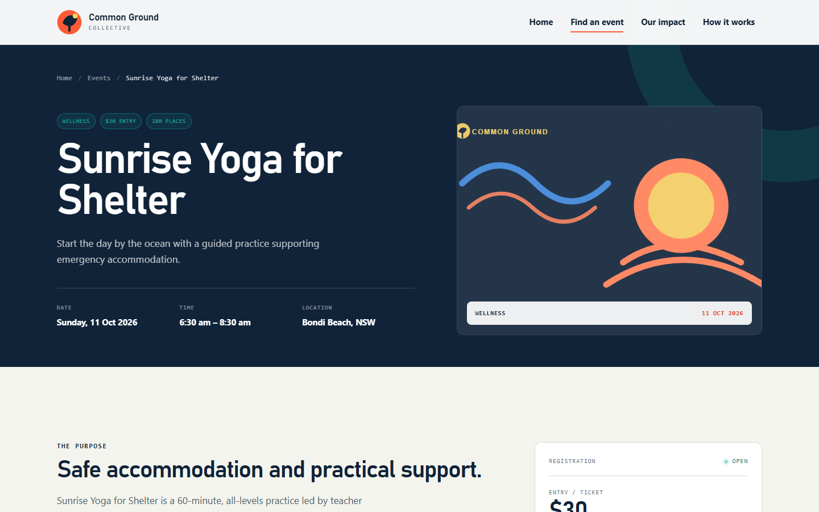
  ELEMENTS | Breadcrumb; category/price/capacity tags; event title; summary; quick facts; event cover; registration card; progress card; detailed information.
  GRAPHICS | Sunrise SVG cover; colour-coded category tag; breadcrumb separators; monogram; fundraising progress bar.
  TEXT | Sunrise Yoga for Shelter | Start the day by the ocean with a guided practice supporting emergency accommodation. | 11 October 2026 | 6:30 am - 8:30 am | Bondi Beach, NSW | $30 | Open.
  AUDIO/VIDEO | 4:20-5:20. Explain that the full record is loaded from GET /api/events/:id. The visitor can now verify organiser, purpose, location, price and fundraising progress before acting.
  NOTES | Event 11 is suspended and is deliberately not reachable; direct access returns the unavailable state. The Register button is present but read-only by design.

Description: | The visitor opens a specific event and sees a complete, trustworthy record assembled from several database tables.
Content: | Event #007 joined with organisation, category, venue and three event highlights. Goal $25,000; raised $19,400; 180 places; Reference Event #007.
Interactions: | Use the breadcrumb; scroll through purpose, highlights and organiser; open Register; return to search; open another event.
Media Creation: | Record the hero at rest, then a smooth scroll to details. Keep the event cover and quick facts visible in the first composition.
Navigation: | Scroll -> S08. Register -> S08 modal. Breadcrumb Search -> S05.

Storyboard
S08 - Event Detail: Progress & Register Modal
TITLE: Common Ground Collective - Charity Events Website | SCREEN ID: S08 | DATE: 5 October 2026

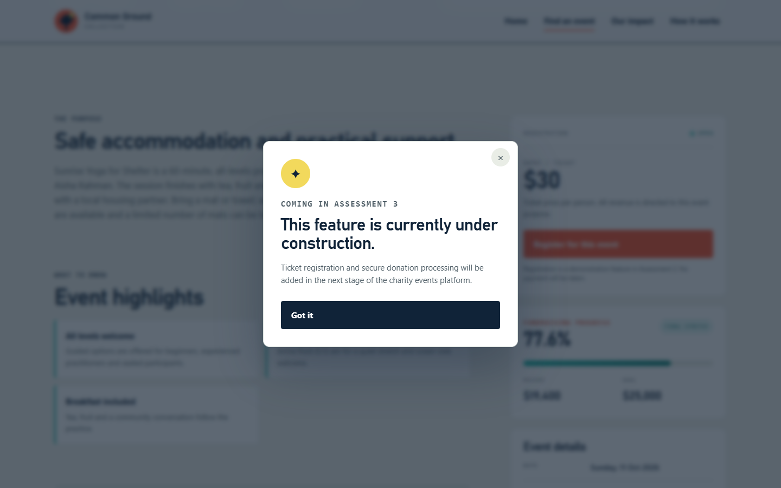
  ELEMENTS | Fundraising progress card; raised/goal amounts; event details list; registration button; modal dialog; close controls; highlighted event data behind the overlay.
  GRAPHICS | Animated progress bar at 77.6%; orange registration CTA; circular modal icon; dimmed backdrop; focus ring.
  TEXT | Fundraising progress | 77.6% | $19,400 raised | $25,000 goal | Register for this event | This feature is currently under construction. | Coming in Assessment 3.
  AUDIO/VIDEO | 5:20-6:00. Explain the read-only scope of Assessment 2. The modal confirms that registration and payment belong to Assessment 3; no request is sent when the button is pressed.
  NOTES | Dialog uses native HTML dialog where supported, focus trapping, Escape to close and an accessible name. The page remains usable with keyboard only.

Description: | The visitor reviews progress and tests the registration call to action; the site clearly communicates the future scope without pretending payment works.
Content: | Three event highlights; organiser mission; registration price; 77.6% progress; event date, time, venue, category, capacity and reference number.
Interactions: | Click Register for this event; modal opens; press Escape, X or Got it to close; tab stays inside the modal while open.
Media Creation: | Record a clean modal open and close. No cursor sits over the text. Keep the progress card visible behind the translucent backdrop in the final frame.
Navigation: | Close modal -> S07 or S05. End of walkthrough -> optional README / repository recap.

