PROG2002 - Web Development II
Assignment 2: Use Case (A Dynamic Website)
Student ID: 24832847 Last Name: Wei First Name: Zhiming
Title of the project:
Common Ground Collective - Charity Events Website

GitHub repository:
https://github.com/Ehoc-Walden/prog2002-charity-events
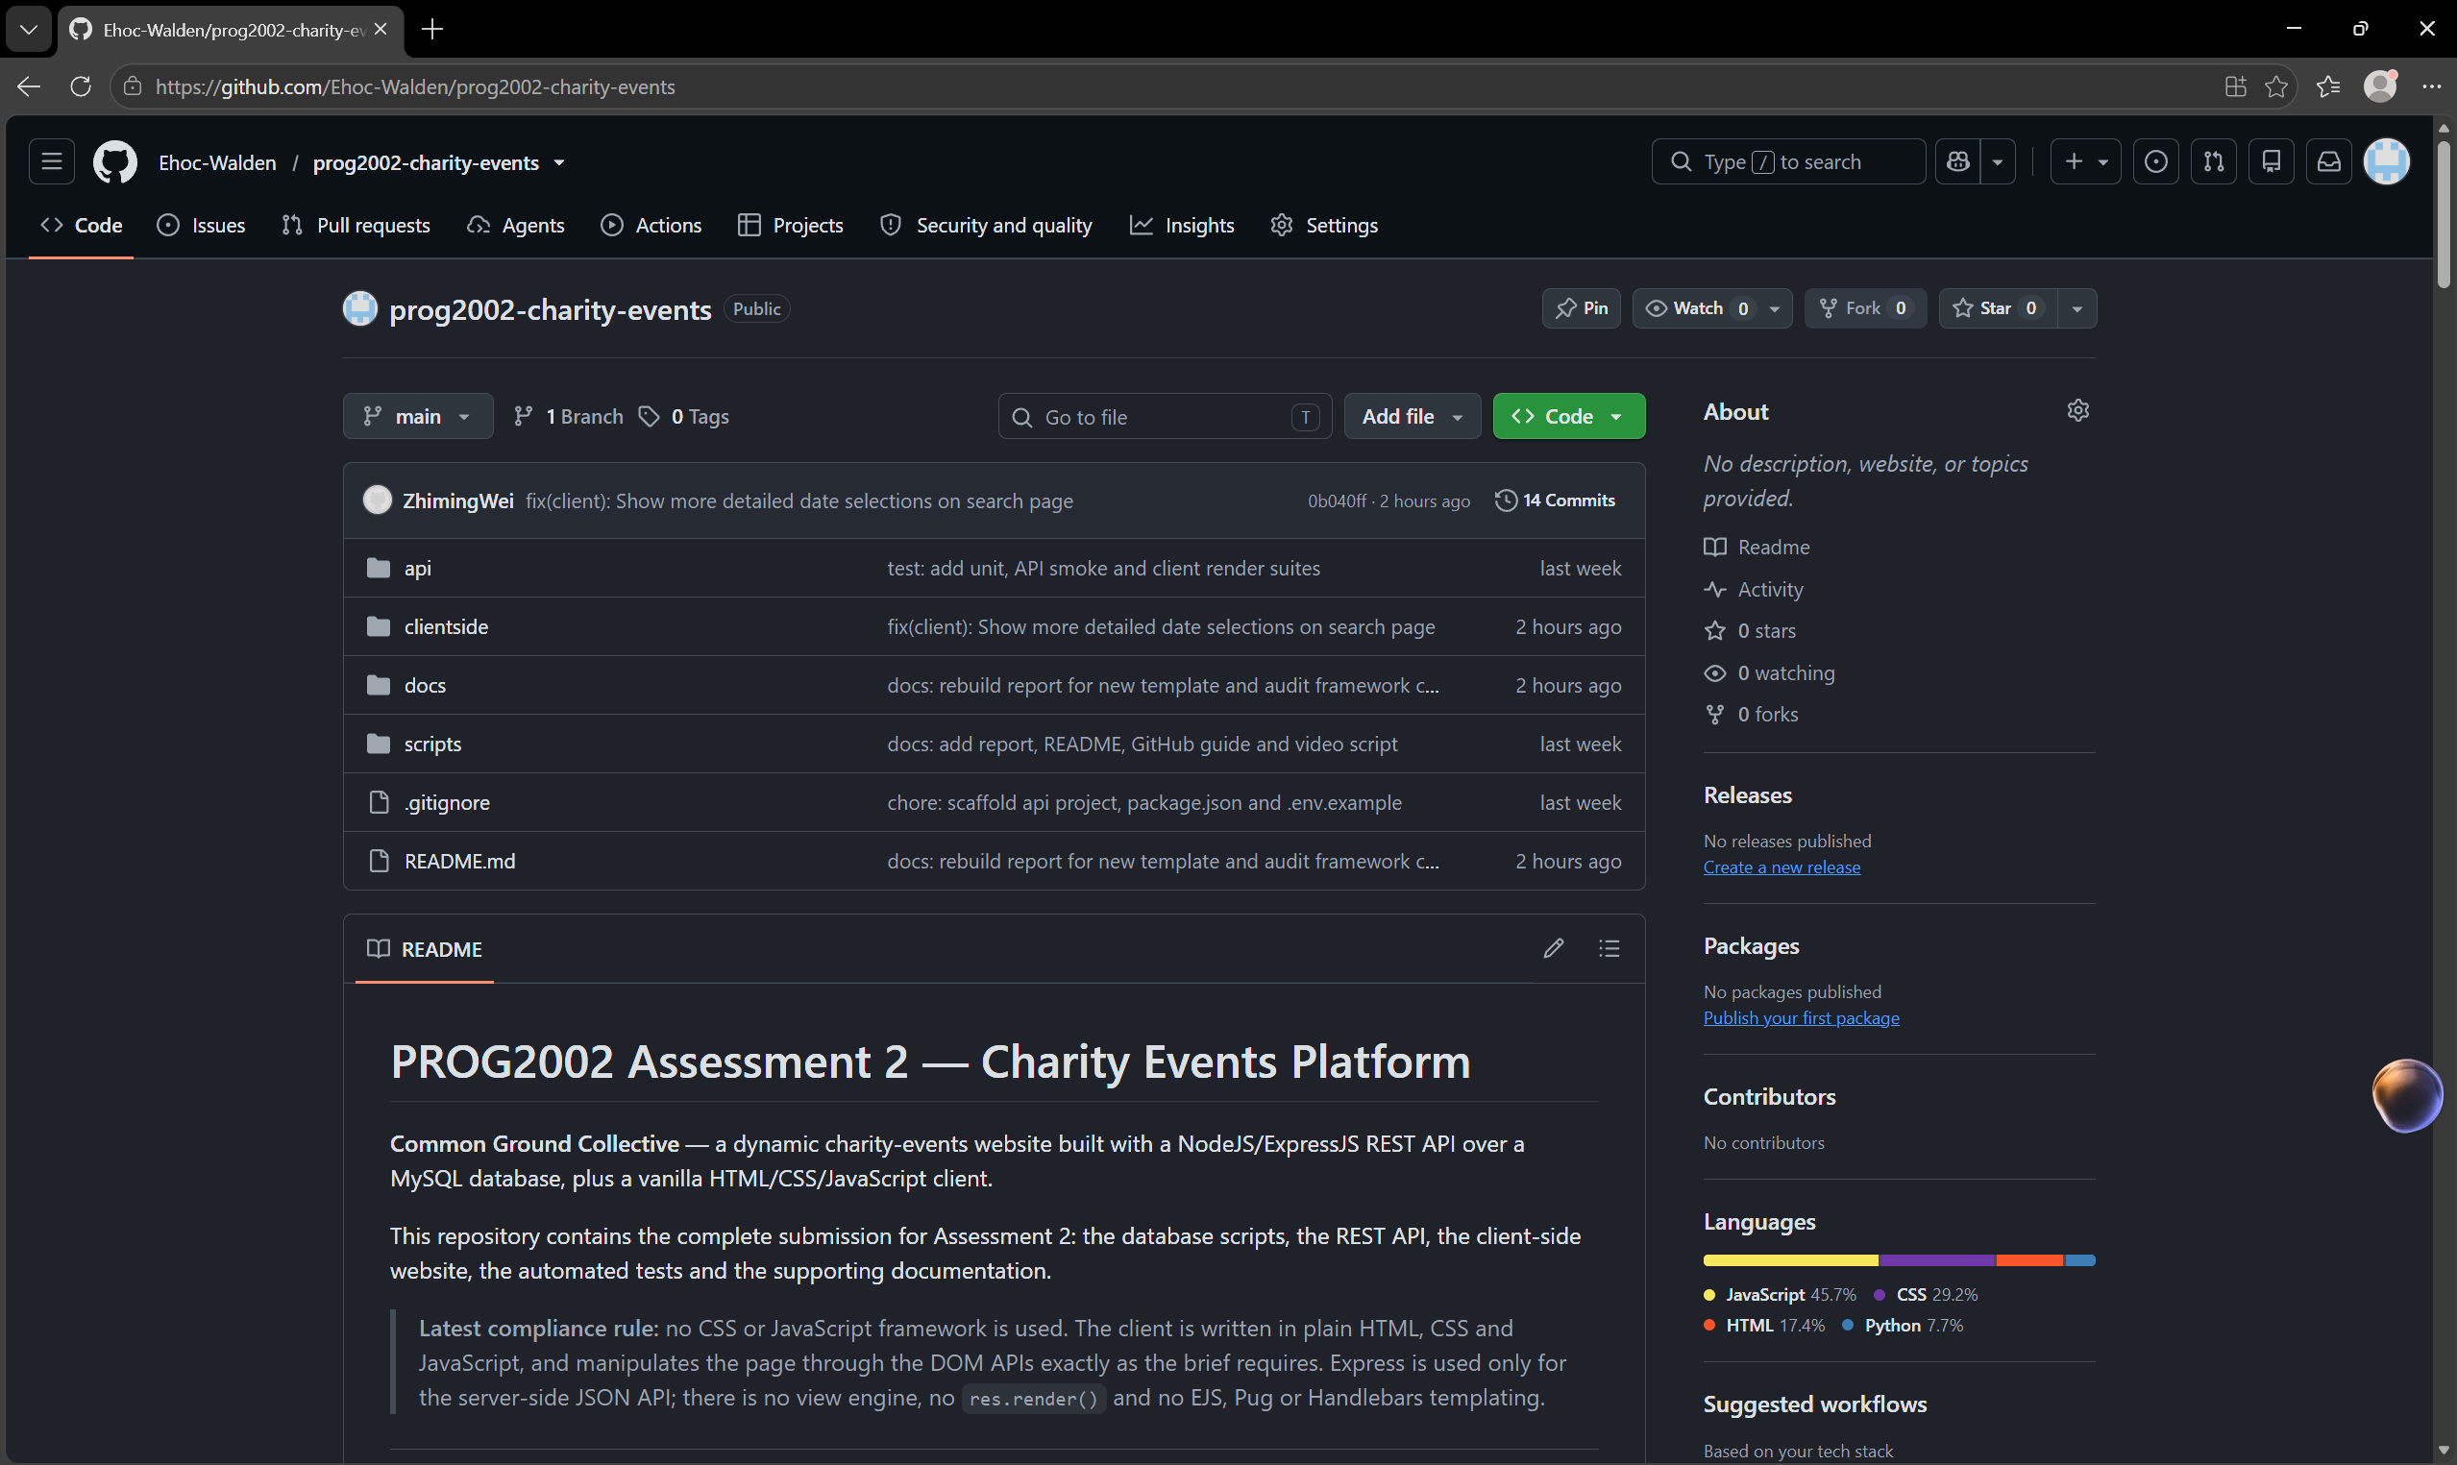

Video demonstration:
Method 1 SCU-OneDrive
https://scuonline-my.sharepoint.com/:f:/g/personal/z_wei_16_student_scu_edu_au/IgDNG-zN_fjuRIaWLiMViCNAATxfqWVG-HjJJXYahGXPBc8?e=tuAB43
Method 2 Tencent Meeting（If the link above cannot be opened）
https://meeting.tencent.com/crm/2y397Y4de4

Introduction/Motivation
Common Ground Collective is a Sydney charity-events platform built for Assessment 2 of PROG2002. It connects the charitable organisations that run fundraising activities - fun runs, gala dinners, silent auctions, live concerts, community walks and volunteer packing sessions - with members of the public who want to discover and support them. A visitor can browse the latest upcoming events, search the full calendar by date, suburb and category, open a complete event record, and see how far each fundraiser has progressed towards its goal.
The motivation comes directly from the case study. Charity events are normally announced on many separate organisational pages and social feeds, so a supporter who wants to help this weekend has no single place to look and no easy way to compare what is on. A charity, for its part, needs each event to look credible before somebody commits money or time: the organiser, the cause, the location, the price and the fundraising progress all have to be visible at a glance. Aggregating published events into one consistent, well-designed site addresses both sides of that problem.
The project is also a deliberate end-to-end exercise in client-side and server-side web development (ULO1 and ULO3). It demonstrates that a browser can be driven entirely by data returned from a web service written by the student: one MySQL database feeds three very different pages through one REST API, and nothing on a page is hard-coded except the organisation's own static introduction and impact figures.
The delivered solution uses only the technologies the brief permits. The data tier is MySQL 8.0; the application tier is a NodeJS 18+ service written with the ExpressJS framework, which is the only framework used anywhere in the submission; the presentation tier is static HTML, CSS and JavaScript that manipulates the DOM and calls the API with fetch() and Promises. No CSS framework (Bootstrap, Tailwind, Bulma and similar) and no JavaScript framework or library (AngularJS, React, Vue, jQuery and similar) is used, and Express never renders a page: there is no view engine and no templating mechanism (EJS, Pug, Handlebars) anywhere in the project. The API answers with JSON only.

Problem Statement
The case study describes a city-based charity sector in which events are plentiful but hard to find. Analysed carefully, it is a discovery-and-trust problem rather than a publishing problem, and it produces five concrete requirements.
- Discovery must work from partial information. A visitor may know only a suburb, only a month, or only the kind of activity they enjoy. The search must therefore accept any combination of date, location and category, allow more than one category at a time, and still return a sensible result when the visitor supplies nothing at all.
- Trust must be visible before commitment. Every event has to expose its organising charity, its purpose, its ticket price (including free entry), and its fundraising goal measured against the amount raised so far.
- Time has to be interpreted, not stored. The same record is "upcoming" before it happens and "past" afterwards, so the site must classify events against the current date at the moment of the request instead of relying on a hand-maintained flag.
- Policy violations must be impossible to display. An event that has been suspended must not appear on the home page, in search results or on its own detail page - even if a visitor navigates to it directly by guessing the address.
- The scope is deliberately read-only. Registration, payment and administration belong to Assessment 3, so this assessment exposes data only and demonstrates the Register button with a clear "under construction" message.
A static brochure site cannot satisfy any of these requirements: the event list changes with the calendar, the search combines three different filters, and the same record has to be shown in three different shapes on three different pages. The data must therefore live in a database and be delivered to the browser through an API that the client controls.

Solution
The solution is a three-tier web application. A MySQL 8 relational database holds the data; a NodeJS service built with ExpressJS exposes it as a read-only JSON REST API; and a static HTML, CSS and JavaScript client running in the browser fetches that JSON and renders it by manipulating the DOM. Figure 1 shows the three tiers and the files that make up each one.
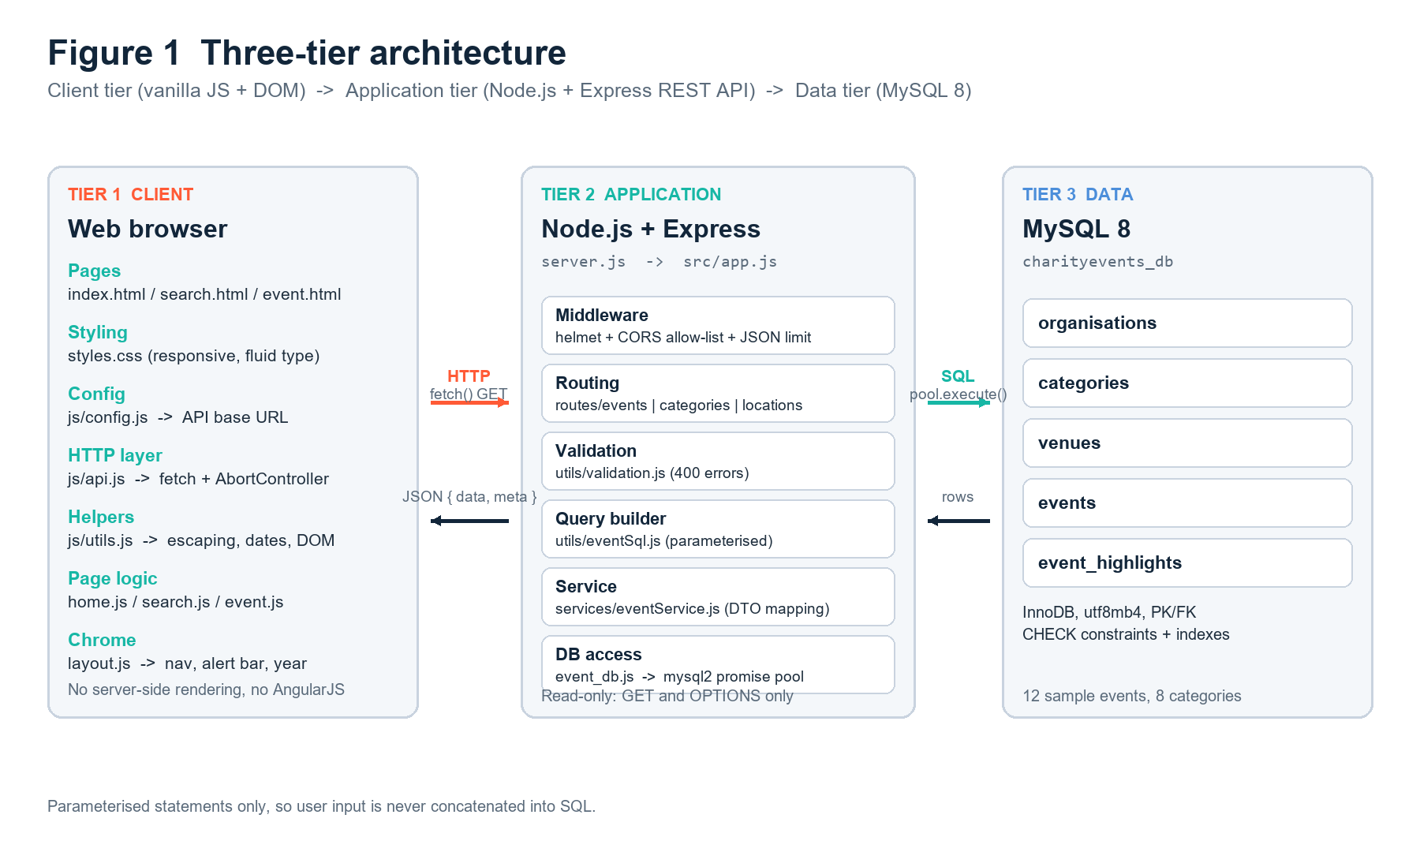
Figure 1 - Three-tier architecture of the submitted solution.
Client and server communication.
The client and the server communicate over plain HTTP, with JSON as the only payload format. When a page needs data it calls a small fetch() wrapper (clientside/js/api.js) with an absolute URL built from the API base URL declared in clientside/js/config.js. The wrapper returns a Promise, checks the HTTP status, unwraps the { data, meta } envelope and throws a readable Error when something is wrong, so every page controller can use the same async/await pattern and the same error handling. On the server the request passes through an Express router, is validated and coerced by src/utils/validation.js, is turned into a parameterised SQL statement, and is executed through the mysql2 connection pool in event_db.js. Rows are mapped into a stable transfer shape by src/services/eventService.js, wrapped in the response envelope and returned as JSON. The browser never sees a table name, a column name or a SQL error.
One request, end to end.
Figure 2 traces a single search submitted from search.html. The submit listener reads the form into a filters object; the client checks that the chosen scope is compatible with the chosen date; api.js issues GET /api/events/search with the filters as query-string parameters; the route validates and coerces every parameter; the query builder assembles a WHERE clause that contains one bound placeholder per user value; MySQL runs the count query and the page of rows; the service maps each row into the event transfer object and computes the progress percentage; and the controller clears the results list, builds a card for each event and inserts it into the DOM. Parsing, transporting, validating and rendering therefore each happen in exactly one place.
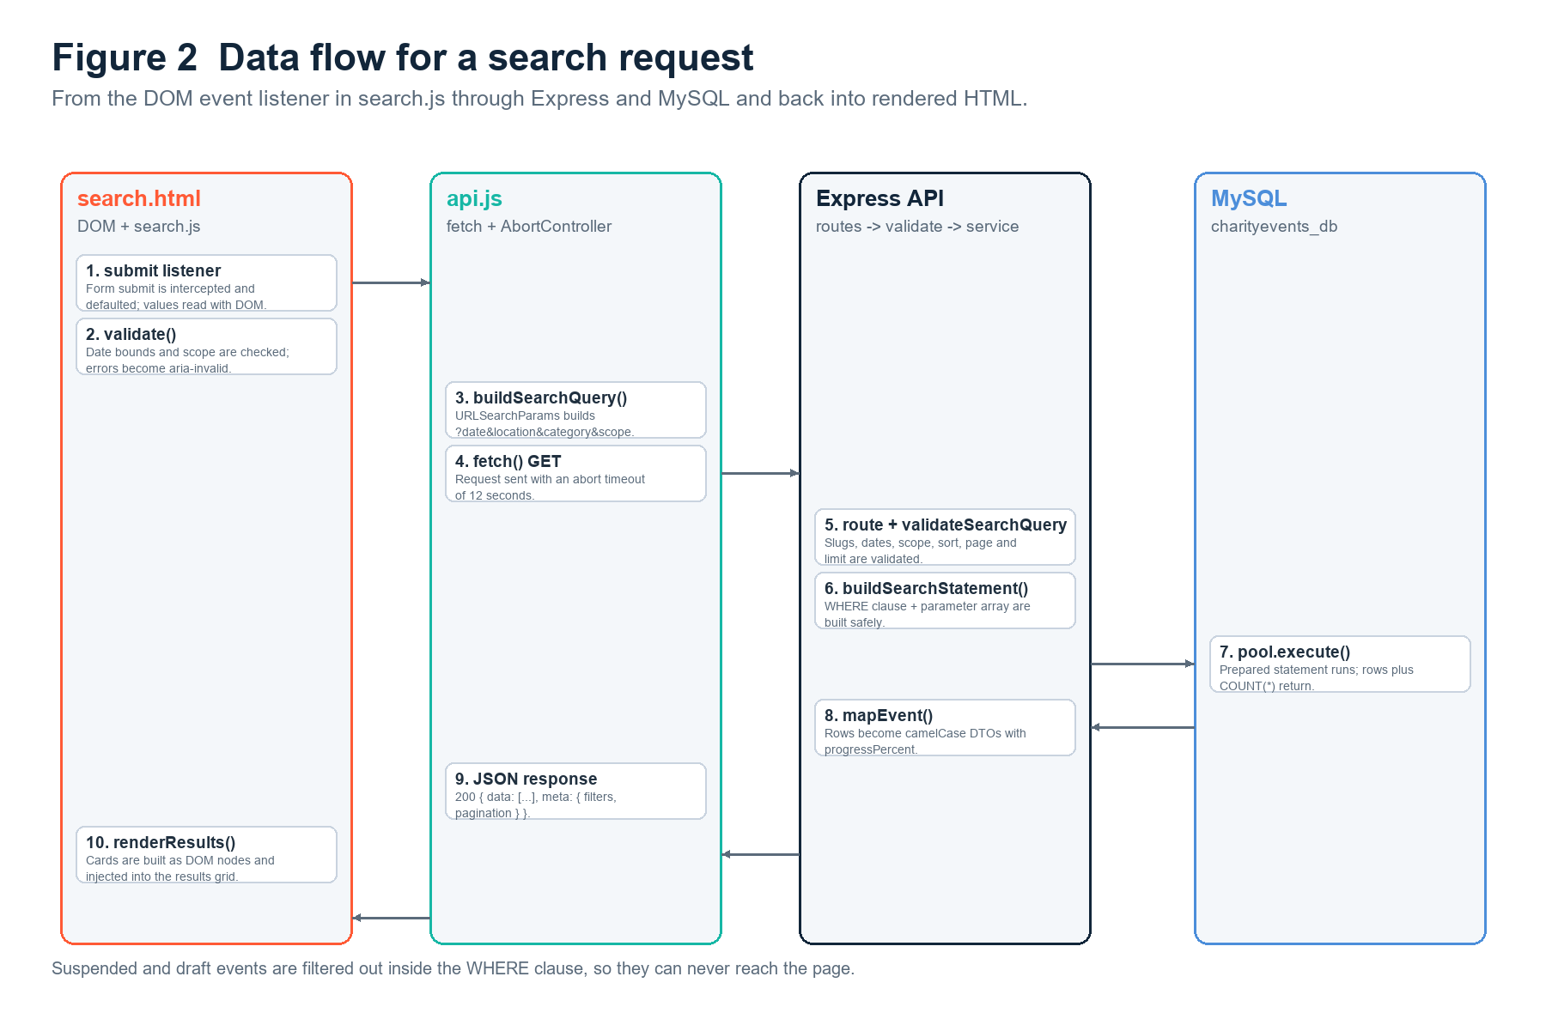
Figure 2 - Request and response data flow for a search on the search page.
Design decisions that shape the rest of the report:
- Read-only by design. Every route is a GET; the API contains no POST, PUT, PATCH or DELETE handler. This matches the assessment scope, removes a whole class of security concerns, and keeps the endpoints safe and idempotent.
- One envelope everywhere. Success is always { data, meta } and failure is always { error: { status, message } }, so the client can handle any response without special cases.
- Validation at the edge. Dates, sort keys, scopes, pagination values and category slugs are all checked before they reach the database, and invalid input is rejected with HTTP 400 and a human-readable message.
- No HTML from the server. Express returns JSON only. There is no view engine, no res.render and no templating, so the boundary between the API and the client-side website is complete.
- Internals stay server-side. Database credentials come from a git-ignored .env file, and database errors are translated into generic 500 responses, so SQL text and stack traces never reach the browser.

Web UX
Design began on paper. Before any HTML was written, low-fidelity wireframes were sketched for the three pages at both desktop and mobile width, and the navigation, the event card and the search form were fixed at that stage. Deciding these shared elements first is what makes three separate pages feel like one site rather than three exercises.
Page | Primary job | Layout and controls | UX rationale
Home (index.html) | Convince and orient | Hero with mission statement, impact figures, "how it works" steps, then a grid of upcoming event cards fetched from the API | Static trust content comes first, dynamic proof second; every card links to its detail page
Search (search.html) | Narrow the calendar | Date input, suburb dropdown, multi-select category chips, scope selector (upcoming/past/all), sort selector, Clear Filters button, active-filter chips, result count | The three brief-mandated criteria are the most prominent controls; every control has a visible label and a hint
Event detail (event.html) | Support a decision | Full description, schedule, venue, "what to expect" highlights, capacity, price or Free badge, goal-versus-progress bar, Register button | Everything a visitor asks for before committing, presented in the order they ask for it

Table 1 - The three pages, their controls and the reasoning behind each layout.
Navigation.
The navigation is identical on all three pages because it is injected by a shared module (clientside/js/layout.js) rather than copied into each file. The header is sticky, begins with a skip link to #main-content, and marks the current page with aria-current="page" so that both visual and assistive-technology users can tell where they are. Below the mobile breakpoint the menu collapses into a button that reports its state through aria-expanded. The event page adds a breadcrumb trail (Home / Events / event title), and every page ends with the same footer of contact details and links. Figure 3 maps each page to the endpoints it consumes.
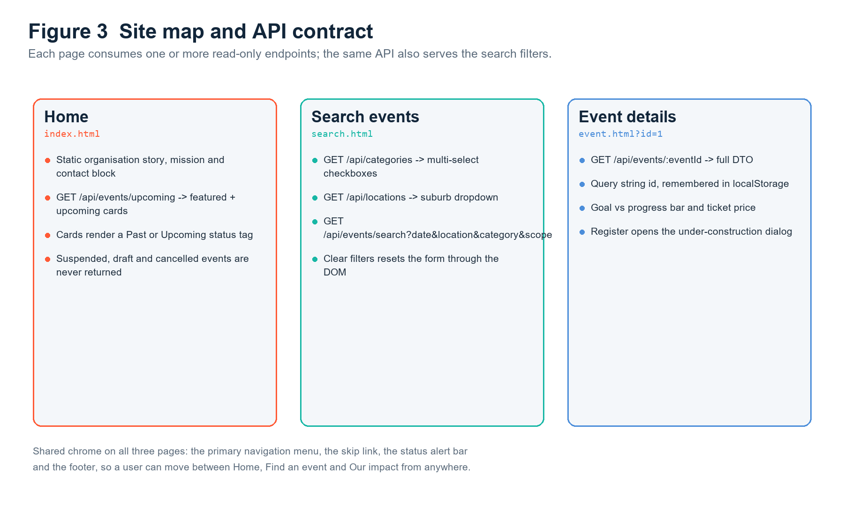
Figure 3 - Site map showing which read-only endpoints each page consumes.
Feedback and validation.
The search page never fails silently. Invalid input is written into the DOM next to the field that caused it, the input is marked with aria-invalid and linked to its message with aria-describedby, and focus moves to the first problem so a keyboard user is not left at the top of the page. The results area has explicit loading, empty and error states plus a visible count of matches. Active filters are repeated as removable chips above the results, so it is always obvious which filters are being applied; removing a chip re-runs the search. Clear Filters resets the form, the URL and the results in a single action, which is the required demonstration of DOM manipulation.
Accessibility was treated as part of usability rather than as an afterthought. The pages use proper landmarks (header, nav, main, footer), a visible focus style, descriptive alt text or aria-hidden on every image, semantic form labels, and a Register dialog built with role="dialog", aria-modal="true", focus trapping and Escape-to-close. Colour contrast was checked against the palette, and no information is conveyed by colour alone. Because the client is plain CSS there is no framework stylesheet to download, and the only JavaScript on a page is the small set of files listed in Appendix A.

Data Schema
The data model is a normalised five-table MySQL 8 database named exactly charityevents_db. At its centre is the events table: each event belongs to exactly one organisation, one category and one venue, and may have many ordered highlights. Figure 4 shows the entities and their relationships, and the complete data definition language is in api/database/schema.sql.
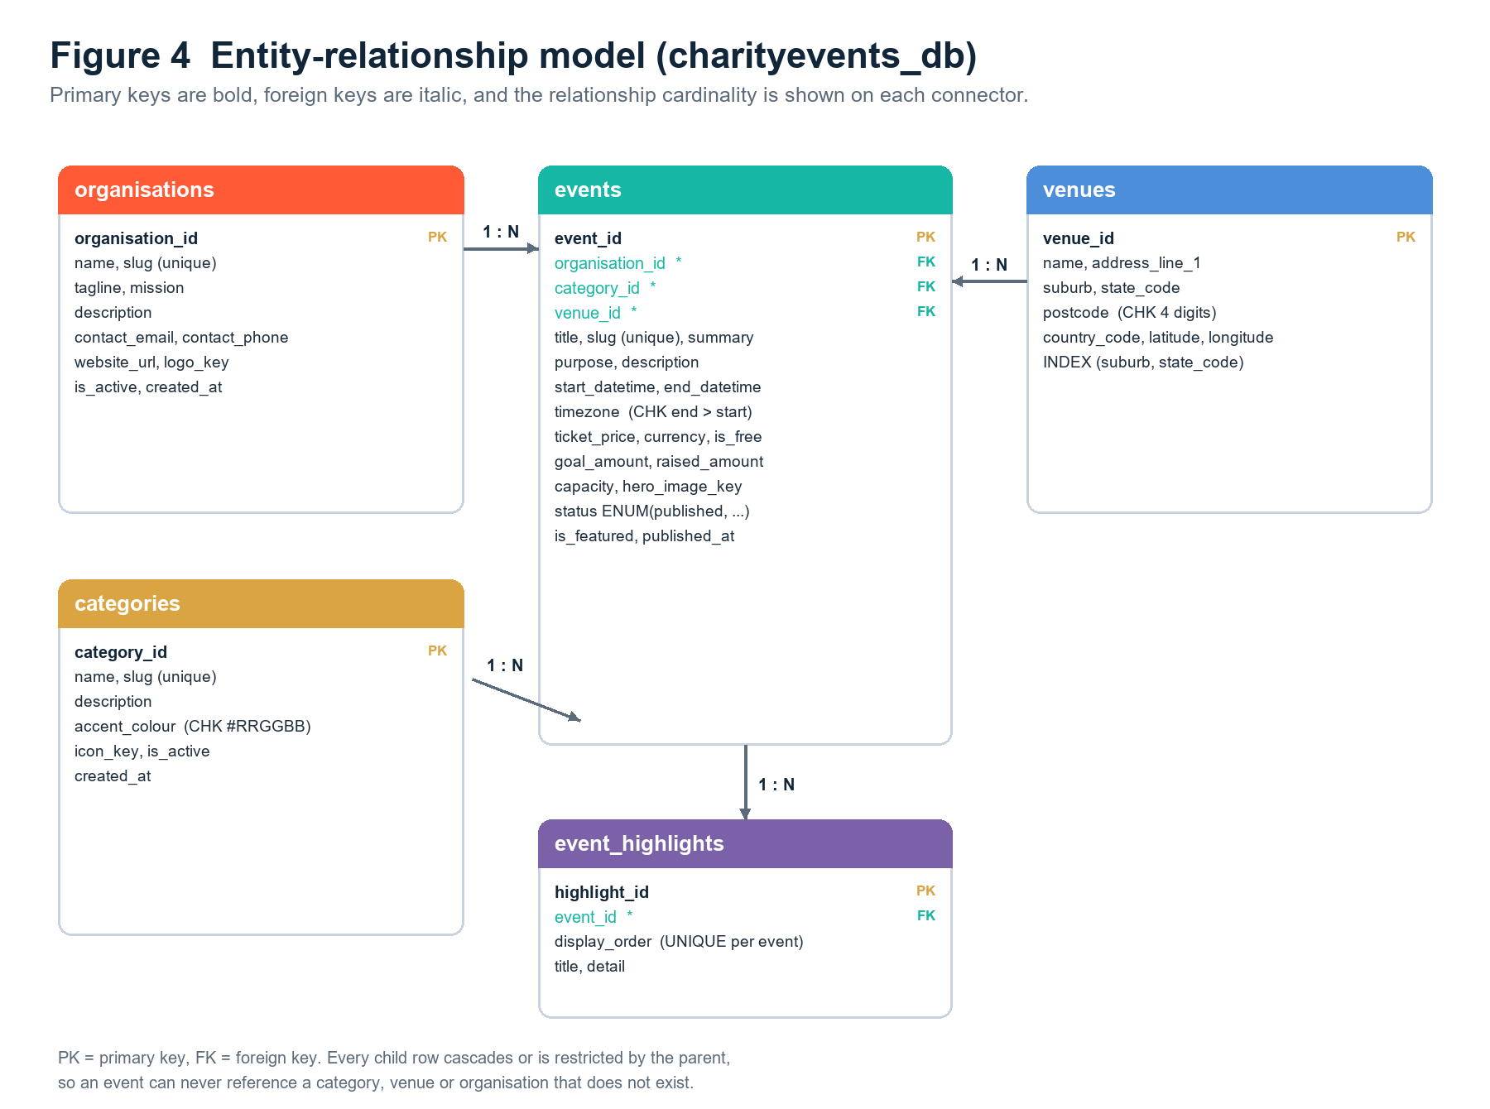
Figure 4 - Entity-relationship model for charityevents_db.
Table | Purpose | Key columns | Relationships
organisations | The charities that run events | organisation_id (PK), name, slug (unique), tagline, mission, contact_email, is_active | 1 -> many events
categories | Reusable event types (fun run, gala, auction, ...) | category_id (PK), name, slug (unique), description, accent_colour, icon_key, is_active | 1 -> many events
venues | Where events take place | venue_id (PK), name, address_line_1, suburb, state_code, postcode, latitude, longitude | 1 -> many events
events | The charity events themselves | event_id (PK); organisation_id, category_id, venue_id (FKs); title, summary, purpose, description; start_datetime, end_datetime, timezone; ticket_price, currency, is_free; goal_amount, raised_amount; capacity, hero_image_key; status, is_featured | many -> 1 organisations, categories and venues; 1 -> many event_highlights
event_highlights | Ordered "what to expect" points for one event | highlight_id (PK), event_id (FK), display_order, title, detail | many -> 1 events (ON DELETE CASCADE)

Table 2 - The five tables, their purpose, key columns and relationships.
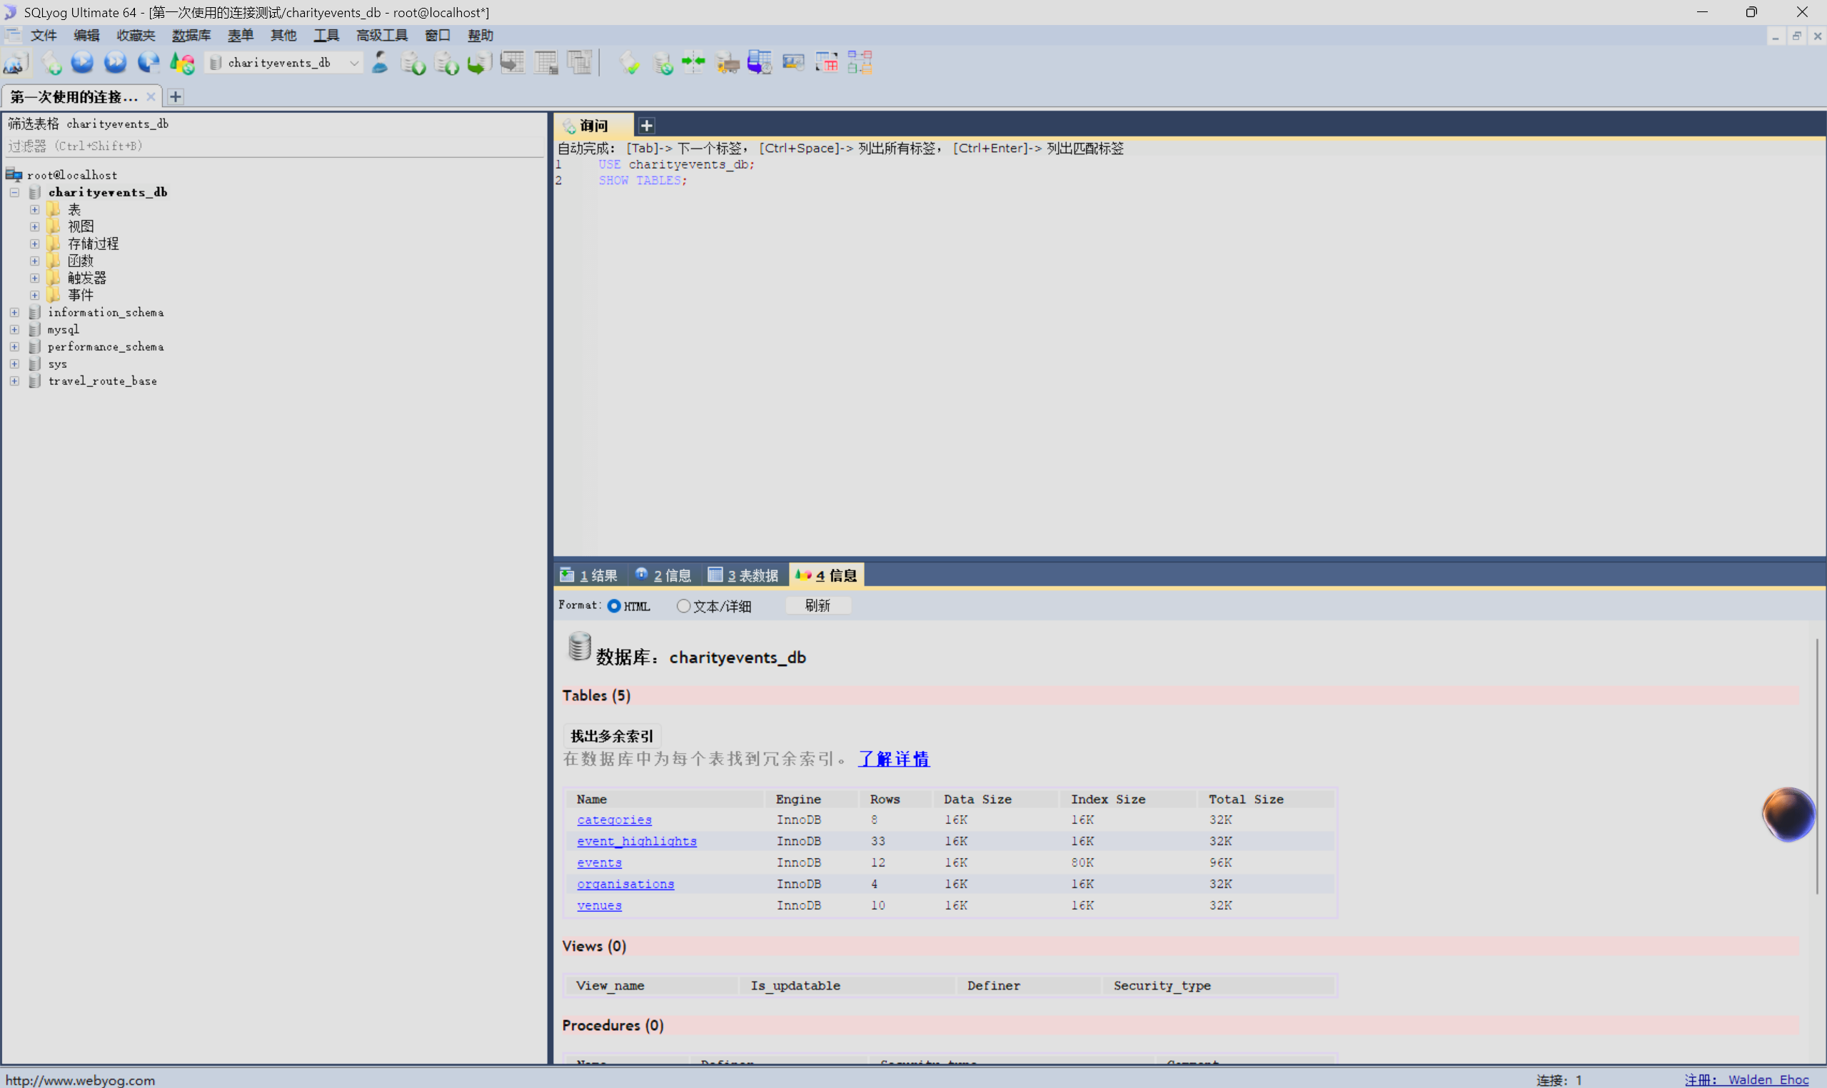
Figure 5 - The five tables created in charityevents_db.
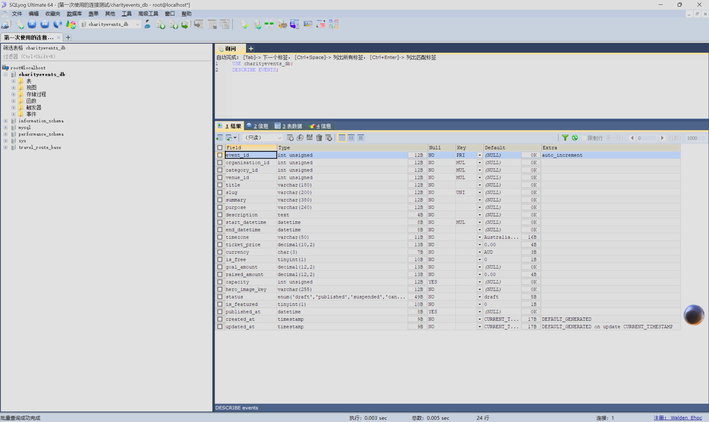
Figure 6 - events table columns, types and primary key.
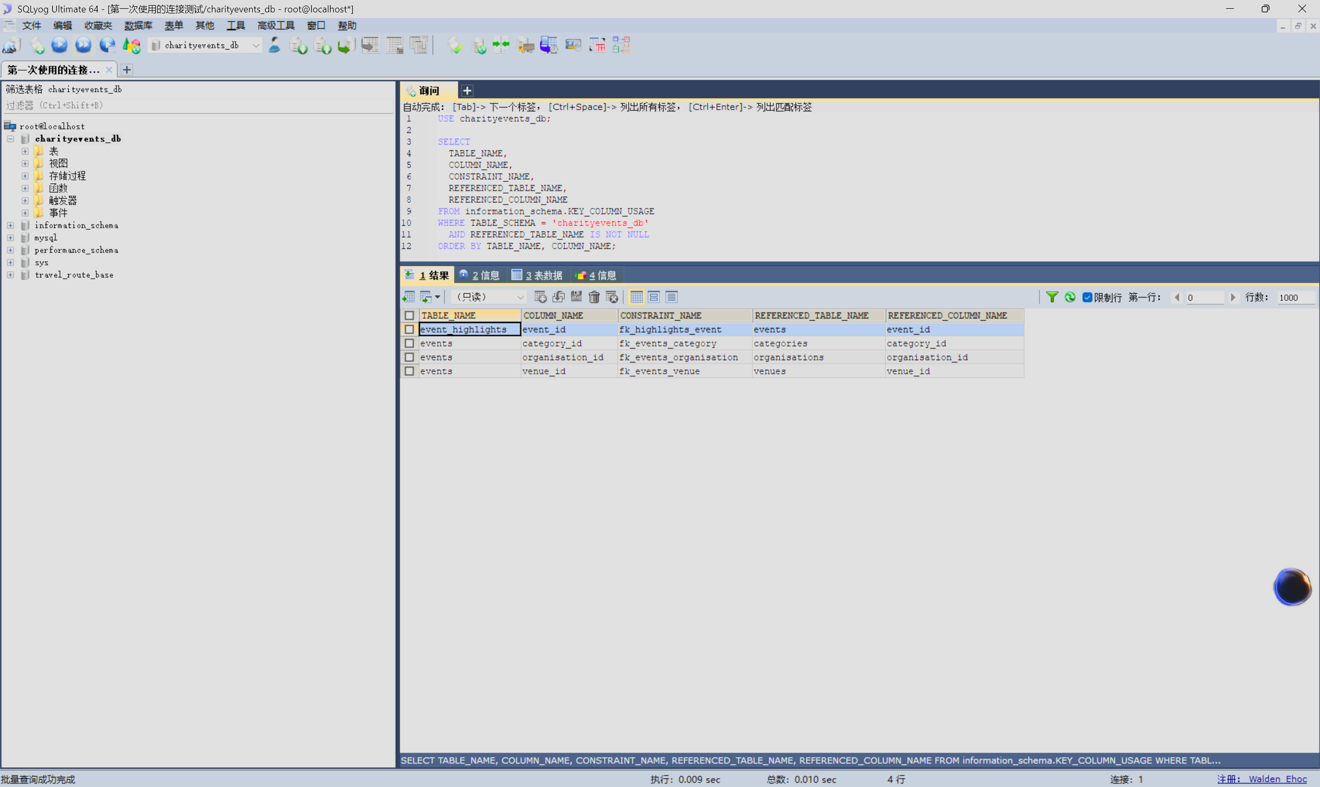
Figure 7 - Foreign-key relationships between the tables.
Modelling decisions.
- Surrogate primary keys. Every table uses an UNSIGNED AUTO_INCREMENT integer key, so relationships stay stable even when a human-readable name or slug changes.
- Foreign keys everywhere. An event can never reference an organisation, category or venue that does not exist, because the constraint is enforced by the database rather than only by application code.
- Integrity enforced in the database. CHECK constraints reject end_datetime <= start_datetime, negative prices, non-positive goals, negative amounts raised, invalid boolean flags and malformed accent colours.
- Money is DECIMAL, never floating point. goal_amount uses DECIMAL(12,2) and ticket_price uses DECIMAL(10,2), so totals and progress percentages never drift.
- Time is explicit. Each event stores start_datetime, end_datetime and a timezone (Australia/Sydney), so past and upcoming are calculated in the event's own time zone rather than the server's.
- Status is a controlled vocabulary. status is an ENUM of draft, published, suspended and cancelled, and every API query filters on status = "published". A suspended event therefore cannot leak into the site.
- Repeating attributes are normalised. Highlights live in their own table with UNIQUE (event_id, display_order), so their order is meaningful and duplicates are impossible.
- Indexes match the access paths. A composite index on (start_datetime, status) supports the home page and date searches, while single-column indexes cover category_id, organisation_id and venue_id.
The seeded dataset deliberately covers every rule the site has to demonstrate: 4 organisations, 8 categories, 10 venues, 12 events and 33 highlights, including past and upcoming events, free and paid tickets, a featured event and one suspended event (event 11) that must never be displayed.
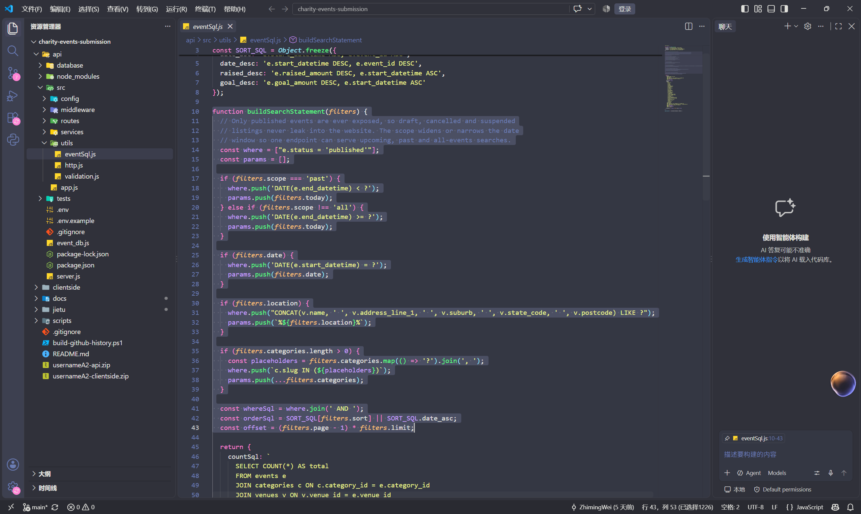
Figure 8 - Parameterised SQL query builder (api/src/utils/eventSql.js).
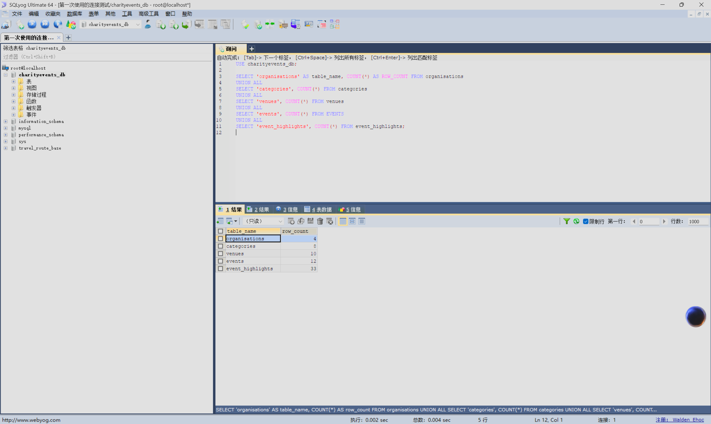
Figure 9 - Seed-data counts returned by the database.

API design
The API is a read-only JSON service rooted at http://localhost:3000/api. Every successful response uses the same envelope, { "data": ..., "meta": ... }, and every failure uses { "error": { "status": ..., "message": ... } }. Table 3 lists the main endpoints; the rest of this section describes one endpoint in full and explains the choice of HTTP methods.
Method | Endpoint | Purpose
GET | /api/health | Liveness probe that confirms the service is running.
GET | /api/events/upcoming?limit=6 | Upcoming published events for the home page. limit is 1-20 and defaults to 6.
GET | /api/events/search | Filtered, sorted and paginated event search. Powers the whole search page.
GET | /api/events/:eventId | Full detail for one published event, including its ordered highlights. Returns 404 when the event is missing, unpublished or suspended.
GET | /api/categories | Active categories, used to build the multi-select filter on the search page.
GET | /api/locations | The distinct suburbs that actually have a published event, used to populate the location dropdown.
GET | /api/organisations | Active organisations, used for the static content on the home page.
GET | /api/organisations/:organisationId | A single active organisation.

Table 3 - The main API endpoints. All traffic is HTTP GET; there is no write endpoint.
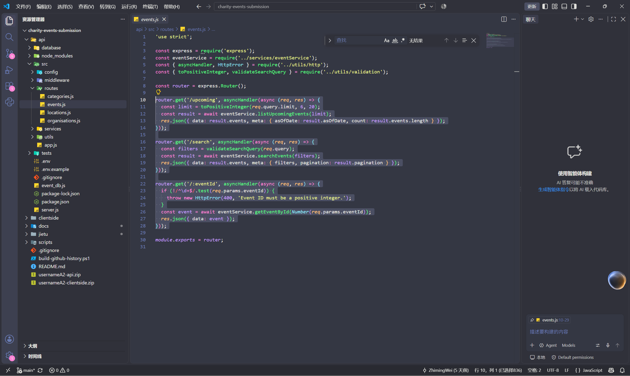
Figure 10 - Express API routes (api/src/routes/events.js).
One endpoint in depth: GET /api/events/search
Purpose.
This is the most important endpoint in the application and the clearest illustration of how the tiers cooperate. It returns the published events that match any combination of date, location and category, sorted and paginated, and it is the only endpoint the search page has to call.
Request.
Parameters are supplied in the query string. There is deliberately no request body: a GET request carries its qualifiers in the URL, which keeps the request cacheable and bookmarkable.
Parameter | Type and format | Default | Behaviour
date | YYYY-MM-DD | none | Returns only events that start on that calendar day. A malformed date is rejected with 400.
location | string, max 80 characters | none | Case-insensitive partial match against the venue name, address, suburb, state code and postcode.
category | repeatable slug, for example category=fun-run&category=gala-dinner | none | Multiple values are combined with OR, so an event matching any selected category is returned.
scope | upcoming | past | all | upcoming | Restricts results to events that have not finished, have finished, or both.
sort | date_asc | date_desc | raised_desc | goal_desc | date_asc | Chooses the ordering column and direction. Any other value is rejected with 400.
page | integer >= 1 | 1 | Selects the result page.
limit | integer 1-50 | 12 | Sets the page size.

Table 4 - Query parameters accepted by /api/events/search. Every value is validated and coerced.
Response.
A successful response is JSON, never HTML. The example below is the shape returned for the first page of a search for fun runs. The exact event objects are built by eventService.mapEvent(), which converts database snake_case columns into a stable client-facing DTO and calculates progressPercent.
HTTP/1.1 200 OK
Content-Type: application/json; charset=utf-8
{
"data": [
{
"id": 1,
"title": "Twilight Harbour 10K",
"slug": "twilight-harbour-10k",
"summary": "Run the harbour at golden hour and fund 4,000 fresh meals for Sydney families.",
"purpose": "Food security and emergency meal support.",
"startDateTime": "2026-10-18T16:30:00",
"endDateTime": "2026-10-18T20:30:00",
"timezone": "Australia/Sydney",
"ticket": { "price": 65, "currency": "AUD", "isFree": false },
"fundraising": { "goal": 80000, "raised": 51500, "progressPercent": 64.4 },
"capacity": 1200,
"heroImage": "/assets/covers/twilight-harbour.svg",
"featured": true,
"isPast": false,
"category": { "id": 1, "name": "Fun Run", "slug": "fun-run" },
"organisation": { "id": 1, "name": "Common Ground Collective" },
"venue": { "name": "Barangaroo Reserve", "suburb": "Barangaroo", "stateCode": "NSW" }
}
],
"meta": {
"filters": {
"date": null, "location": "", "categories": ["fun-run"], "sort": "date_asc",
"scope": "upcoming", "page": 1, "limit": 12
},
"pagination": { "page": 1, "limit": 12, "total": 1, "totalPages": 1 }
}
}
Listing 1 - A representative 200 response for GET /api/events/search. The array may contain zero or more events; meta always reports the effective filters and pagination.
Errors use the same envelope for 400, 404 and 500 responses. The examples below show the messages a client can safely display; a 500 response deliberately replaces internal details with a generic message so database or server information is never exposed.
400 Bad Request
{ "error": { "status": 400, "message": "sort must be date_asc, date_desc, raised_desc or goal_desc." } }
404 Not Found
{ "error": { "status": 404, "message": "Event not found." } }
500 Internal Server Error
{ "error": { "status": 500, "message": "The server could not complete the request." } }
Listing 2 - Uniform error responses. The 404 is also used for an unpublished or suspended event, so the client cannot infer whether a hidden record exists.
Choice of HTTP methods.
Every endpoint is a safe, idempotent read, so GET is the correct method throughout. GET requests can be cached, bookmarked, retried and shared without changing server state. The application has no registration, payment or administration behaviour in Assessment 2, so POST, PUT, PATCH and DELETE are deliberately absent. The browser sends an automatic OPTIONS preflight for the cross-origin request; Express and the CORS middleware answer it, but it is not an application endpoint. Keeping the API read-only also makes the "no write endpoint" requirement easy to verify in the source.
Validation and security.
- Allow-list validation. Dates must match YYYY-MM-DD and be real calendar dates; sort keys must be one of four values; scope must be upcoming, past or all; page must be at least 1; limit must be between 1 and 50; category values must be lower-case slugs; location must be 80 characters or fewer.
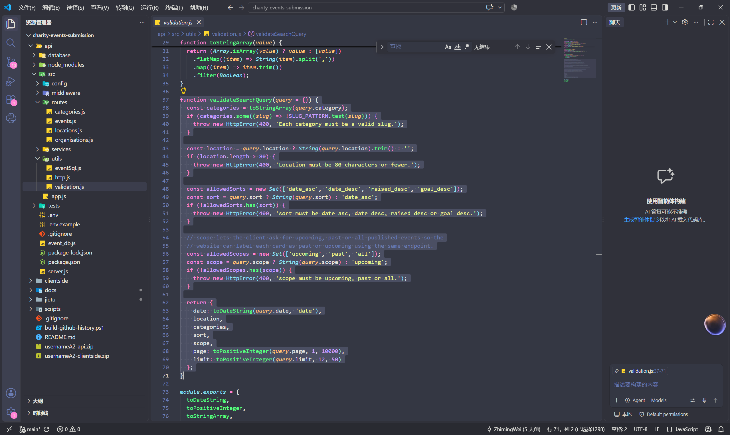
Figure 11 - Search-query validation rules (api/src/utils/validation.js).
- Parameterised SQL only. mysql2 execute() receives a SQL string plus a values array. No user value is concatenated into SQL, which prevents SQL injection even when the location search uses LIKE.
- Published-only policy. The WHERE clause starts with status = "published" in the shared query builder and in the single-event query. Suspended event 11 therefore returns 404 rather than leaking hidden data.
- Safe output and headers. helmet removes identifying headers, x-powered-by is disabled, JSON bodies are limited to 20 KB, and the client escapes API text before inserting it into the DOM.
- No template rendering. The Express app calls res.json() only. It does not set a view engine, does not call res.render() and contains no EJS, Pug, Handlebars, Nunjucks or other template files.
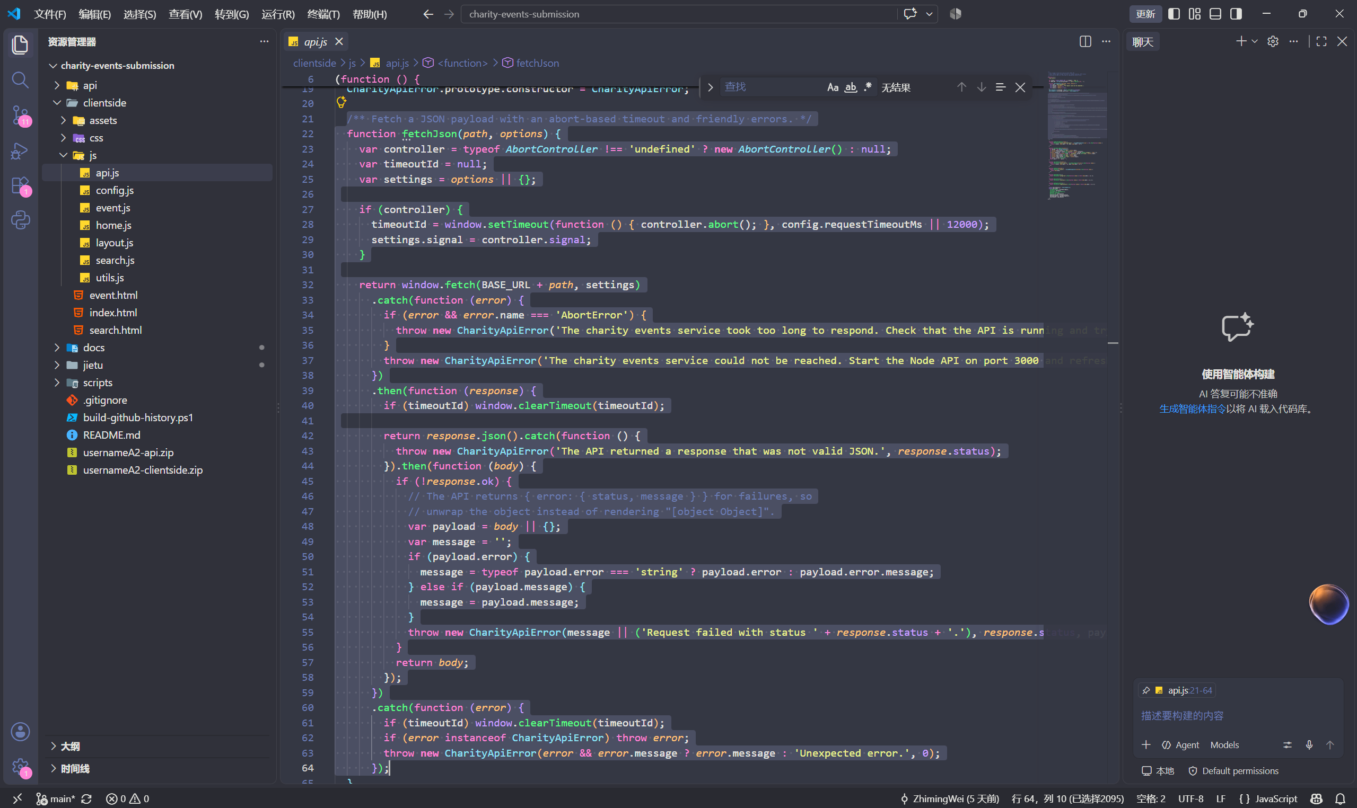
Figure 12 - Native JavaScript API request and error handling (clientside/js/api.js).

Gen AI acknowledgement and Chat Log
I acknowledge that I have used GenAI tools to complete this assessment. I used Deepseek within the parameters outlined in the Assessment Brief and by the Unit Assessor, and only for the permitted Level 2 purposes listed in the brief: brainstorming ideas, checking grammar, paraphrasing for clarity, formatting the document, and designing layout templates.
All database schemas, SQL scripts, API endpoints, Express routes, client-side JavaScript, DOM manipulation, validation logic, and report content were designed, written, and implemented by me. GenAI was not used to generate or copy-paste any code or report text into the submission. Every suggestion I received was reviewed, adapted, tested, and rewritten in my own words before it was included.
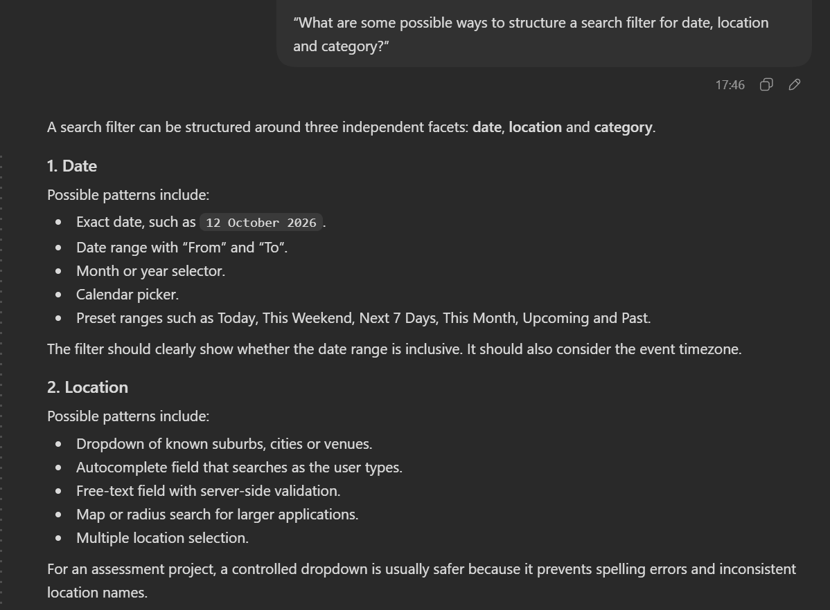
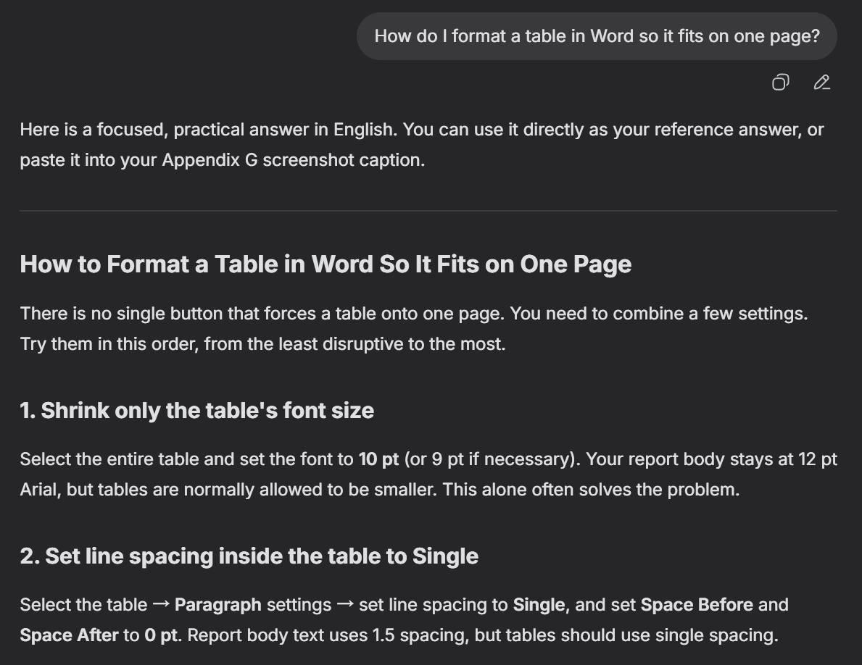
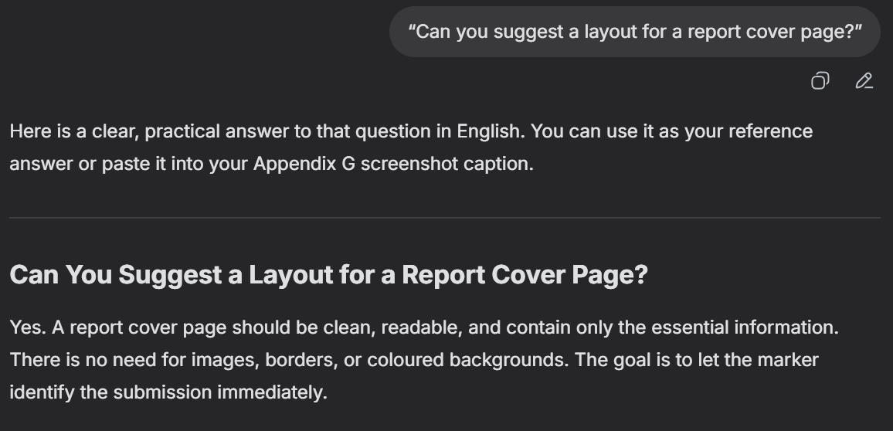
、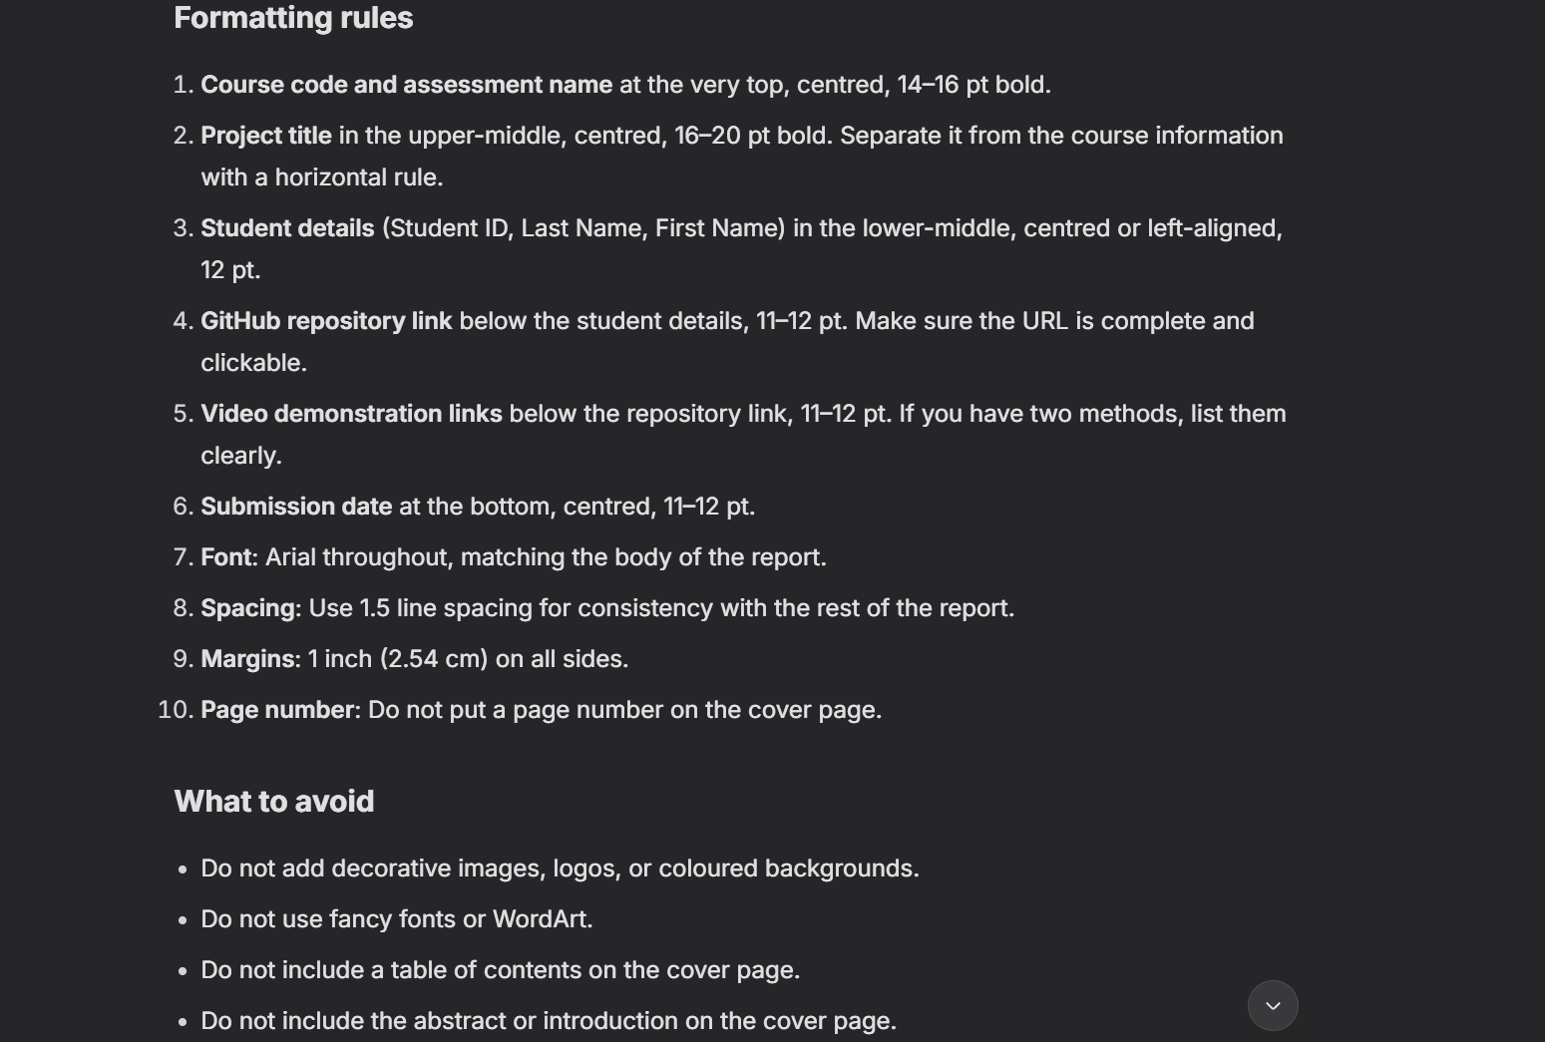

Appendix A - Project structure
The submission is deliberately split into two archives. The API archive contains the Express server, database scripts and automated tests; the client archive contains only static HTML, CSS, JavaScript and local SVG assets. The report, README, video script and checklist are documentation rather than runtime dependencies.
charity-events-submission/
api/
server.js starts the HTTP listener
event_db.js mysql2 connection pool
package.json express + supporting runtime libraries
.env.example documented environment variables
database/
schema.sql five-table schema, keys, checks, indexes
seed.sql realistic sample data
src/
app.js Express middleware and JSON routes
config/env.js environment validation
middleware/errorHandler.js
routes/ events, categories, locations, organisations
services/eventService.js
utils/ validation, SQL builder, HTTP helpers
tests/ validation and query-builder tests
clientside/
index.html Home
search.html Search events
event.html Event details
css/styles.css hand-written responsive CSS
js/ config, utils, api, layout and page logic
assets/ local logo, favicon and SVG covers
docs/
PROG2002_A2_Report_Zhiming_Wei.docx
README.md

Appendix B - Installation and run instructions
The steps below mirror README.md sections 2 and 3.1-3.4 so a marker can reproduce the site without editing the source code. They were tested on Windows PowerShell 7 with Node.js 22, MySQL Server 8.0 and Python 3.14. Run every command from the project root (the folder that contains README.md) unless a step says otherwise.

B.1 Prerequisites
- Node.js 18.18 or newer (developed and tested on Node 20/24).
- MySQL 8.0 or newer (the schema uses utf8mb4_0900_ai_ci and CHECK constraints, both MySQL 8 features).
- A modern browser (Chrome, Edge, Firefox or Safari).
- A simple static web server for the client. Do not open index.html from file:// because browser CORS rules block fetch() from local files.

B.2 Create the database
Open PowerShell in the project root and run:
$root = (Get-Location).Path
$mysql = "C:\Program Files\MySQL\MySQL Server 8.0\bin\mysql.exe"
& $mysql -u root -p -e "SOURCE $($root -replace '\\','/')/api/database/schema.sql;"
& $mysql -u root -p -e "SOURCE $($root -replace '\\','/')/api/database/seed.sql;"
PowerShell does not accept the "<" operator for input redirection, so SOURCE is used instead. If MySQL is installed elsewhere, change the $mysql path. schema.sql drops and recreates the charityevents_db database and its five tables (organisations, categories, venues, events and event_highlights); seed.sql then loads 4 organisations, 8 categories, 10 venues, 12 events and 33 event highlights. In addition, schema.sql creates the read-only charity_app MySQL account that the API logs in with, so no manual MySQL user setup is required.
Verify the load with:
& $mysql -u root -p -e "USE charityevents_db; SELECT COUNT(*) AS events FROM events; SELECT COUNT(*) AS categories FROM categories;"
Expected result: events = 12 and categories = 8.

B.3 Configure the API
No manual configuration is required. The API creates api/.env from api/.env.example automatically the first time it starts, with these defaults:
DB_HOST=localhost
DB_PORT=3306
DB_USER=charity_app
DB_PASSWORD=change_me
DB_NAME=charityevents_db
PORT=3000
CORS_ORIGINS=http://localhost:5500,http://127.0.0.1:5500
The account charity_app is a read-only account that schema.sql creates when it is run as an administrator, so nothing has to be created by hand. The API only ever issues SELECT statements. To change the port or use a different MySQL login, edit api/.env and restart the API. If your MySQL login cannot create users, only the account block at the end of schema.sql fails; in that case set DB_USER=root and DB_PASSWORD to your own password in api/.env.

B.4 Install and start the API
Still in the api folder, install the dependencies and start the server:
cd api
npm install
npm start
Expected output: Charity Events API listening on http://localhost:3000. The server verifies the database connection with SELECT 1 before it starts listening, so any credential problem is reported immediately. Leave this PowerShell window running while you use the site.

B.5 Serve the client
Open a second PowerShell window, navigate to the project root, then serve the clientside folder on port 5500 (this matches the default CORS allow-list):
cd "C:\Users\Walden_Ehoc\Desktop\charity-events-submission\clientside"
py -m http.server 5500
Now open http://localhost:5500/index.html in the browser. Any port works as long as it is added to CORS_ORIGINS in api/.env and the API is restarted. Do not open index.html directly from file://, because the browser blocks fetch() from local files.

B.6 Verify the website
Walk through the four checks below to confirm the whole stack is working:
- Home page - upcoming events load from the API and the supporting-information section renders.
- Search page - filtering by date, location and category returns matching events, and Clear Filters resets the form.
- Event detail - clicking an event card opens its full record with schedule, venue, highlights and price.
- Register button - the dialog shows exactly "This feature is currently under construction."
Press Ctrl+C in each PowerShell window to stop the API or the static server when you have finished.

Appendix C - API quick reference
Endpoint | Key inputs | Successful response
GET /api/health | none | Service status object.
GET /api/events/upcoming | limit 1-20, default 6 | Upcoming published events ordered by featured then start date.
GET /api/events/search | date, location, repeatable category, scope, sort, page, limit | Filtered event array plus effective filters and pagination metadata.
GET /api/events/:eventId | Positive integer event ID | One published event with ordered highlights; missing or suspended IDs return 404.
GET /api/categories | none | Active categories for the search filter.
GET /api/locations | none | Distinct suburbs with at least one published event.
GET /api/organisations | none | Active organisations for the organisation panel.
GET /api/organisations/:organisationId | Positive integer organisation ID | One active organisation.

Table 5 - API quick reference. The API is read-only and returns JSON only.

Appendix D - Compliance with the latest framework restriction
The latest unit instruction states that no CSS or JavaScript framework may be used, that Express may be used only for the server, and that Express templating such as EJS is forbidden. The project was re-audited against that instruction after the new report template was received. The result is compliant, and the evidence is summarised below.
Requirement | Evidence in the submission | Result
No CSS framework | clientside/css/styles.css is a single hand-written stylesheet. The three HTML files link only to that local file; there is no Bootstrap, Tailwind, Bulma, Foundation, Normalize or CDN stylesheet. | Pass
No JavaScript framework or library | The client loads only local files: config.js, utils.js, api.js, layout.js and one page controller. It uses native fetch(), Promises, DOM APIs and event listeners. No React, Vue, AngularJS, jQuery or similar library is present. | Pass
Express server only | api/package.json lists express for routing. cors, dotenv, helmet and mysql2 are supporting libraries, not web frameworks; they do not deliver or render pages. | Pass
No Express templating | api/src/app.js sets no view engine and calls res.json() only. A repository search finds no res.render(), EJS, Pug, Handlebars, Mustache or Nunjucks file. | Pass
Plain HTML/CSS/JS delivery | The browser receives static .html, .css and .js files from the clientside server. Dynamic cards and details are created in the DOM from JSON returned by the API. | Pass
No third-party front-end assets | All logos, favicons and event covers are local SVG files under clientside/assets. No external asset URL is referenced by the pages. | Pass

Table 6 - Latest framework restriction audit. Each row was checked against the actual source tree, not only against the README.
Audit commands used.
# Search runtime code for forbidden frameworks or template engines
Get-ChildItem clientside -Recurse -Include *.html,*.css,*.js |
Select-String -Pattern 'bootstrap|tailwind|bulma|jquery|react|vue|angular|ejs|pug|handlebars'
Select-String api/src -Pattern 'res.render|view engine|ejs|pug|handlebars|nunjucks'
# Inspect the only API dependencies
Get-Content api/package.json
The searches returned no application-code matches. The README mentions AngularJS only to state that it is deliberately not used; that is documentation, not a dependency or import.

Appendix E - Pre-submission checklist
- Report cover. Student ID 24832847, Last Name Wei, First Name Zhiming and the project title are complete. Paste the final SCU OneDrive video link before export.
- Report formatting. Use A4, one-inch margins, Arial 12 pt and 1.5 line spacing. Check that every figure and table is numbered and that no page is clipped.
- Database. Run schema.sql and seed.sql on a clean MySQL 8 instance. Confirm charityevents_db contains 5 tables, 12 events and 8 categories.
- API. Run node tests/validation.test.js and node tests/queryBuilder.test.js. Start the API and confirm GET /api/health, the search endpoint, the upcoming endpoint and one event detail endpoint. Confirm /api/events/11 returns 404 and malformed input returns 400.
- Client. Serve clientside/ over HTTP and test Home, Search and Event detail at desktop and mobile widths. Confirm the suspended event never appears and Register shows the exact required sentence.
- Compliance. Confirm there is no CSS framework, no client JavaScript framework, no Express view engine and no res.render() call. The current audit is recorded in Appendix D.
- Packaging. Create usernameA2-clientside.zip from the contents of clientside/ and usernameA2-api.zip from the contents of api/. Neither archive may contain node_modules or .env.
- Repository and video. Keep the GitHub repository private, invite the marker if required, upload the video to SCU OneDrive with view access, and verify both links in a private browser window.

Appendix F - Website screenshot evidence
Figures 13-15 show the delivered home page, search page with filters and results, and supporting information section of the home page.
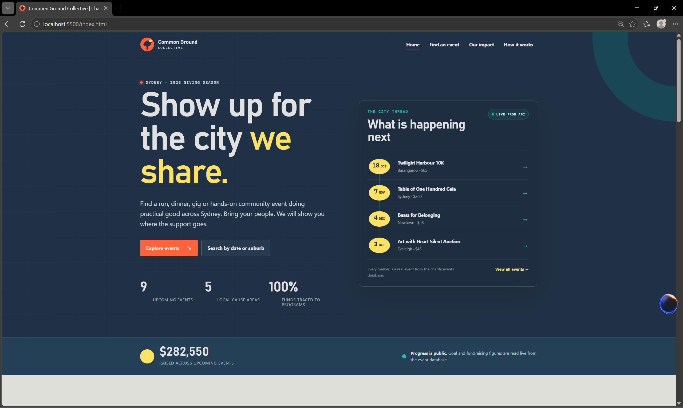
Figure 13 - Home page of the submitted website.
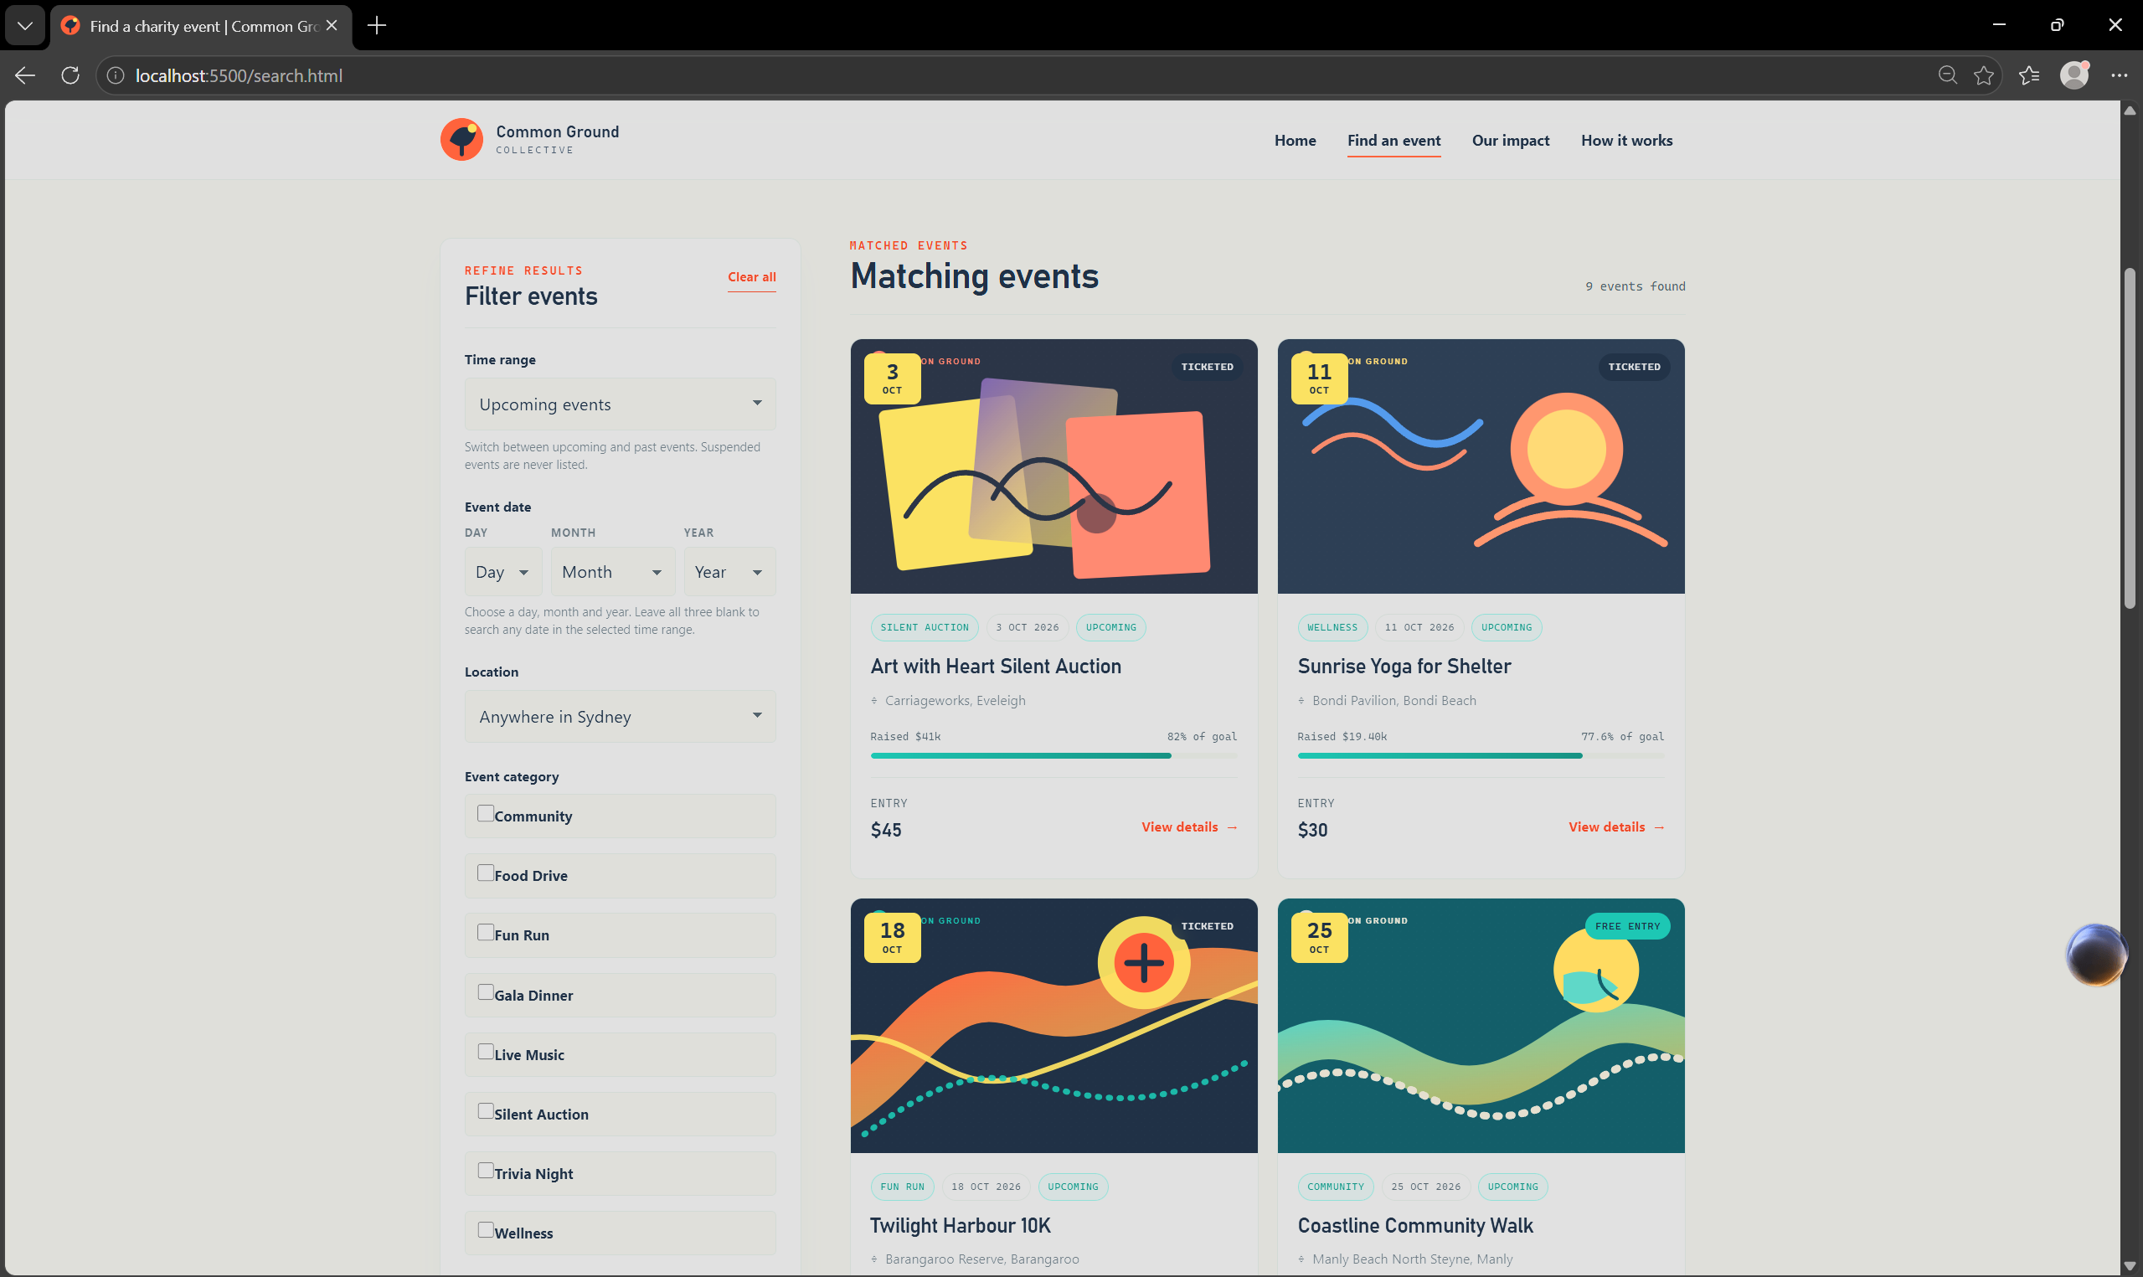
Figure 14 - Search page with filters and matching events.
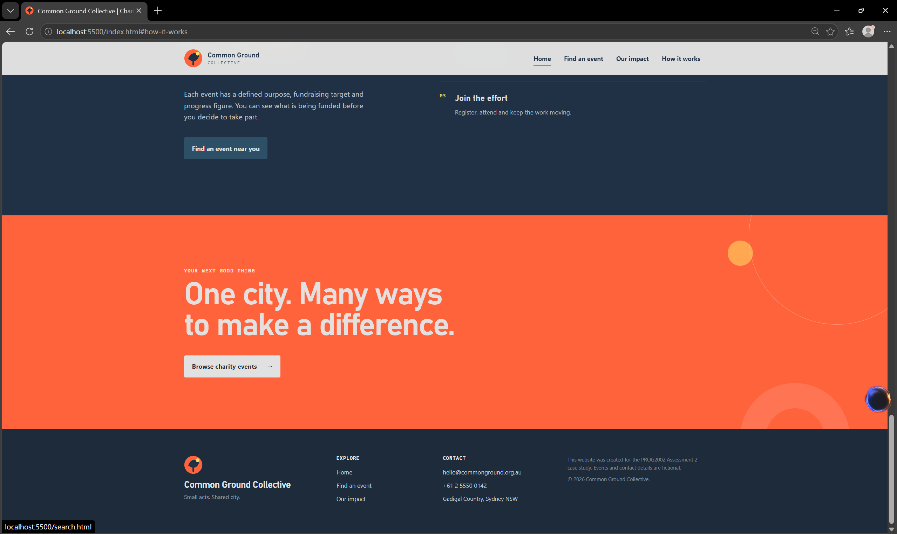
Figure 15 - Supporting information section of the home page.

