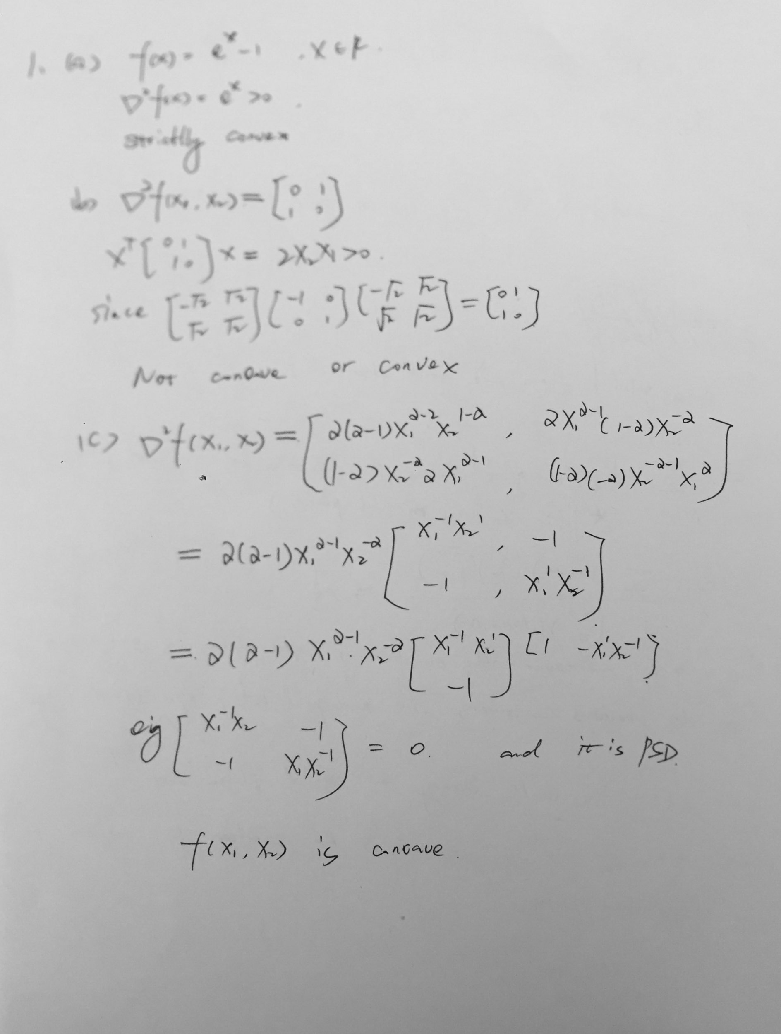

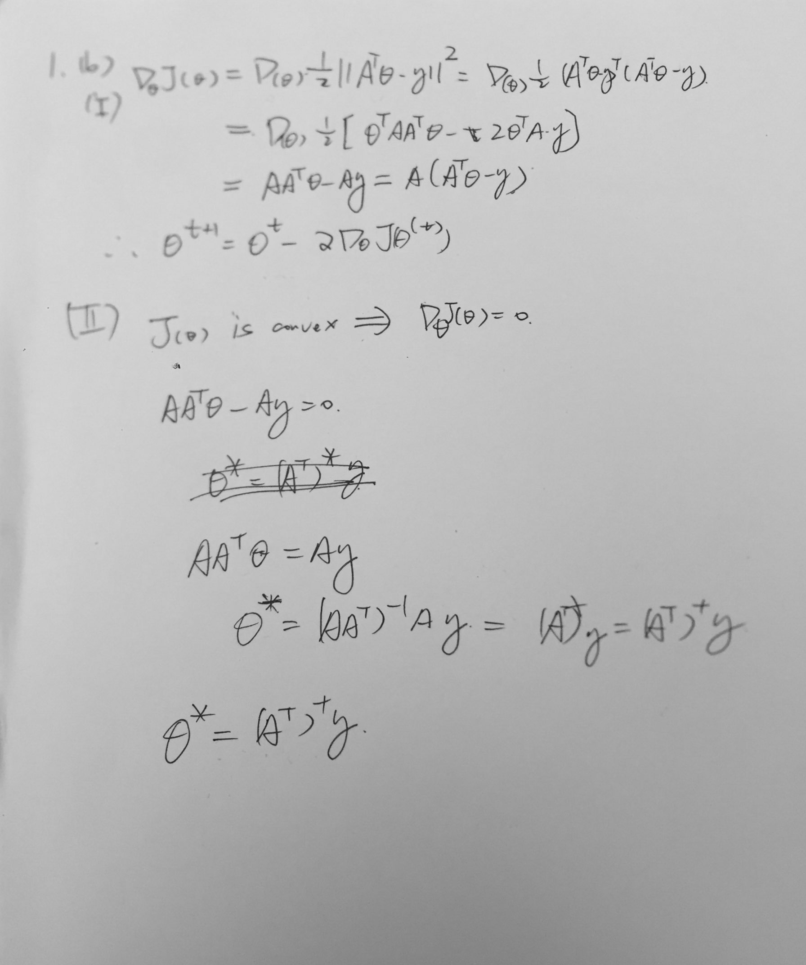

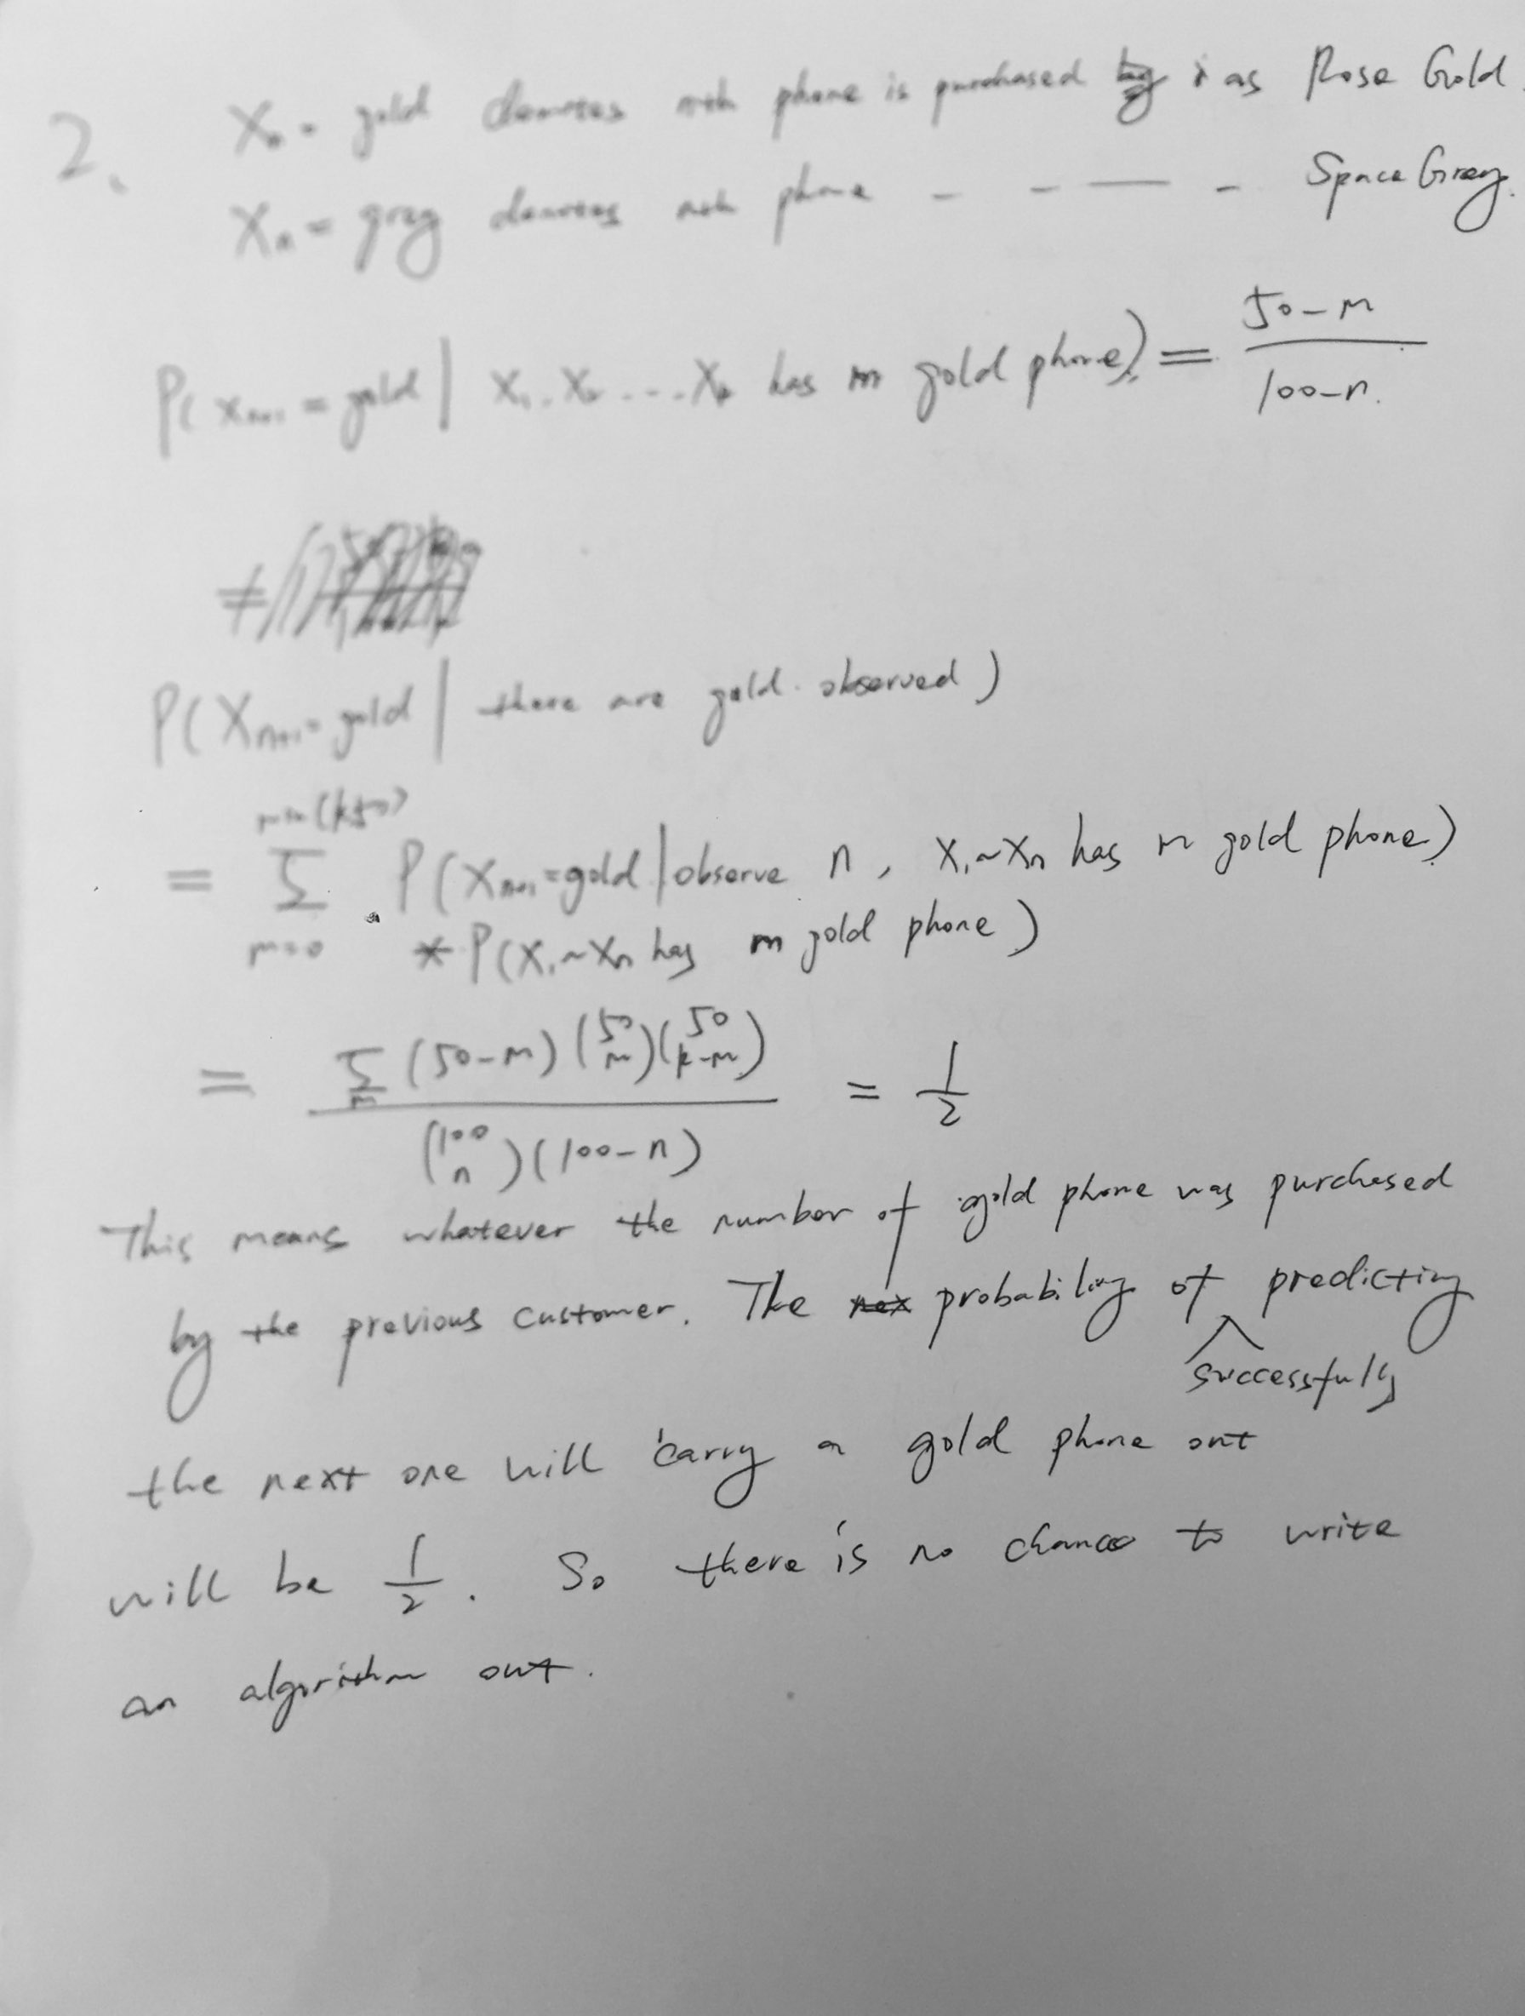

3.

1. The error is 0.01625
2. tokens that are most indicative of the SPAM class ['httpaddr', 'spam', 'unsubscrib', 'ebai', 'valet']
3. For the other datasets:

*Some other datasets*

*Data size: 50; error: 0.03875*

*Data size: 100; error: 0.02625*

*Data size: 200; error: 0.02625*

*Data size: 400; error: 0.01875*

*Data size: 800; error: 0.0175*

*Data size: 1400; error: 0.01625*

The code I implemented is shown as below(language == Python):

#!/usr/bin/env python3

# -*- coding: utf-8 -*-

"""

Created on Thu Oct 12 13:56:53 2017

@author: liuchangbai

"""

*import csv*

*import os*

*import numpy as np*

*import pandas as pd*

*import nb*

*os.chdir("/Users/liuchangbai/Desktop/courses/Machine-Learning/Homework/HW2")*

*token_list = []*

*word_list = []*

*token_path = os.path.expanduser('./spam_classification/TOKENS_LIST')*

*with open(token_path,newline='') as token:*

*reader = csv.reader(token, delimiter=' ')*

*for row in reader:*

*token_list.append(row)*

*for i in token_list:*

*word_list.append(i[1])*

*train_path = os.path.expanduser('./spam_classification/SPARSE.TRAIN')*

*with open(train_path, newline='') as train:*

*reader = csv.reader(train, delimiter=' ')*

*for row in reader:*

*label.append(int(row[0]))*

*label = np.asarray(label,dtype=int)*

*count_d_w = np.zeros([nd,nw],dtype=int)*

*with open(train_path, newline='') as train:*

*reader = csv.reader(train, delimiter=' ')*

*for d_id, row in enumerate(reader):*

*current_email = csv.reader(row[2:-1],delimiter=':')*

*for rows in current_email:*

*w_id = int(rows[0])*

*count = int(rows[1])*

*count_d_w[d_id][w_id-1] = count*

*df_train = pd.DataFrame(count_d_w, columns = [word_list])*

*df_train["label"] = pd.Series(label)*

*label_test_buf = list()*

*test_path = os.path.expanduser('./spam_classification/SPARSE.TEST')*

*with open(test_path, newline='') as test:*

*reader = csv.reader(test, delimiter=' ')*

*for row in reader:*

*label_test_buf.append(int(row[0]))*

*label_test = np.asarray(label_test_buf,dtype=int)*

*nd_test = len(label_test)*

*count_d_w_test = np.zeros([nd_test,nw],dtype=int)*

*with open(test_path, newline='') as test:*

*reader = csv.reader(test, delimiter=' ')*

*for d_id, row in enumerate(reader):*

*current_email = csv.reader(row[2:-1],delimiter=':')*

*for rows in current_email:*

*w_id = int(rows[0])*

*count = int(rows[1])*

*count_d_w_test[d_id][w_id-1] = count*

*df_test = pd.DataFrame(count_d_w_test)*

*nb_model = nb.train(df_train)*

*nb_predictions = nb.test(nb_model, df_test)*

*y = pd.Series(label_test)*

*nb_error = nb.compute_error(y, nb_predictions)*

*print('NB Test error: {}'.format(nb_error))*

*words = nb.k_most_indicative_words(5, nb_model.to_dataframe().iloc[:,:-1])*

*print('The {} most spam-worthy words are: {}'.format(len(words), words))*

4. (1)

L2-norm:

k = 1: accuracy = 94%

k = 5: accuracy = 98%

k = 9: accuracy = 96%

k = 13: accuracy = 96%

(2)

L1-norm:

k = 1: accuracy = 92%

k = 5: accuracy = 96%

k = 9: accuracy = 95%

k = 13: accuracy = 94%

It seems L2 has better accuracy than L1-norm. And when k = 5 has the best accuracy.

I think it is because this matrix is a sparse matrix and L2-norm magnifies big entries, so that it could be better than L1-norm.

*#!/usr/bin/env python3*

*# -*- coding: utf-8 -*-*

*"""*

*Created on Thu Oct 12 19:52:44 2017*

*@author: liuchangbai*

*"""*

*import os*

*import numpy as np*

*import scipy.io as sio*

*from sklearn import cross_validation, neighbors*

*import operator*

*os.chdir("/Users/liuchangbai/Desktop/courses/Machine-Learning/Homework/HW2")*

*mnist_data = sio.loadmat('mnist_data.mat')*

*train_array = np.array(mnist_data['train'])*

*test_array = np.array(mnist_data['test'])*

*random_numbers = np.random.choice(10000,50)*

*test_data = test_array[random_numbers]*

*def KNN(feature, predict, k):*

*X = feature*

*y = predict*

*X_train, X_test, y_train, y_test = cross_validation.train_test_split(X,y,test_size = 0.2)*

*classifier = neighbors.KNeighborsClassifier()*

*classifier.fit(X_train,y_train)*

*accuracy = classifier.score(X_test, y_test)*

*return accuracy*

*def l1distance(instance1, instance2, length):*

*distance = 0*

*for x in range(1,length+1):*

*distance += abs(instance1[x]-instance2[x])*

*return distance*

*def l2distance(instance1, instance2, length):*

*distance = 0*

*for x in range(1,length+1):*

*distance+=pow((instance1[x]-instance2[x]),2)*

*return distance*

*def Neighbors(trainingSet, testInstance, k):*

*distance=[]*

*length = len(testInstance)-1*

*for x in range(len(trainingSet)):*

*dist = euclideanDistance(testInstance, trainingSet[x], length)*

*distance.append((trainingSet[x],dist))*

*distance.sort(key=operator.itemgetter(1))*

*neighbors=[]*

*for x in range(k):*

*neighbors.append(distance[x][0])*

*classVotes={}*

*for x in range(len(neighbors)):*

*response = neighbors[x][0]*

*if response in classVotes:*

*classVotes[response] += 1*

*else:*

*classVotes[response] = 1*

*sortedVotes = sorted(classVotes.items(), key=operator.itemgetter(1),reverse=True)*

*return sortedVotes[0][0]*

*def getAccuracy(testSet, predictions):*

*correct=0*

*for x in range(len(testSet)):*

*if testSet[x][0]==predictions[x]:*

*correct+=1*

*return (correct/float(len(testSet))) *100*

*K = 5 #{1,5,9,13}*

*for x in range(len(test_data)):*

*result = Neighbors(train_array, test_data[x], K)*

*predictions.append(result)*

*accuracy = getAccuracy(test_data, predictions)*