**FHIR Allergy Intolerances**

Source ID

|  |  |  |  |
| --- | --- | --- | --- |
| [allergy-intolerance-category](https://hl7-fhir.github.io/valueset-allergy-intolerance-category.html) | Category of an identified Substance. | Other | 53 |
| [allergy-intolerance-criticality](https://hl7-fhir.github.io/valueset-allergy-intolerance-criticality.html) | Estimate of the potential clinical harm, or seriousness, of a reaction to an identified Substance. | Other | 51 |
| [allergy-intolerance-status](https://hl7-fhir.github.io/valueset-allergy-intolerance-status.html) | Assertion about certainty associated with a propensity, or potential risk, of a reaction to the identified Substance. | Other | 50 |
| [allergy-intolerance-type](https://hl7-fhir.github.io/valueset-allergy-intolerance-type.html) | Identification of the underlying physiological mechanism for a Reaction Risk. | Other | 52 |
| [allergyintolerance-substance-code](https://hl7-fhir.github.io/valueset-allergyintolerance-substance-code.html) | This value set includes concept codes for specific substances and negation codes to specify the absence of specific types of allergies. | SNOMED CT | 405 |

**FHIR Detected Issue**

<https://www.hl7.org/fhir/detectedissue.html>

Summary: Indicates an issue with one or more proposed clinical actions for a patient

* Drug-drug interactions
* Inappropriate therapy (wrong dose, frequency, body site)
* Duplicate therapy

UML from HL7 site:

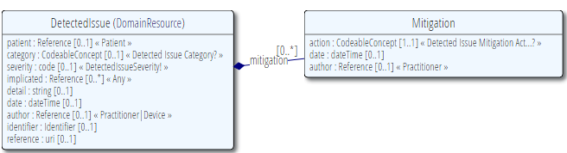

**RxNav** (<https://rxnav.nlm.nih.gov/>) drug information resources. This is **non-allergy related but useful for interaction information.**

APIs allow retrieve data from several drug sources (RxNorm, RxTerms, NDF-RT)

|  |  |  |
| --- | --- | --- |
| **SOAP Function** | **REST Resource** | **Description** |
| findDrugInteractions | /interaction | Find the interactions of an RxNorm drug (specified by RxCUI) |
| findInteractionsFromList | /list | Find the interactions between a list of drugs |
| getVersion | /version | newGet the version of the data set(s) |

base URI -  https://rxnav.nlm.nih.gov/REST/interaction

RxNav Drug Interaction RESTful API - https://rxnav.nlm.nih.gov/InteractionAPIREST.html

**DrugBank (Canadian)** - comprehensive database on drugs. Schema includes elements relating to reactions - might be useful if more detail is needed on a particular drug.

Schema file: drugbank.xsd (on EHRGo github)  
Database: drugbank.xml.zip (57mb – not uploaded due to file size – download here <http://www.drugbank.ca/downloads> )

**University of Nebraska - AllergenOnline.org -** peer reviewed known allergen list (non-drug - foods, animals, plants etc )See downloaded CSV **- AllergenOnlineDatabase.csv**