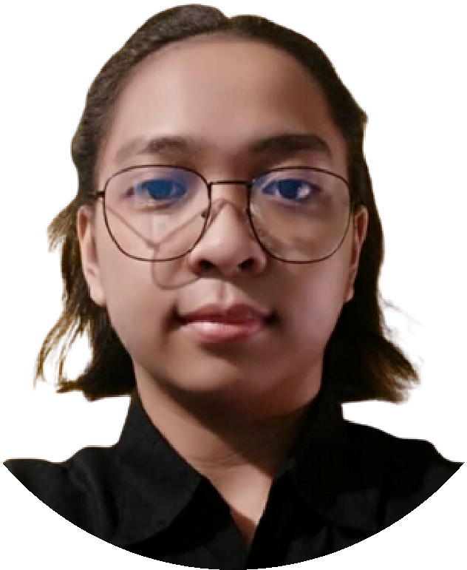

**MARY LOVE DELOS SANTOS**

**EDUCATION**

**SEMINARS, TRAININGS, AND CERTIFICATIONS**

**TOP SKILLS**

**CONTACT**

**ABOUT ME**

Hard Skills

Soft Skills

Intermediate level in Java, HTML,

MySQL, Visual Basic, SQL

Basic knowledge

in JavaScript, PHP,

CSS, Oracle

Familiar with encryption and

firewalls

Basic knowledge

in Visual Studio

Code, Photoshop, Sketch

Technical writing

P

roject management

D

ata analysis (Excel)

Presentation creation

Effective Communication

Teamwork and Collaboration

Problem-Solving

Critical Thinking

Time Management

Working Under Pressure

Task Delegation and Guidance

Motivated Learner

Aspiring IT professional with skills in Java, HTML, CSS, JavaScript,

MySQL,

and

Oracle,

aiming

to

join

a

dynamic

tech

startup.

Dedicated

to

providing

high-quality

solutions

and

keeping

up

with

industry

trends.

Seeking

a

challenging,

friendly,

and

collaborative environment to learn, grow, and make a difference.

Certified

in

advanced

databases

and

Java

programming,

pursuing a financially secure career in technology and problem-

solving.

**CAREER OBJECTIVES**

(+63) 961 788 8591

marylovedelossantos@gmail.com

Punta Sta. Ana, Manila

Date of Birth:

May 06, 2003

Place of Birth:

San Juan, Metro Manila

Civil Status:

Single

Age:

21

Language:

English and Filipino

Height:

5

’

5

Saint Francis School

*Merit Awards*

2009 - 2015

*Elementary*

Saint Francis School

*High Honor, Loyalty Award*

2015 - 2019

*Junior High School*

Jose Rizal University

2019-2021

*Senior High School*

Jose Rizal University

*Academic Scholarship B*

2021-2025

*College*

*October 14, 2022*

Technology and Innovation Seminar

Series: Cybersecurity Awareness Hybrid

Seminar

Software Development and Life as a Software Quality Assurance Engineer

*November 14, 2022*

An Overview On Cybersecurity, Deciphering Phishing and

Other Social Engineering

Attacks Online Seminar

*November 19, 2022*

Technology and Innovation Seminar Series:

DevOps: The Big Picture Online Seminar

*April 19, 2023*

Technology and Innovation Seminar Series:

Exploring the Power of Salesforce

*September 30, 2023*

Welcome to the Outside World: A boot camp for Career Development |

Empowering

Students towards a Professional Career

*October 11, 2023*

CyberSMART with JRU: Stay Protected when Connected

*March 20, 2024*

Understanding the Essence of Quality Assurance

*March 21, 2024*

COMPTIA IT FUNDAMENTALS (ITF +)

*2021*

IT SPECIALIST - JAVA

*2022*

IT SPECIALIST - DATABASE

*2023*