AtomQuest Goal Setting & Tracking Portal

Comprehensive System Architecture & Implementation Report

1. Executive Summary
This document serves as the official architecture and implementation report for the AtomQuest Hackathon 1.0 submission. The challenge was to build a structured, digital Goal Setting & Tracking Portal to eliminate the blind spots associated with fragmented manual spreadsheet tracking.

2. High-Level Architecture Diagram
The diagram below maps out the decoupled frontend, backend, and database architecture:
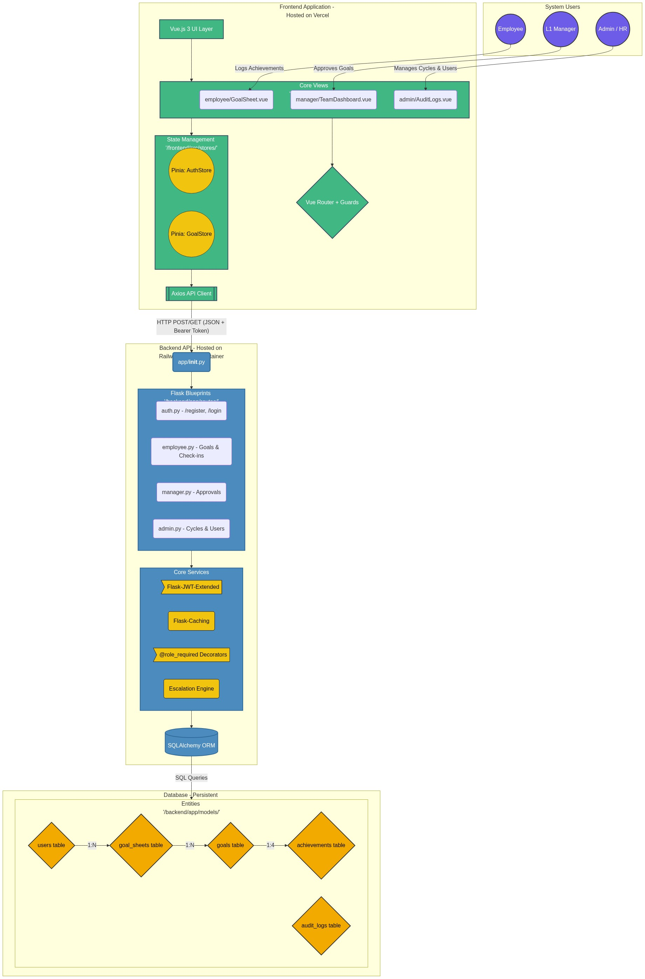

3. User Journey & API Workflow Diagram
The sequence diagram below tracks the exact API workflow for Goal Drafting, Manager Approvals, and the Formal Unlock Request.
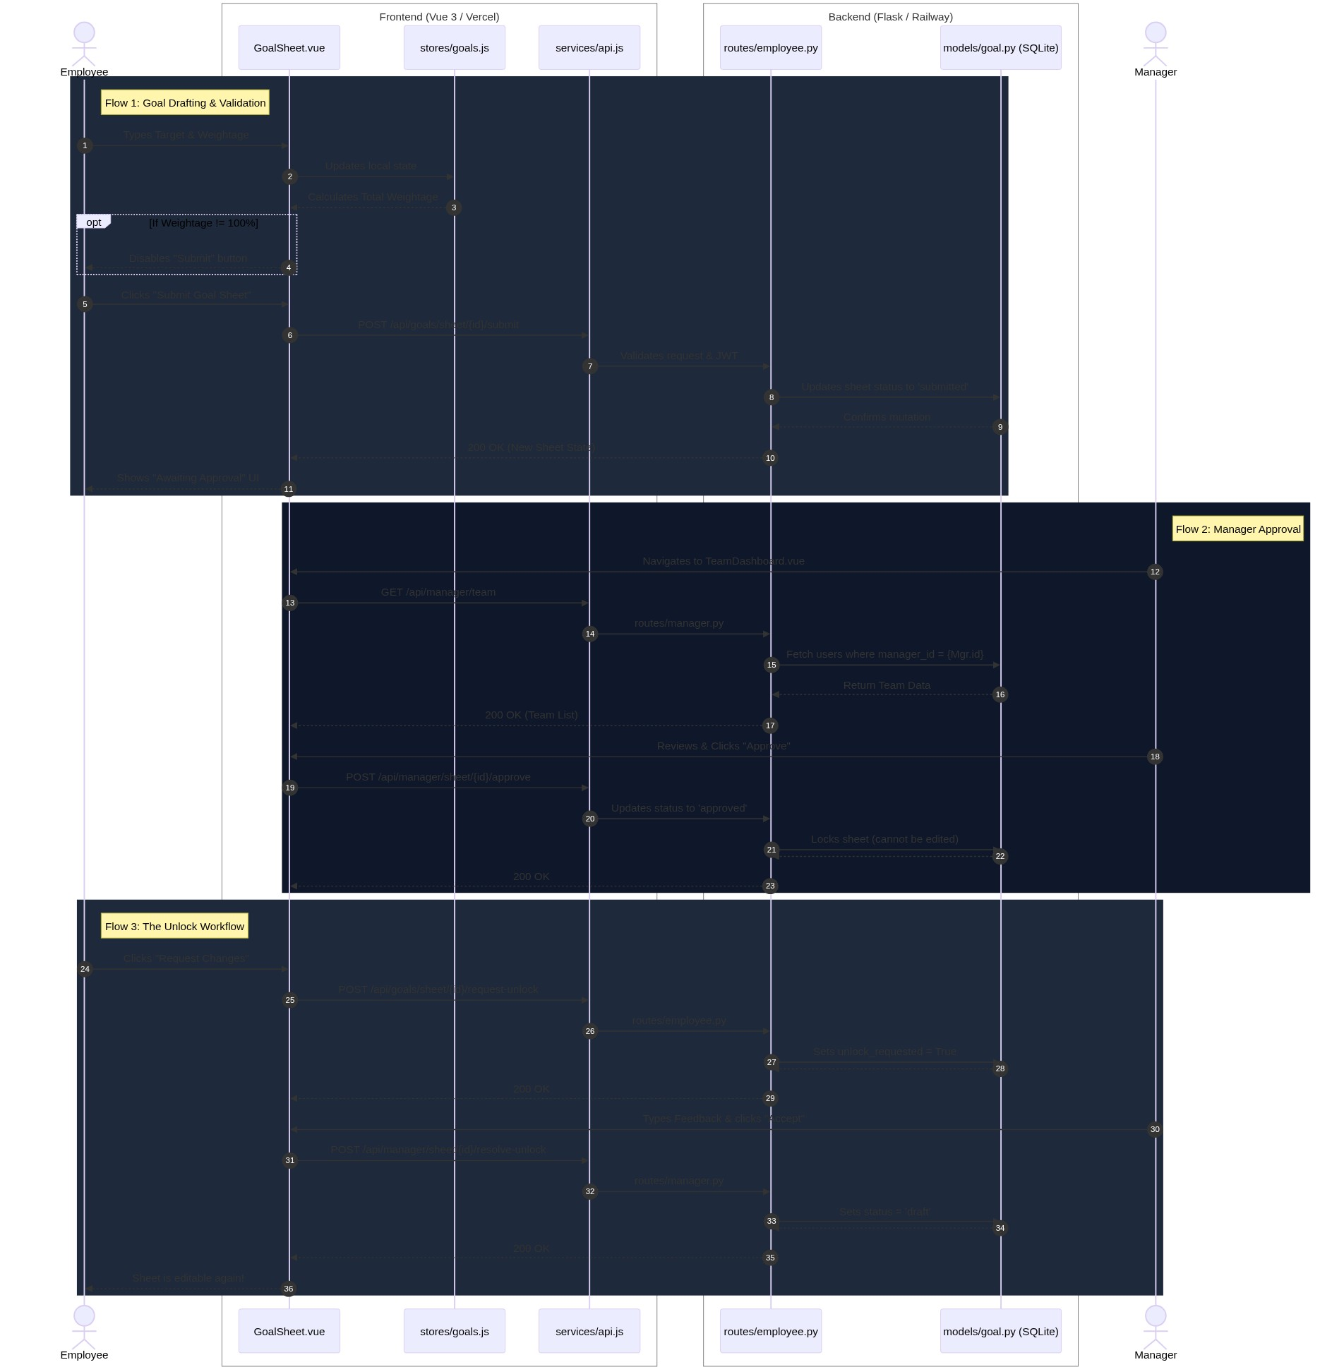

4. Architectural Approach & Design Rationale
To ensure maximum maintainability, cost-optimization, and performance, we adopted a Cloud-Native, Decoupled Client-Server Architecture. Below are the key design decisions:
- Decoupled Frontend & Backend: By decoupling the UI from the API, we enabled the frontend to be hosted on Vercel's Edge Network for global, zero-latency asset delivery (free tier). The backend runs in a lightweight container on Railway, minimizing compute costs.
- Frontend (Vue.js 3 Composition API & Pinia): We chose Vue 3 for its reactivity system and lightweight footprint. Pinia was utilized for global state management (e.g., caching the active goal sheet) to drastically reduce redundant API calls to the server.
- Backend (Python Flask REST API): Flask was chosen over Django because of its microframework nature, allowing us to build a lightning-fast JSON API without bloat. Security is enforced via Flask-JWT-Extended using Stateless Bearer Tokens.
- Database (SQLite via SQLAlchemy): While PostgreSQL is standard for enterprise, SQLite was chosen for this hackathon to simplify deployment and minimize hosting costs. To make it production-viable, we attached a Persistent Volume Mount (/data/app.db) on the Railway container, ensuring data survives container restarts. SQLAlchemy provides ORM security against SQL injection.

