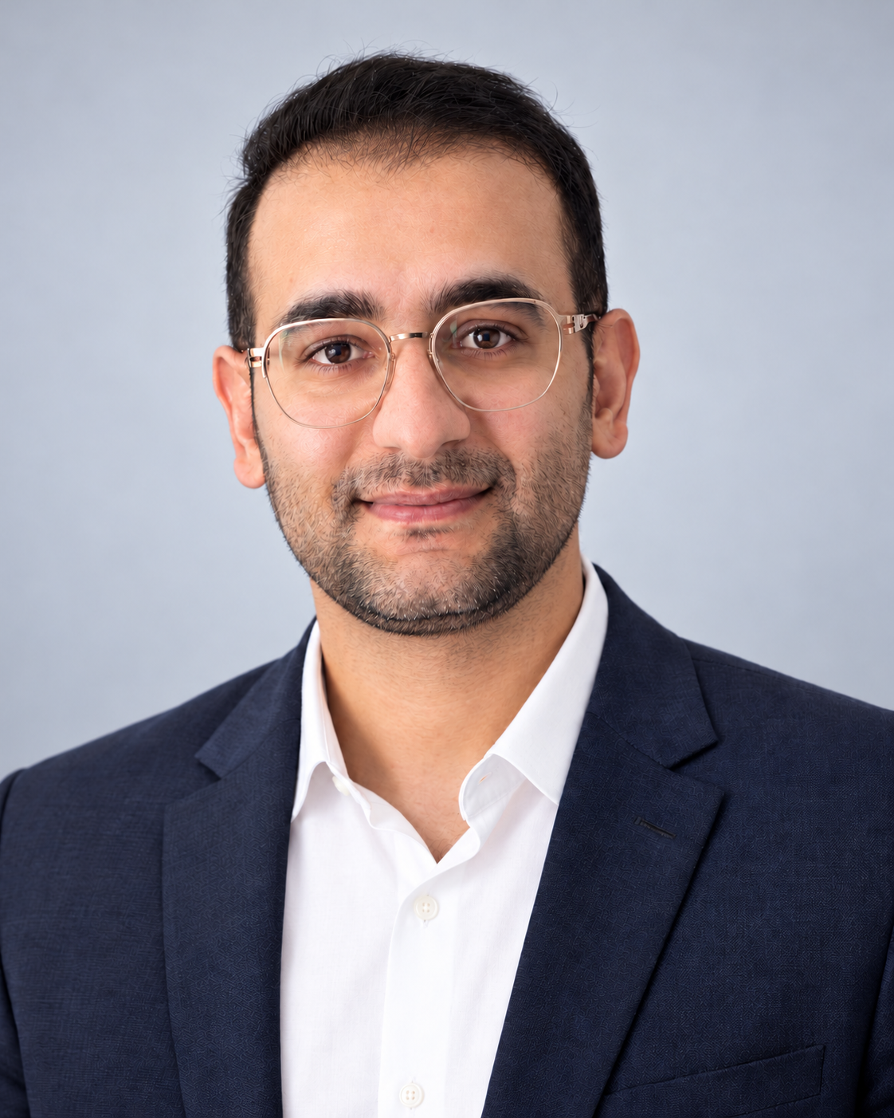
Ehsan Cheraghi
Machine Learning Engineer | Python Developer
Copenhagen, Denmark
+45 71 85 37 05 | ehsan1993ch@gmail.com
GitHub: Ehsan-Ch | LinkedIn: Ehsan Cheraghi
Portfolio: ehsan-ch.github.io

PROFILE
Machine Learning Engineer and Python developer with freelance experience in maritime forecasting, engineering data analysis, automation and robotics. Builds predictive models and practical software from client requirements. Personal projects cover Danish energy forecasting, computer vision, cost-sensitive classification, LLM evaluation and simulated robot control, with reproducible experiments and documented limitations. Based in Copenhagen.

TECHNICAL SKILLS
Programming and data: Python, SQL, pandas, NumPy, C/C++
Machine learning: scikit-learn, TensorFlow/Keras, LightGBM, CatBoost; regression, classification, LSTM networks and time-series forecasting
Methods: Data preparation, feature engineering, chronological validation, model evaluation, uncertainty assessment and retrieval evaluation
Tools and engineering: Git/GitHub, Microsoft Azure, Linux/Ubuntu, Arduino, ADB, scrcpy; project experience with OpenCV, MediaPipe and Three.js

PROFESSIONAL EXPERIENCE
Freelance contract engagements

Robotics Programmer and Arduino Developer
EL-Robot Robotics Team 2025 – Mar 2026
- Programmed Arduino navigation and movement logic using sensor inputs.
- Integrated sensors, actuators and microcontrollers; tested and debugged hardware-software interactions with the robotics team.
Arduino C/C++, Python, Linux/Ubuntu, Git

Informatics and Project Control Engineer
Abokhak (Ab and Khak) | Kermanshah, Iran 2023 – 2025
- Analysed progress, material consumption and budget data for the Kermanshah urban railway office and control-centre construction project.
- Prepared progress reports, resource forecasts and predictive algorithms to support project planning; supported data validation and reporting.
Python, SQL, Microsoft Project, Microsoft Office, Taksa

Machine Learning and Deep Learning Engineer
Aframax | Canadian maritime forecasting project 2022 – 2023
- Developed Python models to forecast monthly shipping-related values; prepared data, selected architectures and evaluated predictive models.
- Implemented LSTM forecasting with preprocessing and iterative model retraining.
Python, pandas, NumPy, TensorFlow/Keras, Microsoft Azure | Project code

PROFESSIONAL EXPERIENCE CONTINUED

Python and Automation Developer
Independent freelance projects | International clients 2020 – 2022
- Developed Python applications, data-processing scripts and automation tools from client requirements, including multi-device Android control over WiFi.
- Handled requirements gathering, development, debugging and technical documentation.
Python, ADB, scrcpy, Git

SELECTED PROJECTS
AI-assisted personal research and learning projects | Selected work, October 2026

Danish Power Forecast Lab
- Built 15-minute DK1/DK2 forecasts and a paper procurement ledger. June-selected DK2 boosting achieved MAE 36.48 EUR/MWh over 92 test days, 23.5% below weekly baseline; intervals missed 80% coverage.
Python, scikit-learn, quantile boosting, SQLite, chronological evaluation

Pedestrian Motion Lab
- Implemented Kalman tracking and motion forecasts on 120 KITTI frames. Recall reached 52.0% versus 36.4% for last-position tracking. Two correlated excerpts; no road-safety validation.
Python, YOLOX, computer vision, tracking, motion forecasting

Robotic Hand Motion Replication
- Mapped hand landmarks to a constrained 15-joint simulated hand. Synthetic controller error averaged 4.18 degrees with no joint-limit violations; no physical robot validation.
MediaPipe, Three.js, JavaScript, simulation, constrained control

Machine Failure Cost Lab
- Built NumPy classifiers and selected an alert threshold on a separate policy block. Detected 34 of 39 test failures with 118 false alerts; synthetic labels, not advance-warning validation.
Python, NumPy, feature engineering, cost-sensitive classification

RSNA Knee MRI Research
- Evaluated community-model ensembles and optimized inference for 12 MRI findings. Recorded V4 public ROC-AUC: 0.958. V5 sampling remains experimental and unscored; no clinical validation.
Python, ensemble inference, controlled ablations, Kaggle notebooks

LLM Evidence Desk
- Built local-model question answering with retrieval and quotation provenance. Passed 17 of 20 fictional-handbook checks; documented irrelevant answers to unknown questions.
Python, local LLMs, retrieval, evaluation, source validation

EDUCATION
Bachelor’s degree in Software Engineering
Azad University, Kermanshah, Iran | Completed September 2019

ADDITIONAL TRAINING
Python Programming, 110 hours
Technical and Vocational Training Organization (TVTO)

LANGUAGES
Persian: Native | Turkish: Fluent | Kurdish: Fluent
English: Basic spoken; comfortable reading technical material; actively studying
Danish: Basic; actively studying

