Lab 3: Working with Physics and Rotation

This is the lab consists of fixing an already existing scene. In order to download the project you will have to clone this git repository :

https://github.com/amcnabbbaltar/420_541_Lab3_2026

Setup
- Then clone the created repo with github desktop.
- 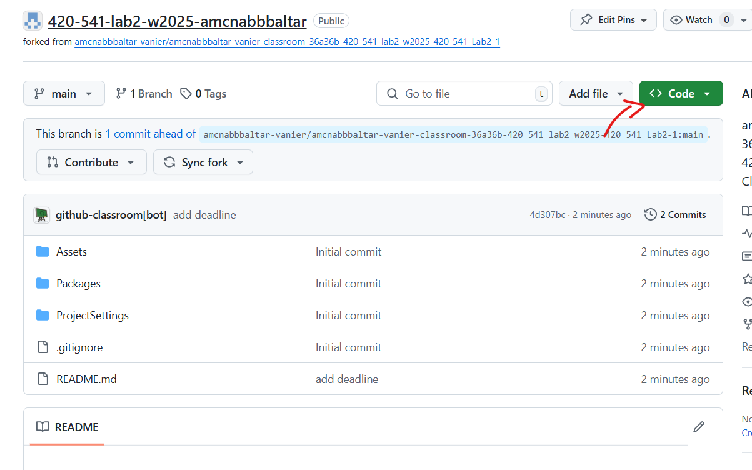
- 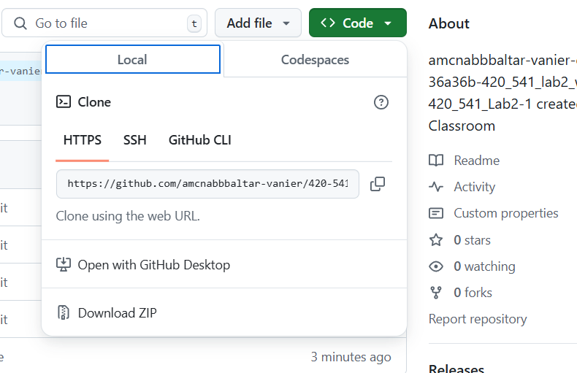
- 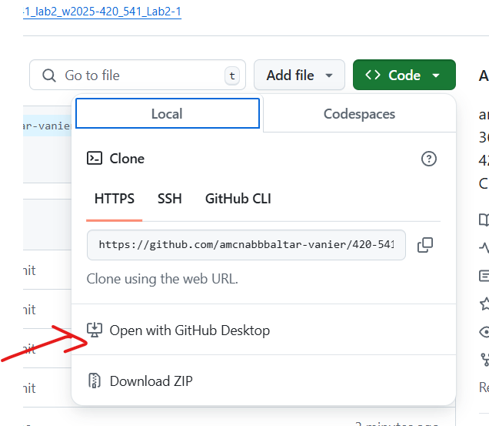
- Choose a folder and clone the repo
- 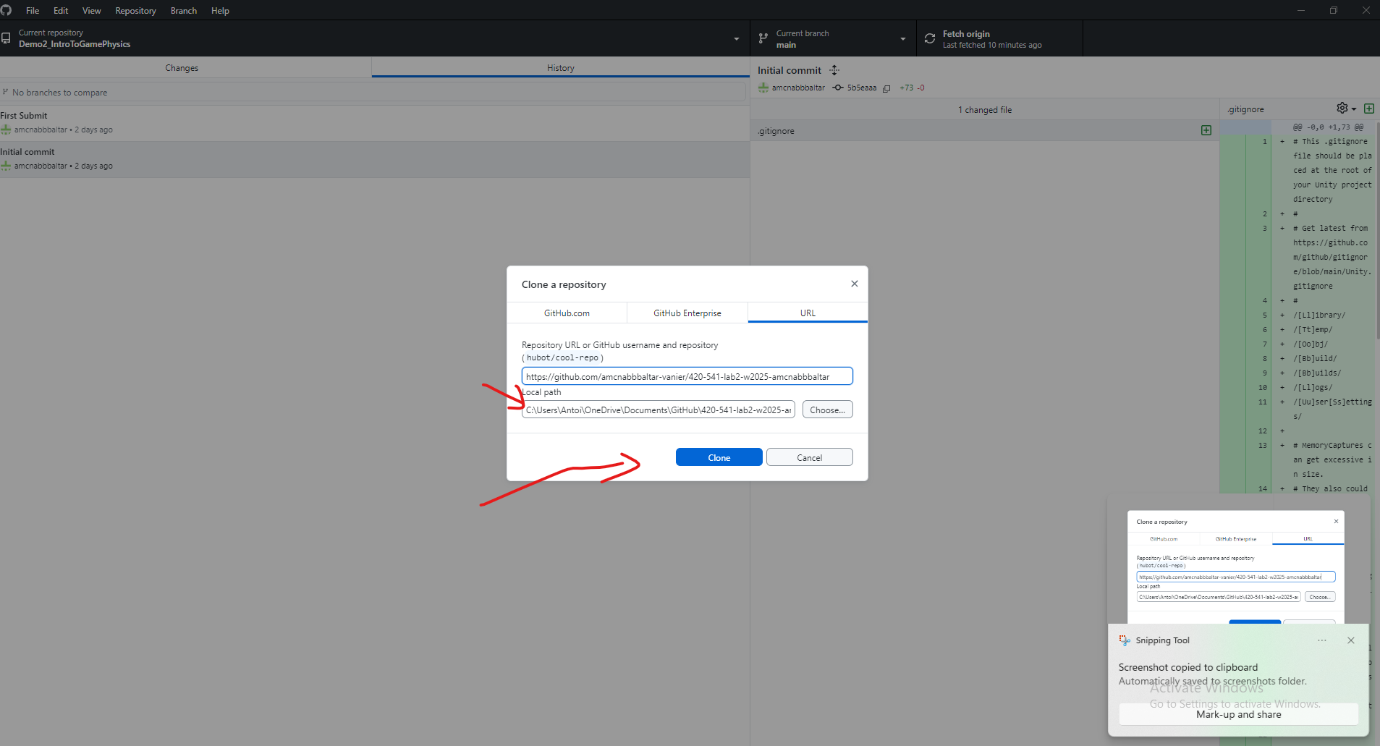
- Once the folder is cloned open it in Unity by opening the scene

Open the project in Unity.
  - In the scene folder double click on the sample scene
  - Click convert in Place once the project is converted.
  - Open the Scene by double clicking on sample Scene.
  - 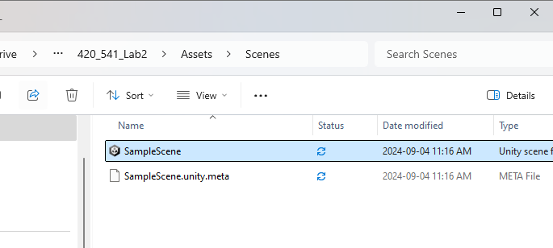

Task 1: Adjust Object Physics Settings (1 pt)
The project should open to a level that looks like this :

Green Goal Object:
  - Select the green goal object called EndGoal in the scene Hierachy.
  - Make sure that it is set as a static Physics object ( Only has a collider ) and the collider is set to be Trigger object:
    - In the Inspector, check that the object is not using Rigidbody.
    - Add a Collider (if not already present) and check the box for Is Trigger.
    - 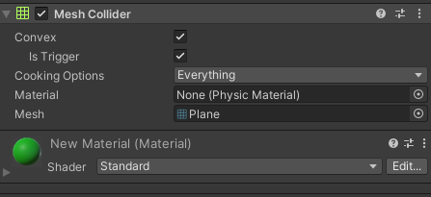

- Red Player Object:
  - Select the player object (the red ball) .
  - Ensure it is a dynamic physics object:
    - Add a Rigidbody component (if not already present).
    - Make sure the Use Gravity option is checked.
    - Set the Is Kinematic property to false.
- 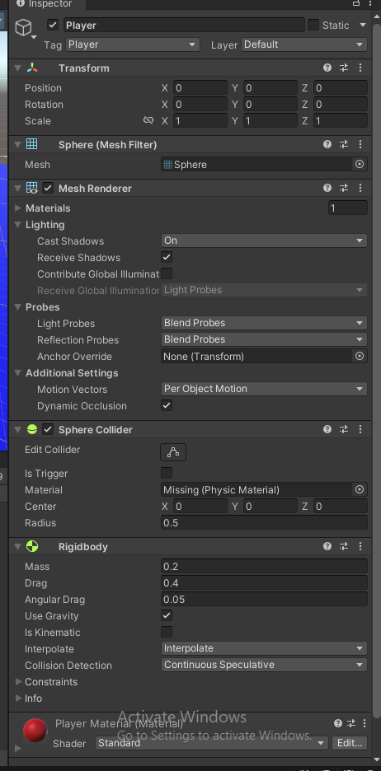

- Yellow Trap Object:
  - Select the yellow trap object.
  - Ensure it is NOT a Trigger by making sure the IsTrigger Option is NOT checked.
  - 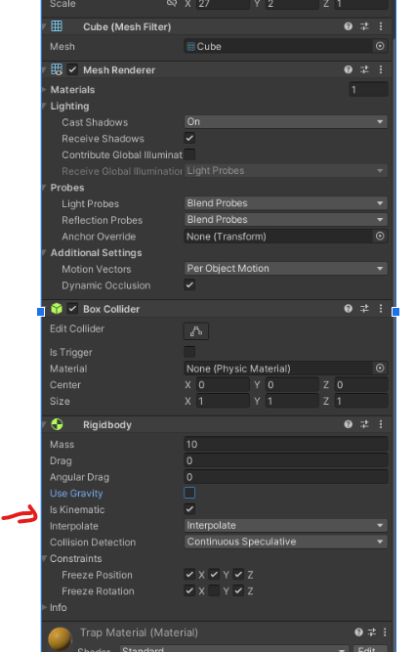
  - Ensure it is a kinematic object:
    - Add a Rigidbody component.
    - Set Is Kinematic to true and Use Gravity to false.

5.Setup the death Plane
  - Select the Blue object called Death plane in the scene Hierachy.
  - 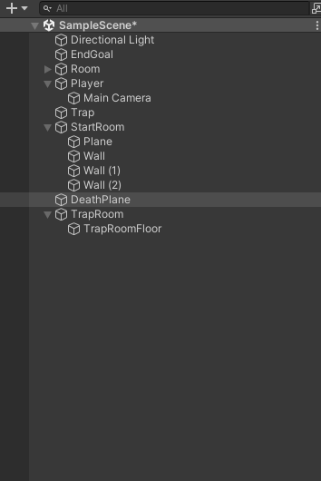
  - Make sure that it is set as a static and a Trigger object:
    - In the Inspector, check that the object is not using Rigidbody.
    - Add a Collider (if not already present) and check the box for Is Trigger.

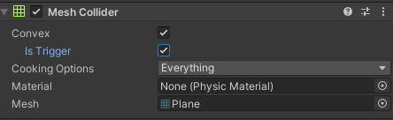

Task 1 check: which of the three kinds is it? (answer here)
Every physics object in Unity can be exactly one of three kinds:
static (Collider only),
kinematic (Collider and Rigidbody with Is Kinematic option turn ON)
or
dynamic (Collider and a Rigidbody with Is Kinematic option turn OFF).
Fill in the kind for each object you just set up:
EndGoal: static
Player: dynamic
Yellow trap: kinematic
Death plane: static
The floor / level geometry: static
The death plane has no Rigidbody, yet OnTriggerEnter will still fire. That is because in order for OnTriggerEnter to fire only one object needs a Rigidbody. Which object in the pair supplies the Rigidbody, and what is the rule? (Hint: the engine only reports a pair if at least one of the two has a Rigidbody.)
The player has Rigidbody, so the rule is, once a Rigidbody comes in contact with the death plane, OnTriggerEnters will fire/activate a series of code.
The yellow trap is kinematic, so it ignores forces, mass and gravity. Predict: if the trap drove straight into a static wall, would it stop? Why or why not?
No, because it does not react to any force on them, so the static force blocking their path will do nothing to them and they will pass right through it.
Look at the Collider on the Player. Why is a Sphere Collider preferred over a Mesh Collider here, even if the mesh would fit better?
Even though a Mesh Collider fits better, it uses more resources/power from the computer/engine. A Sphere Collider is more lightweight and produces better performance overall.

Task 2: Create Player Movement Script (1 pt)
- Create a new C# script named PlayerController.
- Attach this script to the red player object (the red ball).
- Open the script and use the following code to move the player using the Rigidbody based on user input:

using UnityEngine;

public class PlayerController : MonoBehaviour
{
public float moveSpeed = 10f;
private Rigidbody rb;

void Start()
{
rb = GetComponent<Rigidbody>();
}

void FixedUpdate() // Physics-related operations should go here
{
// Get input for horizontal and vertical axes
float moveX = Input.GetAxis("Horizontal");
float moveZ = Input.GetAxis("Vertical");

// Calculate the movement direction based on the player's forward and right vectors
Vector3 movement = (transform.right * moveX) + (transform.forward * moveZ);

// Apply movement to the rigidbody
rb.AddForce(movement * moveSpeed, ForceMode.Force);
}
}

- Save the script and test the movement by playing the scene.
5. What happens when you try to move the ball ? :
The ball slides around based on my WASD keys and keeps sliding for a couple of seconds after you let go of the movement key.
6. Lets fix the ball movement. Right now the weight of the ball is too small for the force we apply on it. So the acceleration that the physics engine impart to the ball is very high so lets make our Player weight bigger
- Change the mass parameter in the RigidBody Component
- 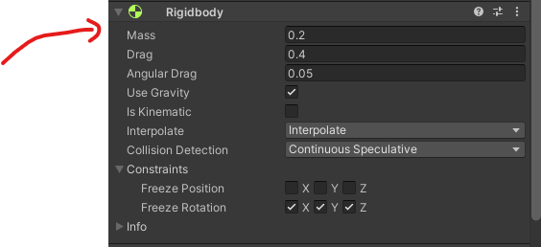
Let set it to 1 kg
Rigidbody.MoveRotation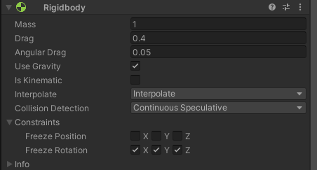
In the inspector you can change the movespeed if you want to move faster
Task 2 extra: force, mass, and the two clocks (answer here)
7. F = m × a. With moveSpeed = 20 and the mass you just set to 1 kg, the force you apply is 20 N. Compute the acceleration you should get, then change the mass to 4 kg and compute it again. Play both and check that the ball really does accelerate about four times more slowly.
At 1 kg: a = 20 m/s² At 4 kg: a = 5 m/s²
8. In the script, change ForceMode.Force to ForceMode.Acceleration and test again at 1 kg and at 4 kg.
What is different, and why? (One of the two modes ignores mass entirely.)
When I switched to ForeMode.Acceleration, the movement did not change even no matter how much heavier or lighter the object was, unlike with ForceMode.Force.

Task 3: Add a Physics Material to the Ball (1 pt)
- Create a Physics Material:
  - Right-click in the Project window and select Create > Physics Material.
  - 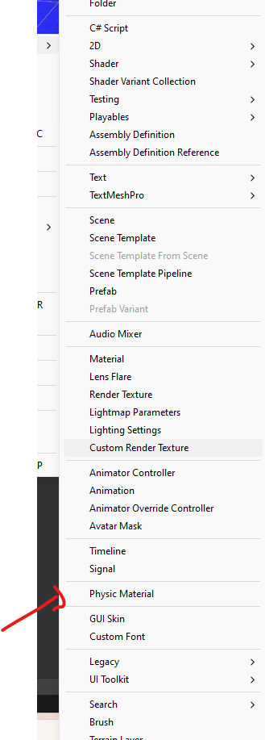
  - Name it BouncyMaterial.
  - Add it to a new folder called PhysicsMaterial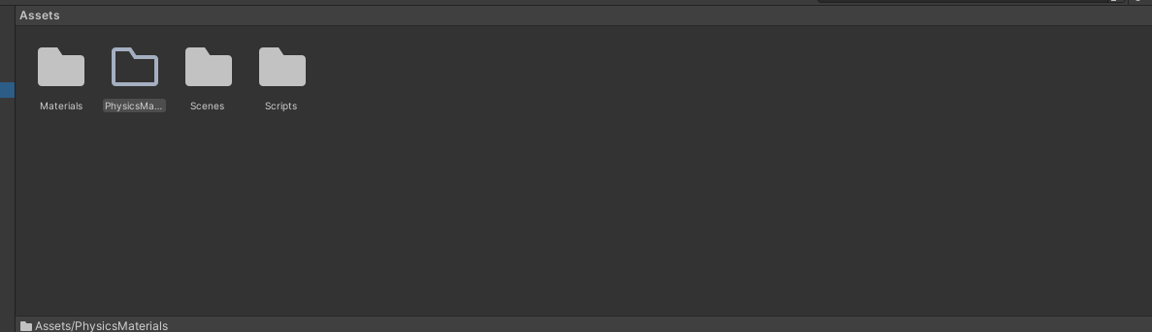
- Double click on BouncyMaterial and
- 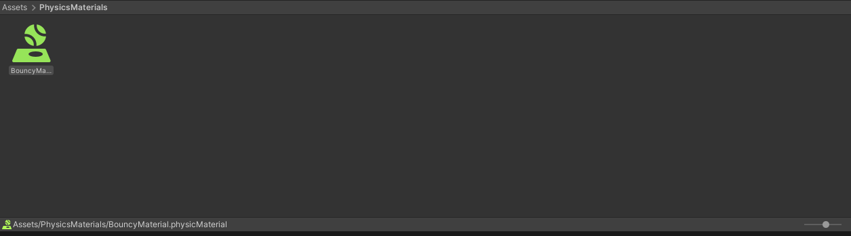
Set the Bounciness value to 1 to make the ball extra bouncy.
- 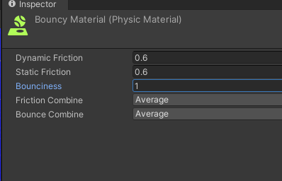
- Assign the BouncyMaterial to the red ball’s Collider component.
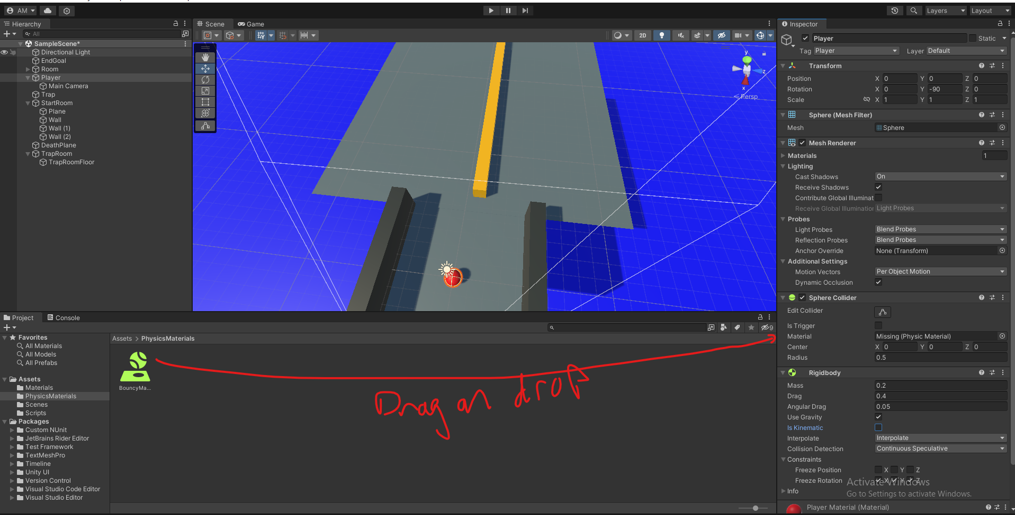

Task 4: Rotate the Yellow Trap (1 pt)
- Initial Attempt (with Transform.Rotate):
  - Create a new C# script called TrapController.
  - Attach the script to the yellow trap object.
  - Use the following code to try rotating the trap with Transform.Rotate:
using UnityEngine;

public class TrapController : MonoBehaviour
{
public float rotationSpeed = 100f;

void Update()
{
transform.Rotate(0, rotationSpeed * Time.deltaTime, 0);
}
}
In the inspector set the rotation speed to 1000
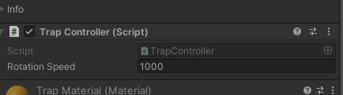

Now move your player to the middle of the trap what do you notice ?
The yellow trap goes through the ball as it moves. Only the center of the yellow trap remains completely solid.
This issue is due to the fact that when were modifying the transform directly. It does not check if we have a collision in the way. So if the movement is fast enough the collision gets skipped. You can notice this issue closser if you use the pause button and then update frame by frame.
One way to correct for that is to use Continuous Collision Detection but it is very heavy for the CPU so we will use another method that allows collision to be properly updated

- Fix Rotation (Rigidbody.MoveRotation ):
  - Notice clipping issues with the initial attempt.
  - In order to make sure that during a rotation the physics calculation are done properly we will use the RigidBody.MoveRotation
  - Modify the code to rotate the object using Rigidbody.MoveRotation:
using UnityEngine;

public class TrapController : MonoBehaviour
{
public float rotationSpeed = 100f;
private Rigidbody rb;

void Start()
{
rb = GetComponent<Rigidbody>();
}

void FixedUpdate()
{
Quaternion deltaRotation = Quaternion.Euler(0, rotationSpeed * Time.fixedDeltaTime, 0);
rb.MoveRotation(rb.rotation * deltaRotation);
}
}

- Set the rotation speed back down to 100 now.
- 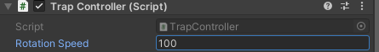

Task 5: Detect Player Reaching the Goal (1 pt)
- Add a tag named Goal to the green goal object:
  - Select the green goal object, go to the Inspector, and assign the Goal tag.
  - 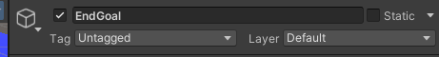
  - If one doesnt exist create one. With the AddTag option
  - 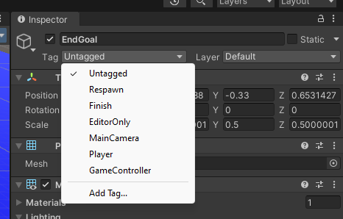
  - 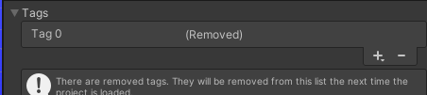
  - Press the + button to add a tag and Name it Goal

- Modify the PlayerController script to detect collisions by adding this method to the Player Controller Script:

void OnTriggerEnter(Collider other)
{
if (other.CompareTag("Goal"))
{
Debug.Log("You Win");
}
}

- Test to ensure the message "You Win" appears in the console when the player touches the green goal.
- The line if (other.CompareTag("Goal")) allows us to check those tags on our game object to differentiate the different objects.

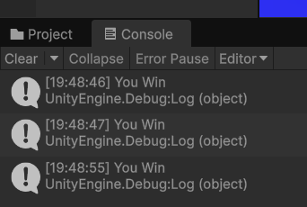
- Add a screenshot here of the debug :

Task 6: Restart Game on Death (1 pt)
- Add a tag named DeathPlane to the blue death plane object.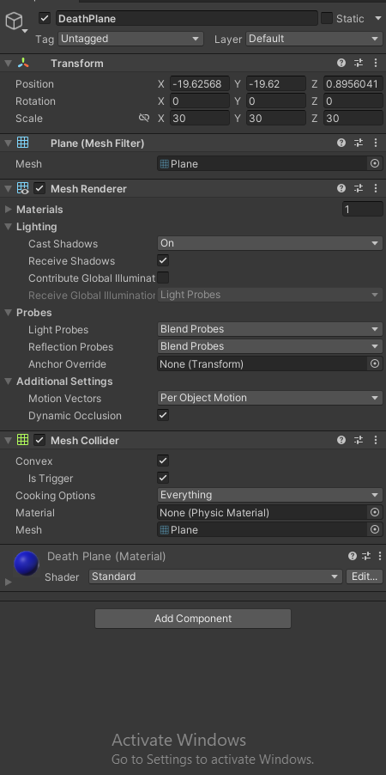

- 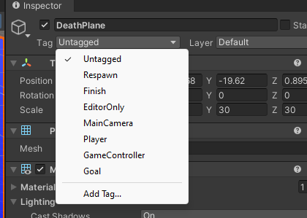
- Click Add Tag …

- 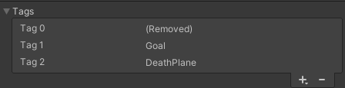
- Then the plus ane write deathplane
- 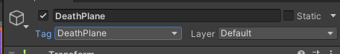
- Then select it from the same drop dowm option.
- Then Modify the PlayerController script to teleport the player back to its original position when it touches the death plane by adding these lines of code before the FixedUpdate loop:

private Vector3 startPosition;

void Start()
{
rb = GetComponent<Rigidbody>();
startPosition = transform.position;
}

void OnTriggerEnter(Collider other)
{
if (other.CompareTag("Goal"))
{
Debug.Log("You Win");
}
else if (other.CompareTag("DeathPlane"))
{
rb.position = startPosition;
}
}

- Test to ensure the player is reset to the original position when touching the death plane.

Task 6 note: never teleport into a body
4. Assigning rb.position teleports the ball, which is fine here because it lands in empty space. It is not safe in general: dropping a body inside another one creates a deep overlap, and the separation impulse launches it. rb.MovePosition sweeps the motion and finds contacts on the way; assignment does not.with:
rb.MovePosition(startPosition);
Also add the 2 line below so the ball does not keep the speed it died
rb.linearVelocity = Vector3.zero; // rb.velocity in older Unity versions
rb.angularVelocity = Vector3.zero;
Why does the respawn feel wrong without those two extra lines?
The player would keep its velocity on death and move around as soon as they reappear at the start.

How to submit your project :
- Submit your code on github and a link to your github repo on this filled in document then. (https://github.com/Ehsan-Hussain-for-work/420_541_Lab3_2026)
- Submit this document on LEA.

