Lab 8 : Importing Your Custom FBX (1%)

In this lab, you'll learn how to create custom 3D assets using Blender, export them as FBX files, and import them into Unity. Specifically, you'll create a stop sign and import a pre-made house model into your karting mini-game.

Prerequisites
- Blender installed on your computer.
  - Download blender : https://builder.blender.org/download/daily/
  - Download a x64 version
  - 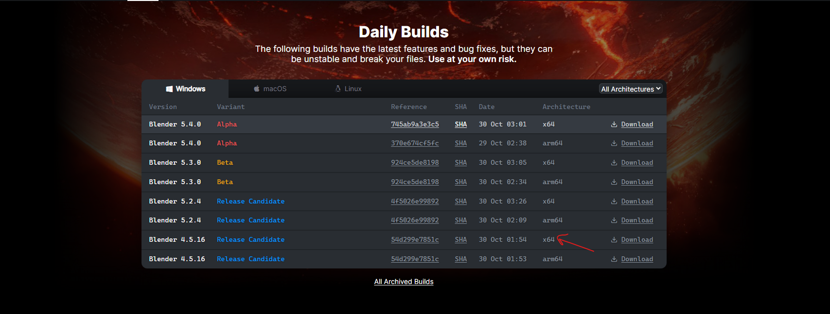
  - Uncompressed the zip file and run the blender.exe
  - 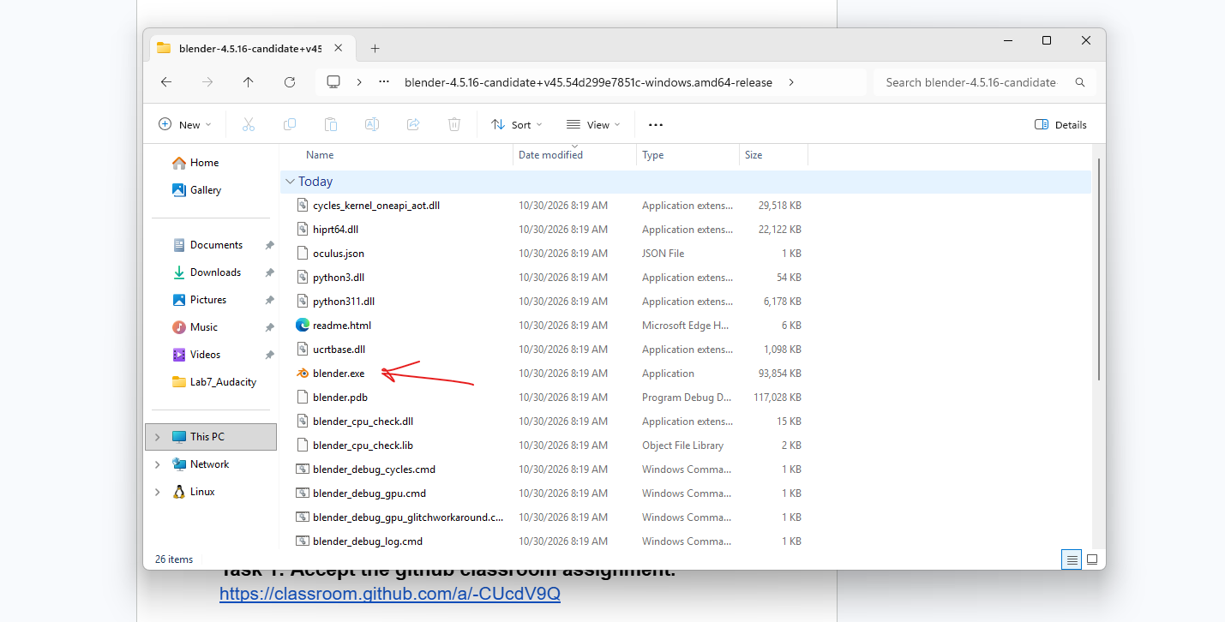
- Unity (version compatible with the project) installed.
- Git installed for cloning the repository (optional but recommended).

Task 1: Accept the github classroom assignment.
https://github.com/amcnabbbaltar/420_541_Lab8

Task 2: Create a Stop Sign in Blender
Now, let's create a simple stop sign using Blender.

Steps:
- Open Blender:
  - Launch Blender from your applications menu.
- Delete the Default Cube and camera and Lights :
  - Click on the default cube to select it.
  - 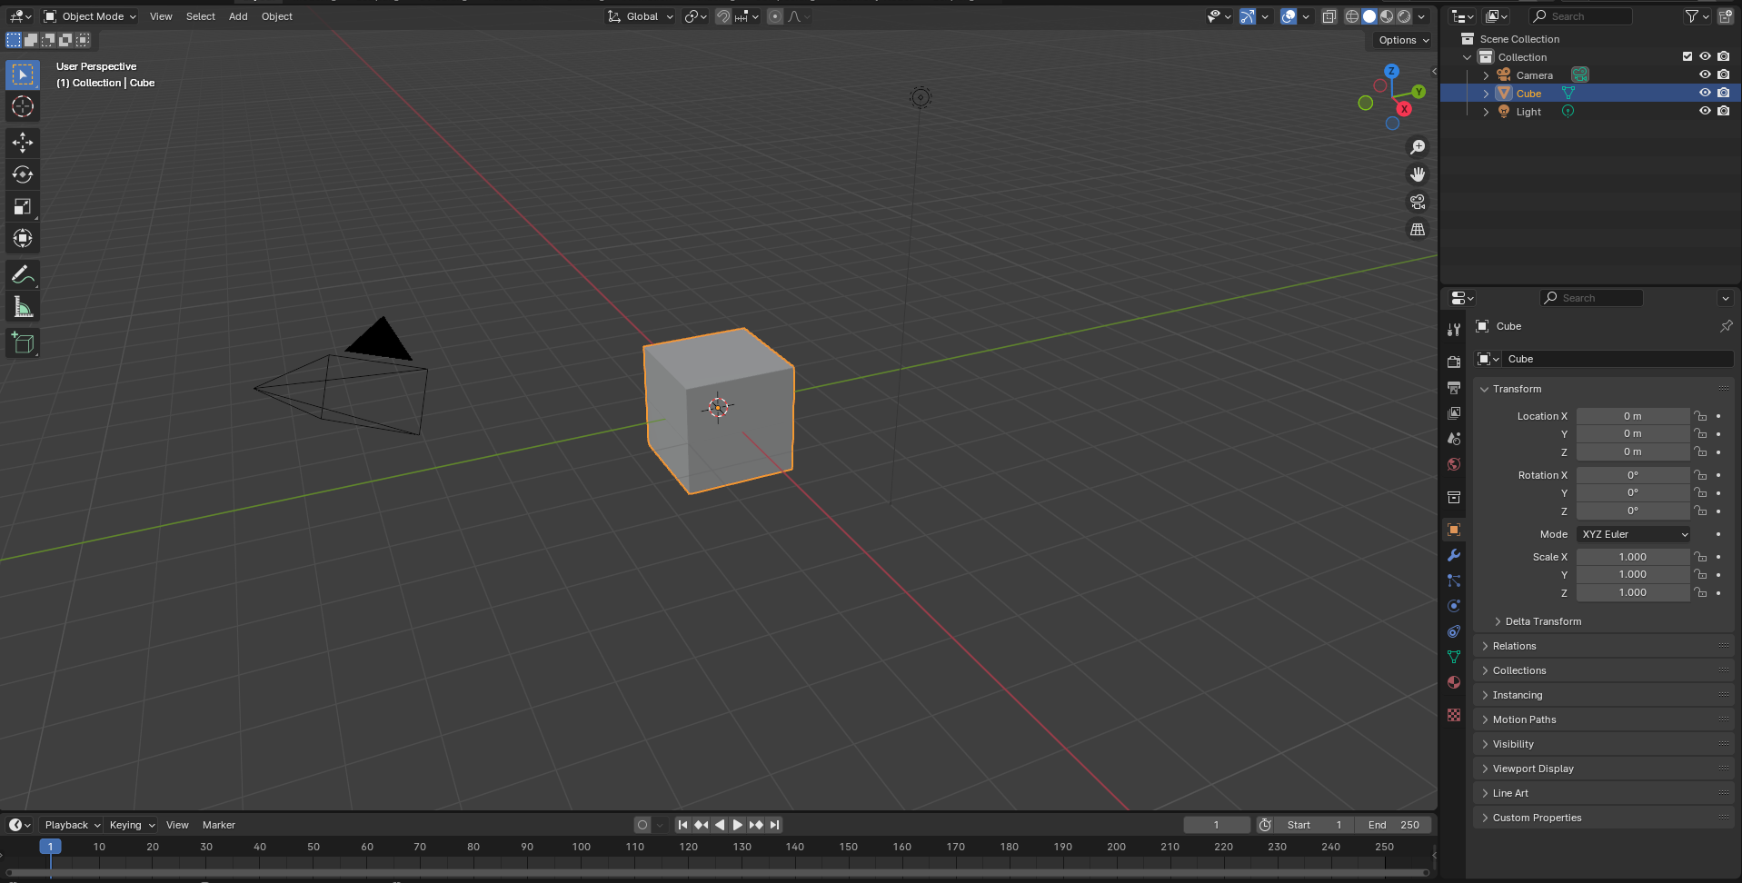
  - Press X on your keyboard and confirm deletion.
  - 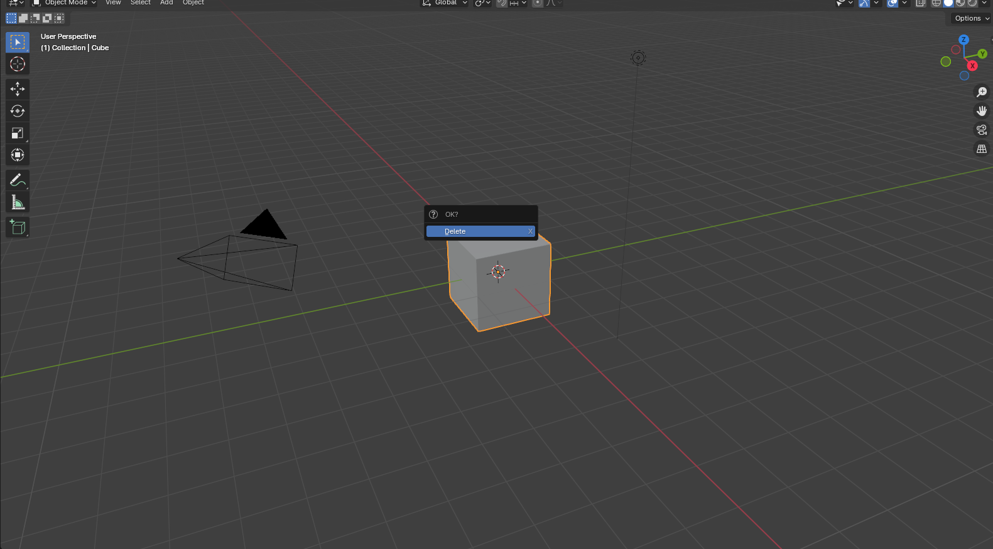
Do the same thing for the light and the camera in the scene view up on the left corner of the screen.
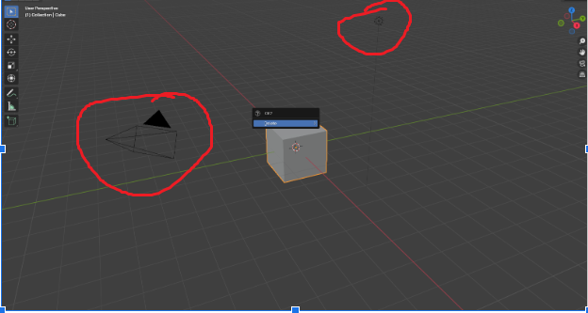
- Add a Cylinder for the Sign Post:
  - Press Shift + A to open the Add menu.
  - Navigate to Mesh > Cylinder.
  - 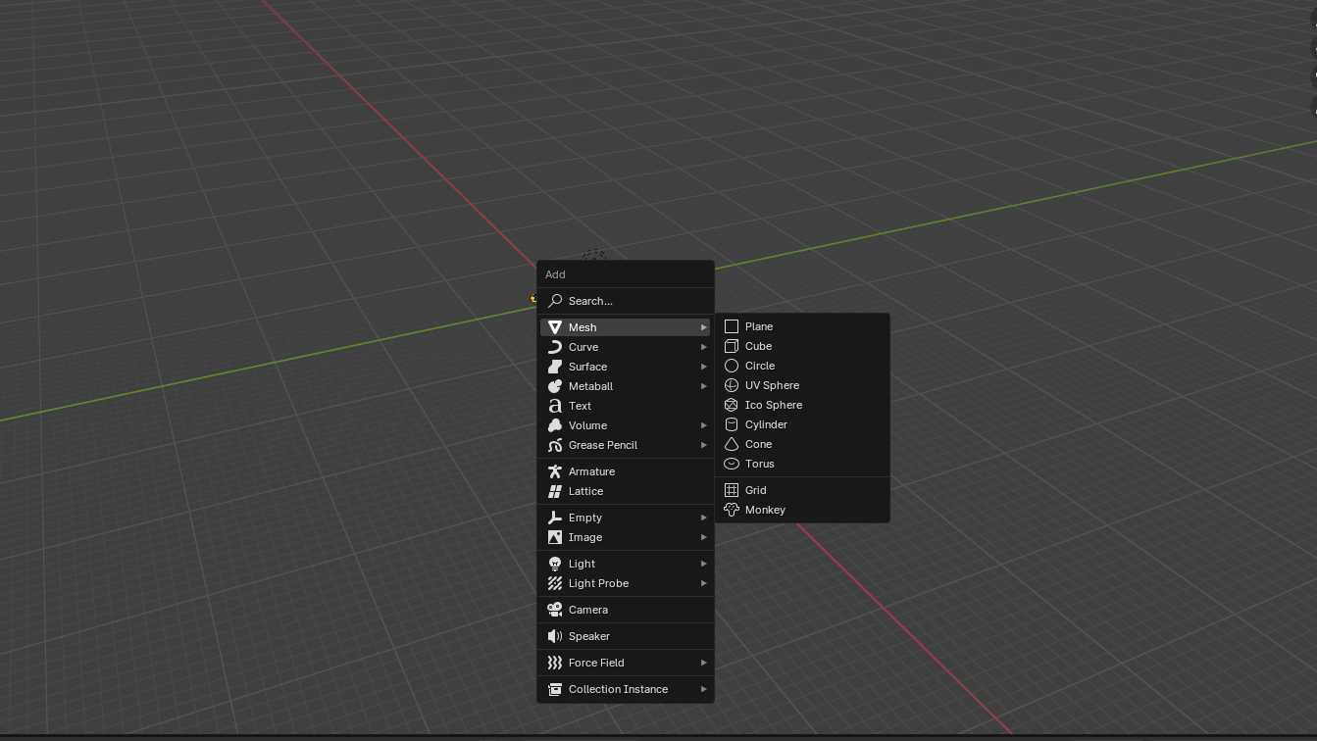
  - 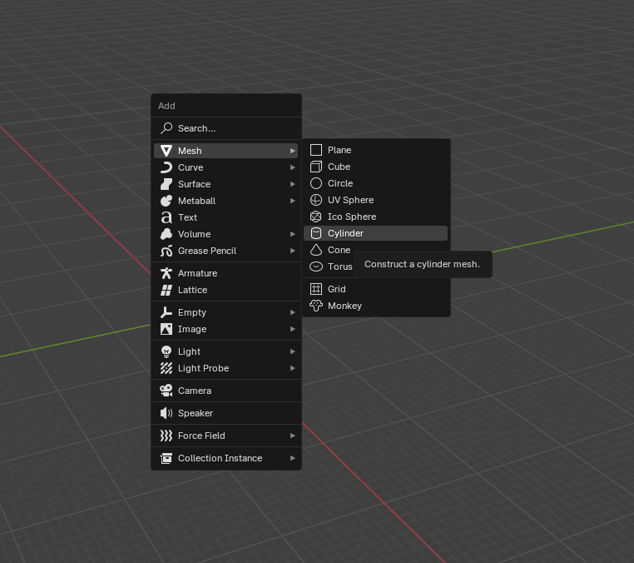
- Adjust the Cylinder Dimensions:
  - With the cylinder selected, go to the Dimensions panel on the right (press N if it's not visible).
  - 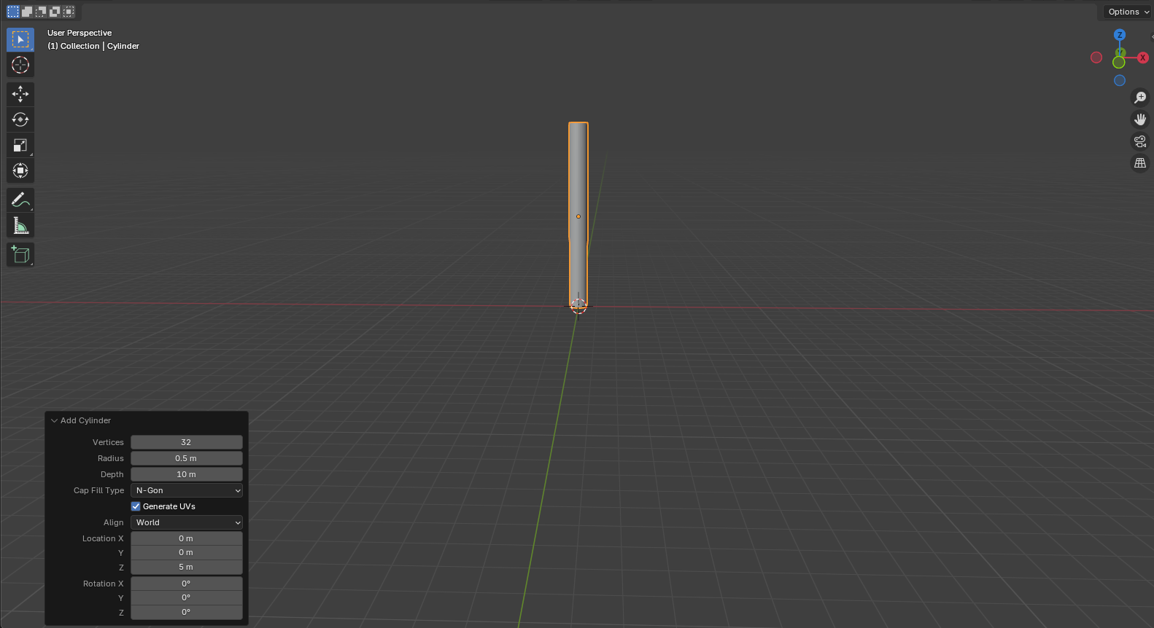
  - Set the dimensions:
    - Vertixe : 32
    - Radius (X): 0.5 units
    - Depth (Y): 10 units
    - Cap Fill Type N-Gon
    - Location ( X : 0 , Y: 0 , Z : 5 )

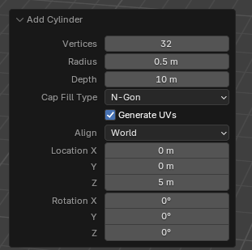
    - 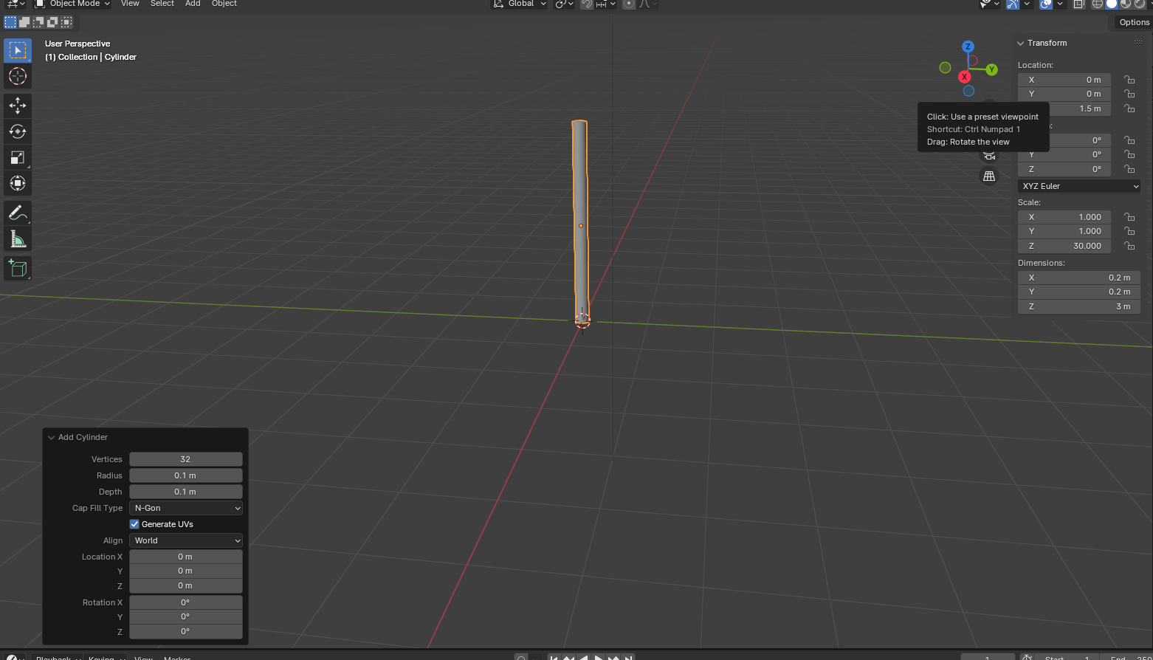
- Add an Octagon for the Stop Sign Face:
  - Press Shift + A and select Mesh > Cylinder.
  - In the bottom-left corner, expand the Add Cylinder panel.
  - Set the Vertices to 8 to create an octagon.
  - Set the Radius to 2.5
  - Set the Depth to 1
  - 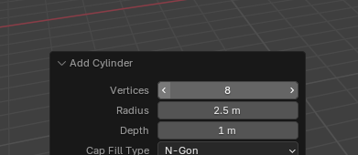
  - 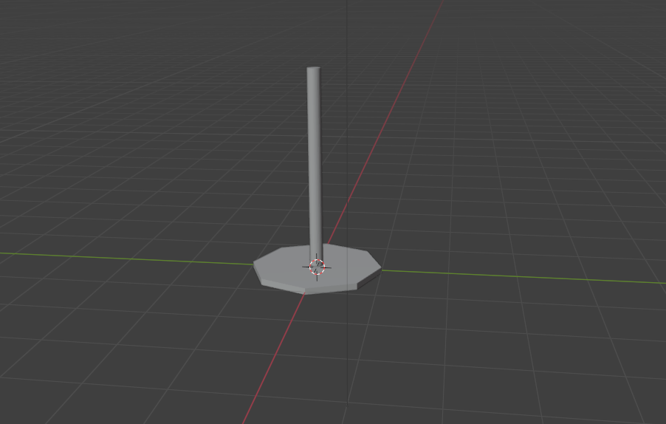
  - Now lets position this octagon
  - Select the octagon and press N
  - 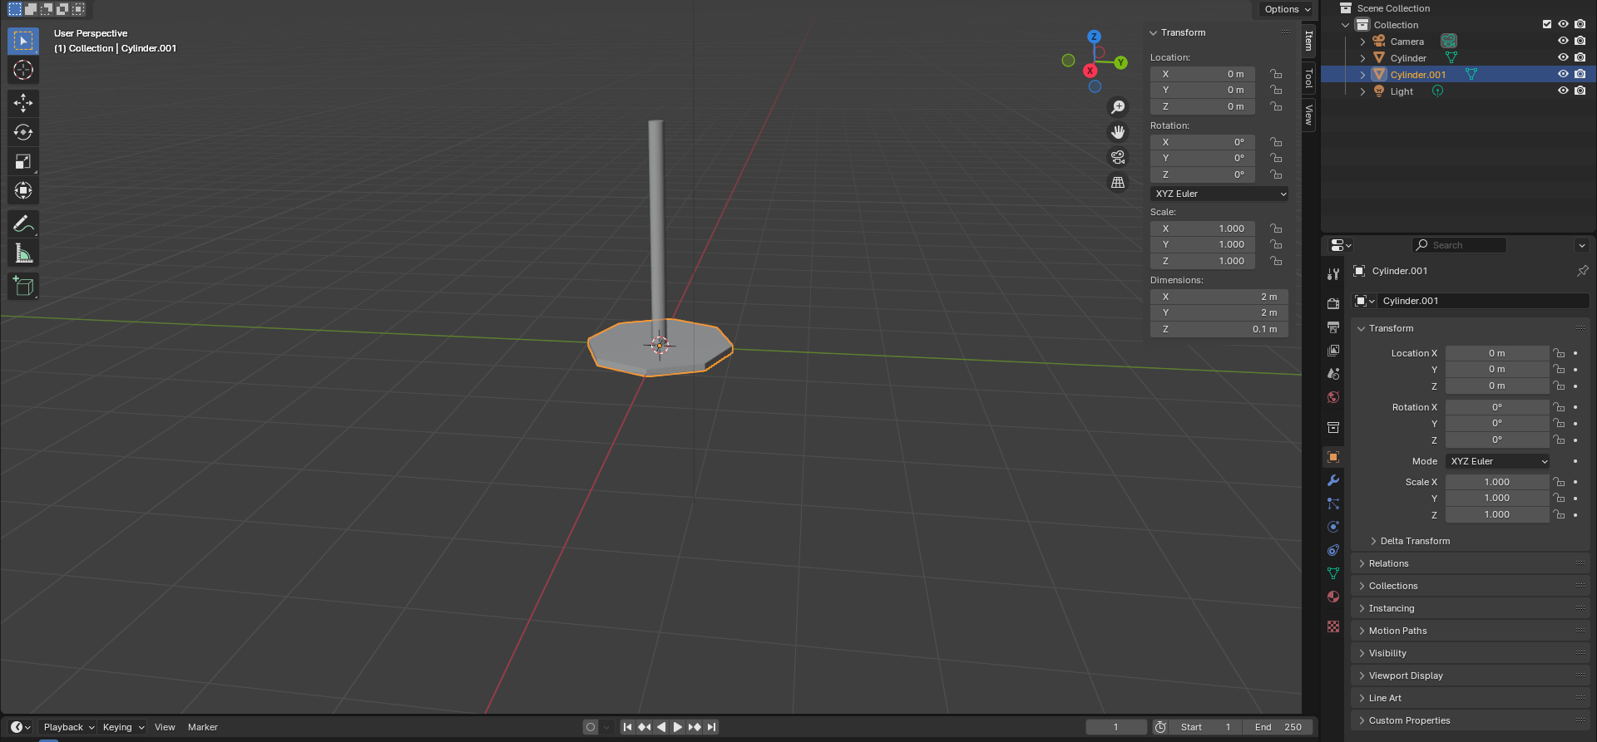
  - Rotate the Octagon 90 degrees in Y
  - And position it at Z = 10
  - 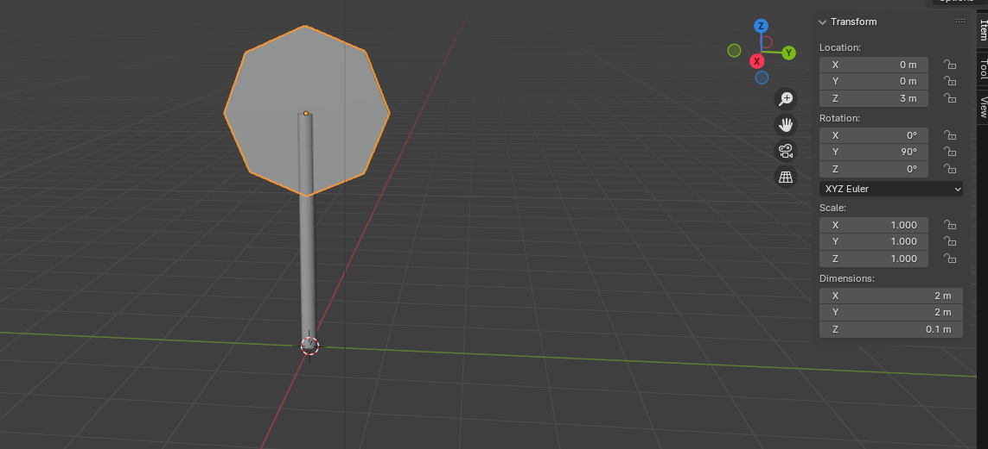

7. Inset the octagon
  - With the octagon selected, press Tab to enter Edit Mode.
  - Select the face Selector
  - Select a face of the octagon and inset it by pressing I to open the Inset tool.
  - 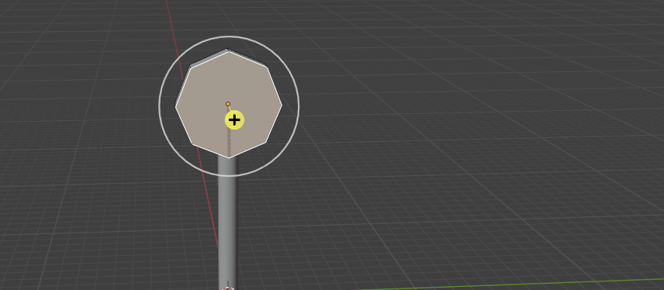
  - 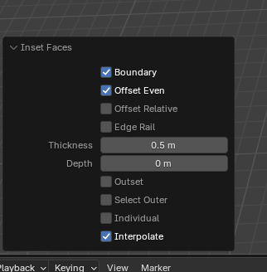
  - Write down 0.5 in the thickness
  - 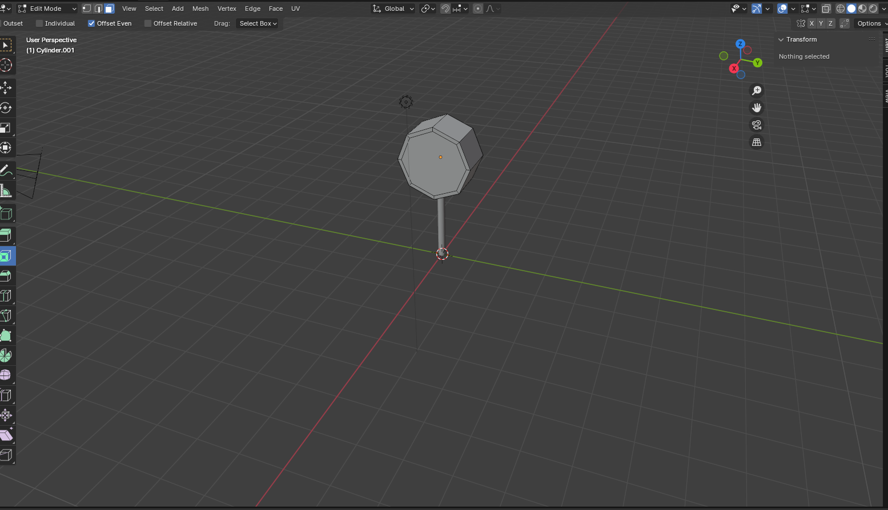

  - Do the same thing on the other side. You can rotate the view by holding down the mouse wheel while moving the mouse.
  - 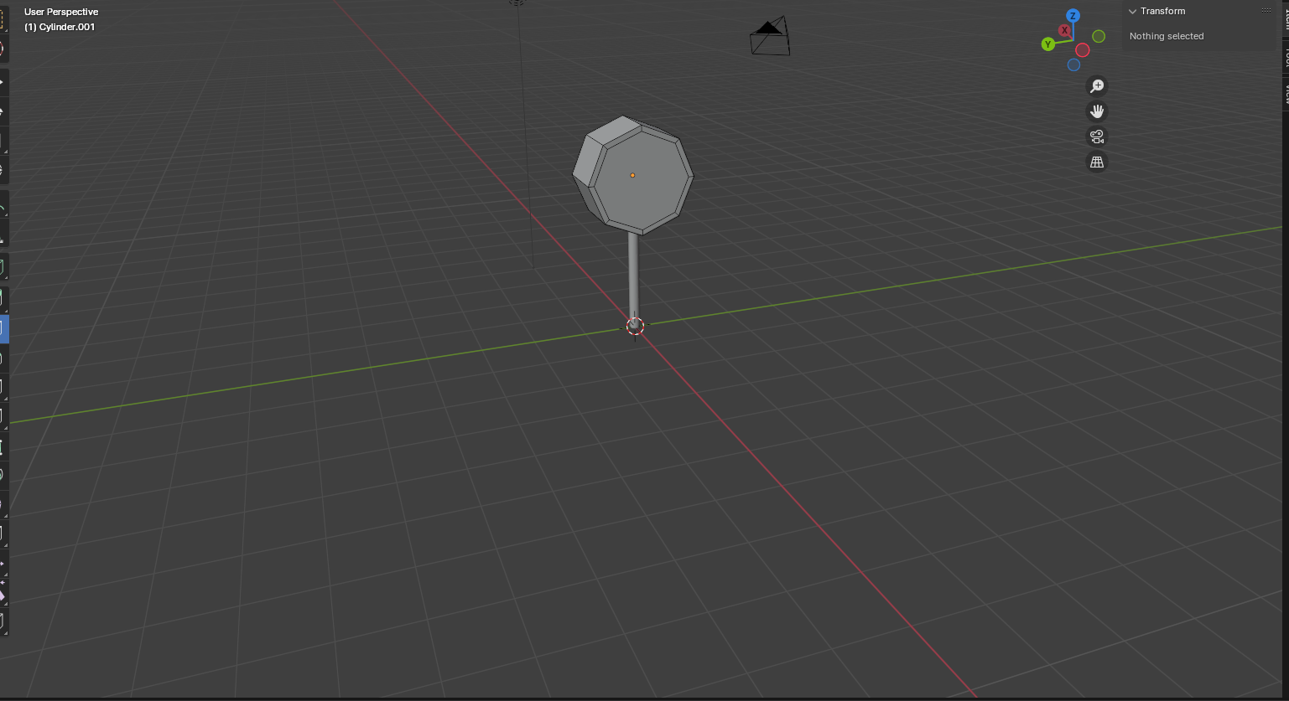
- Extrude the Octagon:
  - Press E to extrude, then X to constrain along the X-axis, and type 0.1 to extrude it by 0.1 units.
  - 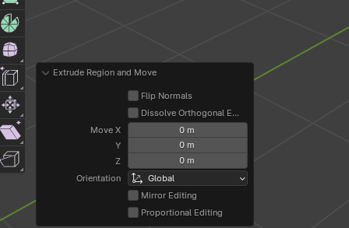
  - 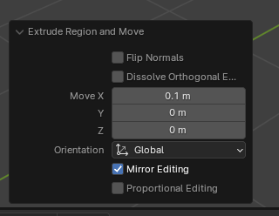
  - Press Tab to exit Edit Mode.
  - To view if your material was properly applied
- Add Materials:
  - Create Red Material for the Sign Face:
    - Select the octagon.
    - 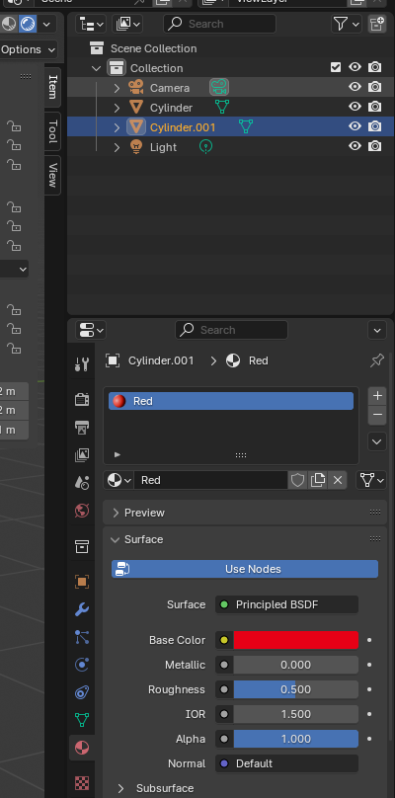
    - Go to the Material Properties tab (sphere icon).

    - 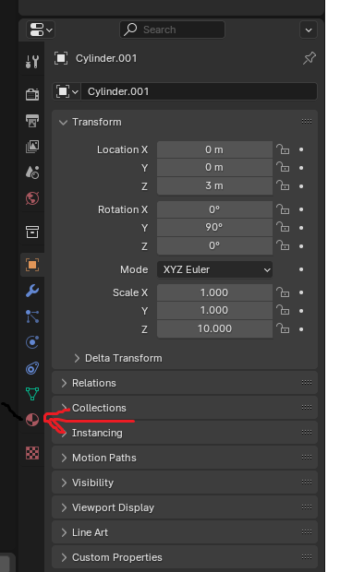
    - Click New to create a new material.
    - 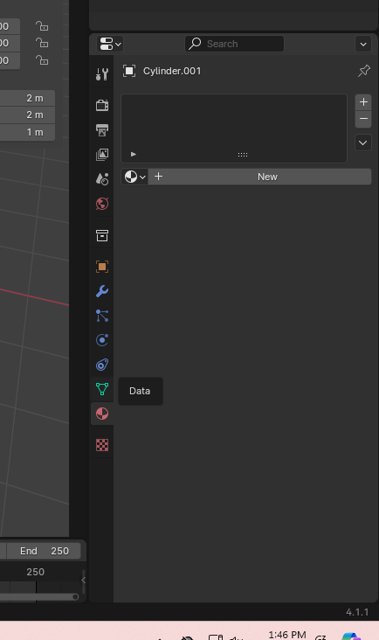
    - Name it Red.
    - 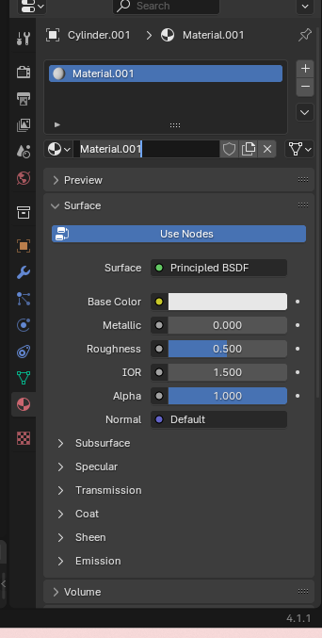
    - 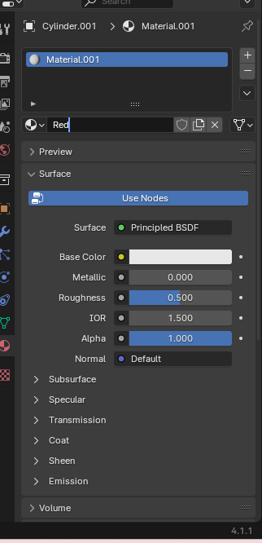
    - 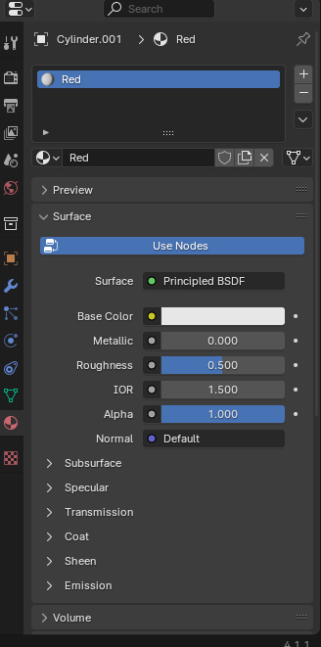
    - Set the Base Color to red.
    - 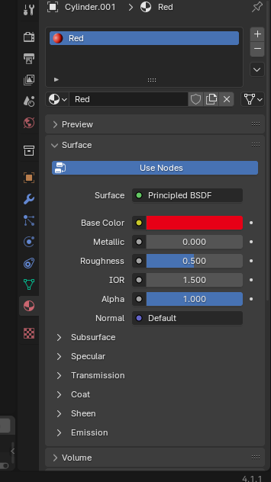
  - Create Gray Material for the Sign Post:
    - Select the cylinder.
    - Repeat the steps above but set the Base Color to gray and name it Gray.

To view if the material were added correctly go to the
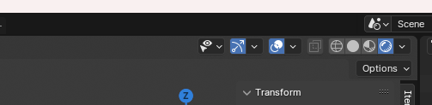

Task 3: Export the Stop Sign as an FBX
Proper scaling and rotation are crucial when exporting models for Unity.

Steps:
- Apply Transformations:
  - Select all objects (A key).
  - Press Ctrl + A and choose All Transforms. This applies location, rotation, and scale transformations.
- Set the Origin Point:
  - With all objects selected, right-click and choose Set Origin > Origin to Geometry.
- Make sure that normals are pointing out of your mesh.
- Go to “Edit Mode” and select all faces.
- Go to “Mesh > Normals > Recalculate Outside”.
- Save your file.
- 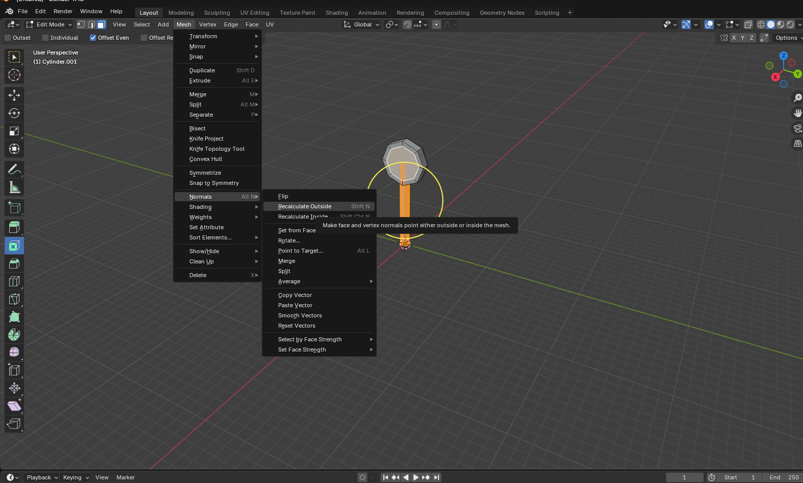
- Join the Objects (Optional):
  - With all objects selected, press Ctrl + J to join them into a single mesh. This simplifies importing into Unity.
- Export as FBX:
  - Go to File > Export > FBX (.fbx).
  - In the export window, set the following options:
    - Path Mode: Copy
    - Apply Transform: Check this option.
    - Scale: Ensure the scale is set to 0.1.
    - Forward: -Z Forward
    - Up: Y Up
  - Choose the destination folder inside your Unity project's Assets folder, e.g., Assets/Models/StopSign.
  - Click Export FBX.

Task 4: Import the Stop Sign into Unity and Add a Collider
Now, we'll bring your custom stop sign into Unity and make it interactive.

Steps:
- Refresh Unity Assets:
  - Switch back to Unity.
  - If you saved the FBX in the Assets folder, Unity should automatically import it.
  - If not, drag and drop the FBX file into the Assets panel in Unity.
- Adjust Import Settings (Optional):
  - Select the stop sign FBX in Unity's Project panel.
  - In the Inspector window, check the Scale Factor. It should be 1.
  - Click Apply if you make any changes.
- Add the Stop Sign to the Scene:
  - Drag the stop sign model from the Project panel into the Hierarchy panel.
- Position the Stop Sign:
  - Select the stop sign in the Hierarchy.
  - In the Inspector, set the Position values as desired to place it in your scene.
- Add a Collider:
  - With the stop sign selected, click on Add Component in the Inspector.
  - Search for and add a Mesh Collider or a Box Collider.
    - Mesh Collider: Conforms to the shape of your model but is more performance-intensive.
    - Box Collider: Simpler shape, better for performance.
  - Adjust the collider's size and position if necessary.
- Test the Collider:
  - Enter Play Mode to test if your player character interacts with the stop sign as expected.

\

Task 6: Import an Animated Character from Mixamo
Now you'll download a rigged character with its texture from Mixamo, add a simple animation, set up its rig as a Humanoid in Unity, and make it play the animation in your scene.

Part A: Download the Character from Mixamo
- Sign In to Mixamo:
  - Go to https://www.mixamo.com and sign in with a free Adobe account (create one if needed).
- Choose a Character:
  - Click the Characters tab at the top of the page.
  - Pick a character that has a texture (any character that is not plain grey, e.g. not Y Bot / X Bot).
  - 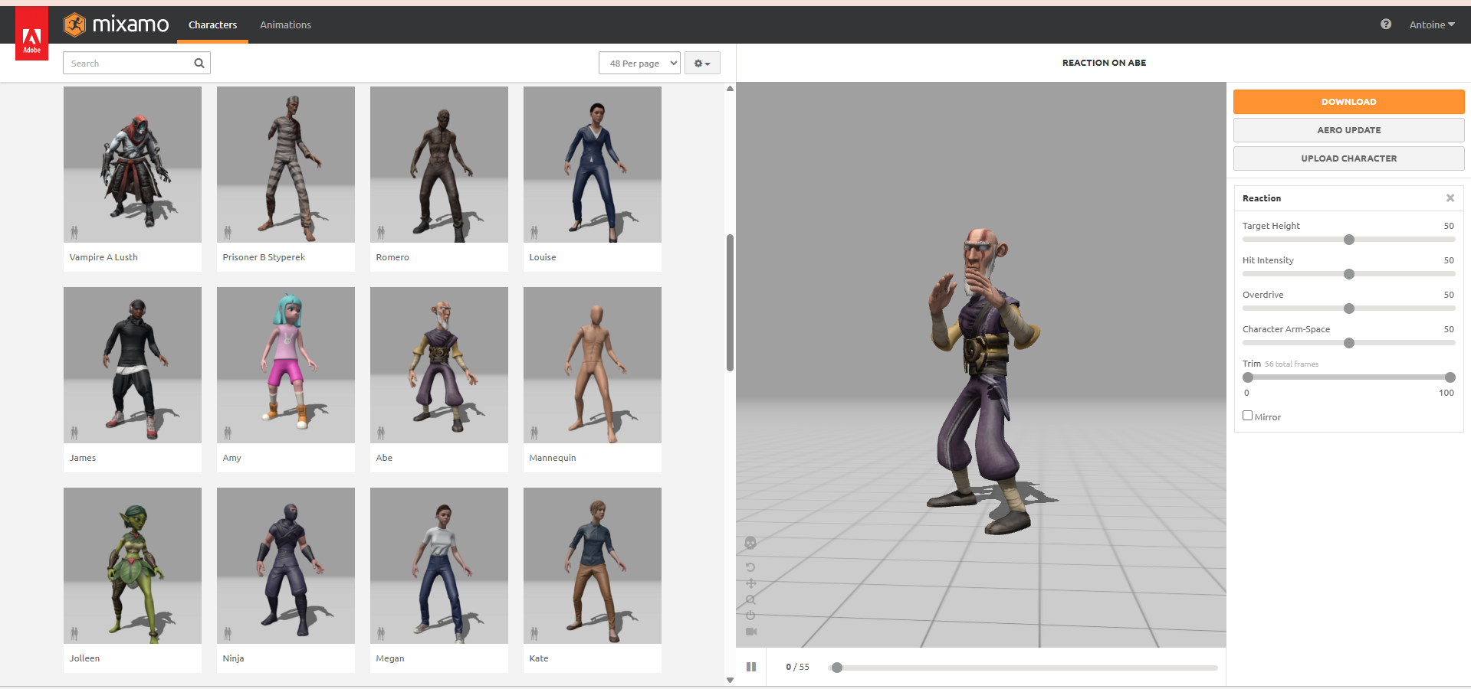
- Download the Character with Its Texture:
  - Click Download on the right side.
  - In the Animation tab select an Idle Animation
- 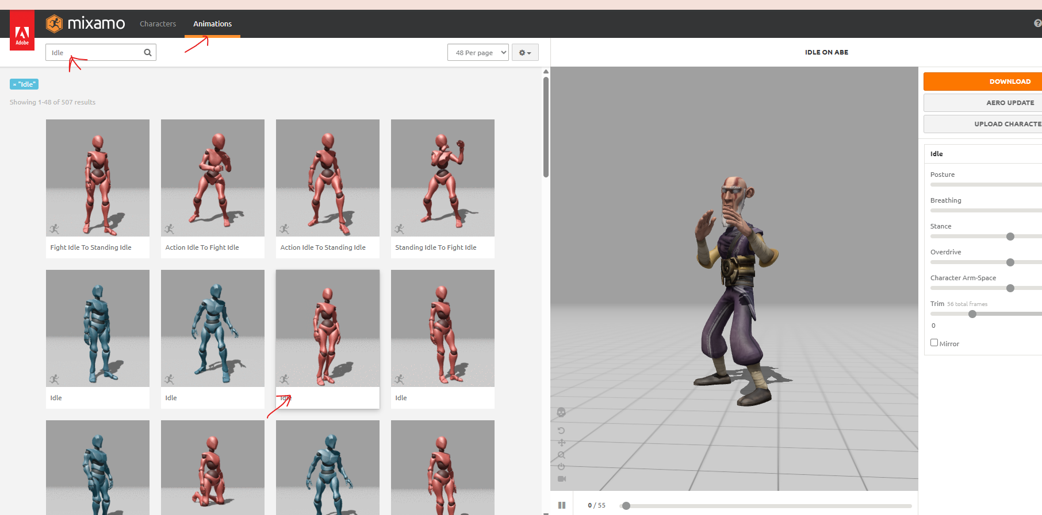
  - Download the animation with a skin
  - Set the options:
    - Format: FBX for Unity(.fbx)
    - Pose: T-pose
  - 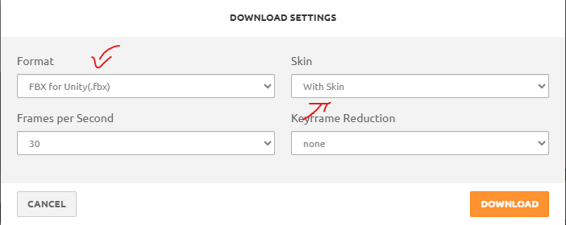
  - Click Download. This file contains the mesh, the skeleton (rig) and the textures embedded inside the FBX.

Part B: Download a Simple Animation
- Choose an Animation:
  - With the same character still selected, click the Animations tab.
  - Search for a simple looping animation such as Waving.
  - 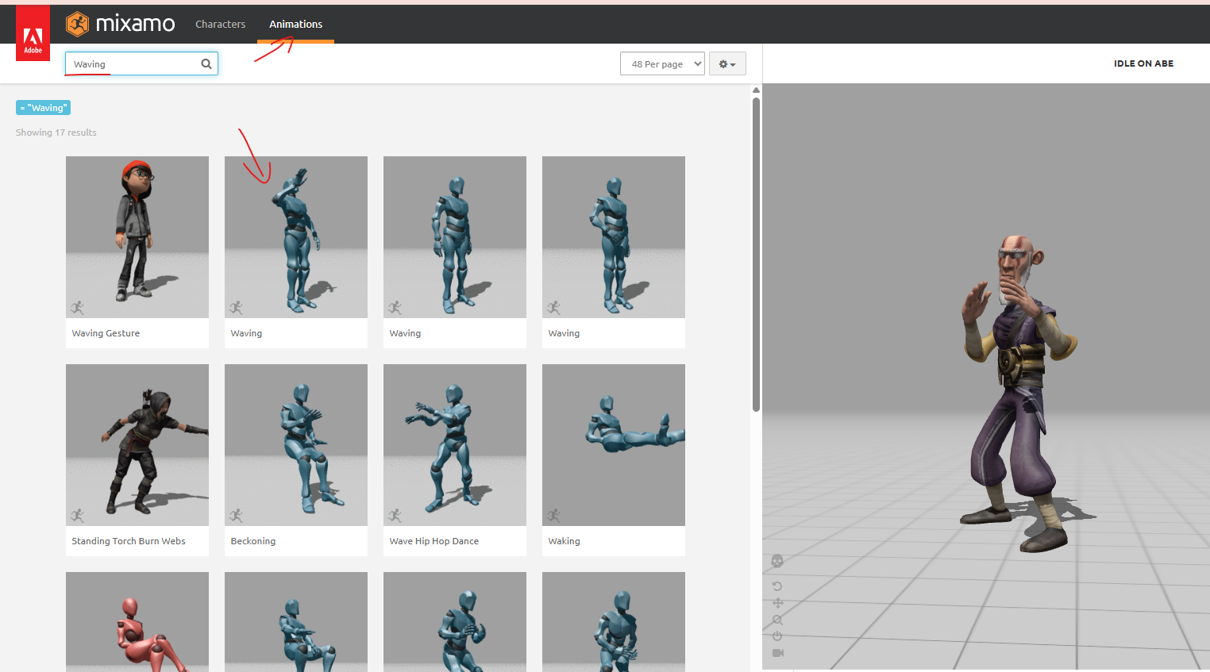
  - Click it to preview it on your character.
  - If you choose a walking or running animation, check the In Place box so the character doesn't move forward on its own.
- Download the Animation:
  - Click Download and set the options:
    - Format: FBX for Unity(.fbx)
    - Skin: Without Skin (we already have the character mesh; this keeps the file small)
    - Frames per Second: 30
    - 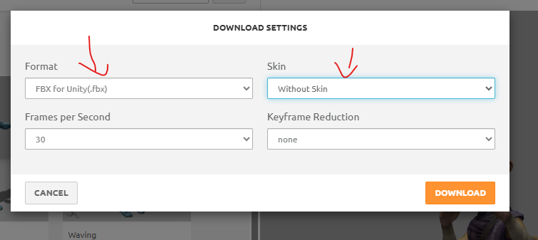
  - Click Download.

Part C: Import the Character and Extract Its Texture
- Create the Folders in Unity:
  - Create Assets/Models/Character, Assets/Models/Character/Textures, Assets/Models/Character/Materials and Assets/Models/Character/Animations.
  - 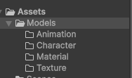
- Import the Files:
  - Drag the character FBX into Assets/Models/Character.
  - 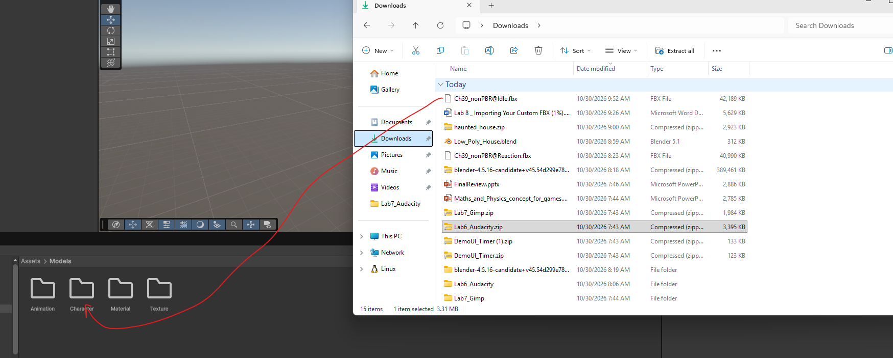
  - Drag the animation FBX into Assets/Models/Character/Animations.
- 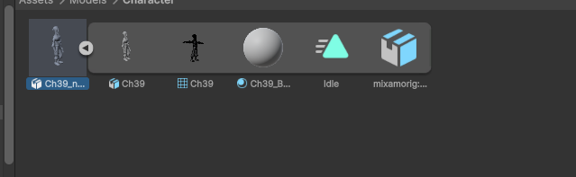
- Extract the Character's Textures:
  - Select the character FBX and open the Materials tab in the Inspector.
- 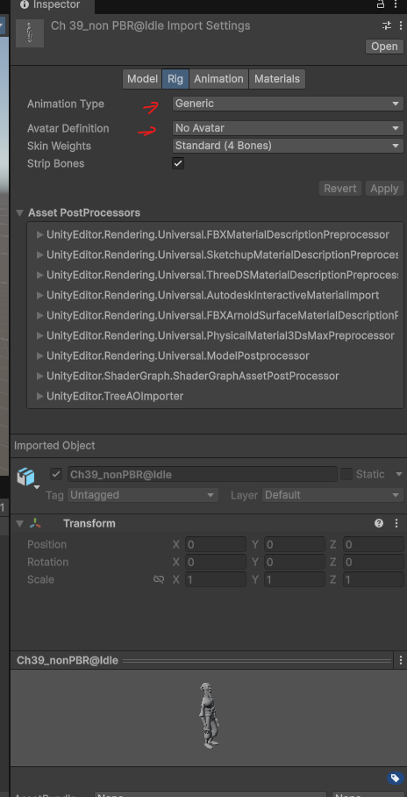
  - Set Location to Use Embedded Materials.
  - 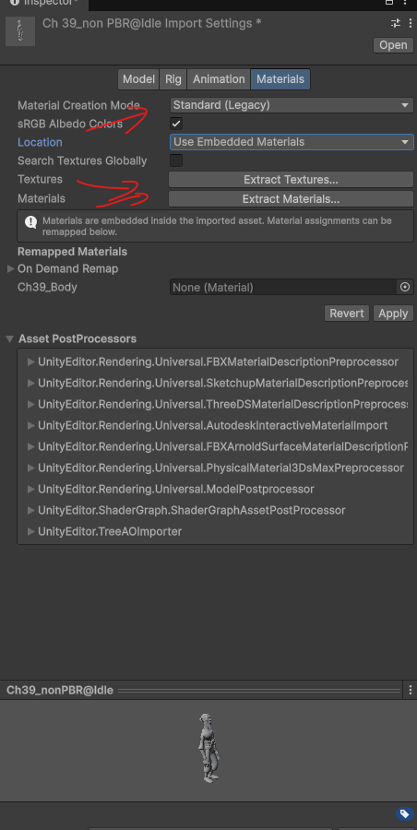
  - Click Extract Textures..., select
  - 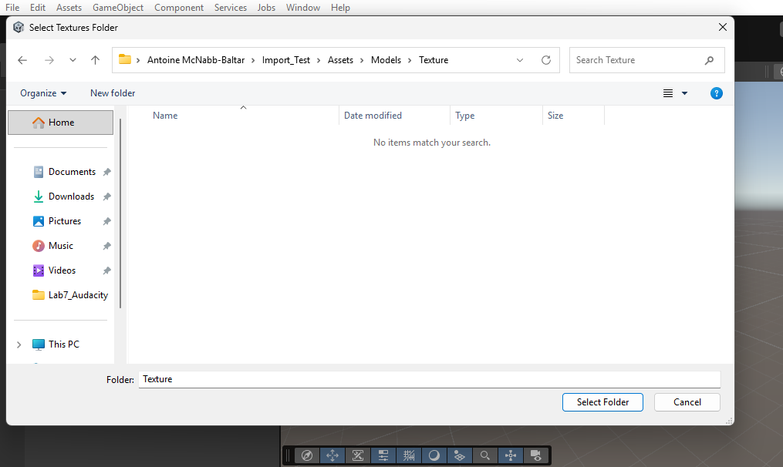
  - Assets/Models/Character/Textures and click Select Folder. Click Fix now if Unity asks about a normal map.
  - Click Extract Materials..., select
  - 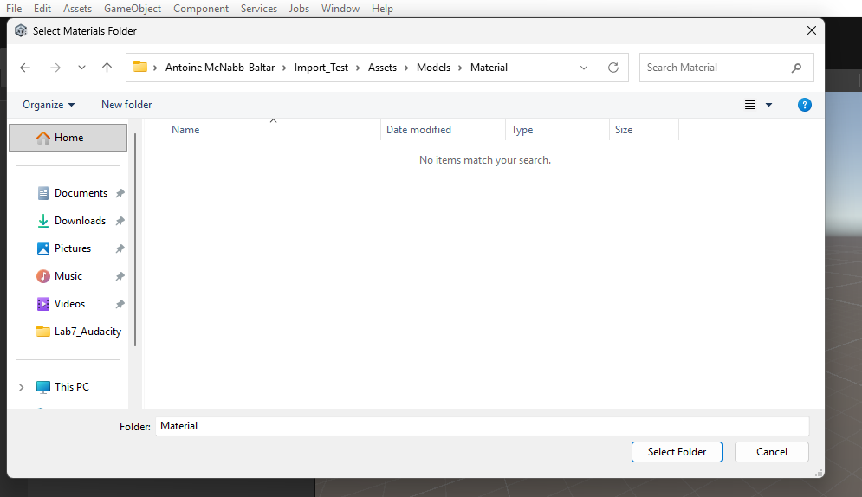Assets/Models/Character/Materials and click Select Folder.
- Set Up the Character's Materials:
  - Open Assets/Models/Character/Materials and select each material.
  - Make sure the Shader is Universal Render Pipeline/Lit.
  - Drag the matching _Diffuse / base color texture from the Textures folder onto Base Map, and the _Normal texture onto Normal Map if there is one.
  - If parts of the character look see-through, set Surface Type to Opaque (Mixamo materials sometimes import as transparent).
  - 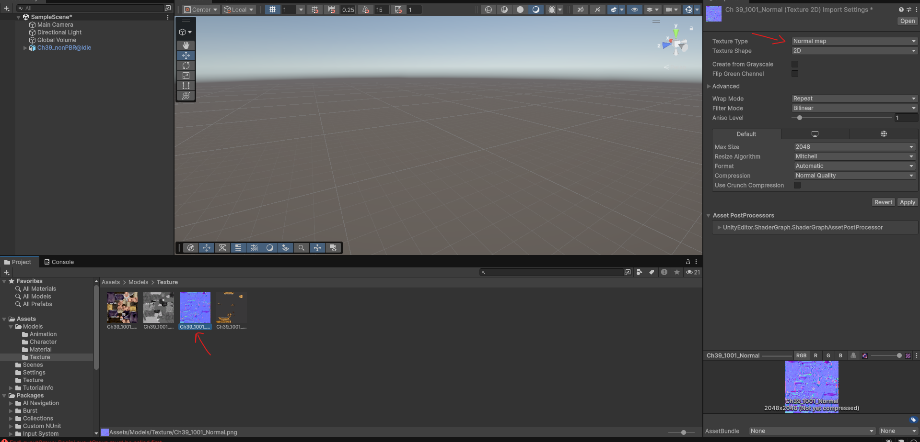
  - 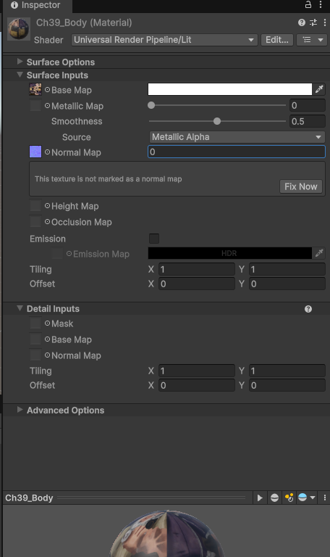

Part D: Set Up the Rig
- Configure the Character's Rig:
  - Select the character FBX and open the Rig tab in the Inspector.
  - Set Animation Type to Humanoid.
  - Set Avatar Definition to Create From This Model.
  - Click Apply. Unity creates an Avatar asset inside the FBX (expand the FBX in the Project panel to see it).
  - Click Configure... to check the bone mapping. All the bones of the body should be green. Click Done to return.
Note: If some bones are red, click Mapping > Automap in the Avatar configuration window, then Apply.
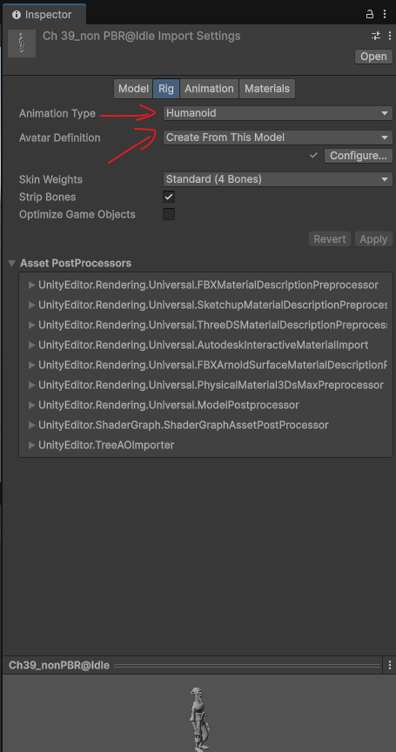
- Configure the Animation's Rig:
  - Select the animation FBX and open the Rig tab.
  - Set Animation Type to Humanoid.
  - Set Avatar Definition to Copy From Other Avatar.
  - In the Source field, choose the Avatar of your character (e.g. CharacterNameAvatar).
  - Click Apply.
  - 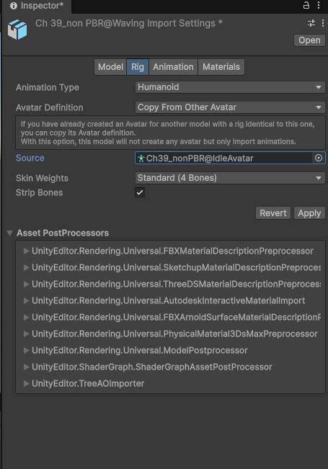

Part E: Play the Animation in the Scene
- Create an Animator Controller:
  - Right-click in Assets/Models/Character/Animations > Create > Animation > Animator Controller. Name it CharacterAnimator.
  - Double-click it to open the Animator window.
  - Expand the animation FBX in the Project panel and drag the animation clip (the triangle icon) into the Animator window. It becomes the default (orange) state.
- Add the Character to the Scene:
  - Drag the character FBX into the Hierarchy and place it near the house.
  - With the character selected, find the Animator component in the Inspector.
  - Drag CharacterAnimator into the Controller field.
  - Make sure the Avatar field shows your character's Avatar.
  - Uncheck Apply Root Motion so the character stays where you placed it.
- Test in Play Mode:
  - Enter Play Mode. Your textured character should play its animation in a loop.

How to Submit Your Project
Zipped the assets folder and Submit on LEA.

