How many capacitances is a device?
Four numbers are floating around — 15, 14, 13 and 9. This is where each of them comes from, and which one belongs in the paper.
The short answer
A device is 14 free parameters. Figure 1(b) prints 15 numbers, but two of them are the same capacitor, so only 14 of them can be chosen independently.
1. Why 15 and not 14 — C_dd is symmetric
The mutual capacitance between dot 1 and dot 2 is one physical quantity. Writing it as a matrix puts it in twice, once above the diagonal and once below:
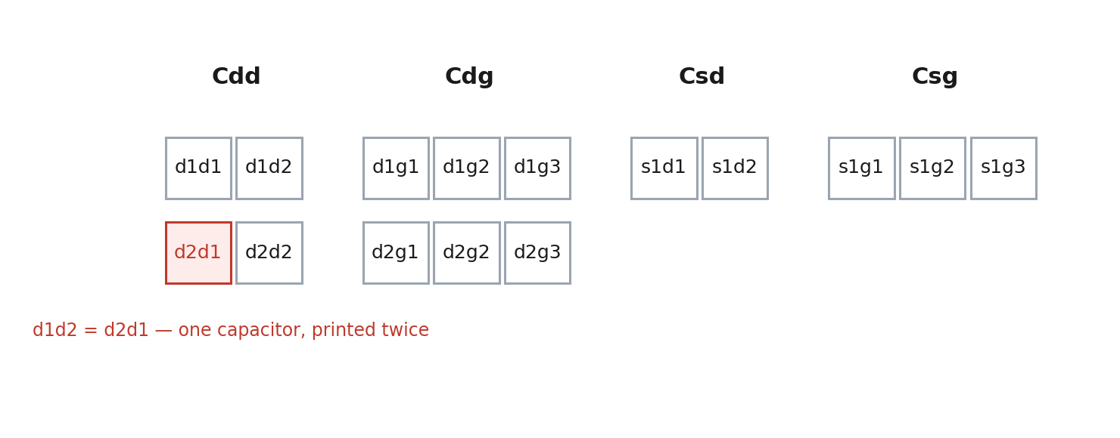
The four matrices as Figure 1(b) prints them. The shaded cell is not a separate capacitance — it is the same number as the one above the diagonal.
So counting the printed cells gives 15, and counting the independent values gives 14. The code enforces this rather than assuming it: MatrixGenerator.generate_all builds C_dd with generate_symmetric(), which draws the upper triangle and mirrors it.
Checked on a stored device rather than argued: data/_device_pools/devices_n550_res100_c1df7b6bf/sample_100/device.json prints 15 numbers, 14 of them distinct, and its C_dd[0][1] equals C_dd[1][0].
matrix | shape | cells printed | free parameters
C_dd | 2 x 2 (symmetric) | 4 | 3
C_dg | 2 x 3 (QArray's Cgd) | 6 | 6
C_sd | 1 x 2 (QArray's Cds) | 2 | 2
C_sg | 1 x 3 (QArray's Cgs) | 3 | 3
total |  | 15 | 14

2. Where 13 came from — it was simply wrong
13 was not a different way of counting. It was a number typed into the text and never checked against the code: the manuscript said a device is “a point in a 13-dimensional box” while, two paragraphs later, the separation sentence printed “14-dimensional normalised parameter space” from the data. Table I has always listed 14 rows. The text contradicted itself and the table.
It is fixed in three places, and neither number is typed any more — both are computed from the shapes the generator uses and from DEFAULT_INTERVALS, and the build asserts they agree.
3. Where 9 comes from — the drawing is incomplete
This is the one still worth acting on. Panel (a) of docs/figures/dqd_model.png draws 9 capacitors. Five that panel (b) tabulates are not in the drawing at all.
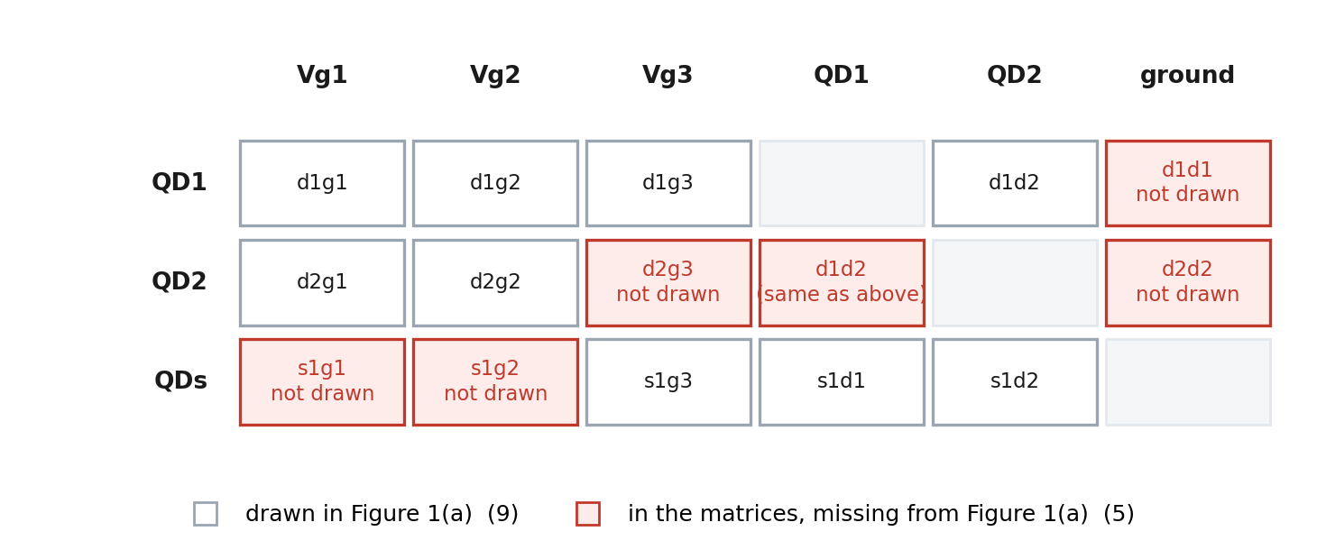
Every capacitance the matrices define, as one cell: what it couples, and whether Figure 1(a) draws it. White: the 9 it draws. Red: the 5 it does not — the two dot self-capacitances to ground, the dot-2 coupling to gate 3, and the sensor's couplings to gates 1 and 2. The shaded QD2/QD1 cell is the symmetric duplicate, not a fifteenth capacitance.
Missing from panel (a): d1d1, d2d2, d2g3, s1g1, s1g2.
9 drawn plus 5 missing is 14, which is the same count arrived at from the matrices — so nothing is wrong with the physics or the code. What is wrong is that a referee who counts the picture will find 9 where the text now says 14.
4. What to do
- Either add the five missing capacitors to panel (a) in Illustrator, so (a) and (b) show the same network;
- or leave the drawing and say so in the caption — that (a) shows the couplings which set the geometry of the diagram and (b) the complete set of 14. Say which and I will write the caption.
The text in Section 3.1 is already correct either way: it states the symmetry, the 15 printed entries, the 14 free parameters and the per-matrix breakdown, all computed at build time.

