4. Results and Discussion
We report the recovery of charge-transition lines as a function of the measurement budget, on 50 held-out devices. The best budget is 8 rays x 60 points: F1 at tau = 1 of 0.817 from 4.66 % of the gate-voltage plane, at a threshold of 0.6 chosen on the validation split.
The recovery of charge-transition lines was evaluated on the 50 held-out devices as a function of the measurement budget. Figure 10 shows F1@1 as a function of the fraction of the voltage plane sampled. For 40 and 60 points per ray, the score increases monotonically with the number of rays. At 50 points per ray, 6 rays (F1@1 = 0.661) scores below 5 rays (0.736). The best budget, 8 rays × 60 points, reaches F1@1 = 0.817 (precision 0.806, recall 0.836) while sampling 4.66 % of the plane, at a binarisation threshold of 0.6 selected on the validation split. At equal coverage, allocating the budget to additional rays yields a higher score than allocating it to additional points per ray in three of the five comparable pairs. The scores of all fifteen budgets are listed in Table II.
The dependence of the scores on the tolerance τ is shown in Fig. 11 for three budgets. For the headline budget, F1 increases from 0.469 at τ = 0 to 0.817 at τ = 1, and then saturates, reaching 0.905 at τ = 2 and 0.946 at τ = 3. The dominant remaining error is therefore the sub-pixel misplacement of lines that were detected, rather than the omission of lines. This gain has a cost in the area over which the score is evaluated: the fraction of the plane lying within τ of a sampled pixel rises from 4.66 % at τ = 0 to 18.91 % at τ = 1. Since the improvement between τ = 0 and τ = 1 is obtained at the expense of a several-fold increase in this area, τ = 1, rather than a larger value, is adopted as the headline tolerance. Pixel accuracy is included in Fig. 11(a) solely to illustrate why it is unsuitable as a metric. Transition lines occupy 7.1 % of the diagram, so a trivial prediction containing no lines would already achieve a pixel accuracy of 0.929. At τ = 0, the budgets score between 0.851 and 0.915, below this trivial value, and from τ = 1 onward all exceed 0.92. In neither regime does pixel accuracy indicate whether the lines were recovered, and it is therefore not reported as a result.
These results may be compared with the work of Hernandes et al.,⁵⁾ who reconstructed the full sensor image using a diffusion model trained on approximately 9000 measured diagrams. They reported that the transition lines were preserved at about 4 % coverage with a uniform point grid, and evaluated horizontal and vertical line cuts at 23–44 % coverage. Although our headline budget samples a comparable fraction of the plane, the two results are not directly comparable: their data are measured and noisy, whereas ours are simulated and noise-free, and the evaluation metrics differ. The two approaches nonetheless differ in principle. The present network predicts the transition lines directly rather than the sensor image, and its training labels are exact, since they are computed by the simulator rather than extracted from measurements by edge detectors.
The central step of this work is the formulation itself: the reconstruction of a stability diagram is posed as the probabilistic reconstruction of its transition lines, rather than of the sensor image from which lines must later be extracted. The network therefore returns the quantity that determines the charge occupation in a single step, with no detector between the measurement and the lines, and the map carries its own uncertainty.
The principal open question is whether a model trained on noise-free constant-capacitance diagrams transfers to fabricated devices. Measured diagrams contain sensor noise, charge switching, drift, and curved or broadened lines arising from finite tunnel coupling and non-constant charging energies, none of which are present in the training data. Several strategies may reduce this gap, including the introduction of realistic noise models during training, the use of simulators that incorporate tunnel coupling, such as QArray+,⁹⁾ and fine-tuning on a small number of measured diagrams. The per-device min–max normalisation of the input may also require revision, since a single outlier caused by charge switching would compress the dynamic range of the remaining signal.
A further consideration concerns which transition lines are needed in practice. The present metric weights every line pixel equally, so the reported F1 score measures the recovery of the diagram as a whole. Many tuning tasks, however, do not require the complete diagram. Setting a double dot to a target charge configuration, or locating the operating point for spin readout, depends mainly on the interdot transition lines and the triple points at their ends. These features are short and therefore contribute only a small fraction of the line pixels in each diagram, so a high overall F1 score does not guarantee that they are recovered accurately. Evaluating the reconstruction specifically on interdot transitions and triple points, and training the network with a loss that emphasises them, is a natural extension of this work.
The choice of window is itself a limitation of the present study. Every diagram is simulated over a voltage window of fixed size, 2 × 2 mV, at a fixed resolution of 100 × 100 pixels, and the window is placed at a random position that generally does not contain the (0,0) configuration. The variation in the capacitances changes the number of honeycomb cells that fall inside this window, but the network is never presented with windows of a different voltage span or pixel density. In experiments, the scan range and resolution are chosen by the experimenter and differ between devices and tuning stages, and whether the present network remains accurate under such changes has not been tested.
A related approach that addresses several of these points is the transformer-based model TRACS of Marchand et al.¹¹⁾ Rather than classifying individual pixels, TRACS detects the triple points of a diagram together with their connectivity, and thus directly returns the features required for gate virtualisation and charge-state initialisation. Input diagrams of arbitrary resolution are rescaled to a common size. Trained entirely on QArray simulations that include thermal broadening, white noise, telegraph noise and latching, it was shown to generalise to measured diagrams from three different device architectures without retraining. However, TRACS requires a fully measured charge stability diagram as input, and therefore does not reduce the acquisition time, which is the aim of the present work. Combining its feature-level output with the sparse ray acquisition proposed here, so that triple points and their connectivity are inferred directly from a few voltage sweeps, is a promising direction for future work.
Reducing the acquisition time is also the point at which the present method connects to recent developments in measurement hardware. The time required to characterise a device consists of two parts: the time spent acquiring the measurements, and the time spent processing them to decide on the next step. The ray-based approach reduces only the first, and its benefit therefore depends on the second remaining small. Fast readout hardware has recently been shown to shorten the first part considerably. Carlsson et al. used radio-frequency (RF) charge sensing to tune spin qubits automatically, with a median tuning time of about 15 minutes, locating interdot transitions with a neural network trained on QArray simulations.¹²⁾ Roux et al. controlled the stability-diagram measurements with an FPGA, which reduced the communication latency and allowed shorter integration times and faster voltage ramps to be exploited. Combining these FPGA-accelerated measurements with a neural network for charge-transition detection, they automatically tuned a SiGe quantum dot into the single-electron regime with a success rate of 90 %.¹³⁾ Once the measurements were accelerated, however, the decision-making between measurements, performed on the host computer, became the limiting step. They noted accordingly that sparse measurement strategies are advantageous only when the measurement time greatly exceeds the time required to decide the next measurement.
With fast RF readout, a complete set of rays could be acquired in a time far shorter than a conventional two-dimensional raster scan, and the time needed for network inference could then dominate. In the present method, the network is evaluated only once, after all rays have been acquired, so this cost is incurred a single time. The network is also small and fully convolutional, which makes its deployment on the host computer, or on the FPGA itself as suggested by Roux et al.,¹³⁾ feasible. A short measurement–prediction loop would further allow the acquisition to become adaptive: the probability map indicates where the model is uncertain, and this information could be used to select the direction of the next ray rather than fixing the ray pattern in advance. In that case, the network would be evaluated after every ray, and low-latency inference, ideally on the FPGA, would become essential.
The placement of the rays could also exploit prior knowledge of the device. In many experimental situations, the approximate positions of the transition lines are already known from earlier measurements of the same device. These positions nevertheless change over time: charge offsets drift, adjustments of barrier or virtual gates shift and tilt the lines, and thermal cycling alters the diagram as a whole. In such cases, the task is not to locate the transitions from scratch but to update their positions quickly, and a few rays are better suited to this than a repeated full raster scan. Prior knowledge could be incorporated into the present method either by placing the rays near the expected transitions, in particular the interdot transitions of interest, or by supplying a previously measured diagram to the network as an additional input channel. The network would then need to infer only how the lines have moved rather than where they are. The setting studied here, in which no prior information is used, therefore represents the most demanding case, and fewer rays may suffice when such information is available.

Tables
Table II. Scores of every measurement budget (rays × points per ray) on the 50 held-out devices: fraction of the voltage plane sampled, binarisation threshold selected on the validation split, precision, recall and F1 at tau = 1, and strict F1 at tau = 0. Budgets marked * were retrained from a different random initialisation (Sec. 3.3). The best budget is 8 × 60.
Budget | Coverage (%) | Threshold | Precision | Recall | F1@0 | F1@1
4 × 40 | 1.57 | 0.6 | 0.617 | 0.719 | 0.335 | 0.660
5 × 40 | 1.94 | 0.6 | 0.625 | 0.813 | 0.363 | 0.701
6 × 40 | 2.33 | 0.4 | 0.683 | 0.804 | 0.378 | 0.735
7 × 40 | 2.72 | 0.3 | 0.700 | 0.819 | 0.396 | 0.747
8 × 40 | 3.11 | 0.6 | 0.748 | 0.830 | 0.426 | 0.783
4 × 50 | 1.95 | 0.5 | 0.628 | 0.758 | 0.350 | 0.683
5 × 50 | 2.44 | 0.7 | 0.709 | 0.773 | 0.394 | 0.736
6 × 50* | 2.94 | 0.7 | 0.625 | 0.713 | 0.344 | 0.661
7 × 50 | 3.42 | 0.7 | 0.696 | 0.796 | 0.396 | 0.738
8 × 50 | 3.88 | 0.7 | 0.786 | 0.815 | 0.449 | 0.796
4 × 60 | 2.35 | 0.6 | 0.623 | 0.736 | 0.348 | 0.670
5 × 60* | 2.96 | 0.5 | 0.674 | 0.809 | 0.393 | 0.731
6 × 60 | 3.52 | 0.6 | 0.732 | 0.822 | 0.422 | 0.772
7 × 60* | 4.10 | 0.4 | 0.756 | 0.837 | 0.438 | 0.789
8 × 60* | 4.66 | 0.6 | 0.806 | 0.836 | 0.469 | 0.817

Figures
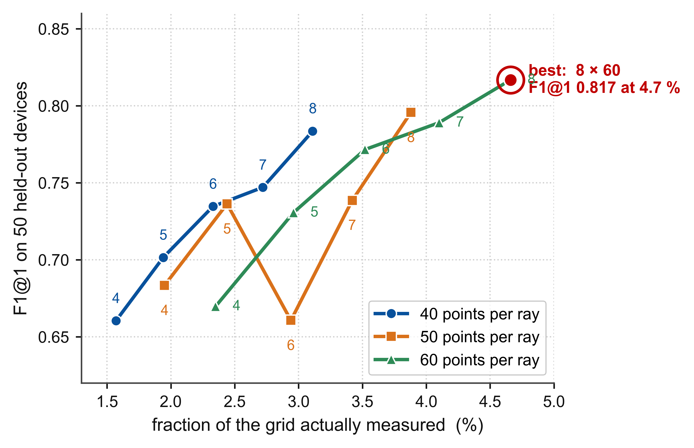
Fig. 10. F1 at tau = 1 against the fraction of the plane measured, for 40, 50 and 60 points per ray; the number beside each point is the ray count. The best budget is ringed.

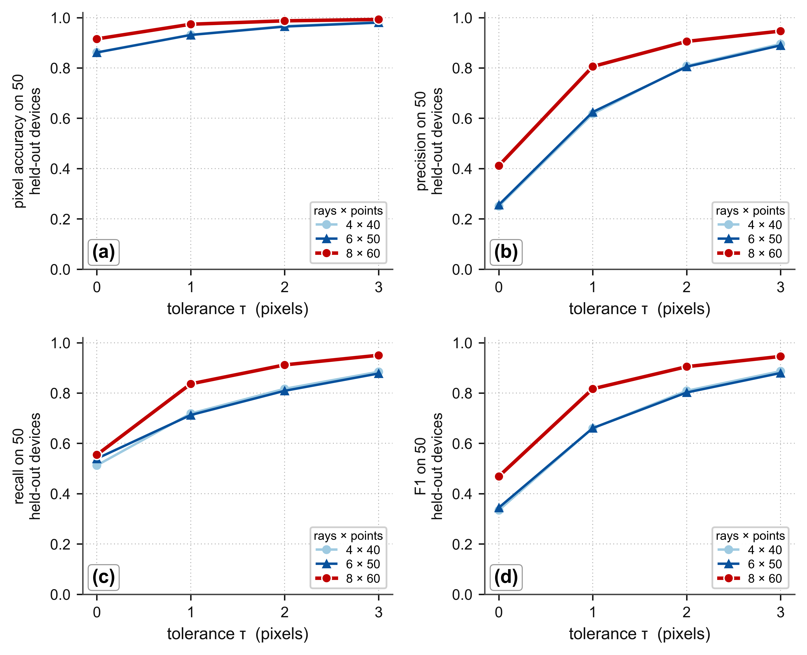
Fig. 11. (a) Pixel accuracy, (b) precision, (c) recall and (d) F1 against the tolerance tau, for three budgets, on 50 held-out devices. Note the jump in F1 in (d) from tau = 0 to tau = 1, the largest step for all three budgets.

