Part 4. From probability map to transition lines: threshold and tolerance
Ehsan Alizadeh Kashtiban^{1,2}*, Takafumi Fujita², and Akira Oiwa²
¹Department of Physics, Graduate School of Science, Osaka University, Toyonaka 560-0043, Osaka, Japan
²SANKEN, Osaka University, Ibaraki, Osaka 567-0047, Japan
*E-mail: alizadeh21@sanken.osaka-u.ac.jp
The network outputs a continuous probability map, while transition lines are binary, so two decisions stand between the output and a score. Where to cut the map is the THRESHOLD, chosen on the validation devices and stored in the checkpoint; for the headline budget it is 0.7. How strictly to compare the result with the truth is the TOLERANCE tau, a distance in pixels. We report F1 at tau = 0 to 3 and quote tau = 1 as the headline, always beside the area that tolerance covers.
1. Binarising the output: the threshold
Every pixel must become 0 or 1, and where the map is cut decides how many lines are drawn. The cut is a fitted quantity and is therefore chosen out of sample: the candidates 0.3, 0.4, 0.5, 0.6, 0.7, 0.8, 0.9, 0.95, 0.99 are each scored on the 75 VALIDATION devices carved out of the training set, and the best is stored inside the checkpoint. The held-out devices are never involved in the choice.
Figure 1 shows that validation curve. It is nearly flat from 0.3 to 0.8 and falls off only beyond 0.9, so the exact value matters far less than the fact that it was chosen out of sample. For the headline budget the stored value is 0.7.
Figures 2 to 4 show the probability map and the effect of cutting it at the chosen threshold and at one deliberately too high.
2. Scoring the output: the tolerance
Transition lines are one pixel wide. Comparing them with the truth pixel for pixel is brutal: a perfectly recovered line displaced by a single pixel shares no pixel at all with the truth and scores zero, for a result any physicist would call correct. Figure 5 is exactly that case, constructed and scored with the same metric code used throughout: strict F1 = 0.00, and F1 at tau = 1 equal to 1.00.
We therefore report F1 at a tolerance tau: a predicted pixel counts as correct if a true line pixel lies within tau pixels of it, and a true pixel counts as found if a predicted one lies within tau. Distances are Euclidean. Figure 6 shows what tau admits around a single pixel: tau = 0 is the same pixel only, tau = 1 adds the four side neighbours, and a diagonal neighbour is 1.41 pixels away so it counts only from tau = 2.
Figures 7 to 9 show one prediction scored at three tolerances, and Figure 10 the same thing zoomed until individual pixels are visible: the truth and the output never move, only the band that is allowed around them.
3. Reporting
F1 at tau can only rise with tau, so it is never quoted alone. Two safeguards are used throughout. First, tau is always stated, and F1 is reported for tau = 0 to 3 rather than at a single convenient value. Second, the score is quoted beside coverage at the same tau: the fraction of the plane lying within tau pixels of a measured pixel, which is the area the score is effectively read over. Across this study, allowing a single pixel of slack inflates the measured area by 4.0 to 4.8 times.
Figure 11 shows F1 against tau together with the precision and recall behind it. Pixel accuracy is not reported as a result anywhere in this work.

Figures
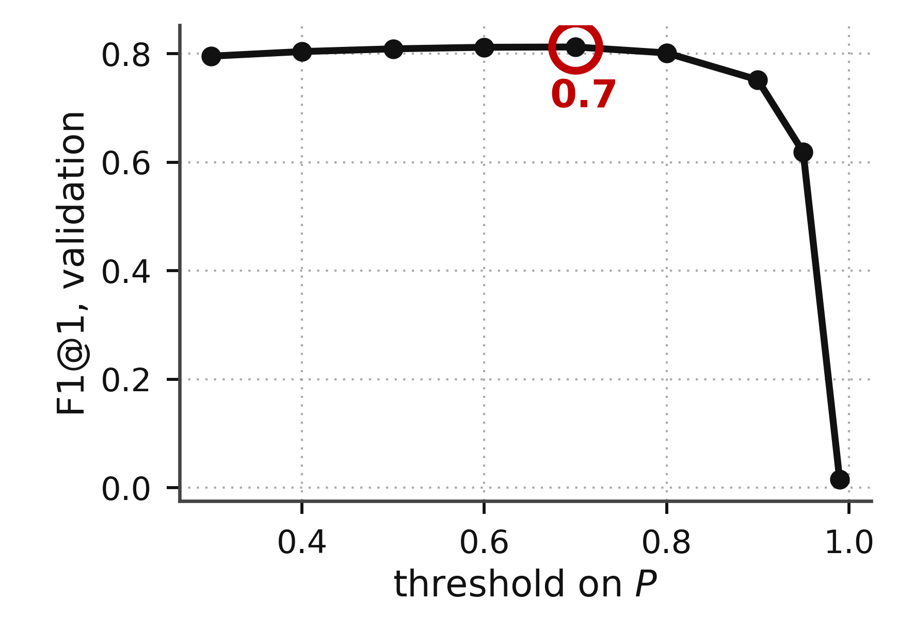
Fig. 1. Choosing the threshold. Mean F1 at tau = 1 over the 75 validation devices for every candidate cut, with the stored value ringed. The curve is flat from 0.3 to 0.8 and collapses only past 0.9.

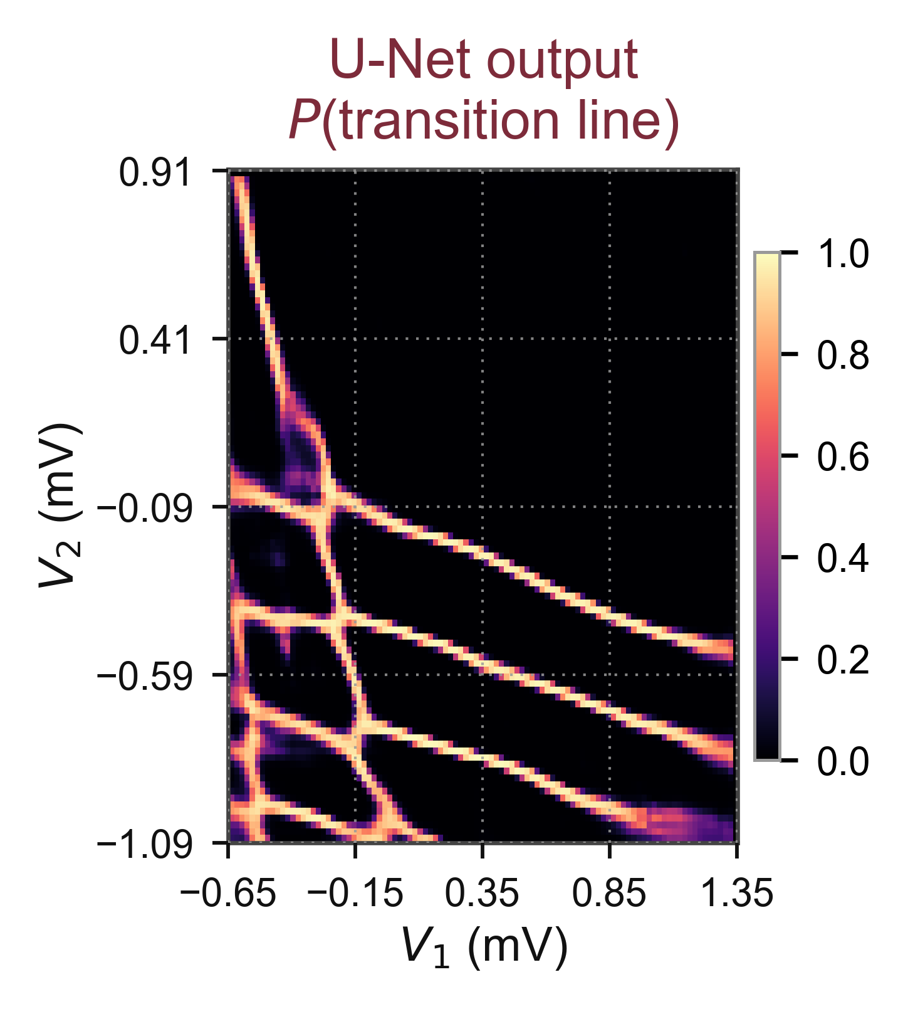
Fig. 2. The U-Net output for one held-out device: a probability per pixel that a transition line passes through it.

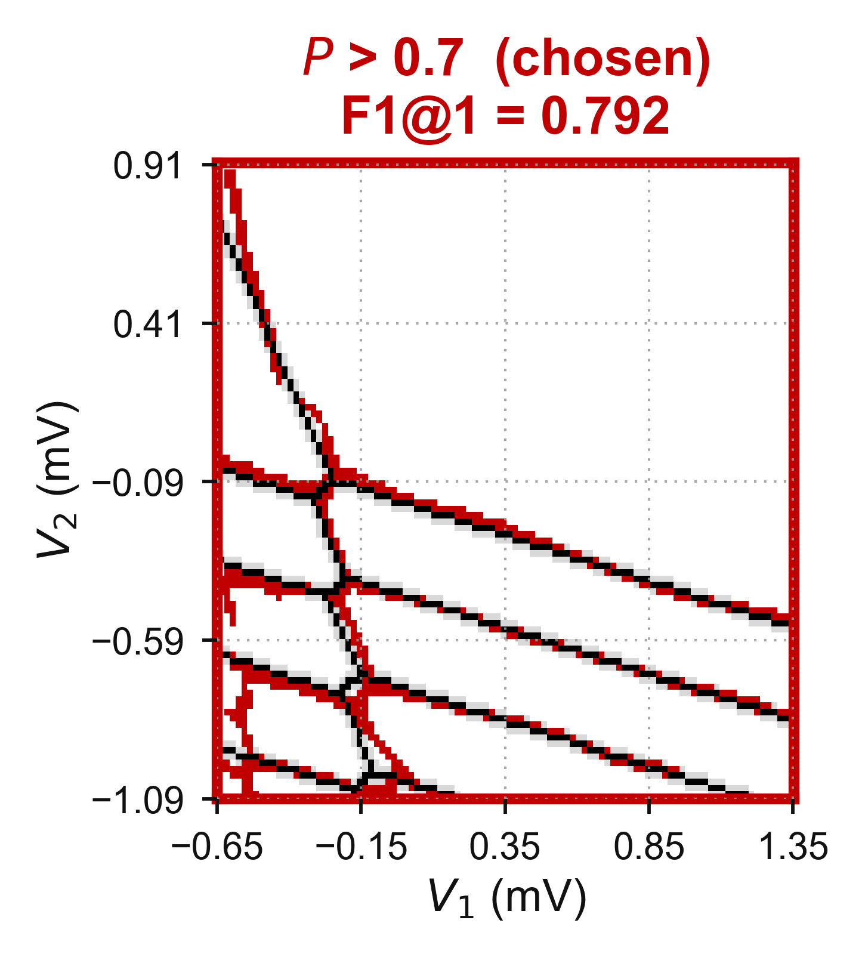
Fig. 3. The same map cut at the chosen threshold, P > 0.7.

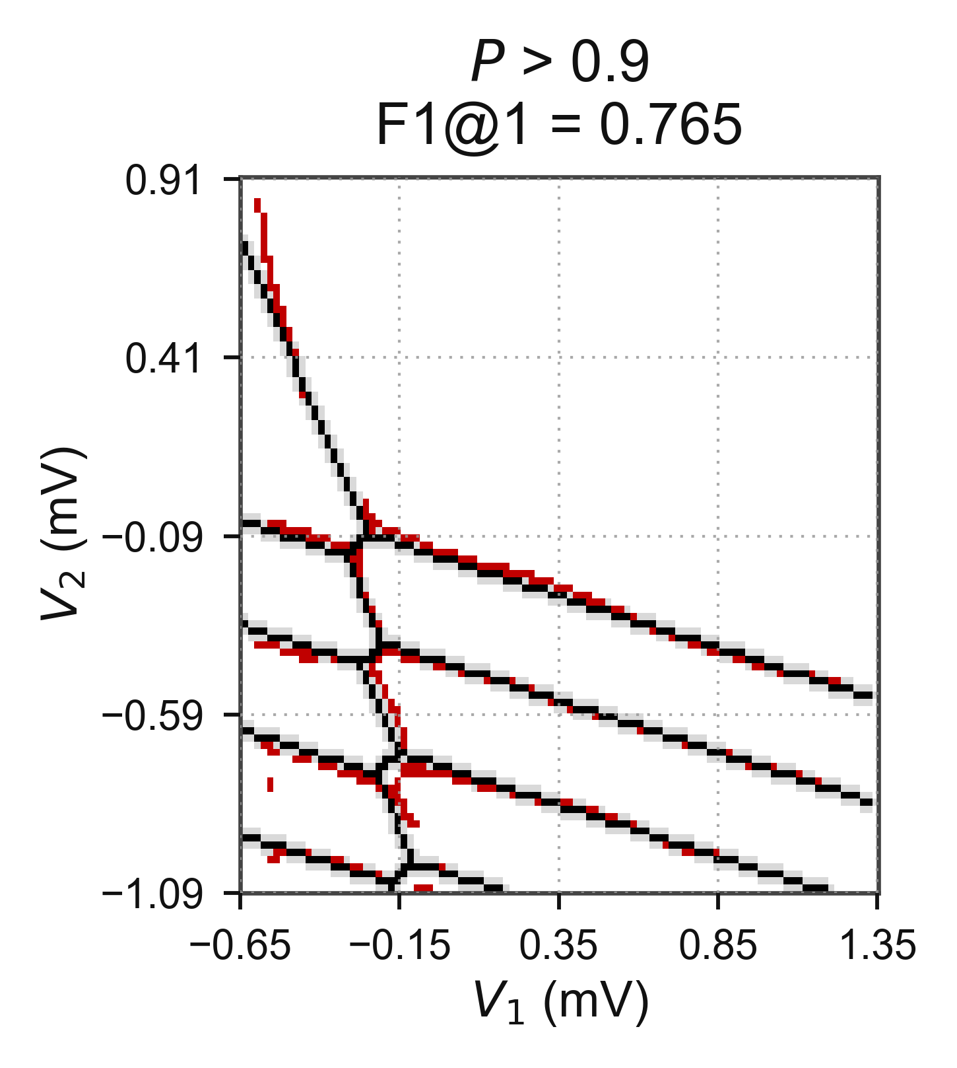
Fig. 4. The same map cut too high, at P > 0.9. Lines break up and are lost.

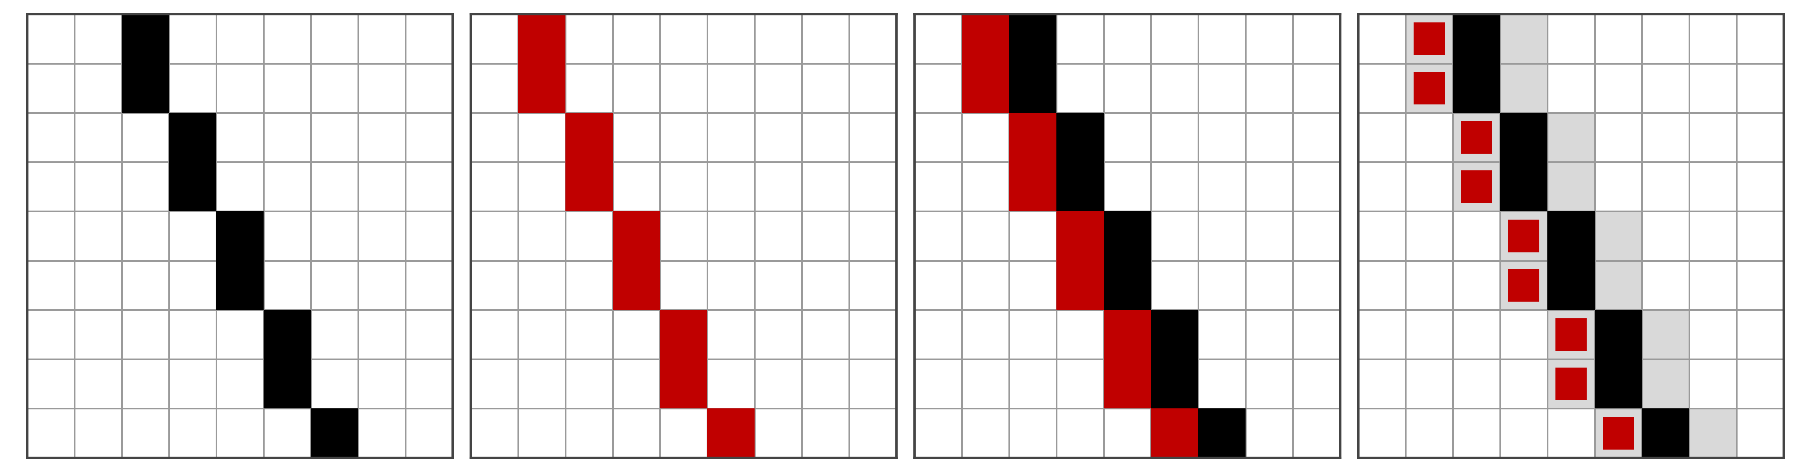
Fig. 5. Why a tolerance is needed. Left to right: the ground truth; the same line drawn one pixel to the left; the two superimposed, adjacent everywhere and coincident nowhere; and the same pair with the tau = 1 band. Strict F1 is 0.00 and F1 at tau = 1 is 1.00.

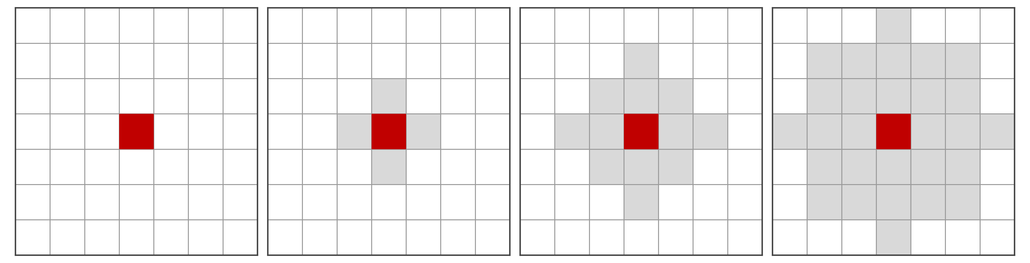
Fig. 6. What tau admits around one pixel the model drew, for tau = 0, 1, 2 and 3. Distances are Euclidean, so a diagonal neighbour (1.41 px) counts only from tau = 2.

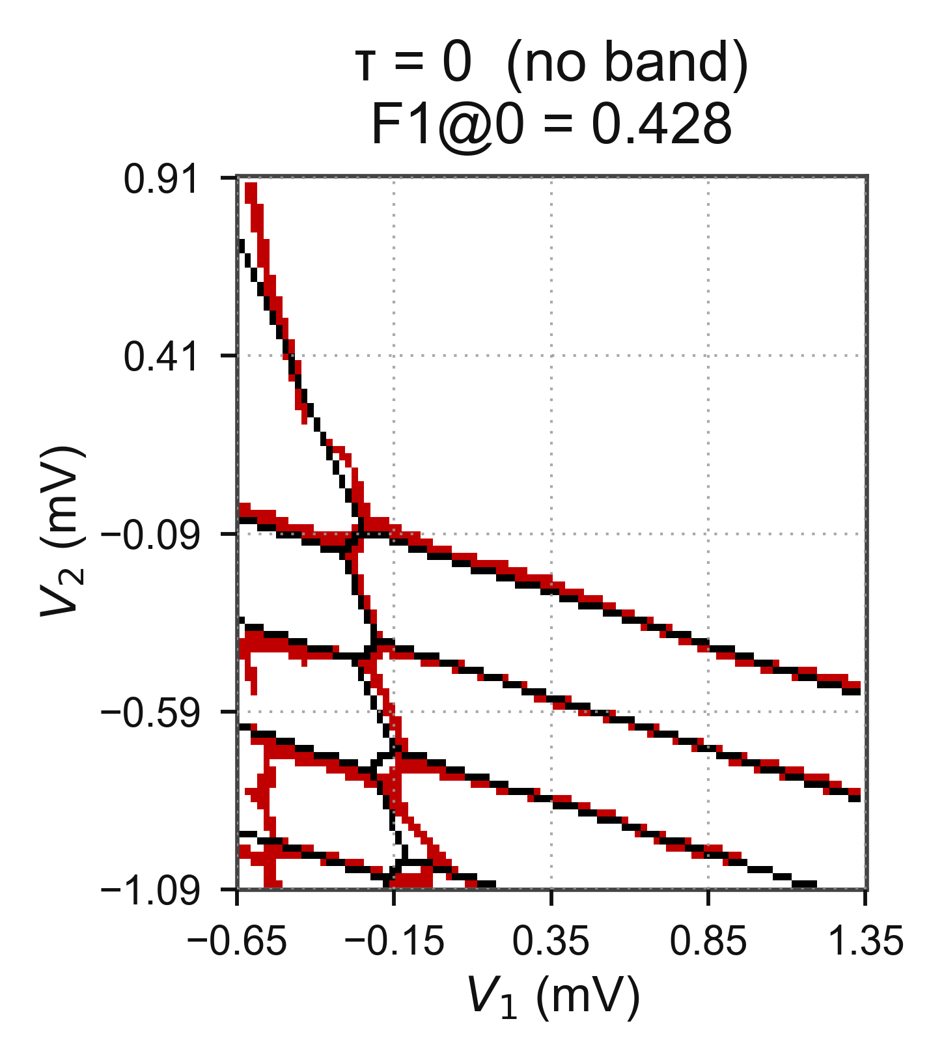
Fig. 7. One prediction scored at tau = 0.

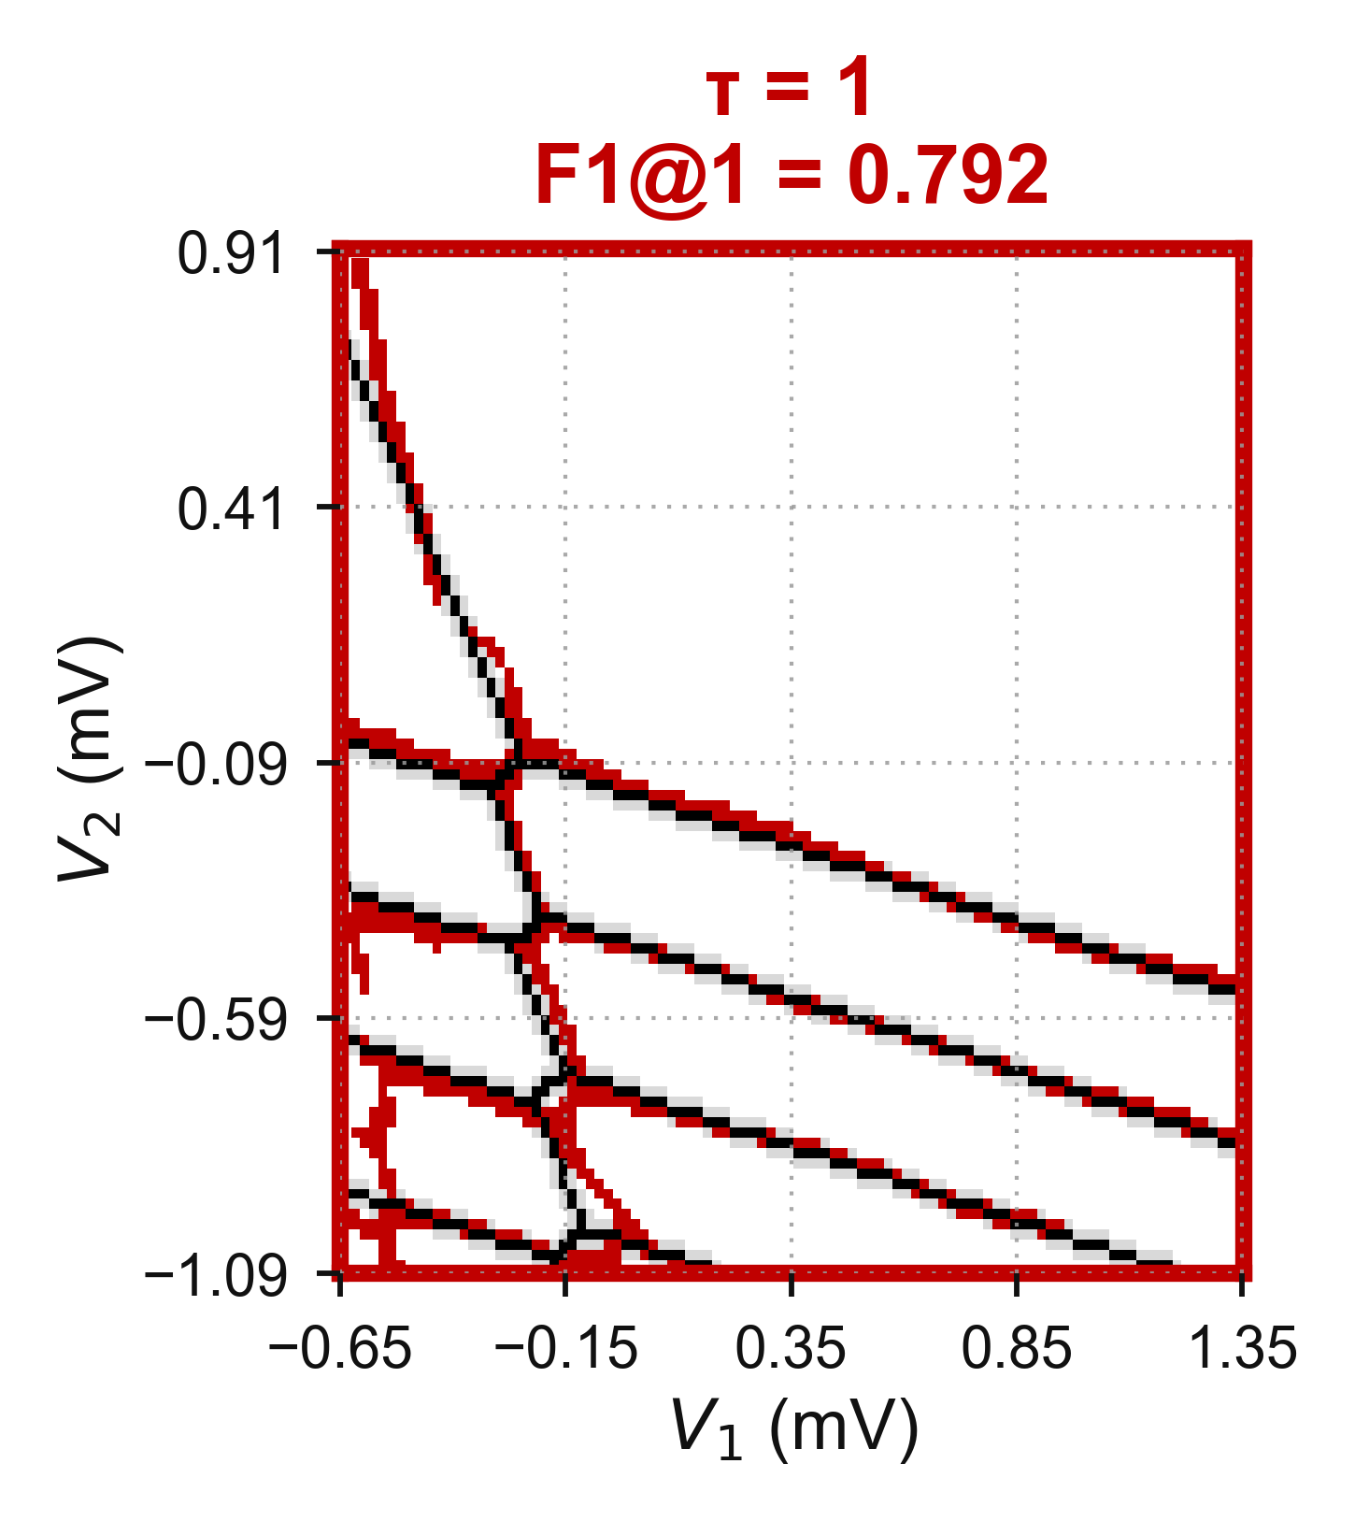
Fig. 8. The same prediction scored at tau = 1, the headline tolerance.

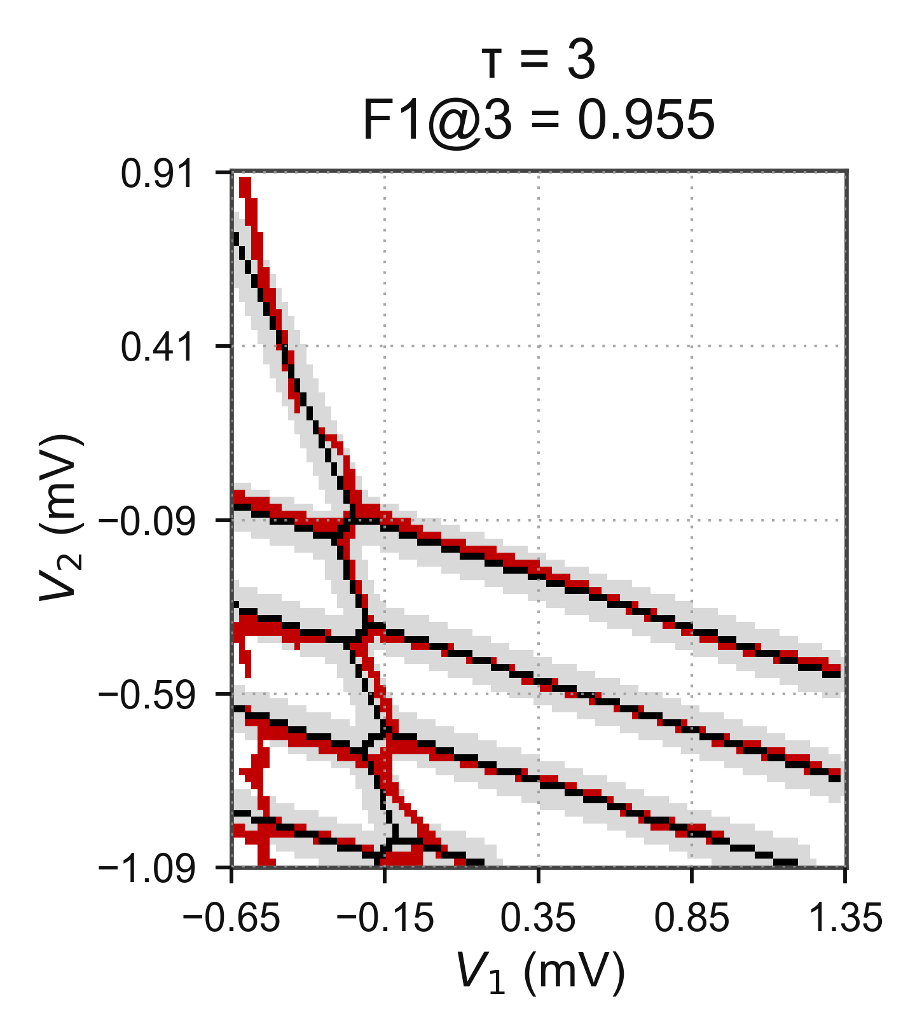
Fig. 9. The same prediction scored at tau = 3.

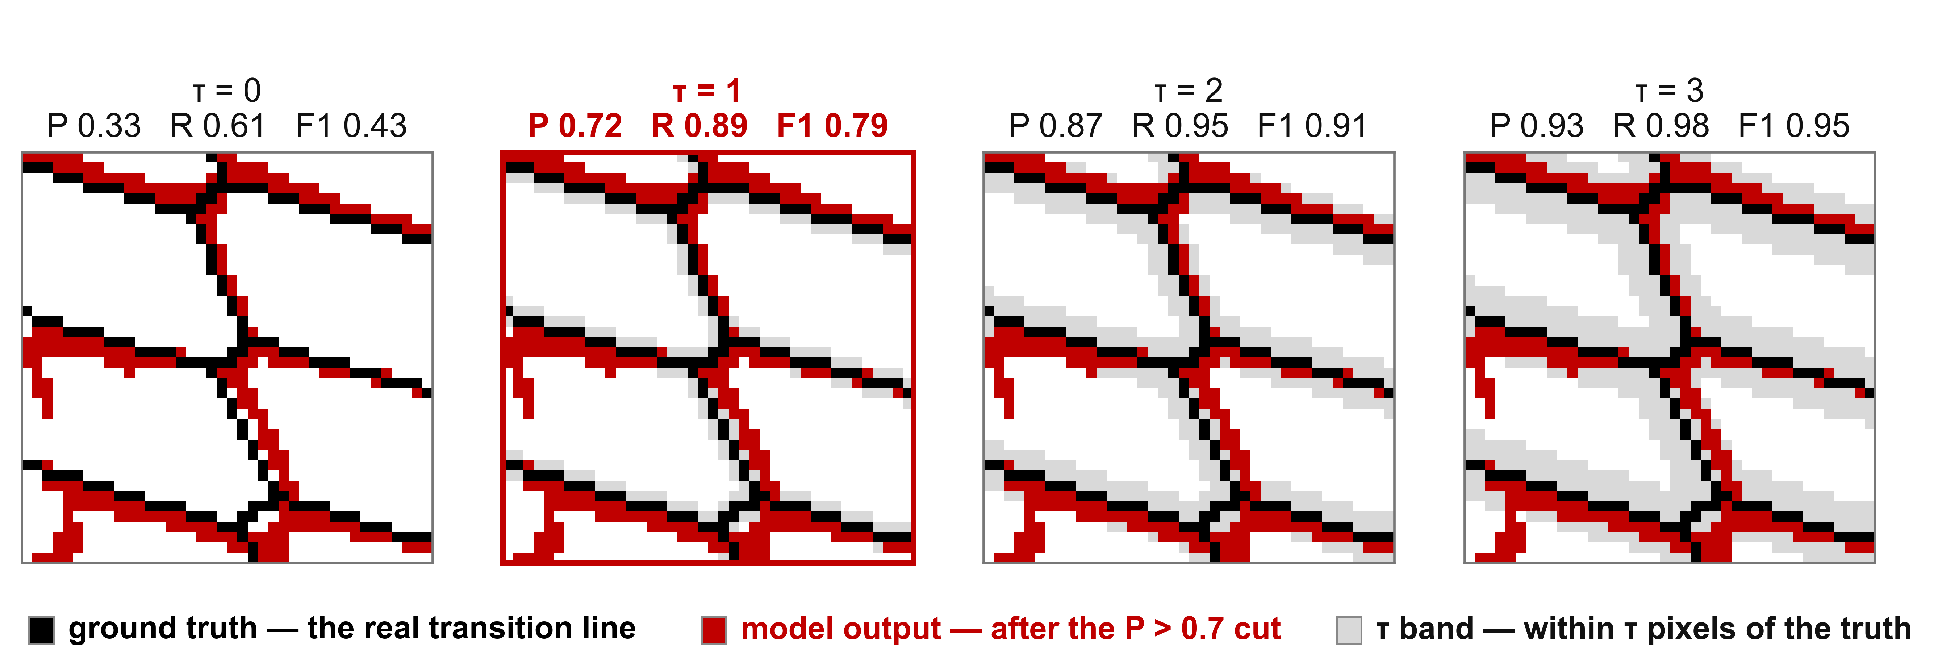
Fig. 10. The same truth and the same output at tau = 0 to 3, zoomed until individual pixels are visible. Only the tolerance band grows.

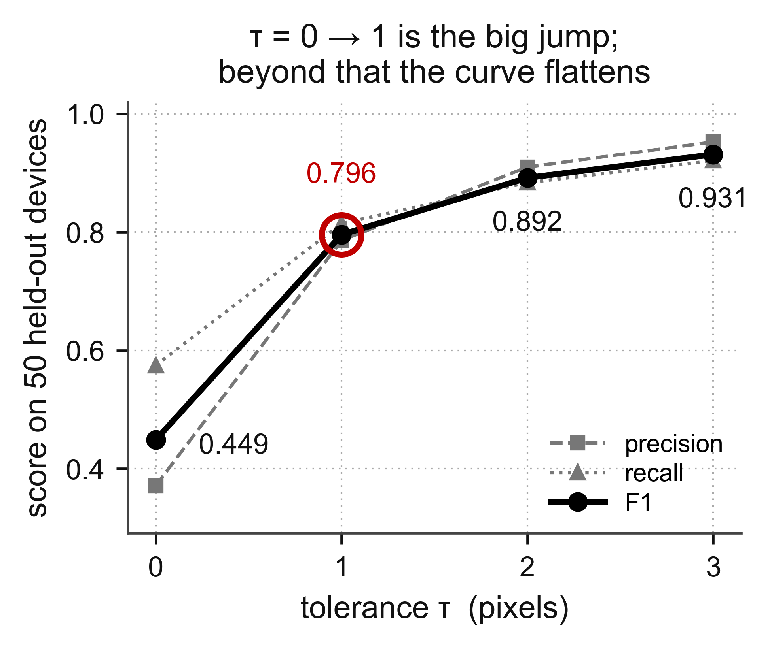
Fig. 11. F1 against tau for the headline budget, with the precision and recall behind it, over the 50 held-out devices.

