Part 1. Device simulation and dataset construction
We describe the simulated double-quantum-dot devices from which every charge stability diagram in this work is drawn, and the train/test split applied to them. 550 devices are generated from a constant-capacitance model with randomly drawn capacitances, each rendered as a 100 x 100 pixel charge-sensor map over a 2 x 2 mV gate-voltage window. The simulation is noise-free. Devices are split by device identity, not by image, so no device contributes to both sets.
1. The constant-capacitance model
Each device is a double quantum dot with a nearby charge sensor, simulated with QArray under the constant-capacitance model. In that model the dot array is a network of capacitors: the charge state of the dots is whichever integer occupation minimises the electrostatic energy at the applied gate voltages, and a transition line in the stability diagram is a locus where that minimiser changes. Four capacitance matrices define a device:
Cdd, the 2 x 2 dot-to-dot matrix, with the self capacitances d1d1 and d2d2 on the diagonal and the interdot capacitance d1d2 off it. Cgd, the 2 x 3 gate-to-dot matrix, whose rows are (d1g1, d1g2, d1g3) and (d2g1, d2g2, d2g3). Cds, the 1 x 2 dot-to-sensor matrix (s1d1, s1d2). Cgs, the 1 x 3 gate-to-sensor matrix (s1g1, s1g2, s1g3).
Three of these entries decide what the honeycomb looks like. The primary gate capacitances d1g1 and d2g2 set the honeycomb PERIOD, i.e. how many cells fall inside the window. The cross capacitances d1g2 and d2g1 set the SLOPE of the two line families, since a dot-1 line has slope -d1g1/d1g2 and a dot-2 line -d2g1/d2g2. The interdot capacitance d1d2 sets the ANTICROSSING, from barely split triple points to a long interdot segment.
The two line families stay distinguishable as long as each dot is driven mainly by its own plunger gate, that is max(cross) < min(primary). Table I satisfies this in every entry, 0.60 < 0.80, but nothing enforces it: the capacitances are drawn and whatever they produce is kept.
Every entry is drawn independently and uniformly from the intervals of Table I, so a device is a point in a 13-dimensional box rather than a perturbation of a template. NO DRAW IS FILTERED, CHECKED OR REDRAWN. A draw that lands somewhere unusual - the two dots merging into one, lines too dense to resolve on the pixel grid, no transition at all inside the window - is kept like any other, and the acceptance rate of the pool is therefore 1.00 by construction.
Table I. The capacitance parameter space. Every device is a single uniform draw from these intervals, in QArray's dimensionless capacitance units. The same intervals are used for the training and the held-out devices; the two sets are separated by device identity, not by parameter range (Table II).
Matrix | Entry | Interval | What it controls
Cdd | d1d1 | 0.30 - 1.40 | dot 1 self capacitance (charging energy)
Cdd | d2d2 | 0.30 - 1.40 | dot 2 self capacitance (charging energy)
Cdd | d1d2 | 0.20 - 2.00 | interdot capacitance: the anticrossing
Cgd | d1g1 | 0.80 - 6.00 | dot 1 primary gate: honeycomb period
Cgd | d2g2 | 0.80 - 6.00 | dot 2 primary gate: honeycomb period
Cgd | d1g2 | 0.05 - 0.60 | dot 1 cross gate: line slope
Cgd | d2g1 | 0.05 - 0.60 | dot 2 cross gate: line slope
Cgd | d1g3 | 0.01 - 0.10 | dot 1 residual coupling to gate 3
Cgd | d2g3 | 0.01 - 0.10 | dot 2 residual coupling to gate 3
Cds | s1d1 | 0.02 - 0.15 | dot 1 to sensor coupling
Cds | s1d2 | 0.02 - 0.15 | dot 2 to sensor coupling
Cgs | s1g1 | 0.02 - 0.10 | gate 1 to sensor cross-talk
Cgs | s1g2 | 0.02 - 0.10 | gate 2 to sensor cross-talk
Cgs | s1g3 | 0.10 - 1.00 | gate 3 to sensor cross-talk

The sensor response is computed with the noise model set to NoNoise and nothing is added afterwards, so the maps are noise-free. The Coulomb peak width is 0.01 and the electron temperature 1e-05 in simulation units.
Each device is rendered over a 2 x 2 mV window at 100 x 100 pixels. The window is randomly offset per device (offset scale 0.35), so the honeycomb is not registered to the frame and the network cannot learn a fixed position for the lines.
The raw sensor map is dominated by a large, smooth gate-to-sensor cross-talk background, with the charge transitions riding on it as a small modulation. Figure 1 shows the same device before and after that slow background is removed; the honeycomb is visible only in the second. This is the reason the reconstruction problem is not trivial.
2. Ground truth
For every device the simulator also returns the exact charge-transition map: a binary image, one pixel wide on each transition line. Transition-line pixels are 7.1 % of the diagram, which is what makes pixel accuracy useless as a score and motivates the metric of Part 4.
3. Train/test split
THE THING THAT IS SPLIT IS THE DEVICE, NOT THE IMAGE. Capacitance configurations are drawn first and each is given an identity; the identities are split once, with seed 12345, into 500 training and 50 held-out devices. Every image and every measurement budget inherits the identity of the device it came from, so a device's data always lands on one side of the split.
The split is stored with the device pool rather than with a configuration. Every cell of a sweep therefore reads the same stored assignment, and a device cannot be a training device for one measurement budget and a test device for another.
A further 15 % of the TRAINING devices (75 of 500) is set aside before any training as a validation split, leaving 425 to fit the weights. This validation split is where the binarisation threshold of Part 4 is chosen. The 50 held-out devices are never used for any decision.
Because both sets are drawn from the same intervals, the split is not an extrapolation test and is not claimed to be one. What it does claim is that no held-out device is a near-duplicate of a training device, and that is measured rather than asserted. In the 14-dimensional normalised parameter space, the closest any held-out device lies to any training device is 0.605, while the closest any two TRAINING devices lie to each other is 0.502. The held-out devices are therefore no closer to the training set than its own members are to one another, which is the relevant yardstick. Table II collects the split and this evidence.
Table II. The train/test split and its separation evidence. Distances are Euclidean in the normalised parameter space and are computed over the generated devices, not over the intervals.
Quantity | Value
Devices generated | 550
Training devices | 500
of which fit the weights | 425
of which validation | 75
Held-out (test) devices | 50
Split performed on | device identity (not image)
Split seed | 12345
Parameter intervals | identical for both sets
Parameter-space dimensions | 14
Min. train-to-test distance | 0.605
Mean nearest train-to-test distance | 0.781
Min. train-to-train distance (yardstick) | 0.502
Devices shared between sets | 0 (checked by ID and by hash)

Figure 2 shows the two levels of the split.

Figures
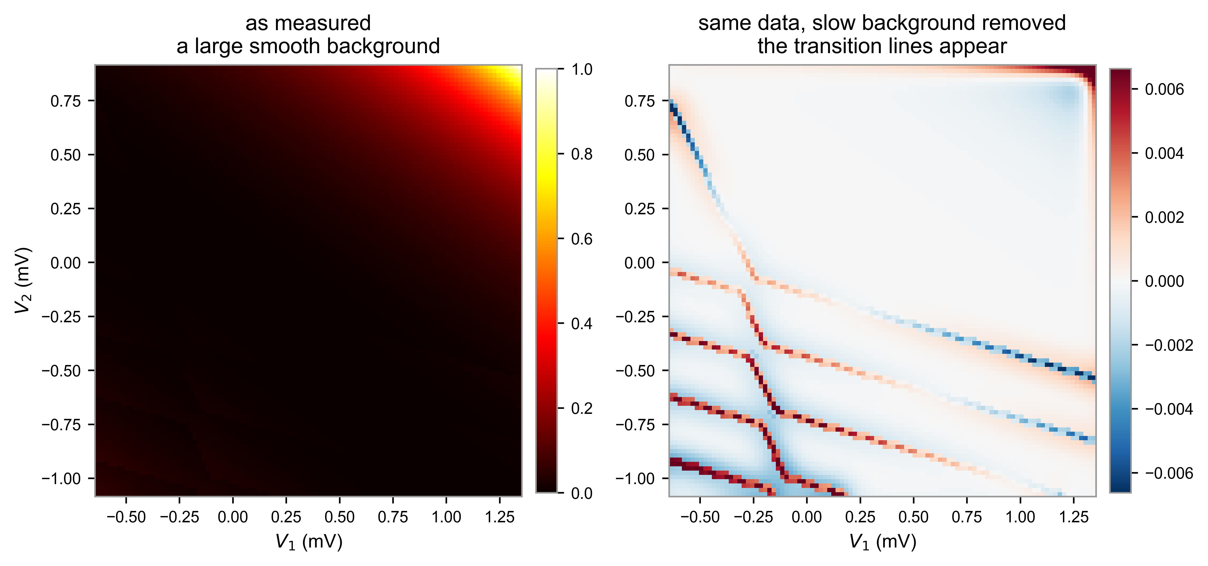
Fig. 1. One simulated device. Left: the charge-sensor map as measured, dominated by a smooth gate cross-talk background. Right: the same data with that slow background differenced away, where the honeycomb of charge transitions becomes visible.

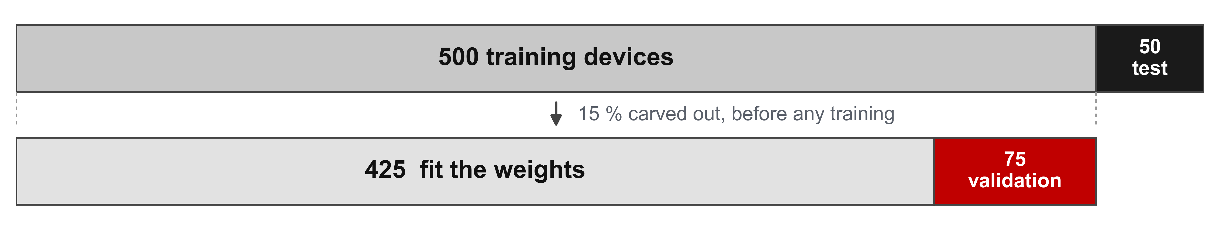
Fig. 2. The train/test split. 550 devices are divided by device identity into 500 training and 50 held-out devices (seed 12345). Inside the training devices, 15 % is carved out as a validation split before any training, leaving 425 devices to fit the weights.

