Part 2. Ray-based measurement and network input
We describe how a small fraction of the gate-voltage plane is measured and how those measurements are presented to the network. A fan of rays is fired from one corner of the window; each ray is sampled at a fixed number of points. For the headline budget of 8 rays x 50 points this touches 3.88 % of the plane. The measurement is encoded as two image channels: the measured signal where a ray passed, and a binary mask of where any ray passed.
1. The ray fan
A measurement budget is a pair: n_rays x n_points. The rays fan out from one corner of the voltage window at equally spaced angles, and each ray is sampled at n_points equally spaced positions along its length. The budget is therefore the total number of single-point measurements, which is the quantity an experiment pays for.
Sampling is nearest-cell: a measured voltage is assigned to the pixel whose centre is closest. Because all rays share an origin, the first point of every ray falls in the same pixel, and adjacent rays can round into the same cell one step out. The number of DISTINCT pixels touched is therefore slightly smaller than the number of measurements: 8 x 50 = 400 measurements touch 3.88 % of the 100 x 100 grid. Coverage is quoted as distinct pixels throughout, since repeating a pixel adds no information.
Along each ray the one-dimensional trace is passed to a peak finder, whose output is retained for the measurement figures but is NOT given to the network.
Figure 1 shows the charge sensor, the ground truth and what the measurement actually sees, for one held-out device.
2. Encoding the measurement
The network is given two channels, both the full size of the diagram. Channel 1 carries the raw sensor value at every pixel a ray visited and zero elsewhere. Channel 2 is a binary visited mask: one where any ray passed, zero otherwise.
The second channel is what separates "measured here, and the signal was low" from "never looked here". Without it a zero in channel 1 is ambiguous at every pixel, and the network cannot distinguish absence of evidence from evidence of absence. Figures 2 and 3 show the two channels for the same device.
The encoding has a property the study depends on: the input shape is the same for EVERY budget. Changing n_rays or n_points changes how much of the two channels is populated, never their size, so one architecture serves every budget and the comparison across budgets is a comparison of measurement alone.

Figures
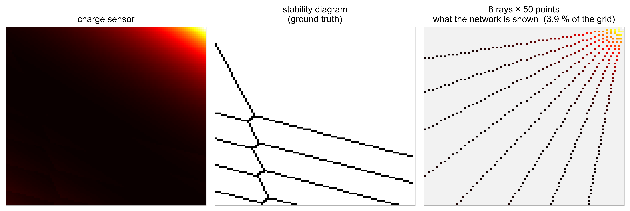
Fig. 1. The measurement, for one held-out device. Left: the charge-sensor map. Centre: the ground-truth transition lines. Right: what the network is shown at 8 rays x 50 points, which is 3.9 % of the grid.

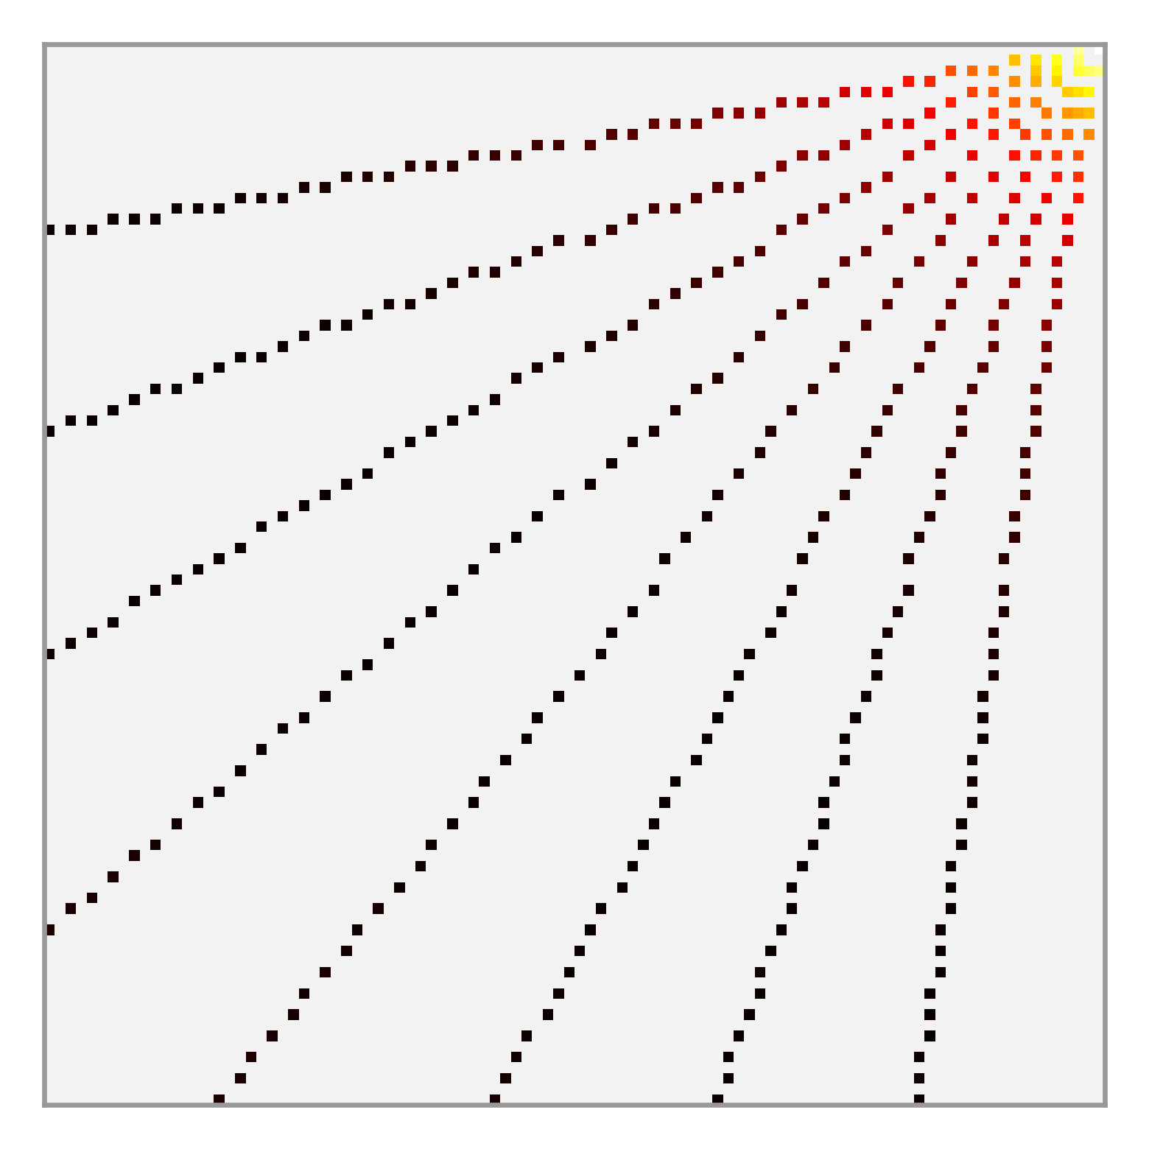
Fig. 2. Channel 1: the measured charge-sensor signal, retained only at the pixels a ray visited.

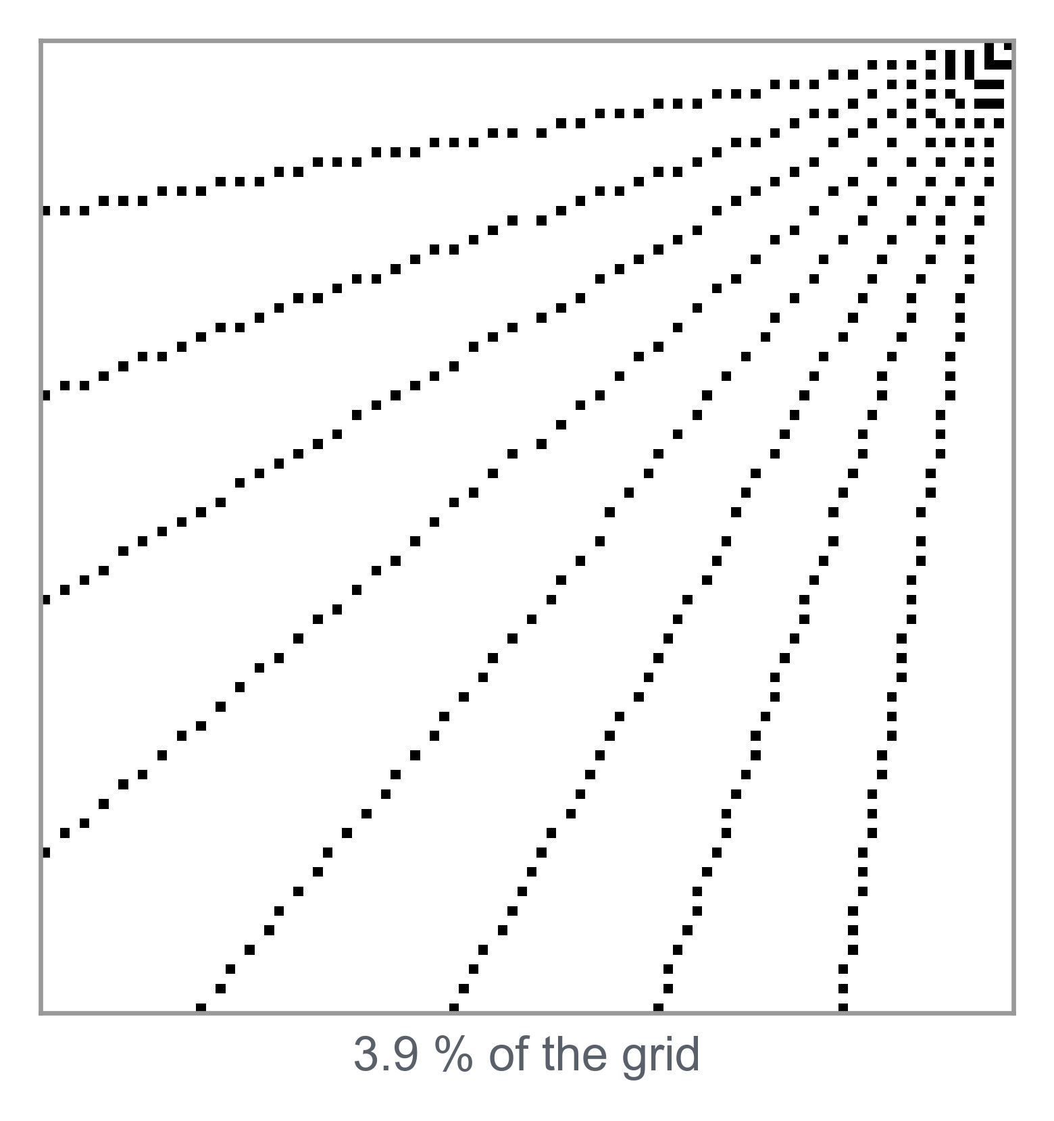
Fig. 3. Channel 2: the visited mask. Black marks every pixel a ray passed through, 3.9 % of the grid.

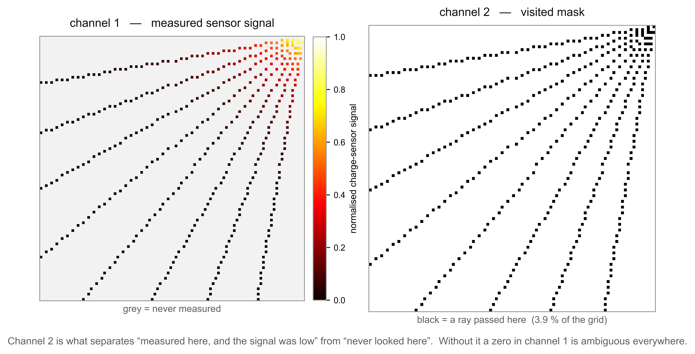
Fig. 4. The two input channels side by side. Channel 2 is what makes a zero in channel 1 unambiguous.

