Part 3. Network architecture and training
We describe the network that maps the two measured channels to one probability per pixel, and how it is trained. The network is a U-Net of depth 3 with channel widths 32/64/128/256. The loss combines a positive-weighted binary cross-entropy with a soft Dice term, which is necessary because transition-line pixels are only 7.1 % of the diagram. Training uses Adam at a learning rate of 0.001, batch size 16, for 50 epochs.
1. Architecture
The network is a U-Net taking 2 channels in and producing 1 channel out, at the same 100 x 100 resolution. The encoder has three stages of widths 32/64/128, each a convolutional block followed by 2x2 max pooling; the bottleneck has width 256. The decoder mirrors the encoder, upsampling by nearest-neighbour resize to the skip tensor's actual size and concatenating the skip connection before each block. A 1x1 convolution produces the single output channel.
Resizing to the skip tensor's own size rather than by a fixed factor is what lets the same architecture run on a grid whose size is not a power of two.
The output is a probability per pixel that a charge-transition line passes through it. The network never outputs lines directly; turning the probability map into lines is a separate decision, described in Part 4. Figure 1 is the architecture and Figure 2 the whole flow, from the two measured channels to the probability map.
2. Loss
Transition-line pixels are 7.1 % of the diagram, so a network that predicts no line anywhere already achieves high pixel accuracy. Two measures counter this. The binary cross-entropy weights the positive class by its rarity, capped at 8 so that an unusually sparse device cannot dominate a batch. A soft Dice term is added because weighted cross-entropy alone judges pixels one at a time and is satisfied by a blanket of positives; Dice penalises the spread.
3. Optimisation
Adam, learning rate 0.001, batch size 16, 50 epochs, seed 0. The seed fixes both the weight initialisation and the order in which batches are drawn, so two runs differing only in this seed see exactly the same data in the same order.
The checkpoint saved is the epoch with the best validation F1, NOT the last epoch. This matters when reading a training log: a run can end on a high last-epoch loss and still have saved a good model.

Figures
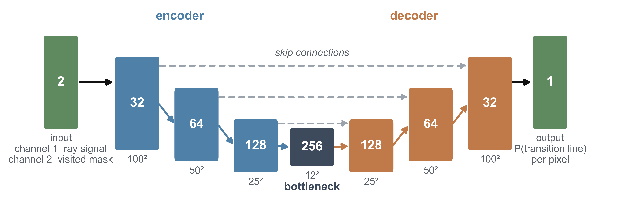
Fig. 1. The network. Two input channels, an encoder of widths 32/64/128 with 2x2 max pooling, a bottleneck of width 256, a mirrored decoder with skip connections, and a 1x1 convolution to one output channel.

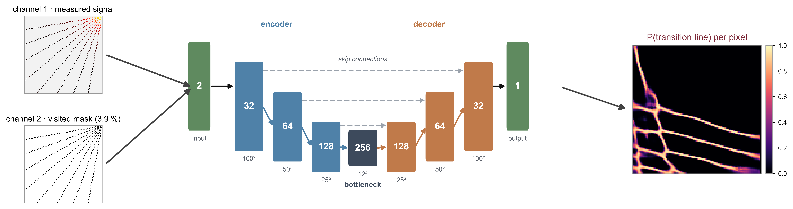
Fig. 2. The whole flow: the two measured channels in, the U-Net, and one probability per pixel out.

