Part 5. Results
We report the recovery of charge-transition lines as a function of the measurement budget, on 50 held-out devices. The best budget that converged is 8 rays x 50 points: F1 at tau = 1 of 0.796 from 3.88 % of the gate-voltage plane, at a threshold of 0.7 chosen on the validation split. Of the 15 budgets in the sweep, 4 did not converge and are excluded from the trend.
1. Recovery against measurement budget
Figure 1 plots F1 at tau = 1 against the fraction of the plane measured. Within a fixed number of points per ray, the score rises monotonically with the number of rays. The best converged budget, 8 rays x 50 points, reaches F1 at tau = 1 of 0.796 from 3.88 % of the plane, with precision 0.786 and recall 0.815.
At equal coverage, spending the budget on MORE RAYS beats spending it on more points per ray. Figure 1 shows the comparison directly rather than asserting it: at the same fraction of the plane measured, the budget with more rays scores higher.
Strict IoU for the headline budget is 0.295. One-pixel-wide lines are punished hard by IoU and it is reported rather than hidden.
2. Dependence on tolerance
Figure 2 reports pixel accuracy, precision, recall, F1 and grid coverage against tau for three budgets. F1 rises from 0.449 at tau = 0 to 0.796 at tau = 1, then flattens to 0.892 at tau = 2 and 0.931 at tau = 3. Most of the remaining error is therefore sub-pixel placement of a line that WAS found, rather than a line that was missed.
The rightmost panel of Figure 2 is the cost of that tolerance. Coverage rises from 3.88 % at tau = 0 to 17.85 % at tau = 1 for the headline budget. The improvement from tau = 0 to tau = 1 is therefore bought with a several-fold increase in the area the score is read over, which is why tau = 1 rather than a larger value is quoted as the headline.
Pixel accuracy is included in Figure 2 only so that it can be dismissed: it exceeds 0.9 at every tolerance and for every budget, because transition lines are 7.1 % of the diagram and predicting no line anywhere already scores highly. It is not used as a result.
3. Runs that did not converge
4 of the 15 budgets in this sweep did not converge. Their best validation F1 at tau = 1 lands near 0.42, where every other run in the sweep reaches at least 0.66, and their test scores follow. These are the scores of a failed fit and not of the measurement budget; they are excluded from the trend in Figure 1 and reported separately rather than dropped, so that the gap in the sweep is visible.

Figures
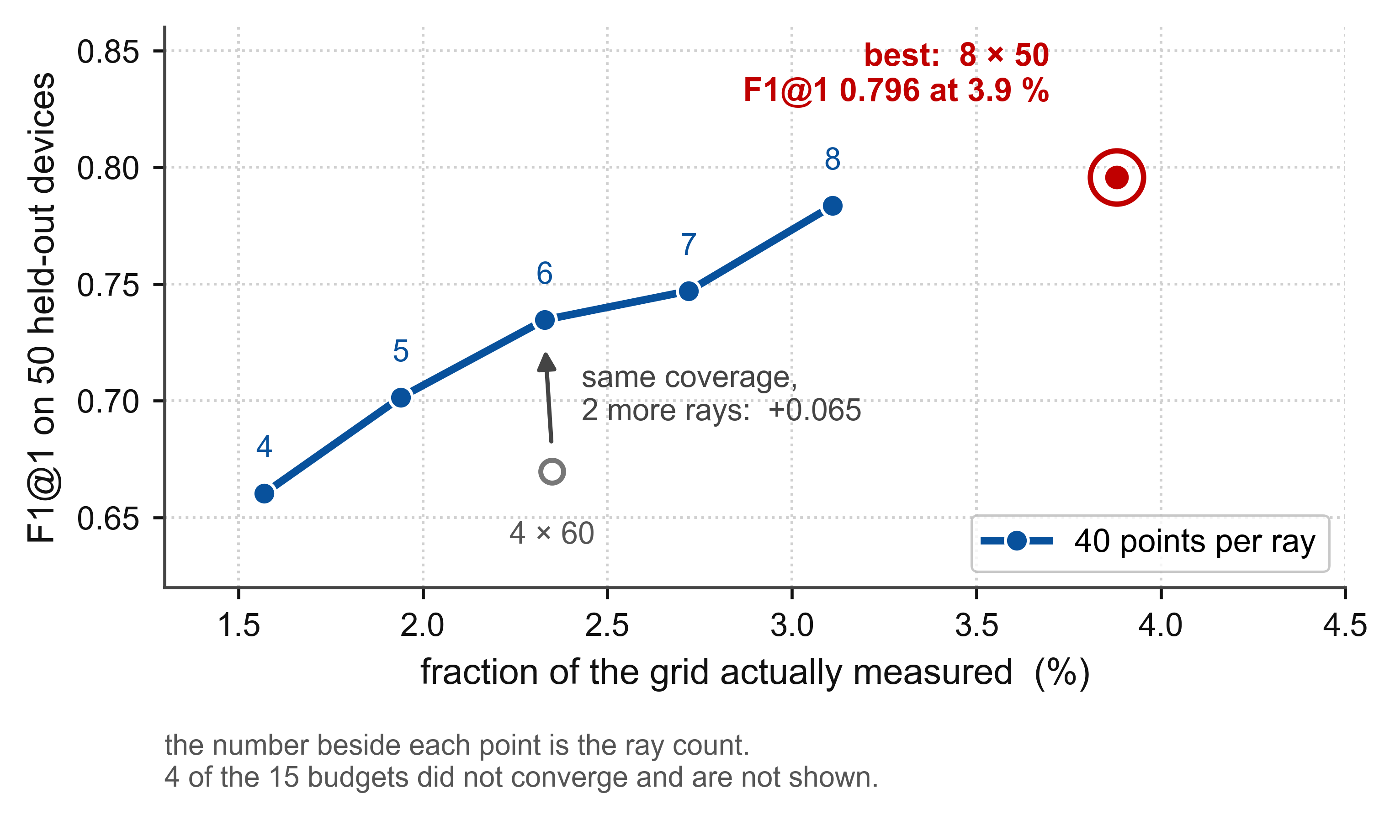
Fig. 1. F1 at tau = 1 against the fraction of the plane measured. The line is the 40-points-per-ray ladder; the number beside each point is the ray count. The best converged budget is ringed. The open marker is a same-coverage comparison showing that more rays beats more points per ray. 4 budgets that did not converge are not shown.

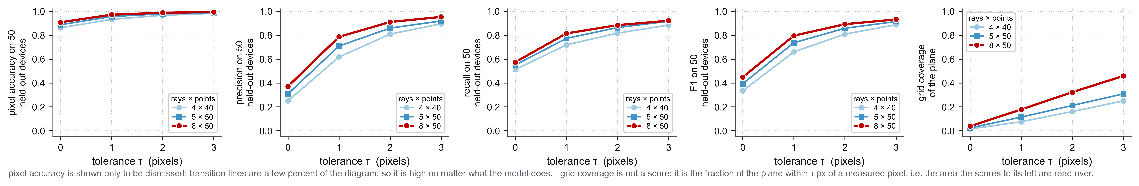
Fig. 2. Pixel accuracy, precision, recall, F1 and grid coverage against the tolerance tau, for three budgets, on 50 held-out devices. Pixel accuracy is shown only to be dismissed. Grid coverage is not a score: it is the fraction of the plane within tau pixels of a measured pixel, i.e. the area the scores to its left are read over.

