1A. Identify the hardware [4 points]
1. Choose one historical photograph or the lecture’s labeled conceptual plan view. Record its source. Label the aft horizontal tail, aft vertical tail, wing-tip vane, and one control-linkage route. If a component is hidden in your photograph, say “not visible in this view” and add a separate labeled sketch.
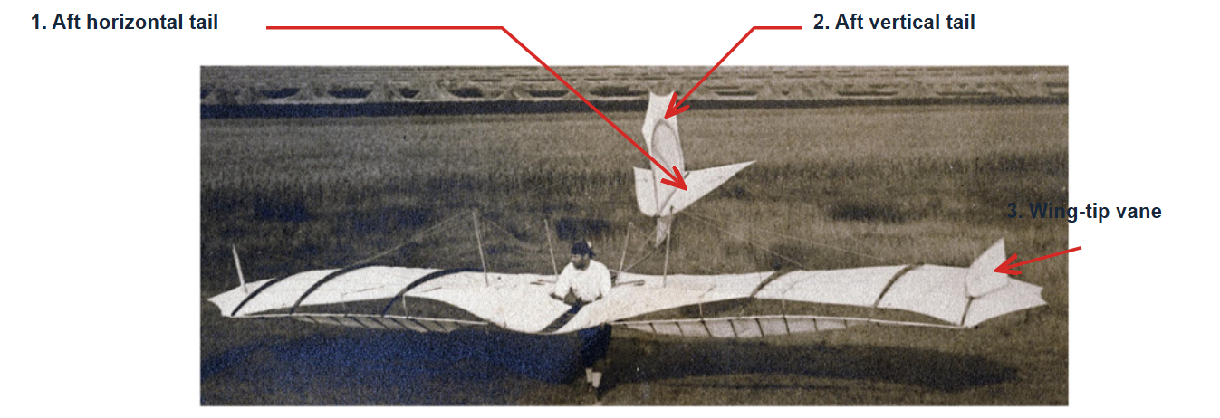
Control-linkage route: not fully visible in this view.
Source: Raffel et al., Flight Controls of Otto Lilienthal's Experimental Monoplane from 1895. (Fig. 1)
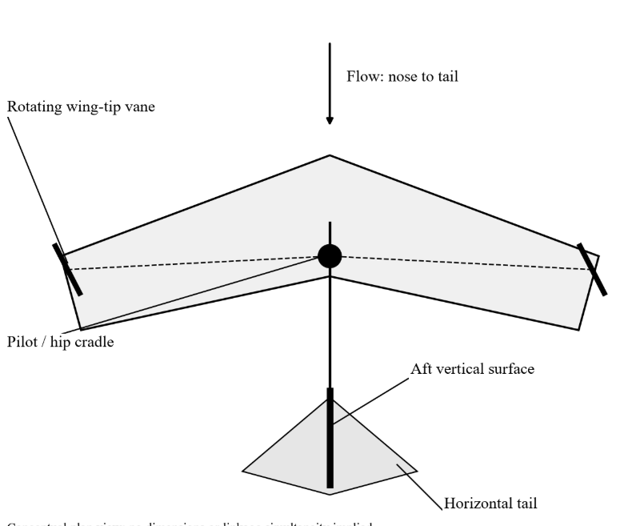
The dashed lines from the “Pilot/hip cradle” location to the wing-tip vanes schematically show the control-linkage path. The pilot’s hip cradle movement is transmitted through the control levers and rods, then through a wire, to the wing-tip vane.
Source: MIE 446, Lecture 01: From Airfoil Geometry to Trustworthy Wing Loads, Section 7A-3a
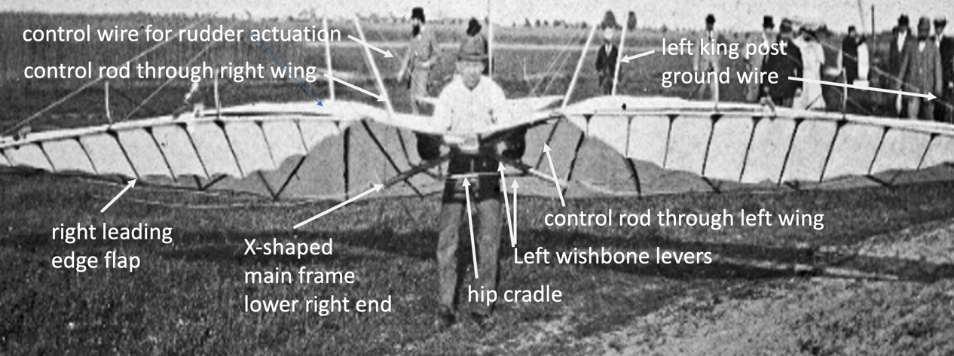

- Hip cradle: A support around the pilot’s hips that transmits the pilot’s body movement into the control mechanism.
- Left wishbone levers: Forked levers that transmit the motion.
- Control rod through left/right wing: Control rods passing through the wings.
- Control wire for rudder actuation: A wire that transmits the control input to move the rudder.
This photograph documents the control-linkage path to the aft rudder; the linkage to the wing-tip vane is not visible in this view.
Source: Raffel et al., Flight Controls of Otto Lilienthal's Experimental Monoplane from 1895. (Fig. 2)
2. Write two or three sentences distinguishing tail presence, surface motion, and control purpose. Explain why the existence of a wing-tip rudder does not imply absence of an aft tail.
Tail presence refers to the aircraft’s physical configuration, surface motion describes how a surface moves or deflects, and control purpose identifies the intended effect, such as pitch, roll, or yaw. The presence of a tail surface does not necessarily mean that it is independently movable or operates like a conventional modern control surface. A wing-tip rudder does not imply the absence of an aft tail: Lilienthal’s 1895 Experimental Monoplane had both horizontal and vertical aft tail surfaces as well as wing-tip control vanes.
1B. Extract and interpret six pairs of coefficients [7 points]
1-4 At angles of attack of 6°, 10°, and 14°, read the centers of the filled-circle markers (90° spoileron) and cross markers (wing warping) in Figures 11 and 12, excluding the open-square rudder markers and dashed trend lines, and use the nearest grid ticks to enter the six readings in rows 7–12 of the Excel Paper sheet, with angle and mechanism in columns A/B, roll and yaw coefficients in C/D, separate reading tolerances where needed in E, and figure/marker notes in F, preserving the plotted signs and reporting appropriate precision.

Alpha (deg) | Mechanism | Roll c_{l} | Yaw c_{n} | Reading tolerance
6 | Wing warping | 0.035 | -0.12 | accept roll ±0.002; yaw ±0.03 to ±0.05
10 | Wing warping | 0.039 | -0.26 | accept roll ±0.002; yaw ±0.03 to ±0.05
14 | Wing warping | 0.052 | -0.32 | accept roll ±0.002; yaw ±0.03 to ±0.05
6 | Spoileron 90 deg | 0.009 | 0.07 | accept roll ±0.002; yaw ±0.03 to ±0.05
10 | Spoileron 90 deg | 0.011 | 0.5 | accept roll ±0.002; yaw ±0.03 to ±0.05
14 | Spoileron 90 deg | 0.017 | 0.89 | accept roll ±0.002; yaw ±0.03 to ±0.05

5- Explain the observed difference between the two mechanisms’ roll–yaw coupling over these selected points. For each mechanism, do roll and yaw have the same sign or opposite signs, and how does Section II.C explain it? Cite the figure and the test configuration (model, tunnel, flow speed) from the opening of Section II. Do not claim a universal response at every angle of attack or every spoileron deflection.
As shown by the measured markers in Figures 11 and 12 and explained in Section II.C of Raffel et al., at the selected angles of attack of 6°, 10°, and 14°, the spoileron deflected by 90° produces roll and yaw moment coefficients with the same sign, so yaw acts in the intended turn direction (proverse yaw). In contrast, wing warping produces roll and yaw moment coefficients with opposite signs (adverse yaw). This difference arises because the spoileron decreases lift and increases drag, whereas wing warping, in the tested configuration, decreases both.
The spoileron reduces lift and increases drag on the actuated wing; consequently, that wing tends to drop, and the nose tends to turn toward the same side. For the tested wing-warping mechanism, pulling the leading edge inward reduces the wing’s local angle of incidence, decreasing both lift and drag. The lift reduction causes that wing to drop, while the drag reduction produces yaw in the opposite direction.
Test conditions: The right half of a 1:5-scale model of Lilienthal’s Experimental Monoplane was mounted directly on a force-and-moment balance in the DLR–1MG one-meter low-speed wind tunnel. The flow velocity was 8.5 m/s. These conclusions apply only to the selected angles of attack and the tested control configurations; they should not be generalized to all angles of attack or spoileron deflections.
1C. Compare two modern examples [4 points]
Choose one of MQ-9 or X-48B and one of X-36, X-47B, or MAGMA from the notebook. Make a two-row table with: aircraft; visible tail/canard/winglet arrangement; one documented control mechanism; physical quantity it changes; and structure receiving the reaction. Cite the relevant notebook section and its linked source; if a photograph alone cannot establish a mechanism, state that limitation instead of guessing.
For this section, we select X-48B from the first group and X-36 from the second group. The required two-row table is completed as follows:
Aircraft | Tail, canard, or winglet arrangement | One documented control mechanism | Physical quantity it changes | Structure receiving the load and reaction
X-48B | Blended wing–body configuration without a conventional aft empennage; vertical fins and rudders at the wingtips, with no canard. | Winglet rudders at the wingtips | Rudder deflection changes the pressure distribution and side force on the vertical surface, producing a yawing moment through its moment arm relative to the center of gravity. | Loads pass from the rudder through the hinges and actuator attachments, then into the winglet root and wing structure, where they can produce bending and torsion.
X-36 | No conventional aft horizontal or vertical tail; a canard ahead of the main wing. | Thrust-vectoring nozzle | Changes the direction of the thrust vector and therefore the components of the propulsive force; acting through a moment arm relative to the center of gravity, this force produces a control moment. | Reactions are transmitted into the nozzle assembly, engine mounts, and supporting fuselage structure.
NASA documents wingtip rudders on the X-48B and a thrust-vectoring nozzle on the X-36; the load-path descriptions follow the structural interpretation presented in the lecture notebook.
Use the following references in the report:
- X-48B: Lecture 1 notebook, Section 7A-9; linked source: NASA X-48 fact sheet, second page, X-48B description.
- X-36: Lecture 1 notebook, Section 7A-10; linked source: NASA X-36 overview, Technical Specifications section.
Evidence limitation: The photographs show the overall aircraft configuration; a single still photograph cannot establish the active control command, rudder or nozzle deflection, or control allocation among actuators. Identification of the mechanisms in this table relies on the written sources.

3A. Sketch and predict [6 points]
1. Draw one plan view and one rear view that show all three cases together. Mark the CG, positive axes, the three application points labeled A, B, and C, each force arrow, and its extended line of action. Sketches may be schematic; write the actual offsets beside the points.
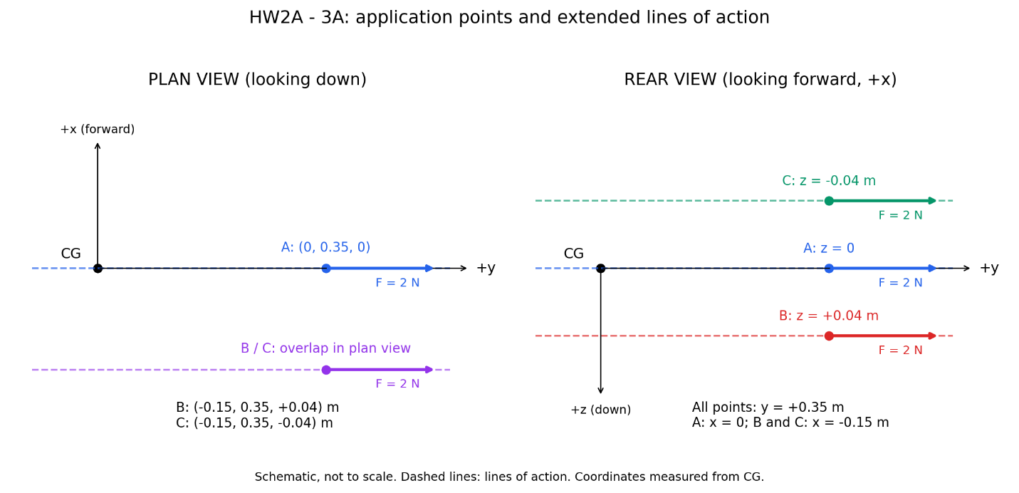
In the figure, the dashed lines extend the forces’ lines of action. In the plan view, points B and C overlap because they differ only in height; this difference is visible in the rear view. The drawing is schematic, with the actual offsets labeled beside the points.
2. Without multiplying numbers, predict which moment components are zero and the signs of the nonzero components. State which component should reverse between B and C and why.
Case | Roll (Mx) | Pitch (My) | Yaw (Mz)
A | Zero | Zero | Zero
B | Negative; the right wing tends to rise | Zero | Negative; the nose tends to turn left
C | Positive; the right wing tends to drop | Zero | Negative; the nose tends to turn left
Reasons for the predictions:
- A: Although the force application point is offset from the center of gravity, the extended line of action passes through the center of gravity. Therefore, the perpendicular moment arm is zero, and no moment is produced about the center of gravity.
- B: The rightward force acts below the center of gravity, producing a negative rolling moment. Since it also acts aft of the center of gravity, it pushes the rear of the aircraft to the right, causing the nose to tend left—a negative yawing moment.
- C: The force acts above the center of gravity, so the rolling moment reverses relative to B. However, it still acts aft of the center of gravity, so the yawing moment remains negative.
Only the roll component changes sign between B and C, because only the sign of the vertical coordinate z changes. The pitching moment is zero in all three cases: a force parallel to the y-axis cannot produce a moment about that same axis.
3B. Calculate three ways [9 points]
- Use the three component formulas in the coordinate-convention section. Show the substituted numbers for Case B by hand, including units; tabulate A/B/C.
Case B by hand:
$M_{x}=yF_{z}-zF_{y}=\left(0.35\right)\left(0\right)-\left(0.04\right)\left(2\right)=-0.08 N​⋅​m$;
$M_{y}=zF_{x}-xF_{z}=\left(0.04\right)\left(0\right)-\left(-0.15\right)\left(0\right)=0$;
$M_{z}=xF_{y}-yF_{x}=\left(-0.15\right)\left(2\right)-\left(0.35\right)(0)=-0.30 N​⋅​m$.
For the given force,
$$F=\left(0,2,0\right) N, r=\left(x,y,z\right),$$
we obtain
$$M=r×F=\left(-2z, 0, 2x\right).$$

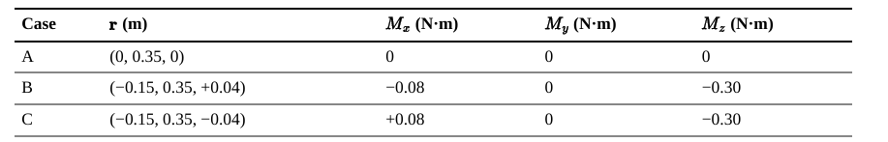
$M_{x}$ reverses between B and C because only the vertical offset changes sign.
- In MATLAB starter Section 3, the rows of rCases are A/B/C. In the loop, rCases(j,:) selects the current row. Replace the TODO with cross(rCases(j,:), Fside). Compare all components against the hand calculation.
The following MATLAB command checks the moment :
r_proposed = [-0.15, 0.35, 0]; % m
Fside = [0, 2, 0]; % N
M_proposed = cross(r_proposed, Fside)
The expected output is:
M_proposed =
0 0 -0.3000
Thus, (M_x=0), (M_y=0), and (M_z=-0.30). The force produces no rolling or pitching moment, but creates a negative yawing moment with a nose-left tendency.
- In Excel Controls, rows 7:9 contain the same cases. Columns B/C/D hold x/y/z; E/F/G hold Fx/Fy/Fz. Enter the formulas below in row 7 and fill through row 9.
H7 (Mx): =C7*G7-D7*F7; I7 (My): =D7*E7-B7*G7; J7 (Mz): =B7*F7-C7*E7. Fill H7:J7 down through row 9. All moments are in N m.
The three routes agree to machine precision.
3C. Explain the geometry [5 points]
(i)Why is the outboard distance y = 0.35 m not sufficient by itself to create roll from this force?
This offset is parallel to the force direction; the moment arm must be a perpendicular distance to the force’s line of action. So, the roll moment-arm magnitude is $|z|$.To produce a rolling moment about the $x$-axis, this lateral force must act above or below the center of gravity, meaning $z≠0$.
Therefore, in case A, even though $y=0.35 m$, the line of action passes through the center of gravity, and the moment is zero, although the force does not.

(ii) Which perpendicular arm controls roll and which controls yaw?
Moment | Expression for this force | Relevant offset
Roll | $$M_{x}=-2z$$ | Vertical offset $z$
Yaw | $$M_{z}=2x$$ | Fore–aft offset $x$
Pitch | $$M_{y}=0$$ | Always zero for this purely lateral force
The moment-arm magnitudes are $\left|z\right|$ and $\left|x\right|$, respectively; the signs of the coordinates determine the directions of the moments.
(iii) Give one application point that produces nonzero yaw but zero roll for this same force. Verify your proposed point with cross.
Choose $z=0$ and $x≠0$. For example,$r=\left(-0.15, 0.35, 0\right) m.$
This point is at the same height as the center of gravity, 15 cm aft of it and 35 cm to its right:
$$M=\left(-2\left(0\right), 0, 2\left(-0.15\right)\right)=\left(0, 0, -0.30\right) N m.$$

