HW 3 Solution: Three beams under distributed loads

Given data:
$$L = 450 mm, b = 16 mm, h = 8 mm, E = 2200 N/mm²$$

Therefore:
$$A = bh = 128 mm^{2} , I = \frac{bh³}{12} = 682.67 mm⁴; EI = 1,501,866.67 N mm²$$

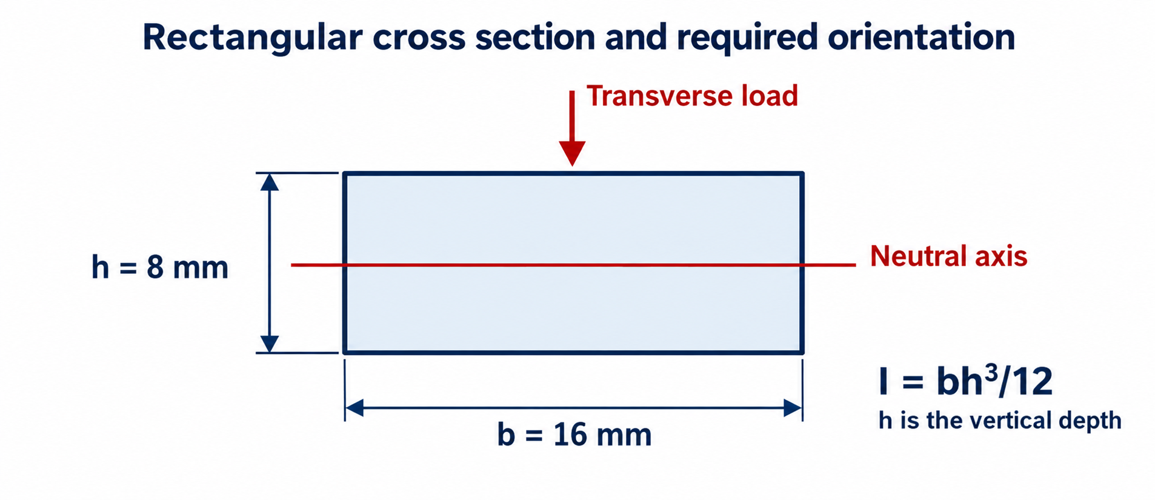
Figure 1. Rectangular cross section used for all three beams. The 8 mm dimension is vertical and parallel to the applied load.
R is positive downward. C is an external support couple, positive clockwise. The distributed load w and displacement v are positive downward; θ = dv/dx is positive clockwise. Internal M is positive in sagging. A is the left end, and B is the right end.

A1 Resultant force and location
$$F_{h} = \int_{0}^{L}{w(x) dx}, M_{load,A} = \int_{0}^{L}{x w(x) dx}, x̄ = \frac{M_{load,A}}{F_{h}}$$
$M_{load,A}$ is the clockwise moment of the downward distributed load about A. It is an applied-load moment, not the internal bending moment M(x). All distances are measured from the left end A; the right end B is at x = L.

Case 1: Triangle increasing toward B
$wₜ=0.002$ $N$/$mm$
$$w(x) = w_{t} \frac{x}{L}$$
$$F_{h} = \int_{0}^{L}{w_{t} \frac{x}{L} dx} = \frac{w_{t} L}{2} = 0.45 N$$
$$M_{load} = \int_{0}^{L}{x w_{t} \frac{x}{L} dx} = \frac{w_{t} L²}{3} = 135 N·mm$$
$$x̄ = \frac{M_{load}}{F_{h}} = \frac{2L}{3} = 300 mm$$

Case 2: Trapezoidal load
$wᵣ=0.001 N/mm, wₜ=0.002 N/mm$
$$w(x) = w_{r} + (w_{t} - w_{r}) \frac{x}{L}$$
$$F_{h} = \int_{0}^{L}{w(x) dx} = \frac{L(w_{r} + w_{t})}{2} = 0.675 N$$
$$M_{load} = \int_{0}^{L}{x w(x) dx} = \frac{L²(w_{r} + 2w_{t})}{6} = 168.75 N·mm$$
$$x̄ = \frac{L(w_{r} + 2w_{t})}{3(w_{r} + w_{t})} =168.75/0.675 = 250 mm$$

Case 3: Triangle decreasing toward B
$$w₀=0.002 N/mm$$
$$w(x) = w_{0} (1 - x/L)$$
$$F_{h} = \int_{0}^{L}{w_{0} (1 - x/L) dx} = w_{0}L - \frac{w_{0}L}{2}=\frac{w_{0} L}{2} = 0.45 N$$
$$M_{load} = \int_{0}^{L}{x w_{0} (1 - x/L) dx} = \frac{w_{0}L²}{2} - \frac{w_{0}L²}{3} =\frac{w_{0} L²}{6} = 67.5 N·mm$$
$$x̄ = \frac{M_{load}}{F_{h}} = \frac{L}{3} = 150 mm$$

A2 Equilibrium and support reactions

Case 1: Cantilever
$$ΣFₓ = 0 ⇒ R_{Ax} = 0$$
$$ΣFᵧ = 0: R_{A}+ 0.450 = 0 ⇒ R_{A} = -0.45 N$$
$$ΣMₐ = 0: C_{A}+ 0.45(300) = 0$$
$$C_{A} = -135 N·mm$$
A supplies an upward force and a counterclockwise couple. B is free, so it has no support reaction. The horizontal reaction at A is zero.

Case 2: Left roller and right pin
$$C_{A} = C_{B} = 0, ΣFₓ = 0⇒ R_{Ax} = R_{Bx} = 0$$
$$ΣMₐ = 0: 450R_{B}+ 0.675(250) = 0$$
$$R_{B} = -0.375 N$$
$$ΣFᵧ = 0: R_{A} + R_{B}+ 0.675 = 0 ⇒ R_{A} = -0.675 - R_{B}= -0.3 N$$
Both reactions act upward. The roller provides no horizontal force; horizontal equilibrium gives zero horizontal reaction at the pin.

Case 3: Fixed at both ends
$$ΣFᵧ = 0: R_{A} + R_{B} = -0.45$$
$$ΣMₐ = 0: C_{A} + C_{B} + 450R_{B}+ 67.5 = 0$$

Two equilibrium equations cannot determine four transverse reactions. The two compatibility equations derived in A3 give:
$$R_{A} = -0.315 N, R_{B} = -0.135 N$$
$$C_{A} = -20.250 N·mm, C_{B} = +13.500 N·mm$$
Horizontal reactions are zero for this linear bending problem with no axial loading or imposed axial deformation.
$$ΣFₓ = 0⇒ R_{Ax} = R_{Bx} = 0$$

A3 Moment equations and integration
$$EI v^{″}= -M\left(x\right), θ =\frac{dv}{dx}, V = dM/dx, dV/dx = -w(x)$$
Cut the beam at x and consider the left segment. Each load element $w(ξ)dξ$ has a lever arm x − ξ to the cut.

Case 1: Equilibrium is sufficient
No additional compatibility equation is needed to determine reactions.
$$w(x) = w_{t} \frac{x}{L}$$
$$M\left(x\right)= C_{A}-R_{A}x - \int_{0}^{x}{w(ξ)(x - ξ) dξ}$$
$$M\left(x\right)= - \frac{w_{t}L^{2}}{3}+ \frac{w_{t}Lx}{2}-\frac{w_{t}x^{3}}{6L}$$
$$EI θ\left(x\right)= + \frac{w_{t}L^{2}x}{3}- \frac{w_{t}Lx^{2}}{4}+\frac{w_{t}x^{4}}{24L}+D_{1}$$
$$EI v\left(x\right)= + \frac{w_{t}L^{2}x^{2}}{6}- \frac{w_{t}Lx^{3}}{12}+\frac{w_{t}x^{5}}{120L}+ D_{1}x + D_{2}$$
At the clamp, $v(0) = θ(0) = 0$:
$$D_{1}=0, { D}_{2}=0$$

Case 2: Integration for the end rotations
$w(x) = w_{r} + kx$ , $k=\frac{(w_{t} - w_{r})}{L}$
$$M\left(x\right)= -R_{A}x - \int_{0}^{x}{w(ξ)(x - ξ) dξ}$$
$$M\left(x\right)= -R_{A}x - \frac{w_{r}x^{2}}{2} - \frac{kx^{3}}{6}$$
$$EI v^{″}= +R_{A}x + \frac{w_{r}x^{2}}{2} + \frac{kx^{3}}{6}$$
Integrate term by term, using $∫xⁿ dx = xⁿ⁺¹/(n + 1)$. Since EI is constant, it stays on the left.
$$EI θ\left(x\right)= +\frac{R_{A}x^{2}}{2} + \frac{w_{r}x^{3}}{6} + \frac{kx^{4}}{24} + D_{1}$$
$$EI v\left(x\right)= +\frac{R_{A}x^{3}}{6} + \frac{w_{r}x^{4}}{24} + \frac{kx^{5}}{120} + D_{1}x + D_{2}$$
The roller and pin impose $v(0) = v(L) = 0$. They allow rotation, so neither end slope is prescribed as zero.
$$v(0) = 0 ⇒ D_{2} = 0$$
$$v\left(L\right)= 0 ⇒ D_{1} =- \frac{R_{A}L^{2}}{6} - \frac{w_{r}L^{3}}{24} - \frac{kL^{4}}{120}$$
$$D_{1} = 10125 - 3796.875 - 759.375 = 5568.75 N mm²$$

So, at $x_{A}=0$ :
$$EI θ\left(x\right)= +\frac{R_{A}x^{2}}{2} + \frac{w_{r}x^{3}}{6} + \frac{kx^{4}}{24} + D_{1}$$
$$EI θ\left(x_{A}\right)= D_{1}$$
$$θ_{A} = \frac{5568.75}{1,501,866.67} = +0.0037 rad$$

at $x_{B}=L=450$ :
$$θ_{B} = \frac{-30375 + 15187.5 + 3796.875 + 5568.75}{1,501,866.67}$$
$$θ_{B} = -0.0039 rad$$

Case 3: Compatibility at both clamps
$$w(x) = w_{0} (1 - x/L)$$
$$M(x) = {C_{A}- R}_{A}x - \int_{0}^{x}{w(ξ)(x - ξ) dξ}$$
$$M(x) = C_{A} - R_{A} x - \frac{w_{0}x²}{2} + \frac{w_{0}x³}{6L}$$
$$EI v^{″}= {-C}_{A}+ R_{A}x+ \frac{w_{0} x^{2}}{2} - \frac{w_{0} x^{3}}{6L}$$
Integrate term by term:
$$EI θ\left(x\right)= {-C}_{A}x+ \frac{R_{A}x^{2}}{2} + \frac{w_{0} x^{3}}{6} - \frac{w_{0} x^{4}}{24L} + D_{1}$$
$$EI v\left(x\right)= -\frac{C_{A}x^{2}}{2}+ \frac{R_{A}x^{3}}{6} + \frac{w_{0} x^{4}}{24} - \frac{w_{0} x^{5}}{120L} + D_{1}x + D_{2}$$
At A, $θ(0) = 0$ gives $D₁ = 0$ and $v(0) = 0$ gives $D₂ = 0$.
$$θ(0) = v(0) = 0 ⇒ D_{1} = D_{2} = 0$$

At B, the beam must return to its original height and have zero slope. Substituting x = L therefore gives:
$$θ\left(L\right)= 0 ⇒ {-C}_{A}L+ \frac{R_{A}L^{2}}{2} + \frac{w_{0} L^{3}}{8} = 0$$
$$v\left(L\right)= 0 ⇒ -\frac{C_{A}L^{2}}{2} + \frac{R_{A}L^{3}}{6} + \frac{w_{0} L^{4}}{30} = 0$$
$$-450C_{A}+ 101250R_{A} + 22781.250 = 0$$
$$-101250C_{A}+ 15187500R_{A} + 2733750 = 0$$

Multiply the first equation by L/2 and subtract the second. The $C_{A}$ terms cancel:

$$\frac{R_{A} L³}{12} + \frac{7w_{0}L⁴}{240} = 0$$
$$R_{A} =- \frac{7w_{0} L}{20} = -0.315 N, C_{A} =- \frac{w_{0} L^{2}}{20} = -20.250 N·mm$$
Return to the two whole-beam equilibrium equations to obtain the right reactions:

$$R_{B} = -0.450 - (-0.315) = -0.135 N$$
$$C_{B} = -67.50 - 450(-0.135) - (-20.25) = +13.50 N mm$$

Both forces are upward. The left external couple is counterclockwise, and the right external couple is clockwise. The internal end moments are M(0⁺) = −20.25 N mm and M(L⁻) = −13.50 N mm.

A4 Displacement and rotation at supports and selected comparison points
Using the integrated elastic-curve equations with EI = 1.50187 × 10⁶ N·mm² gives the following selected values:
Case 1:
$$EI θ\left(x\right)= + \frac{w_{t}L^{2}x}{3}- \frac{w_{t}Lx^{2}}{4}+\frac{w_{t}x^{4}}{24L}$$
$$EI v\left(x\right)= + \frac{w_{t}L^{2}x^{2}}{6}- \frac{w_{t}Lx^{3}}{12}+\frac{w_{t}x^{5}}{120L}$$

$θ(L) = wₜL³/(8EI) = 0.015 rad$ and $v(L) = 11wₜL⁴/(120EI) = 5.006 mm$.

Case 2:
$$EI θ\left(x\right)= +\frac{R_{A}x^{2}}{2} + \frac{w_{r}x^{3}}{6} + \frac{kx^{4}}{24} + D_{1}$$
$$EI v\left(x\right)= +\frac{R_{A}x^{3}}{6} + \frac{w_{r}x^{4}}{24} + \frac{kx^{5}}{120} + D_{1}x$$
$v(L/2) = 0.533 mm$,
$θ(0) = 0.0037 rad$
$θ(L) = -0.0039 rad$.
Case 3:
$$EI v\left(x\right)= -\frac{C_{A}x^{2}}{2}+ \frac{R_{A}x^{3}}{6} + \frac{w_{0} x^{4}}{24} - \frac{w_{0} x^{5}}{120L}$$
$v(L/2) = w₀L⁴/(768EI) = 0.071 mm$.

Case | Support | v in mm | θ in rad | Interpretation
1 | A fixed | 0 | 0 | Translation and rotation restrained
2 | A roller | 0 | +0.0037 | Clockwise rotation
2 | B pin | 0 | −0.0039 | Counterclockwise rotation
3 | A fixed | 0 | 0 | Translation and rotation restrained
3 | B fixed | 0 | 0 | Translation and rotation restrained

At a fixed support, v = 0 and θ = 0. At a pin or roller, v = 0 while θ is generally nonzero. The additional free-end and midspan values below make the effect of the specified section stiffness EI visible in every case.

B Software solution and comparison
Each support and selected deformation location has analytical and software results. R is positive downward, C is positive clockwise, v is positive downward, and θ is positive clockwise. Software results are rounded to the displayed precision.

Case and support | Method | R in N | C in N mm | v in mm | θ in rad
1 A | Hand | −0.45 | −135 | 0 | 0
1 A | Software | −0.45 | −135 | 0 | 0
2 A | Hand | −0.3 | 0 | 0 | +0.0037
2 A | Software | −0.3 | 0 | 0 | +0.00370789
2 B | Hand | −0.375 | 0 | 0 | −0.0039
2 B | Software | −0.375 | 0 | 0 | −0.00387643
3 A | Hand | −0.315 | −20.25 | 0 | 0
3 A | Software | −0.315 | −20.25 | 0 | 0
3 B | Hand | −0.135 | +13.5 | 0 | 0
3 B | Software | −0.135 | +13.5 | 0 | 0

Case 1: Cantilever

Case 2: Left roller and right pin
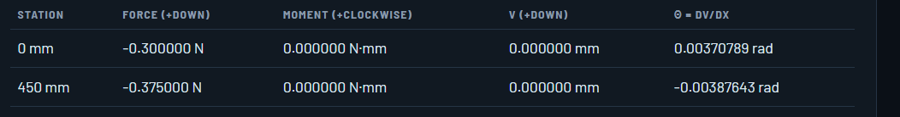

Case 3: Fixed at both ends
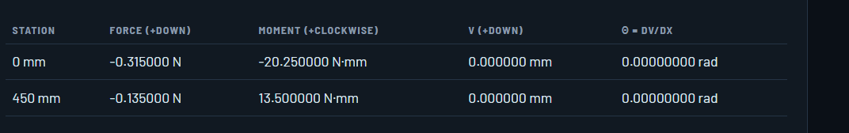
All horizontal reactions are zero analytically. The software uses a transverse-bending model and has no independent axial reaction output.

Difference and numerical checks
The analytical and numerical results agree after rounding to the displayed analytical precision.

Selected deformation checks
Positive v is downward, and positive θ is clockwise. Software values should agree with the analytical results to the displayed precision.
Case | Location | Quantity | Analytical | Software
1 | Free end, x = L | v | 5.006 mm | 5.00565 mm
1 | Free end, x = L | θ | 0.015 rad | 0.0151686 rad
2 | Midspan, x = L/2 | v | 0.533 mm | 0.533272 mm
2 | Left support, x = 0 | θ | 0.0037 rad | 0.00370789 rad
2 | Right support, x = L | θ | −0.0039 rad | −0.00387643 rad
3 | Midspan, x = L/2 | v | 0.071 mm | 0.0711029 mm

