ORCASLICER • OFFLINE WORKFLOW

Offline 3D Printing User Guide
  - Model preparation • Slicing • G-code export • USB transfer • Print supervision
General FDM workflow | Machine-specific profiles required | User Edition

Purpose and Scope
This guide explains a general offline workflow for preparing an FDM model in OrcaSlicer, generating machine-specific G-code, transferring it by USB drive, supervising the first layers, and inspecting the finished part. Machine-specific training, posted laboratory rules, manufacturer documentation, and instructions from the equipment owner take priority.
BEFORE YOU BEGIN
Obtain authorization and machine-specific training before use. Never share access codes or passwords, bypass safety controls, print without required supervision, or change the assigned printer, material, firmware configuration, or process profile without approval.

Workflow at a Glance
- Prepare and validate the intended geometry in its source application.
- Verify millimeter dimensions, watertight solids, interfaces, and printable feature thickness.
- Export each independently oriented component as 3MF or binary STL.
- Open the validated OrcaSlicer template and verify the exact printer, nozzle, material, and process profiles.
- Orient, slice, and inspect every layer from first layer to final layer.
- Complete the pre-print checklist; export G-code locally, copy it to USB, verify the copy, and safely eject the drive.
- Start under supervision and remain for the first layers.
- Cool, remove, inspect, dry-fit, photograph, and record the result.
Slicer | OrcaSlicer with validated printer, nozzle, filament, and process profiles
Transfer | Export G-code locally; copy to USB; verify; safely eject
Example equipment | Creality K2 Pro with the exact installed nozzle configuration
Files to preserve | Native model, STL/3MF, OrcaSlicer .3mf, G-code, screenshots, print log

1. Authorization, Safety, and Material Rules

Authorization and laboratory conduct
- Complete all required user agreements, orientation, and machine-specific training before operating equipment.
- Use only the assigned printer, tools, and materials; follow the site's supervision and reservation requirements.
- Keep the door code private. Guests may not operate equipment and may not be left unsupervised.
- Keep food and drink away from equipment. Do not use headphones or earbuds while operating machinery.
- Secure long hair, loose clothing, jewelry, lanyards, and other tangling hazards before work.
- Outside tools, chemicals, adhesives, sanding processes, or materials that could create hazards require supervisor approval.
- Never bypass guards, alarms, interlocks, or safety systems; never attempt to repair or modify a printer.
STOP WORK IMMEDIATELY
Stop the print and notify the equipment owner or laboratory supervisor if the first layer will not adhere, filament stops feeding, the nozzle drags, the part shifts, a collision occurs, a guard or interlock is missing, or the machine produces smoke, an unusual odor, or abnormal noise. In an emergency, follow the site's posted emergency procedure.

Authorized equipment and material
Assigned printer | Use the exact printer model and installed nozzle profile approved by the equipment owner.
Other printers | Re-slice the source geometry for the exact machine, nozzle, material, and firmware configuration.
Approved material | Use only filament that matches the selected profile and the permitted material path.
Specialty filament | Lightweight, filled, flexible, abrasive, or foaming materials require explicit approval and compatible hardware.
Printer type | These are FDM thermoplastic printers, not resin printers.

2. CAD, Code, and Mesh Release Gate
The slicer cannot repair a fundamentally incomplete engineering model. Release the geometry only after the code/CAD model passes the checks below.
Done | Release requirement | Evidence
☐ | The source application regenerates or displays the intended geometry without error. | Source / revision
☐ | Input parameters and revision number are recorded. | Design record
☐ | All dimensions are in millimeters and match the approved requirements. | Bounding box
☐ | Every printable component is one closed, watertight solid. | Solid check
☐ | Duplicate bodies, self-intersections, internal faces, and zero-thickness surfaces are removed. | Geometry check
☐ | Walls, holes, text, clearances, and interfaces have printable physical dimensions. | Feature review
☐ | Modules fit the assigned build envelope at 100% scale. | Build envelope
☐ | Orientation and acceptable support locations have been planned. | Orientation sketch
☐ | Mating interfaces and critical clearances are checked by dimensions or an approved fit coupon. | Fit evidence
☐ | Native code/CAD files are saved before mesh export. | Archive

Export and file naming
- Save the native code/CAD model so the design remains editable.
- Export each independently oriented part as 3MF or binary STL. Prefer 3MF when units or multiple bodies must be preserved.
- Use millimeters and a reasonably fine mesh: avoid visibly faceted curves and unnecessarily huge files.
- Re-open the exported file and compare its X, Y, and Z bounding-box dimensions with the source model.
- Use Project_Part_Revision_YYYYMMDD.3mf (or .stl) as a traceable naming pattern.
NATIVE CAD IS NOT PRINTER-READY
Do not send .SLDPRT, .SLDASM, .F3D, .FCStd, .PRT, .STEP, or another design file directly to the printer. Export the intended printable geometry, slice it for the exact assigned printer and nozzle, and retain the slicer .3mf. G-code is machine/profile specific and must not be reused for another printer or nozzle.

3. OrcaSlicer Setup, Slicing, and Preview

Select the exact machine, material, and process
- Open the validated .3mf template in OrcaSlicer, or import the configuration bundle supplied by the equipment owner. Confirm the exact printer and installed nozzle; do not select a visually similar machine by name.
- Select the filament profile that matches the physical material and its approved loading path.
- Start from the validated process profile. Do not invent temperatures, flow, speed, acceleration, cooling, retraction, or machine-start commands.
- Import the STL/3MF as geometry while preserving the validated machine profile. If a 3MF tries to load another printer configuration, cancel or import geometry only.
- Verify X, Y, and Z dimensions before changing orientation or process settings.

Orient and prepare the part
- Place a stable, appropriate face on the build plate; use Place on Face or Drop to Bed so no body floats above or below the plate.
- Keep every body inside the printable boundary. Rotate, split at an approved interface, or use a separate plate; never change an engineering scale merely to make the part fit.
- Review walls, top/bottom layers, infill, supports, brim, seam position, and adhesion according to the part's geometry and intended use.
- Confirm that walls, holes, text, internal features, and mating interfaces remain continuous after slicing.

Slice and inspect every layer
Click Slice plate, open Preview, and move the layer slider from the first layer to the top. Look for a complete first layer, continuous closed loops, intended internal features, supported islands, accessible supports, reasonable travel moves, and no missing thin features. Review estimated material use and time, then save the complete OrcaSlicer project as .3mf.
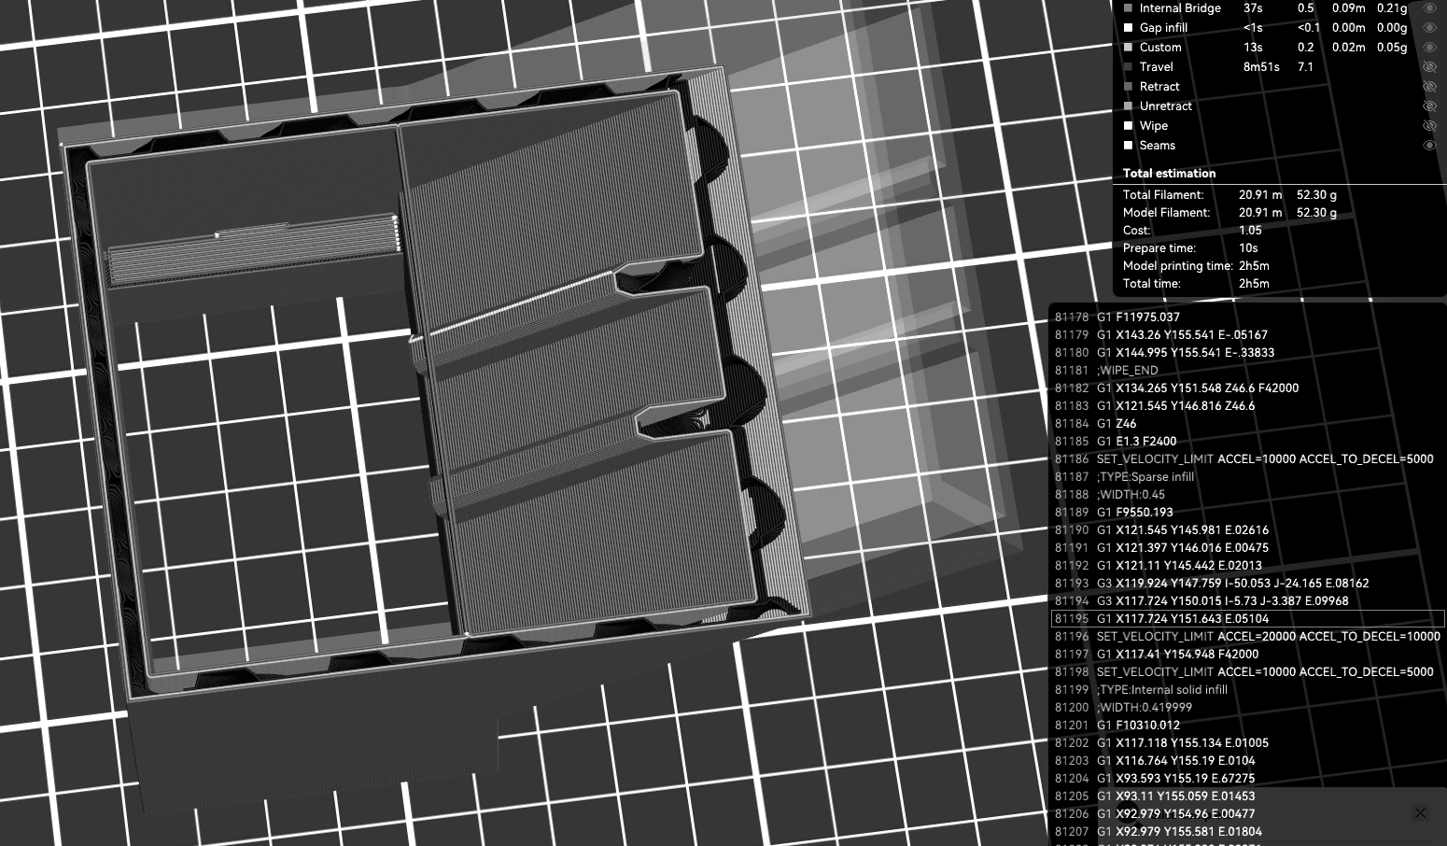
Figure 1. OrcaSlicer-compatible layer-preview example with light infill. Visible toolpaths and estimates are part of the pre-print check. Interface labels may vary by version; do not copy example settings without validation.

4. Pre-Print Release and Safe Execution
Done | Release requirement | Record
☐ | Authorization, required reservation, and trained operator are confirmed. | Name / slot
☐ | Exact printer and installed nozzle profile are selected. | Printer ID / nozzle
☐ | Approved material is mapped to the correct loading path or material-system slot. | Material / source
☐ | X, Y, and Z dimensions match the approved design; scale remains 100%. | Dimensions
☐ | Every body is on the plate and inside the printable boundary. | Plate view
☐ | Orientation, walls, top/bottom layers, infill, supports, brim, and adhesion are reviewed. | Settings
☐ | Preview is inspected from first layer through final layer. | Reviewer
☐ | Walls, holes, internal features, interfaces, and supports remain visible and continuous. | Layer check
☐ | Estimated material mass and print time are reasonable and recorded. | Mass / time
☐ | OrcaSlicer project is saved as .3mf; G-code is generated for this printer/nozzle/material/revision. | Filename
☐ | Build plate and printer interior are clear; required release approval is recorded. | Initials

Generate the printer file and start
- After Preview passes, choose Export G-code file (or File > Export > Export G-code, depending on version) and save the .gcode file to a local project folder. Do not use Send Print, cloud, LAN, or a Device tab in an offline workflow.
- Copy the exported .gcode file to the approved USB drive. Confirm the filename, extension, and file size, then safely eject the drive.
- Insert the USB drive at the assigned printer. Verify the filename, revision, destination machine, material, estimated time, and thumbnail before starting.
- Confirm the build plate is seated and clear, the nozzle area is unobstructed, and the approved filament is loaded from the correct source.
- Start the print under supervision and remain for the first layers. Confirm adhesion, extrusion, walls, supports, and stable motion.
- Leave the machine only when the equipment owner or laboratory procedure permits unattended operation.
FIRST-LAYER STOP CONDITIONS
Stop immediately for poor adhesion, nozzle drag, a shifted or lifting part, missing extrusion, filament-feed failure, collision, smoke, unusual odor, or abnormal noise. Preserve the file and evidence; do not attempt a repair or restart without authorization.

Complete the print and restore the station
- Allow the part and build plate to cool; remove the part only as trained.
- Label the part and revision. Record actual material use, end time, failures, and observations.
- Return tools and materials, clean the work area, clear walkways, and leave the printer ready for the next authorized user. Obtain approval before a reprint when required.

5. Post-Print Inspection and Part Acceptance

Removal and finishing rules
- Allow the part and build plate to cool before removal; use only the approved removal method and tools.
- Remove supports without damaging functional geometry. Sand or cut only as authorized and with required dust, tool, ventilation, and PPE controls.
- Dry-fit mating parts before adhesive or permanent assembly. Do not force, bend, drill, or enlarge a feature without approval.
- Use only approved adhesives and fixtures; follow their handling, ventilation, alignment, and curing instructions.
Done | Release requirement | Evidence
☐ | The printed part is labeled with project, part, and revision. | Visual
☐ | Supports are removed without damage to functional geometry. | Visual
☐ | Overall dimensions agree with the approved drawing, ruler template, or go/no-go gauge. | Template / gauge
☐ | Walls, holes, text, and internal features are present and continuous. | Inspection
☐ | Critical holes and clearances meet the approved acceptance method. | Gauge / dry fit
☐ | Mating interfaces fit in the intended sequence without forced deformation. | Dry fit
☐ | The part shows no unintended twist, distortion, or gross misalignment. | Alignment
☐ | No major crack, layer separation, severe warping, loose section, or sharp hazardous defect is present. | Inspection
☐ | Actual printed mass and visible defects are recorded. | Print log
☐ | CAD, slicer-preview, first-layer, and completed-part photographs are saved. | File archive
☐ | Disposition is selected: Accept / Revise / Reprint Request. | Decision

ACCEPTANCE SCOPE
Print appearance alone is not an acceptance criterion. Evaluate dimensions, feature continuity, mating fit, traceable settings, and intended function using an approved method. Passing this checklist documents fabrication quality only; it does not establish product safety, rated strength, or suitability for service.

Failure and reprint control
- Stop, label, and preserve the failed part, slicer project, warning screenshot, and photographs.
- Identify one plausible cause supported by evidence; do not change several settings at once.
- Propose the smallest useful change in code/CAD, orientation, or approved process setting.
- Obtain approval before consuming material on another attempt when required by the site.
- Create a new revision and link it to the original print-log entry.

6. Troubleshooting
Use the table before changing settings. Return to the source model when geometry is the cause; slicer repair is a secondary check, not a substitute for a valid solid.
Symptom | Likely cause | Required action | Escalate when
Model tiny or enormous | STL unit mismatch | Compare the bounding box with CAD; correct export units once and re-verify. | Dimensions remain uncertain
Nothing appears / 0 layers | Empty/open body or body off the plate | Return to CAD, make a watertight solid, re-export, and Drop to Bed. | Repair warning persists
Rib, shell, or socket disappears | Feature below printable width or zero thickness | Increase physical thickness in code/CAD and re-slice. | A requirement must change
Mesh/repair warning | Open shell, overlap, self-intersection, duplicate faces | Repair the source geometry and re-export; inspect the resulting mesh. | Slicer repair changes geometry
Part red / out of bounds | Model exceeds build area or crosses boundary | Rotate, split at an approved interface, or use another plate. | Scaling seems necessary
Wrong printer opens from 3MF | Foreign printer profile embedded | Import geometry only; reselect K2 Pro and 0.4 mm nozzle. | Settings cannot be verified
First layer will not adhere | Dirty plate, weak orientation, or inadequate approved adhesion | Stop; clean/reseat the plate; review brim and orientation. | Failure repeats
Nozzle drags / part shifts | Lifting, collision, or unstable part | Stop immediately; preserve the file and photographs. | Any equipment contact/damage
Material-system mismatch / feed failure | Wrong slot mapping, empty spool, or unsuitable filament | Stop; correct mapping; use only the approved material path. | Filament breaks in the path
File absent on printer | USB copy, filename, extension, or media issue | Return to the saved OrcaSlicer project; re-export locally, recopy, verify file size, and safely eject. | The local screen still cannot read the file
Warping / layer separation | Orientation, approved profile, adhesion, or rigidity issue | Document the defect and request the smallest approved revision. | A reprint or setting change is needed
Support cannot be removed safely | Inaccessible support or poor orientation | Revise orientation or splitting strategy; do not improvise cutting. | Cutting or sanding is required

Appendix A. Print Log — One Form per Attempt
User information | Project __________________ User / operator ______________________________
Authorization | Date __________ Time __________ Reservation / approval _______________________
Part and revision | Component __________________ Revision ______ Code/CAD file __________________
Exported files | STL/3MF __________________________ Slicer .3mf __________________________
Machine and material | Printer ID __________ Nozzle ______ mm Material / spool ID __________________
Material source | Material-system slot / external spool __________________ Approval ______________
Slicer setup | Scale ____% Layer height ____ mm Walls ____ Top/bottom ____ Infill __________
Support / adhesion | Supports __________________ Brim/adhesion __________________ Orientation __________
Preview record | Estimated mass ____ g Estimated time ______ Every layer reviewed ☐ Dimensions verified ☐
Release | Released by __________________ Date/time __________________ G-code destination verified ☐
Print record | Start ______ First layer: Pass / Stop End ______ Actual mass ____ g
Outcome | Accept / Revise / Failed / Reprint Request Completed-part photo saved ☐
Observed defect or risk | ________________________________________________________________________
Likely cause and evidence | ________________________________________________________________________
One proposed corrective action | ________________________________________________________________________
Change control | New revision? Yes / No Reprint approved by ______________ Date/time __________
Archive filenames / links | ________________________________________________________________________

Required archive
- Clean code/native CAD run and recorded design parameters.
- Exported STL/3MF, saved slicer .3mf, and G-code only when requested.
- Screenshots of dimensions and representative first/middle/final layers.
- First-layer and completed-part photographs, actual mass, and this print log.
- Revision note explaining any failed attempt and the approved change.

Contacts and escalation
Technical questions | Equipment owner, laboratory supervisor, or authorized technical support.
Emergency | Follow the site's posted emergency procedure and provide the exact equipment location.

Official references
- Official OrcaSlicer project and documentation
- Official OrcaSlicer stable releases
- Online OrcaSlicer + USB guide
- Reference K2 Pro G-code — inspection only; do not print
- Creality K2 Series product information
- Creality K2 Pro multi-color/CFS guide
Scope and authority: this guide supplements manufacturer documentation and site-specific safety procedures. Posted laboratory rules, equipment-owner instructions, and machine-specific standard operating procedures supersede this summary.

