HW 2B Lilienthal wing loads and beam bending
MIE 446 Aerospace Structures, Fall 2026. 65 points.
Due: Thursday, November 5, 2026. Submit through Canvas at the time shown there.

Scope and numbering
• Complete Part 2, Part 4 and Part 5 for this HW 2B submission.
• Use the numbered task headings below in your report.
• Parts 1 and 3 belong to HW 2A; do not resubmit HW 2A.
• Complete all three beam support cases. Case A, Case B and Case C are beam cases, not assignment parts.
• Submit individually authored work. Discuss within your existing team, but write your own calculations and explanations.
• Read Lecture 03 in Colab, Sections 2A–2C, 3, 4 and 5.
• Use equilibrium and integration of displacement and rotation equations. Virtual work is not required.

Prescribed model
The three fixtures below are alternative teaching models of a scaled wing member. They are not reconstructions of Lilienthal's actual wing attachments. Cases B and C require load-bearing connections at both ends; they do not represent a free wing tip with an invented extra support.
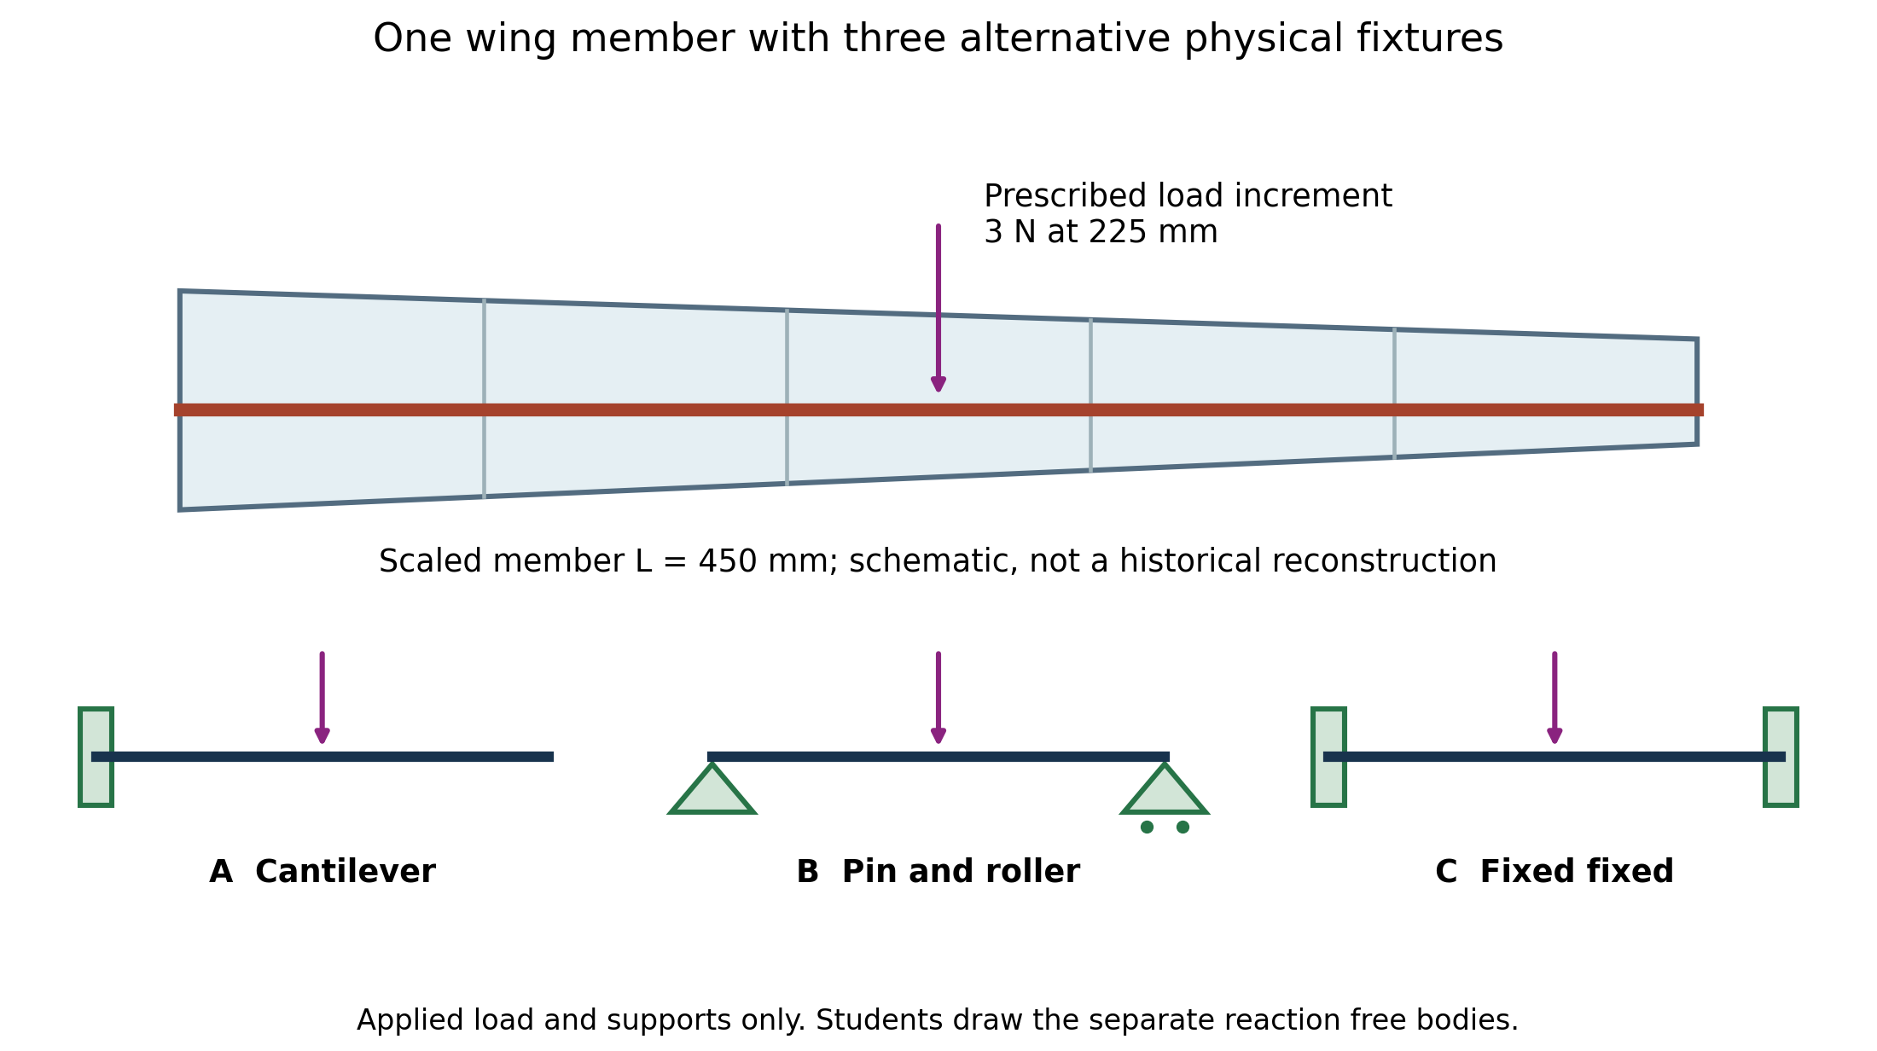
Figure 1. Conceptual load path and fixtures. These are alternative teaching models, not three historical wing attachments.
• Case A: left end fixed and right end free.
• Case B: pin at the left end and roller at the right end.
• Case C: both ends fixed.
• Length: L = 450 mm.
• Rectangular section: width b = 16 mm; vertical depth h = 8 mm.
• Material modulus: E = 2200 MPa = 2200 N/mm².
• Applied point load: P = 3 N downward at a = L/2 = 225 mm, measured from the left end.
• Hand model: straight, constant-section, linearly elastic Euler–Bernoulli beam; neglect self-weight and shear deformation.
• Interpretation: the 3 N load is a prescribed downward increment for comparing supports. It is not measured historical lift and is not the resultant of the Part 5 distributed load.
• Historical limits: the dimensions and modulus are teaching inputs; do not estimate them from the photograph.

Coordinates and signs
• Beam x starts at the left end and runs along the member toward the right end.
• Beam z is upward from the cross-section neutral axis.
• Span coordinate s in Part 5 follows the same direction as beam x.
• Aircraft body x points forward; it is not beam x.
• For hand free bodies, upward forces and counterclockwise external couples are positive.
• Internal bending moment M is sagging-positive.
• Displacement v is positive downward; rotation θ = dv/dx.
• Use subscripts L and R for left and right support reactions.
• A clamp can supply a transverse reaction force and a reaction couple.
• A pin or roller supplies a transverse reaction but no reaction couple in this model.
• No axial load is applied in these cases.
• The governing hand relations are:
$θ = \frac{dv}{dx} EI \frac{d²v}{dx²} = −M(x)$
$σ_{xx} = −\frac{M(x)z}{I}$

Part 2 Beam model and hand solution 35 points

2.1 Image drawings and predictions 5 points
• Submit one annotated historical image: reuse the Lilienthal glider image from Part 1 of HW 2A.
• Add the source URL and a caption identifying the aircraft or glider when known.
• Outline one visible rib, spar or other wing member that motivates your beam model.
• Mark the visible locations where that member connects to other structure.
• If your HW 2A image does not show a suitable member, add one sourced image that does; identify which image supports your interpretation.
• Do not infer hidden dimensions, material properties or joint fixity from a photograph.
• Submit one separate load-transfer sketch: draw the selected member and the neighboring structure that supports it.
• Draw an arrow for the assumed external load acting on the selected member; label the structure or surface applying that load.
• Mark the connection through which the member transfers force to the neighboring structure; name that neighboring structure.
• Label any assumed features as assumptions and any visible features as observations. The sketch does not require measured historical forces.
• Submit three physical-beam drawings: one each for Cases A, B and C, showing the actual support symbols, L, a and the downward 3 N load. Do not add support reaction arrows to these drawings.
• Submit three separate free-body diagrams: remove the support symbols and replace them with unknown reaction forces and, for clamps, reaction couples. Retain the 3 N load and dimensions.
• Submit one cross-section sketch: label b, h, the neutral axis, z, and the extreme-fibre distance c = h/2.
• Submit three bent-centreline sketches: show which end displacements and rotations each fixture permits or prevents.
• Submit coordinate sketches: distinguish aircraft-forward x from beam x and show the upward beam z direction.
• Submit two prediction rankings before calculation: rank Cases A, B and C by maximum absolute displacement and by maximum absolute bending stress. State any predicted ties.
• Give a short reason for each ranking using constraints and load transfer, not numerical answers.

2.2 Reactions shear and moment 10 points
• Complete the following calculations separately for Cases A, B and C.
• Write whole-beam vertical force equilibrium.
• Write whole-beam moment equilibrium and state the moment reference point.
• Identify which reactions equilibrium determines directly and which remain unknown.
• Draw a cut in the interval 0 < x < 225 mm and derive V(x) and M(x).
• Draw a second cut in the interval 225 < x < 450 mm and derive V(x) and M(x).
• Submit the two piecewise expressions with their interval limits and units.
• Submit labeled shear-force and bending-moment diagrams.
• Mark the shear jump at the point load and the internal moments at x = 0+, 225 mm and 450 mm-.
• Distinguish an external support couple from the signed internal moment immediately inside the beam.

2.3 Rotation displacement and compatibility 15 points
• Integrate EI d²v/dx² = -M(x) in each interval for each support case.
• Show the integration constants.
• Write the physical condition used to determine each constant.
• Enforce continuity of displacement and rotation at x = 225 mm; a point force is not a hinge.
• Apply the end conditions listed below.
Case | End conditions
A Cantilever | v(0) = θ(0) = 0. The unloaded outboard interval has M = 0; it is straight but may be tilted.
B Pin–roller | v(0) = v(L) = 0. End rotations are free and must not be set to zero.
C Fixed–fixed | v(0) = θ(0) = v(L) = θ(L) = 0. Equilibrium alone is insufficient.
• For Case C, write the two additional compatibility equations below.
• Explain that they enforce zero rotation and zero displacement at the right clamp, starting from zero rotation and displacement at the left clamp.
$θ(L) = −\frac{1}{EI}\int_{0}^{L}{M(x) dx} = 0$
$v(L) = −\frac{1}{EI}\int_{0}^{L}{(L − x) M(x) dx} = 0$
• Explain the factor L - x in one sentence.
• Substitute the piecewise moment expressions into both integrals and solve for the remaining reactions.
• Use symmetry only to check the result, not to replace the two compatibility equations.
• Submit v(x) and θ(x) for both intervals in each case.
• Calculate v(225 mm) for each case.
• Determine the maximum absolute displacement and its location for each case; do not assume that it occurs under the load in Case A.

2.4 Stress and hand results 5 points
• Calculate section area A = bh, second moment of area I = bh³/12, and c = h/2, with units.
• Calculate the maximum absolute bending stress in each case using the largest absolute internal moment.
• State the beam location of that maximum.
• At a section with maximum absolute moment, calculate and label the upper- and lower-fibre stresses.
• Identify which fibre is in tension and which is in compression.
• Submit one hand-results table with one row per case and units in every column.
• Include all nonzero reaction forces and couples in the table.
• Include the signed internal moments at x = 0+, 225 mm and 450 mm-.
• Include maximum absolute bending stress and its location.
• Include v(225 mm), maximum absolute displacement and its location.
• Compare your results with your two prediction rankings and explain any correction.

Part 4 Software verification 20 points

4.1 Model setup and saved records 5 points
• Open each corresponding beam case:
• Case A Cantilever centre force
• Case B Simply supported centre force
• Case C Fixed–fixed centre force
• The links open baseline lessons, not the assessed HW 2B inputs.
• In Define your beam, set L = 450 mm, b = 16 mm, h = 8 mm and E = 2200 MPa.
• Click Apply beam dimensions before entering the load.
• Click Clear all loads; changing geometry may restore the default tip force.
• Add only one downward 3 N point force at x = 225 mm.
• Confirm the intended support case and the displayed input summary.
• Check that no default 2 N tip force remains.
• Run the calculation.
• Repeat the setup for all three support cases.
• Submit three records using Download study record, one per case.
• Submit a labeled input screenshot for each case.

4.2 Hand and software comparisons 10 points
• Submit result screenshots showing V, M, bending stress and displacement for each case.
• Submit a hand-versus-software table for every quantity in your Part 2 hand-results table.
• For each comparison, give the quantity, unit, hand value, software value, sign conversion, absolute difference and relative difference.
• Document how the software force, moment and displacement signs map to the hand conventions.
• For a nonzero hand value, calculate relative difference as 100 × absolute difference / absolute hand value.
• For an expected zero, report the signed software value and its absolute residual with units; do not divide by zero.
• Use the supplied CSV as a starting template and add rows for all required quantities.
• Retain your original predictions and explain any corrections.
• If the models do not match, identify the differing input or assumption rather than silently changing the hand theory.

4.3 Independent checks and mesh study 5 points
• Calculate the signed sum of applied and reaction forces for each case and report the force residual in N.
• Calculate the signed sum of applied and reaction moments about x = 0 and report the moment residual in N mm.
• Check the constrained end displacements and rotations for each case.
• Report small numerical values explicitly; a rounded display of 0.0000 does not establish exact zero.
• Select one case and use Compare 10 / 20 / 40 elements.
• Submit a table of maximum absolute displacement and maximum absolute bending stress for the three meshes.
• Identify which case and load were used.
• Explain whether the results converge.
• Explain why convergence alone does not verify the real material, connection stiffness or historical wing model.

Part 5 Distributed wing load and design check 10 points

Part 5 prescribed distributed load
• Use Case A with L = 450 mm, b = 16 mm, h = 8 mm and E = 2200 MPa.
• Keep the same downward-load convention.
• Use the following educational load law, not measured historical pressure:
$Δf_{z}(s) = q c(s) A_{z} g(s) q = \frac{1}{2}ρV²$
• Density ρ = 1.225 kg/m³; speed V = 15 m/s; dimensionless coefficient A_z = 0.30.
• Use s in metres in this law.
• Chord c(s) = 0.160 - (0.060/0.450)s in metres.
• Activation g(s) = 0 for 0 ≤ s ≤ 0.300 m.
• Activation g(s) = (s - 0.300)/0.150 for 0.300 < s ≤ 0.450 m.
• Here c(s) is aerodynamic chord, not the stress distance c = h/2.
• Δf_z is downward force per unit span in N/m, not a point force.
• Aerodynamic chord varies along the span; the structural beam section remains constant.
• Convert coordinates to mm and load intensity to N/mm before software input.

5.1 Distributed load and refinement 5 points
• Plot Δf_z against s over the entire 0–450 mm span, including the zero-load region.
• Independently integrate Δf_z to obtain total force in N.
• Independently integrate sΔf_z to obtain the applied moment about the root; report it in N m and N mm.
• State the reference point and sign used for the moment.
• Prepare a load-intensity table at 300, 350, 400 and 450 mm.
• Include each intensity in both N/m and N/mm; divide N/m by 1000 to obtain N/mm.
• Clear the point force from the software.
• Enter three adjacent trapezoidal segments spanning those four coordinates.
• Submit the input screenshot and downloaded record.
• Compare software total force and root moment with your independent integrals.
• Refine to six equal segments over 300–450 mm, using endpoints spaced 25 mm apart.
• Submit the six-segment endpoint table, screenshot, record and comparison.
• Explain the change in error: chord times activation is quadratic, whereas each entered segment is linear.
• Use software for distributed-load displacement; a hand derivation of its full displacement curve is not required.

5.2 Equivalent point force 2 points
• Calculate the equivalent force magnitude from your independent total-force integral.
• Calculate its position s-bar = integral(sΔf_z ds) / integral(Δf_z ds), not automatically L/2.
• Replace the distributed segments with that single downward force at s-bar.
• Submit the point-force position, input screenshot and downloaded record.
• Compare its total force and root moment with the distributed-load results.
• Compare maximum absolute displacement with the six-segment model.
• Explain why equivalent force and root moment do not guarantee the same internal moment distribution or displacement.

5.3 Depth comparison and model limits 3 points
• Restore the Part 2 single downward 3 N point force at 225 mm; do not use the Part 5 distributed load for this depth study.
• Use Case A and keep L = 450 mm, b = 16 mm and E = 2200 MPa unchanged.
• Record maximum absolute bending stress and displacement at h = 8 mm.
• Predict the ratios for h = 10 mm using I = bh³/12 and c = h/2.
• Define each ratio as the 10 mm result divided by the 8 mm result.
• Change only h to 10 mm, rerun, and submit a table of predictions, results and ratios.
• Submit the two study records and a labeled comparison screenshot.
• Explain why changing depth affects stress and stiffness but not the equilibrium reactions in this cantilever case.
• Reuse your historical-image annotation and load-transfer sketch in a final labeled figure.
• Mark what the isolated beam represents and what is omitted.
• State which actual connection information is needed before choosing a clamp, pin or elastic joint.
• Explain why fabric, ribs, multiple members and any source-supported bracing cannot automatically be modeled as a modern closed stressed-skin wing box.
• Distinguish the role of ribs in shape retention and local skin support from the role of longitudinal members in global bending.
• Do not add ribs or build an additional wing model for this assignment.
• An optional printed-wing workspace comparison is not graded and is not a prediction for Lilienthal's aircraft or a full 3-D finite-element result.
• This exercise does not approve a printed wing for loading or flight.

Report questions
• Submit a short answer to each question below in your PDF report.
• Q1: Why can equilibrium solve the cantilever reactions but not all fixed–fixed reactions?
• Q2: Does zero end displacement imply zero end rotation for every support? Use your three cases.
• Q3: Why can the unloaded outboard part of Case A move even though its curvature is zero?
• Q4: What does hand–software agreement verify, and which material or model assumptions remain unvalidated?
• Q5: Which features came from historical evidence, which from the prescribed load law, and which were engineering assumptions?
• Include a short process/AI-use note identifying any tools used and how you checked their output.

Files to submit through Canvas
1. One report PDF: include all drawings, calculations, tables, plots, screenshots and explanations requested in tasks 2.1–2.4, 4.1–4.3 and 5.1–5.3, followed by Q1–Q5 and the process/AI-use note.
2. Software study records: include the three Part 4 point-load cases, the three- and six-segment Part 5 loads, the equivalent point force, and the h = 8 and 10 mm depth cases. Clearly label every record; reuse a saved record where the inputs are identical.
3. Calculation files: include any scripts or spreadsheets actually used; do not create an extra script solely for submission.
4. One README: state units, software version/date, file names, and how to reproduce each study.
5. One Claim–Evidence–Check slide in PDF and PPTX: state one engineering claim, give a quantitative comparison supporting it, and identify one independent check or model limitation.
6. File names: include your name and HW2B in each submitted file name.
7. Submission format: the report is PDF; the editable Word handout is not a required report format.
8. Individual explanation: be prepared to explain one compatibility equation and one discrepancy.
9. Submission limits: do not resubmit HW 2A or publish student work in the course repository.

