HW 3: Three beams under distributed loads
MIE 446 Aerospace Structures, Fall 2026. 65 points.
Due: Thursday, November 5, 2026. Submit through Canvas at the time shown there.

Given data
• All three beams have length L = 450 mm and modulus E = 2200 MPa. Use the same rectangular cross section in all three cases: width b = 16 mm and vertical depth h = 8 mm. The h direction is parallel to the downward load.
• Use the section area A = bh and second moment of area I = bh³/12. Neglect self-weight and shear deformation.
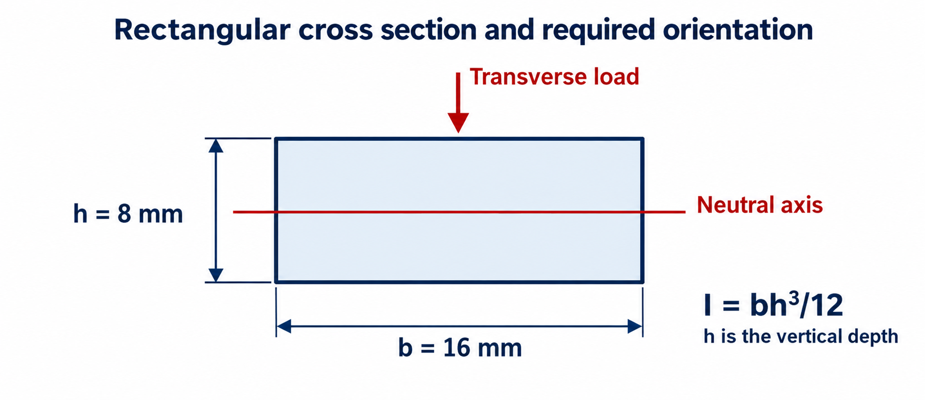
Figure 1. Rectangular cross section used for all three beams. The 8 mm dimension is vertical and parallel to the applied load.
• Measure x from the left end. All distributed loads act downward and vary linearly between the stated endpoint intensities.
• For hand calculations, downward reactions and clockwise external reaction couples are positive. Use downward-positive displacement v, θ = v', and sagging-positive M.
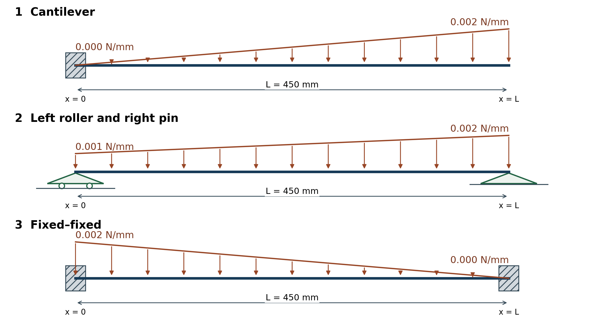

The three cases
1. Cantilever, 20 points: fixed at x = 0 and free at x = L. Triangular load increases from zero at the left end to 0.002 N/mm at the right end.
2. Roller and pin, 20 points: roller at x = 0 and pin at x = L. Trapezoidal load increases from 0.001 N/mm at the left end to 0.002 N/mm at the right end. The two circles identify the left roller.
3. Fixed–fixed, 25 points: fixed at both ends. Triangular load decreases from 0.002 N/mm at the left end to zero at the right end.

A: analytical solution for each case
1. Calculate the resultant distributed force and its position.
2. Write force and moment equilibrium and calculate the support reaction forces and couples, including any zero components.
3. Where equilibrium is insufficient, use EI v'' = -M(x), θ = v ', and the support displacement/rotation conditions to obtain the missing equations. Show the integration and conditions used; do not use only a tabulated answer. For Case 3, apply v = θ = 0 at both clamps to determine the support reactions.
4. Report these deformation quantities in addition to support reactions:
(a) Case 1: v and θ at the free end, x = L.
(b) Case 2: θ at both supports and v at midspan, x = L/2.
(c) Case 3: v at midspan, x = L/2.
Also state prescribed v and θ at every support: a pin or roller imposes v = 0, not θ = 0.

B: Software solution and comparison
1. Open Beam Lab. Select Left fixed / Right free for Case 1, Left roller / Right pin for Case 2, and Left fixed / Right fixed for Case 3.
2. Set L = 450 mm and E = 2200 MPa. Select Solid rectangle, b = 16 mm and h = 8 mm. Check A = 128 mm² and I = 682.67 mm⁴. Remove interior supports and internal hinges, clear existing loads and leave Include self-weight unchecked.
3. Add one full-length line load from 0 to 450 mm: triangle zero at start for Case 1, trapezoid for Case 2, triangle zero at end for Case 3. Use the stated positive downward intensities in N/mm, not total force in N. Inspect the live profile and confirm Add load; do not add a point force.
4. Press Solve after each setup. Read reactions and end rotations in Support reactions and motion. Use the exact station table at x = L or L/2 for Part A4; pending results belong to the previous solved inputs. All horizontal reactions are zero under the stated no-axial-load assumptions; the app solves transverse bending only.
5. Submit one comparison table covering all three cases. List analytical and software reactions at every support and the selected deformation quantities requested in Part A4. Include units and use consistent signs. Explain any discrepancy briefly.

Submit
1. Submit one PDF containing the analytical calculations for the three cases and the comparison table.
2. Include the cross-section properties A and I, but no additional drawings, stress calculations, full maximum-deflection search, mesh study, screenshots, slides, or separate software files are required.
3. Use Lecture 03 for support conditions and integration/compatibility methods.

