Homework 1: Surface Pressure, Lift, and Pressure Drag

Given conditions and conventions

Quantity | Value | Quantity | Value
Airfoil | NACA 2412 | Angle of attack | α = 5.0°
Chord | c = 0.500 m | Reference span | b = 1.000 m
Freestream speed | V∞ = 30.0 m/s | Density | ρ∞ = 1.225 kg/m³
Static pressure | p∞ = 101325 Pa | Dynamic pressure | q∞ = ½ρ∞V∞²

1a. NACA designation and dynamic pressure
1a. Decode the four digits of NACA2412. Calculate$q_{∞}$ and state its unit.
The first digit gives the maximum mean-line camber as a percentage of the chord: 2%, equivalent to 0.010 m.
The second digit is the location of the maximum camber from the leading edge, expressed as a percentage of the chord: 40%, equivalent to 0.200 m.
The final two digits specify the nominal maximum thickness as a percentage of the chord: 12%, equivalent to 0.060 m.
$$q_{∞}=\frac{1}{2}ρ_{∞}V_{∞}^{2}=\frac{1}{2}\left(1.225\right){\left(30.0\right)}^{2}=551.25 Pa$$

1b. Geometry and pressure distribution
1b. Plot Yu and Yl on equal axes. Separately plot Cp,u and Cp,l versus X with the conventional inverted Cp axis. Label the leading-edge suction region and the pressure difference that produces positive lift.

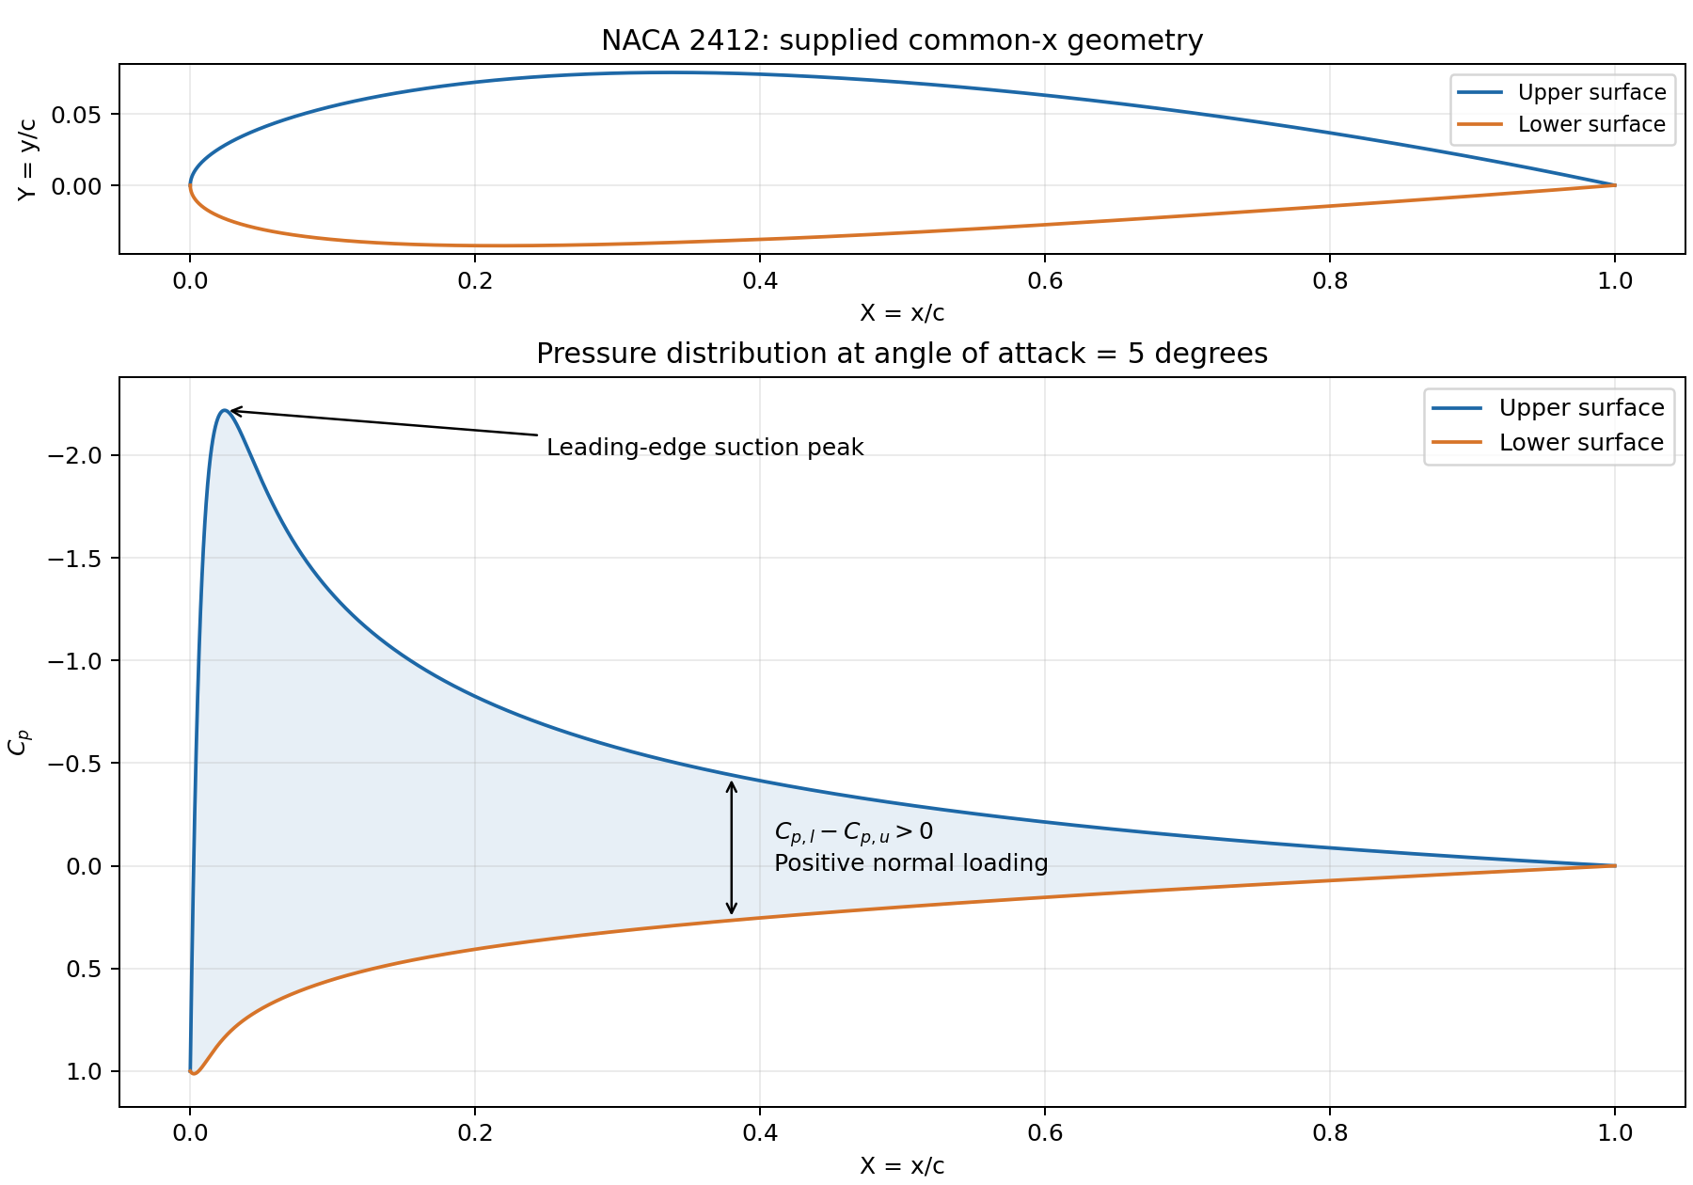
Figure 1. Equal-scale airfoil geometry and pressure coefficients with an inverted Cp axis. The shaded pressure difference produces positive normal loading and, after rotation, positive lift.
The upper-surface suction peak occurs near X = 0.02409, where Cp,u ≈ -2.2184. Throughout 0 < X < 1, Cp,l - Cp,u is positive.

1c. Continuous integration and convergence
1c. Numerically evaluate the supplied pressure-force integrals for CN and CA. Do not derive these formulas. Follow the numerical-integration guide below and document your method and convergence.
The supplied force expressions are evaluated directly, without deriving them.
$$C_{N}=\int_{0}^{1}{\left(C_{p,l}-C_{p,u}\right)} dX, C_{A}=\int_{0}^{1}{\left(C_{p,u}Y_{u}^{'}-C_{p,l}Y_{l}^{'}\right)} dX$$
The thickness derivative contains 1/√X, so its raw expression is not evaluated at X = 0. Setting X = s² and dX = 2s 0 ≤ s ≤ 1) ds gives the following transformed normal and axial integrands:
$$g_{N}\left(s\right)=2s[C_{p,l}\left(s^{2}\right)-C_{p,u}\left(s^{2}\right)]$$
$$g_{A}\left(s\right)=2s[C_{p,u}\left(s^{2}\right)Y_{u}^{'}\left(s^{2}\right)-C_{p,l}\left(s^{2}\right)Y_{l}^{'}\left(s^{2}\right)]$$
Primes denote derivatives with respect to X. At s = 0, the exact endpoint limits are imposed: gN(0) = 0 and gA(0) = 10t(0.2969) = 0.35628. Thus, no division by zero or numerical product 0 × ∞ is evaluated.
Python/NumPy evaluates the supplied pressure and geometry functions at Xj = (j/N)². The composite trapezoidal rule is applied on the uniform s grid, first with N = 1000 and then with N = 2000:
$$I_{N}[g]=\frac{1}{N}[\frac{g\left(0\right)}{2}+\sum_{j=1}^{N-1}{g}\left(j/N\right)+\frac{g\left(1\right)}{2}]$$
Intervals, N | CN | CA
1000 | 0.741999460513 | -0.055822334974
2000 | 0.741999639201 | -0.055822333281
Absolute difference | 1.7869 × 10⁻⁷ | 1.6929 × 10⁻⁹

Convergence was checked by increasing the number of intervals from 1000 to 2000 and verifying that the absolute changes in both (C_{N}) and (C_{A}) were below (10⁻⁴). Both differences are below 10⁻⁴, meeting the assignment criterion. These differences quantify grid refinement, not the exact integration error.

The Python code used to calculate the coefficients is provided below, along with explanatory comments.
import numpy as np

# NACA 2412 geometry parameters
m = 0.02
p = 0.40
t = 0.12

def calculate_coefficients(N):
# N intervals require N+1 points, including both endpoints.
# linspace creates equally spaced points from 0 to 1.
# The coordinate of point j is s_j = j/N.
s = np.linspace(0.0, 1.0, N + 1)

# Change of variable: X = s².
# Points are equally spaced in s, but not in X.
X = s**2

# Point spacing = interval length / number of intervals.
# Since s ranges from 0 to 1, Δs = (1-0)/N.
# The variable ds represents this numerical spacing.
ds = 1.0 / N

# Evaluate the pressure distribution at all X points.
C0 = (1.0 - X) * (
np.exp(-X / 0.010)
+ 0.20 * (1.0 - np.exp(-X / 0.020))
)

delta_Cp = (
0.721896
* (1.0 - np.exp(-X / 0.010))
* (1.0 - X)
/ np.sqrt(X + 0.020)
)

# Upper- and lower-surface pressure coefficients
Cp_u = C0 - 0.80 * delta_Cp
Cp_l = C0 + 0.20 * delta_Cp

# Allocate N+1 entries for each transformed integrand.
# zeros initializes all entries to zero.
gN = np.zeros(N + 1)
gA = np.zeros(N + 1)

# Python indexing starts at zero.
# [0] selects the first entry, corresponding to s=0.
# Assign the exact limiting values at this endpoint.
gN[0] = 0.0
gA[0] = 10.0 * t * 0.2969 # Equals 0.35628

# [1:] selects entries from index 1 to the end.
# This excludes X=0 without changing the original array.
X_pos = X[1:]

# Piecewise camber-line derivative:
# where selects the first expression when X<=p,
# and the second expression otherwise.
dYc_dX = np.where(
X_pos <= p,
(2.0 * m / p**2) * (p - X_pos),
(2.0 * m / (1.0 - p)**2) * (p - X_pos)
)

# Thickness derivative, evaluated only at positive X.
dYt_dX = 5.0 * t * (
0.2969 / (2.0 * np.sqrt(X_pos))
- 0.1260
- 0.7032 * X_pos
+ 0.8529 * X_pos**2
- 0.4144 * X_pos**3
)

# Upper- and lower-surface slopes
dYu_dX = dYc_dX + dYt_dX
dYl_dX = dYc_dX - dYt_dX

# [1:] evaluates all points j=1,...,N at once.
gN[1:] = 2.0 * s[1:] * (Cp_l[1:] - Cp_u[1:])

gA[1:] = 2.0 * s[1:] * (
Cp_u[1:] * dYu_dX
- Cp_l[1:] * dYl_dX
)

# Composite trapezoidal rule:
# Multiply ds by half the first value, the sum of
# all interior values, and half the last value.
#
# [0] selects the first entry.
# [-1] selects the last entry, equivalent here to [N].
# [1:-1] selects the interior entries only.

CN = ds * (
0.5 * gN[0]
+ np.sum(gN[1:-1])
+ 0.5 * gN[-1]
)

CA = ds * (
0.5 * gA[0]
+ np.sum(gA[1:-1])
+ 0.5 * gA[-1]
)

# Return the normal- and axial-force coefficients.
return CN, CA

# Repeat with 1000 and 2000 intervals to check convergence.
CN_1000, CA_1000 = calculate_coefficients(1000)
CN_2000, CA_2000 = calculate_coefficients(2000)

# abs computes the absolute difference between the results.
diff_CN = abs(CN_2000 - CN_1000)
diff_CA = abs(CA_2000 - CA_1000)

# Print the results.
print(f"{'N':>6} {'CN':>16} {'CA':>16}")
print("-" * 40)
print(f"{1000:6d} {CN_1000:16.10f} {CA_1000:16.10f}")
print(f"{2000:6d} {CN_2000:16.10f} {CA_2000:16.10f}")
print("\nAbsolute differences:")
print(f"CN: {diff_CN:.6e}")
print(f"CA: {diff_CA:.6e}")

# Required tolerance: 1e-4 = 0.0001.
tolerance = 1e-4
# Both differences must satisfy the tolerance.
converged = (diff_CN < tolerance) and (diff_CA < tolerance)
# Print PASS if both conditions hold; otherwise print FAIL.
print("\nConvergence criterion: both differences < 1e-4")
print("PASS" if converged else "FAIL")

1d. Wind-axis coefficients and forces per unit span
1d. Use CN and CA to calculate CL, CD,p, and the forces per unit span. Report coefficients to four significant figures, forces with units, and do not call pressure drag total drag.

$$C_{L}=C_{N}cos5^{∘}-C_{A}sin5^{∘}=0.7440413435$$
$$C_{D,p}=C_{N}sin5^{∘}+C_{A}cos5^{∘}=0.009059617223$$
$$L^{'}=q_{∞}cC_{L}=\left(551.25\right)\left(0.500\right)\left(0.7440413435\right)=205.1 N/m$$
$$D_{p}^{'}=q_{∞}cC_{D,p}=\left(551.25\right)\left(0.500\right)\left(0.009059617223\right)=2.497 N/m$$
$$D_{p,Q1}'=$$
CN | CA | CL | CD,p | L′ (N/m) | Dp′ (N/m)
0.7420 | -0.05582 | 0.7440 | 0.009060 | 205.1 | 2.497

Final coefficients and forces above use four significant figures. For b = 1.000 m, L = 205.1 N and D_{p} = 2.497 N. A negative C_{A} indicates a chordwise force toward the leading edge; pressure drag remains positive.

2a. Pressure coefficients from the supplied data
2a. Add columns for Cp,u,i and Cp,l,i calculated from the dimensional pressures and the given p∞ and q∞.
The supplied Data sheet contains 101 stations at uniform spacing ΔX = 0.01, defining 100 straight panels. Original station coordinates and dimensional pressures are retained. Pressure coefficients follow:
$$C_{p,u,i}=\frac{p_{u,i}-101325}{551.25}, C_{p,l,i}=\frac{p_{l,i}-101325}{551.25}$$

Station | x/c | pᵤ (Pa) | pₗ (Pa) | C_{p,u} | C_{p,l}
1 | 0.00 | 101876.250 | 101876.250 | 1.00000000 | 1.00000000
2 | 0.01 | 100418.473 | 101856.271 | -1.64449280 | 0.96375767
3 | 0.02 | 100117.579 | 101803.616 | -2.190332948 | 0.868238496

2b. Straight-panel force contributions
2b. For each of the 100 panels, calculate the mean upper and lower Cp values, the changes in X, Yu, and Yl, and the two force contributions below. Show one row per panel and keep the formulas visible. No finite-difference surface slopes are needed.

$${\overline{C}}_{p,u,i}=\frac{C_{p,u,i}+C_{p,u,i+1}}{2}, {\overline{C}}_{p,l,i}=\frac{C_{p,l,i}+C_{p,l,i+1}}{2}$$
$$ΔC_{N,i}=\left({\overline{C}}_{p,l,i}-{\overline{C}}_{p,u,i}\right)ΔX_{i}$$
$$ΔC_{A,i}={\overline{C}}_{p,u,i}ΔY_{u,i}-{\overline{C}}_{p,l,i}ΔY_{l,i}$$
Each row in the data sheet represents one panel. The calculation uses coordinate increments directly, without finite-difference surface slopes. For the first panel:
Quantity | Value
Mean upper / lower Cp | -0.3222464000 / 0.9818788351
ΔX | 0.0100000000
ΔYu / ΔYl | 0.01802457396 / -0.01604957396
ΔCN / ΔCA | 0.01304125235 / 0.009950382912

Workbook formula trace
Data rows 6:106 hold the supplied stations, with X, Yu, Yl, pu and pl in columns B:F and Pressure Coefficients in columns G and H. Representative first-row formulas are shown below. All workbook formulas remain editable.
Cell | Formula
Upper Pressure Coefficients! (G column) | =(E6-101325)/551.25
Lower Pressure Coefficients! (H column) | =(F6-101325)/551.25
Mean Cp,u! (I column) | =(G6+G7)/2
Mean Cp,L! (J column) | =(H6+H7)/2
Delta CN! (N column) | =(J6-I6)*K6
Delta cA! (O column) | =(I6*L6)-(J6*M6)

2c. Panel sums, forces and comparison
2c. Sum the 100 contributions for CN and CA. Rotate them into CL and CD,p, then calculate L′ and D′p. Compare CL and CD,p with Question 1 using the percentage-difference formula below.

$$C_{N}=\sum_{i=1}^{100}{Δ}C_{N,i}=0.7378948061, C_{A}=\sum_{i=1}^{100}{Δ}C_{A,i}=-0.05875201057$$
Applying the same wind-axis rotation and force normalization as in Question 1 gives the following final results (four significant figures):
CN | CA | CL | CD,p | L′ (N/m) | Dp′ (N/m)
0.7379 | -0.05875 | 0.7402 | 0.005783 | 204.0 | 1.594

2d. Interpretation
2d. In two or three sentences, compare the lift and pressure-drag differences. Pressure drag can be more sensitive to panel resolution because its two wind-axis terms partly cancel. Do not infer skin-friction drag from the pressure data.
The 100-panel method underpredicts lift by 0.5153% and pressure drag by 36.16% relative to the continuous calculation. Approximating the curved surfaces with straight panels and using endpoint-averaged pressures introduces differences in (C_{N}) and (C_{A}); lift is less affected because ($C_{L}=C_{N}cos5^{∘}-C_{A}sin5^{∘}$) is dominated by $C_{N}$ at (alpha=5), whereas the two terms in \($C_{D,p}=C_{N}sin5^{∘}+C_{A}cos5^{∘}$) partly cancel, amplifying the relative effect of small component errors.

$$C_{D,p}^{Q1}=0.06466952967-0.05560991245=0.009059617223$$
The absolute pressure-drag force difference is (0.9030), so the large percentage difference reflects both discretization sensitivity and the small net pressure-drag value; the pressure data do not determine skin-friction drag or total drag.

$$ΔD_{p,abs}=|D_{p,Q1}-D_{p,Q2}|$$
$$ΔD_{p,abs}=|2.497057-1.594030|=0.903027 N/m≈0.9030 N/m.$$
Relative to Question 1, the percentage difference is
$$\text{Percentage difference}=100\frac{ΔD_{p,abs}}{|D_{p,Q1}|}=100\frac{0.903027}{2.497057}≈36.16\%.$$
The absolute difference in lift coefficient is
$$ΔC_{L,abs}=|C_{L,Q2}-C_{L,Q1}|$$
$$ΔC_{L,abs}=|0.7402074687-0.7440413435|=0.0038338748.$$
Relative to Question 1, the percentage difference is
$$\text{Percentage difference}=100\frac{|C_{L,Q2}-C_{L,Q1}|}{|C_{L,Q1}|}$$
$$\text{Percentage difference}=100\frac{0.0038338748}{0.7440413435}=0.5152771\%≈0.5153\%.$$

