MIE 446 • AEROSPACE STRUCTURES

3D Printing Quick-Start Guide
  - Creality K2 Pro + CFS • Code-to-Print Wing Project
Engineering Laboratory 104/104A | 0.4 mm nozzle | Fall 2026 | Student Version 1.0

Purpose and Scope
This guide takes a team from a checked parametric wing model to documented printed parts and assembly readiness. It covers file preparation, slicing, authorized printer operation, first-layer supervision, post-print inspection, and reprint control. It documents fabrication quality; it does not certify aerodynamic or structural performance, product safety, or suitability for use.
BEFORE YOU BEGIN
A signed Print and Inspection Lab agreement, completed orientation, a valid Canvas reservation, machine-specific authorization, and the course print-release gate are required. Never print alone, share the door code, or change the assigned printer, material, or process profile without approval.

Workflow at a Glance
- Generate the intended geometry from a clean code/CAD run.
- Verify millimeter dimensions, watertight solids, interfaces, and printable feature thickness.
- Export each independently oriented component as 3MF or binary STL.
- Select the exact Creality K2 Pro, 0.4 mm nozzle, and approved PLA Pro profile.
- Orient, slice, and inspect every layer from first layer to final layer.
- Complete the release checklist; export G-code only for the assigned machine/profile.
- Start under supervision and remain for the first layers.
- Cool, remove, inspect, dry-fit, photograph, and record the result.
Primary machine | Creality K2 Pro + CFS; exact 0.4 mm nozzle profile
Baseline material | Course-issued regular 1.75 mm PLA Pro
Authoritative schedule | Assigned machine and reservation posted in Canvas
Files to preserve | Code/native CAD, STL/3MF, slicer .3mf, release screenshots, print log

1. Access, Safety, and Material Rules

Authorization and laboratory conduct
- Complete and sign the PIL use agreement and complete the required orientation before entering as a working user.
- Use only the assigned reservation, printer, tools, and materials; never work in the lab alone.
- Keep the door code private. Guests may not operate equipment and may not be left unsupervised.
- Do not bring food or drink into the PIL. Headphones and earbuds are prohibited while operating equipment.
- Secure long hair, loose clothing, jewelry, lanyards, and other tangling hazards before work.
- Outside tools, chemicals, adhesives, sanding processes, or materials that could create hazards require PIL supervisor approval.
- Never bypass guards, alarms, interlocks, or safety systems; never attempt to repair or modify a printer.
STOP WORK IMMEDIATELY
Stop the print and notify lab staff or the instructor/TA if the first layer will not adhere, filament stops feeding, the nozzle drags, the part shifts, a collision occurs, a guard or interlock is missing, or the machine produces smoke, an unusual odor, or abnormal noise. In an emergency, call 911 or UMPD at 413-545-3111 and report ELab 1, Room 104A; direct responders to the ELab 1 loading dock.

Authorized equipment and material
K2 Pro + CFS | Use the assigned Creality K2 Pro and its exact 0.4 mm profile.
Other printers | Use an Ender or another department printer only when assigned; re-slice for its exact machine/nozzle profile.
Course baseline | Regular course-issued 1.75 mm PLA Pro; do not substitute personal filament.
Lightweight filament | Air PLA, Aero PLA, LW-PLA, or similar materials require written instructor/TA and PIL approval. When approved for the external spool path, never route them through the CFS.
Printer type | These are FDM thermoplastic printers, not resin printers.

2. CAD, Code, and Mesh Release Gate
The slicer cannot repair a fundamentally incomplete engineering model. Release the geometry only after the code/CAD model passes the checks below.
Done | Release requirement | Evidence
☐ | A clean run regenerates the intended wing geometry. | Code run / revision
☐ | Input parameters and revision number are recorded. | Design record
☐ | All dimensions are in millimeters and match the approved requirements. | Bounding box
☐ | Every printable component is one closed, watertight solid. | Solid check
☐ | Duplicate bodies, self-intersections, internal faces, and zero-thickness surfaces are removed. | Geometry check
☐ | Shells, ribs, interfaces, holes, and spar sockets have printable physical thickness. | Feature review
☐ | Modules fit the assigned build envelope at 100% scale. | Build envelope
☐ | Orientation and acceptable support locations have been planned. | Orientation sketch
☐ | Assembly interfaces and course-issued rods are checked by CAD dimensions or an approved fit coupon. | Fit evidence
☐ | Native code/CAD files are saved before mesh export. | Archive

Export and file naming
- Save the native code/CAD model so the design remains editable.
- Export each independently oriented part as 3MF or binary STL. Prefer 3MF when units or multiple bodies must be preserved.
- Use millimeters and a reasonably fine mesh: avoid visibly faceted curves and unnecessarily huge files.
- Re-open the exported file and compare its X, Y, and Z bounding-box dimensions with the source model.
- Use MIE446_Team##_Wing_[Component]_R##_YYYYMMDD.3mf (or .stl) as the naming pattern.
NATIVE CAD IS NOT PRINTER-READY
Do not send .SLDPRT, .SLDASM, .F3D, .FCStd, .PRT, .STEP, or another design file directly to the printer. Export the intended printable geometry, slice it for the exact assigned printer and nozzle, and retain the slicer .3mf. G-code is machine/profile specific and must not be reused for another printer or nozzle.

3. Creality Print Setup, Slicing, and Preview

Select the exact machine, material, and process
- Open a new Creality Print project and select Creality K2 Pro with a 0.4 mm nozzle. Do not select K2, K2 Plus, or an Ender profile by similarity.
- Select the exact approved filament profile and map it to the physical CFS slot or approved external spool.
- Start from the department-approved standard process profile; 0.20 mm layer height is the normal starting point for a general PLA part. Do not invent temperatures or speeds.
- If a 3MF contains another printer configuration, import the geometry only and reselect the authorized K2 Pro profile.
- Verify X, Y, and Z dimensions before changing orientation or process settings.

Orient and prepare the wing component
- Place a stable, appropriate face on the build plate; use Place on Face or Drop to Bed so no body floats above or below the plate.
- Keep every body inside the printable boundary. Rotate, split at an approved interface, or use a separate plate; never change an engineering scale merely to make the part fit.
- Review walls, top/bottom layers, infill, supports, brim, and adhesion based on the part's function. Tall, slender wing modules require explicit review with the instructor/TA.
- Confirm that shells, ribs, spar sockets, holes, and interfaces remain continuous after slicing.

Slice and inspect every layer
Click Slice, open Preview, and move the layer slider from the first layer to the top. Look for a complete first layer, continuous closed loops, all intended ribs and sockets, supported islands, reasonable travel moves, and no missing thin features. Review estimated material mass and time, then save the complete slicer project as .3mf.
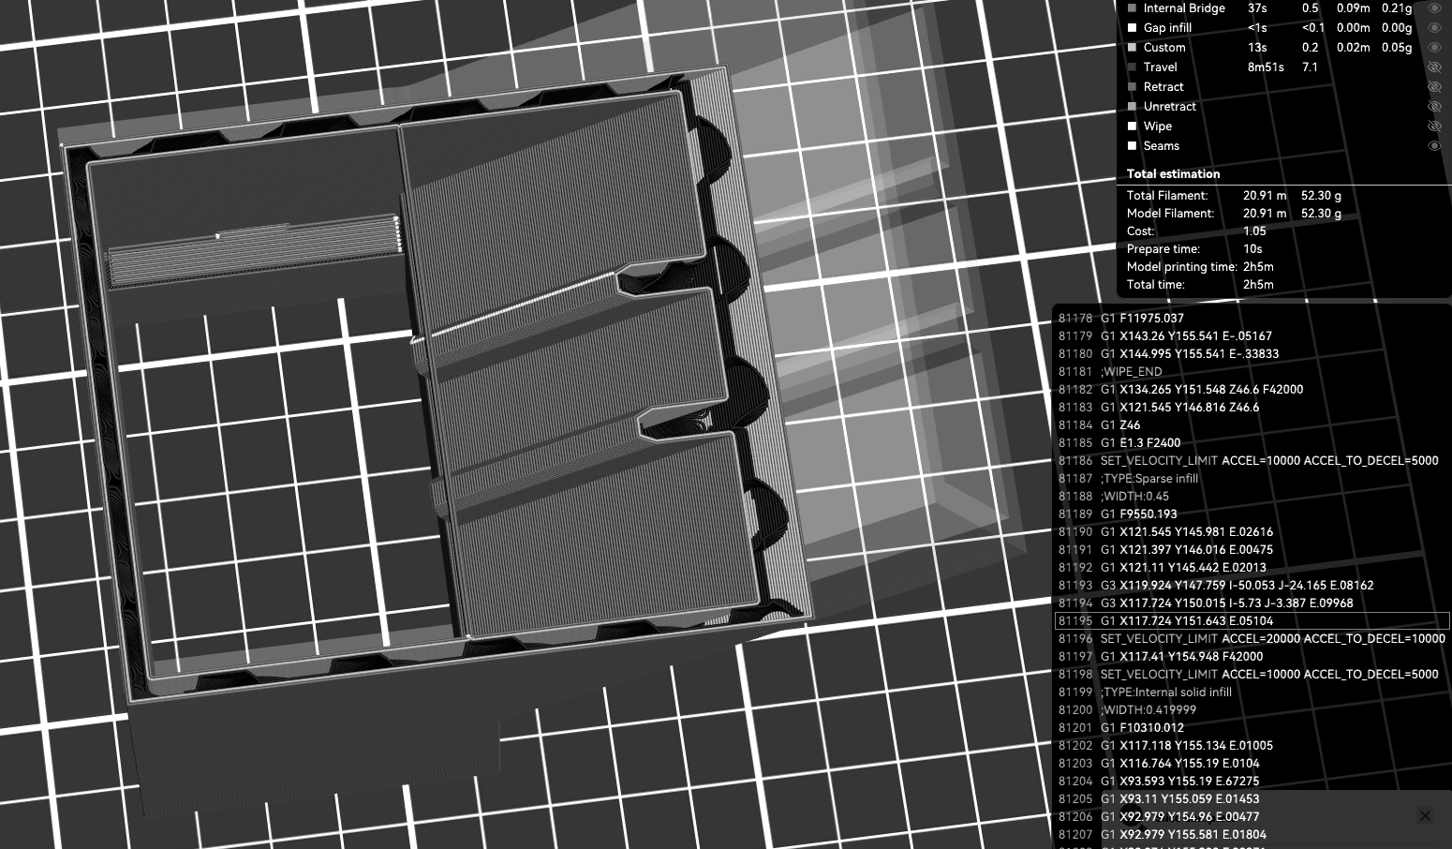
Figure 1. Department slicer-preview example with light infill (52.30 g). Visible layer paths and the estimate are part of the release check; interface labels may vary by software version.

4. Pre-Print Release and Safe Execution
Done | Release requirement | Record
☐ | Authorized reservation and trained operator are confirmed. | Name / slot
☐ | Creality K2 Pro and 0.4 mm nozzle are selected. | Printer ID
☐ | Approved material is mapped to the correct CFS slot or external spool. | Spool / slot
☐ | X, Y, and Z dimensions match the approved design; scale remains 100%. | Dimensions
☐ | Every body is on the plate and inside the printable boundary. | Plate view
☐ | Orientation, walls, top/bottom layers, infill, supports, brim, and adhesion are reviewed. | Settings
☐ | Preview is inspected from first layer through final layer. | Reviewer
☐ | Shells, ribs, spar sockets, holes, interfaces, and supports remain visible and continuous. | Layer check
☐ | Estimated material mass and print time are reasonable and recorded. | Mass / time
☐ | Slicer project is saved as .3mf; G-code is generated for this printer/nozzle/material/revision. | Filename
☐ | Build plate and printer interior are clear; required release approval is recorded. | Initials

Generate the printer file and start
- After preview passes, export G-code locally or use Send Print only for the authorized connected printer.
- At the printer, verify the filename, revision, destination machine, material, estimated time, and thumbnail.
- Confirm the build plate is seated and clear, the nozzle area is unobstructed, and the approved filament is loaded from the correct source.
- Start the print under supervision and remain for the first layers. Confirm adhesion, extrusion, walls, supports, and stable motion.
- Leave the machine only after lab staff or the instructor/TA confirms the approved monitored state.
FIRST-LAYER STOP CONDITIONS
Stop immediately for poor adhesion, nozzle drag, a shifted or lifting part, missing extrusion, filament-feed failure, collision, smoke, unusual odor, or abnormal noise. Preserve the file and evidence; do not attempt a repair or restart without authorization.

Complete the print and restore the station
- Allow the part and build plate to cool; remove the part only as trained.
- Label each component with team, part, and revision. Record actual mass, end time, failures, and observations.
- Return tools and materials, clean the work area, clear walkways, and leave the printer ready for the next team. Do not begin an unscheduled reprint; the instructor/TA approves the smallest useful revision after evidence review.

5. Wing Assembly and Build Acceptance

Dry-fit and assembly rules
- Remove supports without damaging functional geometry. Sand or cut only as authorized and with the required dust, tool, and PPE controls.
- Dry-fit every module and course-issued rod before using adhesive. Do not force a rod, bend it to overcome a misaligned socket, or enlarge a feature without approval.
- Use course-issued 5-minute epoxy only under supervision, with gloves, approved mixing tools, ventilation, and the instructor's alignment fixture or jig.
- Clamp the assembly in alignment and follow the full handling and cure guidance before moving it.
Done | Release requirement | Evidence
☐ | All required modules are present and labeled with team, component, and revision. | Visual
☐ | Supports are removed without damage to functional geometry. | Visual
☐ | Overall dimensions agree with the approved drawing, ruler template, or go/no-go gauge. | Template / gauge
☐ | Shells and ribs are continuous; no required feature disappeared during slicing. | Inspection
☐ | Spar sockets are open and continuous; course-issued rods dry-fit without forced bending or damage. | Dry fit
☐ | Module interfaces mate in the intended sequence. | Dry fit
☐ | The dry-fit wing shows no gross twist or misalignment on a flat reference surface. | Alignment
☐ | No major crack, layer separation, severe warping, loose section, or sharp hazardous defect is present. | Inspection
☐ | Actual printed mass and visible defects are recorded. | Print log
☐ | CAD, slicer-preview, first-layer, and completed-part photographs are saved. | File archive
☐ | Disposition is selected: Accept / Revise / Reprint Request. | Decision

ACCEPTANCE SCOPE
Print appearance alone is not the acceptance criterion. Evaluate dimensional compliance, feature continuity, assembly fit, traceable settings, and documented engineering decisions. Passing this checklist documents fabrication quality only; it does not establish aerodynamic or structural performance, product safety, or suitability for use. No physical performance test is included in this guide.

Failure and reprint control
- Stop, label, and preserve the failed part, slicer project, warning screenshot, and photographs.
- Identify one plausible cause supported by evidence; do not change several settings at once.
- Propose the smallest useful change in code/CAD, orientation, or approved process setting.
- Obtain instructor/TA approval before consuming material on another attempt.
- Create a new revision and link it to the original print-log entry.

6. Troubleshooting
Use the table before changing settings. Return to the source model when geometry is the cause; slicer repair is a secondary check, not a substitute for a valid solid.
Symptom | Likely cause | Required action | Escalate when
Model tiny or enormous | STL unit mismatch | Compare the bounding box with CAD; correct export units once and re-verify. | Dimensions remain uncertain
Nothing appears / 0 layers | Empty/open body or body off the plate | Return to CAD, make a watertight solid, re-export, and Drop to Bed. | Repair warning persists
Rib, shell, or socket disappears | Feature below printable width or zero thickness | Increase physical thickness in code/CAD and re-slice. | A requirement must change
Mesh/repair warning | Open shell, overlap, self-intersection, duplicate faces | Repair the source geometry and re-export; inspect the resulting mesh. | Slicer repair changes geometry
Part red / out of bounds | Model exceeds build area or crosses boundary | Rotate, split at an approved interface, or use another plate. | Scaling seems necessary
Wrong printer opens from 3MF | Foreign printer profile embedded | Import geometry only; reselect K2 Pro and 0.4 mm nozzle. | Settings cannot be verified
First layer will not adhere | Dirty plate, weak orientation, or inadequate approved adhesion | Stop; clean/reseat the plate; review brim and orientation. | Failure repeats
Nozzle drags / part shifts | Lifting, collision, or unstable part | Stop immediately; preserve the file and photographs. | Any equipment contact/damage
CFS mismatch / feed failure | Wrong slot mapping, empty spool, or unsuitable filament | Stop; correct mapping; use only the approved material path. | Filament breaks in the path
Send Print fails | Network, login, or device connection issue | Export locally; verify the correct printer; ask staff to check connection. | Connection remains unavailable
Warping / layer separation | Orientation, approved profile, adhesion, or rigidity issue | Document the defect and request the smallest approved revision. | A reprint or setting change is needed
Support cannot be removed safely | Inaccessible support or poor orientation | Revise orientation or splitting strategy; do not improvise cutting. | Cutting or sanding is required

Recovery sequence when the cause is unclear
- Save the failed slicer .3mf and capture the exact warning and layer view.
- Open a new project; select K2 Pro, 0.4 mm, and the approved material/profile.
- Import one repaired component; verify size, place it on the bed, and try the standard profile without custom modifiers.
- If it still fails, send the native code/CAD file, exported STL/3MF, slicer .3mf, and screenshots to the instructor/TA. Do not send only G-code.

Appendix A. Team Print Log — One Form per Attempt
Team information | Team ____ Members ______________________________ Operator __________________
Reservation | Date __________ Time __________ Canvas slot / approval __________________________
Part and revision | Component __________________ Revision ______ Code/CAD file __________________
Exported files | STL/3MF __________________________ Slicer .3mf __________________________
Machine and material | Printer ID ______ Nozzle 0.4 mm ☐ PLA Pro brand/color/spool ID __________________
Material source | CFS slot ______ External spool only if approved: approval ______________________
Slicer setup | Scale ____% Layer height ____ mm Walls ____ Top/bottom ____ Infill __________
Support / adhesion | Supports __________________ Brim/adhesion __________________ Orientation __________
Preview record | Estimated mass ____ g Estimated time ______ Every layer reviewed ☐ Dimensions verified ☐
Release | Released by __________________ Date/time __________________ G-code destination verified ☐
Print record | Start ______ First layer: Pass / Stop End ______ Actual mass ____ g
Outcome | Accept / Revise / Failed / Reprint Request Completed-part photo saved ☐
Observed defect or risk | ________________________________________________________________________
Likely cause and evidence | ________________________________________________________________________
One proposed corrective action | ________________________________________________________________________
Change control | New revision? Yes / No Reprint approved by ______________ Date/time __________
Canvas filenames / links | ________________________________________________________________________

Required archive
- Clean code/native CAD run and recorded design parameters.
- Exported STL/3MF, saved slicer .3mf, and G-code only when requested.
- Screenshots of dimensions and representative first/middle/final layers.
- First-layer and completed-part photographs, actual mass, and this print log.
- Revision note explaining any failed attempt and the approved change.

Contacts and escalation
Course questions | Instructor or assigned MIE 446 undergraduate TA; use Canvas for current hours and release workflow.
Emergency | 911 or UMPD 413-545-3111; report ELab 1, Room 104A.

Official references
- Creality software and firmware download center
- Creality Print Quick Start Guide
- Creality Print 6/7 quick-start page
- Creality K2 Series product information
- Creality K2 Pro multi-color/CFS guide
Department basis: Creality K2 Pro + CFS Student Quick-Start Guide (July 31, 2026); MIE Print and Inspection Lab Rules & Use Agreement; MIE 446 course project guidance. Canvas, lab signage, staff instructions, and machine-specific SOPs supersede this summary when updated. Information verified August 28, 2026.

