Numerical Project: Wright Flyer Half-Wing Truss
MIE 446 Aerospace Structures | Team project

Analyze an idealized half of the 1903 Flyer biplane: upper and lower wings on one side. Use hand calculations and Truss Lab to compare point and distributed lift loads, then study cable area sensitivity.

Geometry and properties
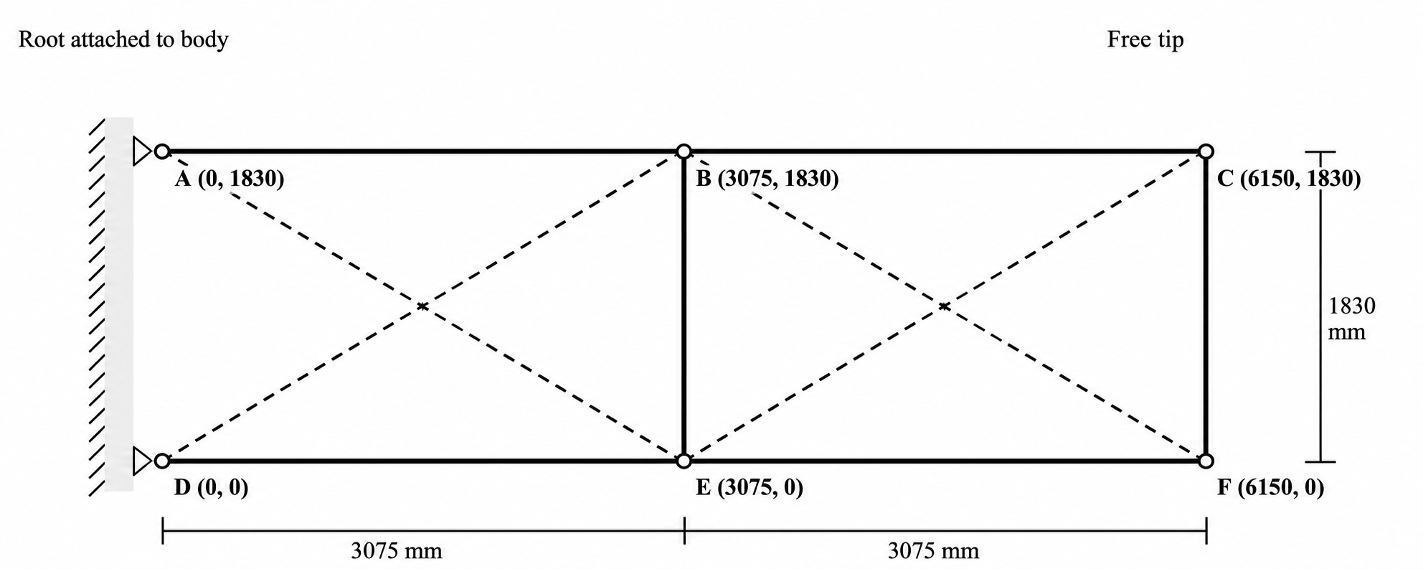
Figure 1. Coordinates in mm. Solid: bars; dashed: tension-only cables. Crossings are not joints. Do not add A–D.

Truss details:
Restrain x and y at A and D using Pin supports; all other nodes are free. Bars: AB, BC, DE, EF, BE, CF. Cables: AE, DB, BF, EC.
Bars: E = 10,000 MPa, A = 600 mm². Cables: E = 200,000 MPa, A = 10 mm². Use these properties in Stages 1 and 2; vary only cable area in Stage 3.

Lift basis
Use m = 341 kg and g = 9.81 m/s². Total lift is mg = 3345.2 N in steady level flight. Assign half to this side and divide equally between the upper and lower wings: 836.3 N per wing. Full span: 12.3 m; wing gap: approximately 1.83 m.

Stage 1: Point loads (Hand and Software calculations)
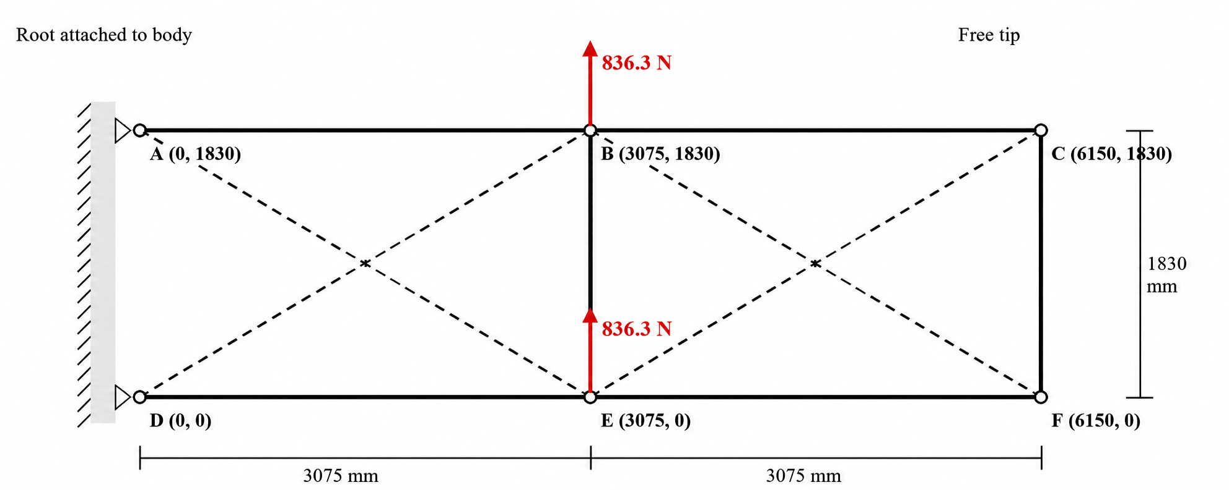
Figure 2. Stage 1 loading.
Apply +836.3 N vertically upward at points B and +836.3 N at E (Figure 1). These are the resultants of the uniform lift used in Stage 2.
a) Hand Calculation: Draw the free-body diagram. Use joint equilibrium and/or sections to find support reactions and every member's axial force. Identify tension, compression, and zero-force members. Check the assumed active cables; cables cannot carry compression. No hand displacement calculation is required.
b) Software: Build and solve the model in Truss Lab. Compare reactions and member forces with your hand solution and explain discrepancies. Report actual displacements and show the displaced truss.

Stage 2: Distributed lift in Truss Lab (Software calculation)
Software: Remove both Stage 1 point loads. Select Distributed → joints. Apply upward uniform loads on paths A–B–C and D–E–F: q_{Start} = q_{End} = 0.1359841463 N/mm; angle = 90°. Each path carries 836.3 N over 6150 mm.

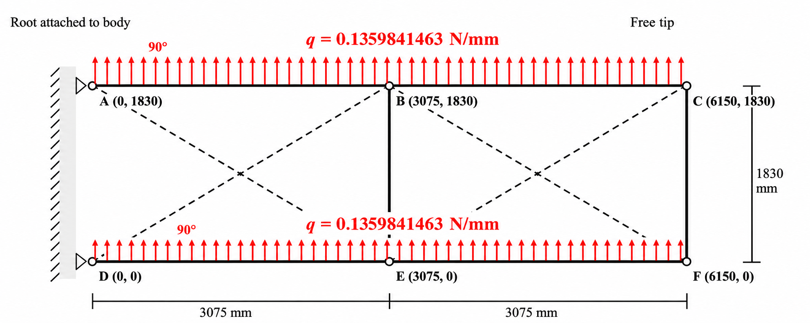
Figure 3. Stage 2 loading

Inspect equivalent nodal loads: approximately 209.1, 418.2, and 209.1 N at the root, middle, and tip of each path. Retain root-node forces. Keep Stages 1 and 2 separate. Check overall force and moment equilibrium in both stages. Report displacements.
Truss Lab transfers line loads to joints; it does not calculate bar bending between joints. No hand solution is required for Stage 2.

Stage 3: Cable area sensitivity and design recommendation (Software calculation)
Use the Stage 2 model. Study cable areas A = 5, 10, and 20 mm², assigning the same area to all four cables in each case. Reuse the 10 mm² baseline. Keep geometry, supports, loads, bar properties, and cable Young’s modulus unchanged. Retain tension-only behavior.
Before solving, predict the effect of increasing cable area on maximum displacement and member forces. Solve all three cases and compare your prediction with the results.
Provide one table: cable area, maximum displacement (mm), maximum absolute cable stress, maximum absolute bar stress, and slack cables. Identify governing nodes/members and explain changes in active cables or force distribution.
Recommend one area considering displacement and total cable material volume, calculated from member lengths and assigned areas. Explain the benefit and cost relative to the baseline. No allowable stress is specified; do not claim a design is safe or unsafe. Limit Stage 3 to one table and approximately one page of discussion. No hand solution is required.

Team report and files
Submit one team report and three editable JSON files: Stage 1, Stage 2, and your recommended Stage 3 design. Include:
- Stage 1 hand solution and a table comparing hand and software member forces and reactions.
- For Stages 1 and 2: axial-force diagrams and undeformed/deformed overlays. State deformation magnification and actual displacement in mm.
- A Stage 1–2 comparison table: reactions, maximum absolute member force and stress, maximum displacement, and slack cables. Explain why equal total lift and root moment need not give identical internal forces or deformation.
- Stage 3 prediction, sensitivity table, cable volumes, and design recommendation.

Assessment rubric out of 100
Criterion | Points | Evidence
Stage 1 hand analysis | 28 | Free-body diagram and reactions (8); member forces and force types (14); active-cable checks (6).
Stage 1 software verification | 16 | Correct geometry, supports, properties, and loads (8); quantitative hand/software comparison and discrepancies (8).
Stage 2 and comparison | 24 | Distributed and equivalent nodal loads (8); equilibrium checks (6); Stage 1–2 results and physical interpretation (10).
Stage 3 sensitivity and design | 20 | Prior prediction (4); three-case results and active-cable interpretation (8); volume–displacement trade-off and recommendation (8).
Report and reproducibility | 12 | Clear diagrams, units, and deformation scales (6); organized report and three working JSON files (6).
Total | 100 | Project score × 0.25 contributes to the course grade.
Award full credit for correct, supported work; partial credit for valid method with errors or omissions; zero for missing work.

Teamwork and confidential peer review
All three members must share the analysis, modeling, and checking and review the final model. Each student rates the other two members for contribution, technical checking, and reliability (1–5), with one brief evidence-based comment per person.
Open the peer review Google Sheet, make a private copy, and submit it separately in Canvas. Do not enter ratings in the shared template or include them in the team report.

